## White Sauce Pasta

1. **Origin**: France/Italy
2. **Source**: Own Recipe
3. **Category**: Main Dish
4. 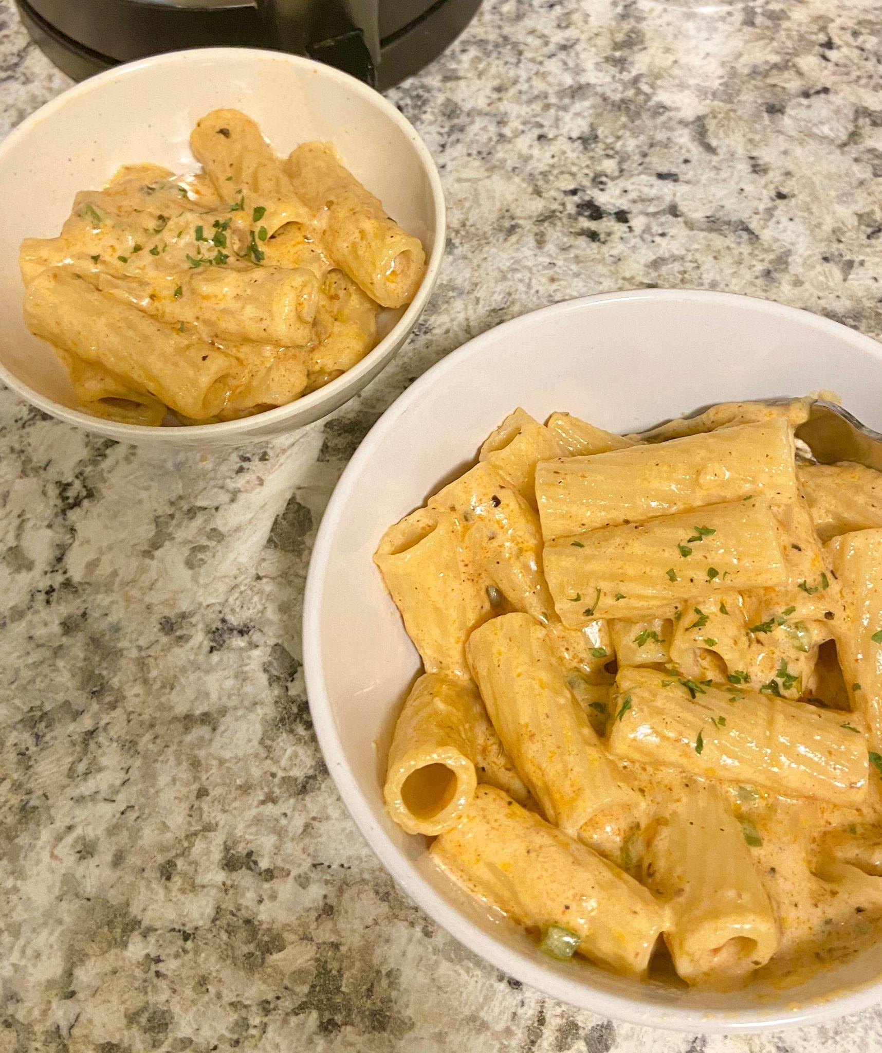
5. White_Sauce_Pasta.JPG
6. White sauce pasta is a creamy and savory dish that can be enjoyed for either lunch or dinner. Inspired by a fusion of Italian and French cuisine, the rough texture of rigatoni pasta allows for heavier sauces to be picked up, including the flavor profile of this delicious sauce. This union of two cultures allows for the perfect balance between each component of the recipe, creating a fulfilling entree that every individual can enjoy.
7. **Recipe Ingredients** 
   1. Olive Oil
   2. Butter
   3. Diced Onion
   4. Diced Garlic
   5. Diced Bell Pepper
   6. Rigatoni Pasta
   7. Heavy Whipping Cream
   8. Milk
   9. Shredded Parmesan Cheese
   10. Salt
   11. Ground Pepper
   12. Garlic Powder
   13. Onion Powder
   14. Paprika
   15. Oregano Leaves
   16. Bay Leaves
   17. Parsley Leaves
8. **Recipe Steps**
   1. Bring a pot of water to a boil. Once the water begins to bubble, add in the pasta, salt, and a drizzle of oil.
   2. While the pasta is cooking, heat oil and butter in a saucepan.
   3. Once the butter has melted, add in diced onions and garlic. Sauté them until golden brown or aromatic.
   4. Stir in the bell pepper until slightly softened.
   5. Pour in the heavy cream, milk, salt, ground pepper, garlic powder, onion powder, paprika, oregano leaves, and bay leaves into the saucepan. Mix well and allow for the mixture to simmer. Adjust the seasoning to your taste.
   6. Add the shredded parmesan cheese and stir until melted.
   7. Throw in pasta and mix until the pasta is coated with the creamy sauce.
   8. Garnish with parsley leaves, and enjoy.
9. **Additional Food Images**
10. BoiledRigatoniPasta.jpg
11. Boiled Rigatoni Pasta in a Strainer
12. SauteedOnions.jpeg
13. Sauteed Onions in a Pan
14. WhiteSauce.jpeg
15. White Sauce in a Pan
16. Lina Lin