|  |  |
| --- | --- |
| *Document title* | How to Check if Esker is responding - Esker - Fax Application |
| *Author(s)* | Teddy Mabulay |
| *submitted to local IT* | Monday, December 9, 2019 |
| *Target Site* | FR – France |
| *Local IT / IT Manager* | Jerome Raynouard |

|  |  |  |  |
| --- | --- | --- | --- |
| Version History | | | |
| Version | Date | Change By | Changes Made |
| 1.0 | 9.12.19 | Teddy Mabulay | Initial changes |
| 1.1 | 20.12.19 | Teddy Mabulay | Common reason of the issue, how to check if issue is resolved |
|  |  |  |  |

# Table of Contents

Table of Contents 4

Summary 5

Ticket sample: 5

Issue description: 5

Issue Impact: 5

Triggers of the alert: 5

Pre-requisite: 5

Issue resolution 5

Ticket process in SNOW 10

Process map 11

Changes/Updates 11

# Summary

## What is Esker[1]:

* A cloud-based document process and information exchange service.
* Esker on Demand enables companies to automate business documents and provide full visibility over all processes with just an Internet connection and web browser.

## Why we use Esker

* Esker is designed to uphold security, confidentiality and traceability always.
* Esker is used by France site for Fax transmission

## Ticket sample:

NA

# Issue:

## Description

* User is not able to send the fax
* Fax application is not responding

## Impact:

* No major impact

## Triggers of the alert:

* User using Esker will contact to report that the FAX application is not accessible

# how to check if issue is resolved

* Go to <https://www.trustesker.com/index.php> and check the environment.

*\*If you have been provided a contract to check the correct environment, please click on "****what is my environment?****" then next enter the provided contract number and click "****OK****"*

* **Service availability** should be green and Environment Uptime at 99.9%

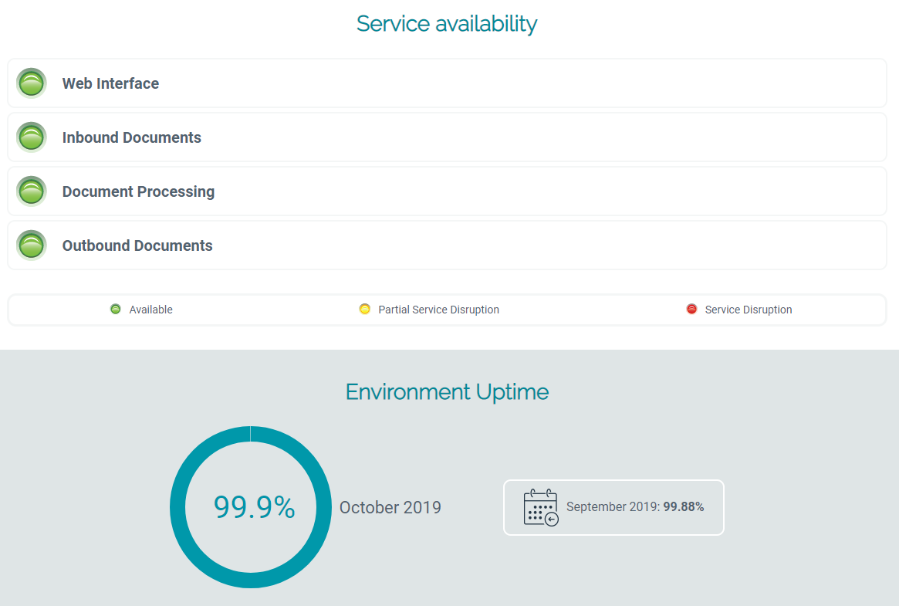

# Ticket process in SNOW

NA

# Process map

NA

# Quality Metrix

|  |  |  |  |  |
| --- | --- | --- | --- | --- |
| Identifier | ITOPS-PROC-FR-001 /version 1.1 | | | |
| Title | How to Check if Esker is responding - Esker - Fax Application | | | |
| Purpose | The primary purpose of this SoP is to check if Esker application is responding. This can be done after a maintenance or anytime Esker is not responding | | | |
| Composition | * Internet connection * Esker Fax Application: <https://www.trustesker.com/index.php> * Reported environment Contract Number | | | |
| Derivation | Jerome Raynouard personal notes | | | |
| Format and presentation | Word document | | | |
| Development skills required | France Local IT | | | |
| Quality criteria | Quality tolerance | Quality method | Quality skills required | Quality responsibilities |
| * *Check if the environment is available* * *Check if service availability is green* * *Check if environment uptime is 99.88%* | * *0%. All quality criteria checks need to be fulfilled* | 1. Open Esker Fax Application from a browser: <https://www.trustesker.com/index.php> 2. Go trough each quality checks and make sure they are all fulfilled. | NA | * **Approver***:* France Local IT – Jerome Raynouard * **Task Owner***:* IT Shared Services Analyst, Europe |

# Changes/Updates

|  |  |
| --- | --- |
| *\* to be filled by the local IT in case there is any comment to the document* | |
| Page | Comment |
|  |  |
|  |  |
|  |  |

1. <https://www.esker.com/business-process-solutions/automation-products/esker-on-demand/>