1. Social login not working.
2. Use the height & Scroll bar on the location filter.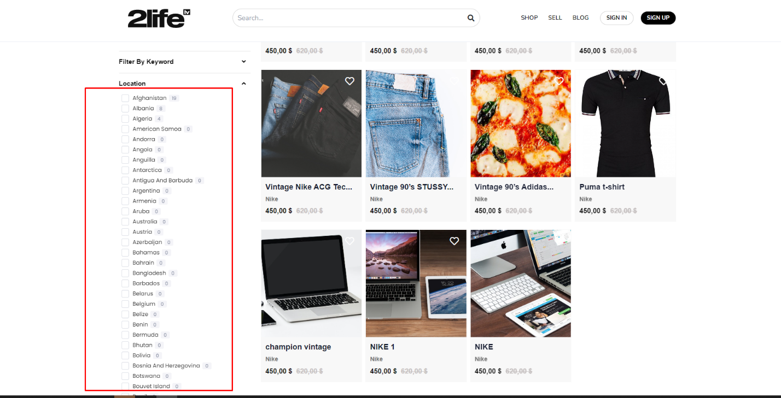
3. Check
4. 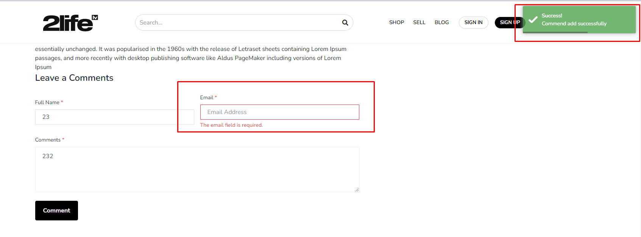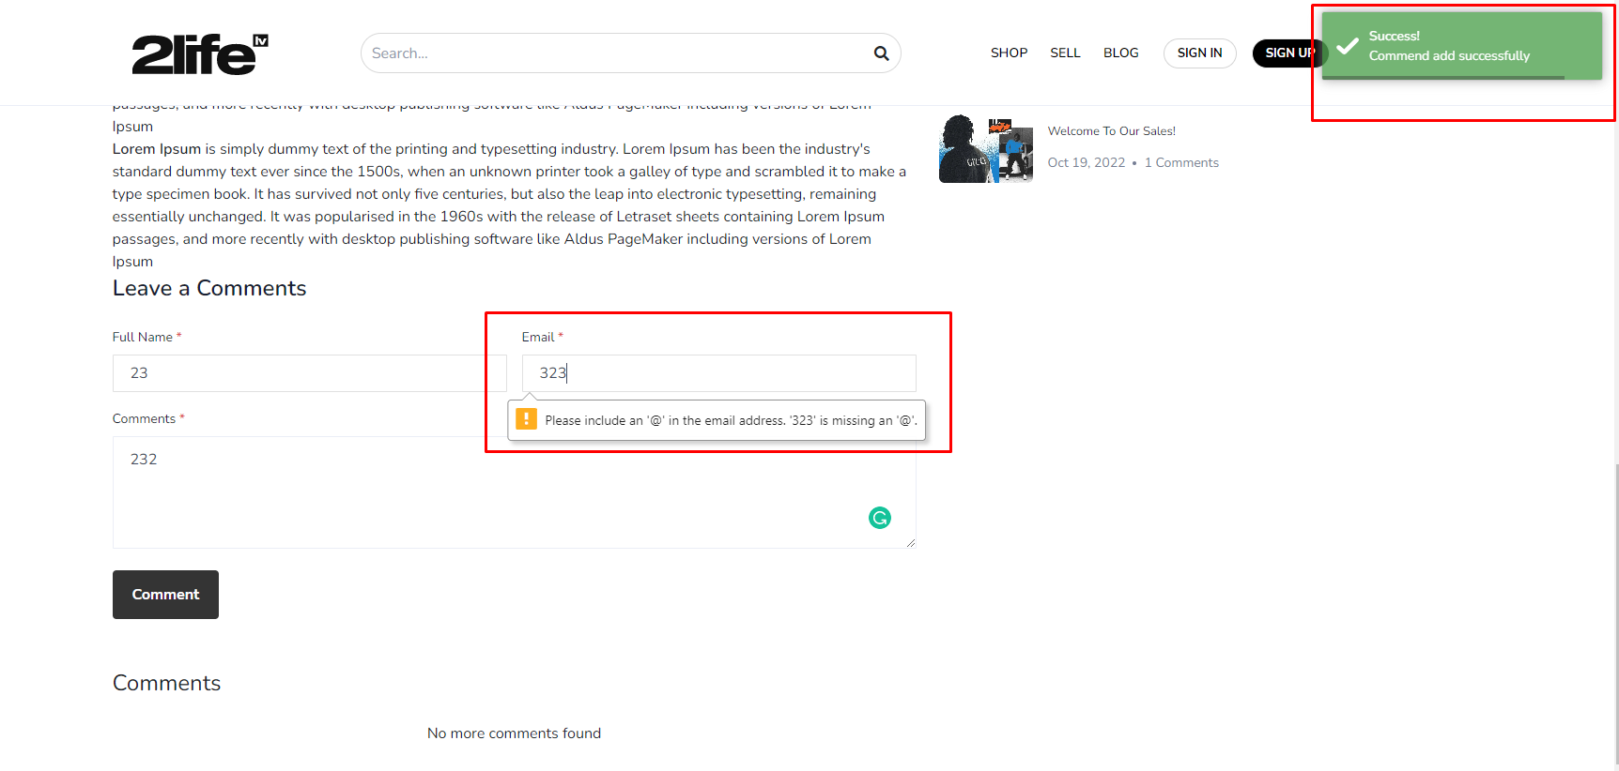
5. 4.check properly
6. 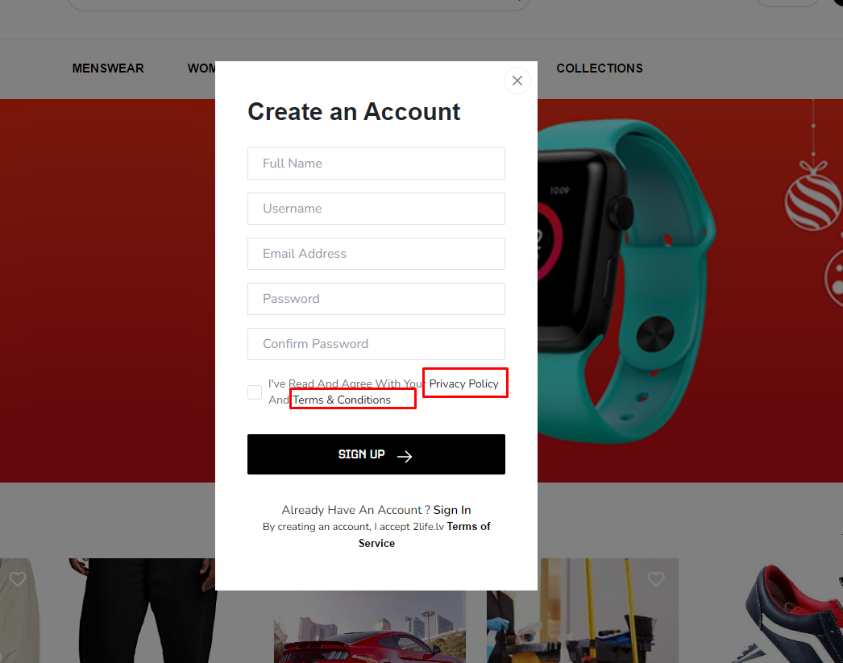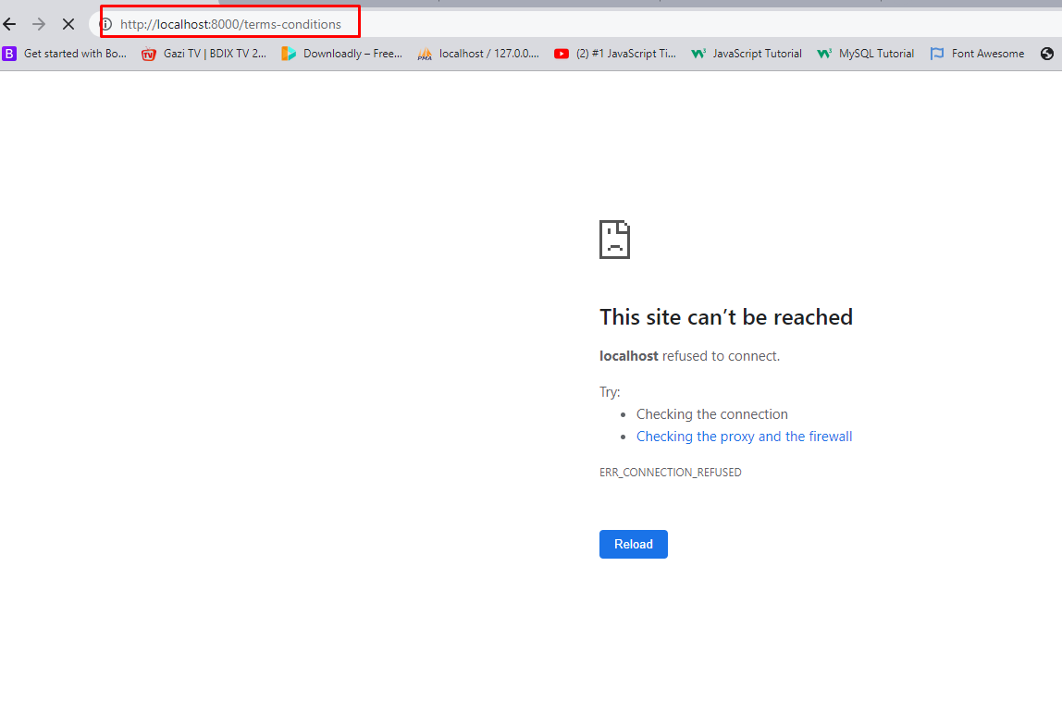
7. User register mail not sent.
8. Remove the view ad button on the user coupon purchased mail.
9. 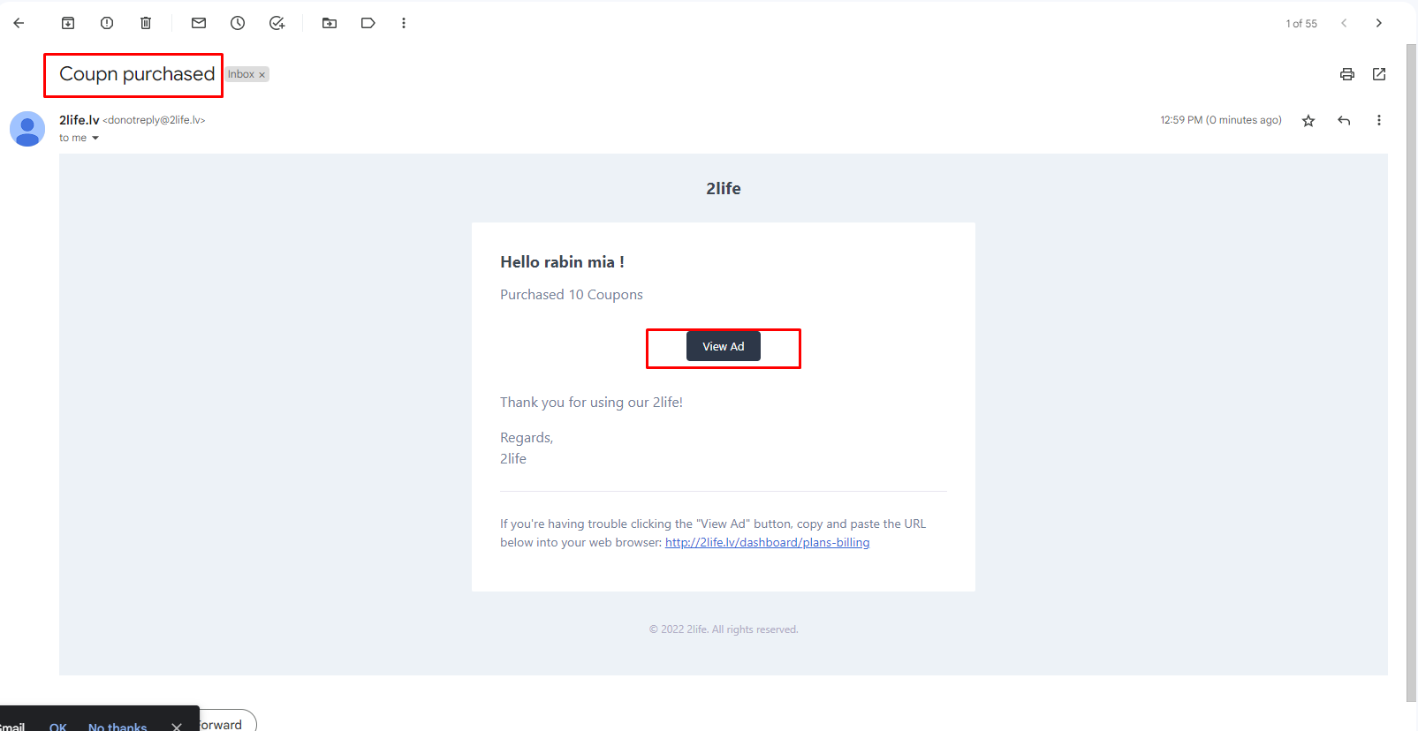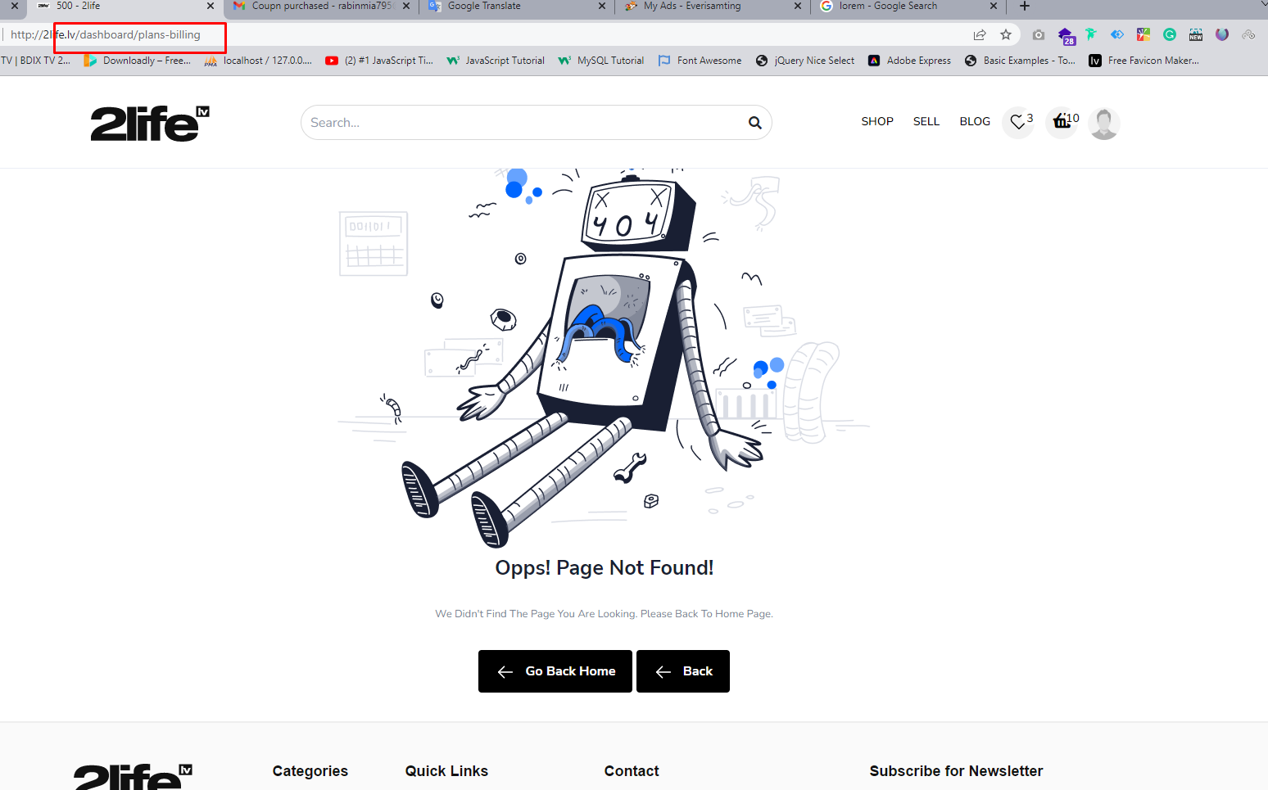
10. Wishlist count not work properly. When I remove wishlist item toaster msg not showing currently.
11. 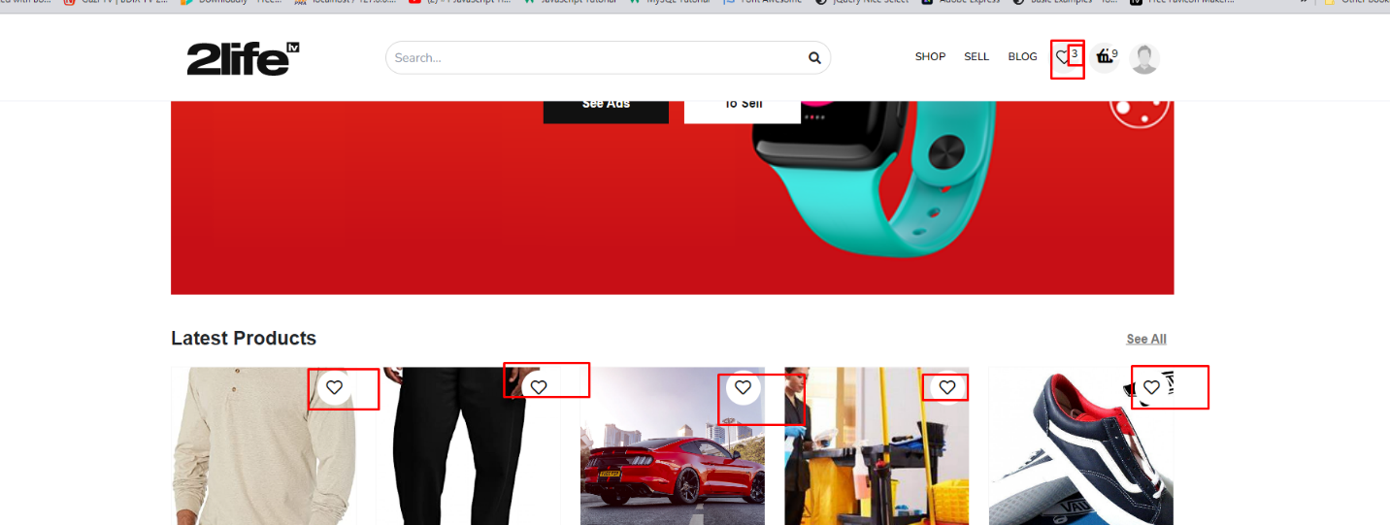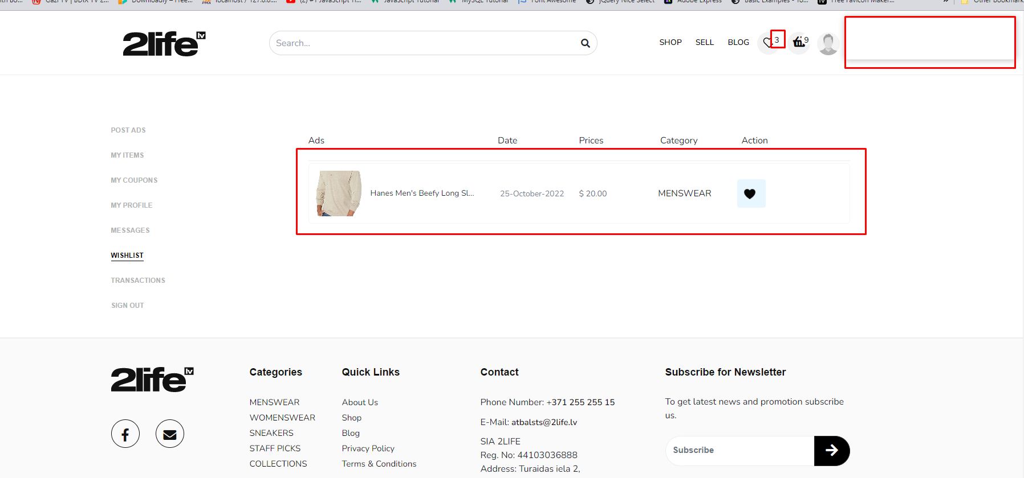
12. when a user add a product to their wishlist they receive mail. I thing this mail receive seller not user
13. Please check this.
14. 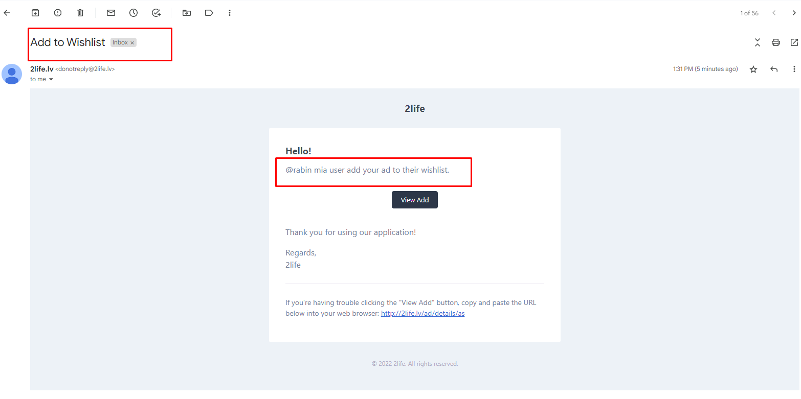
15. 10. If there is no product then hide this section.
16. 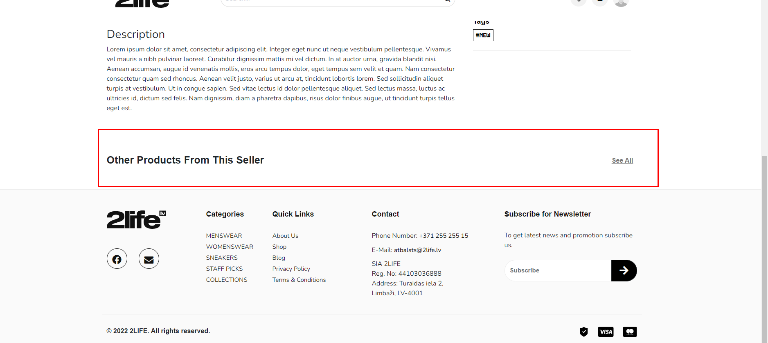
17. 11. Check this properly.
18. 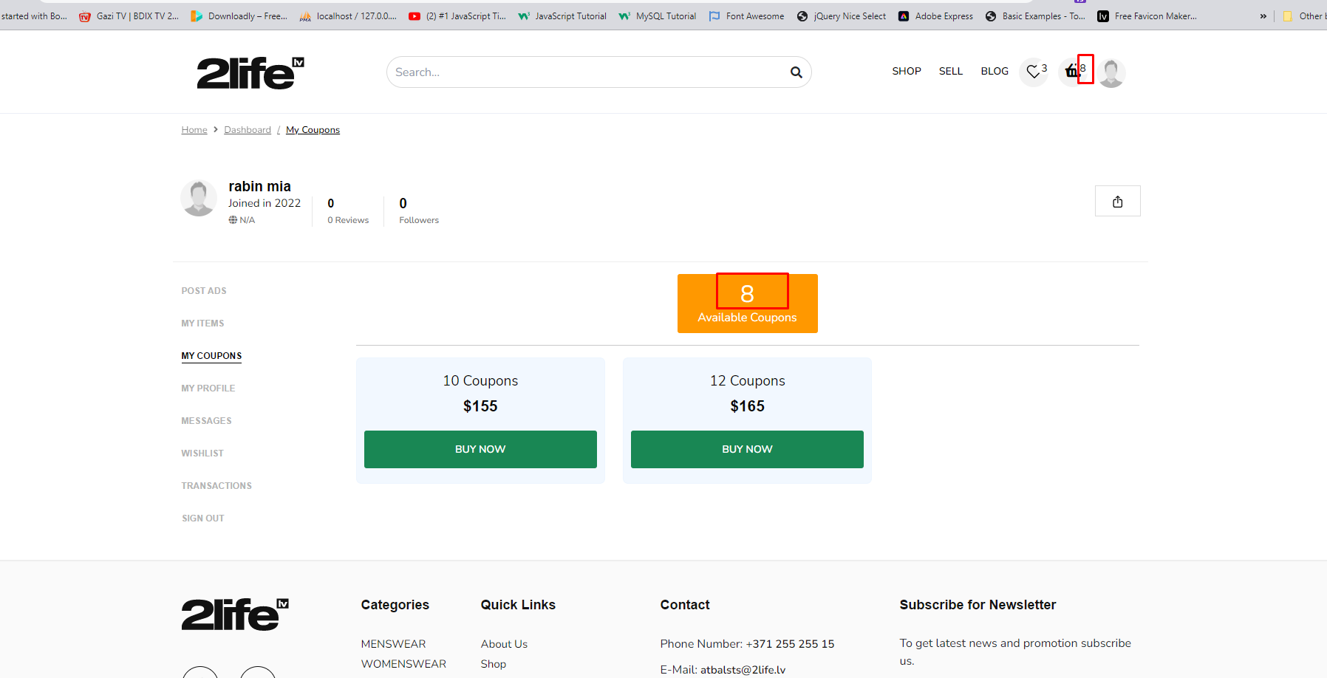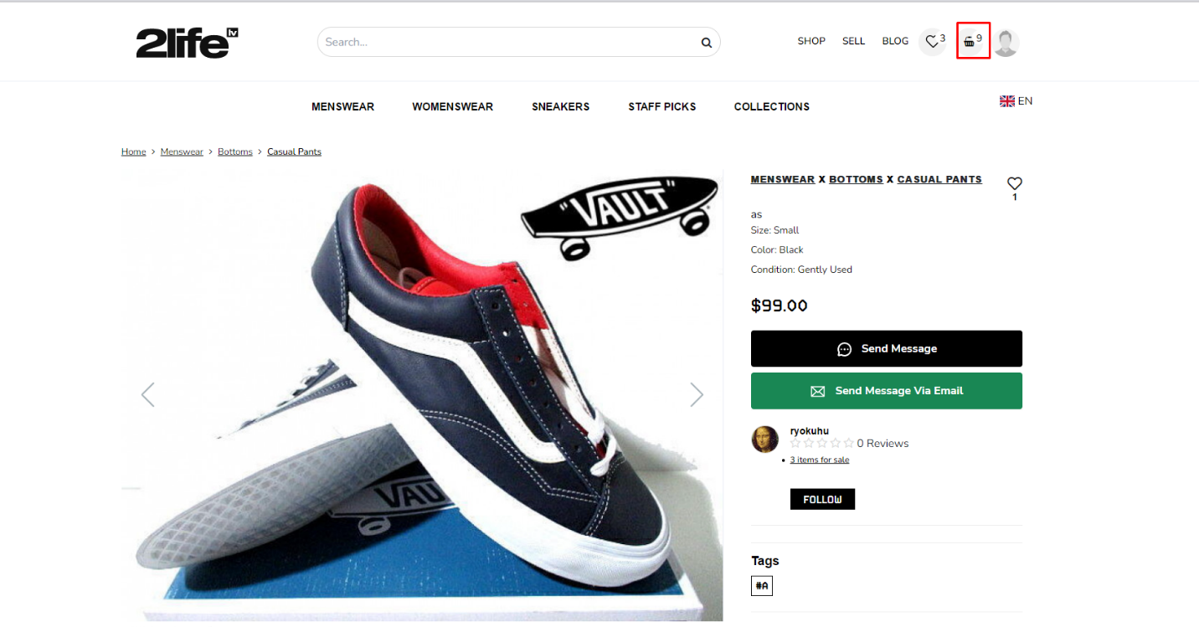
19. 12. Without field the input field When I click the mail send button shows the toaster message (Mail has been sent). Input field not required. Please add the HTML required.
20. 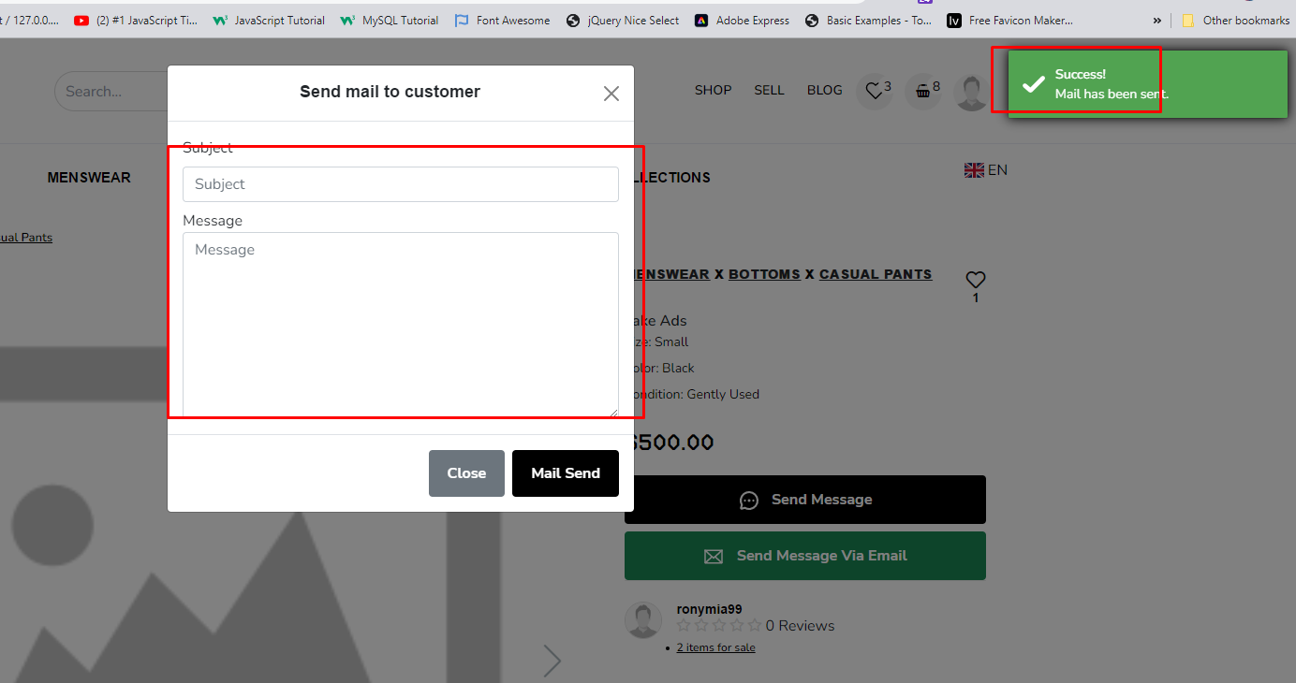
21. 13.Fonts size
22. 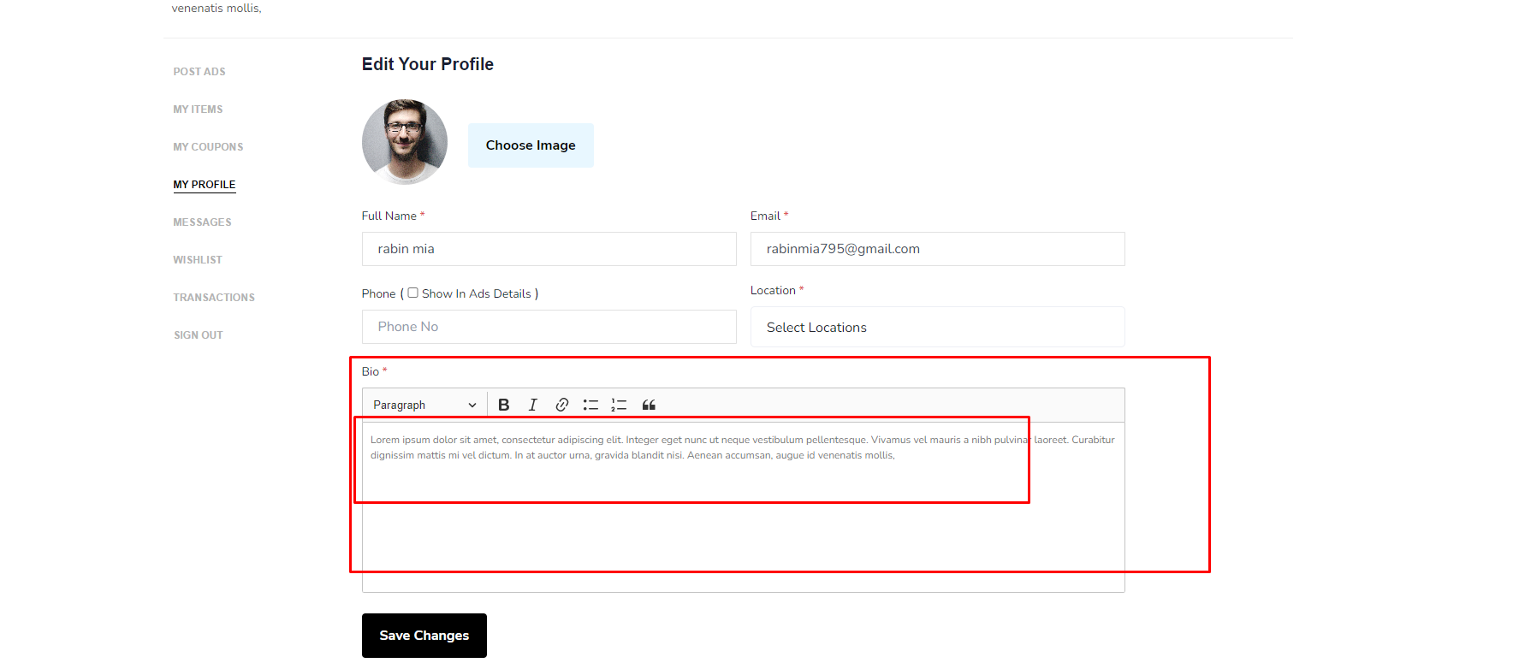
23. 14. When click the use name redirects to the dashboard page but the user dashboard sidebar there has no dashboard menu.
24. 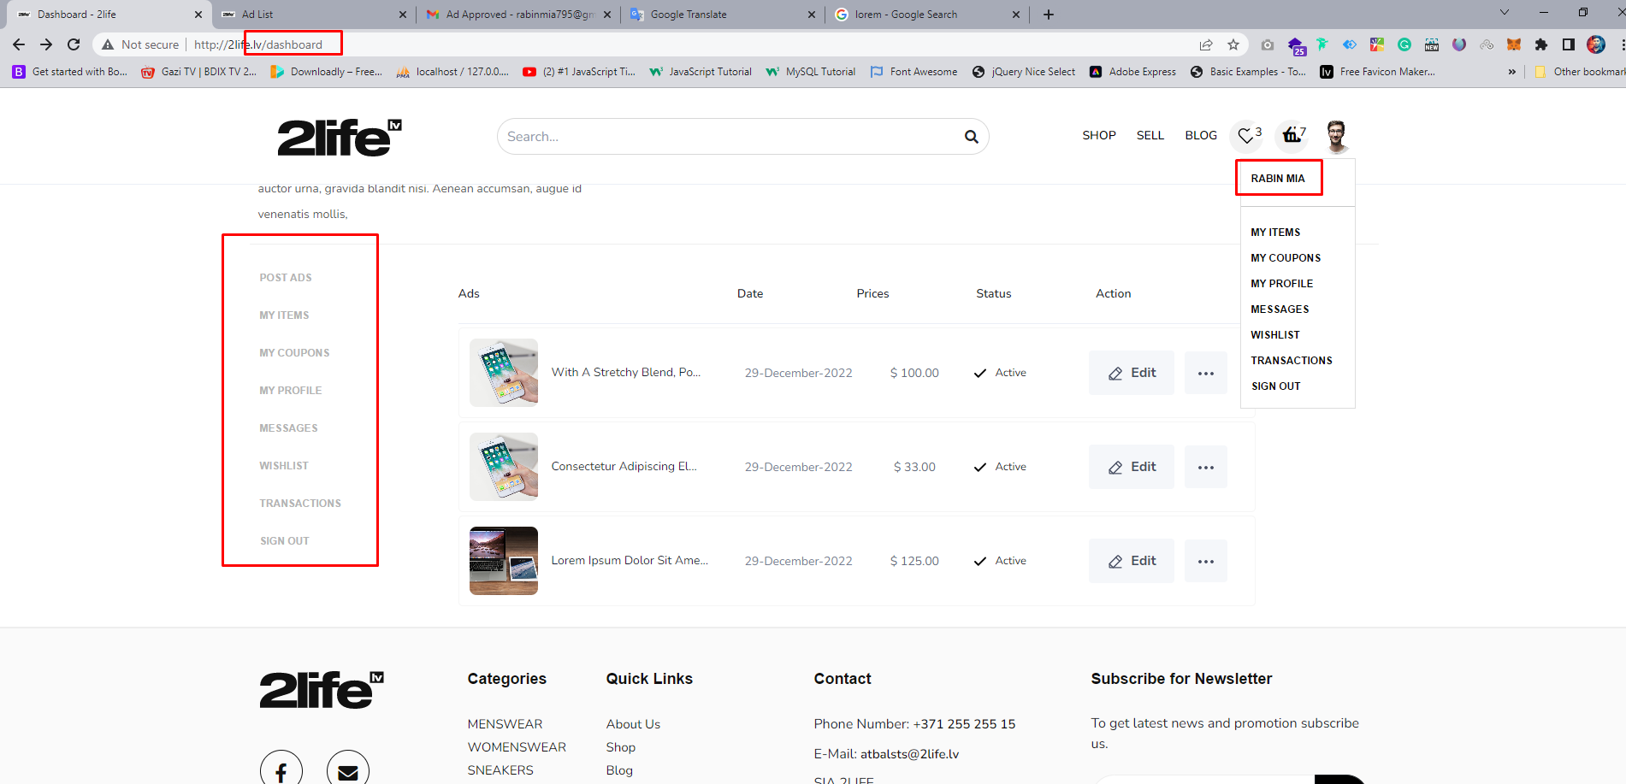
25. \*\*\*\*\*\*\*\*\*\*\*\*\*\*\*\*\*\*\*\* Admin Panel \*\*\*\*\*\*\*\*\*\*\*\*\*\*\*\*\*\*\*\*
26. Country Name
27. 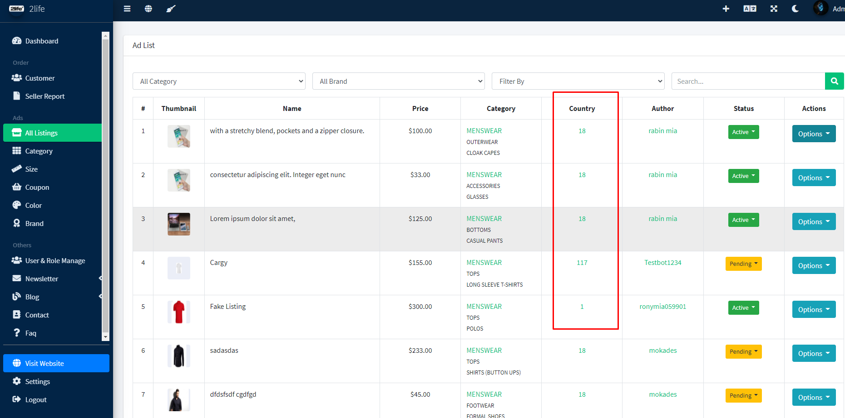
28. Remove This.
29. 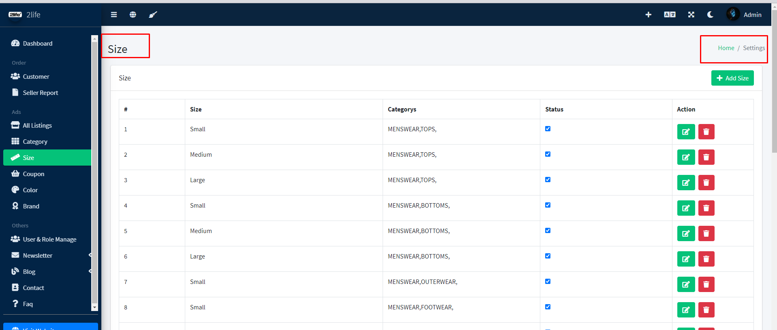
30. 3.Not working.
31. 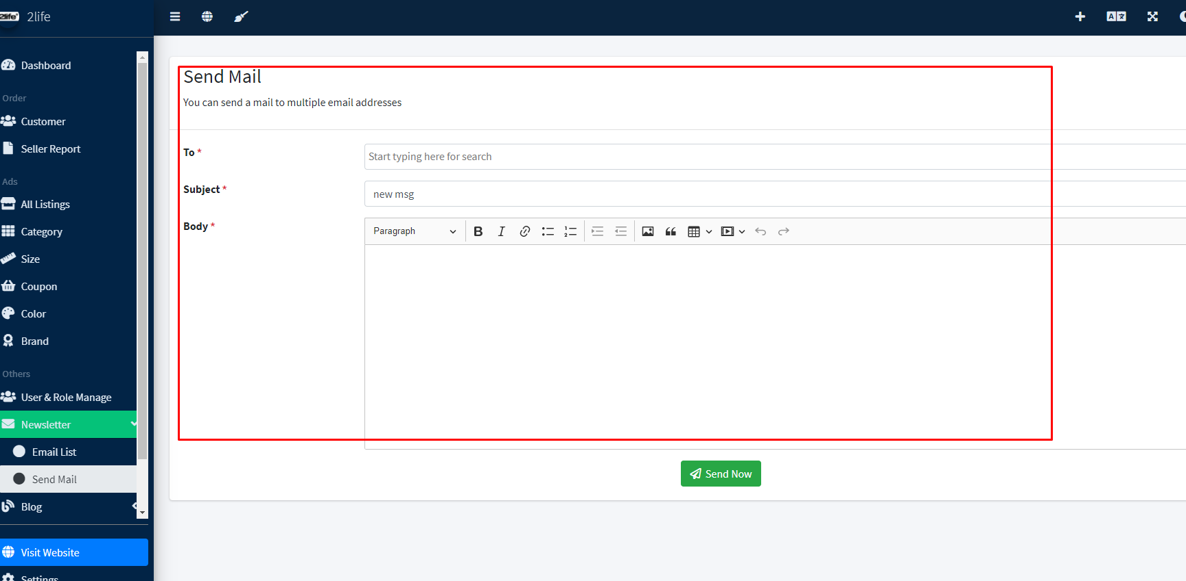
32. Post edit image not showing.
33. 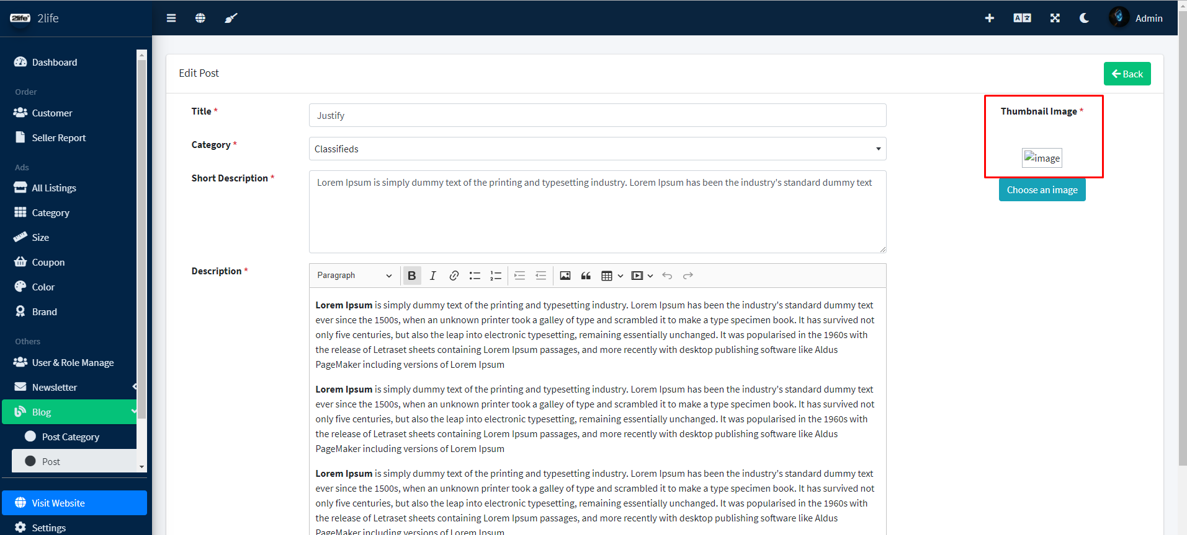
34. 6.Not working.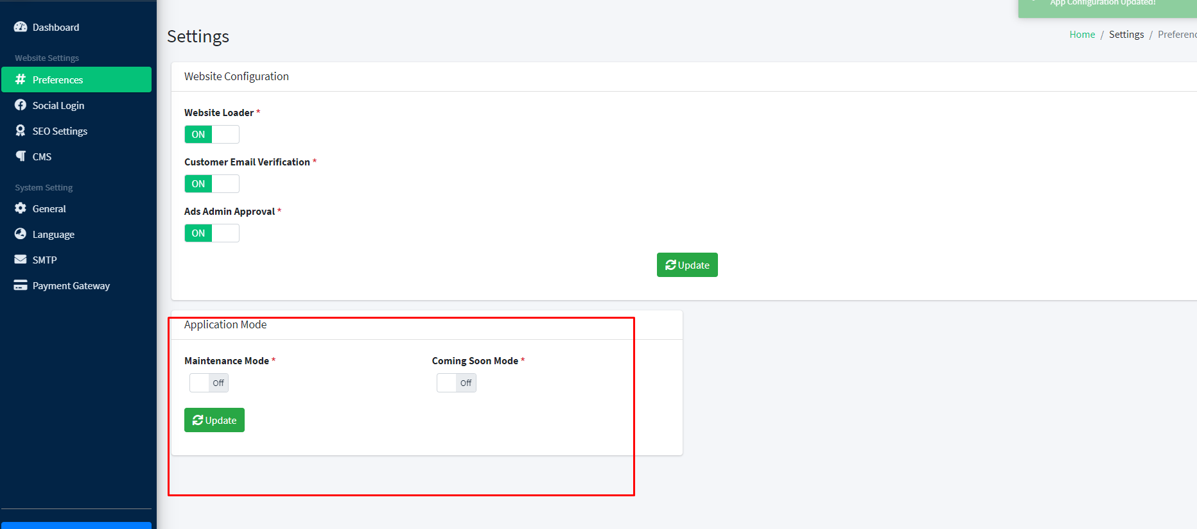
35. "Baltics" should be renamed to Other or Worldwide and with option to not add delivery price, specific delivery costs through world shipping people will discuss between themselves, it will be optional Graphical user interface

    Description automatically generated with medium confidence
36. I would like to have "TikTok" and "Instagram" icons shown in picture A picture containing application

    Description automatically generated