**Requirements:**

1. Latvian, English, Estonian, Lithuanian 2. Primary will be Latvian (Languages)
2. Coupon purchase korbe and coupon ar opor depend kore listing show korbe
3. Chat and seller rating system
4. Seller own sell page

**Questions:**

1. Do you want to do custom ads advertisement? A picture containing text

   Description automatically generated
2. Why the words “Reserve” rather than buy Graphical user interface, website

   Description automatically generated
3. Why do you want to give add to cart section ? it’s not necessary. The buyer will go product details page and able to see seller information and messaging option. And they will do communication for the product. In this category website purchasing happen only one by one product, as like grailed.com if you see
4. When will buyer purchase something then seller will directly received the payment to their stripe and PayPal account?
5. How seller will give product shipment ? say buyer purchased a product with online payment. Now if the seller won’t ship the product then what will you do ?
6. How will the seller define shipping cost for the product?
7. How customer will purchase coupons?

**Answer:**

1. Okey, then no cart section necessary.

2. I think the best way is to let seller and buyer chat how they will pay for that product, I am mostly focusing on Baltics no if 2 persons from same country decide to buy or sell something from each other they might meet up in real life, it`s common in here. But if not, they might use our banking systems like seb bank or swed, works in entire Baltic state. If person from different country uses this service, they just pay with their bank.

3. Entire world uses some kind of postal services, in Baltics it's common to use www.omniva.lv (parcel services). I know that they offer some kind of API aswell. https://www.omniva.lv/pakomatu_spraudnji_e_veikaliem - check this one. This is some kind of a plugin that might be needed for this project. Answering that - if the seller won't ship the product then what will you do? This one is the trickiest, most important thing about this entire project is safety and customer verification, phone, mail e.t.c. I had a idea about manually checking persons ID, which they upload and I accept them. If something goes south I have their identification and can charge them in police. (This one I have to ask some institutions if I can do that) It's up to discussion.

4. Every seller individually discuss with buyer price of the shipping.

7.

**14**

**27 July, 2023**

1. It is not selected and also check for seller own shop pageA screenshot of a computer

   Description automatically generated
2. Size maybe not working properly A screenshot of a computer

   Description automatically generated
3. Icon ta right side a hobe A screenshot of a computer

   Description automatically generated
4. Remove red border A screenshot of a computer

   Description automatically generated
5. Following functionality 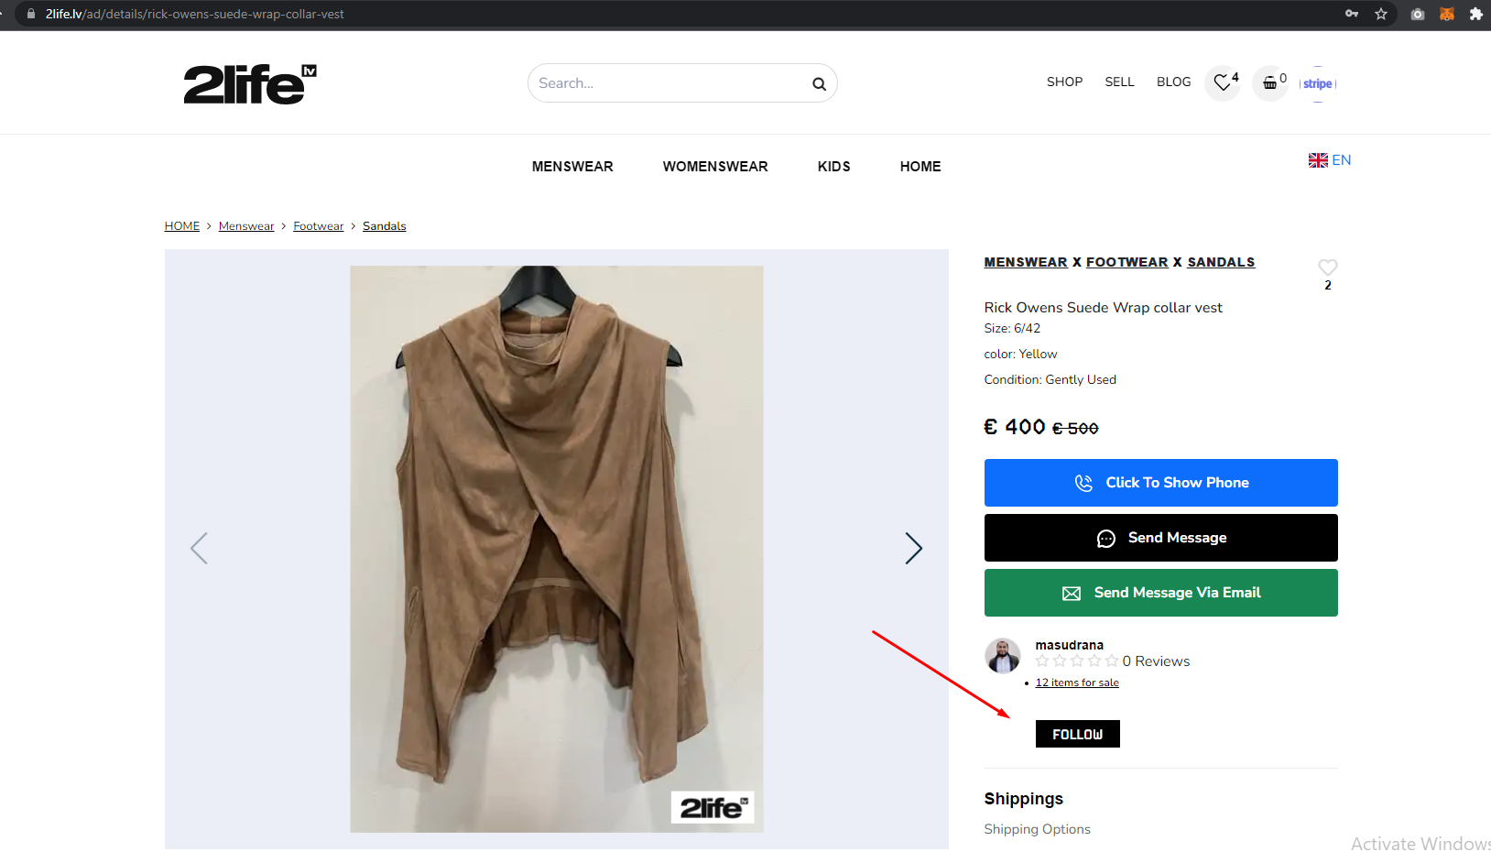
6. Review section korte hobe A screenshot of a computer

   Description automatically generated
7. Invoice A screenshot of a computer

   Description automatically generated
8. Corn url check
9. Language check A screenshot of a computer

   Description automatically generated
10. All fields are required A screenshot of a computer

    Description automatically generated
11. Role wise menu fixing A screenshot of a computer

    Description automatically generated
12. Remove this icon A screenshot of a computer

    Description automatically generated
13. About section a terms content showing A screenshot of a computer

    Description automatically generated
14. Language issue A screenshot of a computer

    Description automatically generated
15. Language issue A screenshot of a computer

    Description automatically generated
16. Language issue A screenshot of a computer

    Description automatically generated
17. Language issue A screenshot of a computer

    Description automatically generated
18. language issue / A screenshot of a computer

    Description automatically generated
19. language issue / including label A screenshot of a computer

    Description automatically generated
20. language issue /A screenshot of a computer

    Description automatically generated
21. language issue /A screenshot of a computer

    Description automatically generated
22. language issue / A screenshot of a computer

    Description automatically generated
23. language issue /A screenshot of a computer

    Description automatically generated
24. user dashboard overview screen change