**Part 3:**

Github is an online project hosting service that uses Git, which is a version control language. Creation of Github began October 1st in 2007. The site was then launched in April 2008 by Tom Preston-Werner, Chris Wanstrath, and PJ Hyett. Github was created in order to make Git popular and create a market for paid Git hosting. Before Github few developers were using Git on a daily basis and there were no commercial Git hosting websites available. Since the invention of Github other platforms such as Bitbucket, SourceForge, GitLab, and Kiln have emerged. Github and other similar platforms have been used to remotely collaborate on projects in an efficient way.

**Part 4:**

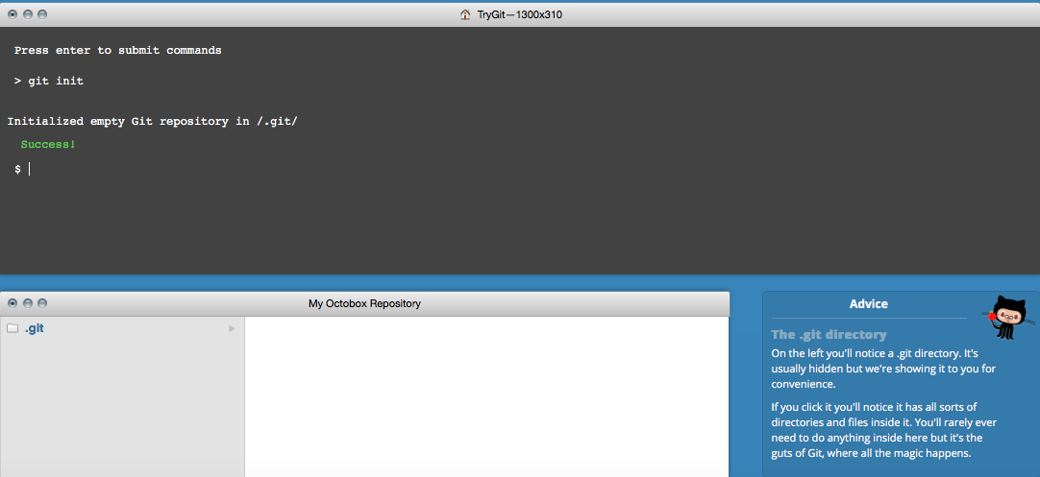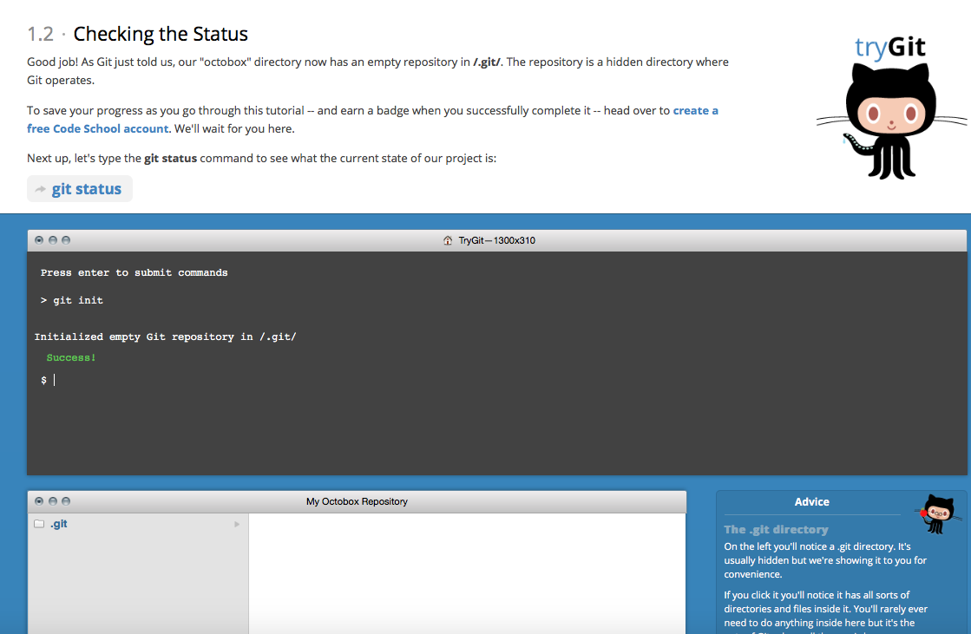

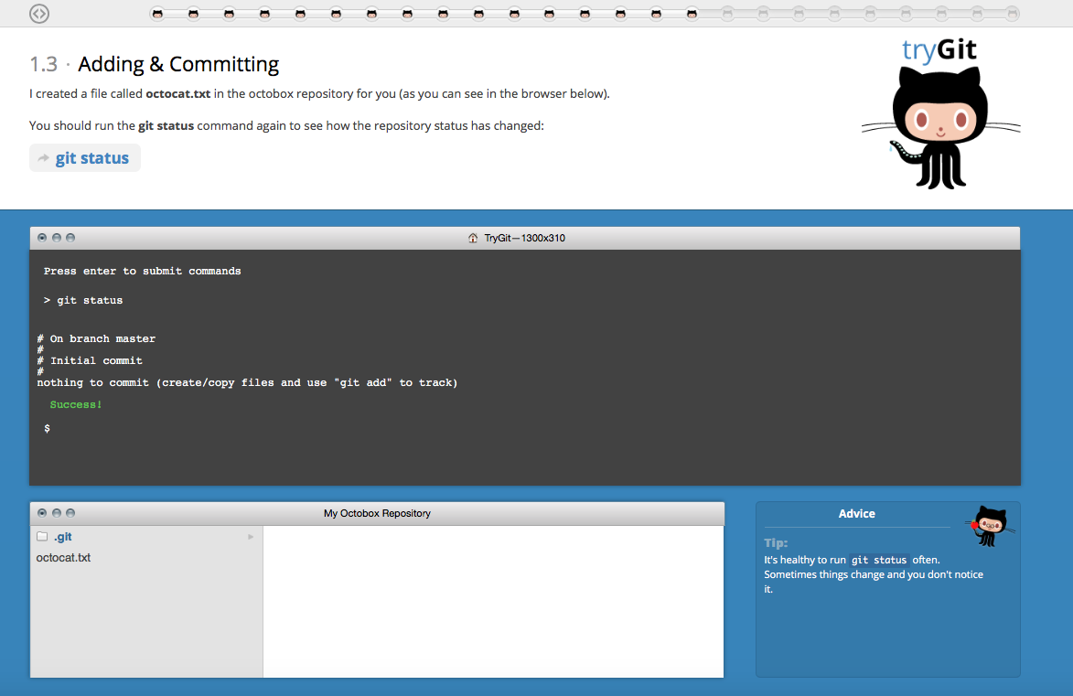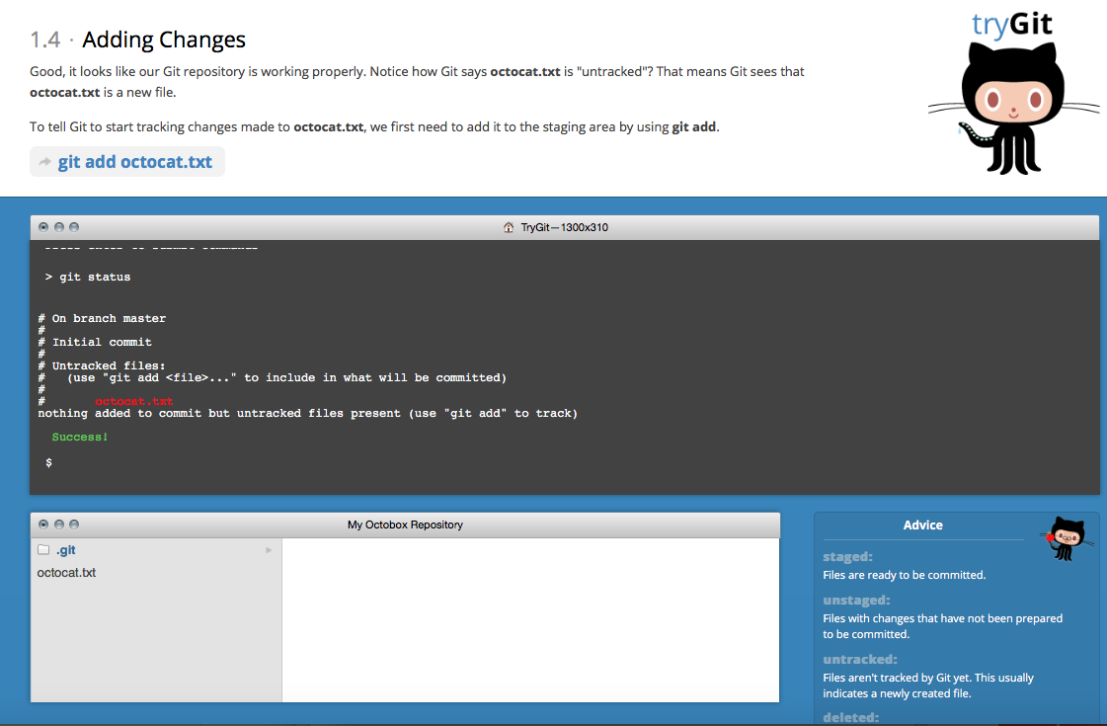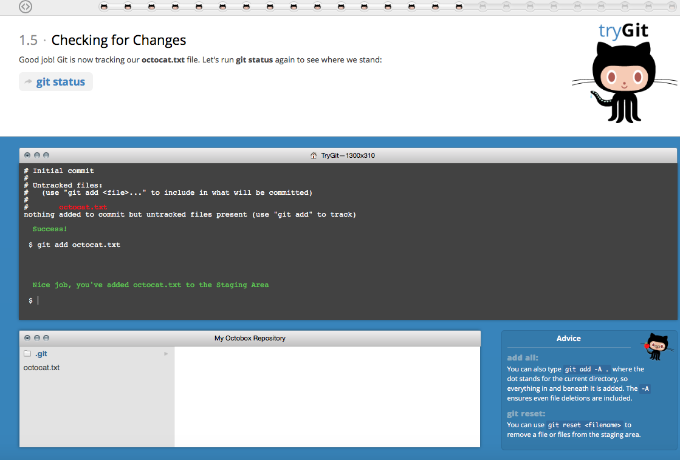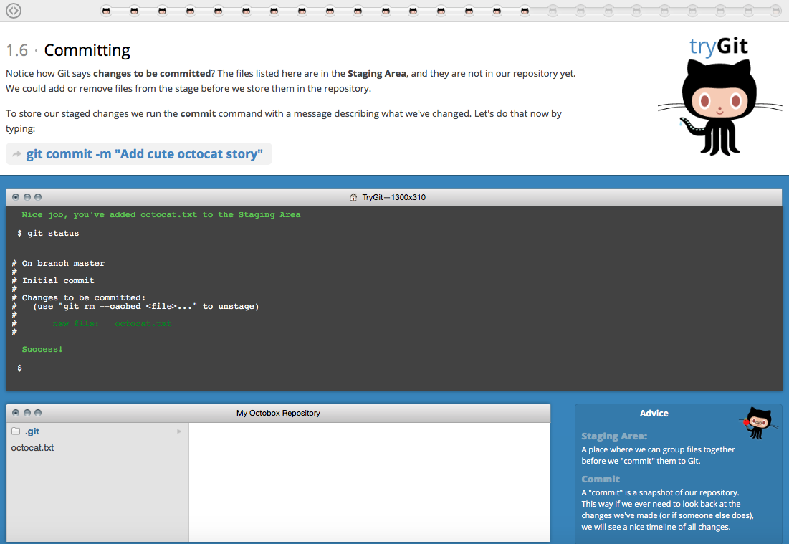

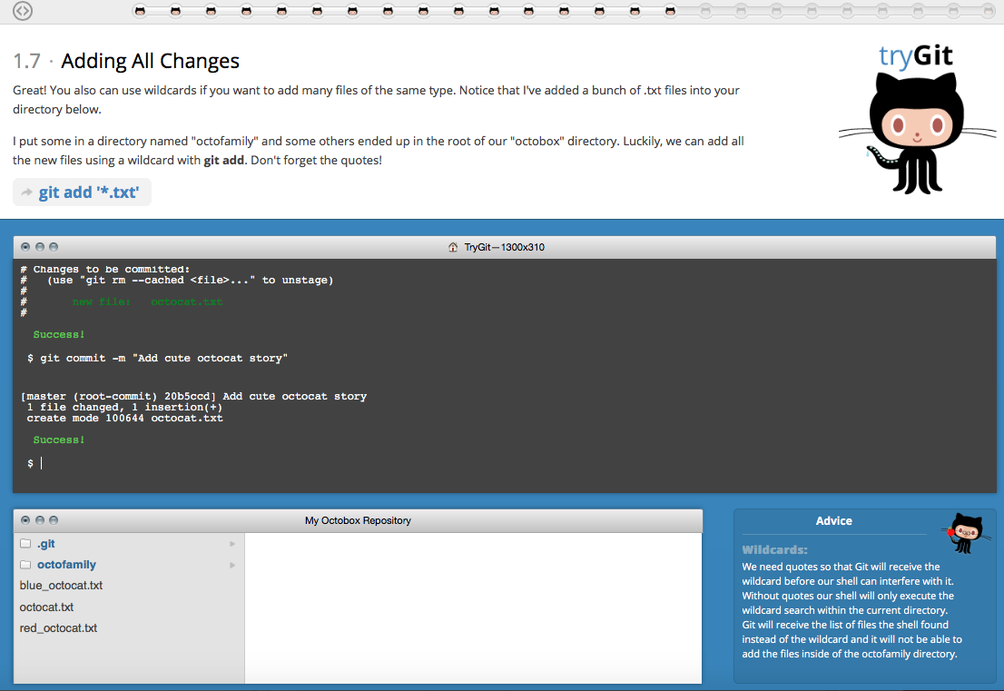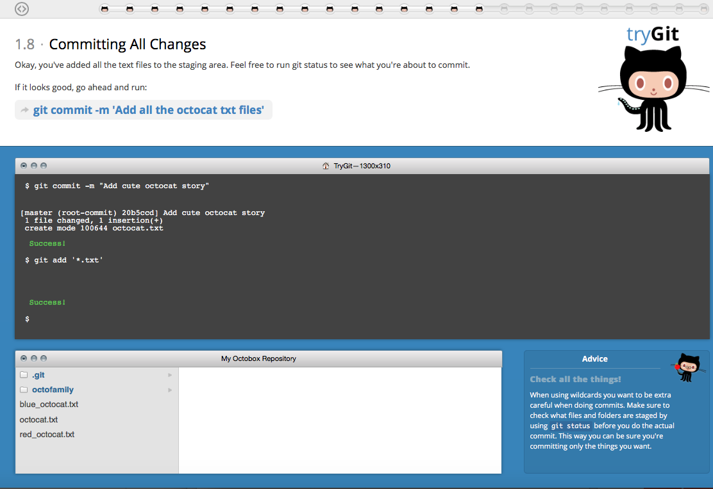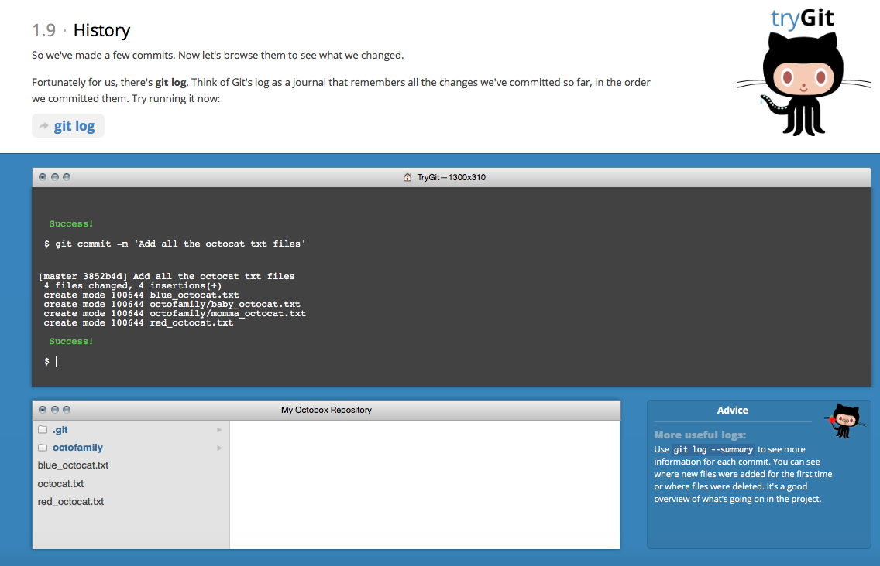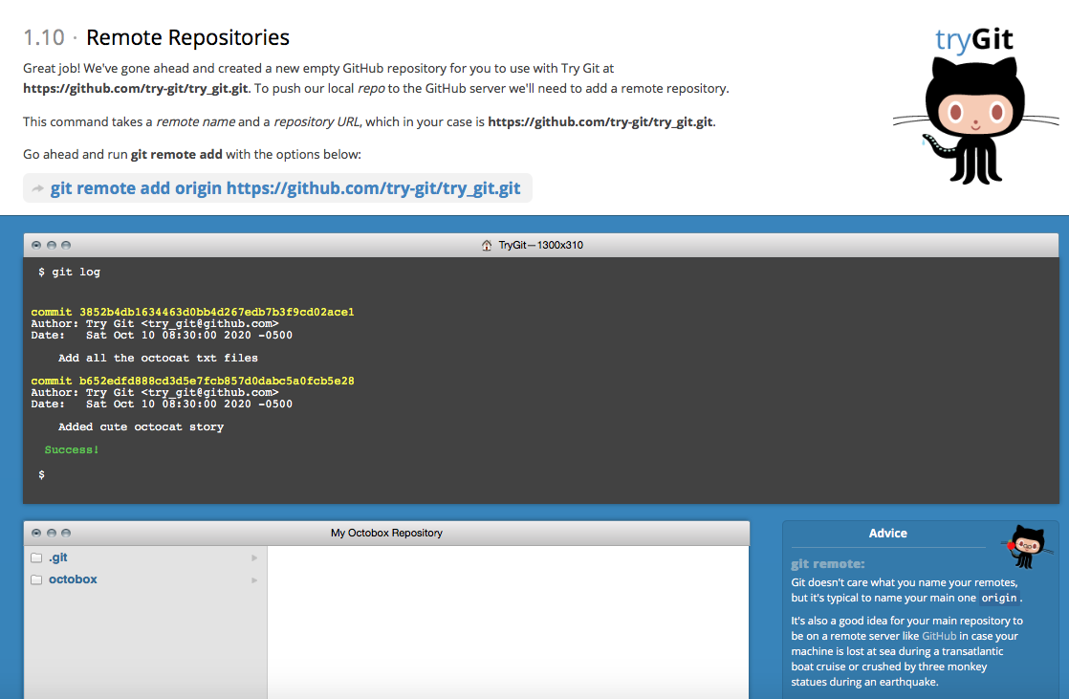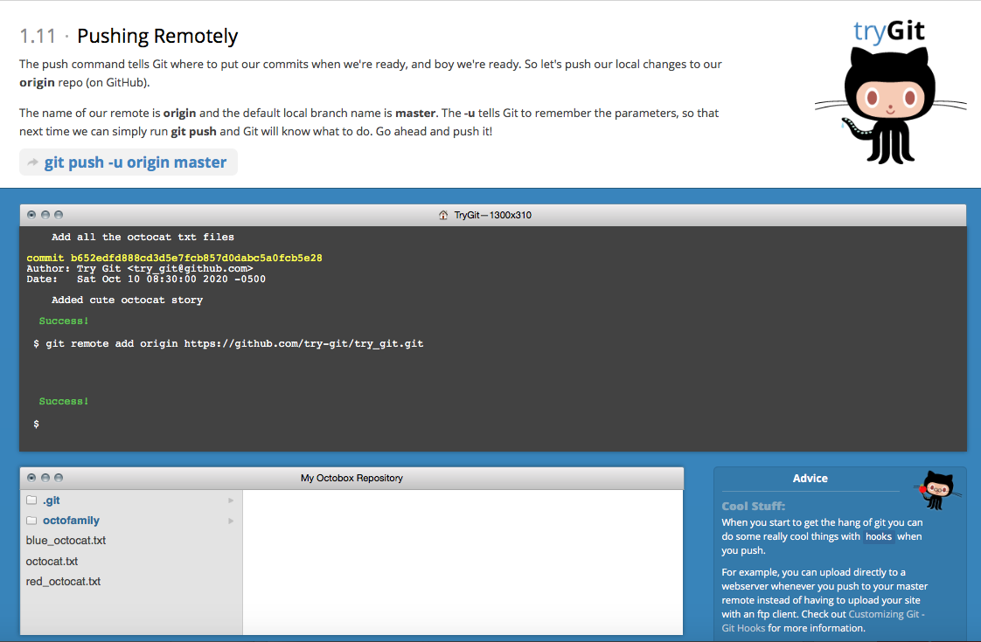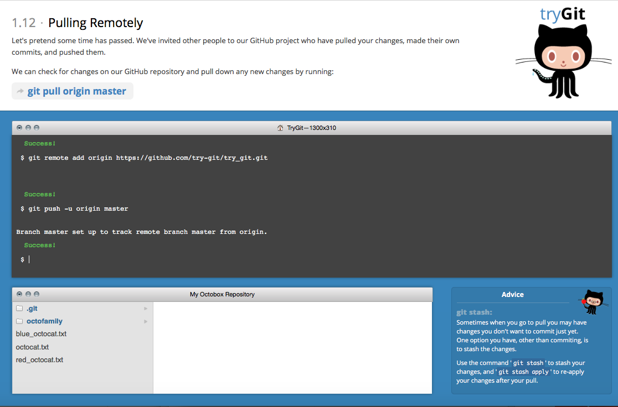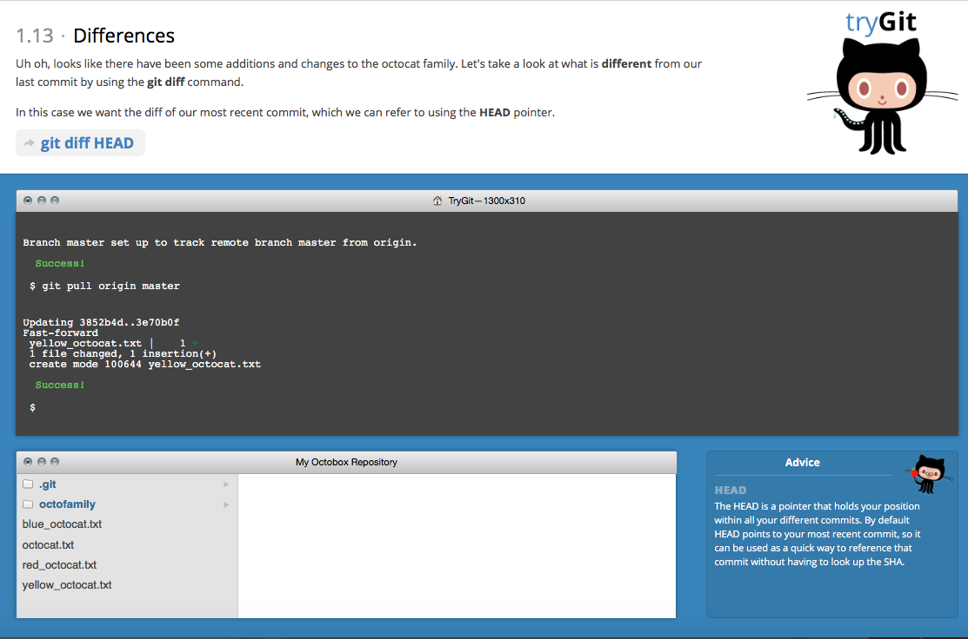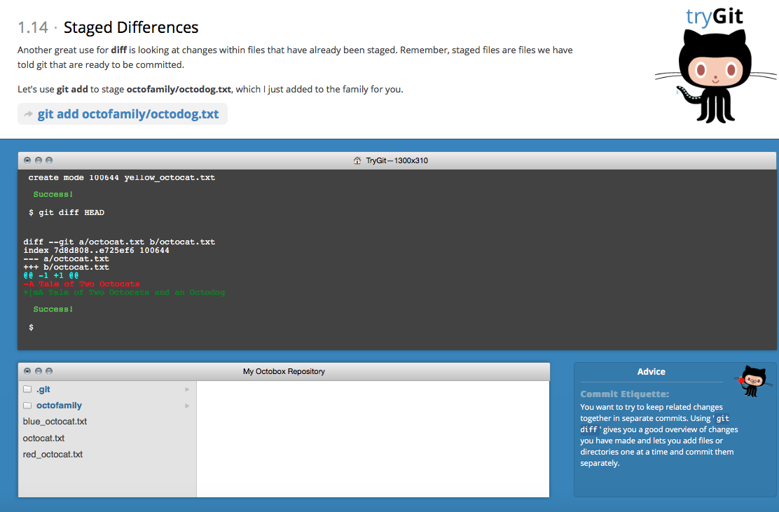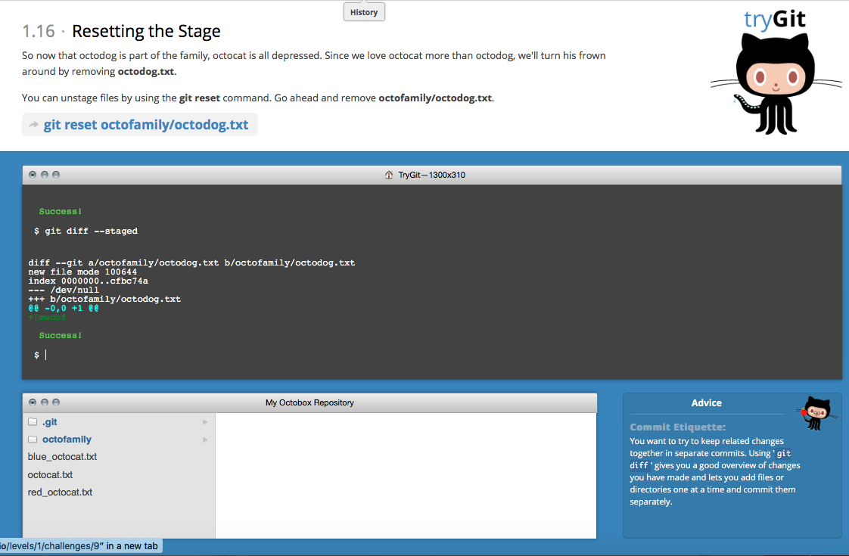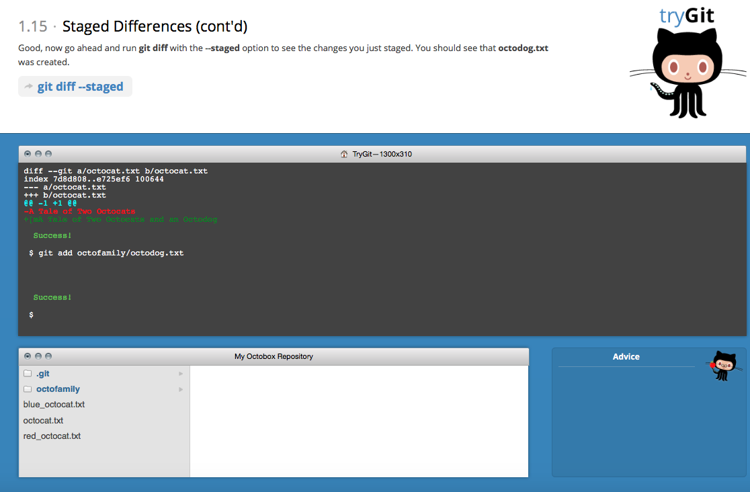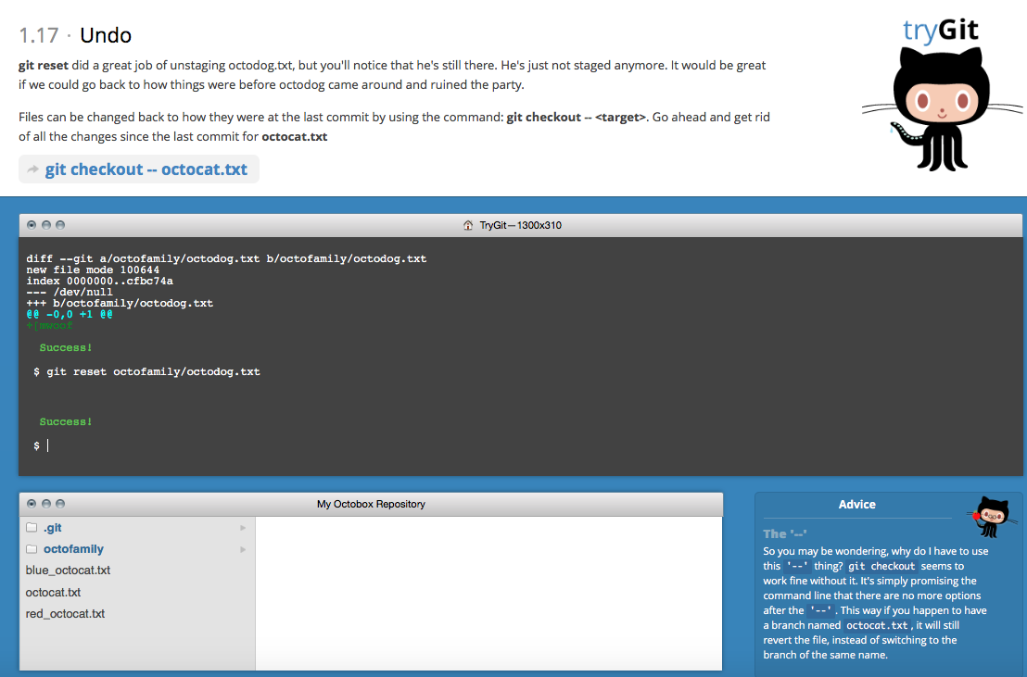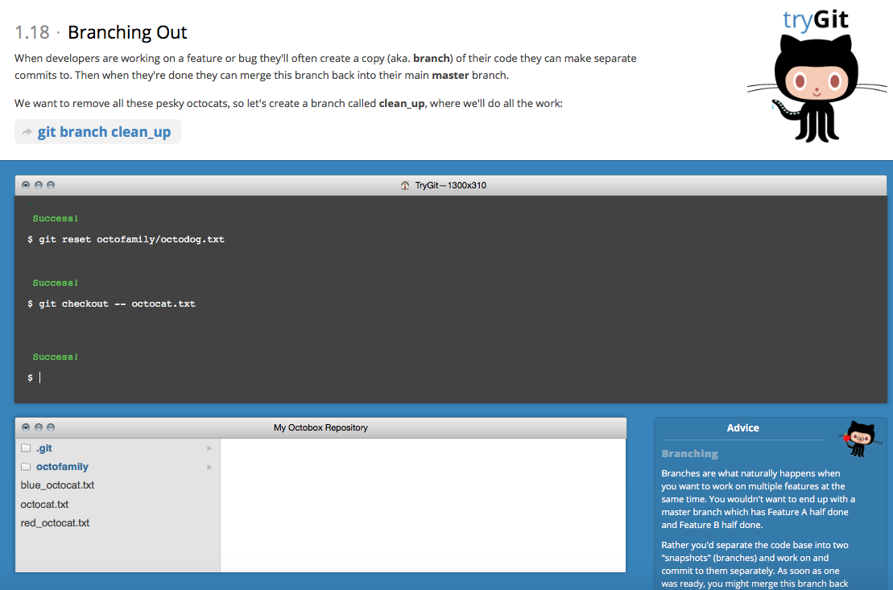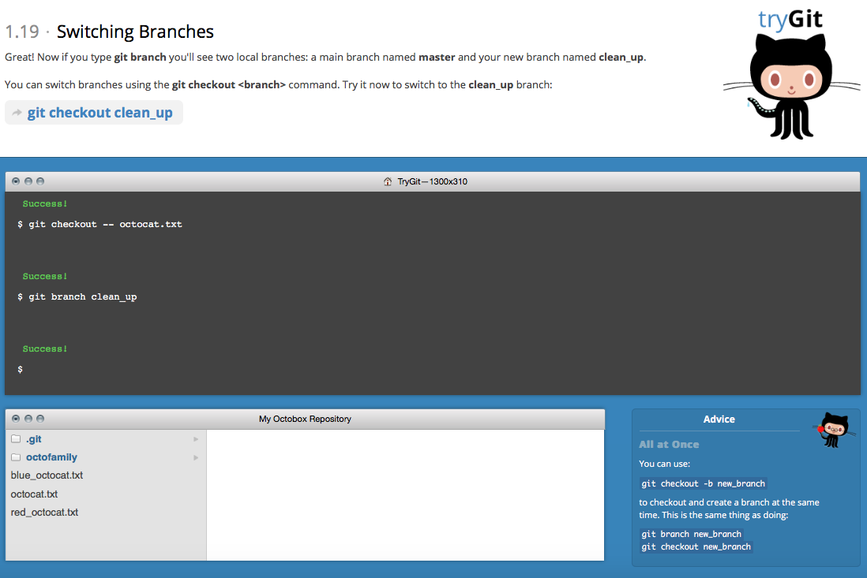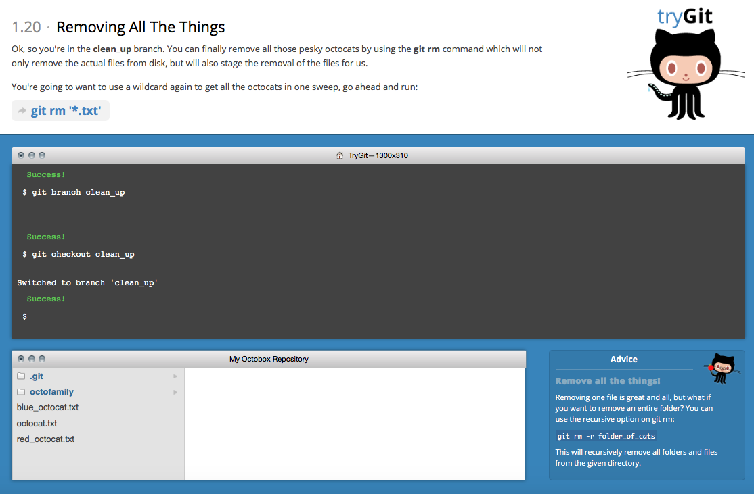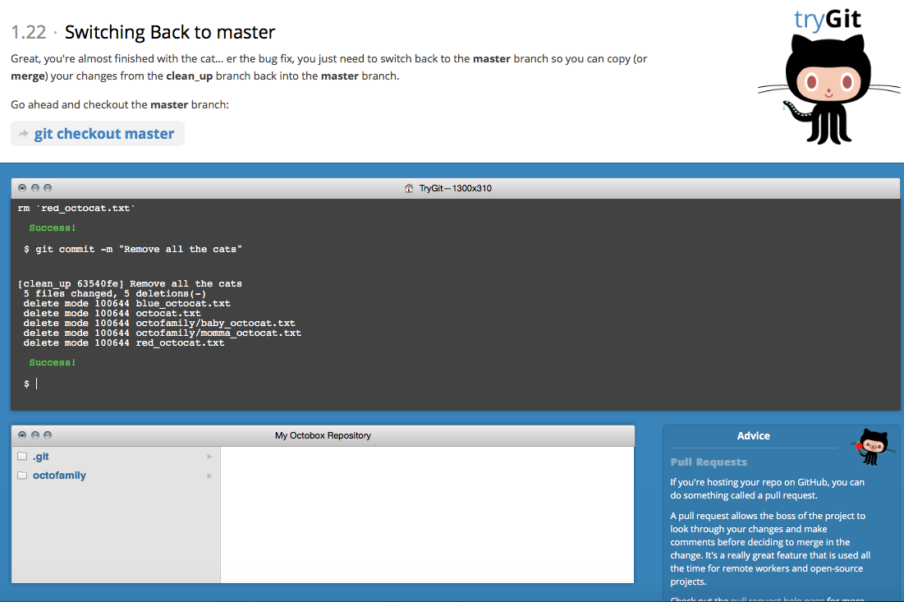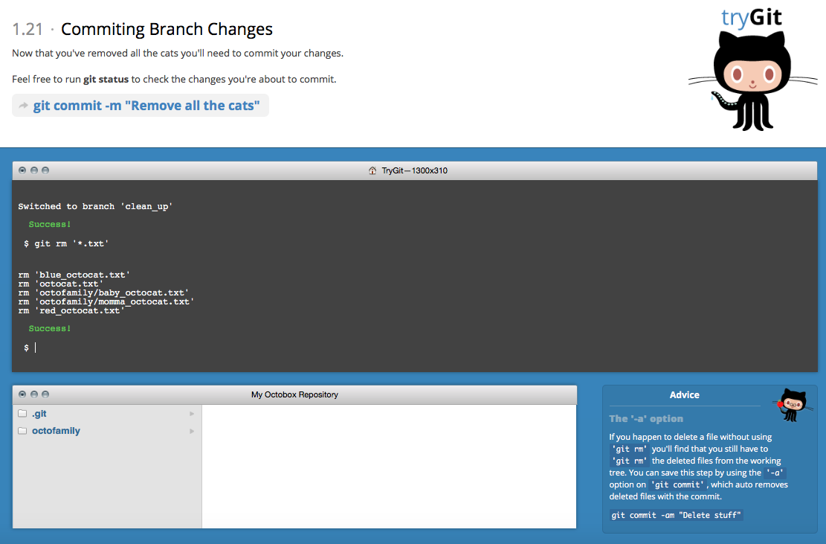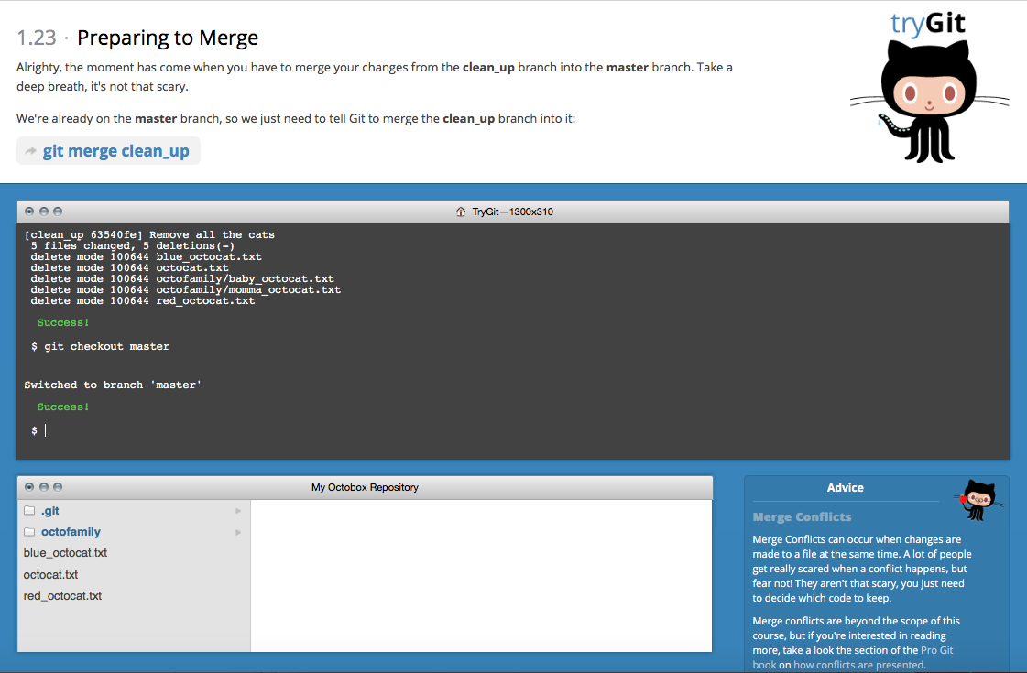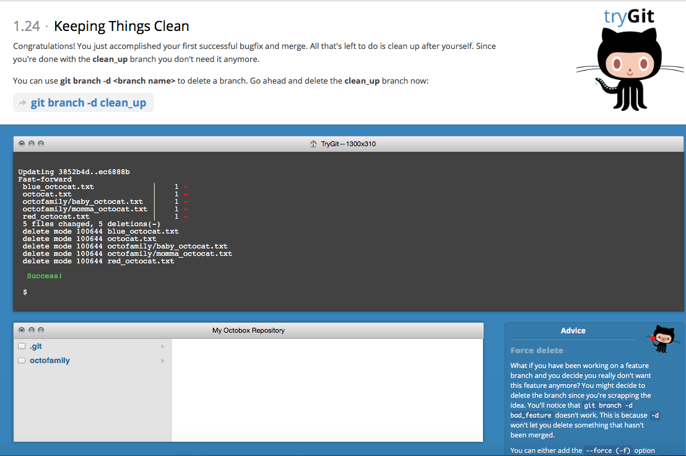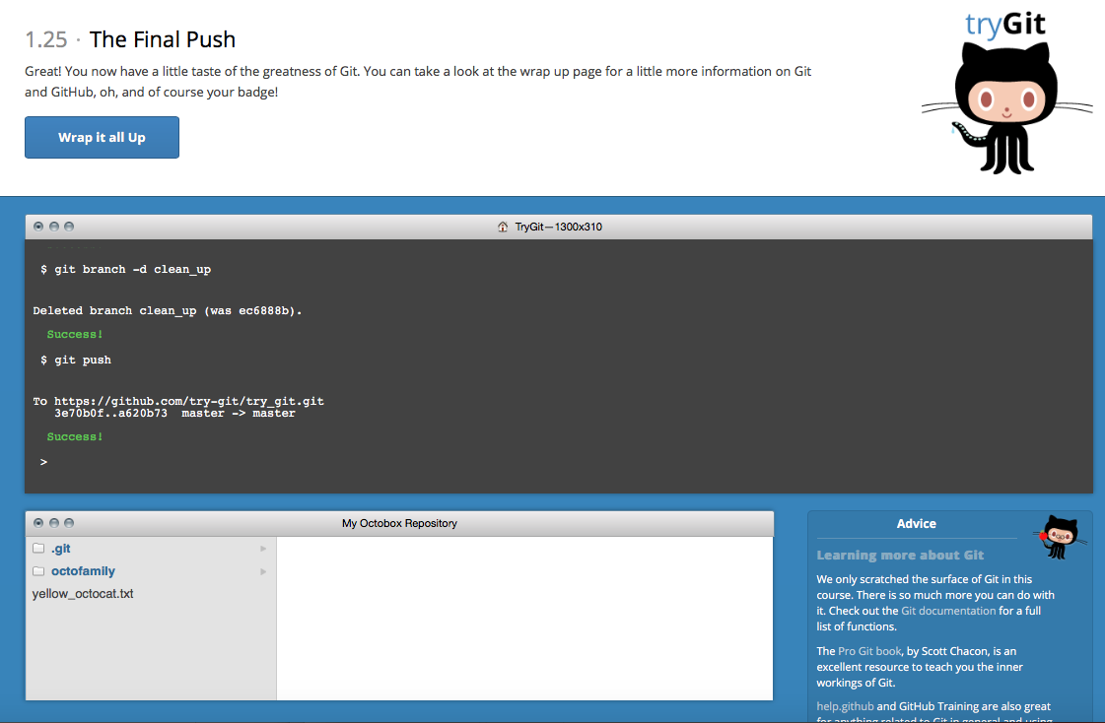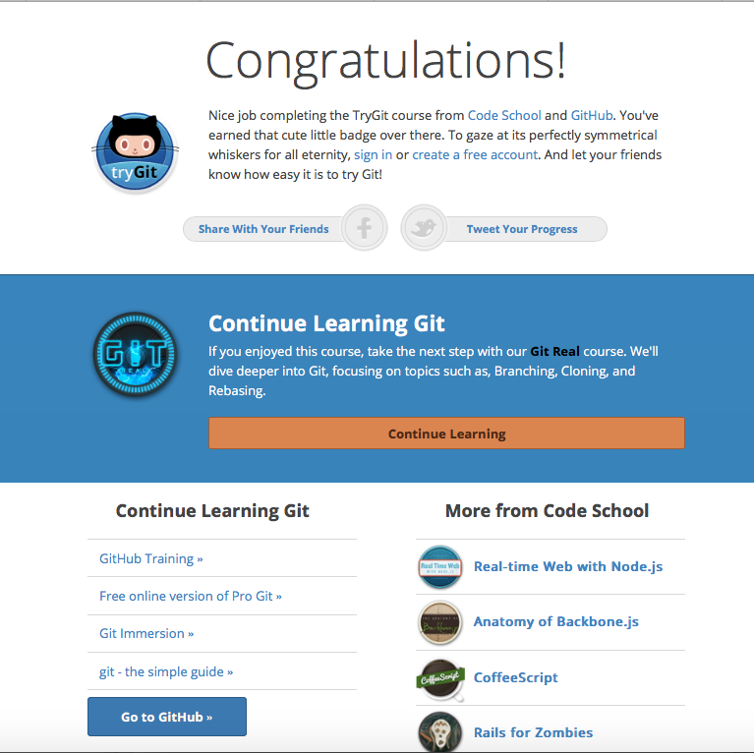

**Part 5:**

* **Repository**: a digital directory or storage space where you can access your project, its files, and all the versions of its files that Git saves
* **Commit:** An individual save to a file
* **Push:** When you push a commit made on your local branch to a remote directory
* **Branch:** a movable pointer to one of our commits
* **Fork:** a copy of a repository
* **Merge:** when you make a changes to a file because a commit you get from an upstream branch on the remote repo changes the same line in a file you’re editing in your branch.
* **Clone:** local copy of the code provided by the developer
* **Pull:** performs a merge on retrieved changes
* **Pull requests:** tells other people working on the code that your changes have been pushed to a Git repository

**Part 7:**

1. **Download README.md**
2. **git clone** [**https://github.com/paceuniversity/courses/blob/master/README.md**](https://github.com/paceuniversity/courses/blob/master/README.md)
3. **Make changes to README.md file**
4. **git pull**
5. **git merge /Users/user/Downloads/README.md**
6. **git add /Users/user/Downloads/README.md**
7. **git diff /Users/user/Downloads/README.md** [**https://github.com/paceuniversity/courses/blob/master/README.md**](https://github.com/paceuniversity/courses/blob/master/README.md)
8. **git commit –m “Initial Commit”**
9. **git push origin** [**https://github.com/paceuniversity/courses/blob/master/README.md**](https://github.com/paceuniversity/courses/blob/master/README.md)