**Social Network Analysis**

**Of Conan TV series**

**by**

**Zakarea Mosa**

**201469800**

**Major: Information System**

**for**

**Dr. Simeon Magliveras**

1. **Introduction**

Social Network Analysis (SNA) is the systematic analysis of social networks. Social network analysis presents social relationships in terms of network theory consisting of nodes (which represent individual actors within networks) and connections (which represent relationships between individuals, such as friendship, kinship, organizational status, sexual relations, etc.). These networks are often portrayed through diagrams. Social networks, where nodes are represented by points and links in the form of lines. This report will apply social network analysis theories on Japanese TV series. It is a manga(manga like comics but in Japanese culture) series by Gosho Aoyama, which was converted into a Japanese anime.. The manga started on June 18, 1994.

The story begins with the emergence of the main character, Seventeen-year-old Shinichi Kudo, who is a high school student and detective who helps police and Inspector Meguri solve some cases, famous for his intelligence and genius that surprise everyone with conclusions that contradict expectations. On one day off, he went out with his childhood friend Ran Mori to the amusement park, and a murder occurred inside the roller coaster, and it was resolved as usual with his intelligence and skill, and while they were there, Shinichi Kudo spotted a black-clothed man carrying out a blackmail. He wanted to know the story, so he was struck from behind and fell unconscious, and then he was forced to take a new drug, which had been used before only on mice, and the black-dressed man thought that he would kill him and would not leave a trace of poisoning in him, but the toxic drug caused his body to shrink to become A seven-year-old boy. This amusement park accident caused the birth of the series hero Konan Edogawa and changed the life of Shinichi Kudo.

1. **METHODS**

The series has many characters and 30 were chosen to apply the social network analysis. The report will use Case-by-case matrices and case-by-affiliation matrix. After that, these matrices will be converted into visualizations. These visualizations will help to gain clear insight of the structure of the network. Farther more, the density of the network and the point of centrality will be calculated and founded. Also, it will be a discussion on the components of the network. Like cliques’ stars, brokers, and influencers.

1. **RESULTS**

**This Key Number for every character**

|  |
| --- |
| Yokiko : 1 |
| Yosako : 2 |
| Shizako : 3 |
| Weizo : 4 |
| Prof.Agasa: 5 |
| Shinchi : 6 |
| Hijey: 7 |
| Hiaibara:8 |
| Aiyomi :9 |
| Conan :11 |
| Genta:12 |
| Ran: 13 |
| Sonoko:14 |
| Metso:15 |
| Kisaki:17 |
| Mori:16 |
| Barboun: 18 |
| Kir:19 |
| Etakakora:20 |
| Pisco:21 |
| Irish:22 |
| Vermouth:23 |
| Gin:24 |
| RUM:25 |
| Vodka:26 |
| Chianti:27 |
| Korn:28 |
| Calvados:29 |
| Taqila:30 |

**Figure 1 for the whole network**

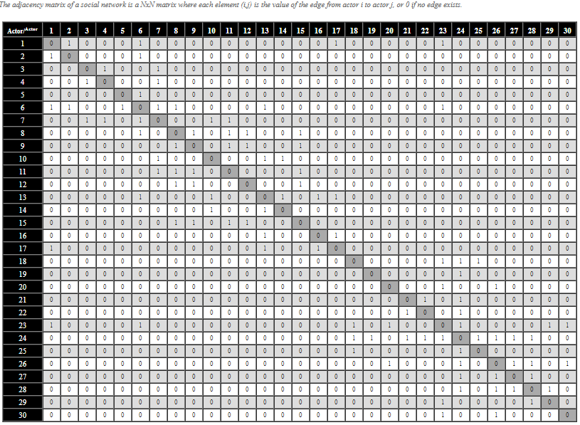

**Table 1 case by case matrix for the whole network**

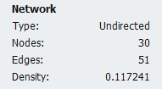

Influence data

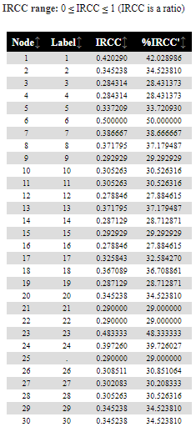

**The Radial Degree of Centrality Graph**

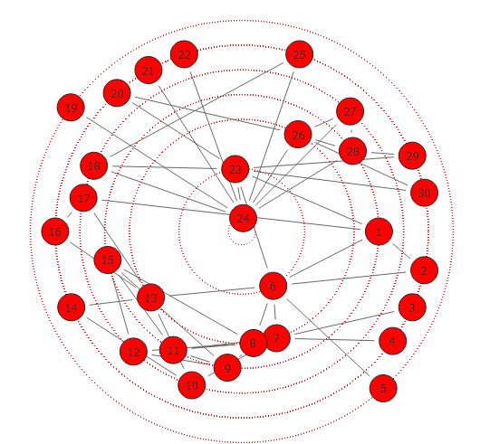

**The Radial Closeness Graph**

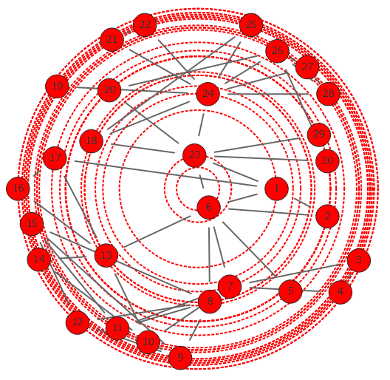

**Police-affiliation**

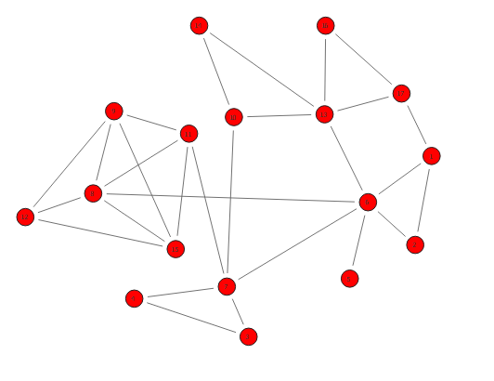

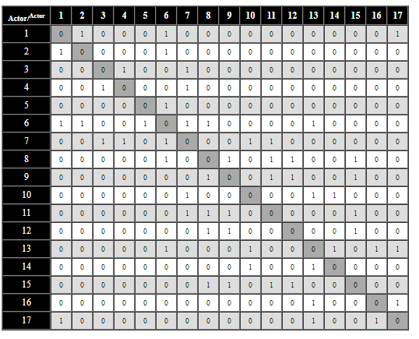

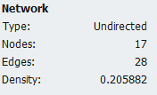

**The Radial Degree of Centrality Graph**

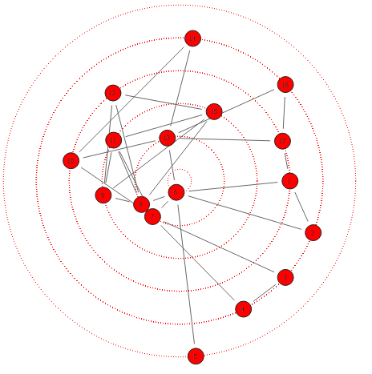

**The Radial Closeness Graph**

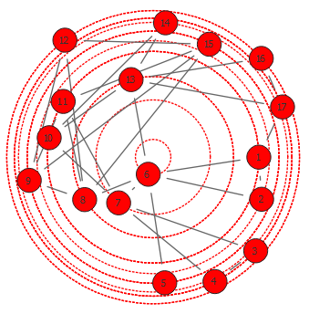

**Black organization -affiliation**

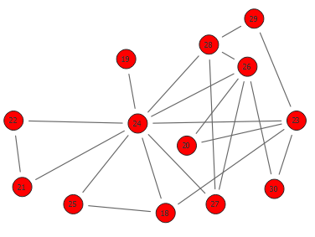

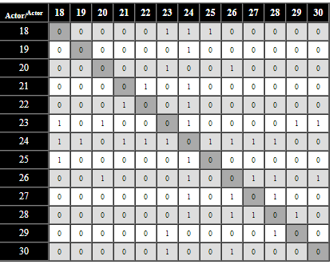

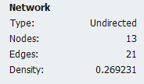

**The Radial Degree of Centrality Graph**

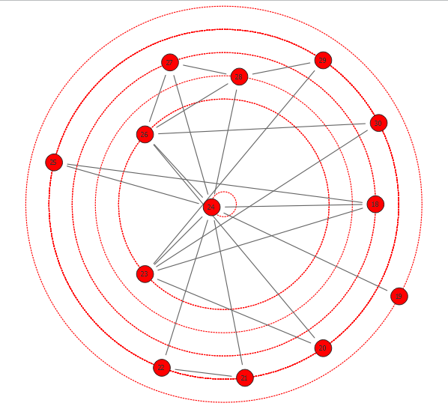

**The Radial Closeness Graph**

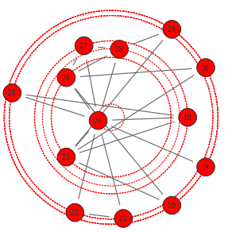

1. **Discussion**

* **The whole network**

in the whole network we have a total node of 30. we have one clique which is consist of: Hiaibara

Aiyomi, Conan, Genta and Metso. the density of whole network is not that low or high (The density of the network = 0.117241).

However, it seems that there is a block in the network that have high density and there will be a discussion in the coming sections.

The density in the network is not high because the whole network is consisting of two affiliations. the influencers table show that Shinchi have is the most influencer by INFLUENCE RANGE CLOSENESS CENTRALITY (IRCC) = 0.5 and (Vermouth has IRCC = 0.48).

about the centrality Gin is the most centered node after that Shinichi and Vermouth. About the closeness the graph shows there is close relation between all the nodes.

* **Police-affiliation**

From the graph Shinchi is the most important node. And that can be proof from the centrality graph. And by little deference in centrality Hiji and Haibara come after.

From the closeness graph also, Shinichi is in the center. the whole graph has density = 0.20 and it is high density compare to the whole network graph.

* **Black organization- affiliation**
* From the graph Gin is the most important node. And that can be proof from the centrality graph. And by big deference in centrality Vermouth and Vodka come after.
* From the closeness graph also, Gin is in the center. the whole graph has density = 0.27 and it is high density compare to the whole network graph.

1. **Conclusion**

From this social network analysis, it concluded that there are two main groups in the whole network holed by two characters Shinichi and Vermouth. These two characters are like bridge between the two groups. Farther more, it concluded that the black organization is stronger than the police because it has better density. Also, Gin the most connected member in the black organization but Vermouth is more influencing than him because it has a connection to the other the group of the whole network. Therefore, more connection does not mean more influencing.