**MUHAMMAD ZAKAULLAH**

**SP22 BSE 021**

**CODE**

<!DOCTYPE html>

<html lang="en">

<head>

<meta charset="UTF-8">

<title>Book List</title>

<link rel="stylesheet" href="https://cdn.jsdelivr.net/npm/bootstrap@5.3.0/dist/css/bootstrap.min.css">

</head>

<body class="bg-light">

<div class="container py-4">

<h1 class="text-center mb-4">📚 Book Collection</h1>

<input type="text" id="authorSearch" placeholder="Search by author..." class="form-control mb-3" />

<div id="bookList" class="row g-4"></div>

<div class="text-center mt-4">

<a href="add.html" class="btn btn-success">➕ Add New Book</a>

</div>

</div>

<script>

const listContainer = document.getElementById('bookList');

const searchInput = document.getElementById('authorSearch');

async function fetchBooks(author = '') {

try {

const res = await fetch(`http://localhost:5000/api/books?author=${author}`);

const books = await res.json();

if (books.length === 0) {

listContainer.innerHTML = `<p class="text-center">No books found.</p>`;

return;

}

listContainer.innerHTML = books.map(book => `

<div class="col-md-4">

<div class="card shadow-sm">

<div class="card-body">

<h5 class="card-title">${book.title}</h5>

<h6 class="card-subtitle mb-2 text-muted">${book.author}</h6>

<p class="card-text">Price: <strong>$${book.price}</strong></p>

</div>

</div>

</div>

`).join('');

} catch (err) {

listContainer.innerHTML = `<p class="text-danger text-center">Error fetching books.</p>`;

console.error(err);

}

}

searchInput?.addEventListener('input', e => fetchBooks(e.target.value));

fetchBooks();

</script>

</body>

</html>

const listContainer = document.getElementById('bookList');

const searchInput = document.getElementById('authorSearch');

async function fetchBooks(author = '') {

const res = await fetch(`http://localhost:5000/api/books?author=${author}`);

const books = await res.json();

listContainer.innerHTML = books.map(book => `

<div class="col-md-4 mb-3">

<div class="card">

<div class="card-body">

<h5>${book.title}</h5>

<p>${book.author}</p>

<p>$${book.price}</p>

</div>

</div>

</div>

`).join('');

}

searchInput?.addEventListener('input', e => fetchBooks(e.target.value));

fetchBooks();

**OUTPUT  
  
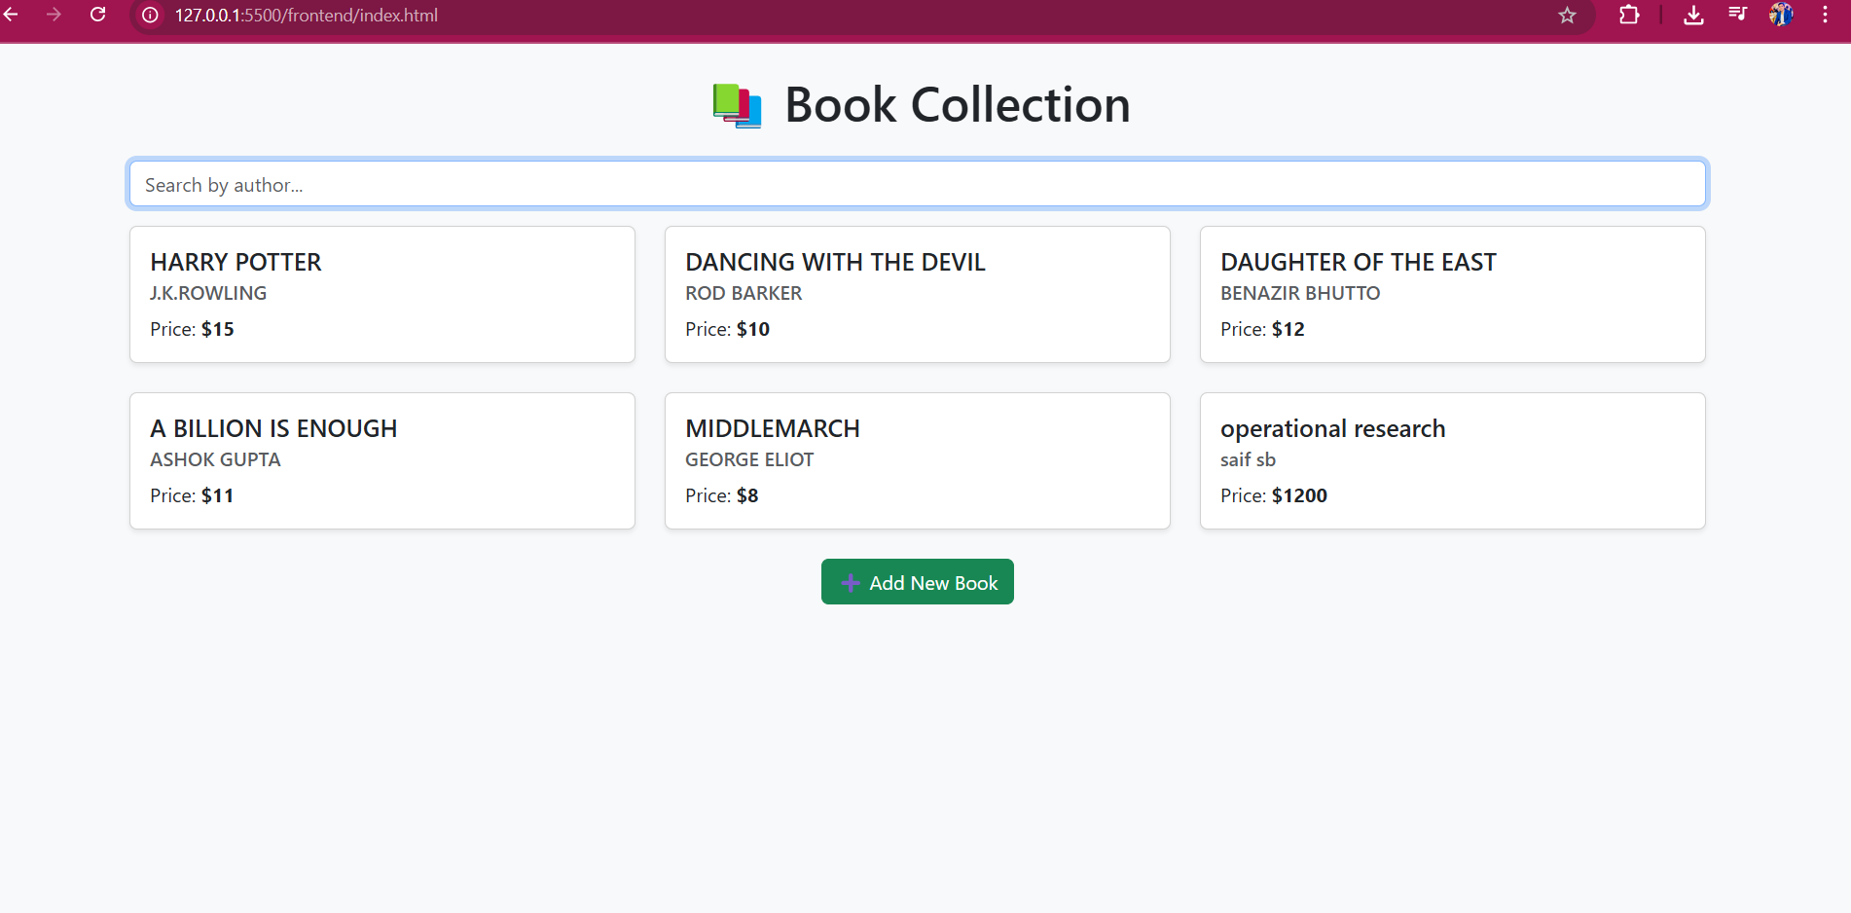  
ADD BOOK**

