 |  | 
Licence Fondamentale
Sciences Mathématiques et Informatiques

Internship Report
Design and Implementation of an Intelligent Meal and Aid Management Platform
Presented by:
Ridha Abataoui
Date of Presentation: 06/30/2025
JURY:
Full Name | Establishment | Role
Abdelaaziz EL HIBAOUI | Faculty of Science Tetouan | Academic Supervisor
Zaz Youssef | Faculty of Science Tetouan | Examiner
Enaanai Adil | Faculty of Science Tetouan | Examiner

Internship at :
Al-Birr et Al-Ihsan Association

Dedications
First and foremost, we would like to dedicate this report to Allah for the blessings and opportunities He has given us along this educational and professional path.
This work is dedicated to our parents, who have never stopped believing in and supporting us through our academic and professional development. Your unconditional love and continuous support make us what we are today. Thank you for always encouraging us to reach for more.
I also dedicate this report to my supervising professor, Mr Abdelaaziz El Hibaoui as a testament to my deep and endless gratitude for your continuous support, patience, and precious advice throughout this semester. Your expertise and patience have helped me shed light on the grey areas of my academic and professional careers.
Your commitment to teaching has had the most significant impact on my training, equipping me with the necessary tools to meet upcoming challenges. I would like to extend my gratitude to the teachers and the entire team at The Science University of Abdelmalek Essaadi , who allowed us to enrich my experience. we express my deep gratitude as much as is humanly possible.
Lastly, we extend our deepest gratitude to our friends and extended families for their continuous encouragement and faith in us. Through your support, we was able to overcome many obstacles.
May each of you read herein the depth of owr gratitude.

Acknowledgments

First and foremost, we want to thank Allah, whose blessings and opportunities He has given us along this educational and professional path.
To my beloved parents, we owe everything to your endless love, patience, and encouragement. Your unwavering faith in us and your sacrifices have paved the way for my achievements. We are forever grateful for your guidance and support.
To my dear brother, thank you for being my rock, my confidant, and my best friend. Your support and understanding have been invaluable throughout this journey.
To my dear professor, your guidance, knowledge, and encouragement have been instrumental in my academic and personal growth. Your dedication and support have inspired us to strive for excellence.
Lastly, to my dearest friends who have become my family, your presence has enriched my lives in countless ways. You are more than just friends; you are my chosen family, always there in times of joy and hardship. Your unwavering support, laughter, and love have been my strength

Abstract
This report presents the design, development, and deployment of an intelligent aid distribution system created for the Al-Birr wa Al-Ihsan Association. The system tackles key challenges in the distribution of food, medicine, and other assistance by offering a secure, scalable, and real-time digital solution.
Developed using Express.js, MySQL, React, and React Native, the platform includes a web-based administrative dashboard and a mobile application for field workers. Core features include QR-based ID card management, real-time distribution tracking, dynamic beneficiary categorization, and comprehensive reporting capabilities.
Beneficiaries are classified into three categories—registered, waiting list, and unregistered—allowing for flexible distribution strategies. This digital system significantly enhances transparency, reduces fraud, and optimizes operational efficiency, thus reinforcing the association’s ability to deliver humanitarian aid effectively.

Keywords:
Smart aid distribution, QR code, meal tracking, humanitarian technology, React Native, Express.js, MySQL, real-time data, beneficiary management, mobile application, web dashboard, nonprofit digital solutions.

Acronyms | Abbreviation
API | Application Programming Interface
HTTP | Hypertext Transport Protocol
JWT | JSON Web Token
MVC | Model-Vue-Controller
SQL | Structured Query Language
UML | Unified Modeling Language
WEB | World Wide Web

LIST OF ABBREVIATIONS

TABLE OF CONTENTS

Contents
INTRODUCTION 12
Chapter I: Presentation of the Association 13
1.1 Introduction 14
1.2 Objectives 15
1.3 Problem 15
1.4 Solution 16
Chapter II: Project management 17
2.1 Introduction 18
2.2 General presentation of the project 18
2.3 Project management 19
2.4 Introduction to Scrum 19
2.5 Scrum lifecycle 20
2.6 Gantt Diagram 20
Chapter III: UML and Functional Specifications 22
3.1 Introduction 23
3.2 UML formalism 23
3.3 Choosing UML 24
3.4 . Project Objectives 24
3.5 Functional Requirements 25
3.6 Environmental and Social Assessment 25
3.7 User Roles and Permissions 26
3.8 Use Case Diagram 27
3.9 Class Diagram 28
3.10 Sequence Diagram 31
3.10.1 Login 31
3.10.2 adding a new beneficiary/worker 32
3.10.3 updating an existing workers or beneficiary's information 33
3.10.4.deleting a beneficiary or worker 34
3.10.5 generating a beneficiary ID card 35
3.10.6 statistics and generating reports 37
3.10.7 Scan Beneficiary QR Code to Distribute a Meal 38
3.10.8 Unregistered Distribution 40
Chapter IV: Technical Specifications 42
4.1 Introduction 43
4.2 Languages and Technologies : 43
4.2.1 JavaScript : 43
4.2.2 React Native 44
4.2.3 React.js 45
4.2.4 Express.js 45
4.2.5 MySQL 46
4.3 Development, Modeling, and Communication Tools 47
4.3.1 Visual Studio Code (VS Code) 47
4.3.2 Postman 47
4.3.3 GitHub 48
4.3.4 Expo go 49
4.4 Conclusion 49
Chapter V: Project Implementation 50
5 .1 Introduction 51
5.2 Web Application 52
5.2.1 Login pages : 52
A . Screen 52
B. Code 53
5.2.2 beneficiary list 53
A . Screen 53
B. Code 54
5.2.3 Add beneficiary 54
A . Screen 54
B. Code 55
5.2.4 Updating beneficiary 56
A . Screen 56
5.2.5 Users List 57
A . Screen 57
B. Code 58
5.2.6 Add User 58
A . Screen 58
5.2.7 report page 60
A . Screen 60
B. Code 61
5.3 MOBILE APP 61
5.3.1 login page 61
A . Screen 61
B. Code 63
5.3.2 Home Screen 63
A . Screen 63
B. Code 65
5.3.3 QR code scanner 66
A . Screen 66
B. Code 68
5.3.4 confirm distribution 68
A . Screen 68
B. Code 70
5.4 ID card 71
A . Old ID card 71
B . New ID card 71
5.5 conclusion 72
General Conclusion 73

TABLE OF FIGURES

Figure 1: Association’s Logo 14
Figure 2: Scrum Process 20
Figure 3: Gantt Diagram 21
Figure 4: use case Diagram 27
Figure 5:Class diagram 29
Figure 6: Login sequence Diagram 31
Figure 7: adding new beneficiary / worker sequence Diagram 32
Figure 8: updating information sequence Diagram 33
Figure 9: delete sequence Diagram 34
Figure 10: generate ID card sequence Diagram 36
Figure 11: statistics and reports sequence Diagram 37
Figure 12: Scan Beneficiary QR Code to Distribute a Meal sequence Diagram 38
Figure 13: Unregistered Distribute a Meal sequence Diagram 40
Figure 15: javaScript’s Logo 44
Figure16: React Native's Logo 44
Figure 17: ReactJS 's Logo 45
Figure 18: nodejs and express’s Logo 46
Figure 20: VS code 's Logo 47
Figure 21: PostMan 's Logo 48
Figure 22: Github's Logo 48
Figure 23: ExpoGO's Logo 49
Figure 25: Login’s page code 53
Figure 26: Beneficiary List page 53
Figure 27: Beneficiary List code 54
Figure 28: adding new beneficiary page 55
Figure 29: Add Beneficiary code 55
Figure 30: Updating Beneficiary page 56
Figure 31: Updating Beneficiary code 57
Figure 32: Users List page 57
Figure 33: Users List code 58
Figure 34: add Users page 58
Figure 36: Report page 60
Figure 37: Report page code 61
Figure 38: mobile app login page 62
Figure 39: mobile app login page code 63
Figure 40: mobile app home page 64
Figure 41: mobile app home page Code 65
Figure 42: mobile app Scanner page 66
Figure 43: mobile app Scanner page Code 68
Figure 44: mobile app Confirm distribution page 69
Figure 46: Old beneficiary id card 71

INTRODUCTION
In the face of increasing poverty, unemployment, and social vulnerability, charitable organizations are under growing pressure to support a rising number of beneficiaries with limited resources. Manual processes, while once sufficient, are no longer adequate to ensure efficient, transparent, and equitable aid distribution.
This report outlines the development and implementation of an intelligent aid distribution system for Al-Birr wa Al-Ihsan Association, a non-profit organization dedicated to providing food, medicine, and essential supplies to those in need. The association has historically relied on manual methods that hinder operational efficiency and limit its ability to scale its support to meet increasing demand—particularly among vulnerable families and unemployed youth.
To address these challenges, a modern digital platform was conceived and developed using state-of-the-art technologies. The system enhances organizational performance by streamlining operations, enabling real-time tracking, improving transparency, and ensuring fair and efficient resource allocation.
This report details the motivations behind the project, the methodologies and technologies adopted, the functional and technical architecture of the system, and the measurable impact it has had on the association’s humanitarian efforts.
This report is structured into five chapters:
- Chapter I – Presentation of the Association: Introduces Al-Birr wa Al-Ihsan Association, its objectives, challenges, and the context in which the project was developed.
- Chapter II – Project Management: Describes the management methodology used (Scrum), the planning process, and the overall objectives of the aid distribution platform.
- Chapter III – UML and Functional Specifications: Details the functional and technical specifications of the system, including use cases, class diagrams, and sequence diagrams.
- Chapter IV – Technical Specifications: Presents the technologies, programming languages, tools, and system architecture used in the development process.
- Chapter V–Project Implementation: Demonstrates the practical realization of the system through the design of the web and mobile interfaces, their functionalities, and database integration..

Chapter I: Presentation of the Association

Introduction


Figure 1: Association’s Logo
Al-Birr wa Al-Ihsan Association is an independent public-benefit organization that provides social and humanitarian services to the elderly, widows, and vulnerable, impoverished segments of society.
It was founded on January 1, 1988, and began its charitable work on January 15, 1988, at the time operating within available space granted by the president of the Islamic Charity Association, Mr. Mahdi Ben Aboud. He allocated part of the facilities of that organization to Al-Birr wa Al-Ihsan Association to carry out its activities.
Later, Mr. Mohamed Boulaich Baysa, generously donated a house located on Abdellatif Al-Madouri Street, Derb Jassous, Tarankat neighborhood, to serve as the association’s headquarters and activity center.

Objectives
Since its founding, Al-Birr wa Al-Ihsan Association has remained committed to the same noble goals for which it was established, which include:
- Assisting the elderly, orphans, widows, the poor, the destitute, and those who are unable to earn a living and have no source of income.
- Providing ready-to-eat meals every day throughout the year—this being its core activity.
- Distributing financial aid during religious holidays, as well as clothing, shoes, and blankets during the winter season.
- Offering medical and emergency assistance.
- Creating job opportunities for those able to work, and encouraging traditional manual crafts to both provide income for this group and preserve cultural heritage.
- Establishing various centers affiliated with the association through projects funded locally or internationally.

1.3 Problem
Despite the association's continuous efforts to meet the growing needs of its beneficiaries, the reliance on manual processes for verifying aid distribution and generating reports presents significant challenges. Manually checking whether each beneficiary has received their aid is time-consuming, prone to errors, and lacks real-time oversight. Additionally, compiling statistics and detailed reports after distributions requires extensive effort, often resulting in delayed decision-making and limited transparency. These issues hinder the association’s ability to scale its support effectively and respond efficiently to the increasing demands of vulnerable populations.

1.4 Solution
This information system will have a significant impact on improving the association’s management and enhancing its efficiency.
- Accurate tracking of beneficiaries: The system will ensure precise tracking of the number of beneficiaries and regular updates of their data.
- Control of distributed aid: The system will accurately track the distributed shares, helping to avoid waste or shortages.
- Monitoring consumed materials: It will assist in accurately determining the quantities of materials consumed and improve purchase planning.
- Organizing the distribution process: The system will help streamline the distribution process by scheduling appointments and specifying distributed quantities.
- Increasing work professionalism: It will contribute to better management and increased efficiency, enhancing the professionalism of the association’s operations.
Overall, this system will help the association improve its resource management and increase the effectiveness of its services

Chapter II: Project management

2.1 Introduction
This chapter provides an overview of the Meal Distribution System project, outlining its purpose, the needs it addresses, and its core strengths. It sets the foundation for understanding the importance of modern technology in streamlining aid distribution within Al-Birr wa Al-Ihsan Association. The chapter highlights the project's objectives, emphasizing its relevance in enhancing efficiency, transparency, and coordination in the distribution of food and medical aid

2.2 General presentation of the project
This project is part of my Final Year Project (FYP) at Science University Abdelmalek Essaadi, aimed at applying the knowledge we have gained throughout my studies. It is designed to meet the needs of aid distribution management within Al-Birr wa Al-Ihsan Association, by developing an integrated system for Aid distribution.
With the growing need for digital solutions in humanitarian efforts, this project addresses the challenges of transparency, communication, and operational efficiency in distributing aid. The Meal Distribution System offers a comprehensive solution for beneficiary management, real-time tracking, reporting, and coordination between field workers and administrators.
The system will allow administrators to manage beneficiary data, distribute meals based on QR code scans, and generate detailed reports on meal distribution and beneficiary status. It also provides the association with insights into the efficiency of its operations, enabling better decision-making and resource management.
The main goal of this project is to develop a reliable and user-friendly system that enhances the effectiveness of aid distribution while ensuring the optimal use of resources. By integrating modern technologies such as QR code scanning, real-time reporting, and database management, we aim to create a seamless experience for all users involved in the aid distribution process.
In summary, this project aims to provide Al-Birr wa Al-Ihsan Association with a robust tool that improves communication, transparency, and task management, ultimately contributing to better coordination and increased efficiency in humanitarian aid distribution

2.3 Project management
We have opted for an agile development cycle, which enables rapid application development. Scrum is an agile methodology dedicated to project management. Its goal is to improve productivity. The approach proposes an iterative management mode that takes into account the changes a development project may undergo along the way. This method does not follow a predictive process, and the tasks to be done are regularly adjusted throughout the project, especially at the end of each iteration, called a "Sprint."

2.4 Introduction to Scrum
A project using the Scrum method has its lifecycle composed of successive Sprints. During a Sprint, the team develops a partial product. This includes all the necessary activities: analysis, design, development, testing, documentation, and integration. Scrum uses a functional approach to gather user requirements. The objective is to establish a list of features to be implemented, called the "product backlog." When starting a Sprint, the team selects which items from the product backlog will be realized during this phase. The team then breaks down each item into a list of elementary tasks, forming the sprint backlog.
The strengths of the Scrum approach are:
- The client is at the heart of the project.
- Team spirit.
- Communication is key.
- Simplicity, efficiency, and quality.
- Flexibility to change.
- Progress based on tangible outcomes.

2.5 Scrum lifecycle


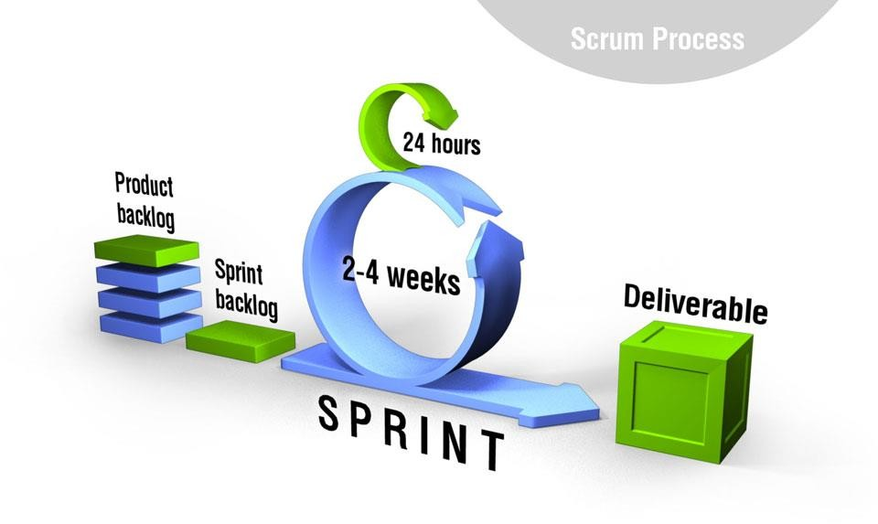
Figure 2: Scrum Process

Figure : Scrum Process
Scrum presupposes that the product backlog is already defined at the beginning of the project. One possible approach to constitute this backlog is to carry out a launch phase. The objective is to identify as many features as possible that the software will need to implement. The following figure illustrates the Scrum lifecycle.
The diagram above illustrates an example of Scrum planning. As shown in the figure, Scrum is an iterative process: the iterations are called sprints and typically last between 2 and 4 weeks. Each sprint has a goal and is associated with a list of product backlog items or features to be completed. These items are broken down by the team into elementary tasks of a few hours each.

2.6 Gantt Diagram
Planning is an important step in a project. It provides a general overview of the development stages and time estimates for the project. Since we have adopted Scrum as our development process, this necessitates partial project planning. In this case, the overall planning consists of the sum of the iteration plans in the process. The following diagram shows our final planning:
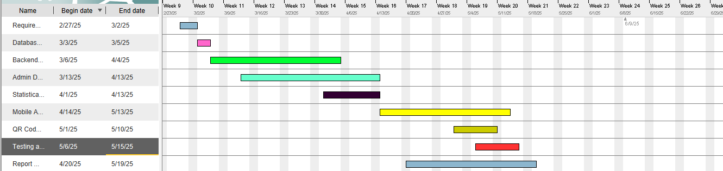

Figure 3: Gantt Diagram
The Gantt diagram provides a clear timeline of the development stages of the Meal Distribution System project, spanning from February 27, 2025 to May 20, 2025. It outlines key tasks including Requirement Analysis, Database Design, Backend Development, Admin Dashboard Implementation, Statistical Reports and Charts, Mobile App Development, QR Code and ID System Integration, Testing and Debugging, and finally, Report Writing. Each task is assigned a specific duration and scheduled in a sequential and sometimes overlapping manner to ensure optimal project flow. This visual representation aids in understanding task dependencies, managing deadlines, and monitoring progress throughout the project lifecycle.

Chapter III: UML and Functional Specifications

3.1 Introduction
In this chapter, the use of Unified Modeling Language (UML) in the Meal Distribution System project is explained. It covers the formalism of UML, and presents various diagrams such as class diagrams, sequence diagrams, and use case diagrams, which collectively describe the system's structure and behavior. and also outline the functional requirements of the Meal Distribution System application. It details the project's objectives, necessary functionalities, environmental and social assessments, and user roles and permissions, providing a comprehensive guide to the application's expected performance and user interaction.

3.2 UML formalism
UML (Unified Modeling Language) is a notation used for modeling a problem. This language emerged from the fusion of several pre-existing methods and has become the standard for object-oriented modeling. Between 1990 and 2000, many analysts developed object-oriented approaches, leading to over 50 object- oriented methods by 1994. However, only three methods truly emerged:
- The OMT method by Rumbaugh
- The BOOCH'93 method by Booch
- The OOSE method by Jacobson (Object-Oriented Software Engineering)
This method represents a way to specify, represent, and construct the components of a computer system. Indeed, the unified notation defines nine diagrams to represent different viewpoints of modeling. These diagrams allow for the visualization and manipulation of modeling elements. The diagrams defined by UML are as follows:
- Use-Case Diagram : Represent the system's functionalities from the users' perspective.
- Sequence Diagram : Temporally present objects and their interactions.
- Class Diagram : Describe the static structure of the system in terms of classes and relationships.

3.3 Choosing UML
Object-oriented modeling is considered the most suitable in this context.
The object-oriented approach has proven effective in developing real-time applications. Therefore, we chose to use UML as the modeling language. This choice can be justified for several reasons:
- UML notation facilitates the understanding and communication of object- oriented modeling.
- It provides visual tools to represent different aspects of a system clearly and coherently.
During my system study, we used three UML diagrams: the use case diagram, sequence diagrams, and class diagram. These diagrams allowed us to model the functionalities, interactions, behaviors, and structure of the system in a precise and structured manner

3.4 . Project Objectives
The primary objective of the Meal Distribution System is to provide a reliable and efficient platform that supports charitable associations (Al-Birr wa Al-Ihsan Association) in the fair and organized distribution of food, medicine, and other aid. By integrating tools for beneficiary management, meal tracking, and reporting, the system addresses common challenges in aid distribution such as data inconsistency, manual tracking, and lack of transparency. Specifically,
the system aims to:
- Ensure accurate identification of registered beneficiaries through QR code scanning to streamline the distribution process.
- Enable real-time tracking of distributed meals to avoid duplication and ensure fairness..
- Support administrators with a centralized dashboard for managing beneficiaries, workers, and distribution records.
- Provide insightful reports and statistics to evaluate performance and improve future planning
- Facilitate flexibility by supporting various beneficiary types (registered, waiting list, unregistered) and different distribution branches.

3.5 Functional Requirements
The functional requirements for the Meal Distribution System are tailored to meet the operational needs of charitable organizations involved in aid distribution. These requirements ensure efficient management, transparency, and ease of use during daily activities. Key functionalities include:
- QR Code Scanning: Enables workers to scan beneficiary ID cards using QR codes for fast and accurate identification during distribution
- Meal Distribution Tracking: Records each meal given to a beneficiary in real time, preventing duplication and ensuring fair distribution.
- Beneficiary Management: Allows administrators to add, update, and manage registered beneficiaries, waiting list entries, and unregistered beneficiaries.
- Worker Management: Provides tools to add and manage workers, assign roles, and track their performance.
- Reporting and Statistics: Generates reports and visual statistics (e.g., total meals distributed, gender/family status breakdowns) filtered by date and beneficiary type.
- ID Card Generation: Generates downloadable ID cards with embedded QR codes for registered beneficiaries.

3.6 Environmental and Social Assessment
- The Meal Distribution System helps reduce paper use and manual work by digitizing beneficiary and meal tracking.
- It saves time and effort for workers by making the process faster and more organized.
- Socially, the system ensures that aid is distributed fairly and consistently, reaching those who need it most.
- It also supports better planning and reporting, helping associations serve the community more effectively

3.7 User Roles and Permissions
  - Admins (Web Platform):
- Beneficiary Management: Add, update, or delete beneficiary records. Generate and download ID cards with embedded QR codes for beneficiaries.
- Worker Management: Create, edit, or remove worker accounts.
- Distribution Monitoring : Access detailed records of distributed items, Filter reports by date, beneficiary, item type
- Statistical Analysis and Reports : View interactive dashboards showing(Gender and family status statistics , Daily, weekly, and monthly distribution totals). Export statistics and reports as PDF files.
- Workers (Mobile App)
- QR Code Scanning:
- Scan QR codes on beneficiary ID cards to identify individuals.
- Check eligibility based on color and distribution history.

- Distribution Logging:
- Record distributions of food, medication, and diapers.
- Support for distributing to unregistered individuals without ID cards.
These roles are structured to ensure efficient collaboration between administrators and field workers. While both roles are essential to the success of the distribution process, admins are equipped with advanced tools for system oversight and data analysis, while workers focus on real-time distribution tasks. This role separation enhances workflow, accountability, and the overall effectiveness of aid delivery.

3.8 Use Case Diagram

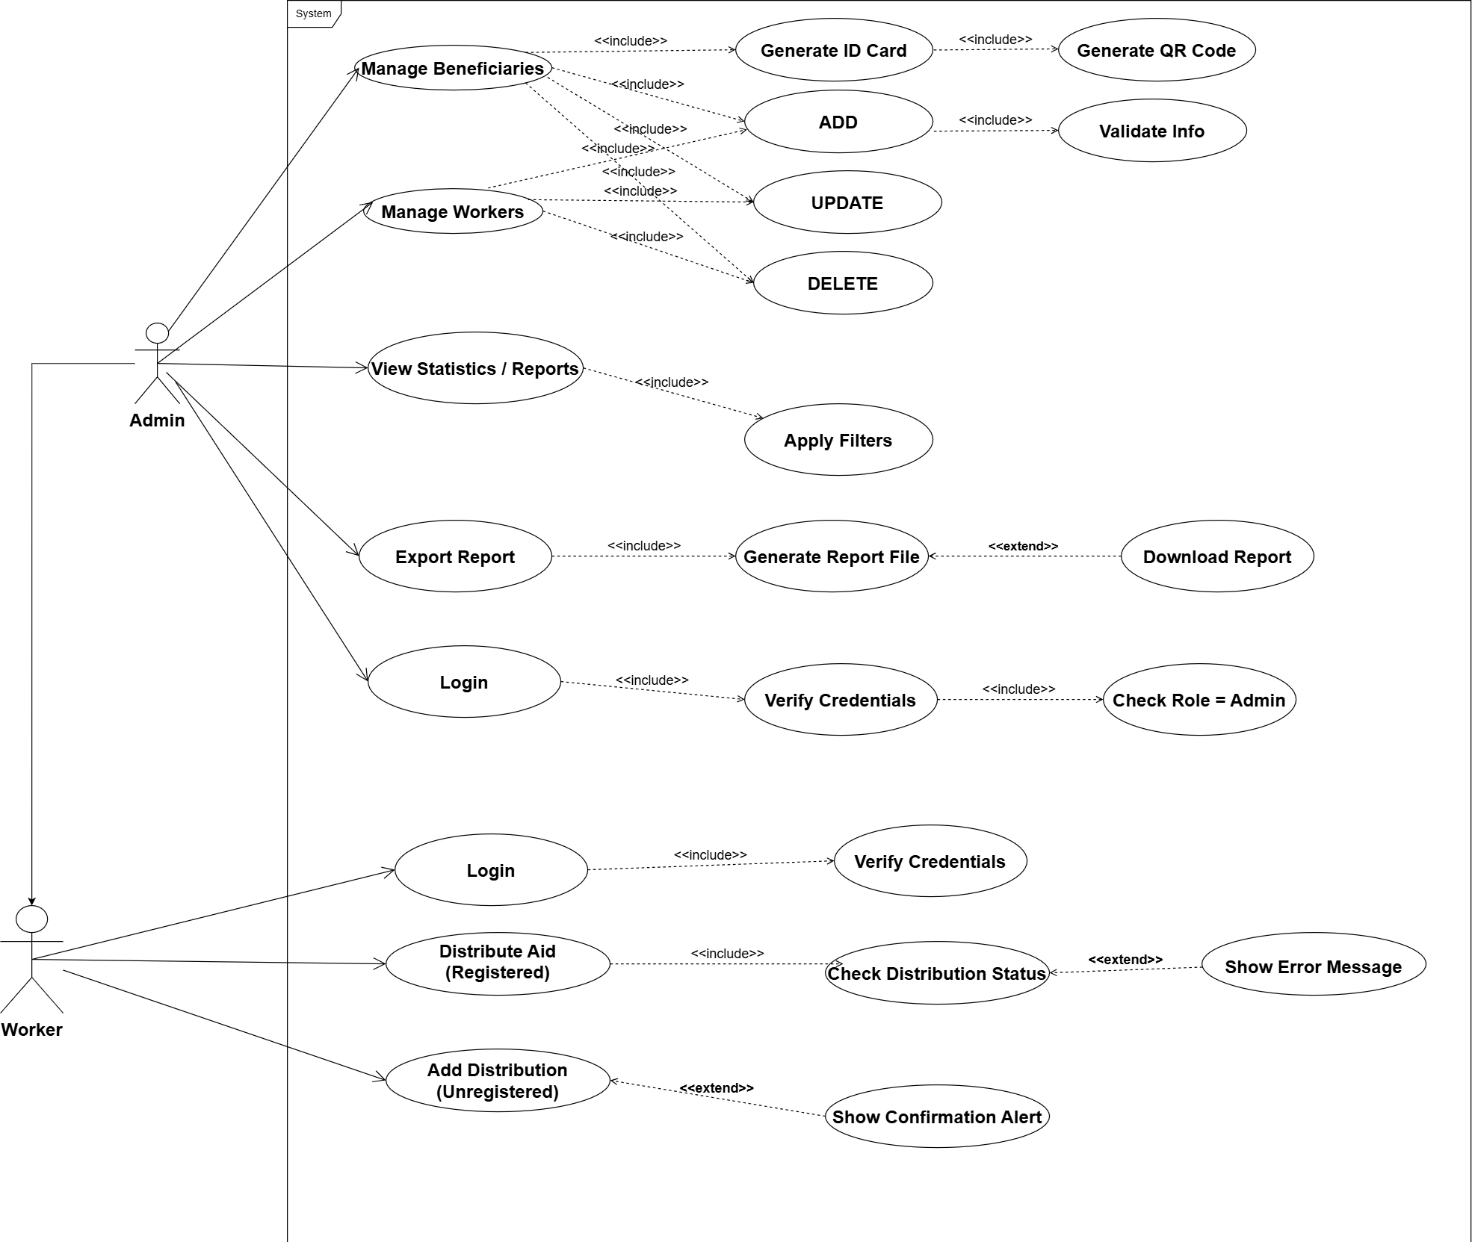Figure 4: use case Diagram
The Figure 14 shows features and actors that exist in the meal distribution management system and we can devise the features like this:
- Admin Features:
  - Manage Beneficiaries: Admins can add, update, delete beneficiaries, generate ID cards, generate QR codes, and validate beneficiary information.
  - Manage Workers: Admins can control staff access and maintain worker profiles within the system.
  - View Statistics/Reports: Admins can view comprehensive data analysis and apply filters for targeted reporting.
  - Export Report: Admins can generate report files and download reports for documentation purposes.
  - Login: Admins can securely access the system with credential verification and role-based authentication.
- Worker Features:
  - Login: Workers can securely access the system with credential verification.
  - Distribute Aid (Registered): Workers can manage aid distribution for registered beneficiaries, check distribution status, and receive error messages for invalid attempts.
  - Add Distribution (Unregistered): Workers can handle aid provision for non-registered individuals and receive confirmation alerts for successful distributions.
All user activities are authenticated, ensuring that only valid users can access their respective features based on their assigned roles

3.9 Class Diagram
The class diagram is a type of UML diagram used to provide a visual representation of the structure of a system by describing the classes and objects, as well as their relationships and interactions. It includes the attributes (characteristics or properties) and methods (functions or operations) of each class. Class diagrams are used to model the design of a system from an object-oriented perspective, offering a static view of the system's structure and serving as a blueprint for software development.
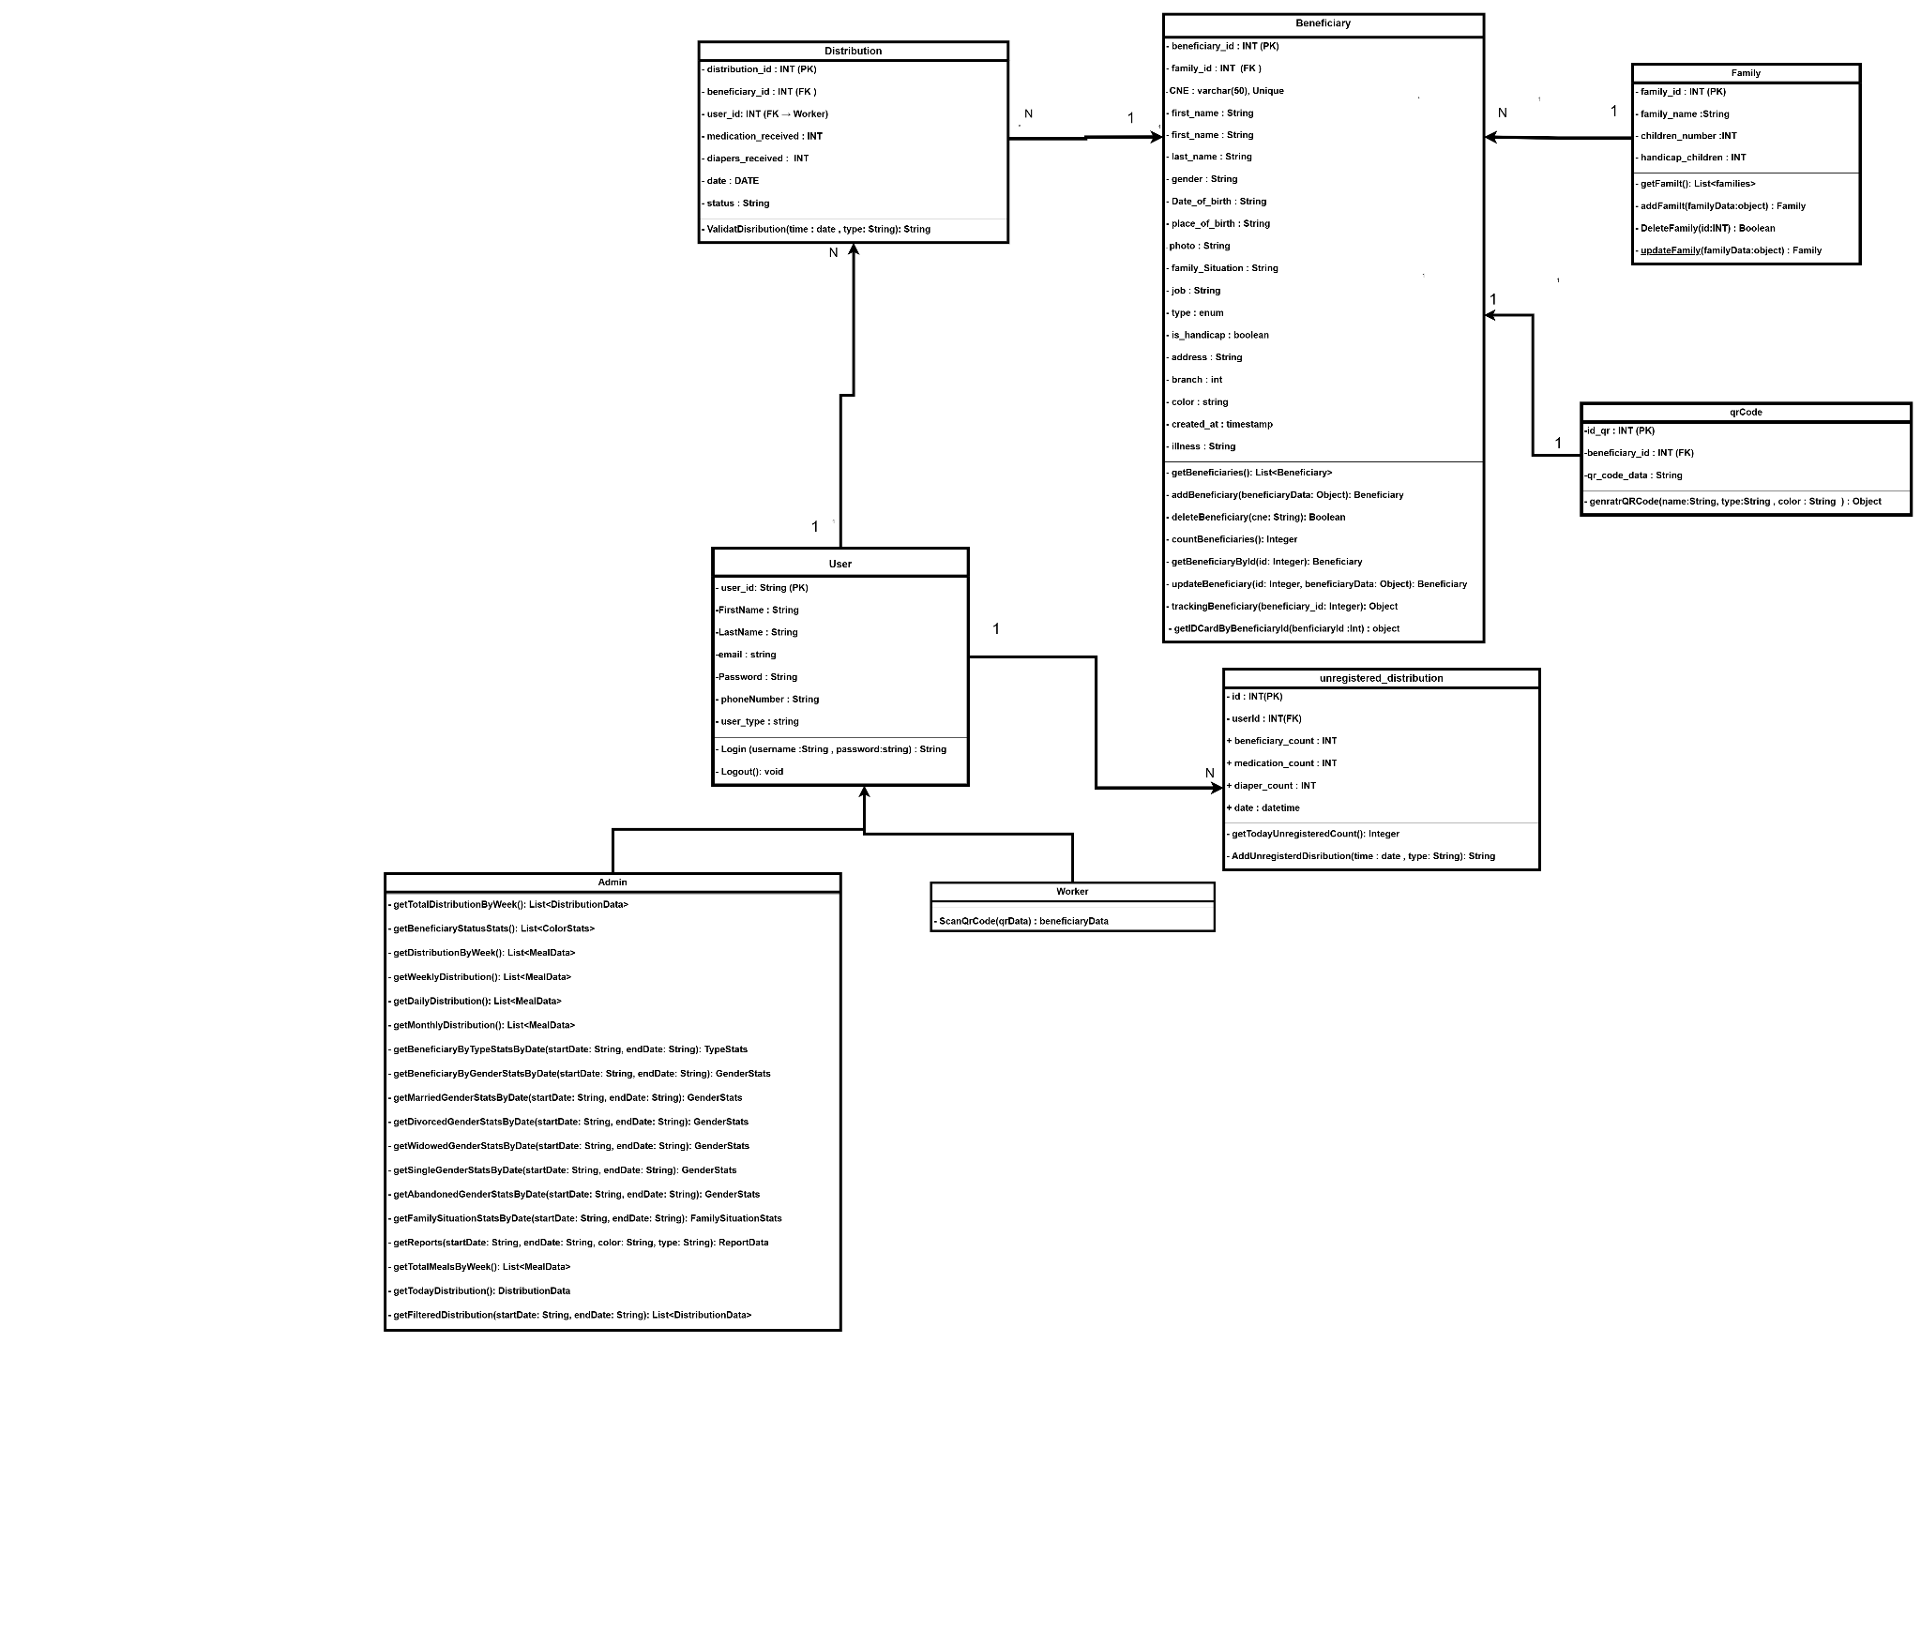

Figure 5:Class diagram
Figure 4 illustrates the structural composition of the Meal Distribution System and the relationships between its core components. Here's an analysis of each part of the diagram:
Classes:
- User Class: The User class contains essential personal and login details including first name, last name, email, password, phone number, and user type. It supports user authentication via login and logout methods.
- Admin Class: Inheriting from User, the Admin class incorporates advanced capabilities such as generating statistical reports related to distributions, beneficiaries, and family situations, based on date ranges and gender or type.
- Worker Class: Also extending from User, the Worker class is designed to handle distribution tasks including QR code scanning and validating distributions based on date and type.
- Beneficiary Class: This class encapsulates comprehensive information about registered individuals such as identification details, demographics, personal circumstances, and medical data. It includes methods for CRUD operations and beneficiary tracking.
- Family Class: Represents families linked to beneficiaries. It tracks family name, number of children, and number of handicapped children. It includes methods to manage family records.
- QRCode Class: Handles the QR code assigned to each beneficiary. It links directly to a beneficiary and includes a method for generating QR codes using the name, type, and color.
- Distribution Class: This class logs the details of aid distributed to beneficiaries (food, medication, diapers) by a specific worker at a certain date and includes the distribution status.
- Unregistered_Distribution Class: Manages daily statistics for aid given to unregistered beneficiaries, capturing counts for people, medication, and diapers.
Relationships:
- Inheritance:
  - Admin and Worker classes inherit from the User class, gaining basic authentication features while extending with their own roles.
- Associations:
  - Admin and Worker interact with the Distribution class. Each distribution record is linked to one worker and one beneficiary.
  - Each Beneficiary is connected to one Family and one QRCode, while a family may include multiple beneficiaries (1..*).
  - QRCode has a one-to-one relationship with Beneficiary (1..1).
  - Unregistered_Distribution records are associated with a user and store summarized distribution data, unlike the detailed records in Distribution.
This structure ensures robust management of both detailed and summarized distribution activities, with scalability for reporting and real-time processing via user roles.

3.10 Sequence Diagram

3.10.1 Login
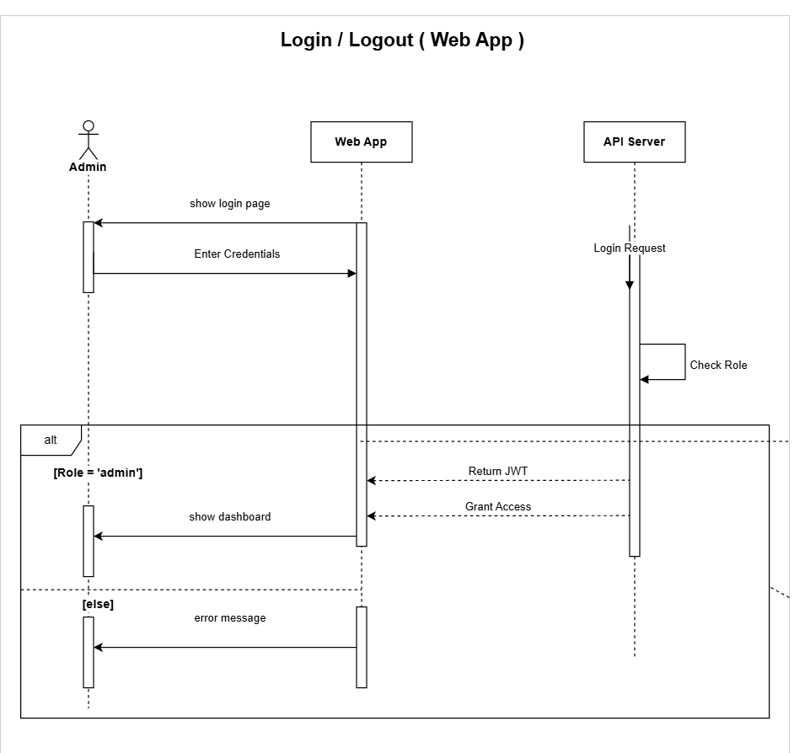

Figure 6: Login sequence Diagram

Figure 5 illustrates the login process for an admin user within the web application. Initially, the system presents a login page where the admin enters their credentials. Upon submission, a login request is sent to the API server, which verifies the credentials and checks the user's role. If the role is identified as 'admin', the server returns a JWT token, grants access, and the admin is redirected to the dashboard. If the role does not match 'admin', an error message is displayed instead. This diagram emphasizes the role-based authentication mechanism, ensuring that only authorized administrators gain access to privileged sections of the system

3.10.2 Adding a new beneficiary/worker
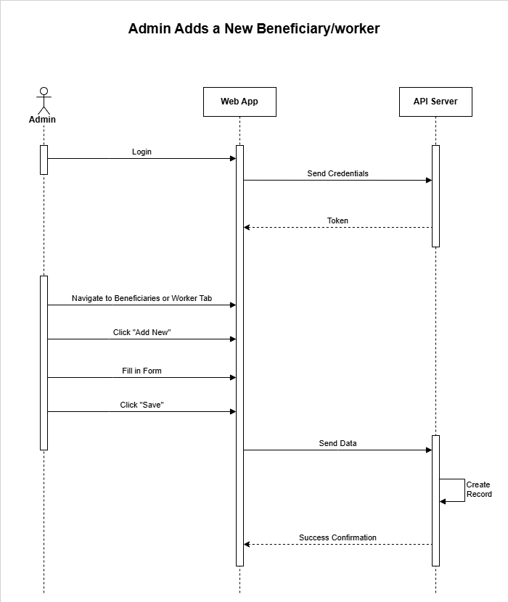

Figure 7: adding new beneficiary / worker sequence Diagram
Figure 7 describes the process of an admin adding a new beneficiary or worker through the web application. The workflow begins when the admin logs into the web app by sending their credentials to the API server, which validates the login and returns an authentication token. Once authenticated, the admin navigates to the Beneficiaries tab within the web application and clicks the "Add New" button to initiate the beneficiary / worker creation process. The admin then fills out the required beneficiary information in the form and clicks "Save" to submit the data. The web app sends the data to the API server, which processes the information and creates a new beneficiary / worker record in the system. Upon successful creation, the API server sends a confirmation response back to the web app, completing the registration process. This diagram illustrates a straightforward administrative workflow for managing beneficiaries / worker through a secure web-based interface with proper authentication and data validation.

3.10.3 Updating an existing workers or beneficiary's information
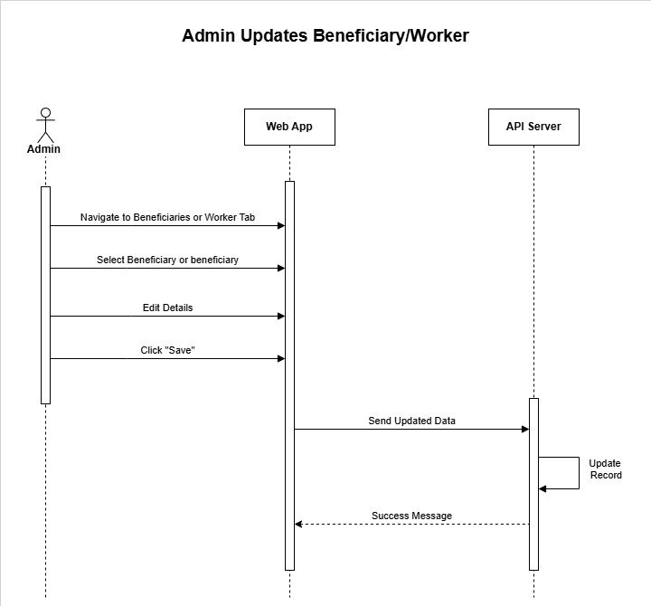

Figure 8: updating information sequence Diagram
Figure 8 describes the process of an admin updating an existing beneficiary's / worker’s information through the web application. The workflow begins when the admin navigates to the Beneficiaries or workers tab within the web app and selects a specific beneficiary or worker from the list whose details need to be modified. The admin then accesses the edit functionality to modify the details, making the necessary changes to the information fields. Once all updates are complete, the admin clicks "Save" to submit the modifications. The web app sends the updated beneficiary data to the API server, which processes the changes and updates the corresponding record in the database. Upon successful completion of the update operation, the API server returns a success message to the web app, confirming that the beneficiary's information has been successfully modified. This diagram illustrates an efficient administrative workflow for maintaining and updating beneficiary records through a secure web interface with proper data validation and confirmation mechanisms

3.10.4. Deleting a beneficiary or worker
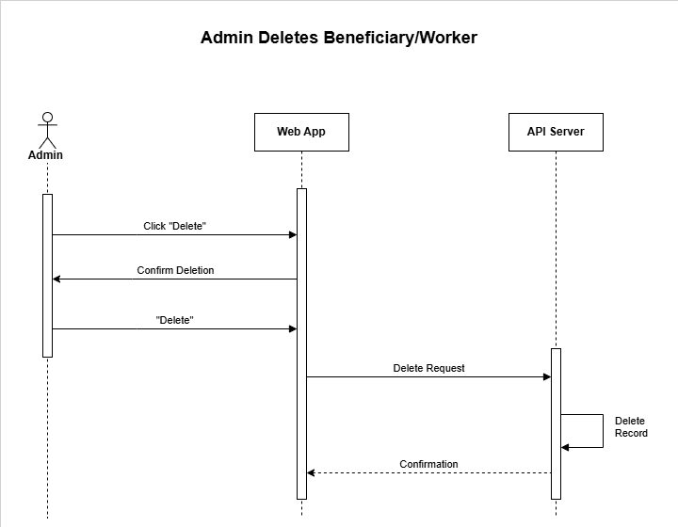

Figure 9: delete sequence Diagram

Figure 9 describes the process of an admin deleting a beneficiary record through the web application. The workflow begins when the admin clicks the "Delete" button for a specific beneficiary or worker within the web app. To prevent accidental deletions, the web app presents a confirmation dialog asking the admin to verify their intention to delete the beneficiary / worker . Once the admin confirms the deletion by clicking "Delete" in the confirmation prompt, the web app sends a delete request to the API server. The API server processes this request and permanently removes the beneficiary / worker record from the database. Upon successful completion of the deletion operation, the API server returns a confirmation message to the web app, notifying that the beneficiary has been successfully deleted from the system. This diagram emphasizes a secure deletion workflow that includes user confirmation to prevent accidental data loss and ensures proper communication between the web interface and backend systems.

3.10.5 generating a beneficiary ID card

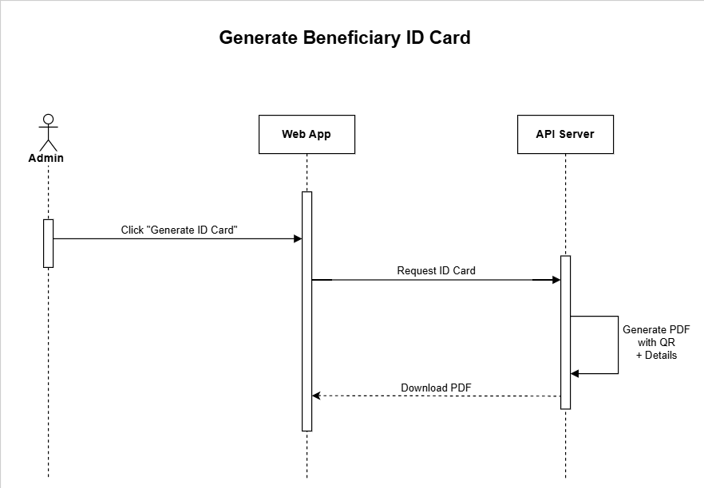

Figure 10: generate ID card sequence Diagram
Figure 10 describes the process of generating a beneficiary ID card through the web application. The workflow begins when the admin clicks the "Generate ID Card" button for a specific beneficiary within the web app. The web app then sends a request to the API server to create the ID card for the selected beneficiary. Upon receiving this request, the API server processes the beneficiary's information and generates a PDF document containing the ID card with relevant details such as beneficiary information and a QR code for verification purposes. Once the PDF generation is complete, the API server makes the document available for download and sends a response back to the web app. The admin can then download the generated PDF ID card directly through the web interface. This diagram illustrates a streamlined process for creating official beneficiary identification documents with integrated QR codes, enabling efficient beneficiary verification and record management.

3.10.6 statistics and generating reports
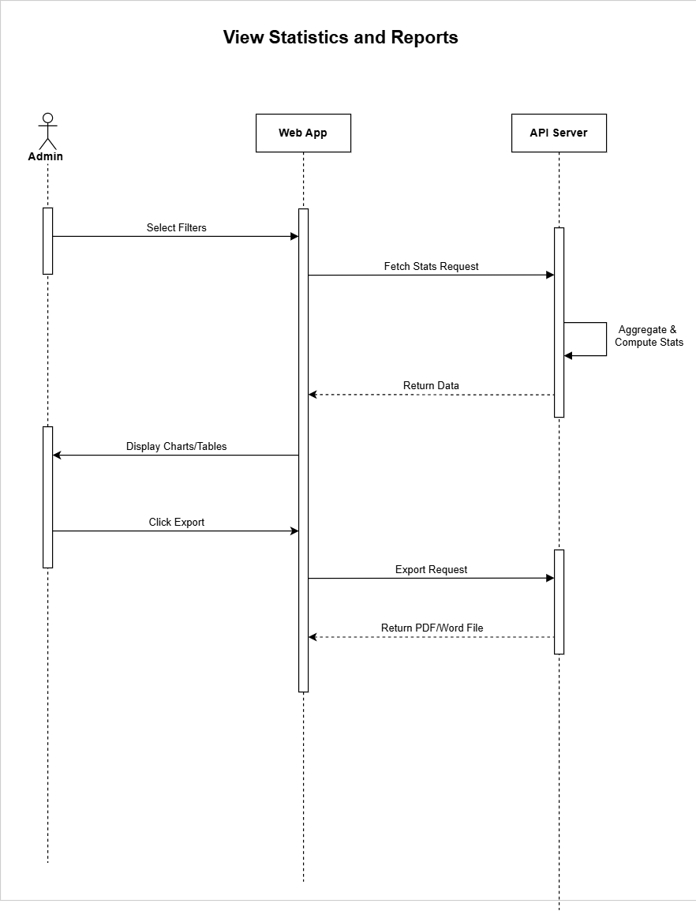

Figure 11: statistics and reports sequence Diagram
Figure 11 describes the process of viewing statistics and generating reports through the web application. The workflow begins when the admin selects specific filters to customize the data they want to analyze within the web app. The web app then sends a fetch statistics request to the API server based on the selected criteria. The API server processes this request by aggregating and computing the relevant statistical data from the database according to the specified filters. Once the calculations are complete, the API server returns the processed data to the web app, which then displays the information in the form of interactive charts and tables for the admin to review. If the admin needs to share or archive the report, they can click the "Export" button, which triggers an export request to the API server. The server generates a comprehensive report in PDF or Word format containing the statistical data and visualizations, then returns the downloadable file to the web app. This diagram illustrates a comprehensive reporting system that enables data-driven decision making through customizable filters, visual representations, and exportable documentation.

3.10.7 Scan Beneficiary QR Code to Distribute a Meal
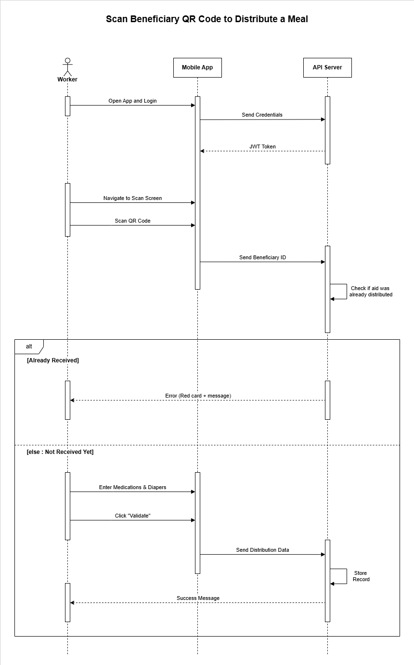

Figure 12: Scan Beneficiary QR Code to Distribute a Meal sequence Diagram
Figure 12 illustrates the process of scanning a beneficiary's QR code to distribute aid through the mobile application. The process begins when the worker opens the app and logs in using their credentials. The mobile app sends these credentials to the API server, which responds with a JWT token to authenticate the user. Once authenticated, the worker navigates to the scan screen and scans the QR code of a beneficiary. The app extracts the beneficiary ID and sends it to the API server to verify whether the beneficiary has already received aid for the current day. If the system detects that aid has already been distributed, the API responds with an error message, which is displayed as a red card on the app to prevent duplicate distribution. If the beneficiary is eligible, the worker proceeds to input the number of medications and diapers being provided, then clicks “Validate.” This action sends the distribution data to the API server, which stores the record in the database and returns a success message to confirm the operation. This sequence ensures that aid distribution is both secure and traceable, preventing duplication and supporting accurate record-keeping within the association's system

3.10.8 Unregistered Distribution

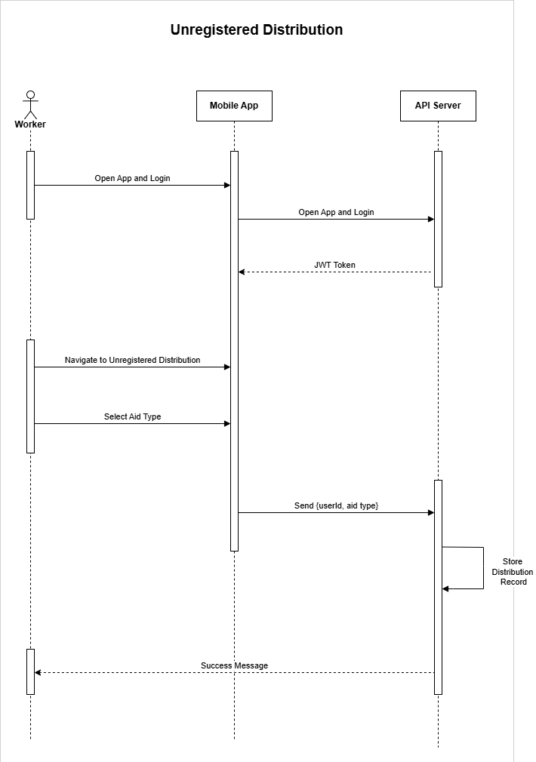

Figure 13: Unregistered Distribute a Meal sequence Diagram
Figure 13 illustrates the process of unregistered aid distribution through the mobile application for beneficiaries without formal QR codes. The workflow begins when the worker opens the mobile app and logs in with their credentials. The app sends these credentials to the API server, which validates the information and returns a JWT token for secure authentication.
Once authenticated, the worker navigates to the "Unregistered Distribution" section within the mobile application. This feature handles aid distribution for individuals who lack registered QR codes but still require assistance. The worker selects the appropriate aid type from available options, such as meals, medical or diapers
After selecting the aid type, the mobile app compiles the distribution data including the worker's user ID and chosen aid category, then transmits this information to the API server. The server processes the request, stores the distribution record in the database to maintain comprehensive tracking of all aid provided, and returns a success message confirming the transaction.
This sequence ensures that unregistered beneficiaries can receive necessary aid while maintaining complete traceability and accountability within the organization's distribution system, supporting accurate record-keeping and preventing resource misallocation.

Chapter IV: Technical Specifications

4.1 Introduction
In this chapter, we delve into the languages, tools, and technologies that form the backbone of the Meal Distribution System developed for the association. we explore the overall architecture, highlighting the integration between the backend services, web dashboard, and mobile application to ensure efficient and real-time aid distribution. Additionally, we present the software tools used during development and discuss the programming languages and frameworks employed to build both the user interfaces and backend APIs. This chapter provides a comprehensive overview of the system's technical foundation and how these technologies contribute to its functionality, scalability, and performance.

4.2 Languages and Technologies :

4.2.1 JavaScript :
JavaScript (Figure 15) is the primary programming language used throughout the project. It powers both the frontend and backend of the system. With JavaScript, we developed the admin dashboard using React.js, the mobile app using React Native, and the API server using Node.js with Express. Its flexibility and wide ecosystem make it ideal for building full-stack web and mobile applications.


Figure 15: javaScript’s Logo

4.2.2 React Native
React Native (Figure 16) is a framework developed by Meta for building native mobile applications using JavaScript and React. It allows the creation of cross-platform apps for both Android and iOS using a single codebase. In this project, React Native is used to develop the mobile app for aid workers, ensuring a seamless experience for scanning QR codes and managing meal distributions


Figure16: React Native's Logo

4.2.3 React.js
React.js (Figure 17) is an open-source JavaScript library maintained by Meta. It is used for building dynamic user interfaces, particularly single-page applications. In this project, React is used to develop the admin web dashboard, offering a responsive and modular architecture that simplifies UI development through reusable components.


Figure 17: ReactJS 's Logo

4.2.4 Express.js
Express.js (Figure 18) is a Node.js framework used to build the backend API of the system. It handles authentication, QR code scanning logic, data fetching, and reporting, ensuring secure and fast communication between the mobile/web clients and the MySQL database
Node. js is an open source, cross-platform runtime environment and library that is used for running web applications outside the client's browser

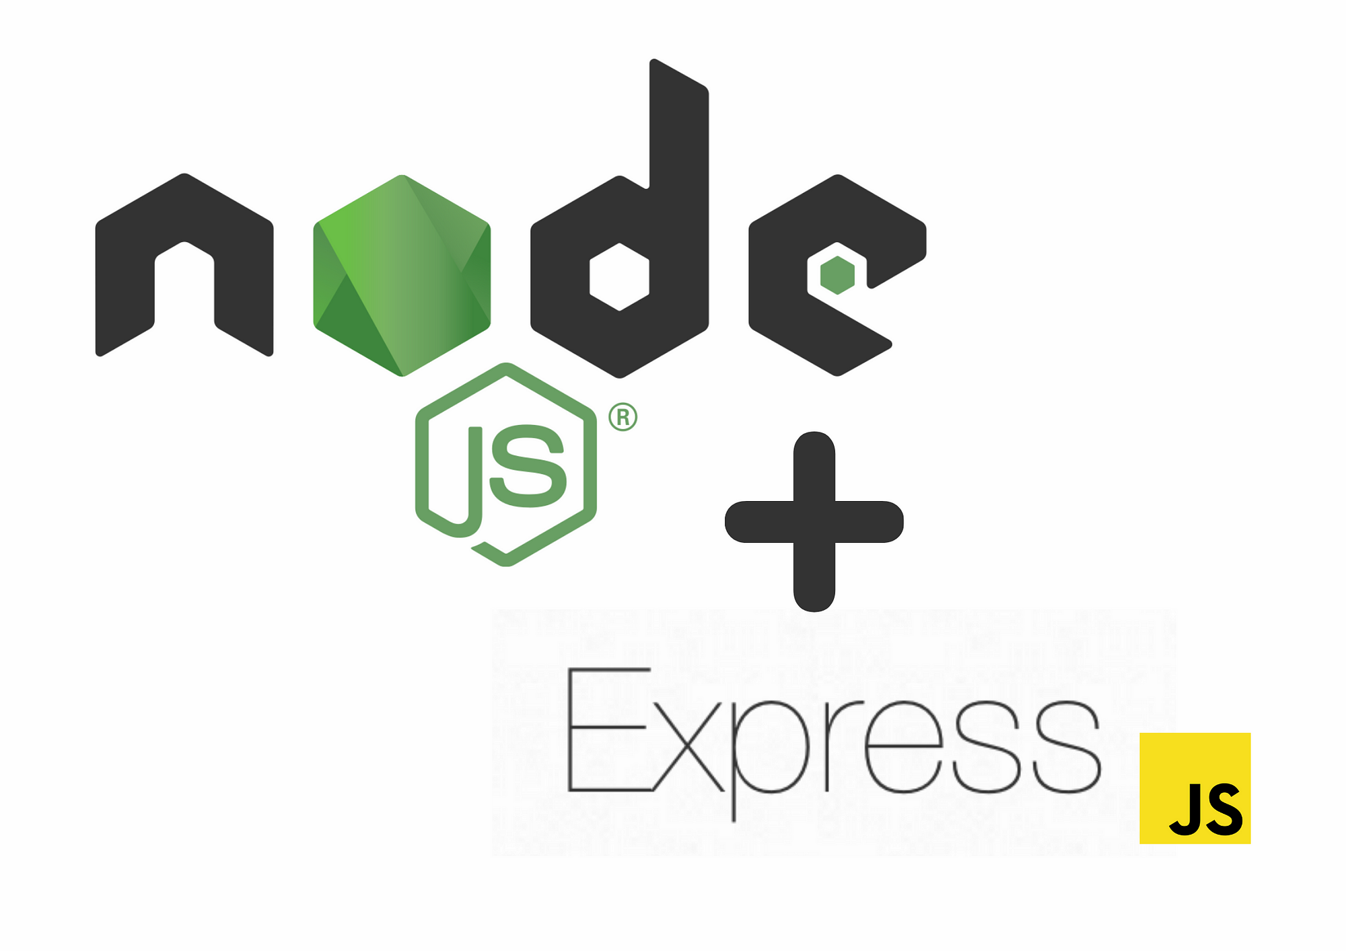

Figure 18: nodejs and express’s Logo

4.2.5 MySQL
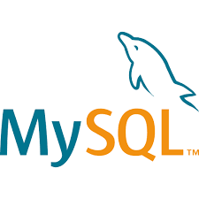
MySQL (Figure 19) is the database system used to store all structured data including beneficiary details, meal distribution records, worker accounts, and system logs. It provides reliable performance and strong data consistency required for managing humanitarian operations.
Figure 19: mySql's Logo

4.3 Development, Modeling, and Communication Tools

4.3.1 Visual Studio Code (VS Code)
Visual Studio Code (VS Code) ( Figure 20 ) is A free, open-source code editor developed by Microsoft. It supports debugging, syntax highlighting, intelligent code completion, snippets, code refactoring, and embedded Git.


Figure 20: VS code 's Logo

4.3.2 Postman
Postman (Figure 21) is an API testing tool used extensively to test and validate backend endpoints. It allows developers to simulate requests, inspect responses, and debug issues effectively during API development.
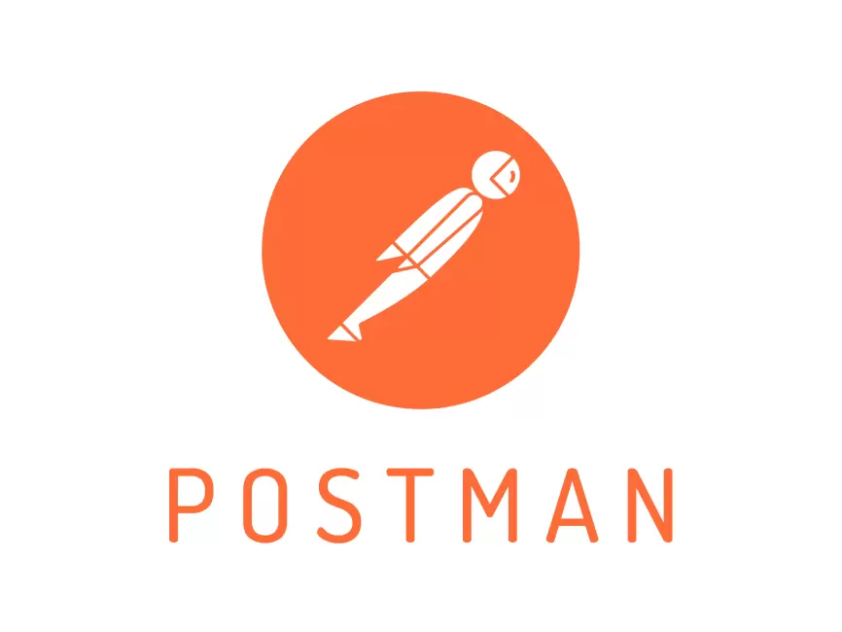

Figure 21: PostMan 's Logo

4.3.3 GitHub
GitHub (Figure 22) is used for version control and collaboration. It helps manage code revisions, branches, and deployment pipelines, ensuring smooth development workflows and code sharing.


Figure 22: Github's Logo

4.3.4 Expo go
Expo Go (Figure 23) is a development tool used in this project to simplify the testing and deployment of the mobile application. It allows developers to run React Native apps instantly on physical devices without compiling native code. By scanning a QR code, the worker app can be tested in real-time, enabling faster debugging and iteration. Expo Go was especially useful during development to preview features such as QR code scanning, login/logout, and meal distribution workflows, ensuring smooth functionality before full deployment.


Figure 23: ExpoGO's Logo

4.4 Conclusion
This chapter provided an overview of the key technologies and tools used in the development of the digital distribution system for the association. By leveraging JavaScript, Node.js, and MySQL on the backend, and React and React Native for the web and mobile interfaces, the system ensures a responsive, scalable, and user-friendly experience. The integration of Expo Go streamlined the mobile testing process, while development tools such as Visual Studio Code, and draw.io supported a smooth and organized workflow. Together, these technologies formed a robust ecosystem that enabled the successful realization of the project’s objectives, including real-time beneficiary tracking, efficient meal distribution, and comprehensive reporting features tailored to the needs of the association

Chapter V: Project Implementation

5 .1 Introduction
This chapter focuses on the design and development of the application’s interfaces. It covers both the front-end and back-end components, the database structure, and the implementation of key interfaces such as the login screen, QR code scanning feature, beneficiary management pages, and real-time distribution tracking. The goal is to demonstrate how users—such as admins and aid workers—interact with the system, and to explain the logic that ensures secure, efficient, and transparent distribution of food and medical aid to beneficiaries.

5.2 Web Application

5.2.1 Login pages :

A . Screen
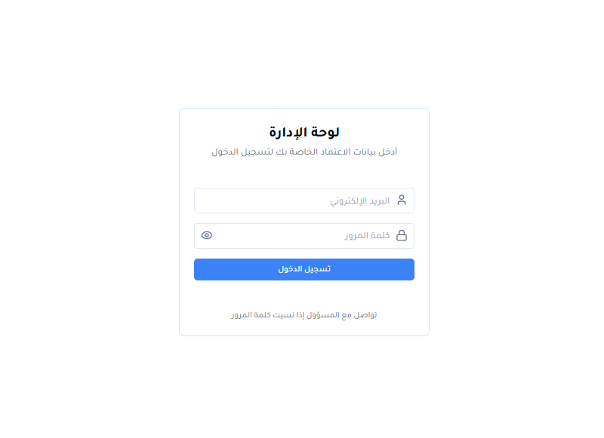
Figure24: Login’s page
The login page features a clean, centered design with a white background. The interface includes input fields for email and password with corresponding icons, a blue login button, and a "forgot password" contact link. The page supports Arabic RTL layout and maintains a minimalist aesthetic focused on user authentication functionality.

B. Code
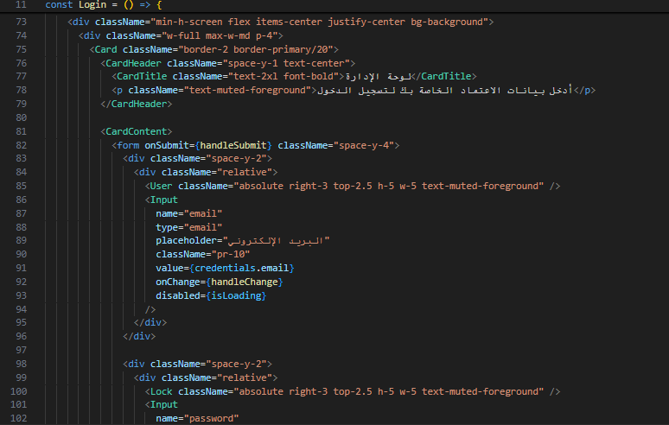

Figure 25: Login’s page code

5.2.2 beneficiary list

A . Screen
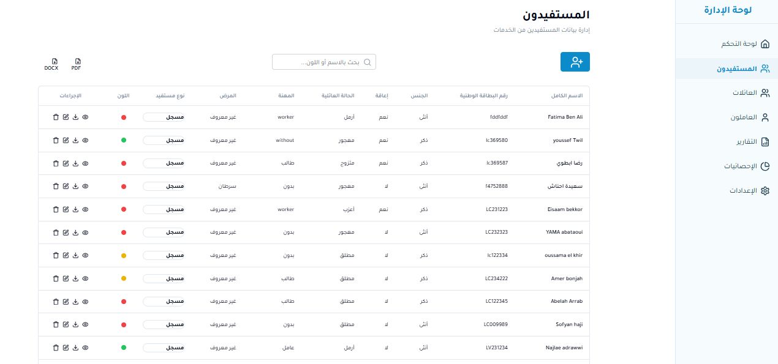

Figure 26: Beneficiary List page
The beneficiaries management page displays a comprehensive data table for managing service recipients. The interface features a search bar at the top and export options (DOCX, PDF). The main table includes columns for actions, status indicators (colored dots), beneficiary type, patient condition, occupation, marital status, disability status, gender, national ID, and full name. Each row contains action buttons for operations like edit, delete, and view details. The page maintains the Arabic RTL layout with a clean sidebar navigation and supports efficient data management through filtering and export functionality

B. Code
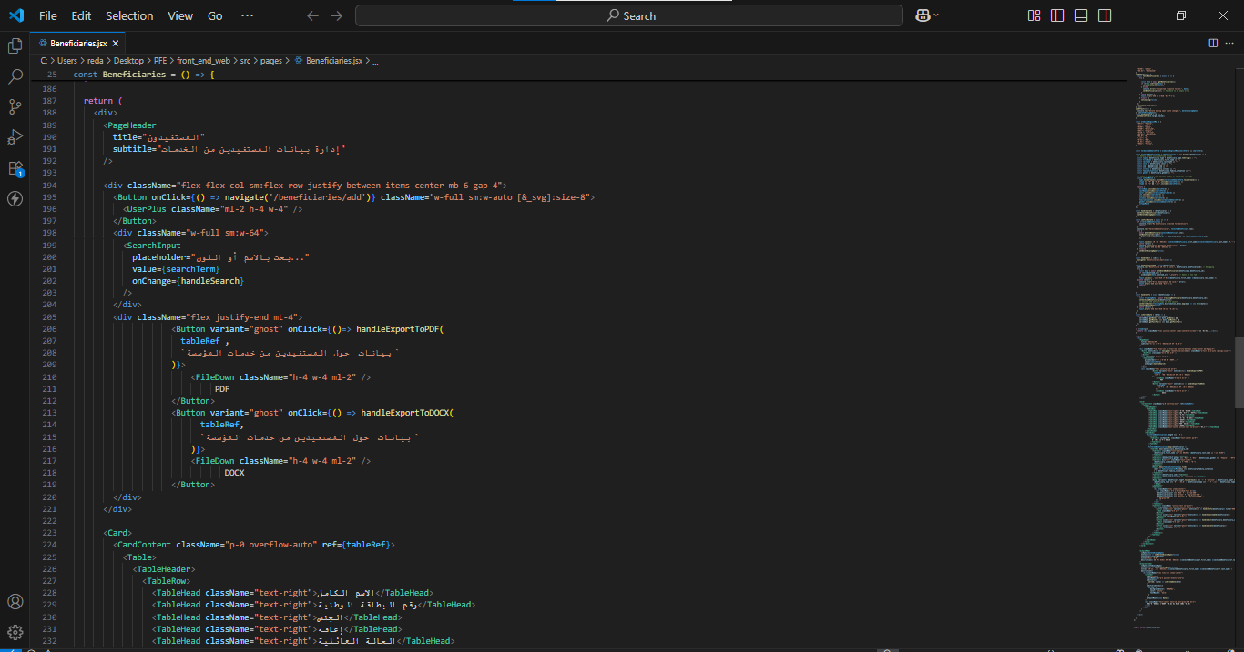

Figure 27: Beneficiary List code

5.2.3 Add beneficiary

A . Screen
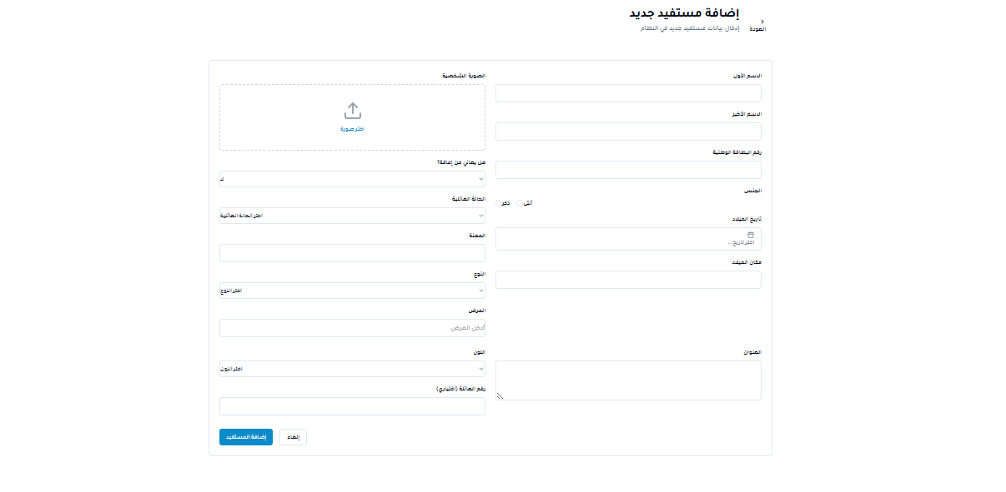

Figure 28: adding new beneficiary page

The add new beneficiary form page provides a comprehensive interface for registering new service recipients. The form includes essential fields such as first name, last name, personal photo upload area with drag-and-drop functionality, national ID number, gender selection, birth date, address, occupation, and marital status. Additional fields capture health status, disability information, and emergency contact details. The page features a clean, organized layout with proper field validation and a blue "Add Beneficiary" submit button at the bottom, along with a cancel option, maintaining the Arabic RTL design consistency

B. Code
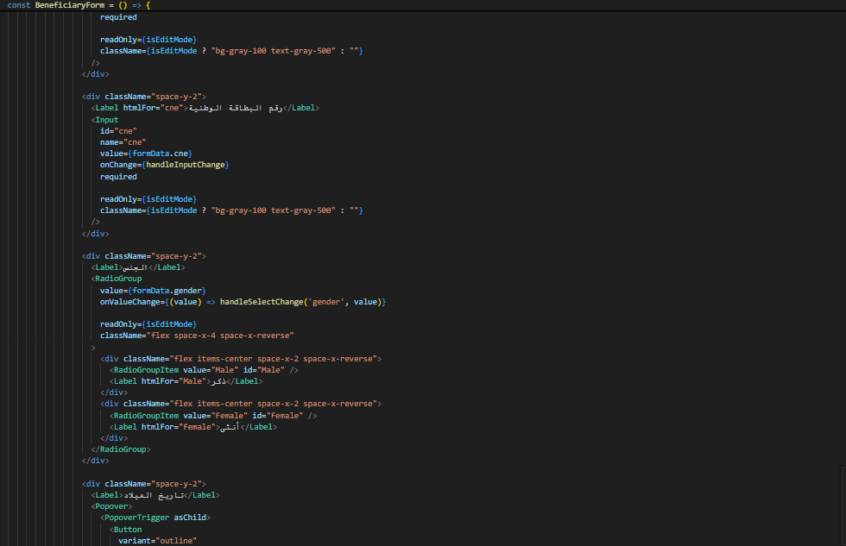

Figure 29: Add Beneficiary code

5.2.4 Updating beneficiary

A . Screen
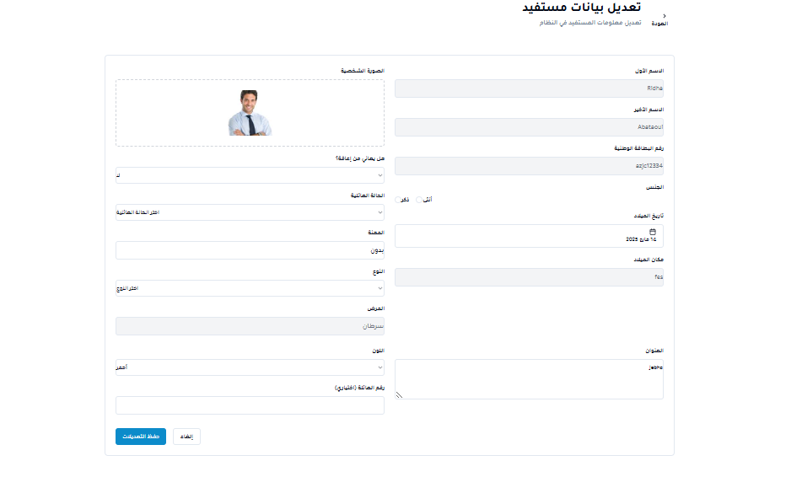

Figure 30: Updating Beneficiary page
The edit beneficiary page allows administrators to modify existing beneficiary information through a pre-populated form. The interface displays the current beneficiary's photo and includes editable fields for personal details such as first name, last name, national ID, gender, birth date, address, occupation, and health status. The form maintains the same structure as the add beneficiary page but with existing data loaded for modification. A blue "Save Changes" (حفظ التعديلات) button and cancel option are provided at the bottom, ensuring seamless data updates while preserving the Arabic RTL layout and user-friendly design.
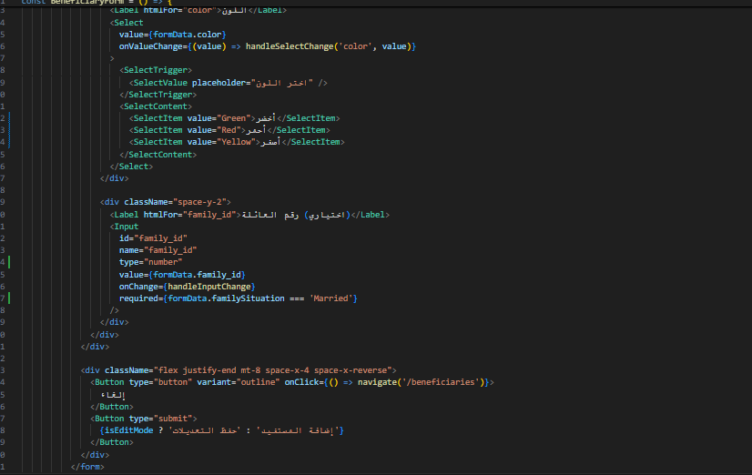

Figure 31: Updating Beneficiary code

5.2.5 Users List

A . Screen
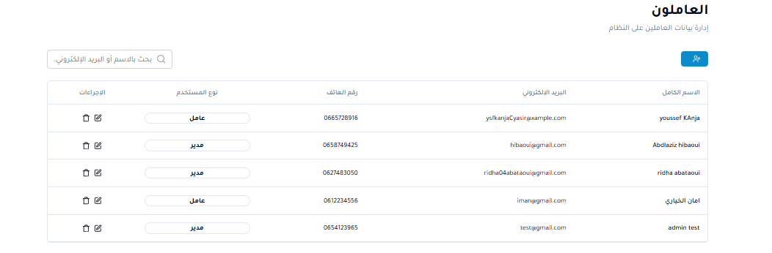

Figure 32: Users List page
number, email address, and full name. Each row contains action buttons for record management operations. The page maintains a clean, organized layout with the Arabic RTL interface design, allowing administrators to efficiently manage employee information and access controls.

B. Code
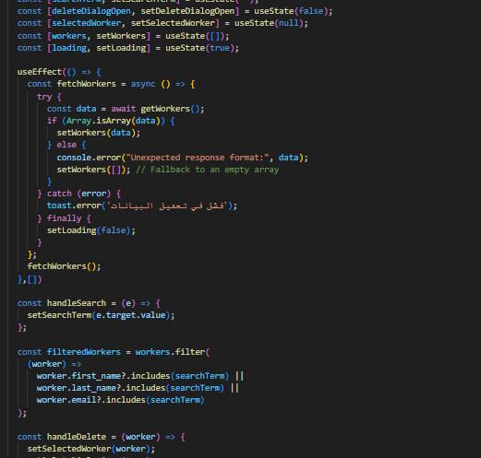

Figure 33: Users List code

5.2.6 Add User

A . Screen
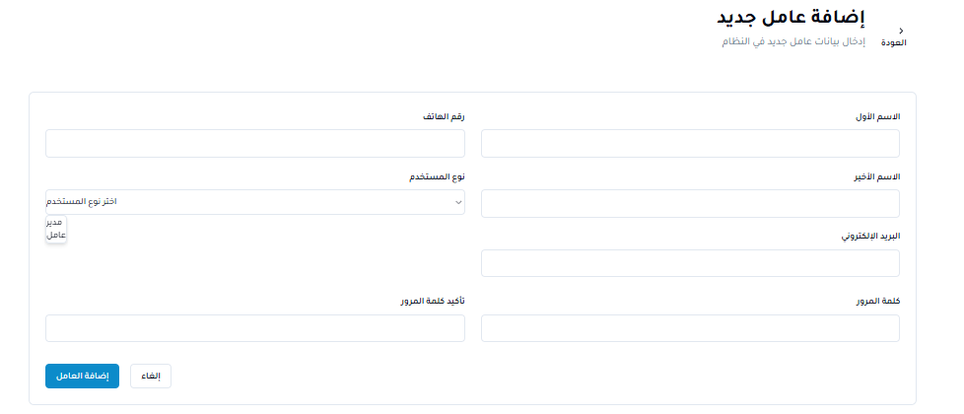

Figure 34: add Users page
The add new employee form provides a simple interface for registering new staff members into the system. The form includes essential fields such as first name, last name, user type selection (with options for manager and employee), email address, phone number, and password confirmation. The layout features a clean, organized design with proper field validation and a blue "Add Employee" submit button, along with a cancel option at the bottom. The page maintains the Arabic RTL interface consistency for efficient employee registration and account creation.
B. Code
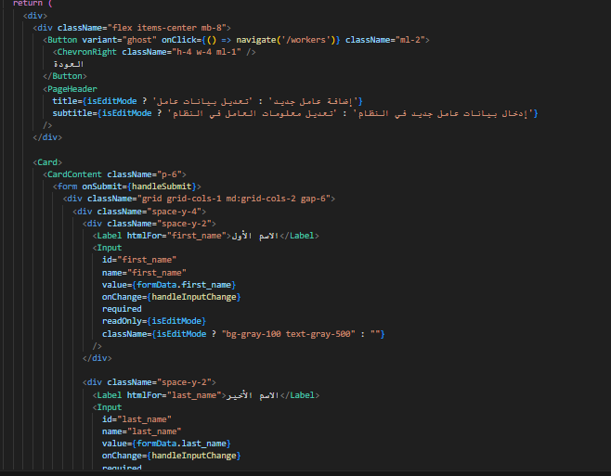
Figure 35 add Users CODE

5.2.7 report page

A . Screen
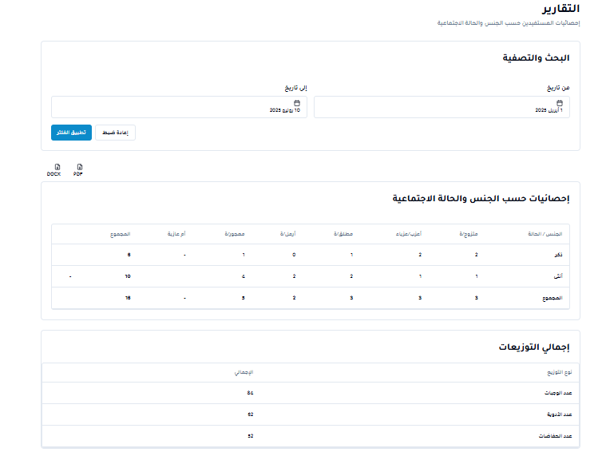
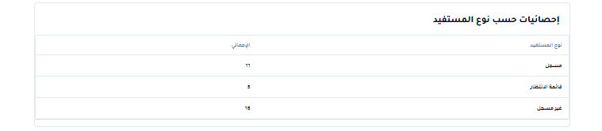

Figure 36: Report page

The reports page provides comprehensive statistical analysis and data visualization for system administrators. The interface features three main sections: a "Search and Export" area with date range filters and export options (DOCX, PDF), a detailed "Statistics by Gender and Social Status" table showing breakdowns across different beneficiary categories (male, female, total) with various social conditions, and a "Distribution Totals" summary displaying overall counts for different beneficiary types. Additionally, there's a "Statistics by Beneficiary Type" section showing numerical breakdowns by category. The page maintains the Arabic RTL layout and offers robust reporting capabilities for data analysis and administrative oversight

B. Code
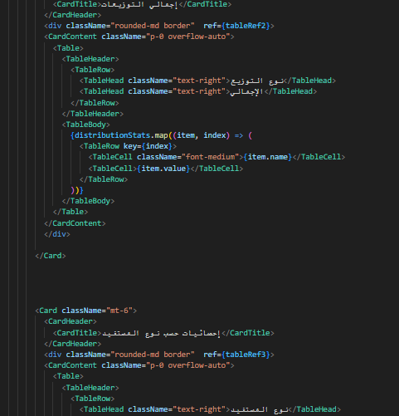

Figure 37: Report page code

5.3 MOBILE APP

5.3.1 login page

A . Screen

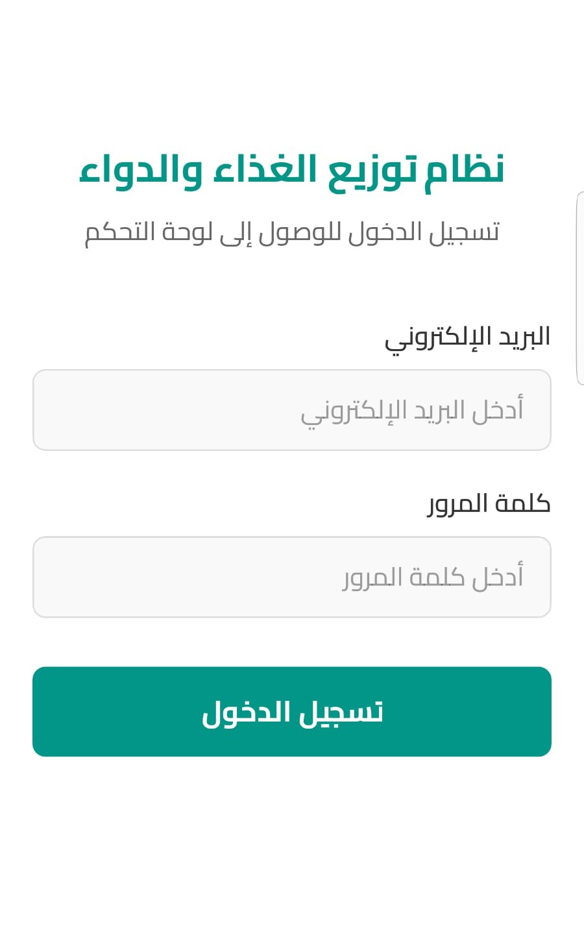

Figure 38: mobile app login page

The login screen serves as the secure authentication gateway for the Food and Medicine Distribution System mobile application, specifically designed to authorize association workers who need field access to begin registering distribution activities. The interface presents a streamlined Arabic RTL layout with explanatory text indicating this is a login registration portal for accessing the control panel functionality. The authentication form contains two essential credential fields - an email input field with Arabic placeholder text guiding users to enter their registered email address, and a password field with corresponding placeholder instructions for secure login verification. The interface concludes with a distinctive green (Login) button that enables authorized association workers to authenticate and gain access to the mobile application's distribution registration features. This mobile-optimized design ensures field workers can quickly and securely log into the system from their devices to immediately commence beneficiary registration and distribution tracking activities, with the clean interface supporting efficient workflow management during active distribution operations in the field .

B. Code
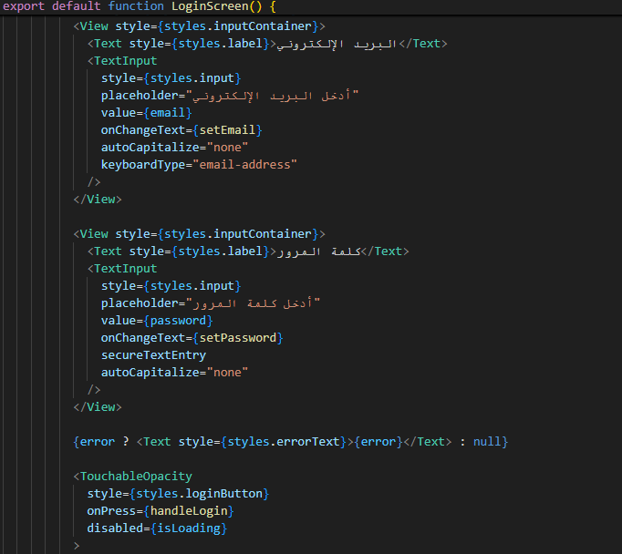

Figure 39: mobile app login page code

5.3.2 Home Screen

A . Screen

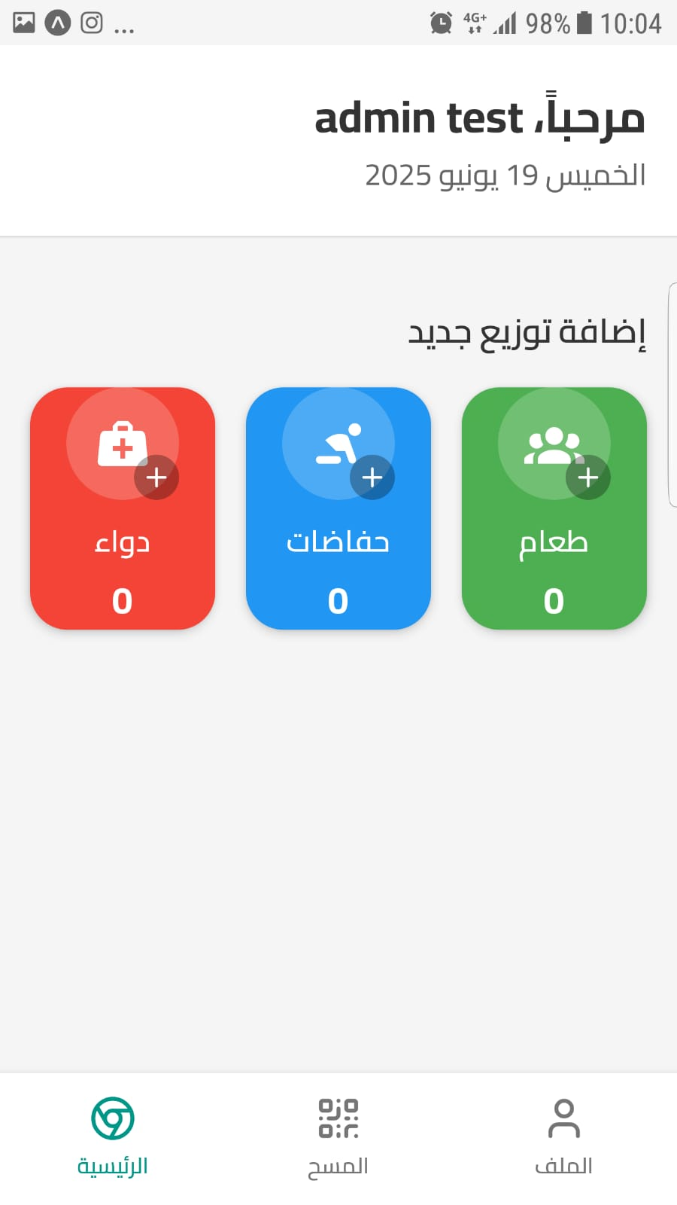

Figure 40: mobile app home page

The main dashboard screen serves as the distribution registration interface for non-registered beneficiaries within the Food and Medicine Distribution System mobile application, welcoming the logged-in administrator "admin test" with the current date displayed at the top. The core functionality centers around the (Add New Distribution) section, which features three distinct color-coded action buttons designed for immediate distribution recording - a red (Medicine) button with medical bag iconography, a blue (Diapers) button with diaper symbol, and a green (Food) button with family/group representation. Each button displays a current distribution count of "0" and includes a plus (+) symbol to indicate the add functionality, allowing field workers to instantly register aid distributions by simply clicking the appropriate category button. When users tap any of these three distribution type buttons, the system automatically captures and transmits the distribution data directly to the database, specifically recording that this particular aid type (meal, medication, or diapers) has been distributed to an unregistered beneficiary. The streamlined interface includes a bottom navigation bar with home, scan (QR code), and profile sections, ensuring efficient workflow management for association workers conducting rapid distribution registration in field environments where beneficiaries may not be pre-registered in the system.

B. Code
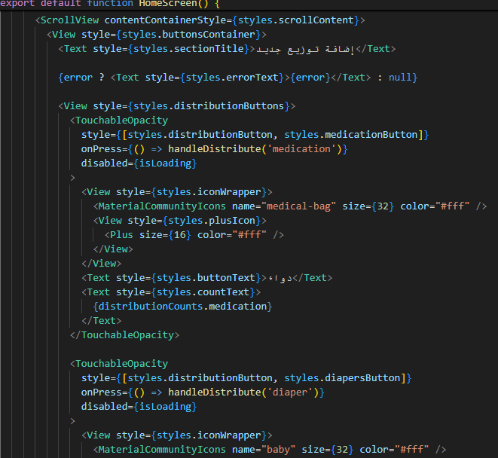

Figure 41: mobile app home page Code

5.3.3 QR code scanner

A . Screen

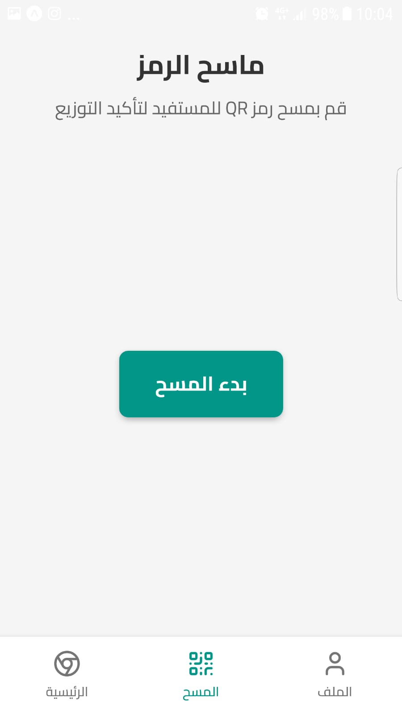

Figure 42: mobile app Scanner page
The QR code scanner screen displays the barcode scanning interface titled (Code Scanner) designed for processing registered beneficiaries within the Food and Medicine Distribution System mobile application. The interface features a clean, minimalist layout with instructional text (Scan the beneficiary's QR code to confirm distribution) that guides association workers on the scanning procedure for verifying and confirming aid distribution to pre-registered beneficiaries. The central area provides space for the camera viewfinder to capture QR codes, while a prominent green (Start Scan) button enables users to activate the scanning functionality. This screen represents the second distribution pathway in the system, specifically designed for beneficiaries who are already registered and possess QR codes for identification and distribution tracking purposes. The bottom navigation bar maintains consistency with the overall application design, featuring home , scan , and profile sections. This scanning interface allows field workers to efficiently verify registered beneficiary identities, confirm their eligibility, and record distributions directly into the database system, ensuring accurate tracking and preventing duplicate aid distribution to the same individuals during distribution operations.

B. Code

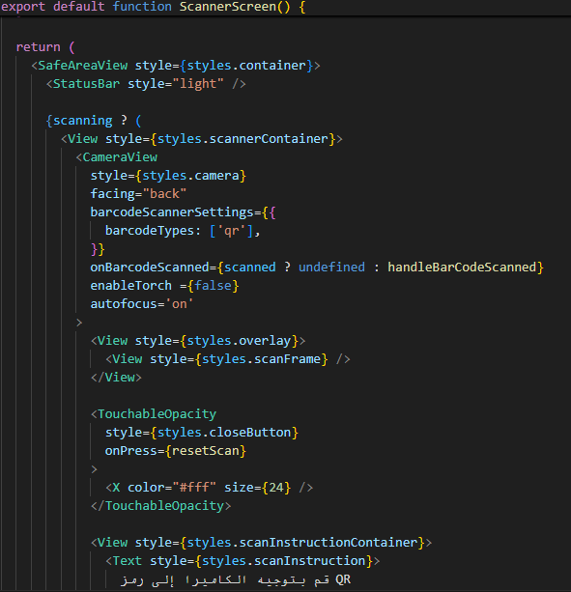

Figure 43: mobile app Scanner page Code

5.3.4 confirm distribution

A . Screen
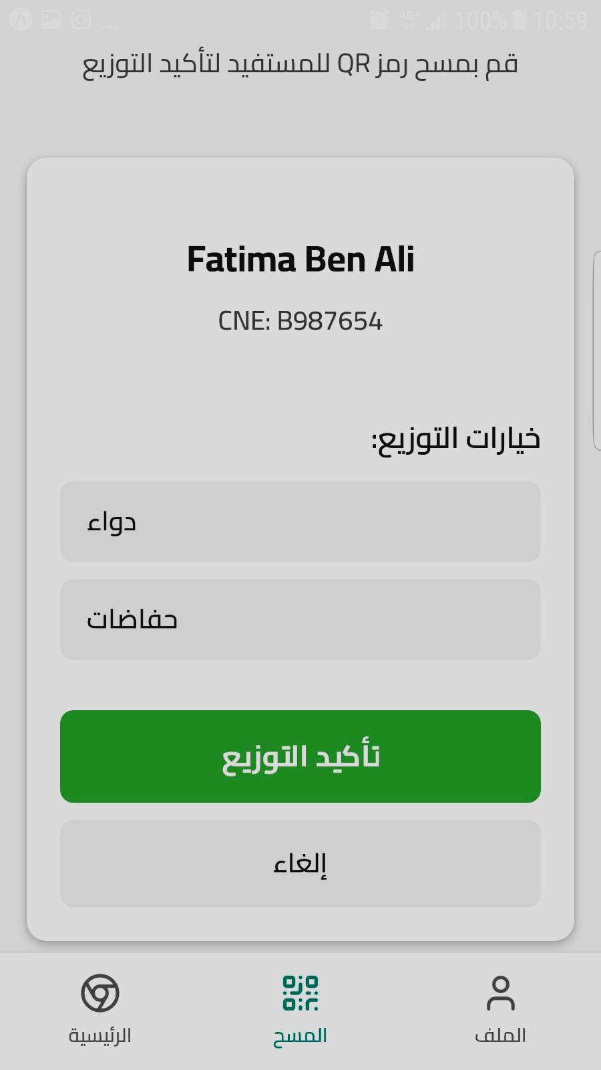

Figure 44: mobile app Confirm distribution page
The beneficiary confirmation screen displays the results of a successful QR code scan within the Food and Medicine Distribution System, showing the scanned beneficiary's information with their unique identifier prominently featured at the top of a white information card. The interface maintains the instructional header (Scan the beneficiary's QR code to confirm distribution) from the previous scanning state. The central section titled (Distribution Options:) presents three selectable aid categories arranged in a vertical list format (Medicine) and (Diapers) displayed as gray inactive buttons, indicating these distribution types are available for selection. A prominent green (Confirm Distribution) button serves as the primary action element, allowing field workers to finalize the distribution record once they have selected the appropriate aid type. At the bottom, a gray (Cancel) button provides the option to abort the current transaction. This screen enables association workers to verify the scanned beneficiary's identity, select the specific type of aid being distributed, and confirm the transaction to update the database with accurate distribution records for registered beneficiaries, ensuring proper tracking and preventing duplicate distributions during field operations

B. Code
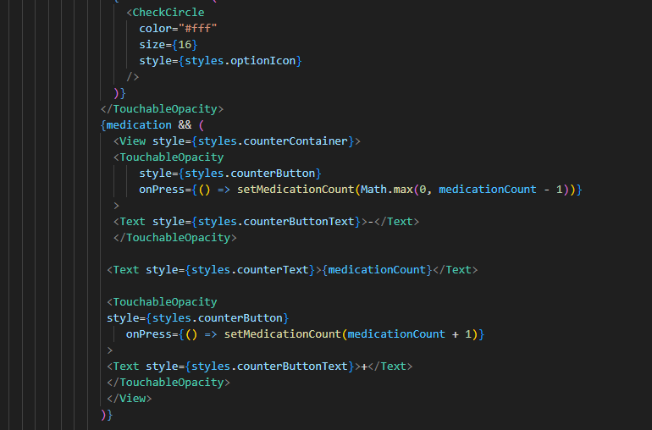
Figure 45: mobile app Confirm distribution page Code

5.4 ID card

A . Old ID card

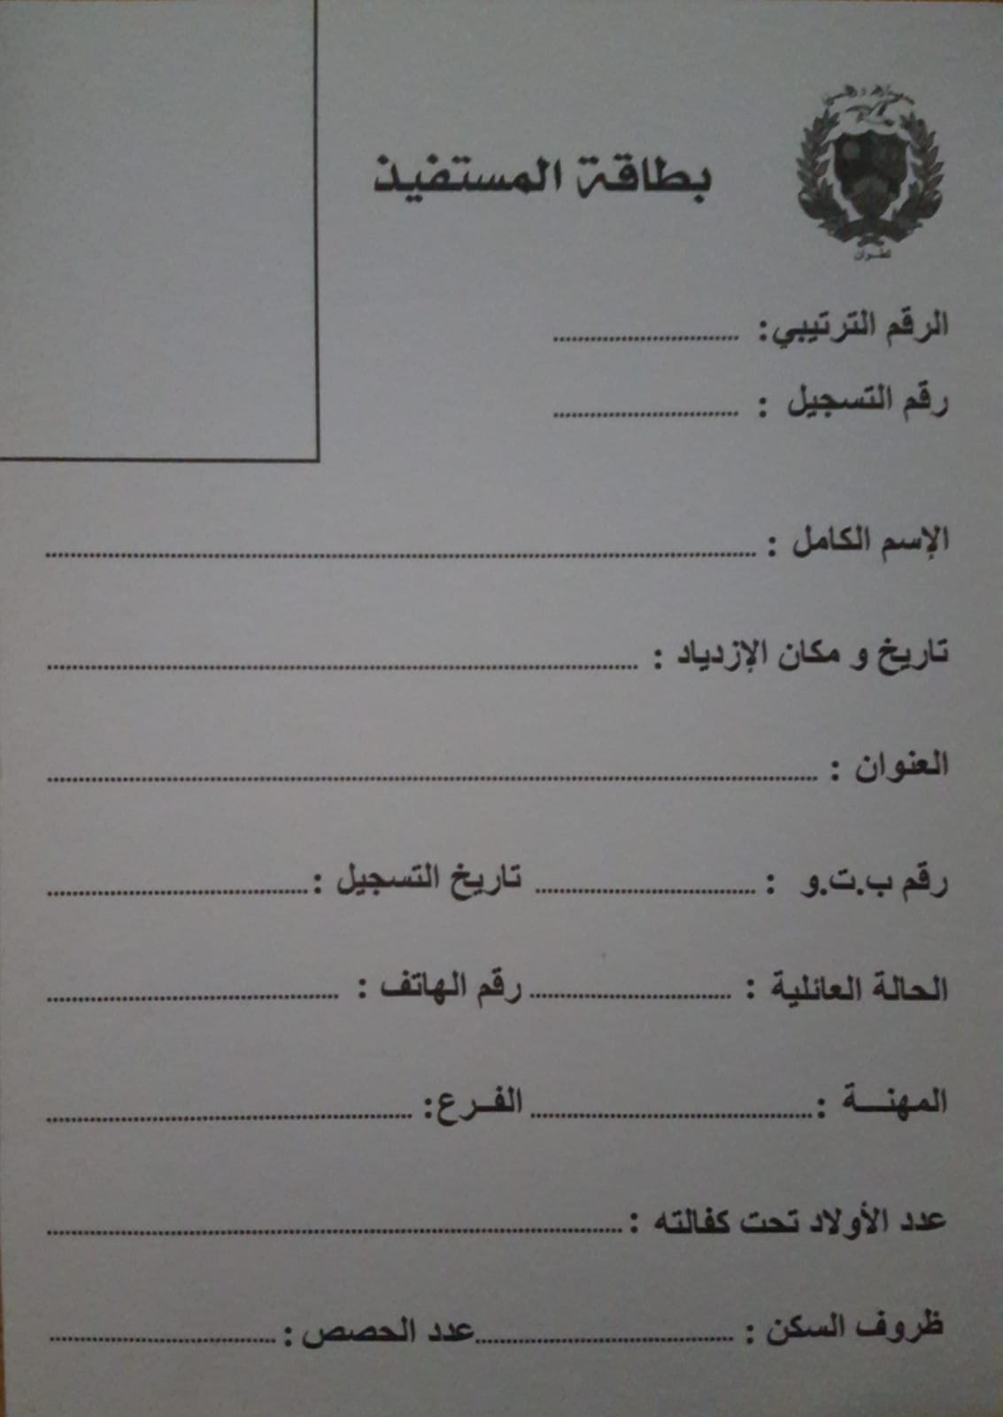

Figure 46: Old beneficiary id card

B . New ID card
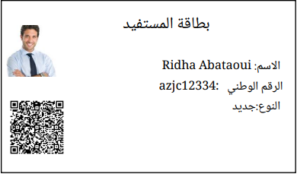
Figure 47: new beneficiary id card

5.5 conclusion
In conclusion, Chapter 4 provides a detailed overview of the interface design and development of the Meal Distribution System. By covering both the front-end and back-end components, the chapter highlights how the system ensures a smooth and efficient user experience for both administrators and field workers. The presentation of interface layouts, database structures, and key functionalities demonstrates the practical implementation of a robust and user-centered aid distribution platform

General Conclusion

The Meal Distribution System was designed to meet the growing need for organized, transparent, and efficient aid management within charitable associations such as Al-Birr wa Al-Ihsan. By replacing manual workflows with a smart digital platform, the system significantly improves the tracking, management, and equitable distribution of essential resources like food and medicine.
The solution integrates a user-friendly web dashboard for administrators and a mobile application for field workers. Key features—such as QR code-based identification, beneficiary status management, real-time tracking, and statistical reporting—enable better coordination, prevent duplication, and support data-driven decision-making.
From a technical standpoint, the project relies on a robust and scalable architecture built with Express.js, MySQL, React, and React Native. It employs JWT-based authentication to ensure security and offers a seamless user experience for all stakeholders involved.
Beyond its technical merits, the system contributes meaningfully to the social mission of the association. It promotes fair access to aid, reduces administrative burden, minimizes paper usage, and helps optimize the use of limited resources.
Future enhancements include the development of:
- A public-facing website to promote the association’s mission and encourage donations.
- A stock management system for tracking food and medicine inventory.
- New features to simplify the work of volunteers and support further scalability.
In conclusion, the Meal Distribution System lays the foundation for a smarter, more effective humanitarian aid process. With continued development, it has the potential to become a comprehensive platform for charitable organizations aiming to expand their reach and impact.

References

- Visual Studio Code (VS Code): [https://code.visualstudio.com/]
- GitHub: [https://github.com/]
- draw.io: [https://www.diagrams.net/]
- Gantt Project: [https://www.ganttproject.biz/]
- Node.js: [https://nodejs.org/]
- react.js: [https://react.dev/]
- reactNative [https://reactnative.dev/]
- GitHub: [https://github.com/]
- expo go [https://expo.dev/go]

