**Agricultural Advisor**

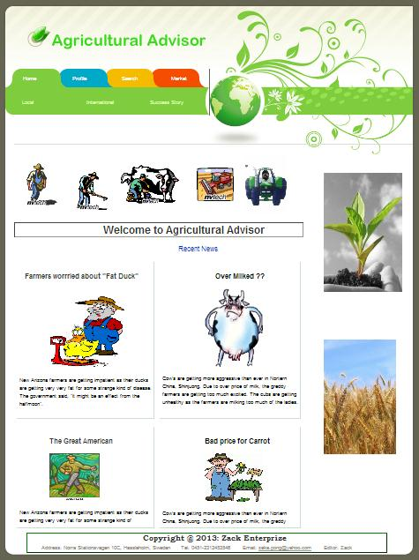

**Introduction**

“Agricultural Advisor” project started with the hopes and dreams of helping farmers to get good price on their products. While developing it, i have learnt and experienced a lot on ASP.NET programming.

**Requirement specification**

This system has 4 types of users - Farmer, Merchant, Administrator and General public. This requirement specification is based on user roles.

**Farmer:** The farmer will be able to see what the other farmers are growing, which crops are popular amongst the merchants and put his crop to sell.

**Merchant:** The merchant should be able to see which crops are popular among farmers and which farmers are willing to sell their crops soon.

**Administrator:** Administrator can be Agricultural officer or Manager people, to see an overview of everything happening in the system.

**General public**: They should be able to see the price of crops they want to buy. It is java web service.

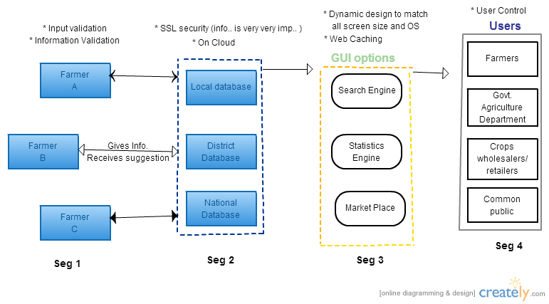System design

System implementation:

**Profile:**

I have 3 type of profile for 3 major user roles – farmer, merchant and administrator.

The farmer profile allows the farmer to search our database, see what other farmers are growing and which crops are in demand by the merchants. Also contain a news feed with latest discovery/tips in agriculture.

The merchant profile allows the merchant to see which crops are popular among farmers and which farmers are willing to sell their crops soon.

The administrators can manipulate data in the administrator page. He can also update the texts on homepage from here.

**MarketPlace:**

Market place is the place to sell and buy crops. Here the farmers can put their crops and the date they are ready to deliver. The merchants find it from this list and can buy directly. Also, the administrators can see the recent sales report in the statistics page.

**Search & Statistics:**

We have 2 kind of search. One is Google custom search which will search our site according to Googles architecture and second one search from our databases.

The statistics page allows the administrator to see and monitor over which crops are most popular, how much crop is in stock and recent transactions.

**News Feed:**

This section has some agriculture related news- Local news, International news and success stories.

Testing and results

I have done white box and black box testing.