

C# Exam
Name:
Duration: 1 h 30 min

- General Information
- What is .NET Framework? 1pt
A programming infrastructure or software framework created by Microsoft for building, deploying, and running applications and services that use .NET technologies, such as desktop applications, web Applications and Web services.

- List the .NET Framework main components. 2pt
Common Language Runtime (CLR) and .NET Framework Class Library (FCL).

- What is the difference between the compiler and just in time compiler? 2pt
Compiler is responsible for code syntax checking and to convert code to IL. JIT convert IL to machine code at runtime.

- What is the role the garbage collector? 2pt
When we run our .NET application, many objects are created. Garbage collection is a background process which deletes the objects which are not in use by the application and frees memory. “free unreferenced object [for reference type only]”

- What is the difference between an Assembly generated from VB.NET and another one generated from C#.NET? 1pt
They are the same, both are CLR/CTS languages and compiled to the same IL.

- Define an Assembly. 1pt
Compiled code generated by CLR language compiler (MSIL)

- List the Assembly content? 2pt
Manifest, Type metadata, IL code, Resources

- List the difference between a dynamic link library/exe and an Assembly. 1pt
They are the same, all are assemblies.

- What is C#.NET? 2pt
CLR/CTS compliant language, object oriented, type safe, managed code, strongly types language

- List one difference between .NET Framework 4.0 and .NET Framework 3.5? 1pt
CLR version. 4.0 And 2.0 in Framework 3.5.

- A user bought a new Game (F1 1995), install it in his machine. Then he decided to play a game already installed in his machine (FIFA 1995). The FIFA 1995 game crashes. Again he installed the FIFA 1995 game.
Suddenly the F1 1995 new game crashes.
What is this problem? 1pt
DLL Hell.
- We use a strongly named assemblies for security. 1pt
True ☐ False ☒

- Define one condition to have a domain neutral assembly. 2pt
we must sign the assembly.
- A Web Application references a signed assembly. We put that assembly in the bin directory. After testing our application, we concluded that we have a bug in a method in that signed assembly. The developer fixed the method and then he replaced the dll in the bin directory. But the same problem remains.
Help this developer to troubleshoot this weird problem! 4pt
He must check the GAC, it’s a signed assembly so the CLR look for the DLL in the GAC than in the bin folder, so we have a version registered in the GAC.
- What is a Process? 1pt
Provides the resources needed to execute a program. (Windows construct not .NET construct).

- What is an Application Domain? 1pt
NET construct that provides a layer of isolation between loaded sets of assemblies within a process. Application domains provide an isolation boundary for security, reliability, and versioning, and for unloading assemblies.

- What is a Value Type? 1pt
A data type is a value type if it holds the data within its own memory allocation.

- What is the difference between String and string? 1pt
string is an alias to String.
- What represent String to System.String? 2pt
String is the primitive type to System.String, so basically they are the same.
- String is a reference type. 1pt
True ☒ False ☐
- Define the term Boxing. 1pt
When the data moves from value types to reference types.

- What is the difference between const and readonly? 4pt
const:
  - Complied time, the IL is directly the value, variable don’t exists in the IL.
  - Cannot assign a method to it.
  - Once assigned cannot be changed.
  - Must be assigned once it’s declared.
  - Can be written as global or in a method body.
readonly:
- runtime.
- Can assign a method to it.
- Cannot change the value once it’s assigned.
- Cannot be declared in a method body.
- Can be declared without assignment but we need to assign it at most in the ctor.

- Casting is an Implicit Conversion. 1pt
True ☐ False ☒
- We cannot change the value of a reference type object from a method. 1pt
True ☐ False ☒
- We can write a property directly within a namespace. 1pt
True ☐ False ☒
- We can write a delegate directly within a namespace. 1pt
True ☒ False ☐
- We can write an interface directly within a namespace. 1pt
True ☒ False ☐
- A namespace can contains another namespace. 1pt
True ☒ False ☐
- Default access modifier for a class in a namespace is private. 1pt
True ☐ False ☒
- Default access modifier for an interface is public. 1pt
True ☐ False ☒
- Default access modifier for a property is internal. 1pt
True ☐ False ☒
- A sealed class can inherit another class. 1pt
True ☒ False ☐
- A class marked as abstract must have at least one abstract method. 1pt
True ☐ False ☒
- A class marked as partial cannot be inherited. 1pt
True ☐ False ☒
- Methods within an interface must have an access modifier. 1pt
True ☐ False ☒
- A class with a private constructor only, can be initiated using the new keyword. 1pt
True ☐ False ☒
- A class marked as static can contain a non-static method or property. 1pt
True ☐ False ☒
- We can always override a method. 1pt
True ☐ False ☒
- Struct supports inheritance. 1pt
True ☐ False ☒
- Struct member can have protected access modifier. 1pt
True ☐ False ☒
- What is a Delegate? 2pt
it’s a reference type, it’s a pointer to a method. We have multicast delegates and unicast, basically they are all a multicast.
- There is a ThreadPool per AppDomain. 1pt
True ☐ False ☒
- Invoke method in a delegate make the call as Async. 1pt
True ☐ False ☒
- Generics are used for runtime execution performance boost. 1pt
True ☐ False ☒
- List the Generic constraint types: 1pt
Value/Reference Type, derivation, default Ctor.
- The compiler lets you explicitly cast generic type parameters to any class. 1pt
True ☐ False ☒
- What advantages offer Async/Await keywords on other threading options? 5pt
With Async/Await so Microsoft introduce a state machine code. So when writing to HDD, why waiting the write operation? So it’s a “device” dependent. Async/Await advantage is the release the thread until it’s finish, then it took again the thread from the thread pool to finish the execution.
- What is an exception bubbling? 4pt
methods are pushed to a stack, so when an exception is raised from a child method it bubble to the called method, so we put a try catch only in the method not all childs.
- Can we create a new instance of class with only a static constructor? 1pt
True ☒ False ☐
- What a Singleton design pattern is used for? 2pt
When we need to make sure that a one instance of that object exists in the memory.
So when we can an object used application wise, or the creation of it is heavy, we use singleton design pattern. (advantage on static class, it can be inherited)
- Exercises
- Is the following class have the right naming convention? In case of “False” please correct 4pt it.
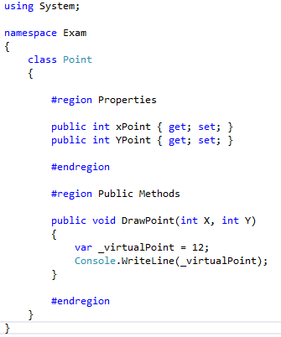
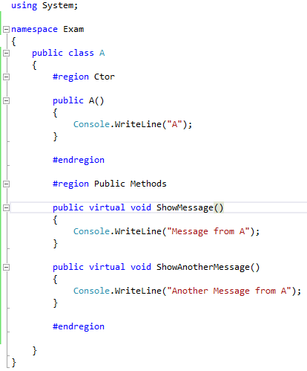
- Considering the following Class A, B and C, what is the output of below console application? 14pt

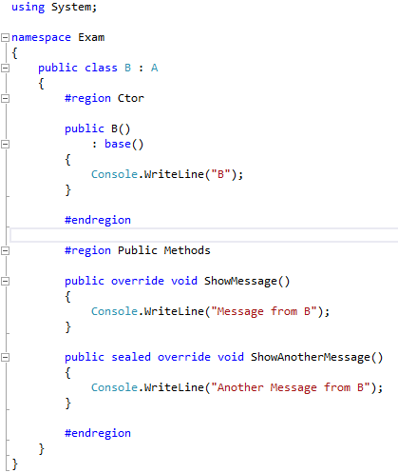
Figure 1-Class A
Figure 2-Class B
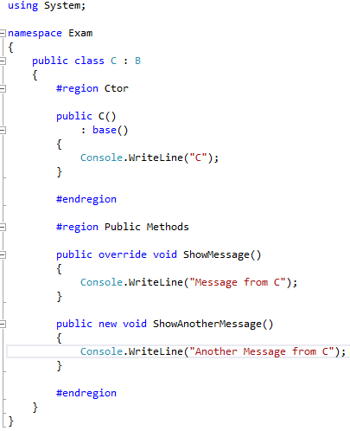
Figure 3-Console Application

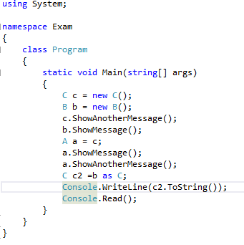
Figure 4-Class C

- What is the output of below program: 5pt
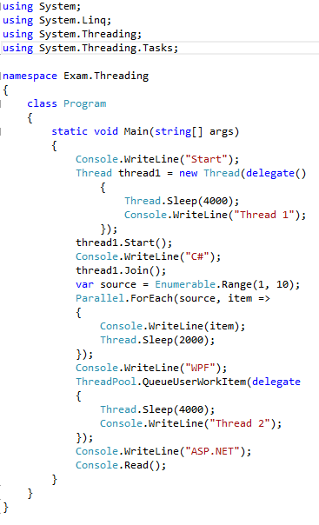
- What is the output of below program: 4pt
