a) a picture of the molecule using GaussView, including the atom numbering used in the Gaussian calculation

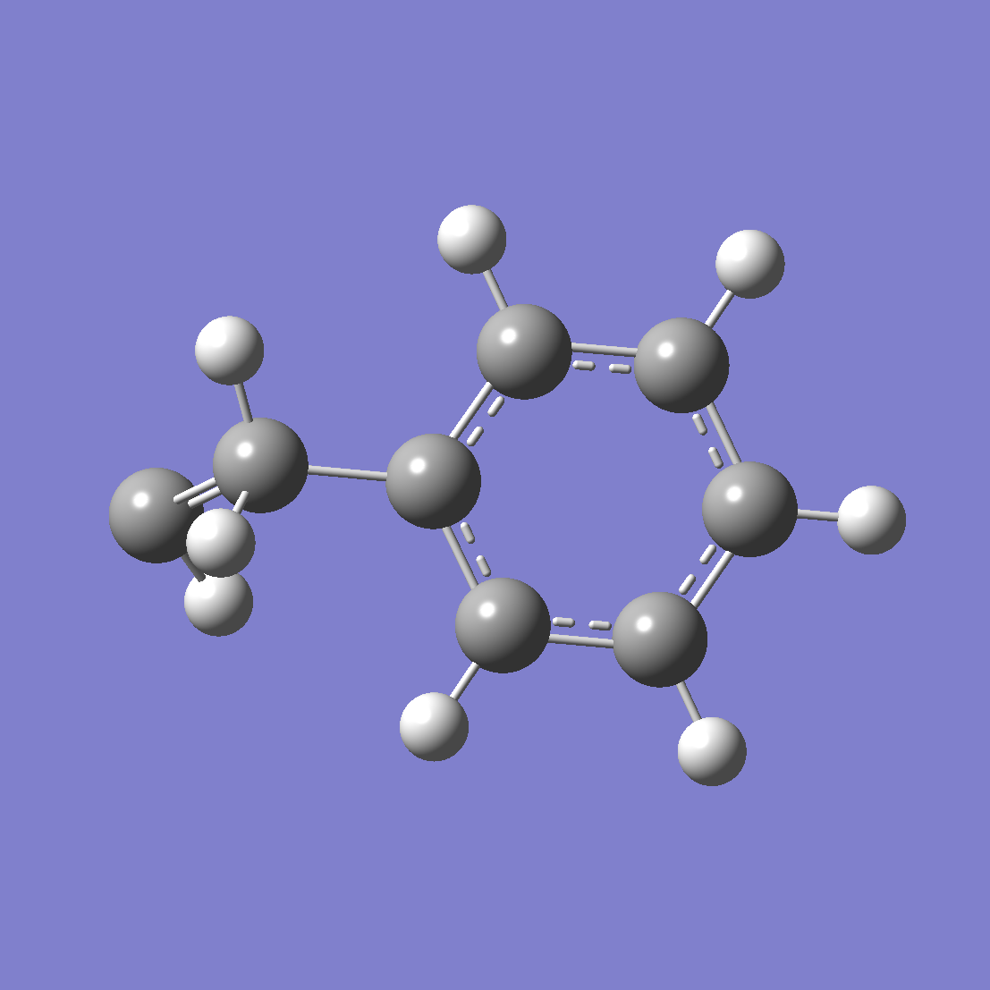
styrene.png
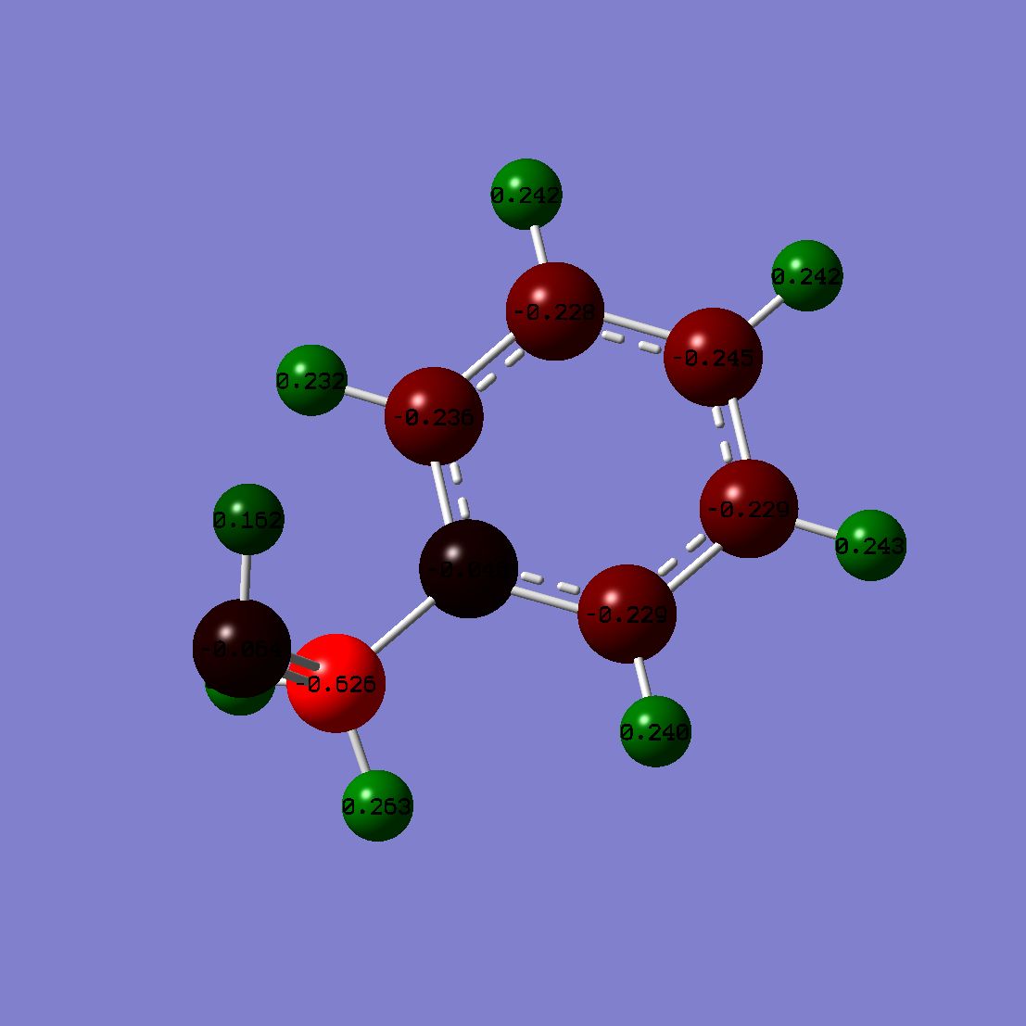
styrene_charge.png

(b) the archive entry from the end of the Gaussian output (so that I can see the details of your calculation) and the total energy (6 decimal places)

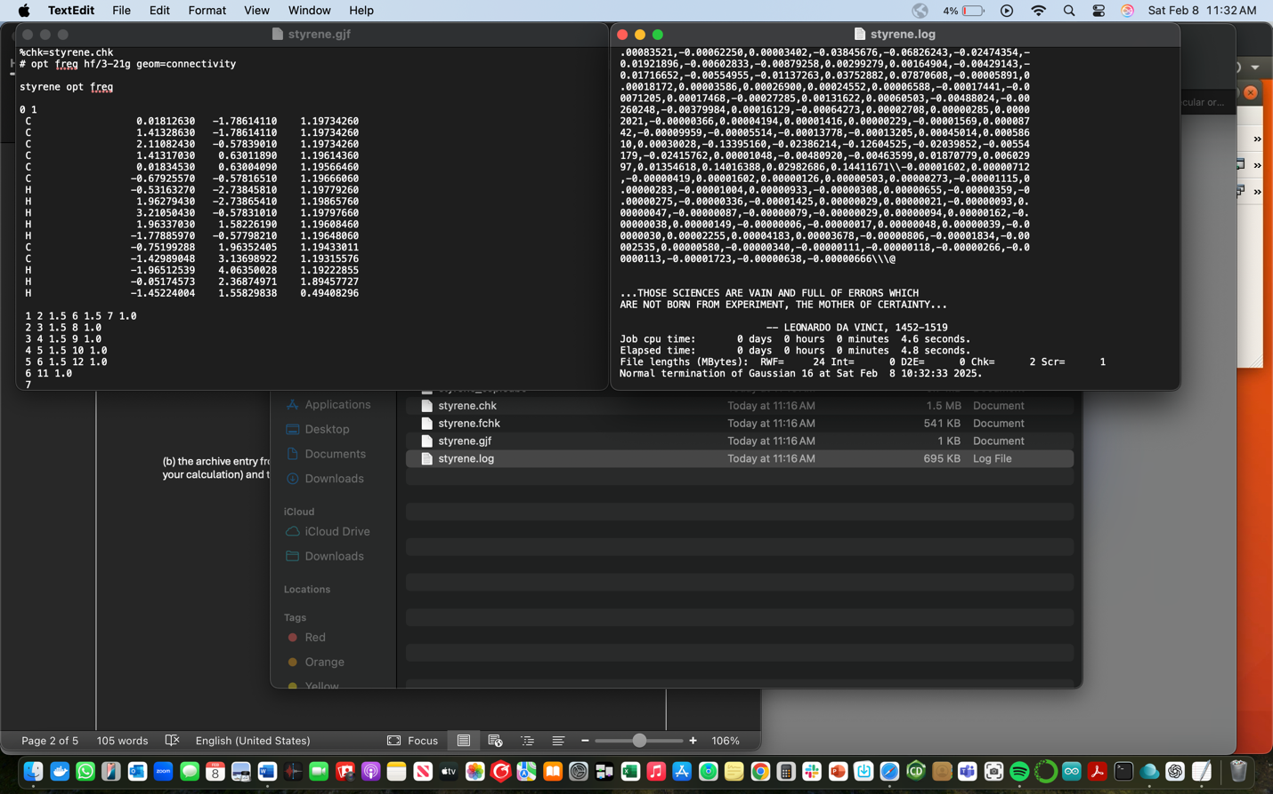
styrene_results_log.png
(c) a picture of the highest occupied molecular orbital and its orbital energy
(d) a picture of the lowest unoccupied molecular orbital and its orbital energy

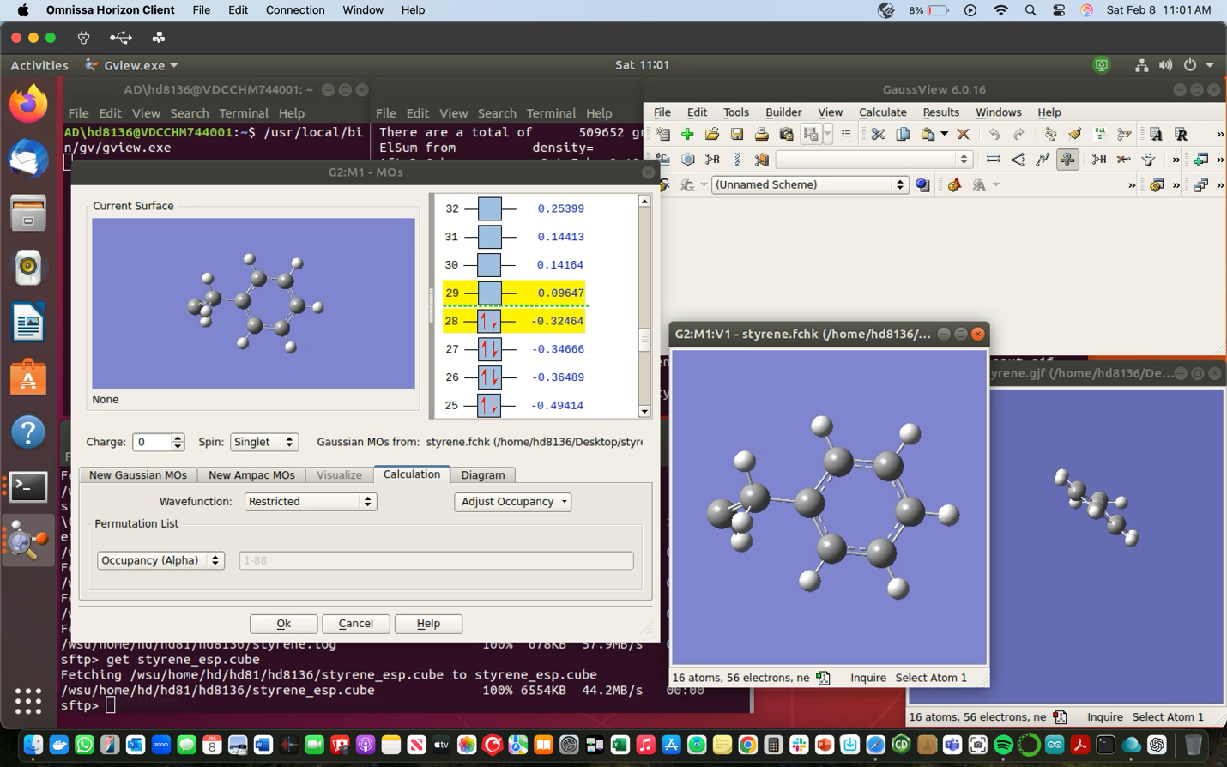
styrene_homolumo.png
(e) a list of the Mulliken charges (2 decimal places, atom numbers) and the dipole moment.

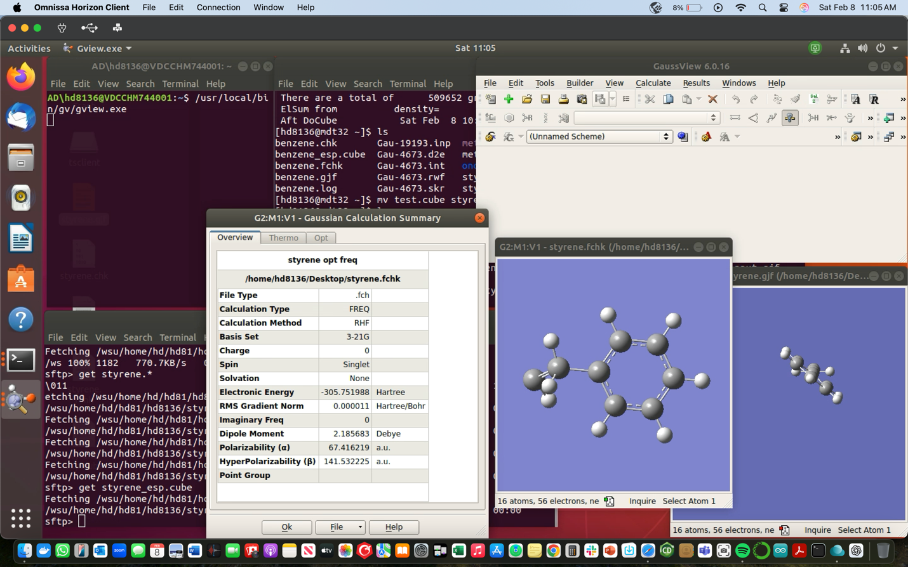
styrene_dipole_moment.png
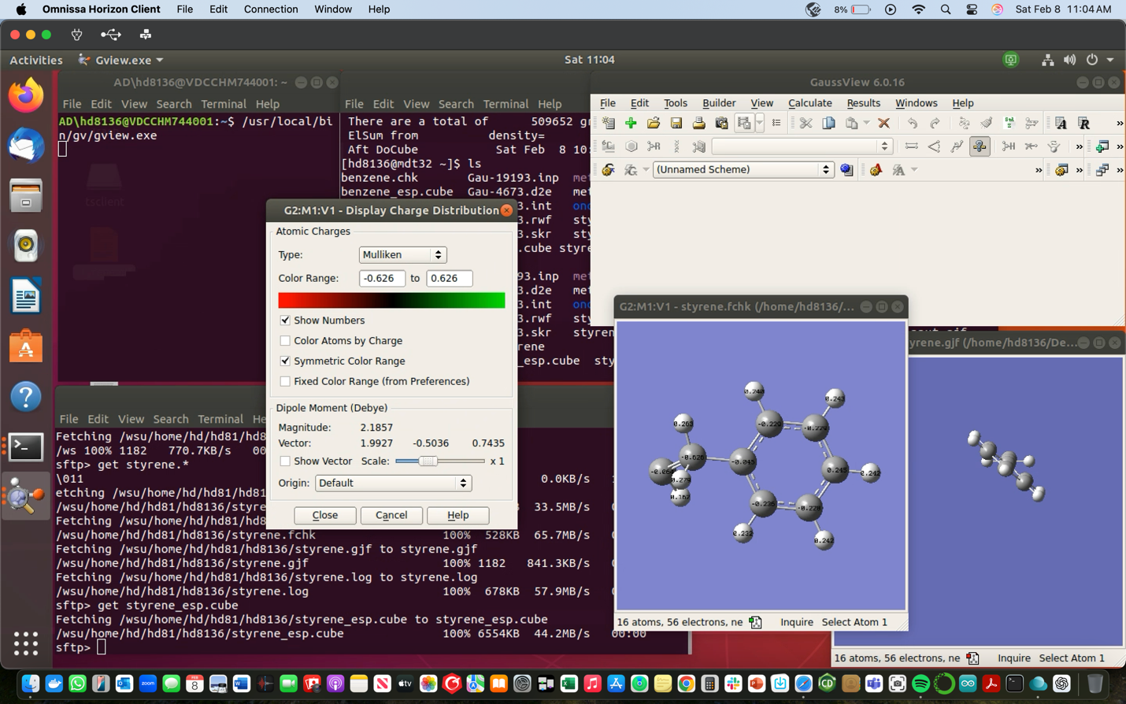
styrene_mulliken_charges.png
Not sure if needed but the electrostatic potential mapped on the density surface:
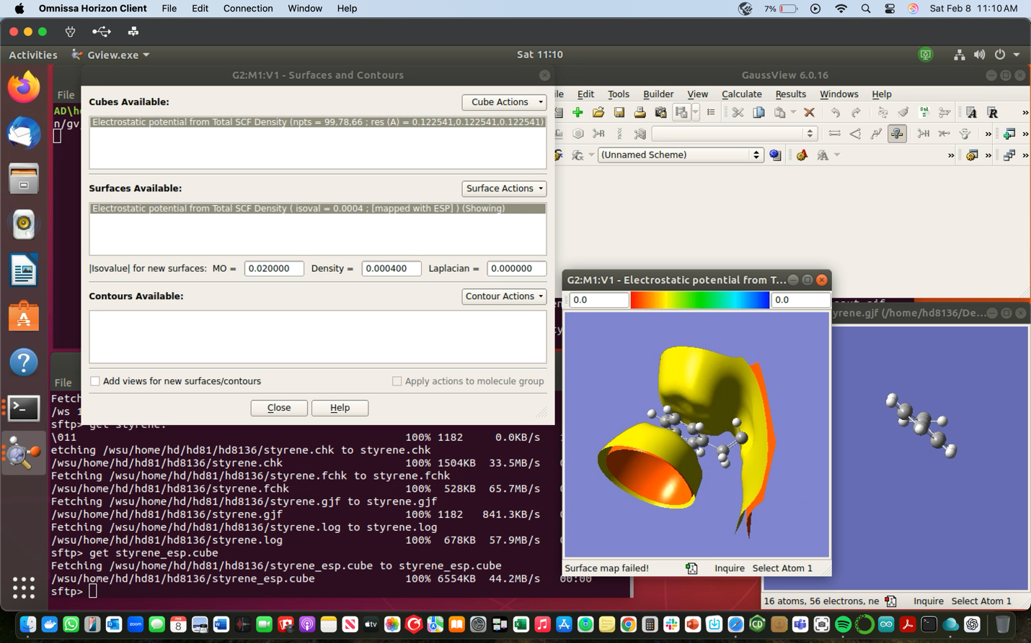
styrene_electrostaticV.png

