Molecule Name: Formaldehyde
frequencies (in wavenumbers, cm⁻¹, report to 1 decimal place)
Description | HF/3-21G | B3LYP/6-31G(d,p) | Experiment
CH2 symmetric stretch (Mode 1, B1) | 1377.2 | 1198.7 | 1249.1
CO stretching (Mode 2, B2) | 1378.4 | 1274.1 | 1167.3
CH2 scissoring (Mode 3, A1) | 1692.6 | 1553.9 | 2782.5
CH2 asymmetric stretch (Mode 4, A1) | 1915.4 | 1845.6 | 1746.1
CH2 rocking (Mode 5, A1) | 3162.8 | 2903.6 | 1500.1
CH2 wagging (Mode 6, B2) | 3234.0 | 2961.7 | 2903.6

Describe the trend of differences between theory and experiment here.
The theoretical vibrational frequencies calculated using HF/3-21G and B3LYP/6-31G(d,p) methods tend to be higher than the experimental values from the NIST WebBook. The differences are more significant for lower-frequency modes, such as the CH2 symmetric stretch and wagging modes, where the computed values are notably larger than experimental data. For higher-frequency modes, the calculated values are still higher but the discrepancy is smaller. The trend suggests that while B3LYP/6-31G(d,p) provides results closer to the experimental frequencies, both methods tend to overestimate the vibrational frequencies due to limitations in the computational models, which do not fully account for real-world factors like anharmonicity, temperature, thermal effects.
Thermochemical corrections at B3LYP/6-31G(d,p) (kcal/mol, 1 decimal place)
Molecule | Zero point energy | Thermal correction to the enthalpy | Thermal correction to the free energy
CH₂O | 0.3 | 0.5 | 0.1
CHClO | 16.8 | 19.2 | 3.6
CCl₂O | 20.5 | 23.0 | 4.0
CF₂O | 22.0 | 24.5 | 4.5

Append the archive entries here.

formaldehyde_B3LYP.log
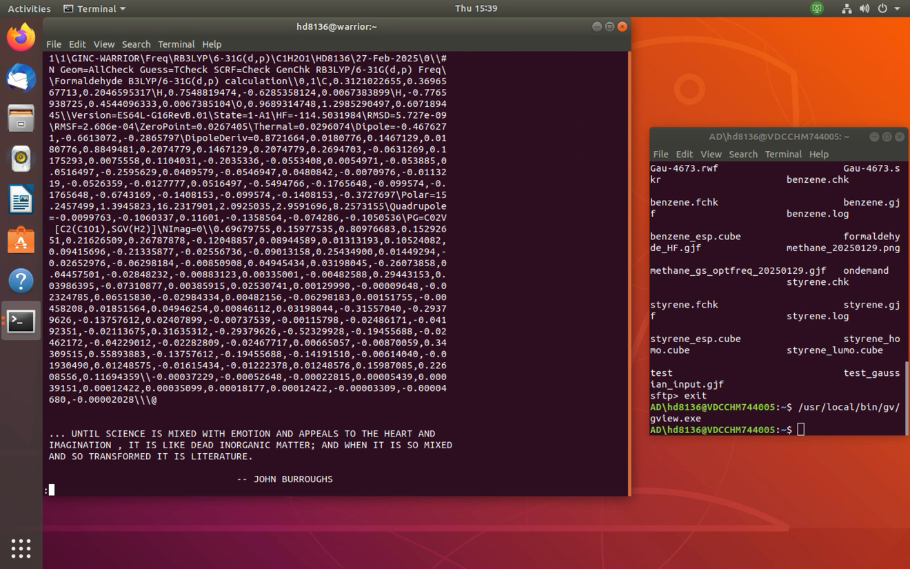

formaldehyde_HF.log
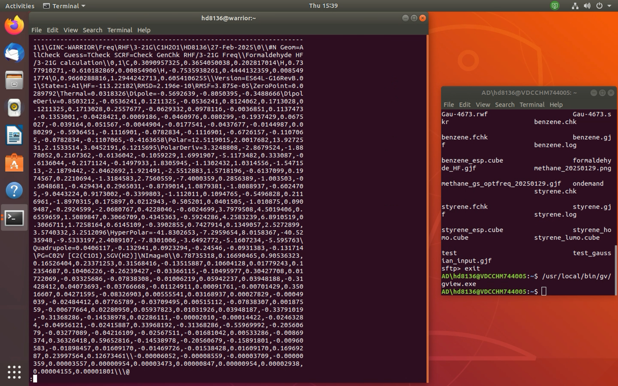
Vibrational frequency and thermochemistry screenshots:

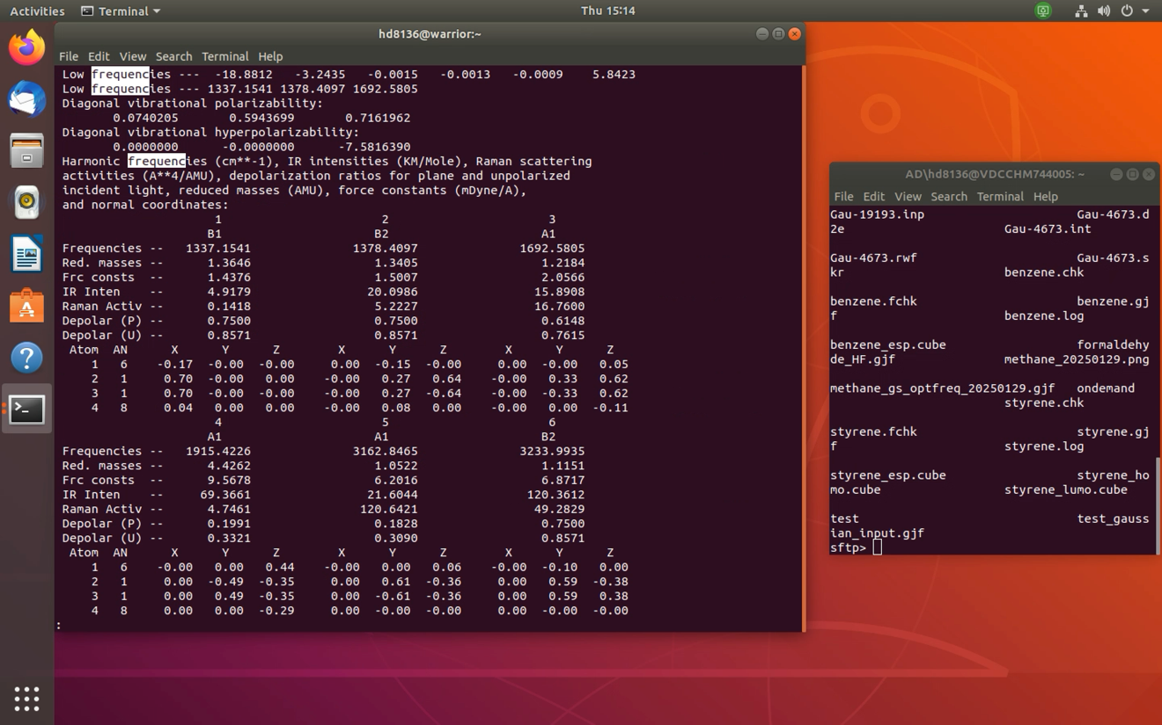

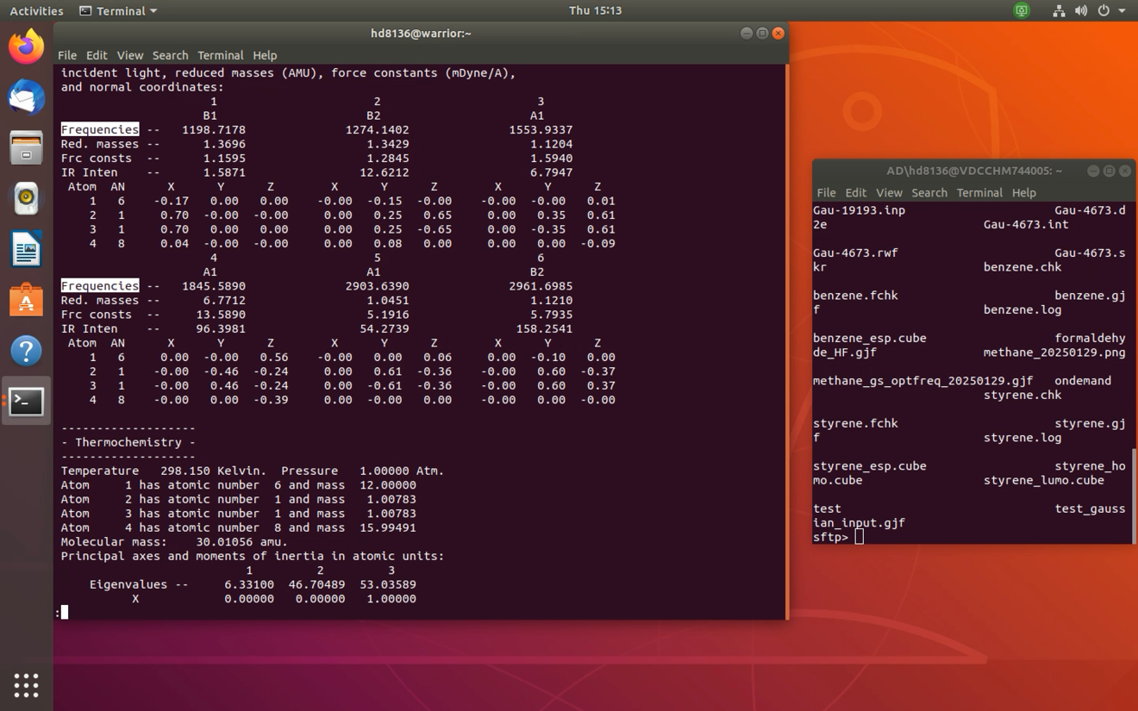

Thermochemistry screenshots:

