From EPLAN Schematic to TwinCAT Project
Complete Beckhoff/TwinCAT control implementation of the Jenoptik "Funktionsmuster LCLW" machine
Sources: EPLAN electrical schematic (90 pages) + Festo pneumatic circuit diagram
Platform: TwinCAT XAE Shell (64-bit), simulation only — no physical hardware
Student: Ahmed Zakaria Benadda Date: 27/10/2026

Lemsi Adams Favour

1. Introduction
This project rebuilds the complete control system of a Jenoptik machine prototype ("LCLW") as a TwinCAT 3 project, based on two original source documents: a 90-page EPLAN electrical schematic and a Festo pneumatic circuit diagram covering the same machine. Together they describe a conveyor-based part-handling machine that detects, clamps, inspects, and sorts parts along an infeed-to-outfeed line, with a central safety interlock and two reject paths.
All nine mechanical stations documented across both drawings have been implemented, chained into a single working process sequence, and verified by forcing I/O values live in TwinCAT with no physical hardware connected.

2. Hardware Architecture
Every control device identified across both drawings is a Beckhoff EtherCAT component:
Device | Function | Eplan Designation
C6015 | Embedded IPC — EtherCAT master, runs TwinCAT | +MP-4A1
CU1128 | 8-port EtherCAT switch | +MP-5K1
EK1100 (x2) | EtherCAT coupler — cabinet / CW-laser controller | +MP-6K1 / +LS-7K1
EL1809 (x2) | 16-channel digital input terminal | +MP-6K10 / +LS-7K10
EL2809 (x2) | 16-channel digital output terminal | +MP-6K20 / +LS-7K20
EP1018-0001 (x3) | IP67 remote input box, 8DI — field-mounted | +MS-9K1 / 9K2 / 9K3
EP2028-0001 (x2) | IP67 remote output box, 8DO — field-mounted | +MS-10K1 / 10K2
AX5206 | 2-axis servo drive, 400 V | +MP-11T1
AM8033 (x2) | Servo motors | +MS-11M1 / 11M2
The pneumatic drawing adds Festo valve-terminal and cylinder part numbers (VUVG series valves, ADN-series cylinders, SMC CUJ4-6 for the ejector) but introduces no new electrical signals — every cylinder it shows is driven by the digital outputs already present in the EPLAN schematic.

3. Machine Process Overview
The nine stations, in process order, with the two outcomes after the sorting decision:
Einlauf | → | Zylinder Einlauf | → | Spanner (clamp) | → | Weiche (decision) | →

 | ↗ NIO | Auswerfer | → | Ausblasen (1s pulse)
 | ↘ OK | Zylinder Auslauf | → | Auslauf (confirmed)

Auswurf Bypass is a tenth, standalone station — no sensor or signal in either drawing defines what triggers it, so it is implemented independently with its own placeholder trigger (see Section 6.3).

4. TwinCAT Project Structure

4.1 EtherCAT Device Tree
I/O
└─ Devices
└─ EtherCAT_Master
├─ EK1100_6K1
│ ├─ Term 2 (EL1809) — cabinet digital inputs
│ └─ Term 3 (EL2809) — cabinet digital outputs
├─ EP1018_9K1 / 9K2 / 9K3 — field input boxes
├─ EP2028_10K1 / 10K2 — field output boxes
├─ AX5206_11T1 — servo drive (2 axes, NC config)
└─ EK1100_7K1
├─ EL1809_7K10 — CW/laser controller inputs
└─ EL2809_7K20 — CW/laser controller outputs
All devices set Disabled = Yes — no physical hardware connected (pure simulation).

4.2 Complete I/O Variable List

Safety
Variable | Tag | Description
xNotHalt_Betaetigt | E0.1 | Emergency stop active
xLaserEnable | A0.1 | LaserEnable output

Einlauf (infeed)
Variable | Tag | Description
xLichtschranke_Einlauf | E1052.0 | Infeed photoelectric sensor
xServo_Einlauf_Eingerastet | E1052.1 | Infeed servo engaged (sensor)
xServo_Einlauf_AS | E1052.2 | Infeed servo working position
xServo_Einlauf_GS | E1052.3 | Infeed servo home position
xEinlaufBereit | — | Calculated: part ready (latch)

Zylinder Einlauf
Variable | Tag | Description
xZylinderEinlaufAS / GS | E1051.0 / .1 | Infeed cylinder position feedback
xVentilEinlaufAS / GS | A1051.0 / .1 | Infeed cylinder valve control
xZylinderEinlaufBereit | — | Calculated: cylinder confirmed in position

Spanner (clamp)
Variable | Tag | Description
xZylinderSpannerAS / GS | E1050.2 / .3 | Clamp cylinder position feedback
xVentilSpannerAS / GS | A1050.2 / .3 | Clamp valve control
xSpannerBereit | — | Calculated: clamp confirmed closed

Weiche (diverter) and sorting decision
Variable | Tag | Description
xPartOK | — | PLACEHOLDER: external quality decision (not present in either drawing)
xZylinderWeicheAS / GS | E1050.4 / .5 | Diverter cylinder position feedback
xVentilWeicheAS / GS | A1050.4 / .5 | Diverter valve control
xWeicheRejectBereit | — | Calculated: diverter confirmed reject position
xWeicheAcceptBereit | — | Calculated: diverter confirmed accept position

Auswerfer (ejector) + Ausblasen (blow-off) — reject path
Variable | Tag | Description
xZylinderAuswerferAS / GS | E1050.0 / .1 | Ejector cylinder position feedback
xVentilAuswerferAS / GS | A1050.0 / .1 | Ejector valve control
xAuswerferBereit | — | Calculated: ejector confirmed extended
xVentilAusblasenAS / GS | A1051.4 / .5 | Blow-off valve control (no feedback sensor)

Zylinder Auslauf + Auslauf — accept path
Variable | Tag | Description
xZylinderAuslaufAS / GS | E1051.2 / .3 | Outfeed cylinder position feedback
xVentilAuslaufAS / GS | A1051.2 / .3 | Outfeed cylinder valve control
xZylinderAuslaufBereit | — | Calculated: outfeed cylinder confirmed
xLichtschranke_Auslauf | E1052.4 | Outfeed photoelectric sensor
xServo_Auslauf_Eingerastet | E1052.5 | Outfeed servo engaged (sensor)
xServo_Auslauf_AS | E1052.6 | Outfeed servo working position
xServo_Auslauf_GS | E1052.7 | Outfeed servo home position
xAuslaufBereit | — | Calculated: part confirmed exited

Auswurf Bypass — standalone
Variable | Tag | Description
xBypassTrigger | — | PLACEHOLDER: no defining condition in either drawing
xVentilAuswurfBypassAS / GS | A1051.6 / .7 | Bypass valve control

5. PLC Software Architecture
One Function Block per mechanical station, mirroring the one-page-per-station structure of the EPLAN drawing itself. Each FB reads/writes the shared GVL_IO variable list and is called once per cycle from MAIN, in physical process order.

5.1 MAIN
PROGRAM MAIN
VAR
fbEinlauf : FB_Einlauf;
fbZylinderEinlauf : FB_ZylinderEinlauf;
fbSpanner : FB_Spanner;
fbWeiche : FB_Weiche;
fbAuswerfer : FB_Auswerfer;
fbAusblasen : FB_Ausblasen;
fbZylinderAuslauf : FB_ZylinderAuslauf;
fbAuslauf : FB_Auslauf;
fbAuswurfBypass : FB_AuswurfBypass;
END_VAR

GVL_IO.xLaserEnable := NOT GVL_IO.xNotHalt_Betaetigt;
fbEinlauf();
fbZylinderEinlauf();
fbSpanner();
fbWeiche();
fbAuswerfer();
fbAusblasen();
fbZylinderAuslauf();
fbAuslauf();
fbAuswurfBypass();

5.2 FB_Einlauf — infeed detection (SET/RESET latch)
IF GVL_IO.xLichtschranke_Einlauf AND GVL_IO.xServo_Einlauf_GS THEN
GVL_IO.xEinlaufBereit := TRUE;
ELSIF NOT GVL_IO.xLichtschranke_Einlauf THEN
GVL_IO.xEinlaufBereit := FALSE;
END_IF

5.3 FB_ZylinderEinlauf
GVL_IO.xVentilEinlaufAS := GVL_IO.xEinlaufBereit;
GVL_IO.xVentilEinlaufGS := NOT GVL_IO.xEinlaufBereit;
GVL_IO.xZylinderEinlaufBereit := GVL_IO.xZylinderEinlaufAS;

5.4 FB_Spanner
GVL_IO.xVentilSpannerAS := GVL_IO.xZylinderEinlaufBereit;
GVL_IO.xVentilSpannerGS := NOT GVL_IO.xZylinderEinlaufBereit;
GVL_IO.xSpannerBereit := GVL_IO.xZylinderSpannerAS;

5.5 FB_Weiche — sorting decision
GVL_IO.xVentilWeicheAS := GVL_IO.xSpannerBereit AND NOT GVL_IO.xPartOK;
GVL_IO.xVentilWeicheGS := GVL_IO.xSpannerBereit AND GVL_IO.xPartOK;

GVL_IO.xWeicheRejectBereit := GVL_IO.xZylinderWeicheAS;
GVL_IO.xWeicheAcceptBereit := GVL_IO.xZylinderWeicheGS;

5.6 FB_Auswerfer
GVL_IO.xVentilAuswerferAS := GVL_IO.xWeicheRejectBereit;
GVL_IO.xVentilAuswerferGS := NOT GVL_IO.xWeicheRejectBereit;
GVL_IO.xAuswerferBereit := GVL_IO.xZylinderAuswerferAS;

5.7 FB_Ausblasen — first timer (TON)
// Declaration:
tonBlow : TON;

// Implementation:
tonBlow(IN := GVL_IO.xAuswerferBereit, PT := T#1S);
GVL_IO.xVentilAusblasenAS := GVL_IO.xAuswerferBereit AND NOT tonBlow.Q;
GVL_IO.xVentilAusblasenGS := NOT GVL_IO.xVentilAusblasenAS;
TON (Timer On-delay): IN starts the countdown; once PT (here 1 second) elapses while IN stays TRUE, output Q becomes TRUE. Here, Q flipping TRUE is what cuts the blow valve back off automatically, one second after the ejector confirms — no further input needed.

5.8 FB_ZylinderAuslauf
GVL_IO.xVentilAuslaufAS := GVL_IO.xWeicheAcceptBereit;
GVL_IO.xVentilAuslaufGS := NOT GVL_IO.xWeicheAcceptBereit;
GVL_IO.xZylinderAuslaufBereit := GVL_IO.xZylinderAuslaufAS;

5.9 FB_Auslauf
IF GVL_IO.xLichtschranke_Auslauf AND GVL_IO.xServo_Auslauf_GS THEN
GVL_IO.xAuslaufBereit := TRUE;
ELSIF NOT GVL_IO.xLichtschranke_Auslauf THEN
GVL_IO.xAuslaufBereit := FALSE;
END_IF

5.10 FB_AuswurfBypass
// Declaration:
tonBypass : TON;

// Implementation:
tonBypass(IN := GVL_IO.xBypassTrigger, PT := T#1S);
GVL_IO.xVentilAuswurfBypassAS := GVL_IO.xBypassTrigger AND NOT tonBypass.Q;
GVL_IO.xVentilAuswurfBypassGS := NOT GVL_IO.xVentilAuswurfBypassAS;

6. Design Notes

6.1 SET/RESET latch pattern
Used in FB_Einlauf and FB_Auslauf: a condition sets a flag TRUE and it holds even as other inputs change, mirroring a part physically staying detected as it moves further into the machine — only clearing once the relevant light curtain goes clear again.

6.2 Feedback-gated chaining
Every actuator station both drives its valve from the upstream condition AND separately reports its own confirmed position back as a *Bereit ("ready") flag, calculated from its own position sensor — never from the command it was just given. This means each next station only fires once the previous one has physically confirmed arrival, not merely been commanded — the same principle a real safety-rated sequence would require.

6.3 Two placeholder variables
xPartOK and xBypassTrigger represent decisions neither source drawing defines (a quality/vision check, and whatever condition sends a part to bypass reject). Both are implemented as plain forced variables, clearly commented, standing in for signals that would come from equipment outside the scope of these two drawings.

7. Safety Interlock
GVL_IO.xLaserEnable := NOT GVL_IO.xNotHalt_Betaetigt;
In the real machine this runs through a certified hardware safety relay, not PLC logic alone — this line models the intent for simulation purposes only.

8. Testing and Verification
All testing was performed with no physical hardware connected, by forcing GVL_IO variables live through TwinCAT's online Watch/Force interface and observing dependent outputs update once per PLC cycle.
Chain tested | Result
Not-Halt pressed / released → LaserEnable | Pass
Infeed sensors → Einlauf latch → cylinder command | Pass
Latch holds after GS clears, resets after Lichtschranke clears | Pass
Cylinder confirms → clamp commanded → clamp confirms | Pass
xPartOK = TRUE → Weiche accept path commanded | Pass
xPartOK = FALSE → Weiche reject path commanded | Pass
Diverter confirms reject → Auswerfer commanded → confirms → Ausblasen fires | Pass
Ausblasen auto-cuts off after 1s via TON | Pass
Diverter confirms accept → Zylinder Auslauf commanded → confirms | Pass
Outfeed sensors confirm part fully exited (xAuslaufBereit) | Pass
Auswurf Bypass fires on trigger, auto-cuts off after 1s | Pass
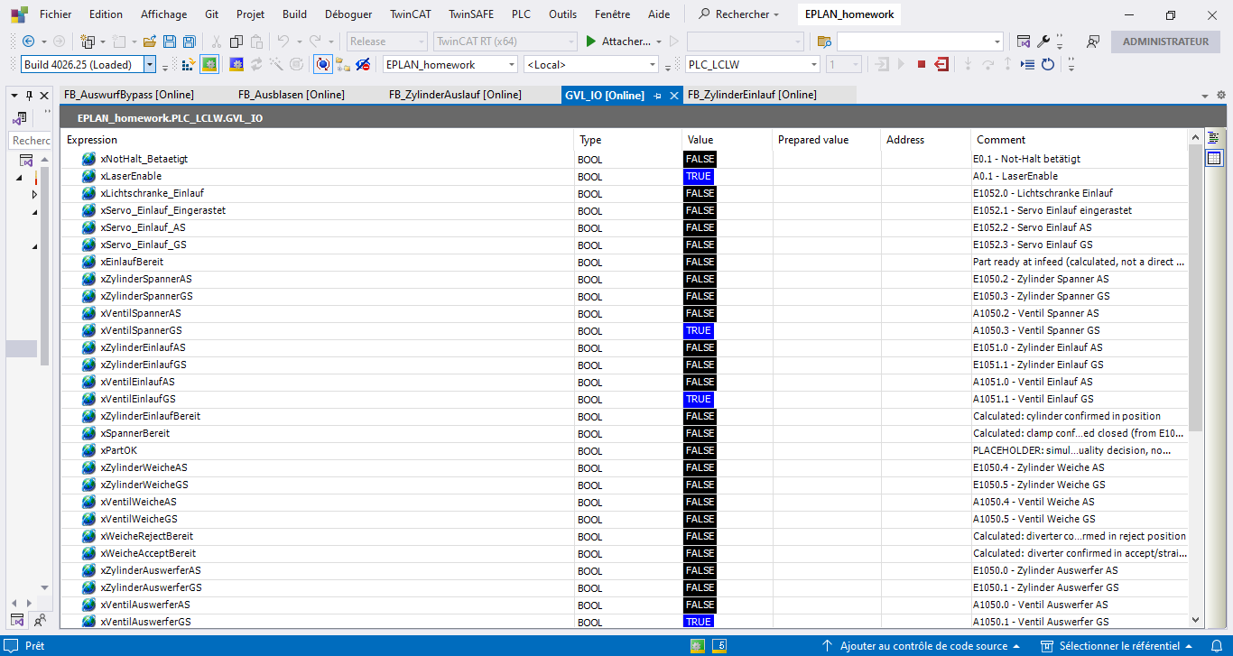
GVL_IO online view during the full-chain test sequence :

EtherCAT device tree and full POUs list in Solution Explorer.
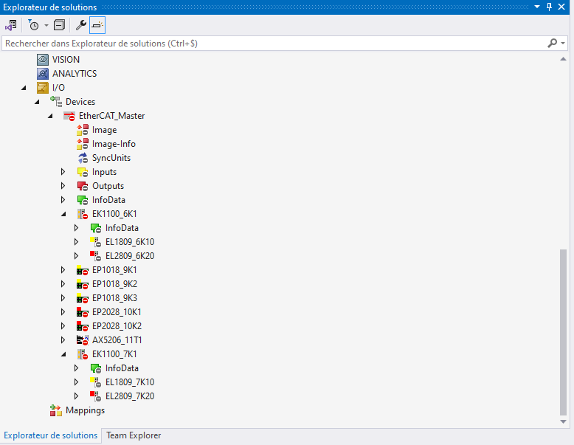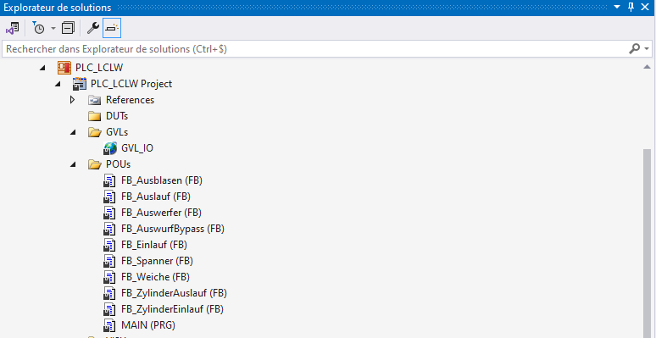

9. Conclusion
This implementation covers the complete process documented across both source drawings: nine mechanical stations plus the safety interlock, structured as independent Function Blocks chained through feedback-confirmed state, including a genuine sorting decision and two timer-based pulse outputs. The pattern is fully consistent across every station, directly traceable back to specific tags on the original EPLAN pages, and was verified end-to-end by simulated forcing from infeed sensor through to outfeed confirmation on both the accept and reject paths.

