**Test of 5 different methods of features extraction for CBIR**

**BiT – biodiversity – taxonomy – BiT+Haralick – BiT+GLCM**

**Images used : OUTEX**

**First Test:**

**Query Image**

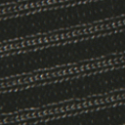

**Class: 7**

**Outputs:**

**BiT / BiT+GLCM / BiT + Haralick**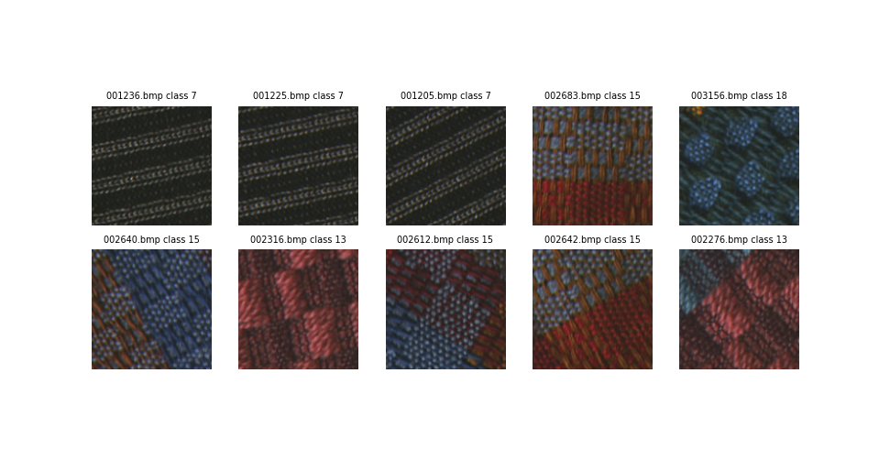

**The 3 methods output the same result : only 3 images from the same class.**

**Biodiversity:**

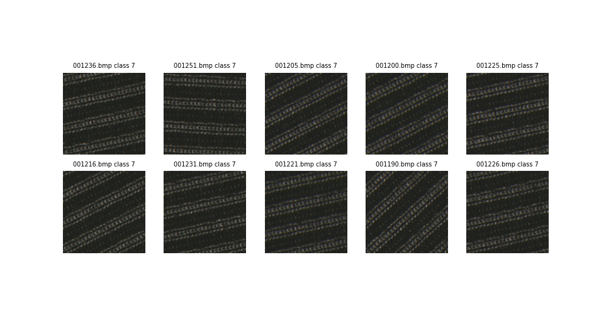

**Biodiversity outputs 10 images from the same class.**

**Taxonomy**

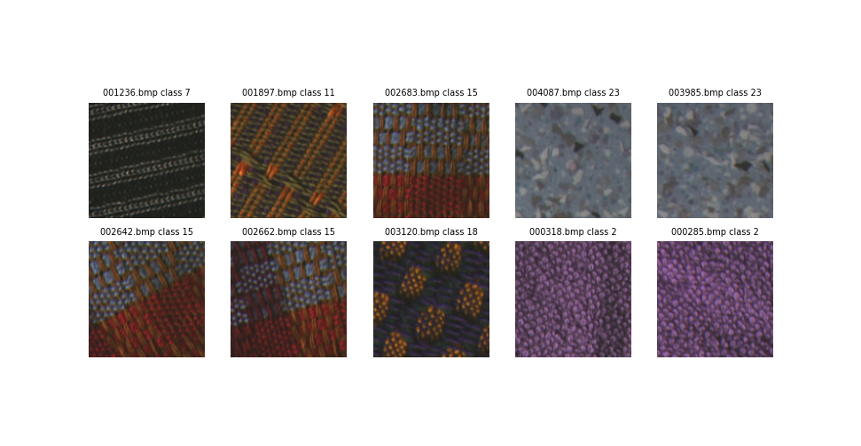

**Taxonomy outputs only 1 image from the same class.**

**Second test:**

**Query Image:**

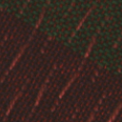

**Class: 14**

**Outputs:**

**BiT / BiT+GLCM / BiT + Haralick**

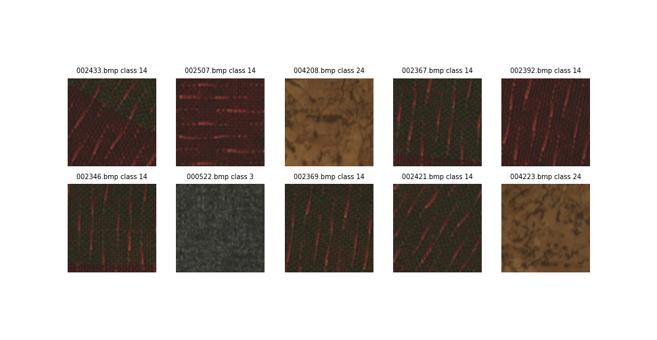

**The 3 methods output the same result : 7 images from the same class.**

**Biodiversity:**

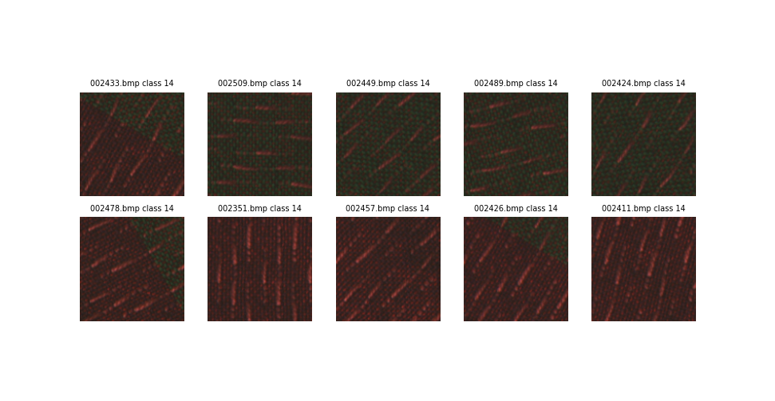

**Biodiversity outputs 10 images from the same class.**

**Taxonomy**

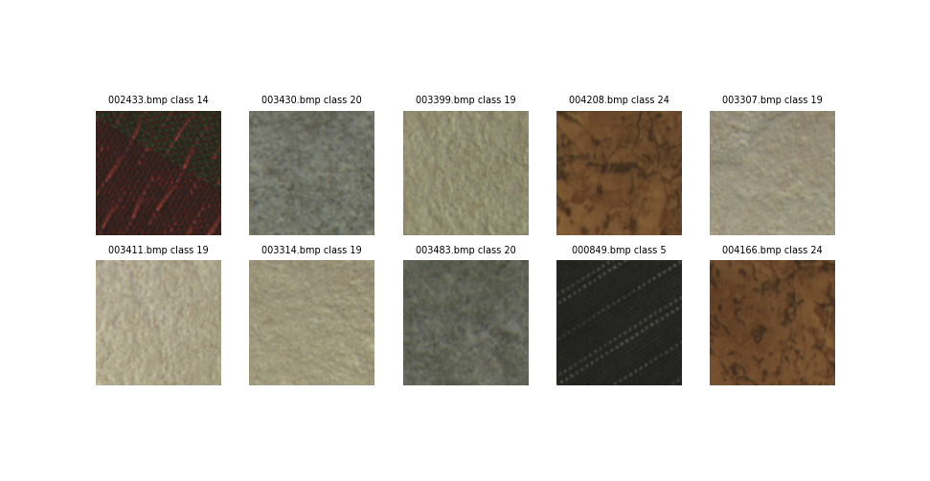

**Taxonomy outputs only 1 image from the same class.**

**Third Test:**

**Query Image:**



**Class: 24**

**Outputs:**

**BiT / BiT+GLCM / BiT + Haralick**

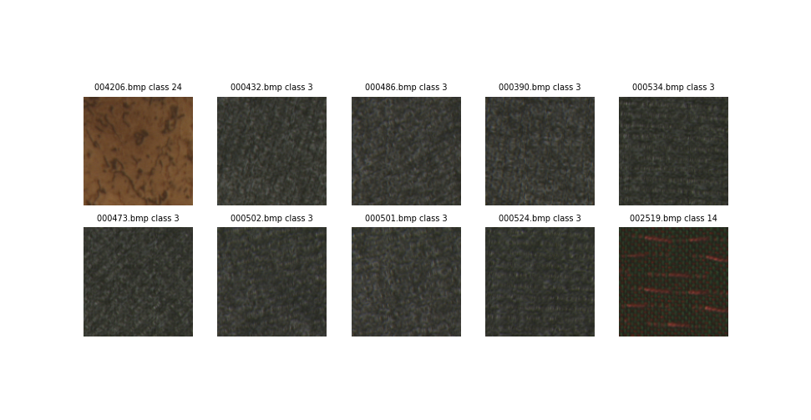

**The 3 methods output the same result: 1 image from the same class.**

**Biodiversity:**

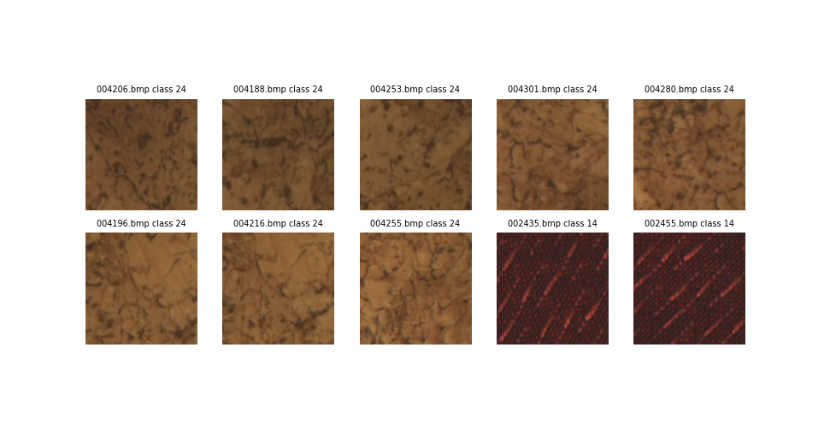

**Biodiversity outputs 8 images from the same class.**

**Taxonomy**

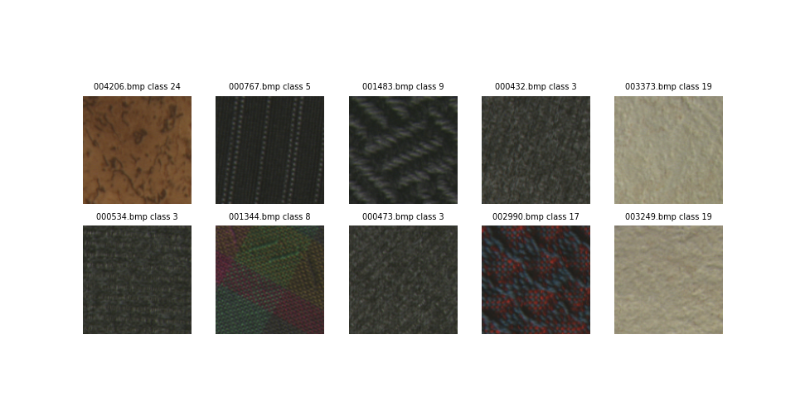

**Taxonomy outputs only 1 image from the same class.**

***So, the biodiversity method gave the best results in the three tests, while taxonomy returned one image only from the same class as the query image!***

***BiT, BiT+Haralick, and BiT+GLCM gave better results than taxonomy but not as accurate as biodiversity.***