Manufacturing Downtime Analysis – Full Documentation

Project Overview
This consolidated document contains project planning, stakeholder analysis, detailed database design (ERD), DAX measures, screenshots from the presentation for each phase, a Gantt chart, and recommendations for the Manufacturing Downtime Analysis project. Content is sourced from the provided PowerPoint and Power BI files.

Problem Statement
The manufacturing process may experience inconsistent productivity and unplanned production halts due to unexpected downtime and inefficiencies among operators and machines. This analysis aims to identify root causes and provide recommendations.

Data Cleaning
Data cleaning was performed in Power Query: trimmed whitespace, removed blank columns, standardized formats, checked primary keys for uniqueness, handled missing values, and unpivoted where necessary.

Goal & Success Criteria
Goals: Identify main downtime causes, highlight extreme downtime cases, quantify impact on productivity, focus on high-loss factors, and enable teams to track and act on downtime trends.

Business Questions, DAX & Sample visuals
Business questions: Total Downtime, Total Productive Time, Top Downtime Factors, Top Downtime Operators, Downtime by Batch/Line. Sample visuals include KPI cards, donut charts, and line charts for downtime over time.

Data Resources
Data from DEPI Excel spreadsheets: Line Productivity, Line Downtime, Products, Downtime Factors.
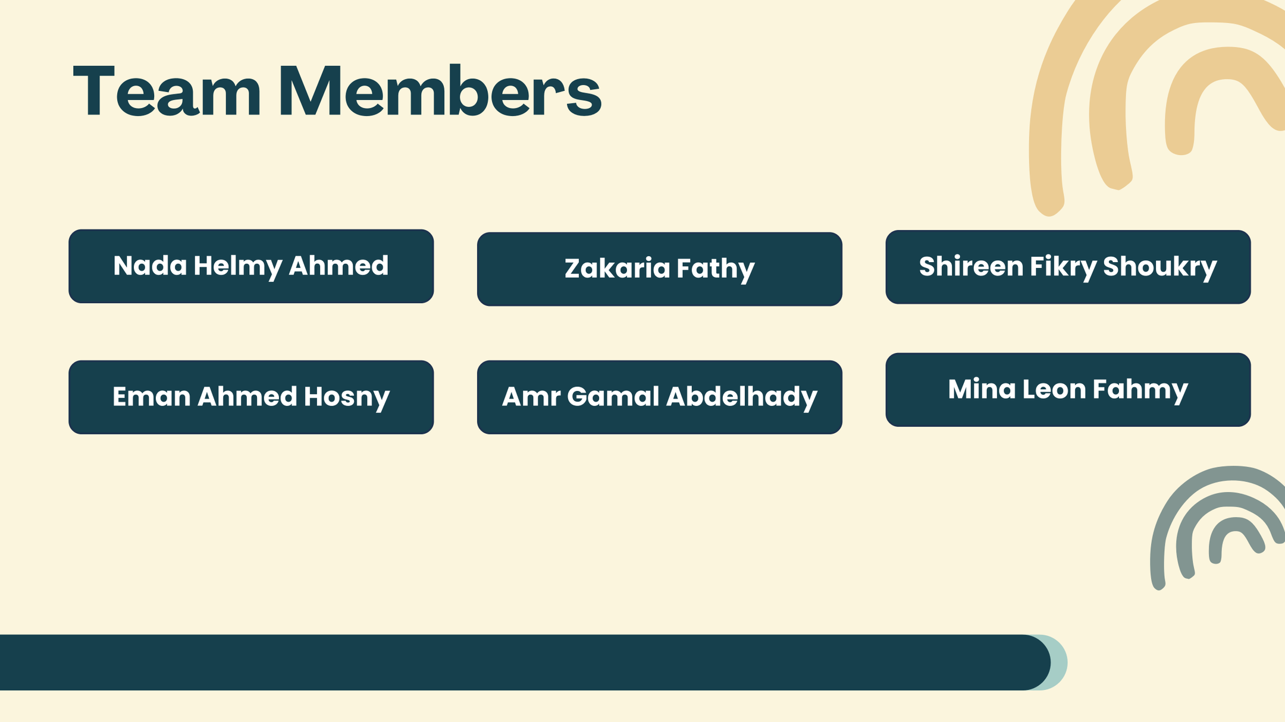

Dashboard & Reports
Power BI dashboards show KPIs, breakdowns by factor/operator, time-series trends, and batch-level details.
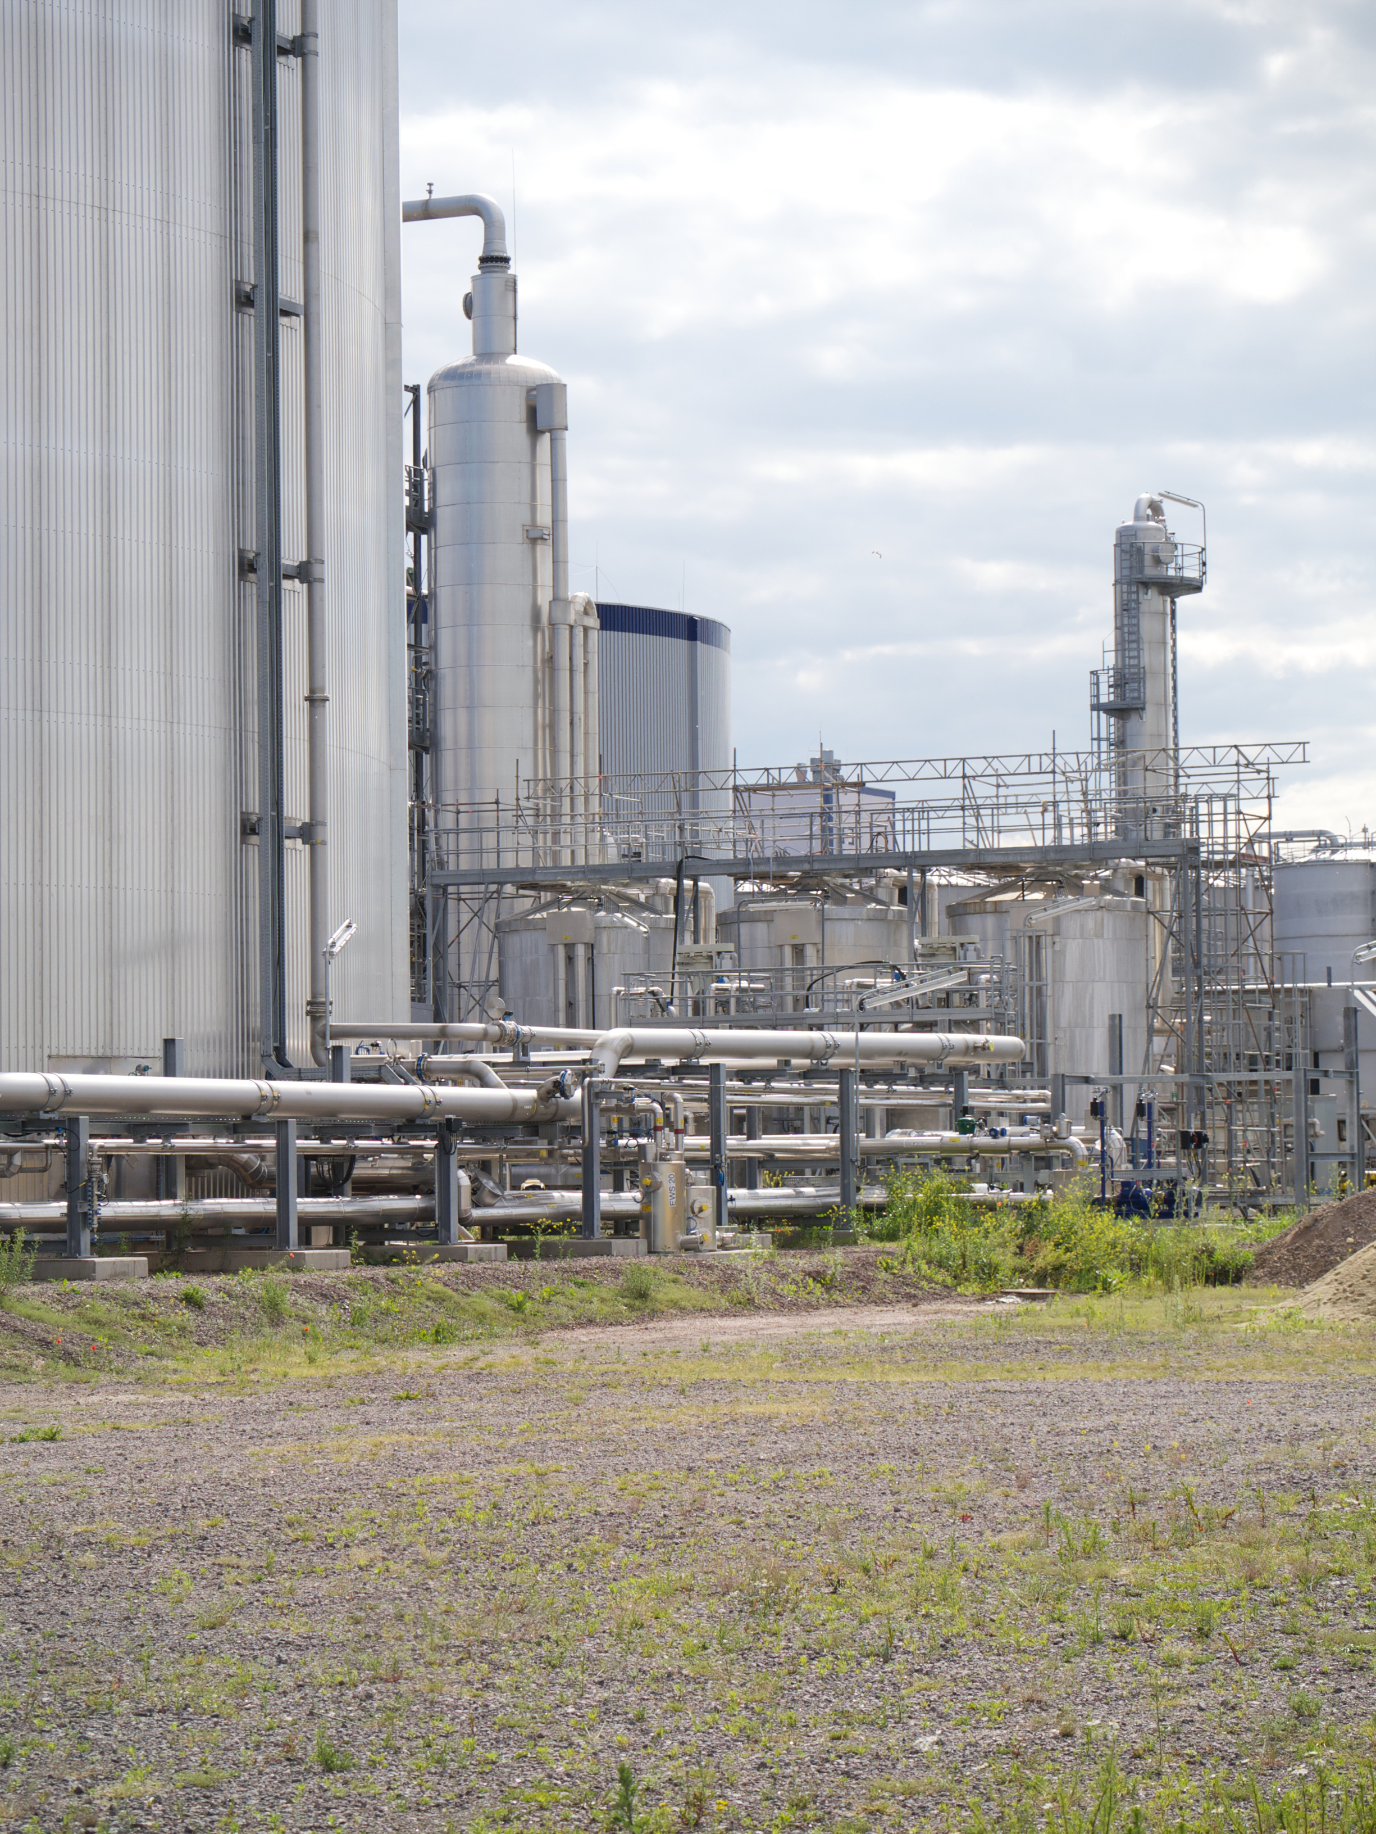

Key Insights, Recommendations & Conclusions
Key insights, recommendations, and conclusions derived from the analysis and dashboards.

Data Modelling
Key insights, recommendations, and conclusions derived from the analysis and dashboards.

Detailed ERD (Entity-Relationship Diagram)
The detailed ERD below shows entities, primary keys (PK), foreign keys (FK), and main attributes used in the data model.
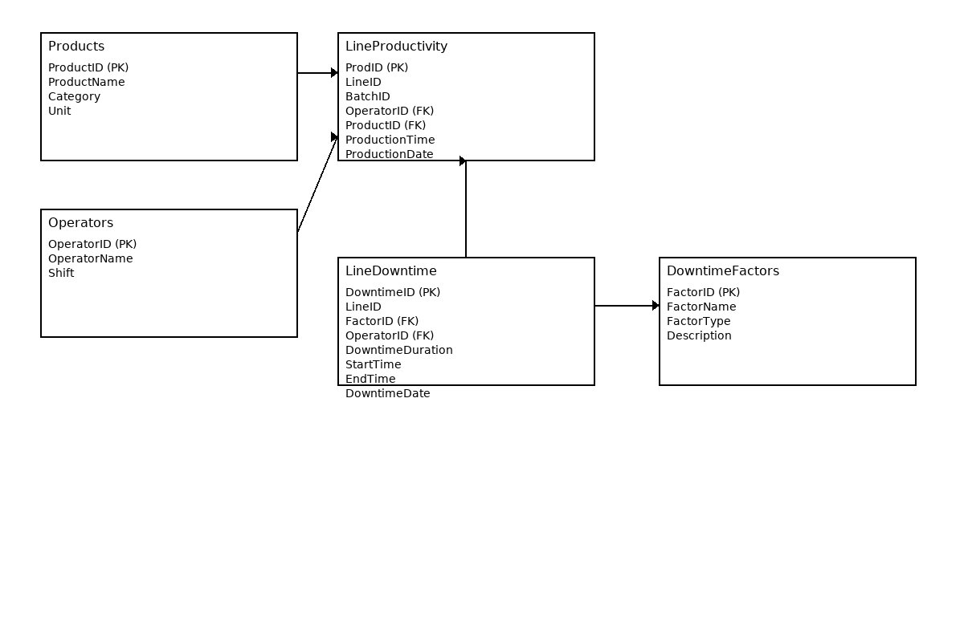
Entities and Keys:
• Products: ProductID (PK), ProductName, Category, Unit
• Operators: OperatorID (PK), OperatorName, Shift
• LineProductivity: ProdID (PK), LineID, BatchID, OperatorID (FK), ProductID (FK), ProductionTime, ProductionDate
• LineDowntime: DowntimeID (PK), LineID, FactorID (FK), OperatorID (FK), DowntimeDuration, StartTime, EndTime, DowntimeDate
• DowntimeFactors: FactorID (PK), FactorName, FactorType, Description

Database Design - Considerations
Design considerations: use surrogate integer PKs for performance, ensure datetime fields are stored in UTC if collecting from devices, index foreign keys used in joins, and maintain a lookup table for downtime factor categories for consistency.

DAX Measures
Below are DAX measures (text) used to compute core KPIs in Power BI:
Total Production Time = SUM(LineProductivity[ProductionTime])
Total Downtime = SUM(LineDowntime[DowntimeDuration])
Total Productive Time = [Total Production Time] - [Total Downtime]
Availability % = DIVIDE([Total Productive Time], [Total Production Time], 0)
Total Batches = DISTINCTCOUNT(LineProductivity[BatchID])
Downtime per Batch = DIVIDE([Total Downtime], [Total Batches], 0)
Operator Downtime = CALCULATE([Total Downtime], FILTER(LineDowntime, LineDowntime[DowntimeType] = "Operator Error"))
Machine Downtime = CALCULATE([Total Downtime], FILTER(LineDowntime, LineDowntime[DowntimeType] = "Machine Error"))
Top Downtime Factor = TOPN(1, SUMMARIZE(LineDowntime, DowntimeFactors[FactorName], "Total", SUM(LineDowntime[DowntimeDuration])), [Total], DESC)
MTTR (Mean Time To Repair) = AVERAGE(LineDowntime[DowntimeDuration])
MTBF (Mean Time Between Failures) = DIVIDE(SUM(LineProductivity[ProductionTime]), COUNT(LineDowntime[DowntimeID]), 0)
Percent Downtime by Operator = DIVIDE([Operator Downtime], [Total Downtime], 0)

Project Timeline (Gantt Chart)
Planned timeline and durations for each project phase.
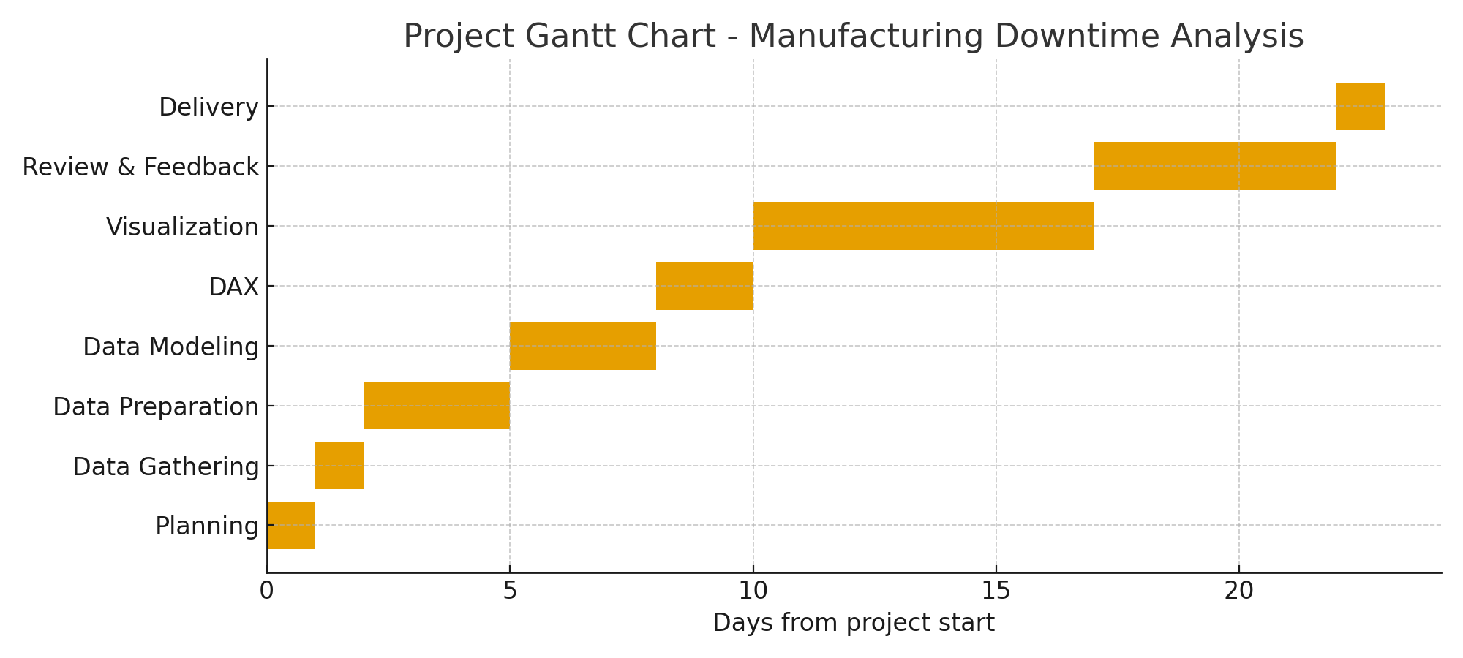

Stakeholder Analysis & Matrix
Stakeholders, interests, influence, and engagement strategy:
Stakeholder | Interest/Needs | Influence | Engagement Strategy
Plant Director | Executive KPIs, summary recommendations | High | Monthly briefs; final presentation
Production Manager | Downtime trends, root causes, action items | High | Weekly updates; dashboard access
Operators | Visibility on performance and training needs | Medium | Daily briefings; training modules
Maintenance Team | MTTR, recurring failures, maintenance scheduling | Medium | Shared reports; maintenance tickets
Quality Team | Quality impact and rework analysis | Low | Ad-hoc reports; review meetings
Inventory/Planning | Material availability and scheduling | Medium | Coordination meetings; KPI dashboards

Key Insights & Recommendations
Key Insights:
• ~56% of total downtime is due to Operator error.
• Five issues (Machine Adjustment, machine failure, inventory shortage, batch change, coding errors) cause ~80% of downtime.
• Unbalanced batch distribution (e.g., CO-600 handling 15 of 38 batches) leads to bottlenecks and increased downtime.
Recommendations:
1. Launch targeted operator training modules focused on handling and troubleshooting.
2. Address high-frequency downtime causes proactively with maintenance and process changes.
3. Redistribute batches to balance line utilization and reduce pressure on high-volume products.
4. Strengthen coordination between production planning and inventory to avoid material shortages.
5. Flag high-downtime batches for cross-functional review and implement continuous improvement loops.

