4. System Architecture and Pipeline

4.1 Overview
Our system is a five-stage Big Data pipeline that takes raw network flow records from the CIC-IDS2017 dataset and ends with a working binary classifier that decides whether each flow is BENIGN or part of an attack. We built the whole thing on top of a small Hadoop and Spark cluster, packaged with Docker so any teammate can spin it up in a couple of minutes without manually installing anything. HDFS stores everything (raw inputs, every intermediate dataset, and the model predictions), and Spark — running in standalone mode with one master and one worker — handles all the heavy work: cleaning, feature engineering, training three models with Spark MLlib, and comparing them at the end. The final stage produces a self-contained HTML dashboard with all the charts and metrics we use in this paper. Figure 1 shows the full architecture.
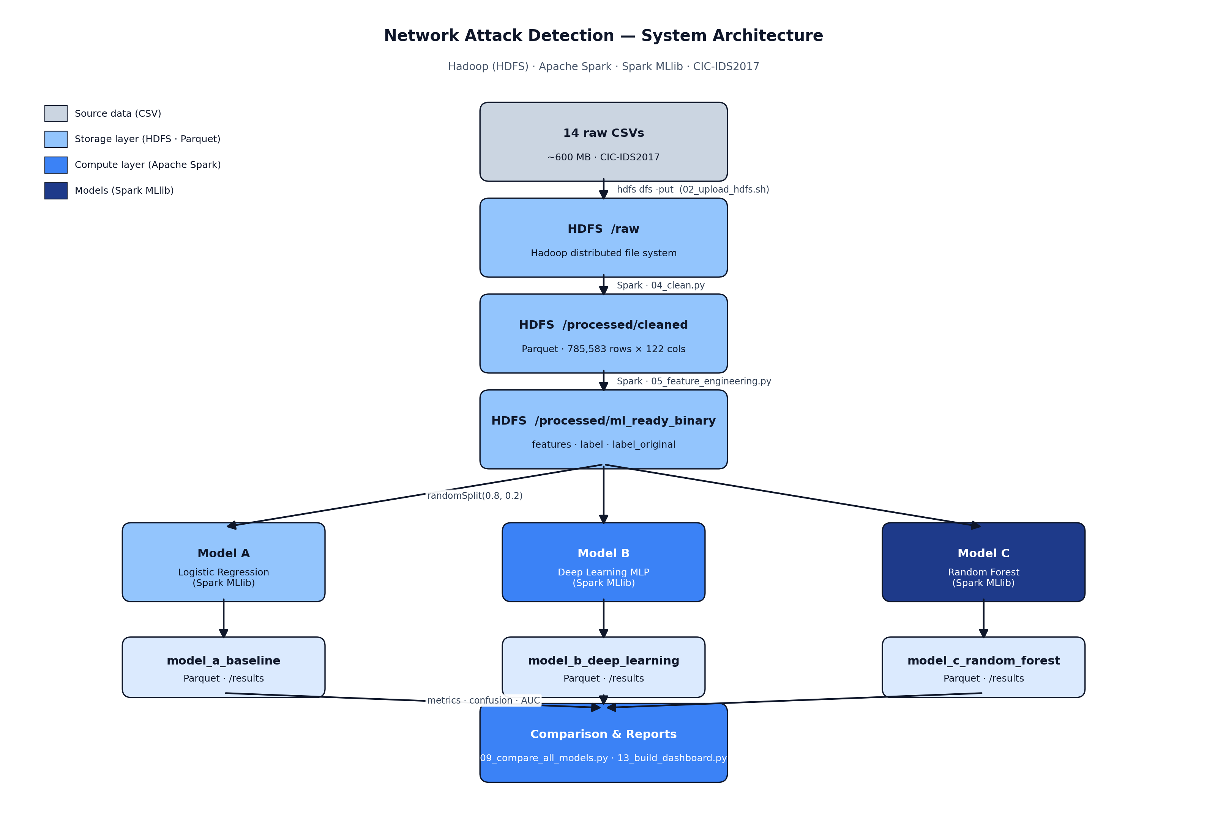
Figure 1 — End-to-end system architecture.

4.2 Storage layer (HDFS)
Everything lives in HDFS under /user/bigdata/ids2017. The 14 raw CSVs (around 600 MB in total) are uploaded once into /raw using the 02_upload_hdfs.sh helper script. After each Spark stage we save the resulting DataFrame back to HDFS in Parquet format with Snappy compression. We chose Parquet over CSV for three practical reasons: it keeps the schema, it reads back into Spark much faster (columnar storage), and Snappy gives us a decent size reduction at almost no CPU cost. Every output directory also gets a _SUCCESS marker file, which we use as a simple checkpointing trick — if a stage already has its _SUCCESS file, we know we can skip it and pick up from there.

4.3 Compute layer (Apache Spark)
The cluster runs Spark in standalone mode: one spark-master container and one spark-worker. Each pipeline stage is a separate spark-submit call rather than one giant job, which makes it much easier to debug and inspect each step independently in the Spark UI at localhost:8080. We sized the cluster small on purpose — 1.5 GB executor memory, 1 executor core, 512 MB driver memory, and 4 shuffle partitions — so it fits comfortably on a laptop while still actually being distributed. All the Spark code is written in PySpark, and the features column produced in stage 4.4 is a Spark MLlib vector that the model trainers can consume directly without any extra conversion.

4.4 Data preparation: cleaning and feature engineering
The first cleaning job (04_clean.py) reads all 14 CSVs at once, renames every column to snake_case, drops rows with missing labels or infinite values, and groups the three web-attack subtypes (Brute Force, XSS, SQL Injection) under a single WEB_ATTACK label. After cleaning we are left with 785,583 flows and 122 numeric columns, all cast to double, written to /processed/cleaned.
The feature-engineering job (05_feature_engineering.py) then turns this into the dataset that the models actually train on. It keeps the original multiclass attack name in a column called label_original (useful for the dataset-distribution chart later), and creates a binary target column called label where 0.0 means BENIGN and 1.0 means any attack. We added a handful of engineered features that summarise each flow more compactly — total_packets, total_payload_bytes, avg_payload_per_packet, fwd_bwd_packet_ratio, and log-scaled versions of duration, bytes-rate and packets-rate. After that, every numeric column is clipped at the 1st and 99th percentile to deal with outliers, any remaining nulls are filled with 0.0, and everything is packed into a single features vector with VectorAssembler. The ML-ready dataset is saved to /processed/ml_ready_binary with three columns: features (vector), label (double), and label_original (string).

4.5 Modelling: three Spark MLlib classifiers
From the ML-ready dataset, we do a deterministic 80/20 randomSplit with seed = 42, giving roughly 628,000 training rows and 157,348 test rows for each model. We train three classifiers from the same split so the comparison is fair. Model A is a Logistic Regression baseline (06_model_baseline.py). Model B is Spark MLlib's MultilayerPerceptronClassifier — a small deep-learning MLP (07_model_improved.py). Model C is a Random Forest (08_model_random_forest.py). For each model we save not just the metrics but the full test-set prediction DataFrame — features, label, label_original, prediction, and probability — back to its own folder under /results/. We did this on purpose: keeping the full predictions means we can later recompute any metric, draw any confusion matrix, or trace any misclassified flow back to its original record without retraining anything.

4.6 Evaluation and reporting
The comparison step (09_compare_all_models.py) reads back the three prediction Parquets and computes five metrics for each: accuracy, weighted precision, weighted recall, weighted F1, and AUC-ROC, using Spark's standard MulticlassClassificationEvaluator and BinaryClassificationEvaluator. It also builds a 2×2 confusion matrix per model. The aggregated metrics and confusion counts go back into HDFS under /results/model_comparison_all/, and a self-contained HTML report (reports/model_comparison_report.html) is written out — every chart inside it is an inline SVG so the report renders identically anywhere, even offline.
On top of that, a small Python tool (10_export_readable_outputs.py) pulls every HDFS output down to local CSV and HTML for inspection without needing a cluster, and a dashboard generator (13_build_dashboard.py + 14_build_html_dashboard.py) produces all eight figures used in this paper: the original attack-type distribution, the binary class share, the metric-comparison bar chart, three confusion matrices, the overlaid ROC curves, and a pipeline data-flow figure showing row counts at each stage. Table 1 summarises the final numbers.
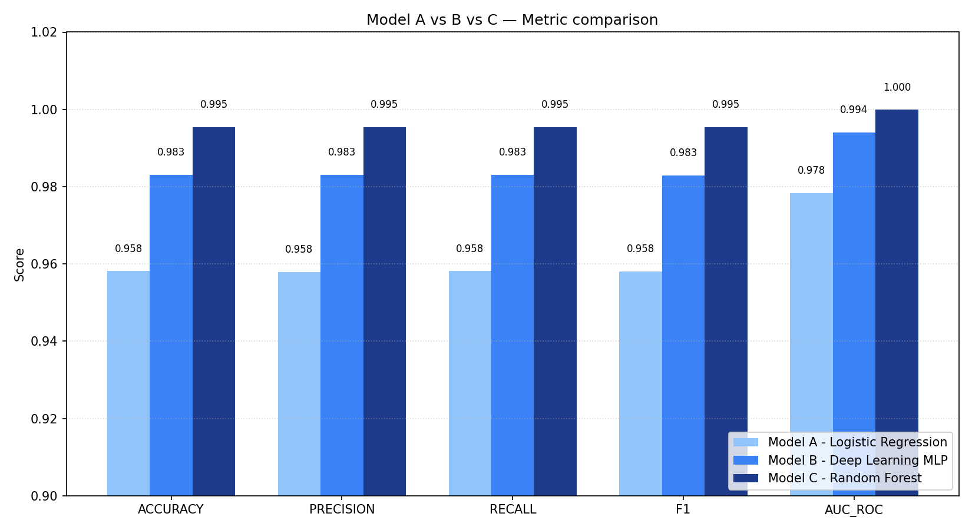
Figure 2 — Per-model metric comparison.
Table 1 — Final per-model test metrics (157,348 test rows each).
Model | Accuracy | Precision | Recall | F1 | AUC-ROC
Model A — Logistic Regression | 0.9581 | 0.9579 | 0.9581 | 0.9580 | 0.9783
Model B — Deep Learning MLP | 0.9831 | 0.9830 | 0.9831 | 0.9829 | 0.9940
Model C — Random Forest (best) | 0.9954 | 0.9954 | 0.9954 | 0.9954 | 0.9999

Table 2 — Confusion matrices (rows = actual, columns = predicted).
Model | TN (BENIGN→BENIGN) | FP (BENIGN→ATTACK) | FN (ATTACK→BENIGN) | TP (ATTACK→ATTACK)
Model A | 23,161 | 3,480 | 3,106 | 127,601
Model B | 24,593 | 2,048 | 610 | 130,097
Model C (best) | 26,361 | 280 | 440 | 130,267

Random Forest comes out clearly ahead. It hits 0.9954 on every weighted metric and an AUC-ROC of 0.9999, with only 280 false positives and 440 false negatives across the 157,348-row test set. That is more than an order-of-magnitude improvement in error count over the logistic-regression baseline. Figure 3 shows the three ROC curves on the same axes.
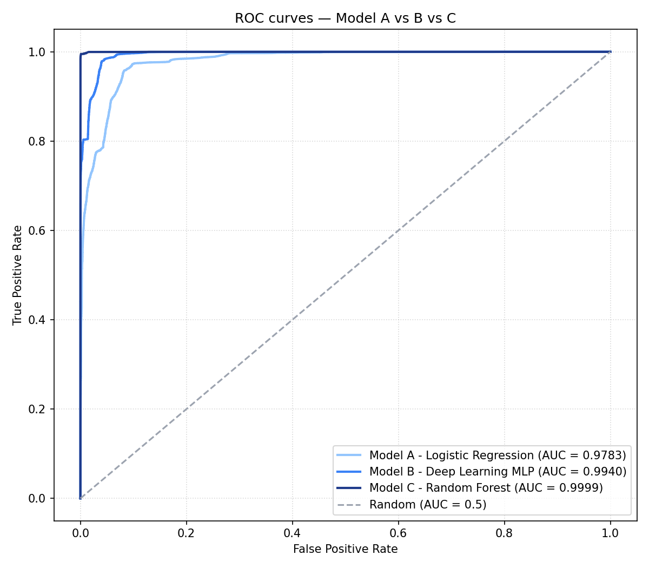
Figure 3 — Overlaid ROC curves for the three models.

4.7 Reproducibility and engineering choices
Reproducibility was a hard requirement for us. Every Spark job uses a fixed random seed (seed = 42) for splitting and model initialisation, so identical inputs give identical outputs. Every intermediate Parquet is committed to git under outputs/hdfs_export/, which means anyone reviewing the project can rebuild every chart and table in this paper by running a single Python script (13_build_dashboard.py) — no Hadoop install needed. Python dependencies are pinned in requirements.txt, and the cluster itself is captured as a docker-compose.yml file.
A few engineering choices are worth calling out explicitly:
First, Parquet over CSV at every intermediate stage. We tested this early — reading the cleaned dataset back from Parquet is roughly an order of magnitude faster than from CSV, and it carries the schema, so downstream stages do not have to re-infer types.
Second, one spark-submit per stage rather than one big script. Each stage is independently restartable and independently profilable in the Spark UI. Combined with the _SUCCESS marker trick, a re-run of the pipeline only redoes the stages that are actually missing.
Third, persisting the full prediction DataFrames rather than just scalar metrics. This added some storage cost but it was completely worth it: we could regenerate any chart, any table, any confusion matrix in this paper without retraining a single model.

4.8 Pipeline data flow
Table 3 lists what the dataset looks like at every stage, and Figure 4 shows the same flow visually with the actual row counts.
Table 3 — Row counts at each stage of the pipeline.
Stage | HDFS path | Rows | Cols | Format
Raw | /raw/CSVs/ | ~3,000,000 | — | 14 CSV files
Cleaned | /processed/cleaned/ | 785,583 | 122 | Parquet
ML-ready | /processed/ml_ready_binary/ | 785,583 | 3 | Parquet
Test predictions (each model) | /results/model_*/predictions/ | 157,348 | 5 | Parquet
Comparison | /results/model_comparison_all/ | 15 metric + 12 confusion rows | — | Parquet + HTML

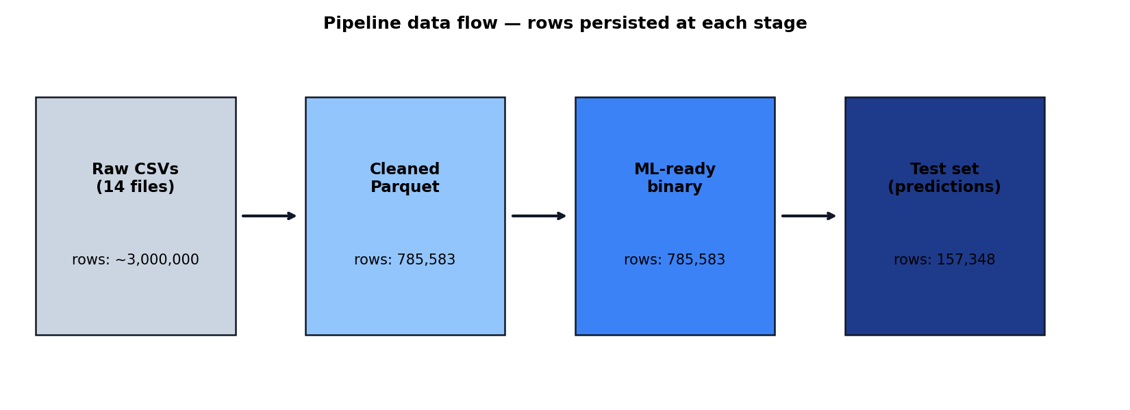
Figure 4 — Row counts persisted at each pipeline stage.
This monotonic flow — raw bytes in, schema-typed Parquet artefacts at every stage, scalar metrics out at the end — is really the central design idea of the whole system. It is what makes the pipeline restart-safe, easy to inspect, and easy for someone else to reproduce without us in the room.

