Home Video Display - PrestaShop Module

Overview
Home Video Display (v1.3.0) is a robust PrestaShop module designed to showcase a sequence of videos directly on the homepage. It features a built-in playlist system, configurable video controls, and multi-language text areas that can be toggled independently for mobile and desktop devices.

Technical Stack & Requirements
- PrestaShop Compatibility: 8.0.0 or higher.
- Supported Video Formats: MP4, WebM, and OGG.
- Maximum File Size: 100MB per video.

Key Features
- Video Playlist: Upload multiple videos that will automatically play in a sequence. Includes front-end navigation controls (Next/Previous).
- Advanced Playback Controls: Toggle Autoplay, Loop, and Muted states directly from the back office.
- Responsive Multi-language Text: Add descriptive text next to the video player with full multi-language support.
- Device-Specific Visibility: Independently show or hide the text content on Mobile and Desktop views to optimize the user experience.
- Smart Autoplay: Utilizes JavaScript IntersectionObserver to trigger autoplay only when the video scrolls into the user's viewport, saving bandwidth and improving page load performance.

Installation
- Download the module as a .zip file.
- Navigate to your PrestaShop Back Office: Modules > Module Manager.
- Click on Upload a module and select the .zip archive.
- Once uploaded, click Install. The module will automatically create the necessary upload directories and register its hooks.

Configuration & Usage
Once installed, click Configure on the module.

1. General Settings
- Enable module: Toggle the visibility of the entire block on the homepage.
- Autoplay: Set the video to play automatically. (Note: Most modern browsers require videos to be 'Muted' for autoplay to function ).
- Loop playlist: When the last video finishes, it will restart from the first video.
- Muted: Mutes the video audio by default.
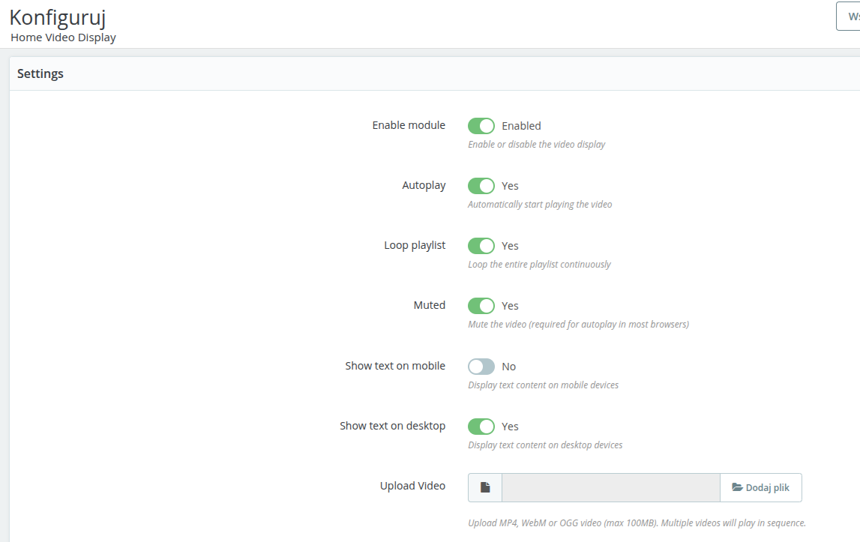

2. Device Visibility
Control where your multi-language text appears:
- Show text on mobile: Yes/No.
- Show text on desktop: Yes/No.

3. Video Management
- Use the Upload Video field to add new clips.
- The Current Videos table displays all uploaded files in their playback order.
- You can View or Delete existing videos directly from this table.
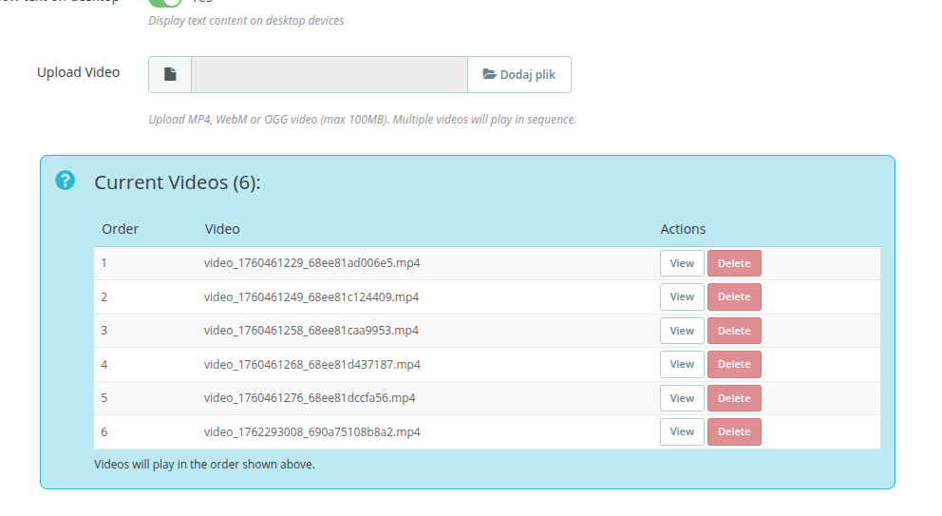

4. Text Content
- Add rich text, HTML, or links using the WYSIWYG editor.
- Use the language selector to provide translations for all active store languages.
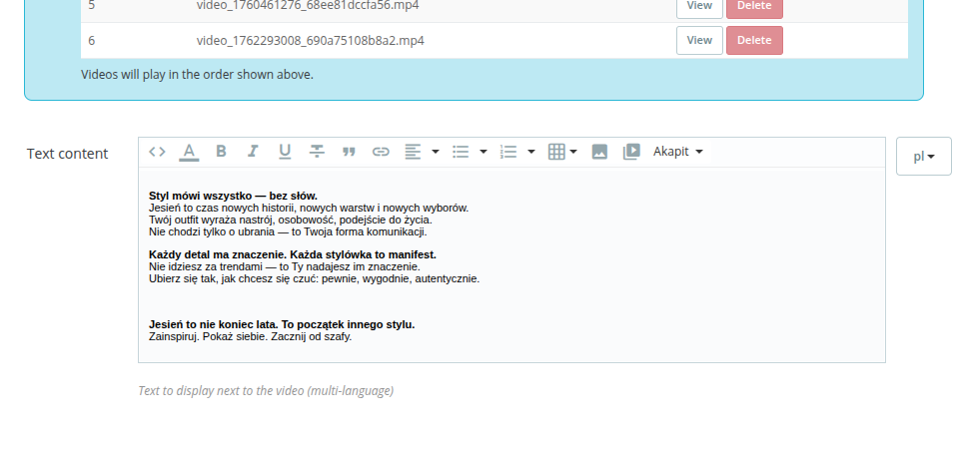

Technical Details for Developers

Hooks Utilized
- displayHome: Renders the main template (homevideo.tpl) and the video player logic.
- actionFrontControllerSetMedia: Injects the custom stylesheet (front.css) exclusively on the index controller to prevent unnecessary CSS loading on other pages.

Database & Storage
- Configuration: Settings are stored in the ps_configuration table under keys prefixed with HOMEVIDEO_ (e.g., HOMEVIDEO_VIDEOS, HOMEVIDEO_AUTOPLAY).
- File Storage: Uploaded videos are securely stored in /modules/homevideodisplay/views/videos/. The directory is protected via a .htaccess file that blocks directory listing and strictly allows only .mp4, .webm, and .ogg files.

Uninstallation
Uninstalling the module will cleanly remove all associated Configuration keys and physically delete all uploaded video files from the server, preventing orphaned data.

