
COLLEGE OF COMPUTING AND INFORMATICS (CCI)
CGEB4313 FINAL YEAR PROJECT 1 (FYP1 SW)
REGISTRATION FORM
STUDENT DETAILS
1 | STUDENT’S NAME | Muhammad Zakariyya bin Ahmad Radzif
2 | STUDENT’S ID | BSW01085129
3 | CONTACT NUMBER | 0176709783
4 | EMAIL ADDRESS | zakariyyawork@gmail.com BSW01085129@student.uniten.edu.my

SUPERVISOR DETAILS
1 | SUPERVISOR’S NAME | Suhaimi bin Ab. Rahman, Ts. Dr.
2 | CONTACT NUMBER | 019 272 3060
3 | EMAIL ADDRESS | smie@uniten.edu.my
4 | SIGNATURE | 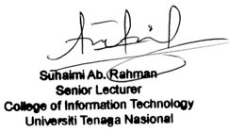  DATE: 2/9/2026

PROJECT DETAILS
1 | PROJECT TITLE | uniTERN – Centralized Uniten Internship System
2 | PROJECT’S DESCRIPTION  (summarize in 50 words) | uniTERN Centralized Uniten Internship System target is to create a one centralized point for internship student, to download required documents, get announcement on important date, online digital logbook, all around submission field for any related internship stuff. Future plan to implement AI summarizer / expand on logbook area and AI chat bot for frequently asked question.
3 | Is your project developed for specific user/company? (Y/N)  If yes, specify the Company Name and Contact Number. | Yes,  Uniten  03-8921 2020

Student’s Signature:
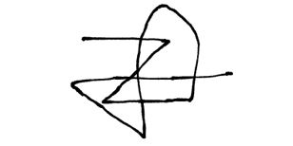
(Name: Muhammad Zakariyya bin Ahmad Radzif)

