**MLOPS – B**

**Assignment 1**

**I191995, i190651**

* **Requirements.yml**

We have written this requirements.yml file that works on push when the requirements file is uploaded. It install the dependencies if the dependencies were successfully installed then It will show success in github actions.

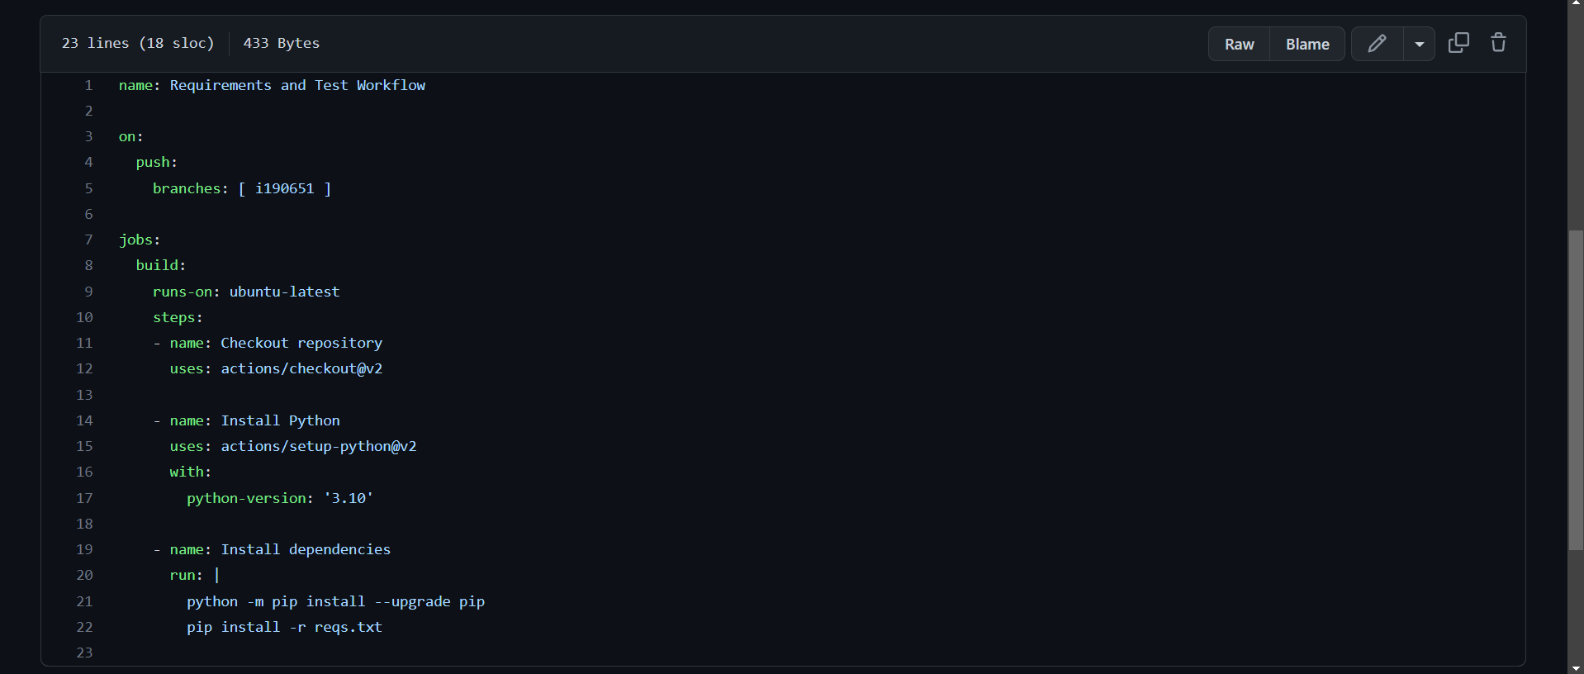

It works when ever the requirements.txt file is push to github.

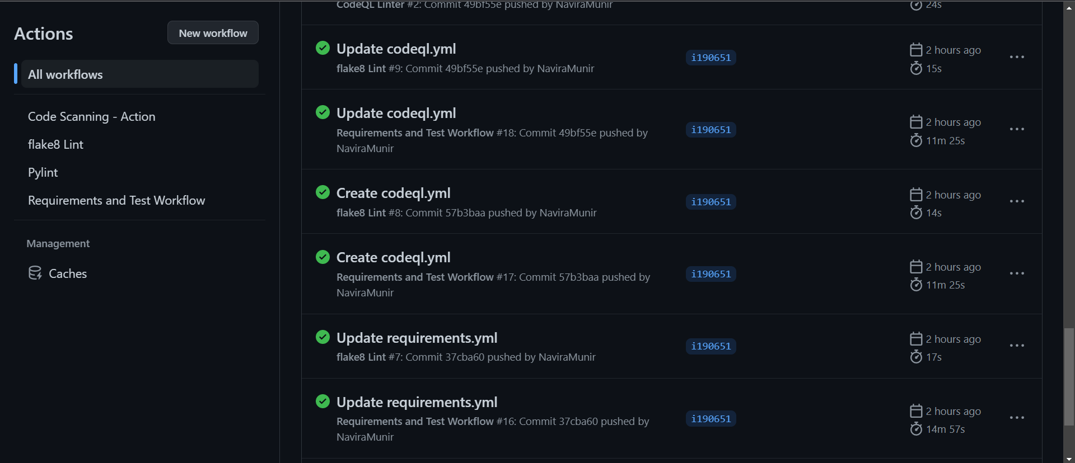

* **Flake8.yml**

Flake 8.yml file check the various styles and the syntax issues in the python file. It only works correct when all the python syntax is followed properly

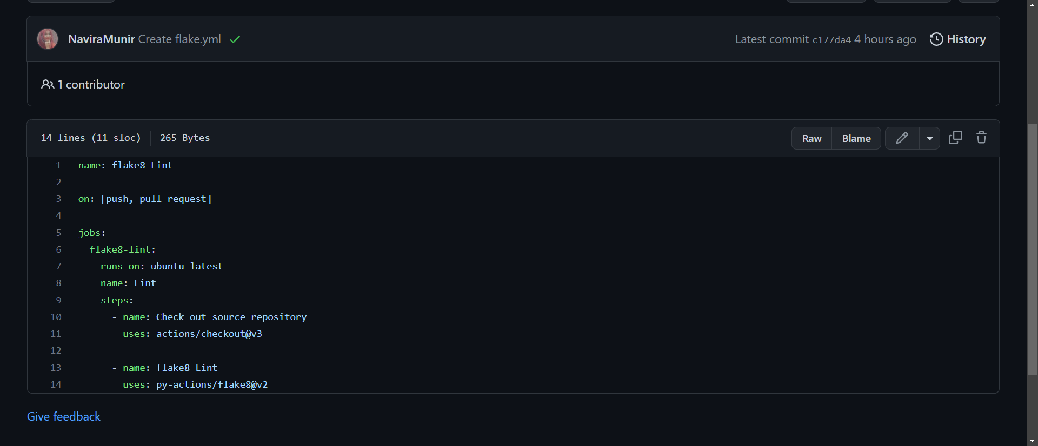

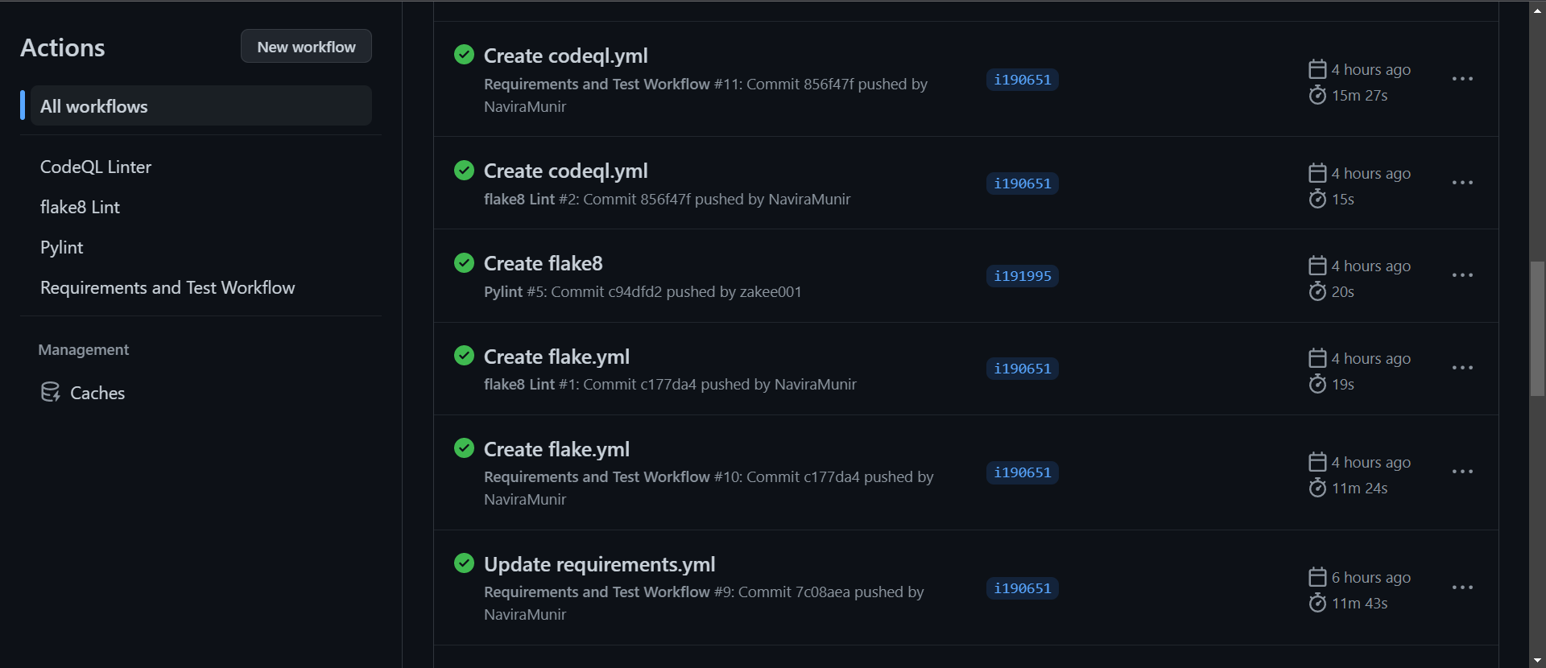

* **Pylint**

It is used to check the programming errors in the code.

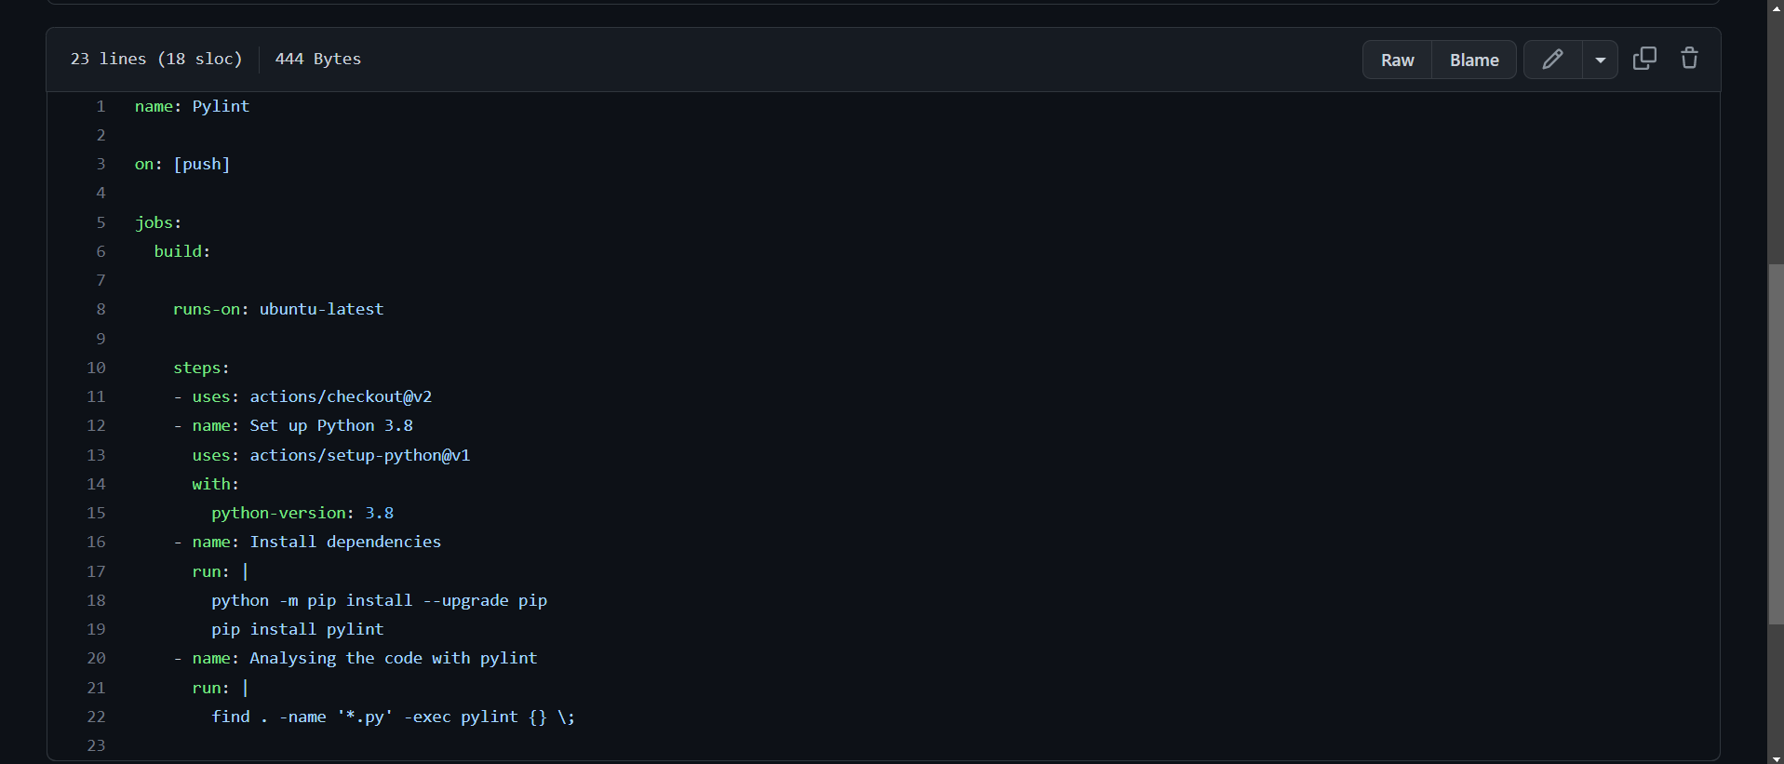

Following is the runs for pylint file. We can see that it is successful at github actions.

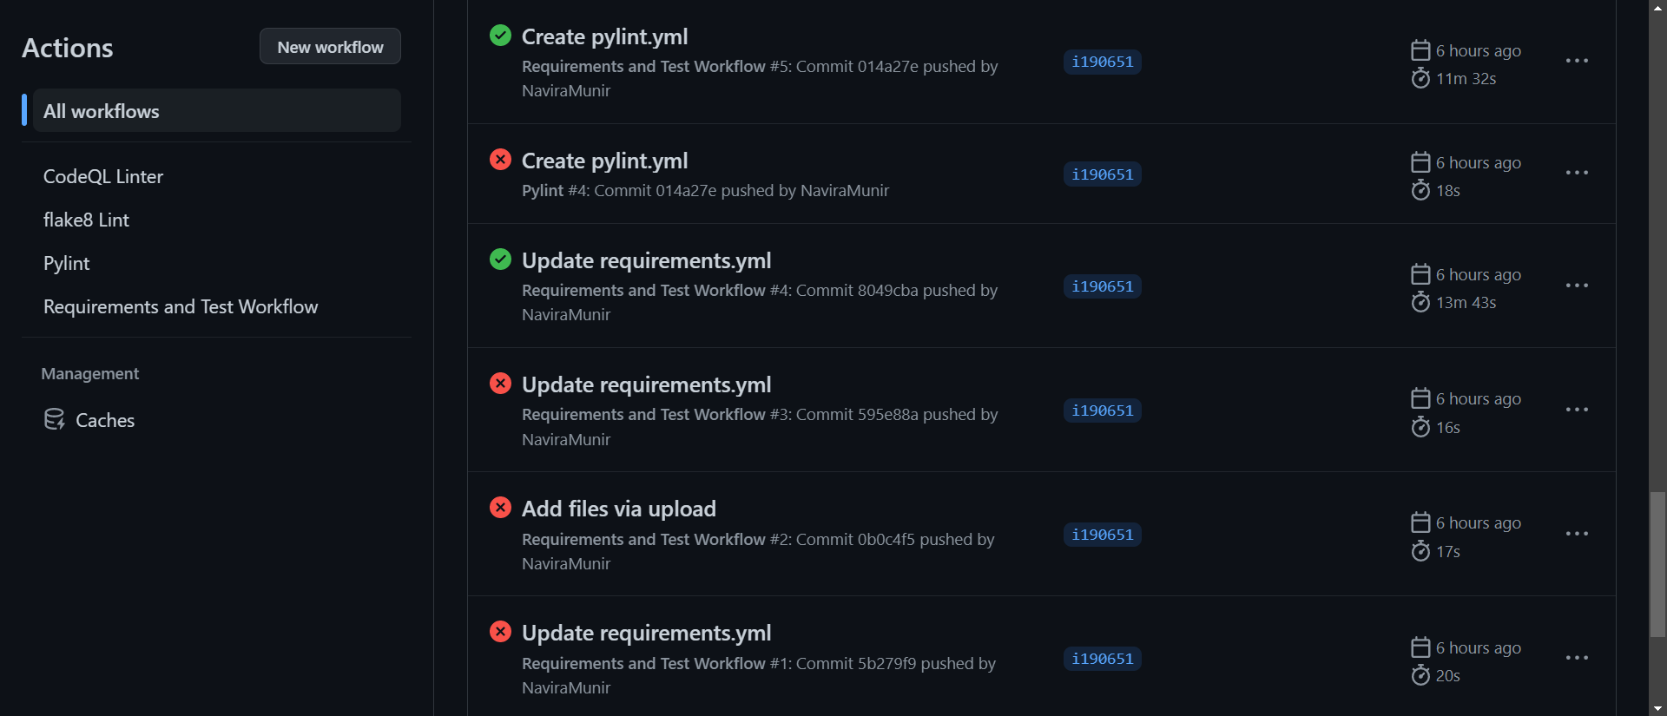

* **CodeQl**

Following is the code we have written using github action for CodeQl. It is used fot the security of the code.

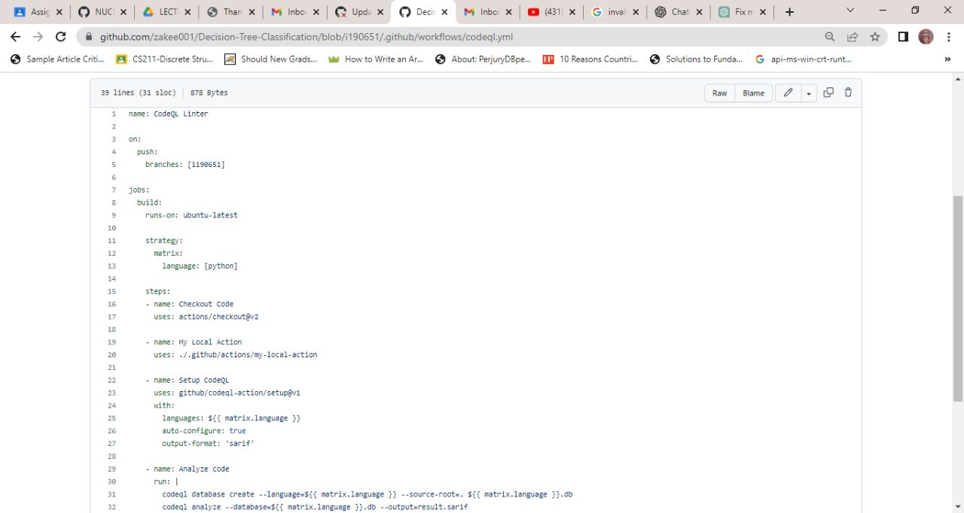

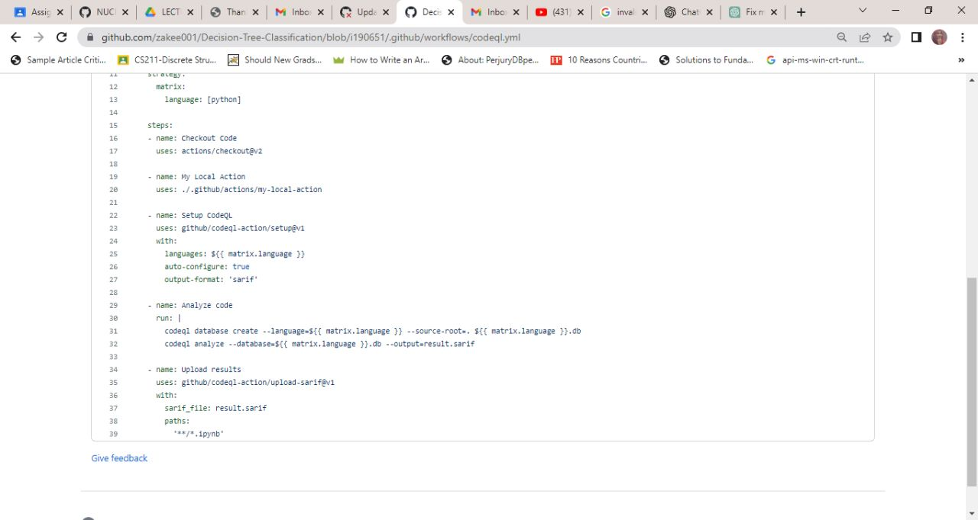

We can see that all the CodeQl oprations were successful

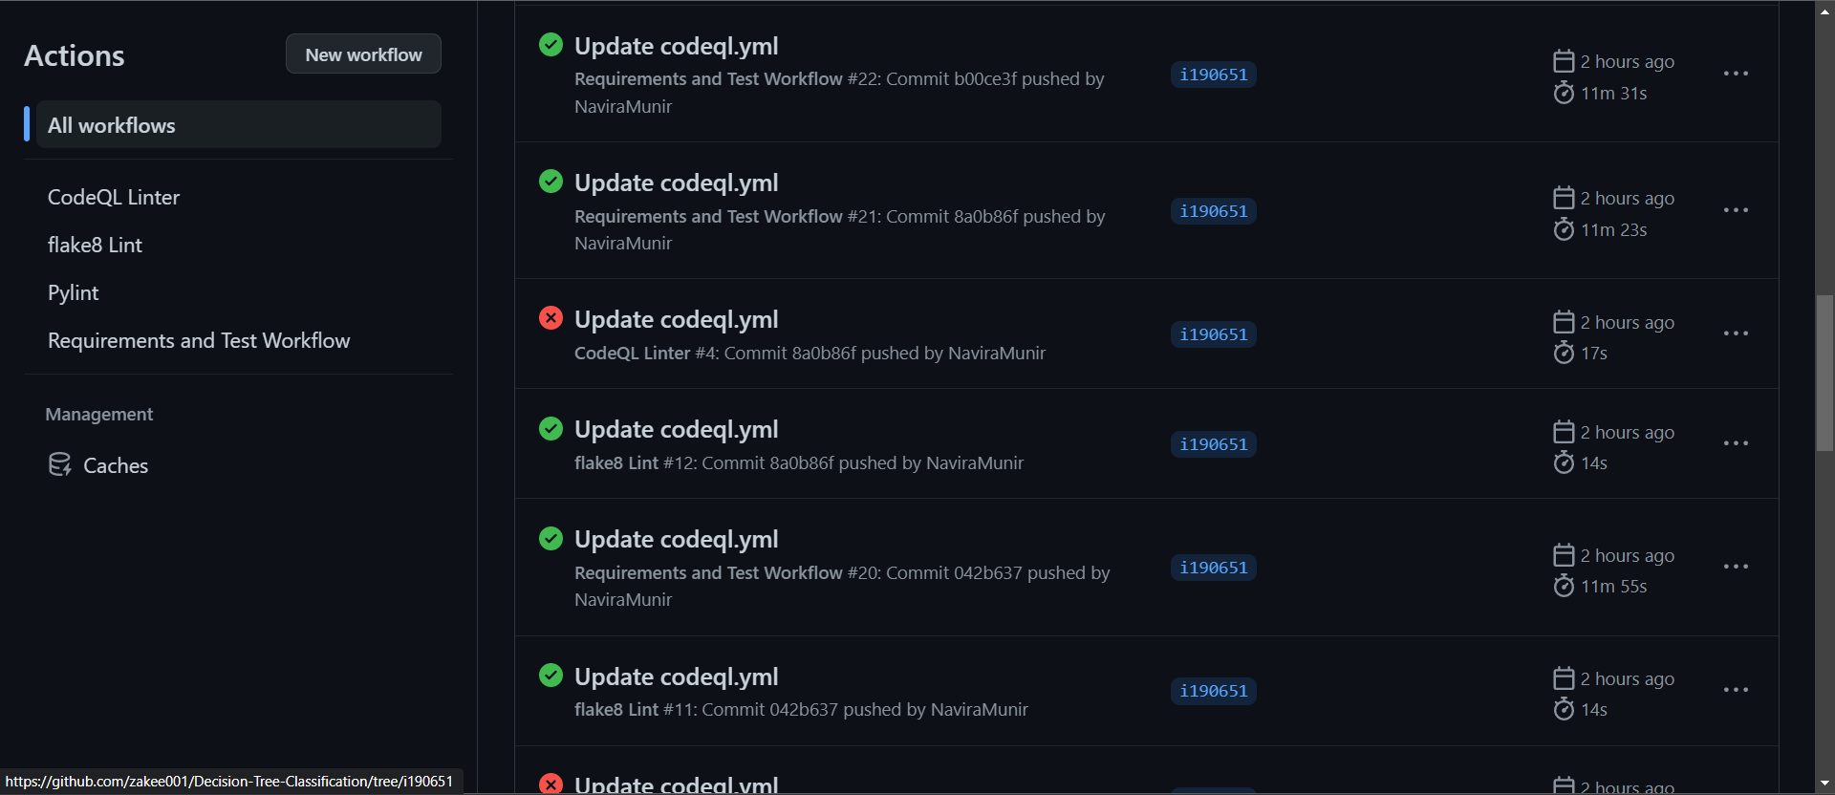

* **Merging to the Main Branch**

We have worked on the two separate branches and at the end we have merged the brances to the main branch.

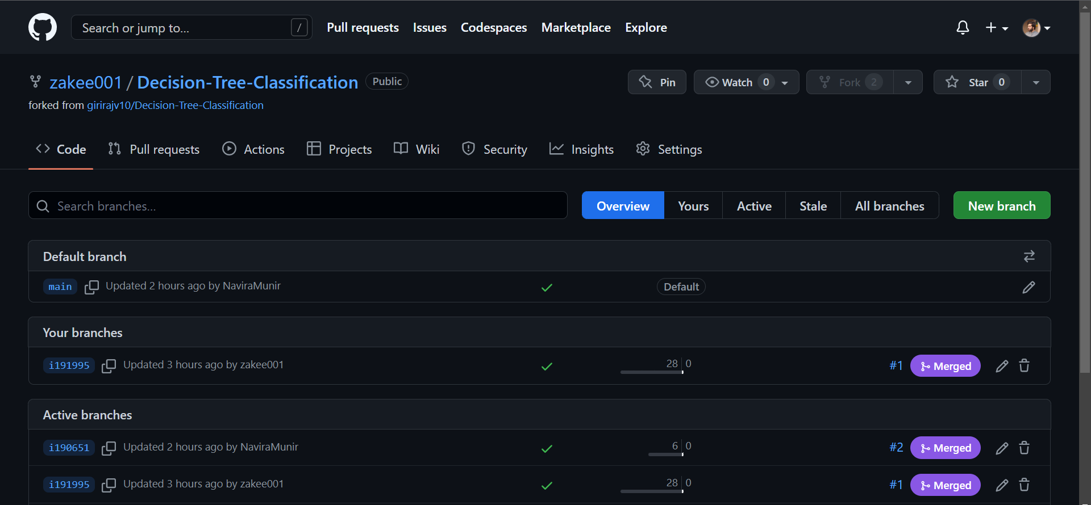

We can see that all the merge oprations were successful.

