**User Roles**

There will be three user roles available to choose from :

* Developer (Can only be created by other Developers)
* Administrator (Can create administrators and Crew Members)
* Crew Member (Cannot create any other accounts)

**Developer**

The Development Role will have access to everything on the platform with no restrictions.

Developers can create new developers and other user roles.

Developers cannot be deleted by any user role below developer.

The first developer account will be for dev@voteq.co.uk

**Administrator**

The Administrator Role will have access to everything on the platform with no restrictions other than not being able to delete or edit the developer user role..

**Crew Member**

Crew members will not have access to the following from the main menu and should be redirected to the dashboard if they try to access these areas.:  
  
- Crew Members  
- Activity Items  
- Analytics  
- Settings

**Dashboard Page**

The **Crew Member** will see a list of upcoming activities they are scheduled for over the next 30 days. They can click the “View All My Activities button which will take them to the My Activities page. The menu dots should show “View Activity” and “I’m not available” which will remove their availability and put their name back in the unavailable list.

**All Activities Page**  
The **Crew Member** can see the entire list of activities but does not have the ability to create or delete activities. The Create activity button in the top right will be hidden from the user.

In the activity list, when clicking the three dots next to an activity, their only option will be to “View Activity” and “I’m Available / I’m Unavailable”.

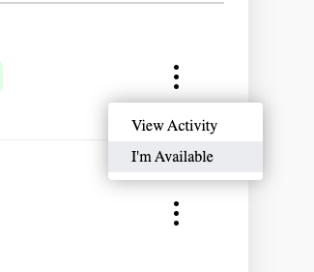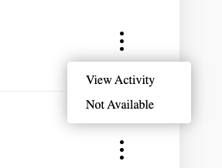

**Specific Activity Page**When viewing an activity page, the **Crew Member** can only add themselves to the Available Crew list. They cannot edit any other Information on this page. Maybe we add a button that says “I’m Available” they can click that will add their user into the available crew list. And then the button changes to “I’m Unavailable” to then remove themselves if needed.

**My Activities Page**The **Crew Member** will see a list of all boat trips that they have been marked as confirmed crew.

They will not see the Create Activity button in the top right corner.

They will see the same options when they click the three dots: “View Activity” and “Not Available”

**Documents Page**

The **Crew Member** will be able to view and download the documents but cannot upload or delete documents or create new / delete document categories.

**My Account Page**

The **Crew Member** can see all the information about them but they cannot edit the system information section. This information is only editable by administrators.

The Crew Member can update the Your Information section, change their image and password.

The button should read: “Save Changes”