**Access all the tables created in Assignment 1 and run those queries through the python API**

1. **Create a table album**

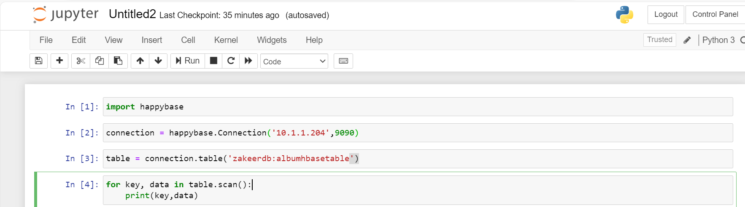

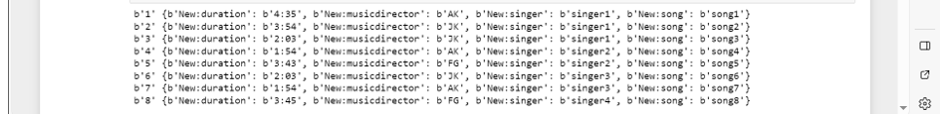

1. **Which singer sung for music director AK and what were the songs**

for key, data in table.scan(filter="SingleColumnValueFilter('New','musicdirector',=,'substring:AK')"):

print(key,data)

1. **getall songs sung by a singer**

for key, data in table.scan(row_start=b'1:singer1', columns = [b'New:song',b'New:singer']):

print(key, data)

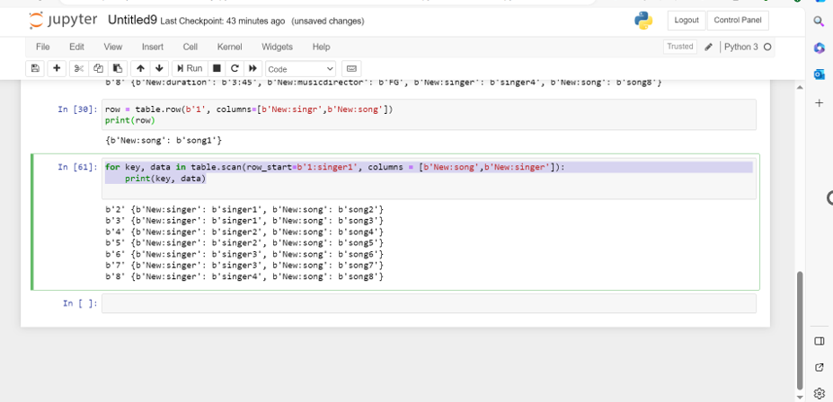

**Design a Data model comments given by various users on stock symbols**

1. **What are the various comments given by all the users?**

for key, data in table.scan(row_start=b'1', columns = [b'sampledata:comment']):

print(key, data)

1. What are the comments by user3?

for key, data in table.scan(filter="SingleColumnValueFilter('sampledata','userid',=,'substring:user3')"):

print(key,data)

1. Which users have inactive comments?

for key, data in table.scan(filter="SingleColumnValueFilter('sampledata','active',=,'substring:False')"):

print(key,data)

**Also Create new tables from python and insert some data in to those tables**

import happybase

connection=happybase.Connection('10.1.1.204',9090,table_prefix='kouahik_project')

connection.create_table(

'customer01',

{'cf1': dict(max_versions=10),

'cf2': dict(max_versions=1, block_cache_enabled=False),

'cf3': dict(), # use defaults

}

)

table = connection.table('customer01')

for i in range(20):

table.put(b'Cust-%d'%(i), {b'cf1:name': b'Customer-%d'%(i),b'cf1:orderid': b'%d'%(i)})

for key, data in table.scan():

print(key, data)

