1. Create a table in Hbase (using hive-hbase integration) with proper row key design efficiently to load the data from hive to hbase.

2. There shoud not be any data loss when moving data from hive to hbase

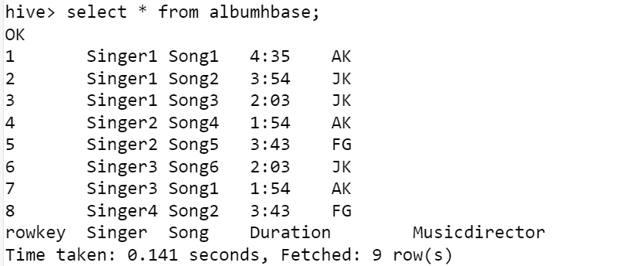

Run queries like 1) getall songs sung by a singer 2) Which singer sung for music director AK and what were the song

First Solution =>

Second Solution =>

