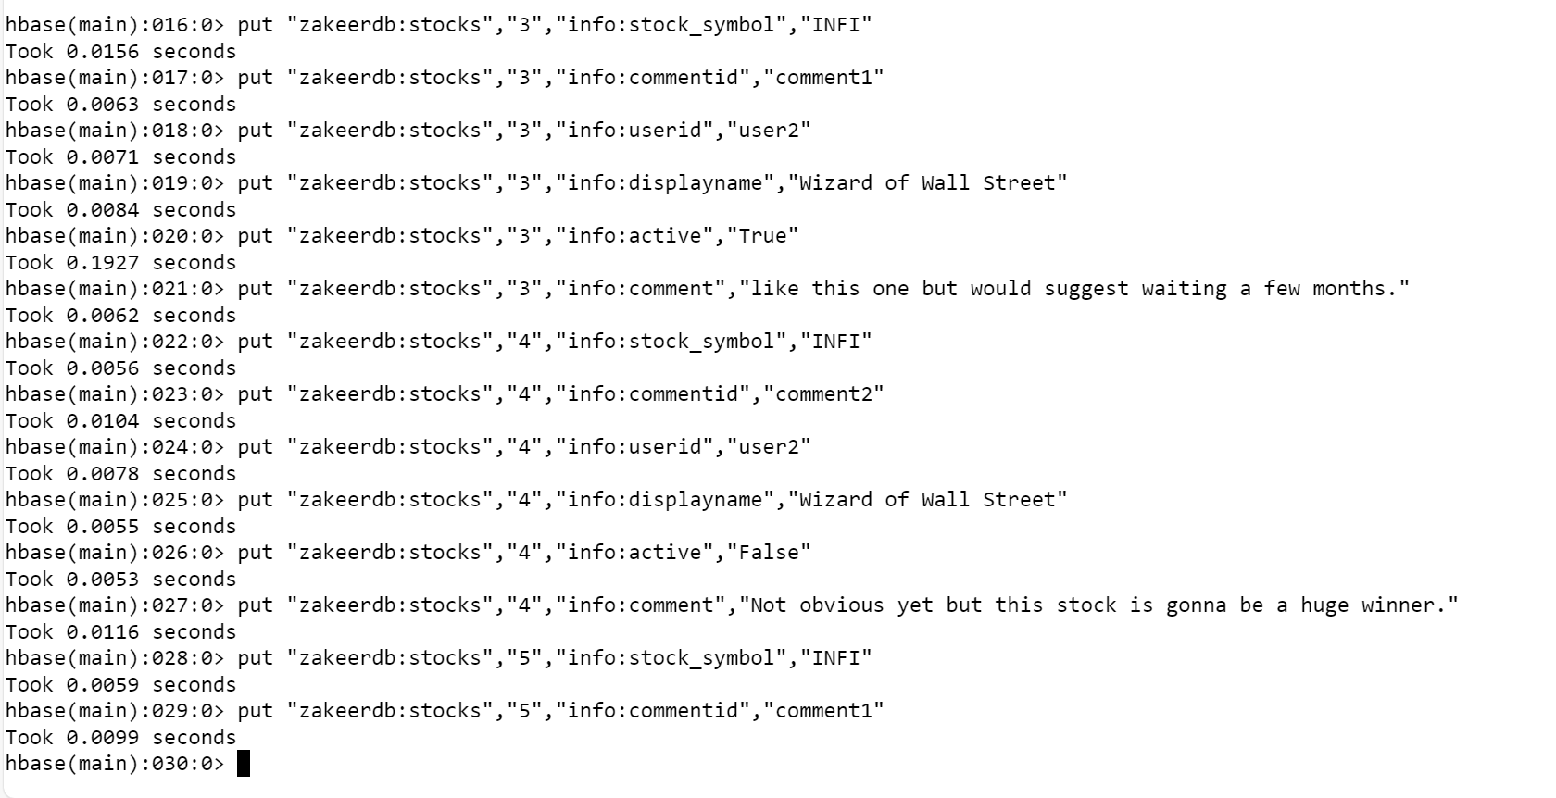

What are the various comments given by all the users?

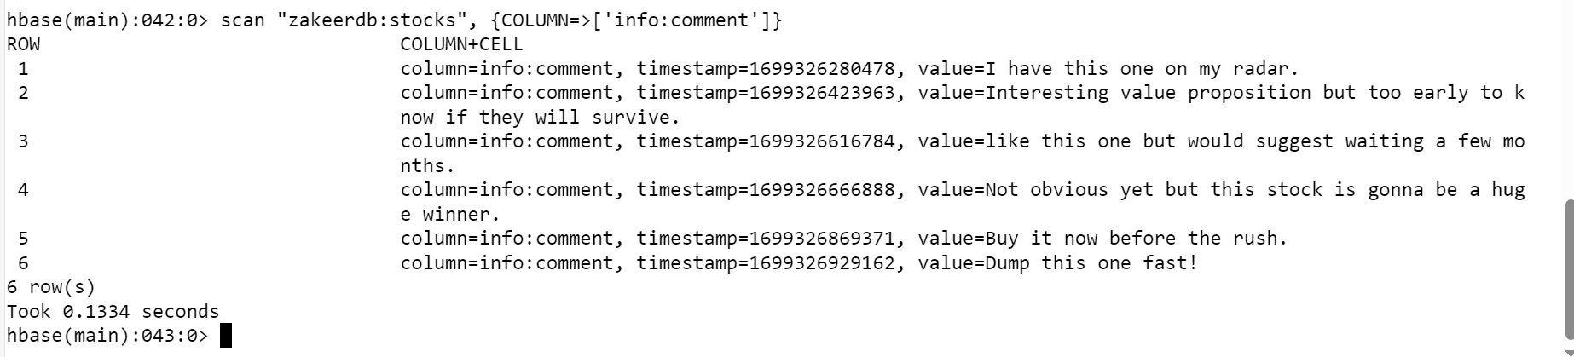

What are the comments by user3?

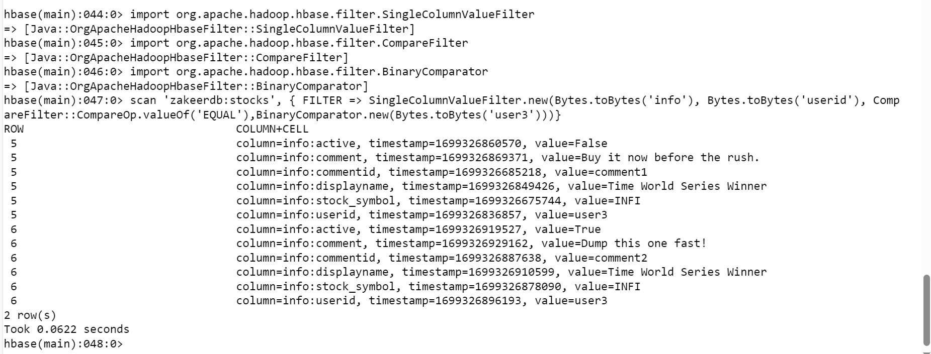

Which users have inactive comments?

