Task 2:

Access the hbase data from hive

For the above hbase table create a corresponding hive table and access the data by running queries in hive

Creating External table in Hive =>

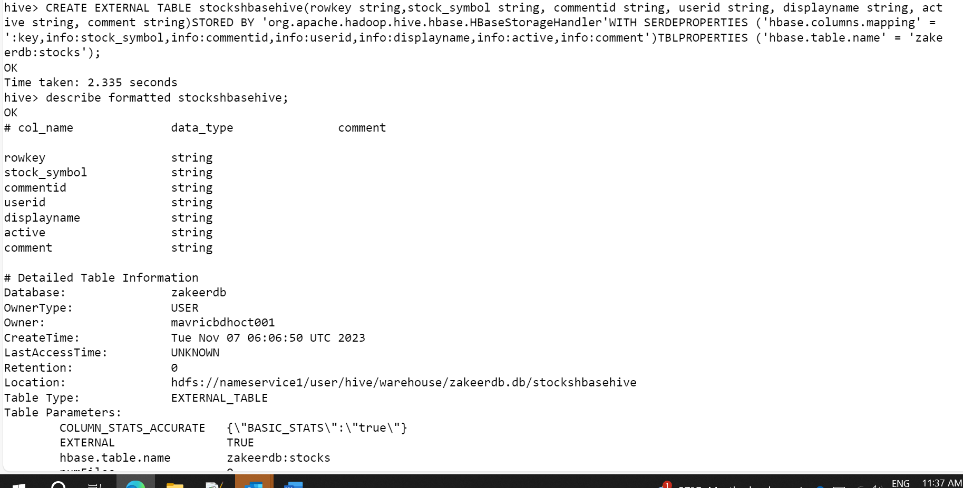

What are the various comments given by all the users?

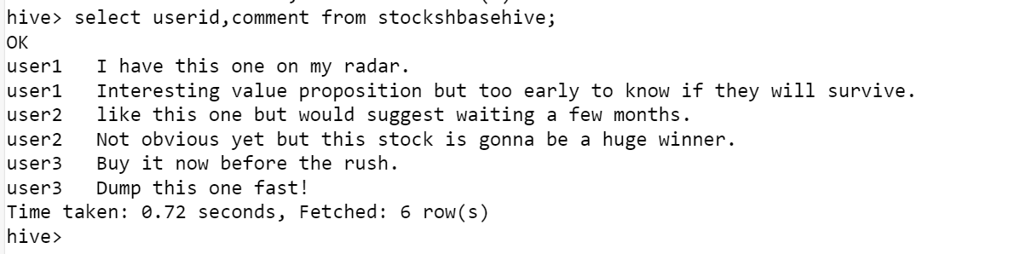

What are the comments by user3?

Which users have inactive comments?

