**Project background and description:**

1. To register for the game user, enter his/her details: username and user password.
2. Computer shows the message the registration is successful.
3. User enters his/her login credentials to start the game.
4. Cards are assigned to the users
5. Players flip their cards.
6. Player having the higher rank of card wins the round and the cards are added to his/her deck.
7. If the player’s card matches then the war starts between them.
8. Players draw four more cards from their deck and flip the fourth card.
9. The player with the highest rank on the fourth card wins the round.
10. The player who has all cards at the end will win the game.
11. If a player wants to exit the game at any time he/she can.
12. 1 point is given to the player who wins the round.

**Project Scope:**

There are four of us in the Runtime terror group, Ahmad Zaki Sultani, Manjot Kaur, Navneet Kaur, and Karan Mehta. We are planning to build a Card Game called War. We have a 15 minutes sprint meeting everyday where we plan how our game should work and which feature should it have. We split up the work by giving every group member a task to work on like, working on a specific method or class. Our game is going to be played in console.

**High – level Requirement**

* The game has a ability to resigter your username and password.
* The game will ask the user to login back.
* The game will have a print rules first and then it will ask you to start the game.
* The game will give status of the wins and loses.
* The game will also display the final winner.

**Implementation Plan**

We have a git repository and add all the group members as a collaborator.

Everybody is going to push and pull codes using git.

Git reop : https://github.com/zaki001/War

Screenshot of our repo:

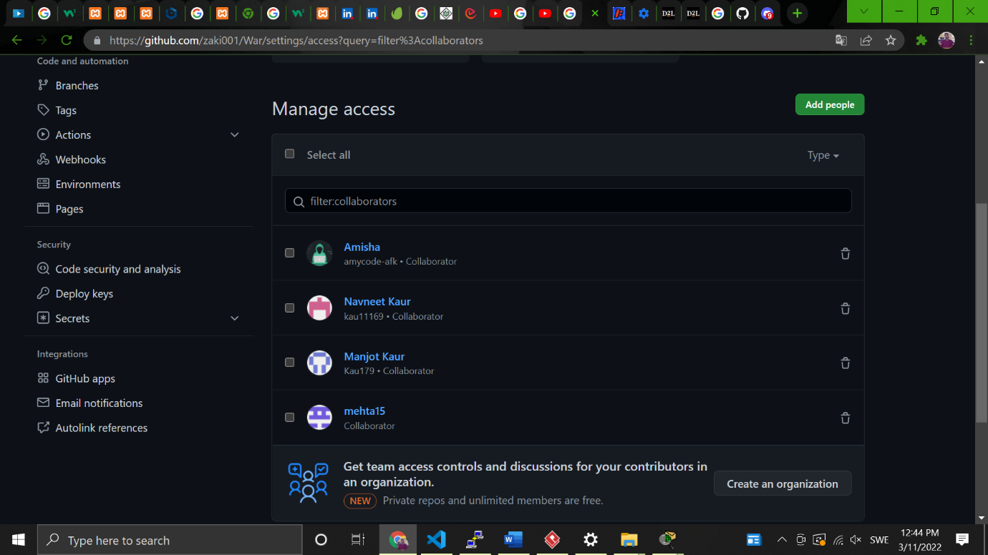

**Stakeholders:**

* Player: The one playing the game
* Experts: The ones reviewing the game and the code could be Professor, etc.
* Team members: Responsible for developing the whole game from scratch including coding, testing, running, etc.
* Public: The ones playing the game

**Actors:**

Players

|  |  |  |
| --- | --- | --- |
| Event | User Case | Event Type |
| User register for the game | Registration User | External |
| User login in the game with his/her credentials | Login user | External |
| Cards are distributed | Distribute cards | External |
| Players flip their cards | Flipping cards | External |
| If cards match war occur between players | Start War | Temporal |
| In the end, the winner is displayed | Displays Winner | External |

**USE CASE**

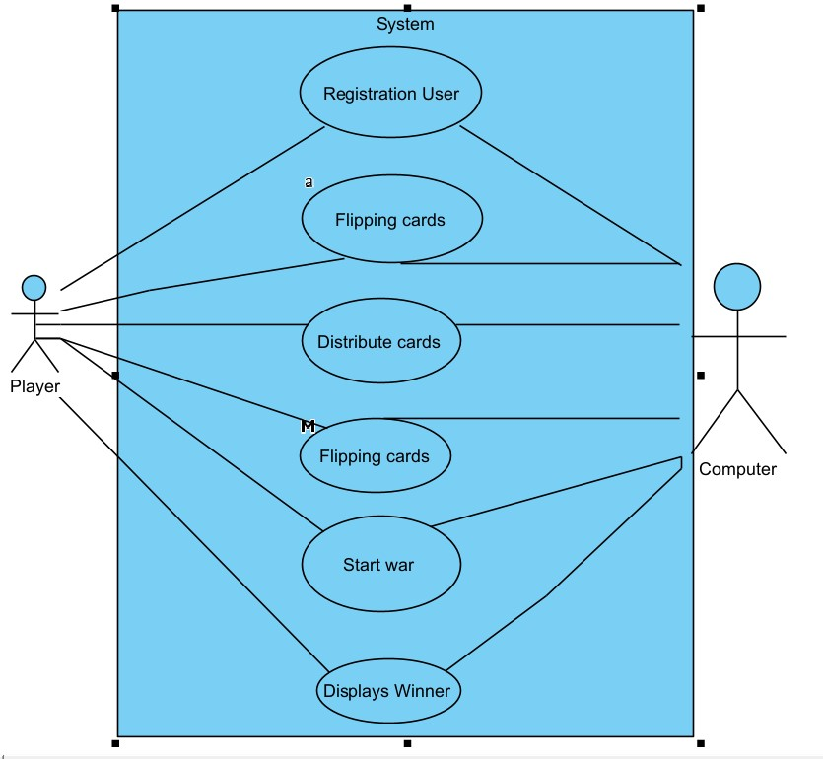

**This is a class diagram of our card game:**

