**Day 6: Deployment Preparation and Staging Environment Setup**

**NAME: Zakia Bashir**

**Roll No: 141704**

**Objective:**

Prepare the marketplace for deployment by setting up a staging environment and ensuring it's ready for customers.

**1. Hosting Platform Setup:**

* **Platform Chosen:** Vercel
* **Steps Taken:**
  1. Created an account and logged into Vercel.
  2. Connected the GitHub repository to Vercel.
  3. Configured build and deployment settings.
  4. Confirmed the staging environment was created and deployed successfully.

**2. Configuring Environment Variables:**

* **Environment Variables Used:** Stored API keys, database credentials, and other sensitive info in a .env file.
* **Steps Taken:**
  1. Created a .env file in the project root.
  2. Added variables like
     + NEXT_PUBLIC_SANITY_PROJECT_ID,
     + NEXT_PUBLIC_SANITY_DATASET,
     + and SANITY_API_TOKEN.
  3. Uploaded the environment variables through Vercel's dashboard.

**3. Deploying the Application:**

* Ran npm run build in the terminal to check for errors.

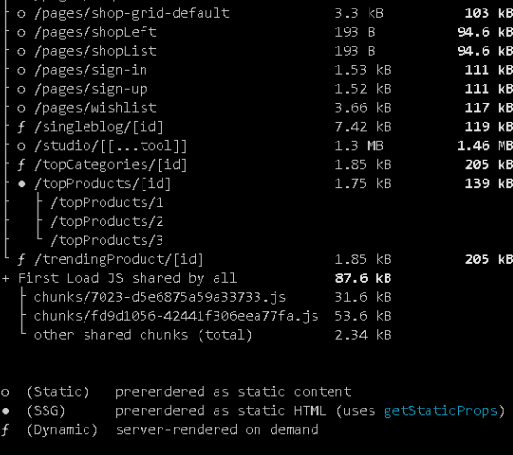

* Clicked the Deploy button on Vercel to trigger deployment.

**4. Testing the Staging Environment:**

* **Functional Testing:** Manually tested features like the product listing page and cart functionality.
* **Performance Testing:** Used Lighthouse and GTmetrix to analyze speed and responsiveness.

**Lighthouse:**

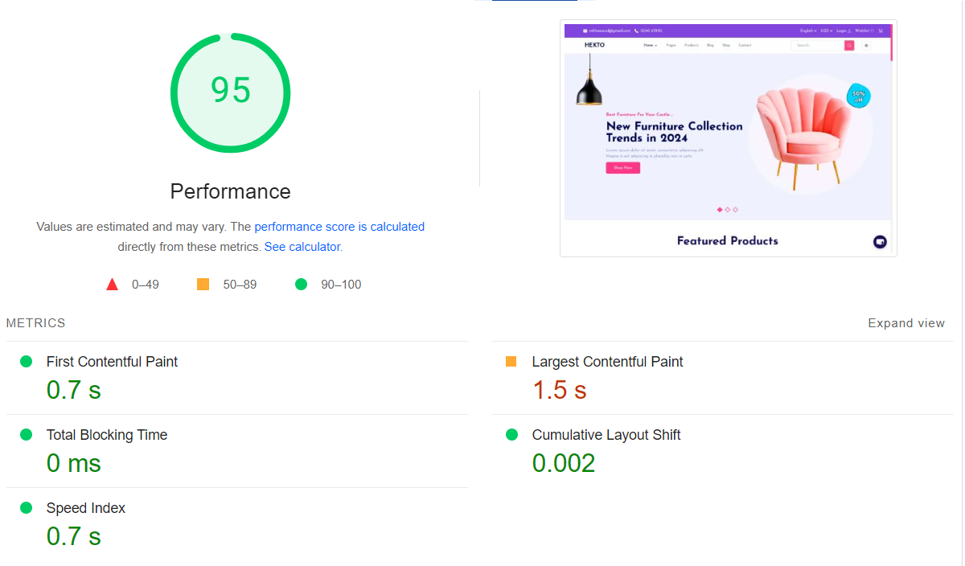

**GTmetrix:**

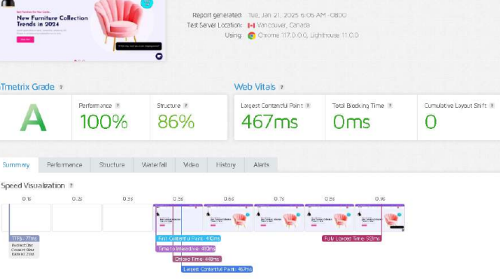

* **Security Testing:** Validated input fields, confirmed HTTPS was enabled, and checked for data encryption.

**5. Test Results:**

* **Functional Testing:** All major features worked as expected.
* **Performance Testing:** Passed performance tests with no significant issues.
* **Security Testing:** All input fields were secure, HTTPS was active, and no vulnerabilities were found.

**6. Documentation Created:**

* **Test Case Report:** Documented all test cases, steps, expected results, and actual results.
* **Performance Report:** Added Lighthouse performance test reports.
* **Deployment Documentation:** Updated the README.md file with deployment process, testing results, and steps for running the app.
* **File Organization:** Organized project files in a structured folder hierarchy.

**7. Project Structure:**

* **Folders:**
  + src/ for source code files.
  + public/ for static files like images and assets.
  + documents/ for all project documentation.
* **README.md:** Contains a summary of the project and steps for setup, deployment, and testing.

**Conclusion:**

By setting up a staging environment and ensuring all configurations were in place, the marketplace is ready for a customer-facing application. Testing and optimization confirmed the application's functionality, performance, and security. The deployment process was streamlined with Vercel, and environment variables were securely managed. Comprehensive documentation supports ongoing maintenance and collaboration. The project is well-structured, ensuring a smooth transition to a live production environment.