Use Cases for Online Code Compiler and Judging System

Main Actors
User (Student or Contestant): Submits solutions, participates in contests, receives feedback.
Administrator: Manages users, problems, and contests.
Judge Subsystem (Automated): Compiles, executes, and evaluates code based on predefined criteria.

Primary Use Cases

Use Case | Actor(s) | Description
Register Account | User | User creates a new system account for participation and submission.
Login/Logout | User, Admin | Authenticates users and manages secure sessions.
View Problem Set | User | Users browse or search available programming problems.
Submit Code Solution | User | Users upload their code for specific problems.
Receive Feedback/Result | User, Judge Subsystem | Upon judging, users can view verdicts (Accepted, Wrong Answer, TLE, etc.), score, and resource usage.
Participate in Contest | User | Users join and attempt problems within timed competition windows.
View Rankings | User | During or after contests, users see updated rankings and leaderboards.
View Submission History | User | Users access a personal history of past submissions and results.
Manage User Accounts | Administrator | Admin can add, edit, delete users or reset accounts.

Use Case | Actor(s) | Description
Manage Problem Set | Administrator | Admin can create, edit, or remove programming problems, including test cases and constraints.
Create/Manage Contests | Administrator | Admin schedules contests, assigns problems, oversees progress.
Judge Code Automatically | Judge Subsystem | System compiles, executes, tests user-submitted code, and computes verdicts and scores.
Monitor System/Logs | Administrator | Admin reviews system status, sandbox integrity, and historical logs for security and reliability.

Use Case Relationships
All users interact with core actions (registering, submitting code, viewing problems/results). Administrators extend (add/manage) users, problem sets, and contests.
The Judge Subsystem is invoked whenever code is submitted or called by an administrator for batch evaluation.

Use Case Diagram (Textual Description)

User:
→ Register, Login, Logout
→ View Problem Set, Submit Code Solution, Participate in Contest, View Rankings, View Submission History, Receive Feedback/Result

Administrator:
→ Login, Manage User Accounts, Manage Problem Set, Create/Manage Contests, Monitor System/Logs

Judge Subsystem:
← Invoked by code submission or contest action
→ Judge Code Automatically, return verdicts/feedback to users and administrators
Activity Diagram
- User Actions: Login to the system
Browse and select problems
Write or upload code
Submit code for judging
- System (Backend) Actions: Receive code submission
Compile and execute code in a secure sandbox
Evaluate the code using judge logic
Branch to outcome: Accepted, Wrong Answer, Compile Error, Time Limit Exceeded, Runtime Error
Provide feedback/results to the user
- Feedback Loop: If the submission is not accepted, the user may return to write or update the code and resubmit.

The following activity diagram illustrates these interactions and feedback paths in swim lanes for both the user and the system:

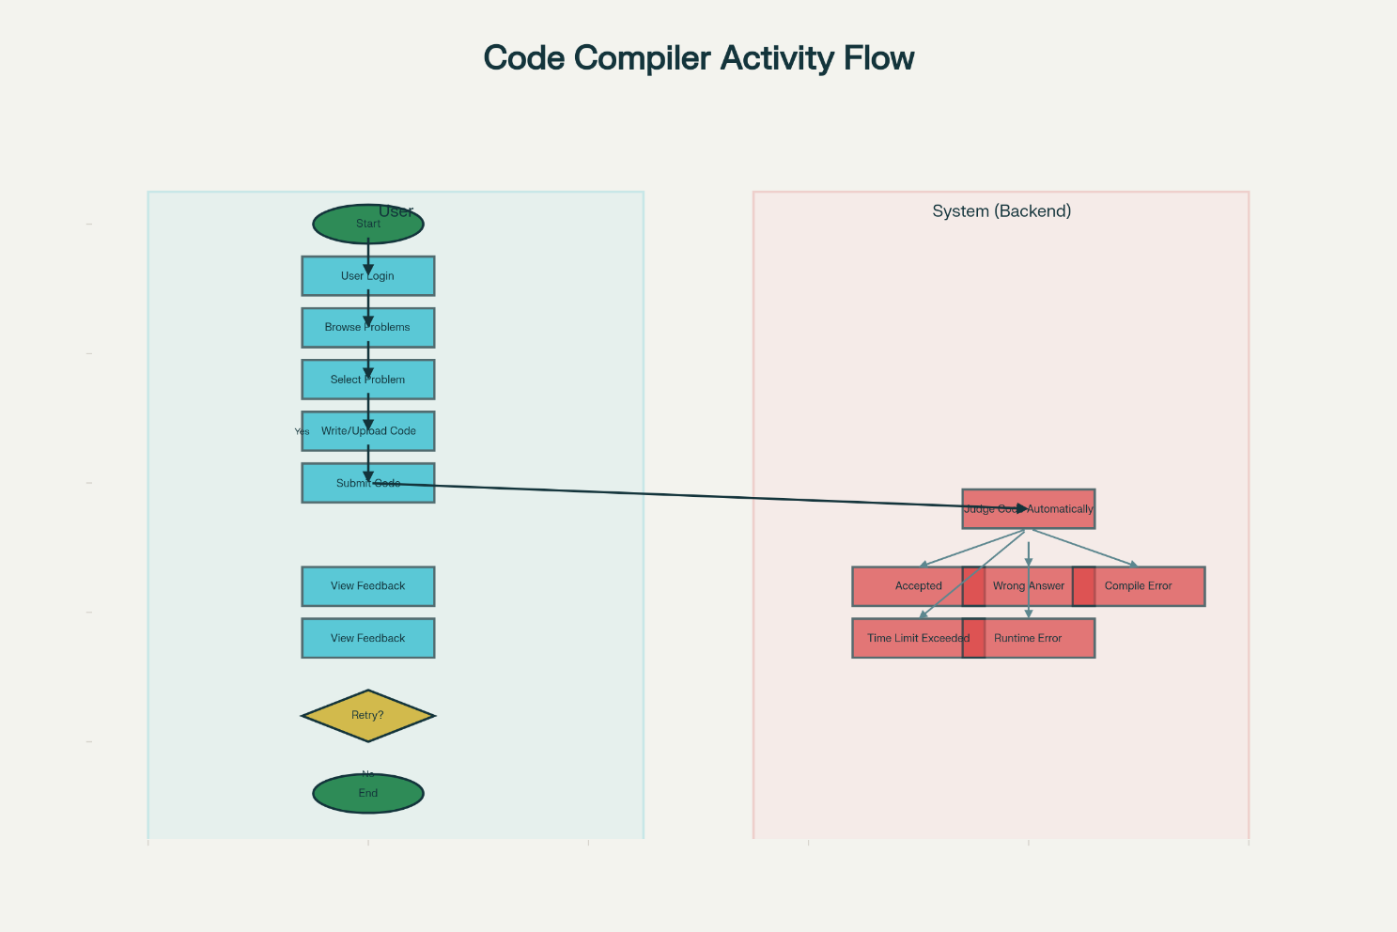

The diagram depicts the cycle from login to successful submission or iterative resubmission until solution acceptance, showing system processing, automated branches for multiple outcomes, and the user feedback loop.

