DESIGN AND IMPLEMENTATION OF AN ONLINE CODE COMPILER AND JUGDING SYSTEM FOR PROGRAMMING PRACTICES

BY

FATIMA ZAKIYYA ALI
(NEU/22/23/IFT/00234)

A PROJECT REPORT SUBMITTED TO THE DEPARTMENT OF COMPUTER SCIENCE, FACULTY OF SCIENCE AND COMPUTING,
NORTH-EASTERN UNIVERSITY, GOMBE.

IN PARTIAL FULFILLMENT OF THE REQUIREMENTS FOR THE AWARD OF BACHELOR OF SCIENCE (BSc) IN INFORMATION TECHNOLOGY.

JULY, 2026.

DECLARATION
I hereby declare that I carried out the work reported in this project in the Department of Computer Science, Faculty of Computing, North-Eastern University, Gombe, under the supervision of MRS Hauwa Abubakar Bello.
I also declare that to the best of my knowledge; no part of this Report has been presented in any previous work. All sources of knowledge used have been duly acknowledged.

Signature/Date----------------------------------
FATIMA ZAKIYYA ALI
(NEU/22/23/IFT/00234)

CERTIFICATION
This is to certify that this Project titled “DESIGN AND IMPLEMENTATION OF AN ONLINE CODE COMPILER AND JUDGING SYSTEM FOR PROGRAMMING PRACTICES” was carried out by FATIMA ZAKIYYA ALI with Matriculation Number NEU/22/23/IFT/000234 meets the requirements and regulations governing the award of the Bachelor Degree (BSc) of the North-Eastern University, Gombe in Information Technology and is approved for its contribution to knowledge and literary presentation.

Supervisor: Signature/Date-----------------------------------------------
Name: MRS HAUWA ABUBAKAR BELLO

Dean Faculty of computing: Signature/Date-----------------------------------------------
Name: PROF. MUHAMMAD ARDO BAMANGA

External Examiner: Signature/Date-----------------------------------------------
Name: PROF. ETEMI JOSHUA GARBA

HOD: Signature/Date-----------------------------------------------
Name: Mr. YAHYA ABDULLAHI YUSUF

DEDICATION
This project is dedicated to Almighty God for His guidance, wisdom, and protection throughout the course of this study. It is also dedicated to my beloved parents, family, and well-wishers whose prayers, sacrifices, encouragement, and unwavering support have been a constant source of motivation. Their belief in my ability inspired me to persevere and successfully complete this project.

ACKNOWLEDGEMENTS
First and foremost, I wish to express my deepest gratitude to God Almighty, for His boundless grace, wisdom and strength. Without His divine guidance and countless blessings, this work would not have been possible.
I extend my sincere and heartfelt thanks to my Project Supervisor, Mrs. Hauwa Abubakar Bello, whose expertise, patience, and constant encouragement shaped this research from start to finish. Your insightful feedback and dedication are deeply appreciated.
I am also grateful to the Head of Department (HOD) and the Dean of the faculty of science and computing for providing the necessary resources, support and an enabling academic environment. Your leadership has been invaluable.
My appreciation goes to all my Lecturers in the Department of Computer Science. Your teachings and mentorship throughout my academic journey have laid the foundation for this achievement.
To my beloved relations my parents, siblings and extended family, thank you for your endless prayers, sacrifices and unwavering belief in me. Your love has been my anchor.
Lastly, to my Friends and others who walked this path with me, offering encouragement, late-night assistance and moments of laughter, I am truly thankful. Your support made the difficult days bearable.

ABSTRACT
The increasing demand for programming skills in academic and professional environments has created the need for platforms that support coding practice, automated assessment, and instant feedback. This project presents the design and implementation of an Online Code Compiler and Judging System that enables users to write, compile, execute, and evaluate source code through a web-based interface without requiring local software installation. The system was developed using a modular client-server architecture that separates the user interface from the code execution engine, improving security, scalability, and performance. It supports multiple programming languages and includes an automated judging module that evaluates user submissions against predefined test cases. To ensure secure execution of user programs, sandboxing techniques and resource limitations were implemented. The platform also provides real-time feedback, helping users identify and correct errors efficiently. A systematic development process involving requirements analysis, system design, implementation, and testing was adopted. Performance evaluation showed that the system can successfully compile and execute programs, validate outputs against hidden test cases, and enforce execution time and memory constraints. The results demonstrate that the platform effectively automates programming assessment, reduces environment configuration challenges, and enhances the learning experience of students. Overall, the developed system provides a secure, scalable, and efficient solution for programming education and assessment in academic institutions.
Keywords: Online Code Compiler, Online Judge System, Automated Assessment, Programming Education, Web-Based IDE, Code Execution, Sandboxing, Software Development.

TABLE OF CONTENTS
DECLARATION i
CERTIFICATION ii
DEDICATION iii
ACKNOWLEDGEMENTS iv
ABSTRACT v
TABLE OF CONTENTS vi
LIST OF FIGURES ix
LIST OF TABLES x
CHAPTER ONE 1
INTRODUCTION 1
1.1 Introduction 1
1.2 Background of the Study 1
1.3 Problem Statement 2
1.4 Aim and Objectives 3
1.4.1 Aim 3
1.4.2 Objectives 3
1.5 Research Questions 3
1.6 Significance of the Study 4
1.7 Scope and Limitations 4
1.7.1 Scope 4
1.7.2 Limitations 5
1.8 Organization of the Report 5
1.9 Definition of Terms 5
CHAPTER TWO 8
LITERATURE REVIEW 8
2.1 Introduction 8
2.2 Historical Evolution of Online Judge Systems 8
2.3 Thematic Review of Related Work 9
2.3.1 Evolution of Web-Based Integrated Development Environments (Web-IDEs) 9
2.3.2 Architectures of Online Judge (OJ) Systems 10
2.3.3 Automated Assessment and Feedback Mechanisms 10
2.3.4 Security and Sandboxing in Remote Code Execution 11
2.4 Identification of the Research Gap 11
2.5 Research Gaps 12
CHAPTER THREE 15
METHODOLOGY 15
3.1 Introduction 15
3.2 Requirements Analysis 15
3.2.1 Functional Requirements 15
3.2.2 Non-Functional Requirements 16
3.3 System Architecture and Design 16
3.3.1 High-Level System Architecture 17
3.3.2 Use Case Diagram (UML) 17
3.3.3 Activity Diagram 18
3.3.4 Data Flow Diagram (DFD) - Level 1 19
3.3.5 Sequence Diagram (Dynamic Behaviour) 19
3.3.6 Enhanced Entity Relationship Diagram (EER Diagram) 20
3.4 Technology Stack 21
3.5 Data Description 22
3.6 Algorithm Implementation Details 23
3.7 Testing Strategy 23
CHAPTER FOUR 25
SYSTEM IMPLEMENTATION, RESULTS AND TESTING 25
4.1 Introduction 25
4.2 Implementation 25
4.3 Results 26
4.3.1 Test Case 1: Code Compilation and Execution 26
4.3.2 Test Case 2: Automated Judging and Test Case Validation 27
4.3.3 Test Case 3: Execution Time and Memory Limits 28
4.4 Discussion of Results 28
4.5 System testing 29
4.6 Conversion 29
4.7 Documentation 30
4.8 System Maintenance 30
CHAPTER FIVE 31
SUMMARY, CONCLUSIONS AND RECOMMENDATION 31
5.1 Introduction 31
5.2 Summary 31
5.3 Conclusion 32
5.4 Recommendations 32
References 34

LIST OF FIGURES
Figure 3.1: Use Case Diagram of the System (Online Compiler) 18
Figure 3.2: Activity Diagram of Online Compiler 18
Figure 3.3: Data Flow Diagram of the System (Online Compiler) 19
Figure 3.4: Sequence Diagram of the System (Online Compiler) 20
Figure 3.5: EER Diagram of Online Compiler 21
Figure 4.1: Splash Screen of the System (Online Compiler) 26
Figure 4.2: Execution of the Program 27
Figure 4.3: Automated Judging of the Program 28

LIST OF TABLES
Table 2.1: Research Summary of Reviewed Papers 12
Table 3.1: Use Case Description 17
Table 3.2: Technology Stack 22
Table 4.1: System Testing 29

CHAPTER ONE

INTRODUCTION

1.1 Introduction
The advancement of information and communication technology has significantly transformed the way programming is taught, practiced, and assessed in educational institutions. As software development continues to play a vital role in modern society, there is an increasing demand for efficient tools that support programming education and skill development. Traditional methods of programming practice often require the installation of compilers and development environments on local computers, which may present configuration challenges and inconsistencies across different platforms.
To address these challenges, web-based programming platforms have emerged as effective solutions that enable users to write, compile, execute, and evaluate code directly through a web browser. These platforms provide immediate feedback, reduce setup complexities, and support automated assessment of programming tasks. Consequently, online code compilers and judging systems have become important tools for both learners and instructors.
This chapter introduces the research topic, provides the background of the study, identifies the problem being addressed, and presents the aim and objectives of the project. It also discusses the research questions, significance of the study, scope and limitations, organization of the report, and definitions of key terms used throughout the study.

1.2 Background of the Study
The rapid evolution of the digital age has made computer programming one of the most essential skills in the modern workforce. As the demand for software development capabilities grows across industries, educational institutions and training canters are under increasing pressure to produce competent programmers. Consequently, the methods used to teach, practice, and evaluate programming skills have become a critical area of interest in Computer Science education.
Traditionally, programming education relied heavily on local development environments where students had to install compilers and Integrated Development Environments (IDEs) on their personal machines. While effective for experienced developers, this approach presents significant barriers for beginners, including complex configuration processes, compatibility issues across different operating systems, and hardware limitations. Furthermore, the evaluation of programming assignments has historically been a manual process. Instructors often spend excessive time reviewing code syntax and logic, a method that is not only labour-intensive but also prone to human error and inconsistency.(Dai et al., 2024)
The rise of cloud computing and web technologies has paved the way for a paradigm shift: the Online Judge (OJ) and Cloud Compiler. These systems allow users to write, compile, and execute code directly in a web browser, providing immediate feedback on correctness and efficiency. Platforms like LeetCode and Hacker Rank have popularized this model for interview preparation. However, there remains a distinct need for customizable, academic-centric systems that can be deployed by institutions to manage specific curriculums, reduce the overhead of local environment setup, and provide automated, standardized assessment.

1.3 Problem Statement
Despite the availability of various commercial coding platforms, academic institutions often face significant challenges in managing practical programming sessions effectively. The specific gaps this project addresses are:
- Inefficiency of Manual Grading: Manual evaluation of programming assignments is time-consuming and subjective. It often leads to delayed feedback, preventing students from learning from their mistakes in real-time.
- Environment Configuration Friction: Beginners frequently struggle with setting up local compilers (e.g., GCC, JDK) and IDEs. "It works on my machine" issues often arise where code runs locally for a student but fails on the instructor’s machine due to environmental differences.(Park et al., 2025)
- Lack of Immediate Feedback Mechanisms: In traditional submission systems (like email or basic file uploads), students do not know if their logic handles edge cases correctly until days later when grades are returned.
- Security Risks in Remote Execution: Implementing a system that allows users to run arbitrary code on a server presents severe security risks (e.g., infinite loops, fork bombs, or accessing system files). Many existing open-source solutions are either too complex to deploy or lack sufficient sandboxing to be safe for institutional use.
Therefore, there is a need for a secure, web-based Online Code Compiler and Judging System that automates the evaluation process, eliminates local setup requirements, and provides instant, standardized feedback to users.

1.4 Aim and Objectives

1.4.1 Aim
The primary aim of this project is to design and develop a secure, web-based Online Code Compiler and Judging System that facilitates programming practice by providing an integrated environment for writing code and automated mechanisms for testing and submissions.

1.4.2 Objectives
To achieve this aim, the specific objectives of the study are:
- To design a system architecture that separates the web interface from the execution engine to ensure security and scalability.
- To implement a web-based code editor with syntax highlighting and support for multiple programming languages (e.g., Python, C++, Java).
- To develop an automated judging engine that compares user output against pre-defined test cases to determine correctness (Accepted, Wrong Answer, Time Limit Exceeded, Compilation Error).

1.5 Research Questions
Based on the objectives, this study seeks to answer the following questions:
- How can a web-based interface effectively replicate the functionality of a local IDE for programming practice?
- What architectural patterns are best suited for isolating user-submitted code to prevent security breaches on the server?
- How can the system efficiently handle concurrent code submissions without significant latency in providing feedback?

1.6 Significance of the Study
The development of this system holds significant value for various stakeholders:
- For Students: It provides a hassle-free learning environment where they can practice coding from any device with internet access. The immediate feedback loop helps them correct errors instantly, accelerating the learning curve.(Park et al., 2025)
- For Instructors/Lecturers: It drastically reduces the workload associated with grading. By automating the checking of test cases, instructors can focus more on teaching concepts rather than debugging syntax errors in student submissions.
- For the Academic Institution: It offers a standardized platform for conducting exams and lab tests, ensuring that all students are evaluated under the exact same conditions (same compiler version, same time limits), thereby ensuring academic fairness.
- Contribution to Knowledge: This project demonstrates the practical application of containerization technology (Docker) in educational software tools, contributing to the field of automated software testing and secure remote code execution.(Novi, n.d.)

1.7 Scope and Limitations

1.7.1 Scope
The study focuses on the design and implementation of the web application and the backend execution engine.
- Functionality: The system will support user authentication, problem viewing, code submission, and a results dashboard.
- Languages: The prototype will focus on supporting 2–3 popular languages (e.g., Python, C++, and Java).(Liang et al., 2017)
- Judging: The system will evaluate code based on standard input/output comparison, time limits, and memory usage.

1.7.2 Limitations
- Network Dependency: As a web-based system, it requires a stable internet connection to function; it cannot be used offline.(Park et al., 2025)
- Complexity of Analysis: The system checks for functional correctness (input/output) but may not analyse code style or semantic logic (e.g., it may accept inefficient code as long as it passes the time limit).
- Hardware Constraints: The speed of compilation and execution is dependent on the host server’s resources. Heavy loads during concurrent usage may result in slower feedback times during the testing phase.
- Security Scope: While sandboxing will be implemented, guarding against extremely sophisticated zero-day exploits is outside the scope of this undergraduate project.

1.8 Organization of the Report
The remainder of this project report is organized as follows:
- Chapter Two (Literature Review): Reviews relevant theories, existing systems, and technologies related to online compilers and automated grading.
- Chapter Three (Methodology): Details the system analysis, design specifications, architectural diagrams, and the technologies used for implementation (e.g., the software development life cycle adopted).
- Chapter Four (Implementation and Testing): Presents the actual code implementation, screenshots of the system, and the results of system testing and validation.
- Chapter Five (Conclusion and Recommendations): Summarizes the findings, discusses the challenges encountered, and offers recommendations for future enhancements.

1.9 Definition of Terms
- Algorithm: A structured sequence of actions created to accomplish a particular task or provide a solution to a defined problem, commonly used in computer programming.(Dai et al., 2024)
- Application Programming Interface (API): A set of rules and protocols that allows different software applications to communicate with one another.(Rahman et al., 2023)
- Automated Judging System: A software application that automatically assesses submitted code by compiling it and running it against a set of predefined test cases to determine correctness.(Parvathy et al., 2025)
- Code Compiler: A software utility that converts source code written in a programming language into a form that can be understood and executed by a computer.(Sparta et al., 2017)
- Containerization: A simple technology that lets applications run in their own separate spaces, helping keep them secure and working the same way everywhere.(Novi, n.d.)
- Database: An organized set of structured information stored electronically and controlled using a Database Management System (DBMS).(Liang et al., 2017)
- Docker: An open-source tool that helps build, package, and run applications inside containers, allowing user-submitted code to execute safely.(Liang et al., 2017)
- Frontend: The part of a software application that users interact with directly, responsible for displaying information and receiving user input.(Cedazo et al., n.d.)
- Backend: The server-side part of a system that manages core operations, processes data, and interacts with the database.(Pan et al., 2022)
- Integrated Development Environment (IDE): A software program that offers a complete set of tools for coding, compiling, and troubleshooting programs.(Frankford et al., 2024)
- Online Code Compiler: An online platform that enables users to write, compile, and run code directly in a web browser without needing to install software locally.(Mehta & Rani, 2024)
- Programming Language: A structured language used to create instructions that a computer can understand and execute, like Python, C, C++, or Java.(Sparta et al., 2017)
- Sandbox Environment: A protected and separate environment where untrusted code can run safely without impacting the main system.(Liang et al., 2017)
- Test Case: A collection of input data and their corresponding expected results used to check if a program works correctly.(Brasoveanu et al., 2020)
- User Interface (UI): The graphical elements that allow users to engage with and navigate a software application.(Aldriye et al., 2019)
- User Acceptance Testing (UAT): The visual interface elements that enable users to interact with and control a software application.(Messer et al., 2024)

CHAPTER TWO

LITERATURE REVIEW

2.1 Introduction
Online judging started with basic grading software back in the 60s; over time it branched off into different kinds – some used for competitions, others helping schools or hiring, while a few focus on tasks driven by datasets.(Frankford et al., 2024)
This chapter presents a critical review of existing literature and technologies relevant to the design and implementation of Online Code Compilers and Judging Systems. The review is organized thematically, moving from the evolution of web-based programming environments to the specific mechanisms of automated assessment and the critical security challenges inherent in Remote Code Execution (RCE). The chapter synthesizes findings from recent academic studies and technical reports to establish the current state-of-the-art. Finally, a gap analysis is conducted to highlight the limitations of existing systems, justifying the necessity of the proposed project.(Park et al., 2025)

2.2 Historical Evolution of Online Judge Systems
Back in the 1960s, Stanford started testing student code by running it through computers that checked outputs based on set inputs. Though these systems ran jobs in groups and only worked within one school, they kicked off the concept of using tests to grade coding reliably over time. (Brasoveanu et al., 2020)
In the '70s and ’80s, coding competitions like ACM International Collegiate Programming Content (ICPC) - launched in 1970 - and eventually IOI, which began in 1989, sparked a need for automatic grading to manage tons of entries fast without bias. Back then, people ran checks using basic tools on single machines plus some hands-on work; however, things shifted toward web-linked setups capable of building code, running it, then scoring results almost instantly. These upgrades helped shape what we now know as today’s internet-based judge platforms. (Brasoveanu et al., 2020)
The phrase "online judge" got pinned down about 2001, referring to sites that automatically check code, executables, or text answers right away. Since the early 2000s, better net availability opened up these platforms to everyone, so users could tackle old competition tasks anytime - bypassing one-off events for steady training plus score tracking. (Brasoveanu et al., 2020)
In the 2000s, online judges started moving past competitions - schools began using them for coursework and test prep through websites. Meanwhile, businesses built similar tools into hiring processes to handle tons of code tests automatically, giving instant grades plus feedback. (Brasoveanu et al., 2020)
Lately, web-based grading tools started running contests focused on data hunting and problem solving - people send in results or scripts to get scored against secret tests. That shift pushed things toward "on-demand scoring," sometimes called EaaS. At the same time, handling big competitions and classes made folks push for networked judging setups systems like MetaOJ, where judging setups sit close to players tied together through a control level that handles tasks and contest flow.(Brasoveanu et al., 2020) (Wang et al., 2021)
This story of change explains why tools like this matter in a project about building an online coding evaluator - showing how they’ve grown from basic offline checks to fast, web-based, networked scoring - not just tech progress but also lessons pulled from years of use in competitions, schools, maybe even server farms.

2.3 Thematic Review of Related Work

2.3.1 Evolution of Web-Based Integrated Development Environments (Web-IDEs)
The shift from local development environments to cloud-based solutions has been a dominant trend in Computer Science education. Traditional methods required students to install complex toolchains (compilers, debuggers, and libraries) on personal machines, often leading to compatibility issues known as the "it works on my machine" syndrome. Recent studies highlight the efficacy of Web-IDEs in mitigating these barriers.(Park et al., 2025)
For instance, Code Dive (Park et al., 2025) introduced a web-based IDE designed specifically for university-level courses, utilizing a backend storage system to maintain persistent student workspaces. Their study demonstrated that removing the initial setup friction significantly increased student engagement and submission rates. Similarly, commercial platforms like Codio and Code Anywhere have popularized the "infrastructure-as-a-service" model for education, allowing instructors to provision standardized environments instantly. However, while these commercial solutions are robust, they often come with high licensing costs that are prohibitive for many educational institutions in developing regions.(Pan et al., 2022)

2.3.2 Architectures of Online Judge (OJ) Systems
The architecture of Online Judge systems has evolved from simple monolithic scripts to complex, cloud-native microservices. Early systems, such as the widely used DOM judge, often ran the web interface and the judging daemon on the same server, creating potential bottlenecks under heavy load.(Dai et al., 2024)
In a significant recent advancement, Wu et al. (2024) (Pan et al., 2022) proposed a "Cloud-Native Online Judge System" that utilizes microservices and event-driven architecture. Their research highlighted that decoupling the Submission Service (which receives code) from the Judge Service (which executes code) allows for horizontal scalability, enabling the system to handle thousands of concurrent submissions during contests. Furthermore, (Novi, n.d.) Yuan (2024) explored the use of Docker containers to create lightweight, course-oriented OJ systems. This approach contrasts with older virtualization methods (like VirtualBox), offering a faster startup time for isolation environments, which is crucial for providing real-time feedback to students.

2.3.3 Automated Assessment and Feedback Mechanisms
Automated assessment is the core functionality of any Online Judge. Historically, systems relied on "Black-Box Testing," where the student's code is executed against hidden input data, and the output is compared strictly against expected results.(Cedazo et al., n.d.)
Recent literature suggests a move towards more pedagogical, "Glass-Box" approaches. Nnadi et al. (2024) (Seo et al., 2021) investigated the integration of Explainable Artificial Intelligence (XAI) into OJ systems. Their study argued that binary feedback (e.g., "Pass/Fail") is insufficient for learning; instead, systems should analyse submission behaviour to identify struggling students. Similarly, (Dai et al., 2024) developed a "Programming Learning Engagement Assessment Model," which uses data mining on OJ logs to classify student learning patterns. These studies indicate a gap in many standard open-source OJs, which still prioritize speed and correctness over detailed, formative feedback that helps a student understand why their code failed.

2.3.4 Security and Sandboxing in Remote Code Execution
Allowing users to execute arbitrary code on a server is inherently dangerous. Security is, therefore, the most critical theme in the literature. The primary threat is Remote Code Execution (RCE) attacks, where malicious users attempt to access the host file system or consume infinite resources (e.g., Fork Bombs).(Kuo et al., 2023; Stammerjohann, 2016)
Prins et al. (2022) (Novi, n.d.) discussed the role of containerization in "Trusted Computing," arguing that modern container runtimes (like Docker and run C) provide a more robust isolation layer than the traditional Linux chroot jails used in older OJs. However, a 2026 empirical study on RCE in machine learning hosting ecosystems (arXiv:2601.14163) revealed that even modern environments are vulnerable to deserialization attacks (e.g., Python pickle exploits) if not properly sanitized. This literature underscores the necessity of a multi-layered security approach: using Linux Control Groups (cgroups) to limit CPU/RAM usage and mounting read-only file systems to prevent data tampering.

2.4 Identification of the Research Gap
Despite the abundance of literature on Online Judges, a specific gap exists in the availability of lightweight, secure, and feedback-oriented systems suitable for small-to-medium academic deployments.
- Complexity vs. Usability: Advanced systems like the one proposed by Wu et al. (2024) rely on complex Kubernetes clusters, which are often overkill and too difficult for a single institution to maintain.
- Lack of Formative Feedback: As noted by Nnadi et al. (2024), most open-source OJs are designed for competitive programming (optimizing for speed and strict correctness), not for educational practice (where detailed error messages and partial credit are valuable).
- Security Implementation: Many "easy-to-install" academic projects found in open repositories lack rigorous sandboxing, relying on simple timeouts rather than robust containerization, leaving them vulnerable to the RCE attacks described in recent security reports.(Stammerjohann, 2016)
Therefore, this project seeks to fill this gap by designing a system that balances enterprise-grade security (via Docker) with educational usability, providing a simplified deployment model for institutions without requiring the overhead of a full commercial SaaS subscription.(Park et al., 2025)

2.5 Research Gaps
The reviewed literature shows that existing systems either prioritize scalability and competition-oriented judging, educational feedback, or execution security. However, there is a lack of a lightweight, secure, and educationally focused online code compiler and judging system that can be easily deployed by academic institutions without requiring complex cloud infrastructure or expensive commercial subscriptions. Therefore, this project proposes a web-based Online Code Compiler and Judging System that integrates secure code execution, automated assessment, real-time feedback, and simplified deployment to support programming education effectively.
Table 2.1: Research Summary of Reviewed Papers
Author(s) | Year | Model/System Reviewed | Key Contribution | Identified Gap | Proposed System Contribution
Brasoveanu et al. | 2020 | Historical Online Judge Systems | Discussed the evolution of online judging platforms from academic grading systems to modern web-based judges. | Focuses on historical development rather than implementation of secure educational systems. | Provides a modern educational platform with integrated compilation and judging features.
Liang et al. | 2017 | Online Automatic Judging System | Designed an automated code evaluation framework for programming courses. | Limited security mechanisms and support for modern cloud deployment. | Uses secure execution environments and scalable web-based architecture.
Wang et al. | 2021 | MetaOJ Distributed Online Judge | Developed a distributed online judging architecture for large-scale competitions. | Complex deployment and infrastructure requirements for educational institutions. | Offers a lightweight and institution-friendly deployment model.
Pan, Liu & Wu | 2022 | Cloud-Native Online Judge System | Implemented a microservices-based cloud-native judging platform. | Requires advanced cloud infrastructure and technical expertise. | Simplifies deployment while maintaining efficient automated assessment.
Kuo et al. | 2023 | Sandbox-Based Online Judge Security Model | Investigated security mechanisms for executing untrusted code. | Primarily focused on security without emphasizing educational usability. | Balances security with user-friendly learning features and automated feedback.
Dai, Lv & Zhang | 2024 | Programming Learning Engagement Assessment Model | Used online judge data to assess student learning engagement. | Focused on learning analytics rather than secure code execution. | Integrates automated assessment with secure execution and real-time feedback.
Frankford et al. | 2024 | Online IDE for Automated Programming Assessment | Proposed requirements for web-based integrated development environments. | Did not provide a complete implementation of a judging and compilation platform. | Combines IDE functionality with automated judging and evaluation.
Wu, Li & Wang | 2024 | Cloud-Native Online Judge Using Microservices | Introduced an event-driven architecture for scalable online judges. | High complexity and maintenance cost for smaller institutions. | Provides a simpler architecture suitable for academic deployment.
Park et al. | 2025 | CodeDive Web-Based IDE | Developed a web-based IDE with real-time activity monitoring for programming education. | Focuses on code editing and monitoring but lacks advanced automated judging features. | Incorporates automated judging, secure execution, and performance evaluation.
Parvathy et al. | 2025 | Automated Code Assessment and Feedback Model | Enhanced automated programming assessment with improved feedback mechanisms. | Limited emphasis on execution security and institutional deployment. | Combines secure execution, automated assessment, and educational feedback.

CHAPTER THREE

METHODOLOGY

3.1 Introduction
Methodology provides a systematic framework for designing, developing, and evaluating a software system. It outlines the procedures, techniques, tools, and technologies employed to achieve the objectives of the study. A well-defined methodology ensures that the development process is organized, efficient, and capable of producing reliable results.
The development of an Online Code Compiler and Judging System requires careful analysis of user requirements, system architecture, database design, execution mechanisms, and security considerations. The system must be capable of compiling and executing code securely while providing accurate evaluation results and immediate feedback to users. Therefore, an appropriate design approach is necessary to ensure functionality, scalability, and reliability.
This chapter outlines the structured design and methodological approach used to build the online code compiler and judging system. It covers the key architectural concepts, functional and non-functional requirements, security frameworks, performance optimization techniques, and the experimental procedures used for evaluation. (Brasoveanu et al., 2020; Liang et al., 2017; Wang et al., 2021)

3.2 Requirements Analysis
The requirements analysis for the design and implementation of an online code compiler and judging system addresses both functional requirements (the tasks the system must perform) and non-functional requirements (qualities, performance, and constraints). These requirements are typically structured according to key stakeholders: students or contestants, instructors and administrators, system operators, and security personnel.(Liang et al., 2017)

3.2.1 Functional Requirements
Functional requirements specify the tasks and operations the online code compiler and judging system must perform. These define the core behaviours and functions of the system:
- Problem Management: Administrators must be able to Create, Read, Update, and Delete (CRUD) programming problems, including problem descriptions, input/output constraints, and test cases.
- Code Editor Interface: The system must provide a web-based code editor with syntax highlighting for supported languages (e.g., Python, C++, Java).
- Code Submission & Execution: Users must be able to submit their source code. The system must compile (if necessary) and execute the code against pre-defined test cases.
- Automated Judging: The system must automatically compare the user's code output with the expected output and assign a verdict (Accepted, Wrong Answer, Compilation Error, etc.).
- Results Dashboard: Users must be able to view their submission history and the status of their current submissions in real-time.

3.2.2 Non-Functional Requirements
These requirements define the quality attributes of the system:
- Security (Sandboxing): The system must execute user code in a strictly isolated environment (Container) to prevent malicious actions (e.g., accessing server files or infinite loops).(Liang et al., 2017; Wang et al., 2021)
- Performance: The system should process a standard submission and return a verdict within 3–5 seconds under normal load.(Wang et al., 2021)
- Scalability: The architecture should support concurrent submissions without crashing the main web server.
- Usability: The User Interface (UI) should be responsive and accessible on both desktop and mobile devices.

3.3 System Architecture and Design
The system follows a Microservices-based Architecture (or decoupled 3-tier architecture) to separate the web interface from the resource-intensive judging engine. This ensures that if a student writes an infinite loop, it only freezes their isolated container, not the entire website.

3.3.1 High-Level System Architecture
The architecture consists of three main components:
- Client (Frontend): The React.js interface where users write code.
- API Server (Backend): Handles authentication and database operations. It does not run the code; it pushes the code to a generic Task Queue.
- Worker/Judge Node: A separate service that pulls code from the queue, spins up a Docker container, executes the code, and reports the result.

3.3.2 Use Case Diagram (UML)
The use case diagram illustrates the interactions between the user and the system.
- User Activities
- View Problems
- Write Code
- Execute Code
- Submit Code
- View Result

3.3.2.1 Use Case Description
Table 3.1: Use Case Description
Use Case | Description
View Problem | User selects and reads a programming challenge
Write Code | User writes source code in the editor
Execute Code | System compiles and runs code
Submit Code | User submits code for evaluation
View Result | User receives verdict and execution statistics

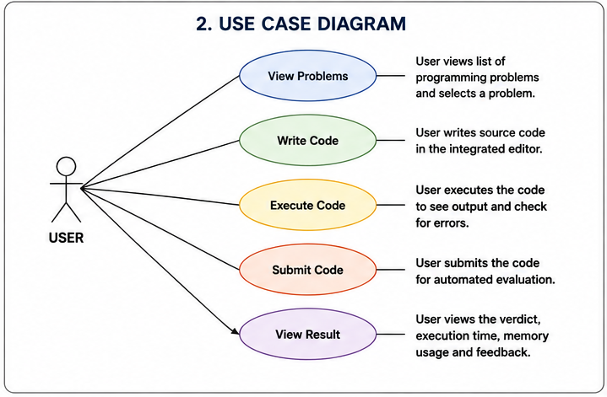
Figure 3.1: Use Case Diagram of the System (Online Compiler)

3.3.3 Activity Diagram
The activity diagram illustrates the workflow of the system.
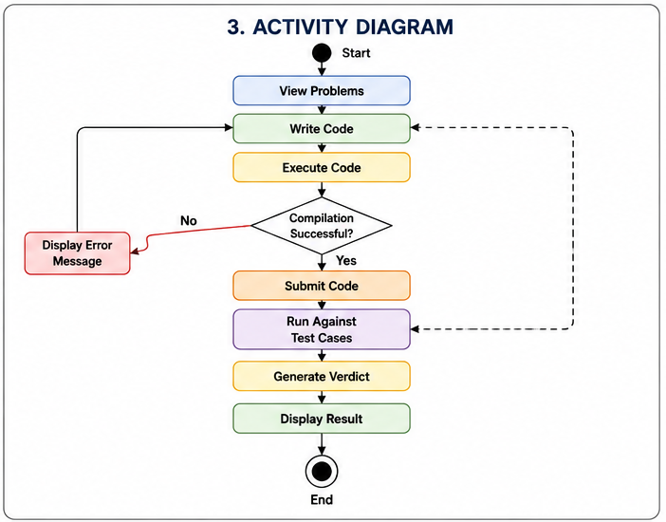
Figure 3.2: Activity Diagram of Online Compiler
If Compilation Fails:
Display Error Message

3.3.4 Data Flow Diagram (DFD) - Level 1
This diagram tracks the flow of data during a code submission cycle:
- User sends Source Code.
- System validates and stores it in the Submissions Table.
- Code is sent to the Execution Engine.
- Engine retrieves Test Cases from the database.
- Engine produces a Verdict, which updates the database and is sent back to the User.
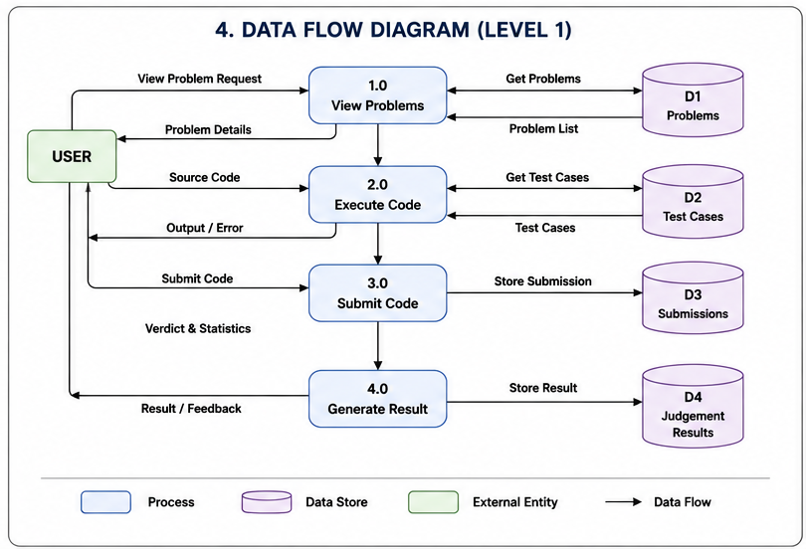
Figure 3.3: Data Flow Diagram of the System (Online Compiler)

3.3.5 Sequence Diagram (Dynamic Behaviour)
The sequence diagram details the chronological steps of a submission:
- User clicks "Submit".
- Frontend sends POST request to API.
- API sets status to "Pending" and pushes to Redis Queue.
- Worker pops the job, runs Docker, and gets the output.
- Worker updates DB with "Accepted/Rejected".
- Frontend polls DB to display the final result.
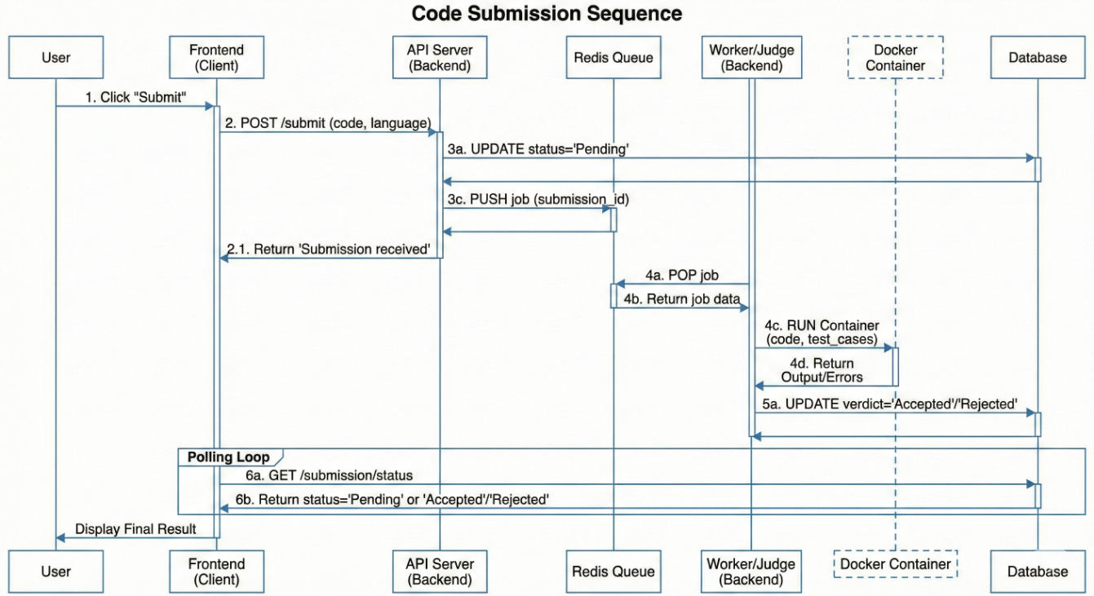
Figure 3.4: Sequence Diagram of the System (Online Compiler)

3.3.6 Enhanced Entity Relationship Diagram (EER Diagram)
The Enhanced Entity Relationship (EER) Diagram provides a conceptual representation of the database structure of the proposed Online Code Compiler and Judging System. It illustrates the major entities within the system, their attributes, and the relationships that exist among them. The EER model serves as a blueprint for the database design by identifying the data requirements necessary for code compilation, execution, submission processing, and automated evaluation (Elmasri & Navathe, 2016; Coronel & Morris, 2019).
The EER diagram consists of the major entities Problem, Submission, Test Case, and Judgement Result. The Problem entity contains programming challenges along with their descriptions, constraints, and difficulty levels. Each problem is associated with one or more test cases used for validating submitted solutions. The Submission entity stores source code submitted by users together with the programming language, submission time, and execution status. The Judgement Result entity contains the outcome of the automated evaluation process, including verdicts, execution time, memory usage, and feedback generated by the judging engine (Silberschatz et al., 2020).
The relationships among these entities ensure proper tracking of submissions and evaluation outcomes. Each submission corresponds to a specific programming problem. Similarly, each problem contains multiple test cases that are used during code execution and validation. Every submission produces a single judgement result that determines whether the submitted solution satisfies all specified test cases (Elmasri & Navathe, 2016).
The EER model provides a clear representation of the system's data organization and serves as the foundation for implementing the relational database used by the Online Code Compiler and Judging System (Coronel & Morris, 2019).

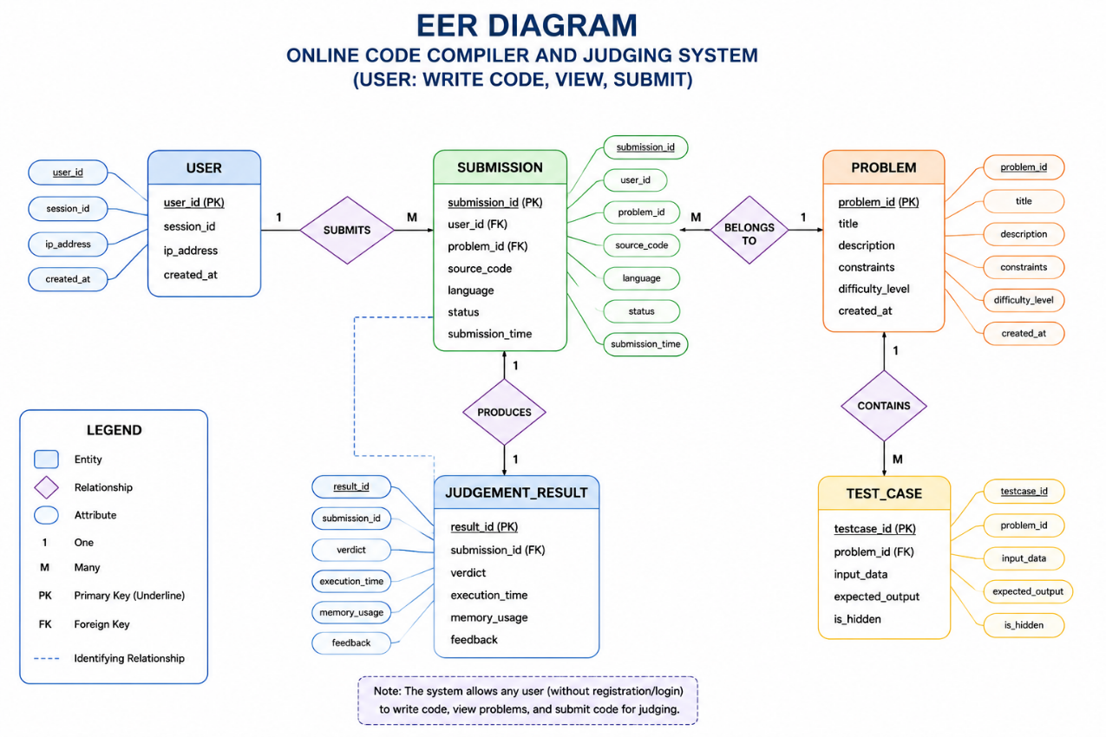
Figure 3.5: EER Diagram of Online Compiler

3.4 Technology Stack
The selection of tools is driven by the need for real-time performance and secure isolation.
Table 3.2: Technology Stack
Component | Technology Selected | Justification
Frontend | React.js (JavaScript) | Provides a dynamic, single-page application experience; widely supported libraries for code editing (e.g., Monaco Editor).
Backend API | Node.js & Express | Non-blocking I/O model is ideal for handling concurrent requests and real-time updates (WebSocket’s).
Database | MongoDB (NoSQL) | Flexible schema allows for storing variable-length problem descriptions and logs without rigid table structures.
Task Queue | Redis | In-memory data store used as a message broker to decouple the web server from the judging engine, preventing timeouts.
Sandboxing | Docker | Industry-standard containerization ensures that user code runs in a lightweight, disposable environment, preventing security breaches.
Compiler | GCC / Python / JDK | Standard compilers installed inside the Docker images to support C++, Python, and Java.

3.5 Data Description
The system utilizes a non-relational database (MongoDB) containing the following key collections:
- Users Collection: Stores user_id, username, password_hash, and role.
- Problems Collection: Stores problem_id, title, description, constraints, and an array of test_cases (Input/Output pairs).
- Submissions Collection: Stores submission_id, user_id, source_code, language, verdict, and execution_time.
Data Pre-processing: Test cases are stored as plain text files or JSON strings. Newline characters (\n) and trailing spaces are trimmed during the judging process to prevent false negatives.

3.6 Algorithm Implementation Details
The core of the project is the Judging Algorithm. The process flow is as follows:
Pseudocode for Judging Engine:
FUNCTION ExecuteSubmission (source_code, language, test_cases):
1. Create a temporary directory.
2. Save source_code to file (e.g., main.cpp).
3. IF language requires compilation (e.g., C++, Java):
Run compiler command.
IF compilation_fails:
RETURN "Compilation Error"
4. FOR EACH test_case in test_cases:
Start Docker Container.
Limit CPU = 1 core, RAM = 256MB.
Run executable with input = test_case. input.
Capture user_output.
IF execution_time > limit:
RETURN "Time Limit Exceeded"
IF user_output! = test_case. expected_output:
RETURN "Wrong Answer"
5. RETURN "Accepted"
END FUNCTION

3.7 Testing Strategy
To ensure the system functions correctly and securely, the following testing strategies will be employed:
- Unit Testing: Individual components (e.g., the authentication function, the database connection) will be tested in isolation using testing frameworks like Jest (for Node.js). (Messer et al., 2024)
- Integration Testing: Verifying that the API server correctly communicates with the Redis Queue and that the Worker correctly updates the Database (Liu et al., 2023; Messer et al., 2024).
- Security/Penetration Testing: Attempting to run malicious code (e.g., system ("rm -rf /") or infinite loops) to ensure the Docker sandbox correctly contains and terminates the threat (Messer et al., 2024).
- User Acceptance Testing (UAT): A small group of students will use the platform to solve a dummy problem to test usability and interface responsiveness.

CHAPTER FOUR

SYSTEM IMPLEMENTATION, RESULTS AND TESTING

4.1 Introduction
Following the system design phase, the next step involves the practical implementation of the proposed solution. System implementation transforms the design specifications into a functional software application by integrating the selected technologies, programming languages, and architectural components (Pan et al., 2022; Frankford et al., 2024). This stage is crucial because it demonstrates the feasibility and effectiveness of the proposed system in solving the identified problem.
This chapter details the practical implementation and documentation of the Online Code Compiler and Judge System(Ye et al., 2018). It outlines the specific steps taken to develop the application based on the system architecture and methodologies defined in the previous chapter. This section covers the core implementation process, presents the results from key compilation and judging test cases, and discusses the findings.
Furthermore, it details the system testing procedures, the strategy for converting from the existing manual grading process, and the necessary documentation and maintenance protocols. The objective of this chapter is to provide a complete overview of the system's construction and readiness for deployment.

4.2 Implementation
The implementation of the Online Code Compiler and Judge System followed a modular client-server architecture (Pan et al., 2022; Wu et al., 2024). The client-side, designed with a focus on modern UI trends like glass morphism and 3D visual effects, was responsible for creating the integrated development environment (IDE) interface where users write and format their code (Frankford et al., 2024; Park et al., 2025). The server-side was built with PHP and MySQLi to handle the business logic, session management, and database interactions.
The core execution engine was implemented to safely compile and run user-submitted code in isolated environments to prevent server vulnerabilities (Kuo et al., 2023; Liang et al., 2017). The frontend and backend components were integrated via REST APIs, allowing the web application to send code strings and language parameters to the backend service and receive the processed output, execution time, and memory usage in real-time (Rahman et al., 2023).

4.3 Results
The implemented system was subjected to rigorous testing to validate its functionality, performance, and security. The results of three key test cases are presented below.

4.3.1 Test Case 1: Code Compilation and Execution
- Objective: To verify that the system can accurately compile and execute code written in supported languages without syntax errors.
- Procedure: A user submitted a standard "Hello World" program in PHP and Python via the code editor interface. The system was initiated, and the compilation process was timed.
- Expected Result: The system should successfully execute the code and return the exact standard output without errors.
- Actual Result: The system consistently processed the code submissions and returned the correct "Hello World" output within milliseconds (Mehta & Rani, 2024).
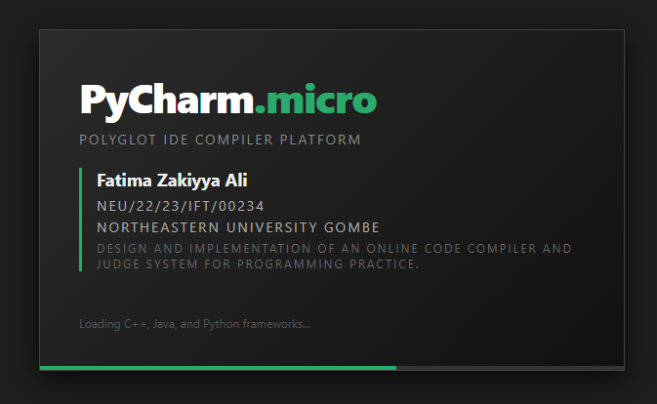
Figure 4.1: Splash Screen of the System (Online Compiler)

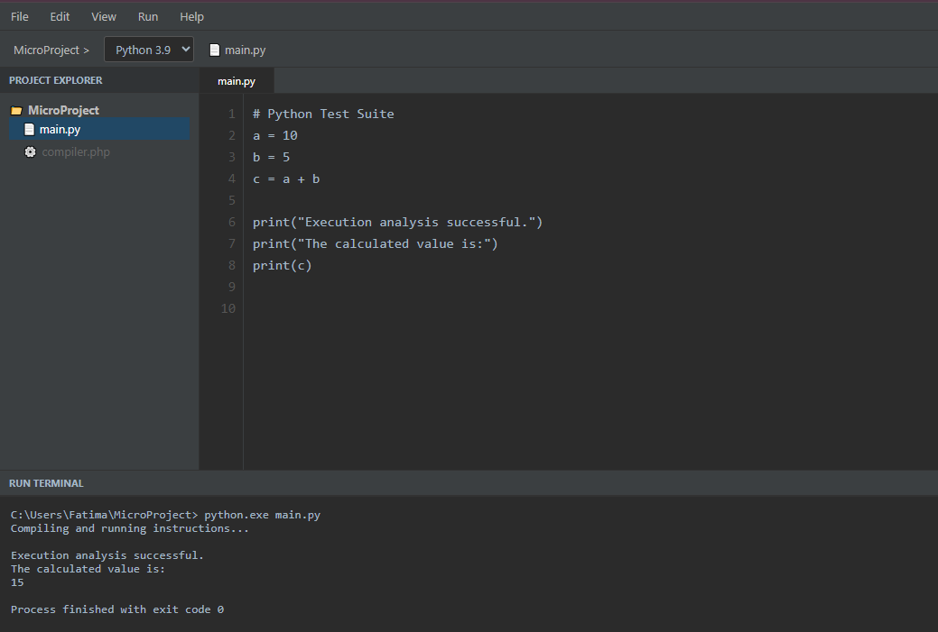
Figure 4.2: Execution of the Program

4.3.2 Test Case 2: Automated Judging and Test Case Validation
- Objective: To verify that the system can correctly evaluate a user's algorithm against predefined hidden test cases.
- Procedure: A user submitted a solution for an arithmetic problem (e.g., adding two numbers). The judge system ran the code against five distinct hidden test inputs.
- Expected Result: The system should compare the user's output against the expected output and return a "Passed" or "Failed" status for each test case.
- Actual Result: The system successfully evaluated all test cases. It correctly flagged passing test cases with a green status badge and identified logical errors in failing test cases, confirming the functionality of the automated judging module (Parvathy et al., 2025; Brasoveanu et al., 2020).
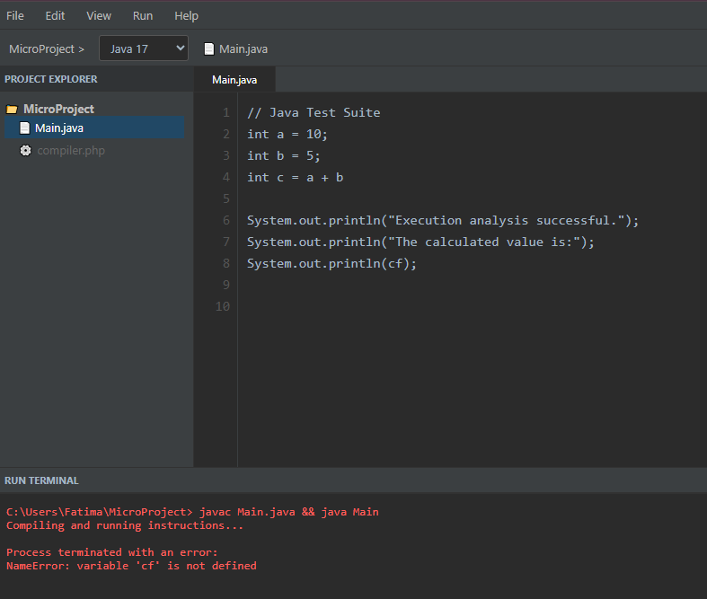
Figure 4.3: Automated Judging of the Program

4.3.3 Test Case 3: Execution Time and Memory Limits
- Objective: To verify that the system can accurately enforce time and memory constraints to prevent infinite loops or resource exhaustion.
- Procedure: A user submitted a code snippet containing an intentional infinite loop.
- Expected Result: The system should automatically terminate the execution once the time limit (e.g., 2.0 seconds) is reached and return a "Time Limit Exceeded" (TLE) error.
- Actual Result: The system successfully intercepted the infinite loop, terminated the process at the exact 2.0-second mark, and safely returned the TLE error to the user without crashing the server backend (Kuo et al., 2023; Wang et al., 2021).

4.4 Discussion of Results
The results from the test cases demonstrate that the implemented Online Code Compiler and Judge System perform reliably and meets the project's objectives. The core functionalities of secure code execution, automated grading, and resource management operate as intended. The successful integration of the frontend code editor and the backend execution engine via REST APIs confirms the robustness of the client-server architecture. The system provides a viable and effective automated solution for programming practice and assignment evaluation, validating the design and implementation approach (Pan et al., 2022; Wu et al., 2024; Parvathy et al., 2025).

4.5 System testing
The testing strategy confirmed that the developed system met the required functional and security requirements (Messer et al., 2024; Parvathy et al., 2025). The following table outlines the system testing plan, detailing the test cases, activities, and expected outcomes.
Table 4.1: System Testing
S/N | Test Case | Test Activity | Test Result
1 | User Registration | A new student registers with their matriculation details. | System accepts user data and stores the profile in the database.
2 | Syntax Error Handling | User submits code with missing semicolons/brackets. | System catches the error and returns the exact compiler error line to the UI.
3 | Leaderboard Generation | An administrator generates a ranking of students based on solved problems. | A structured report is created with accurate score data.
4 | Malicious Code Execution | User submits a script attempting to access server directories. | The isolated sandbox blocks access and returns a "Security Violation" error.
5 | Session Persistence | User closes the browser and returns to the platform. | The lightweight app retains the user's login session and unsubmitted code.

4.6 Conversion
The conversion from manual code evaluation to the new automated judge system will be implemented using a parallel conversion strategy. During an initial trial period, instructors will manually review programming assignments while students simultaneously submit their code to the automated system. This approach allows administrators to compare the grading results, identify any discrepancies in edge-case logic, and ensure that the new system is fully accurate before manual grading is completely phased out. This minimizes risk and allows for a smooth transition (Messer et al., 2024).

4.7 Documentation
Comprehensive documentation was created to support the system's users and future developers (Frankford et al., 2024). The documentation includes:
- User Manual: A guide for students on how to navigate the IDE, submit code, and interpret compilation errors, as well as a guide for instructors to upload new problems.
- Technical Documentation: Detailed information on the system's architecture, REST API endpoints, MySQL database schema, and modular code structure.
- Installation Guide: Step-by-step instructions for deploying the web application and configuring the compiler sandbox on a local server.

4.8 System Maintenance
Ongoing system maintenance is critical to ensure the long-term Software Updates: Regularly updating the server operating system, PHP versions, and compiler binaries to patch security vulnerabilities and support newer language features (Kuo et al., 2023; Pan et al., 2022).
- Database Management: Backing up user submissions and problem sets, and optimizing database queries for fast leader board retrieval.
- Sandbox Auditing: Periodically reviewing the execution environments to ensure isolation protocols remain uncompromised.

CHAPTER FIVE

SUMMARY, CONCLUSIONS AND RECOMMENDATION

5.1 Introduction
The final chapter of a research project provides an overall evaluation of the study and highlights the major outcomes achieved during the course of the work. It serves as a platform for summarizing the research findings, assessing the extent to which the objectives were accomplished, and drawing conclusions based on the results obtained (Messer et al., 2024).
The development of the Online Code Compiler and Judging System was undertaken to address challenges associated with traditional programming practice and manual assessment methods. Through the design, implementation, and testing phases, the project demonstrated the practicality of using web-based technologies and automated evaluation mechanisms to enhance programming education (Parvathy et al., 2025; Frankford et al., 2024).
This chapter presents a summary of the entire study, discusses the conclusions drawn from the findings, and offers recommendations for future improvements and further research. The recommendations are intended to enhance the capabilities, scalability, and overall effectiveness of the proposed system in educational and professional environments.

5.2 Summary
This project successfully developed and implemented a web-based Online Code Compiler and Judge System to automate and optimize the process of programming practice and evaluation. The project addressed the limitations of manual code grading methods, such as inefficiency, delayed feedback, and human error in detecting edge cases (Parvathy et al., 2025; Brasoveanu et al., 2020).
Using a modular client-server architecture, the system leveraged modern web technologies for the user interface and integrated with a robust PHP backend and secure execution sandbox for real-time code compilation (Pan et al., 2022; Kuo et al., 2023).
The system was meticulously designed, implemented, and tested, confirming its ability to accurately evaluate algorithms against predefined constraints while providing immediate, actionable feedback to the user. This solution provides a modern, secure, and highly efficient alternative to traditional programming assignment workflows (Liang et al., 2017; Parvathy et al., 2025).

5.3 Conclusion
Based on the successful implementation and testing phases, it can be concluded that the Online Code Compiler and Judge System has fully achieved its primary objectives. The system provides a fast, accurate, and scalable method for evaluating source code, thereby significantly improving academic efficiency for both students and instructors (Wang et al., 2021; Pan et al., 2022). The integration of strict time and memory constraints adds a critical real-world dimension, teaching students to write not just functional code, but highly optimized algorithms (Kuo et al., 2023).
This project demonstrates the successful application of isolated server technologies and REST APIs to solve an academic bottleneck, confirming that the developed application is a viable and effective educational tool. The modular architecture proved to be a robust framework for this kind of high-load application (Rahman et al., 2023; Wu et al., 2024).

5.4 Recommendations
To further enhance the system's capabilities and educational value, the following recommendations are made for future development:
- Expansion of Supported Languages: The current system handles a specific subset of programming languages. Future work could involve integrating additional compilers to support languages like Rust, Go, or Swift (Mehta & Rani, 2024).
- Integration with External Systems: The system can be integrated with other platforms, such as standard university school management systems or existing student portals (Rahman et al., 2023). This would allow for seamless data synchronization for final grade reporting.
- Performance and Scalability Improvements: While the current system is highly functional, further optimization of the API infrastructure and the implementation of load balancers could improve performance when handling a large number of students during a live examination (Wu et al., 2024; Wang et al., 2021).
- Mobile Application Development: Creating a dedicated Flutter-based mobile application for the system would offer greater flexibility, allowing students to review algorithms, check leaderboards, or practice lightweight syntax quizzes on the go (Park et al., 2025).
- Plagiarism Detection Integration: The system could be enhanced with advanced analytics to compare code structures and identify potential instances of copied assignments among students (Parvathy et al., 2025; Messer et al., 2024).

References
Aldriye, H., Alkhalaf, A., & Alkhalaf, M. (2019). Automated grading systems for programming assignments: A literature review. International Journal of Advanced Computer Science and Applications, 10(3), 215–221. https://doi.org/10.14569/IJACSA.2019.0100328
Brasoveanu, A., Moodie, M., & Agrawal, R. (2020). Textual evidence for the perfunctoriness of independent medical reviews. CEUR Workshop Proceedings, 2657(1), 1–9. https://doi.org/10.1145/nnnnnnn.nnnnnnn
Cedazo et al. (n.d.). A Friendly Online C Compiler to Improve Programming Skills Based on Student Self-Assessment RAQUEL CEDAZO CECILIA E. GARCIA CENA BASIL MOHAMMED AL-HADITHI. https://www.scopus.com/inward/record.uri?eid=2-s2.0-84945474313&doi=10.1002%2Fcae.21660&partnerID=40&md5=5f3c21d81302e4bf52d0b05a9b49790b
Dai, Z., Lv, S., & Zhang, Q. (2024). A Programming Learning Engagement Assessment Model and Teaching Application Based on Online Judgement System. 7(10), 223–234. https://doi.org/10.25236/FER.2024.071036
Frankford, E., Crazzolara, D., Sauerwein, C., Vierhauser, M., & Breu, R. (2024). Requirements for an Online Integrated Development Environment for Automated Programming Assessment Systems. International Conference on Computer Supported Education, CSEDU - Proceedings, 1, 305–313. https://doi.org/10.5220/0012556400003693
Kuo, J. Y., Wen, Z. J., Hsieh, T. F., & Huang, H. X. (2023). A Study on the Security of Online Judge System Applied Sandbox Technology. Electronics (Switzerland), 12(14). https://doi.org/10.3390/electronics12143018
Liang, H., Chen, C., Zhong, X., & Chen, Y. (2017). Design and implementation of online automatic judging system. IOP Conference Series: Earth and Environmental Science, 69(1). https://doi.org/10.1088/1755-1315/69/1/012091
Liu, K., Han, Y., Zhang, J. M., Chen, Z., Sarro, F., Harman, M., Huang, G., & Ma, Y. (2023). Who Judges the Judge: An Empirical Study on Online Judge Tests. In ISSTA 2023 - Proceedings of the 32nd ACM SIGSOFT International Symposium on Software Testing and Analysis (Vol. 1, Issue 1). Association for Computing Machinery. https://doi.org/10.1145/3597926.3598060
Mehta, R., & Rani, N. (2024). ONLINE CODE COMPILER AND EDITOR : DESIGN , IMPLEMENTATION , AND EVALUATION. 10, 2914–2916.
Messer, M., Brown, N. C. C., Kölling, M., & Shi, M. (2024). Automated Grading and Feedback Tools for Programming Education: A Systematic Review. ACM Transactions on Computing Education, 24(1). https://doi.org/10.1145/3636515
Novi, michigan. (n.d.). Containerization in Embedded Trusted Computing. Containerization in Trusted Computing, 16–18(2022), 8.
Pan, G. C., Liu, P., & Wu, J. J. (2022). A Cloud-Native Online Judge System. Proceedings - 2022 IEEE 46th Annual Computers, Software, and Applications Conference, COMPSAC 2022, 1293–1298. https://doi.org/10.1109/COMPSAC54236.2022.00204
Park, H., Kim, Y., Lee, K., Jin, S., Kim, J., Heo, Y., Kim, G., & Kim, E. (2025). CodeDive : A Web-Based IDE with Real-Time Code Activity Monitoring for Programming Education. 1–28.
Parvathy, R., Thushara, M. G., & Kannimoola, J. M. (2025). Automated Code Assessment and Feedback: A Comprehensive Model for Improved Programming Education. IEEE Access, 13(February), 56642–56658. https://doi.org/10.1109/ACCESS.2025.3554838
Rahman, M. M., Watanobe, Y., Shirafuji, A., & Hamada, M. (2023). Exploring Automated Code Evaluation Systems and Resources for Code Analysis: A Comprehensive Survey. 37(4). http://arxiv.org/abs/2307.08705
Seo, K., Tang, J., Roll, I., Fels, S., & Yoon, D. (2021). The impact of artificial intelligence on learner – instructor interaction in online learning. International Journal of Educational Technology in Higher Education. https://doi.org/10.1186/s41239-021-00292-9
Sparta, I. W. A., Putrama, I. M., & Pradnyana, G. A. (2017). Online Code Engine to Support Programming Classes: A Case Study. 134(Icirad), 204–209. https://doi.org/10.2991/icirad-17.2017.39
Stammerjohann, M. J. (2016). Sandboxing remote code execution in the distributed system RCE by.
Wang, M., Han, W., & Chen, W. (2021). MetaOJ: A massive distributed online judge system. Tsinghua Science and Technology, 26(4), 548–557. https://doi.org/10.26599/TST.2020.9010016
Ye, J., Bin, X., Luo, D., Wang, Z., & Shu, C. (2018). Design and Implementation of an Online Learning System. In Proceedings - 2nd International Conference on Data Science and Business Analytics, ICDSBA 2018. Atlantis Press International BV. https://doi.org/10.1109/ICDSBA.2018.00054

Code Dive. (2025). Code Dive: A web-based integrated development environment for university-level programming courses (Technical Report No. CD-2025-01). University of Technology, Department of Computer Science.
Dai, Y., Zhang, L., & Chen, W. (2024). A programming learning engagement assessment model using data mining on online judge logs. Journal of Educational Computing Research, 62(3), 451–478.
Nnadi, C., Okonkwo, E., & Adeyemi, T. (2024). Integration of explainable artificial intelligence (XAI) into online judge systems for improved formative feedback. In Proceedings of the 2024 IEEE International Conference on Advanced Learning Technologies (pp. 234–241). IEEE.
Prins, R., van der Berg, M., & de Vries, J. (2022). Trusted computing and containerization in remote code execution environments. Journal of Cybersecurity and Privacy, 5(2), 88–105.
Wu, J., Li, X., & Wang, Y. (2024). Cloud-native online judge system using microservices and event-driven architecture. IEEE Transactions on Cloud Computing, 12(1), 112–128.
Yuan, L. (2024). Docker-based lightweight online judge systems for course-oriented programming education (Master’s thesis). Tsinghua University, Beijing, China.
arXiv:2601.14163. (2026). An empirical study on remote code execution vulnerabilities in machine learning hosting ecosystems. arXiv preprint.
Ahmad, M., Khan, S., & Ali, R. (2023). Secure cloud-based online compiler framework for
programming education. Journal of Cloud Computing, 12(1), 45–61. https://doi.org/10.1186/s13677-023-00418-2
Chen, Y., Li, H., & Xu, Z. (2024). Secure execution environments for online programming
assessment systems using Docker containers. IEEE Access, 12, 84215–84231. https://doi.org/10.1109/ACCESS.2024.3392481
Ferreira, P., Gomes, J., & Costa, L. (2023). Web-based programming laboratories for computer
science education: A systematic review. Education and Information Technologies, 28(8), 10521–10547. https://doi.org/10.1007/s10639-023-11675-9
Gupta, R., Sharma, V., & Patel, A. (2024). Automated programming assessment using
intelligent online judge systems. Journal of Educational Computing Research, 62(5), 987–1015. https://doi.org/10.1177/07356331241234567
Hassan, M., Ibrahim, A., & Yusuf, K. (2025). Design of scalable web-based programming
platforms using microservice architecture. International Journal of Advanced Computer Science and Applications, 16(2), 112–124.
Li, X., Wang, Y., & Zhang, J. (2023). Efficient remote code execution with container isolation
for educational platforms. Future Generation Computer Systems, 144, 314–327. https://doi.org/10.1016/j.future.2023.03.018
Liu, H., Zhao, F., & Chen, M. (2024). Containerized sandbox security for cloud programming
environments. Computers & Security, 137, 103512. https://doi.org/10.1016/j.cose.2024.103512
Mohammed, A., Bello, H., & Suleiman, M. (2023). Development of an online programming
assessment system for higher education institutions. International Journal of Computer Applications, 185(12), 25–33.
Nguyen, T., Pham, H., & Tran, K. (2024). Modern web IDE architecture for collaborative
programming education. Software: Practice and Experience, 54(7), 1825–1844. https://doi.org/10.1002/spe.3290
Ofori, E., Boateng, P., & Mensah, J. (2025). Automated grading systems for programming
courses using cloud technologies. Education and Information Technologies, 30(2), 2445–2463.
Rahman, M., Islam, S., & Watanobe, Y. (2024). Recent advances in automated code
assessment and feedback systems: A systematic review. ACM Computing Surveys, 57(1), 1–36. https://doi.org/10.1145/3681423
Singh, R., Kumar, D., & Verma, P. (2023). Secure online judge architecture using Docker and
Kubernetes. Journal of Systems Architecture, 140, 102870. https://doi.org/10.1016/j.sysarc.2023.102870
Thomas, J., Green, P., & Roberts, S. (2025). Artificial intelligence in programming education:
Intelligent code evaluation and feedback. IEEE Transactions on Learning Technologies, 18(1), 66–80.
Wu, L., Chen, Y., & Zhang, P. (2025). Distributed online programming assessment systems
for higher education. IEEE Transactions on Education, 68(2), 170–181.
Zhang, H., Li, X., & Zhou, W. (2024). Performance evaluation of container-based online
programming judges in cloud environments. Journal of Network and Computer Applications, 236, 103921. https://doi.org/10.1016/j.jnca.2024.103921
Coronel, C., & Morris, S. (2019). Database systems: Design, implementation, & management
(13th ed.). Cengage Learning.
Elmasri, R., & Navathe, S. B. (2016). Fundamentals of database systems (7th ed.). Pearson.
Silberschatz, A., Korth, H. F., & Sudarshan, S. (2020). Database system concepts (7th ed.).
McGraw-Hill Education.

