FINAL REPORT
Level 04
AI-Powered Digital Marketing Orchestration
An Integrated, Closed-Loop Framework for Cold-Start Digital Marketing
Team Binary
215001G | Aadhil M. H. M.
215015D | Arqam Z. H.
215110N | Sarah M. M. F.
215129F | Zanar M. H. M. R. A.

Supervised by
Dr. A. L. A. Romesh R. Thanuja (IN/CM Supervisor)
Ms. M. A. N. Perera (IDS Supervisor)
Faculty of Information Technology
University of Moratuwa
July 2026

AI-Powered Digital Marketing Orchestration
An Integrated, Closed-Loop Framework for Cold-Start Digital Marketing
Team Binary
215001G Aadhil M. H. M.
215015D Arqam Z. H.
215110N Sarah M. M. F.
215129F Zanar M. H. M. R. A.

Dissertation submitted to the Faculty of Information Technology, University of Moratuwa, Sri Lanka, for the partial fulfilment of the requirements of the Degree of Bachelor of Science Honours in Information Technology.
July 2026

ACKNOWLEDGMENT
We wish to record our sincere gratitude to our supervisors, Dr. A. L. A. Romesh R. Thanuja and Ms. M. A. N. Perera, whose guidance shaped this project from a loose collection of four marketing ideas into a single coherent research system. Their insistence that every claim be supported by a measurement, and their patience through several changes of direction, are the reason this report is able to report failures as openly as it reports successes.
We thank the academic and technical staff of the Faculty of Information Technology, University of Moratuwa, for the knowledge and the facilities that made this work possible, and the panel of evaluators whose questions at the proposal and interim stages exposed weaknesses in our methodology early enough for us to correct them.
We acknowledge the maintainers of the open datasets on which this study depends — in particular the UCI Machine Learning Repository for the Bank Marketing dataset, which provided the only real behavioural benchmark available to us, and the publishers of the Digital Marketing Campaign and social-media engagement datasets used for segmentation and content modelling.
Finally, we thank our families and our colleagues in the Level 4 batch for their encouragement over the course of this project, and the free education system of Sri Lanka, without which none of us would have reached this point.

ABSTRACT
Digital marketing is executed through fragmented tools: one system segments an audience, another automates campaigns, a third reports analytics and a fourth generates content. Because these systems do not exchange information, the outcome of a campaign rarely improves the next one. The difficulty is sharpest for a newly launched product, where almost no historical interaction data exists — the cold-start condition — and where conventional data-hungry marketing models are least effective.
This project designs, implements and evaluates an integrated, closed-loop AI marketing orchestration framework built specifically for cold-start conditions. Four research modules are joined by a shared data layer so that the output of each becomes the input of the next: (1) a hybrid audience segmentation engine that combines rule-based logic with K-Means and hierarchical clustering through an agreement vote, preserving a cold-start segment that clustering alone destroys; (2) a campaign automation engine that compares fixed, trigger-based and hybrid strategies under identical conditions; (3) an analytics and decision-support module that constructs funnels, compares five attribution models, predicts conversion and drop-off risk, and generates ranked recommendations; and (4) an AI content refinery that crawls the client's own website and produces platform-specific marketing assets scored on semantic fidelity, platform suitability and predicted engagement. The modules run behind a FastAPI service over PostgreSQL, with a Next.js dashboard and a first-party website tracking snippet that supplies a live audience.
Evaluation used a mixture of public datasets, a calibrated behavioural simulator and live tracked traffic. Hybrid segmentation separated the highest- from the lowest-converting segment by 38.4 percentage points while retaining a New Cold User segment that pure clustering eliminated. The hybrid automation strategy raised conversion by 26.2 % over a fixed workflow (bootstrap 95 % CI 10.1 %–44.6 %, p < 0.001). Conversion and drop-off models reached AUC 0.9756 and 0.9902 on simulated data, but the honest figure reported is the AUC of 0.9535 obtained on the real UCI Bank Marketing dataset. Multi-touch attribution matched ground-truth channel credit with a mean absolute error of 0.0178 against 0.0260 for last-touch, and a learned recommender reached 94.4 % accuracy against 82.8 % for the rule baseline. In Module 4 both text classifiers selected TF-IDF over Sentence-BERT, while the engagement regressor is reported as having no demonstrable skill (R² −0.30) and its weight in content scoring was reduced accordingly.
The principal contribution is not any single model but the demonstration that the four functions can be operated as one measurable feedback loop under cold-start conditions — together with a set of mechanisms that prevent simulated results from being reported as measured behaviour.
Index Terms — digital marketing orchestration, cold-start, hybrid segmentation, marketing automation, funnel analytics, multi-touch attribution, conversion prediction, AI content generation, closed-loop optimisation.

DECLARATION
We declare that this thesis is our own work and has not been submitted in any form for another degree or diploma at any university or other institution of tertiary education. Information derived from the published or unpublished work of others has been acknowledged in the text and a list of references is given.

……………………………………… Aadhil M. H. M. (215001G)
……………………………………… Arqam Z. H. (215015D)
……………………………………… Sarah M. M. F. (215110N)
……………………………………… Zanar M. H. M. R. A. (215129F)
Date: ……… / ……… / 2026
Supervised by
……………………………………… Dr. A. L. A. Romesh R. Thanuja
Date: ……… / ……… / 2026
……………………………………… Ms. M. A. N. Perera
Date: ……… / ……… / 2026

TABLE OF CONTENTS
Table of contents — place the cursor here, press F9 and choose “Update entire table”.

LIST OF FIGURES
List of figures — place the cursor here and press F9.

LIST OF TABLES
List of tables — place the cursor here and press F9.

CHAPTER 1 — INTRODUCTION

1.1 Introduction
Digital marketing has become the primary means by which organisations acquire, engage, convert and retain customers. A modern campaign spans email, social platforms, paid advertising, search and the organisation's own website, and each of those channels generates behavioural data that could, in principle, be used to improve the next campaign. In practice this rarely happens. The tools that perform segmentation, automation, analytics and content production are separate products with separate data models, and the marketer is left to carry insight between them manually.
The consequence is that digital marketing is executed as a series of disconnected actions rather than as a learning process. Segmentation output does not inform the automation strategy; analytics describe what has already happened without prescribing what to do next; and content is produced without reference to which platform actually earned the last conversion. The marketing cycle does not close.
This project addresses that gap directly. It designs, builds and evaluates an AI-powered digital marketing orchestration framework in which four research modules — audience targeting, campaign automation, analytics and decision support, and AI content refinement — operate over a single shared data layer, so that the measured outcome of one campaign becomes an input to the next. The framework is targeted deliberately at the hardest case: a newly launched product for which almost no historical customer data exists.
The system produced is both a working software platform and a research instrument. A company creates an account, registers its website and installs a single tracking snippet; the visitors to that website become the audience on which the four modules operate. Every figure the platform reports is accompanied by a statement of whether the underlying data was measured or simulated — a design decision that runs through the whole of this report.

1.2 Background and Motivation
Three observations motivated this work.
Fragmentation is the normal state of marketing technology. Commercial platforms such as HubSpot, Mailchimp, Salesforce Marketing Cloud and Marketo each solve part of the problem well, but integration between customer intelligence, campaign execution and decision support is shallow. Academic work mirrors this division: studies address segmentation, or automation, or attribution, but seldom the interaction between them. Where integration is discussed it is usually described architecturally rather than evaluated experimentally.
The cold-start condition is under-studied and commercially acute. Most published marketing analytics assumes an established customer base with a rich interaction history. A start-up or a newly launched product has neither. Clustering algorithms need behavioural variance to form meaningful groups; predictive models need converted examples to learn from; attribution models need multi-touch journeys. At launch, none of these are available in sufficient quantity, and precisely the organisations that most need marketing efficiency are the ones the literature serves least well.
Descriptive analytics is not decision support. Existing analytics tools report clicks, impressions and conversion counts. They tell a marketer what happened; they do not say which audience to contact next, on which platform, with which message. Turning measurement into a prescribed action — and then measuring whether that action worked — is what closes the loop, and it is the part that is generally missing.
A fourth motivation emerged during the project itself. While converting the interim-stage notebooks into a running system, the team discovered several defects in its own research code that had produced impressively good but invalid results. These are documented openly in Section 6.6 and Chapter 7, because the experience shaped the project's methodology: a research system should be constructed so that it is difficult to fool oneself.

1.3 Problem in Brief
There is no integrated, empirically evaluated framework that unifies audience intelligence, campaign automation, attribution-aware predictive analytics and AI content generation into a single closed feedback loop that remains usable under cold-start, low-data conditions.
This decomposes into five concrete problems:
- Segmentation collapses under low data. Clustering requires behavioural variance that a newly launched product does not have, and rule-based segmentation alone cannot adapt.
- Automation strategies are asserted rather than compared. Fixed, trigger-based and hybrid campaign strategies are advocated in the literature, but rarely evaluated against one another on the same users under the same conditions, and rarely with operational cost considered alongside conversion.
- Attribution is either simplistic or unusable at launch. Single-touch models oversimplify the journey; data-driven models such as Markov or Shapley require volumes of journey data that a launch-stage product cannot supply.
- Analytics does not prescribe. Funnel reports identify drop-off but stop short of recommending the corrective action, and are not connected back to the automation engine.
- Generated content is disconnected from performance. AI content tools optimise for fluency, not for the platform that actually produced conversions, and typically have no feedback path from campaign analytics.

1.4 Aim and Objectives

1.4.1 Aim
To design, implement and experimentally evaluate an integrated, closed-loop, AI-powered digital marketing orchestration framework that unifies audience segmentation, campaign automation, attribution-aware predictive analytics and AI content refinement, and that remains effective for newly launched products operating under cold-start and limited-data conditions.

1.4.2 Objectives
- To design and implement a hybrid segmentation engine that combines rule-based logic with unsupervised clustering, and to evaluate it against each constituent method on segment separation, stability and downstream conversion.
- To implement fixed-workflow, trigger-based and hybrid campaign automation strategies and compare them experimentally on identical user cohorts using engagement, conversion, time-to-convert and operational complexity.
- To construct a marketing funnel and drop-off analysis capable of isolating loss by stage, segment and automation strategy.
- To implement and compare first-touch, last-touch, linear, multi-touch and Markov attribution against a known ground truth, and to quantify the error of each.
- To build calibrated conversion-probability and drop-off-risk models, validate them on a real-world dataset rather than only on simulated data, and explain their behaviour using SHAP.
- To generate ranked, actionable marketing recommendations from analytics output, and to compare a learned recommender against a rule-based baseline.
- To build an AI content refinery that converts a client's own website copy into platform-specific marketing assets, and to evaluate those assets on semantic fidelity, platform suitability and predicted engagement.
- To integrate the four modules into a single multi-tenant platform with a shared database, a tracking-based live audience and a dashboard, and to demonstrate that analytics output measurably re-enters segmentation, automation and content generation.
- To establish mechanisms that prevent simulated results from being presented as measured behaviour, and to report the framework's limitations and negative results explicitly.

1.5 Proposed Solution
The proposed solution is a four-module orchestration framework sharing one data layer. Each module is an independent research contribution that is separately evaluable, and each is also a producer and consumer of data for its neighbours. The modules are summarised below and specified in detail in Chapters 4 to 6.

1.5.1 Module 1 — Audience Targeting and Personalization Engine
Module 1 converts raw behavioural data into labelled audience segments. Three segmentation methods run in parallel over the same feature matrix — a rule-based segmenter encoding marketing heuristics, K-Means clustering and agglomerative hierarchical clustering — and their outputs are combined through an agreement vote that also yields a confidence score. Five segments are shared across the whole system: High Intent, Loyal Customer, Price Sensitive, Low Engagement and New Cold User.
The novel element is the treatment of the cold-start case. A visitor with almost no history has no distinguishing behavioural variance, so clustering assigns them to whichever centroid is nearest and the fact that they are new is lost. In the proposed engine the cold-start rule takes precedence over the clustering vote, and below a minimum audience size the engine declines to cluster at all and reports why. Segment labels and confidences are written to the shared user_segments table for Modules 2 and 3.

1.5.2 Module 2 — Marketing Automation and Campaign Management
Module 2 consumes segments and executes campaigns. Its research purpose is comparative: three automation strategies operate on the same user population under the same conditions so that the difference between them can be attributed to the strategy alone.
- Fixed workflow — an identical scheduled sequence for every user; the baseline.
- Trigger-based — the next action is selected from the user's most recent observed event.
- Hybrid — scheduling, behavioural triggers, segment labels from Module 1 and a machine-learned response probability are combined in one policy engine.
Execution produces interaction events (sent, opened, clicked, ignored, converted) which are written to the shared interactions table and become the primary input to Module 3. Strategies are compared not only on conversion but on operational complexity, because a strategy that converts slightly better while trebling the number of rules to maintain may not be the correct engineering choice.

1.5.3 Module 3 — Marketing Analytics and Decision Support
Module 3 is the intelligence layer. It converts the interaction log into four kinds of output: a funnel with drop-off attribution by stage, segment and strategy; a comparison of five attribution models against ground truth; calibrated conversion-probability and drop-off-risk predictions with SHAP explanations; and ranked, actionable recommendations naming the audience, the action and the platform.
Two design decisions distinguish it from conventional analytics. First, attribution models are not merely reported but benchmarked against a known ground truth, so the report can state which model is wrong and by how much. Second, the module refuses to report what the data cannot support: below five converting journeys attribution returns no numbers, and degenerate predictions raise a calibration warning rather than a confident answer. Its output is written to analytics_output and flows back to Modules 2 and 4, which is what closes the loop.

1.5.4 Module 4 — AI-Powered Content Refinery and Multi-Platform Distribution
Module 4 crawls the client's own website, extracts a business summary and brand vocabulary, classifies the campaign goal and tone, and generates platform-specific assets — captions, hashtags, calls to action, image prompts and short-video briefs — for Instagram, Facebook, LinkedIn, YouTube and email.
Each asset is scored on three axes: semantic similarity to the source material, rule-based platform suitability, and predicted engagement. The composite score ranks the assets, and the platform ordering is supplied by Module 3's attribution output, so content production is driven by which platform actually earns conversions rather than by assumption. A human-baseline harness scores manually written content through the identical pipeline so that the AI output can be compared fairly.

1.5.5 Flow of the Overall System
Figure 1 shows the end-to-end flow. A visitor arrives at the client's website, where the tracking snippet records first-party behaviour. Module 1 segments that audience; Module 2 selects and executes a campaign action per segment; the resulting interaction events are logged; Module 3 analyses those events and produces predictions and recommendations; Module 4 generates the content for the next cycle using Module 3's platform priorities. Module 3's recommendations simultaneously re-enter Module 2 as campaign optimisation and Module 1 as re-targeting priorities.
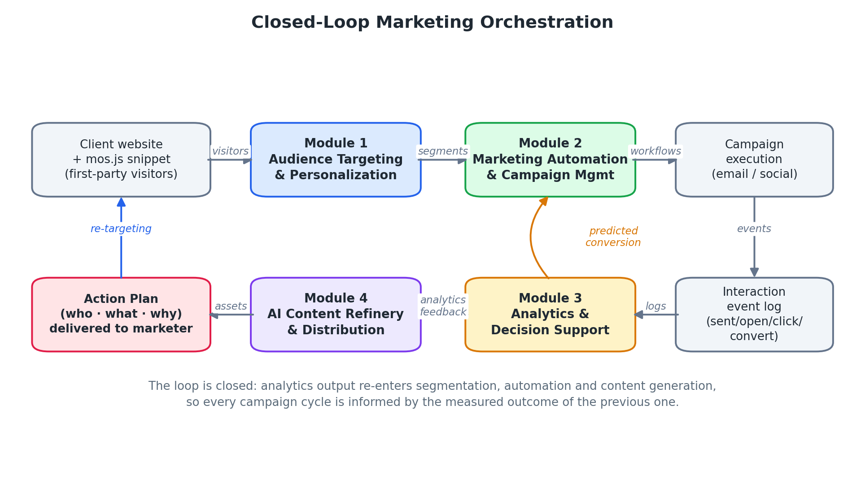
Figure 1 — Closed-loop flow of the overall orchestration framework.
The loop is genuine rather than decorative: the highest-scoring content asset from Module 4 becomes the opening message of the next campaign plan, and the attribution credit computed by Module 3 changes which platform Module 4 writes for first. Chapter 7 reports the measurement of this behaviour.

CHAPTER 2 — RELATED WORK

2.1 Introduction
This chapter reviews the research that this project builds on and positions the proposed framework against it. It is organised in three parts: work addressing the marketing pipeline as a whole (Section 2.2); work specific to each of the four modules (Section 2.3); and the research gaps that follow from that review (Section 2.4). Throughout, the review pays particular attention to two questions that are decisive for this project — whether a technique remains usable when interaction data is scarce, and whether its output is connected to any downstream marketing decision.

2.2 Overall Related Work
Wedel and Kannan [49] survey marketing analytics for data-rich environments and establish the analytical vocabulary — segmentation, response modelling, attribution — that most subsequent work adopts. Their framing is explicit about its premise: the methods assume abundant historical data. Davenport et al. [12] and Huang and Rust [21] examine how artificial intelligence changes marketing practice, and both identify integration across the marketing function as the principal unrealised opportunity, while stopping short of specifying or evaluating an integrated architecture.
Kotler et al. [24] describe the strategic case for technology-led marketing, and Chaffey and Ellis-Chadwick [8] provide the operational treatment of channel-specific strategy that informs the platform-aware element of Module 4. Kumar et al. [26] review the digital transformation of marketing and note the persistent gap between the analytics an organisation collects and the decisions it actually takes — the same gap this project's Module 3 is designed to close.
Verma et al. [48] conduct a systematic review of AI in marketing and report that the overwhelming majority of studies address a single function in isolation. Where a full pipeline is proposed, it is generally presented as an architecture diagram rather than an implemented and measured system. Two consequences follow. First, the interaction effects between modules are unknown: it is not established whether better segmentation actually improves campaign outcomes, because the two are rarely measured together. Second, the cost of integration is invisible. This project responds by implementing the pipeline end to end and reporting the interaction effects it produces, including where they are smaller than expected.
Commercial systems — IBM Watson Marketing, Salesforce Einstein, HubSpot and Adobe Experience Platform — do integrate these functions, but as closed products they publish neither their methods nor controlled comparisons, and their models are trained on the mature customer bases of established enterprises. The cold-start behaviour of these systems is not documented, and it is not possible to reproduce their results.

2.3 Module-wise Related Work

2.3.1 Audience Segmentation and Personalization
Customer segmentation moved from demographic rules to behavioural clustering as machine learning became routine. Han et al. [16] give the standard treatment of K-Means and hierarchical clustering, and Aggarwal [2] and Hastie et al. [17] cover the assumptions each method carries — in particular K-Means's assumption of roughly spherical, similarly sized clusters and its requirement that k be fixed in advance. Alves Gomes and Meisen [3] review segmentation for e-commerce personalisation specifically and find that clustering quality metrics dominate the evaluation literature while downstream marketing outcomes are rarely reported.
Hybrid approaches that combine business rules with clustering have been proposed to retain interpretability while gaining adaptability, and are reported to improve personalisation reliability relative to either method alone. What is not addressed is arbitration: when the rule and the cluster disagree, which wins? This project found that the answer is consequential. In an early implementation, resolving disagreement in favour of the clustering result silently destroyed the cold-start segment entirely (Section 6.6), because a new visitor has no behavioural signature and is therefore absorbed into whichever cluster is nearest.
The cold-start problem itself is well characterised in recommender systems. Schein et al. [42] define the methods and metrics for cold-start recommendation; Bobadilla et al. [5] and Ricci et al. [40] survey the mitigations — content-based fallbacks, transfer learning, hybrid recommenders. That work concerns recommending items to users with no history. The analogous marketing problem — segmenting users who have no history, at the launch of a product that has no history either — receives markedly less attention, and it is the specific gap Module 1 addresses.

2.3.2 Marketing Automation and Campaign Management
Chaffey and Ellis-Chadwick [8] document fixed-workflow campaign management and its limitations: identical sequences delivered regardless of behaviour produce low engagement and slow conversion. Davenport et al. [12] describe behaviour-triggered automation, in which campaign actions respond to opens, clicks and abandonment, and report improved relevance at the cost of growing rule complexity. Kumar and Reinartz [27] propose a blended approach in which a stable base workflow is modulated by predicted engagement probability, and report improvements in open and click-through rates.
Predictive campaign optimisation applies supervised learning — logistic regression, random forests, gradient boosting — to response prediction; Provost and Fawcett [37] set out the practical framing. Sutton and Barto [44] provide the foundation for reinforcement-learning approaches to sequential campaign decisions, which are attractive in principle but require extensive interaction histories and carefully designed reward functions, restricting them to warm-start settings.
Two gaps persist. First, controlled comparison is rare: the three strategies are seldom run on the same users under the same conditions, so reported differences confound strategy with population. Second, operational cost is almost never measured alongside effectiveness, although it is decisive in practice. Module 2 addresses both by running all three strategies over an identical 8,000-user cohort and reporting rule count and workflow complexity beside conversion.

2.3.3 Marketing Analytics, Attribution and Decision Support
Funnel analysis is the established framework for locating loss in the customer journey. Court et al. [10] introduced the consumer decision journey, arguing that purchase paths are not linear, and Järvinen and Karjaluoto [22] show that stage-to-stage transition analysis is more actionable than any single aggregate engagement metric. The limitation they share with commercial analytics is that funnel reporting is descriptive: it identifies the leak without prescribing the repair.
Attribution modelling assigns conversion credit across touchpoints. First-touch and last-touch attribution are computationally trivial and, as Dalessandro et al. [11] argue, causally unsound — they assign all credit to one interaction on the basis of position alone. Shao and Li [43] present data-driven multi-touch attribution that learns contribution weights from interaction sequences and demonstrate more realistic conversion analysis. Markov-chain and Shapley-value formulations extend this, at the cost of requiring substantial journey volume.
A methodological weakness runs through this literature: attribution models are usually compared with one another rather than against a known ground truth, because in observational data the true credit is unobservable. Module 3 exploits its simulator to address this directly. Because the simulator generates each journey from known per-channel influence weights, the true credit is known, and each attribution model can be scored by mean absolute error against it (Section 7.4.3).
Predictive analytics for conversion and churn is well established [5], [37], with deep sequence models applied to behavioural prediction [15]. Interpretability is addressed by Lundberg and Lee [29] through SHAP and by Molnar [33] more broadly; these methods are used in Module 3 to explain what drives each prediction. The remaining gap is connective rather than algorithmic: analytics outputs are seldom wired back into campaign execution, so the loop stays open. Providing that wiring, and measuring it, is a central objective of this project.

2.3.4 AI Content Generation and Multi-Platform Optimisation
Transformer architectures [47] and large pre-trained language models [6] made fluent, controllable text generation practical, and Tunstall et al. [45] document the applied pipeline. In marketing this supports caption generation, product copywriting, tone adaptation and summarisation. Sentence embeddings and BERTScore [50] provide the standard means of checking that generated text preserves source meaning, and Radford et al. [38] and Li et al. [28] extend the approach to multimodal content.
Platform-aware optimisation is emphasised in the practitioner literature [8], [25]: platforms differ in length conventions, hashtag norms, formality and format expectation, so republishing one message everywhere underperforms. Rule-based platform-fit scoring is straightforward and is adopted in Module 4.
Engagement prediction is the weakest link. Models are trained to predict likes, shares or engagement rate from post features, but outcomes are dominated by factors absent from the text — platform ranking algorithms, timing, follower composition, trending topics. Reported successes are frequently inflated by leakage when engagement components are left among the features. This project encountered exactly that defect in its own code (Section 6.6) and reports the corrected result — no demonstrable skill — as a negative finding rather than removing the model.
Finally, the literature almost never connects content generation to campaign analytics. Generated content is evaluated on linguistic quality in isolation, not on whether it was produced for the platform that earns conversions. Module 4 consumes Module 3's attribution output to order platform generation, which is the specific integration this review found missing.

2.4 Research Gaps
The review identifies six gaps that define this project's contribution.
Table 1 — Research gaps identified in the literature and the response of this project.
# | Research gap | How this project responds
G1 | Lack of integrated marketing intelligence: segmentation, automation, analytics and content are studied and built separately. | All four modules implemented over one shared data layer with measured feedback paths (Ch. 5–7).
G2 | Cold-start marketing is under-researched; methods assume mature customer data. | Hybrid segmentation with cold-start precedence and a minimum-audience refusal rule (§4.2, §7.2).
G3 | Automation strategies are asserted, not compared under controlled conditions. | Fixed, trigger and hybrid run on an identical 8,000-user cohort; complexity reported with conversion (§7.3).
G4 | Attribution models are compared to each other, not to a ground truth. | Simulator with known channel influence enables MAE scoring of five attribution models (§7.4.3).
G5 | Analytics describes but does not prescribe, and is not wired back to execution. | Recommendation generator plus learned recommender; output re-enters Modules 2 and 4 (§4.4, §7.4.5).
G6 | Generated content is disconnected from campaign performance, and engagement models are often leakage-inflated. | Attribution-driven platform ordering; leakage-guarded engagement model reported honestly (§4.5, §7.5).

2.5 Summary
The reviewed literature provides mature methods for each individual marketing function but leaves three things open: the behaviour of these methods when interaction data is scarce, the effect of connecting them into one loop, and the honest evaluation of models whose reported performance is easily inflated by leakage or by evaluation on the data that generated them. These three concerns shape the approach set out in Chapter 4, the design in Chapter 5 and the evaluation strategy in Chapter 7.

CHAPTER 3 — TECHNOLOGY ADAPTED

3.1 Introduction
This chapter describes the technologies selected to implement the framework and the reasoning behind each choice. Selection was governed by four criteria: suitability for machine-learning research; the ability to run the four modules behind a single service; reproducibility, so that any reported result can be regenerated; and modest resource requirements, since the system targets small organisations. Section 3.7 records where the delivered stack differs from the interim report and why.

3.2 Programming Languages

3.2.1 Python
Python 3.11 is the primary language. All four research modules, the data pipelines, the model training scripts, the simulator and the backend service are written in Python. It was selected for the maturity of its scientific stack, its dominance in machine learning research and the fact that a single language across modelling and serving removes an entire class of training/serving-skew defects: the model that produced a reported number is the same object the API loads.

3.2.2 JavaScript and TypeScript
The marketer-facing dashboard is written in TypeScript. Static typing was valuable because the dashboard consumes a wide API surface across six pages; type errors that would otherwise appear as blank charts are caught at build time. JavaScript is also used for mos.js, the first-party tracking snippet installed on a client's website, which is deliberately dependency-free and small so that it does not slow the host page.

3.3 Machine Learning and Data Science Libraries
- scikit-learn — K-Means, agglomerative clustering, logistic regression, random forests, TF-IDF vectorisation, pipelines, cross-validation and the metric suite. It is the backbone of Modules 1, 2 and 3, and of the text classifiers in Module 4.
- XGBoost — gradient-boosted trees for conversion and drop-off prediction in Module 3 and for engagement regression in Module 4; used as the strong learner against which simpler models are compared.
- pandas and NumPy — tabular data handling, feature engineering and numerical computation throughout.
- SHAP [29] — model-agnostic explanation of the conversion and drop-off models, so that predictions can be defended rather than merely reported.
- sentence-transformers — Sentence-BERT embeddings for semantic similarity scoring in Module 4 and as one of the two candidate feature representations for the goal and tone classifiers.
- SciPy and statsmodels — bootstrap confidence intervals, significance testing and correlation analysis used in Chapter 7.
- Matplotlib and Seaborn — figure generation for the research outputs reproduced in Chapter 7.

3.4 Web Application and API Frameworks
- FastAPI — the backend service. Chosen because it is Python native (so the research modules are imported directly rather than invoked across a language boundary), because request and response schemas are validated automatically, and because it generates interactive API documentation used during evaluation and demonstration.
- Next.js 16 with React — the marketer dashboard: Overview, Audience, Campaigns, Analytics, Content and Research pages, plus authentication and site-onboarding flows.
- Recharts — funnel, attribution and prediction charts in the dashboard, matching the visualisation design specified at the interim stage.
- Streamlit — retained only for the standalone research dashboards used during module development; superseded in the integrated system by the Next.js dashboard.

3.5 Data Storage and Infrastructure
- PostgreSQL 16 — the single shared data layer. Relational storage was appropriate because the four modules exchange well-structured entities with strict referential relationships (a segment belongs to a visitor, an interaction belongs to a campaign), and because the honesty constraints described in Section 5.5 are enforced as database-level derivations rather than application conventions.
- Docker and Docker Compose — the database runs in a container so that the entire system can be reproduced on any machine with a single command, which matters for a research artefact that must be re-runnable by an examiner.

3.6 Development, Testing and Version Control Tools
- pytest — the automated test suite (208 test functions across the platform and Module 3 suites) covering data contracts, API behaviour, tenant isolation and regression tests for each defect described in Section 6.6.
- Git and GitHub — version control, with a branch per module during independent development and integration branches for the unified system.
- Make — a task interface (`make setup`, `make db`, `make api`, `make web`, `make demo`, `make test`) that makes the reproduction path explicit.
- Visual Studio Code, PyCharm and Jupyter — development and exploratory analysis; the original module notebooks are retained for traceability.

3.7 Deviations from the Interim Report
Two technology decisions differ from the interim report and are recorded here for transparency.
Table 2 — Technology decisions that differ from the interim report.
Interim report | Delivered system | Reason
Section 3.6 states a Node.js / NestJS backend service layer. | FastAPI (Python). | Figure 5.1 of the interim report already specified FastAPI, so the report was internally inconsistent. Every model is Python; a Node backend would have required a second service and a serialisation boundary between the API and the models, adding failure modes for no research benefit.
MongoDB and PostgreSQL are both named as data stores. | PostgreSQL only. | All five architecture figures in the interim report show PostgreSQL. The data exchanged between modules is strongly relational, and running two stores would have split the integrity constraints that the honesty mechanisms depend on.

A third change is one of scope rather than technology. At the interim stage the audience was to be supplied by uploading a CSV of customers. In the delivered system the audience is collected from the client's own website through a tracking snippet. This was necessary for the research question: a cold-start study is not credible if the audience arrives pre-formed with a complete behavioural history.

3.8 Summary
Table 3 — Summary of the adopted technology stack by layer.
Layer | Technology | Role in the framework
Presentation | Next.js 16, React, TypeScript, Recharts | Marketer dashboard, authentication, site onboarding
Tracking | JavaScript (mos.js) | First-party visitor collection on the client website
Application | FastAPI, Uvicorn, Pydantic | Routers, services, tenant isolation, provenance
Research modules | scikit-learn, XGBoost, SHAP, sentence-transformers, pandas, NumPy | Segmentation, automation, analytics, content
Data | PostgreSQL 16, Docker | Shared tables: user_segments, interactions, analytics_output, content_assets
Quality | pytest, Git, Make | Regression tests, reproducibility, evaluation reruns

The stack is deliberately conventional. The research contribution of this project lies in the integration and the evaluation methodology, not in the novelty of the tools, and using well-understood components makes the results easier to reproduce and to challenge.

CHAPTER 4 — APPROACH

4.1 Introduction
This chapter specifies what each module receives, what it does with it and what it produces. The four modules are described in the order in which data flows through them, followed by the integration strategy that joins them (Section 4.6) and the evaluation strategy that governs how their results are measured and reported (Section 4.7).
The overall methodology is experimental rather than purely constructive. Each module implements at least two competing approaches — for example three segmentation methods, three automation strategies, five attribution models, two text representations — so that a comparison, and not merely a demonstration, is possible.

4.2 Module 1 — Audience Targeting and Personalization

4.2.1 Input
Module 1 operates over two distinct feature domains, using the same algorithm in both.
Table 4 — The two feature domains of the segmentation engine.
 | Research domain | Live web domain
Source | Digital Marketing Campaign dataset (8,000 users, 20 columns) | Visitors collected by the mos.js tracking snippet
Features | email opens, email clicks, website visits, pages per visit, time on site, social shares, previous purchases, loyalty points | page views, clicks, sessions, unique pages, scroll depth, time on site, form submits, purchases
Purpose | Reproduce and evaluate the study | Operate the product on a real audience

The two domains are kept separate deliberately. A first-time visitor to a newly launched product has no email history at all, so forcing web visitors into the research schema would require inventing values for columns that do not yet exist — which is precisely the cold-start distortion this project sets out to study.

4.2.2 Process
Preprocessing handles missing values, encodes categorical attributes and standardises numeric features, since both K-Means and Ward-linkage hierarchical clustering are distance-based. Derived behavioural features — engagement score, click ratio, recency — are then computed.
Three segmentation methods run in parallel over the identical feature matrix:
- Rule-based segmentation. Marketing heuristics expressed as explicit thresholds. Fully interpretable, and the only method that can identify a genuinely new user, because it can test for the absence of history rather than for proximity to a centroid.
- K-Means clustering with k = 4 on scaled features, capturing behavioural groupings that no rule was written for.
- Hierarchical (agglomerative) clustering with Ward linkage, providing a second, differently biased partition against which K-Means can be checked.
An agreement vote then combines the three labels. Where all three agree, confidence is highest; where two agree, the majority label is taken with reduced confidence; where all three disagree, the rule-based label is retained and confidence is lowest. One rule overrides the vote entirely: if the rule-based method identifies a New Cold User, that label stands regardless of what the clustering methods report. Section 6.6 explains why this precedence is not optional.
Cluster names are derived from cluster centroids rather than assigned to cluster indices, so that the same code produces correct names on a new audience and a new random seed. Below a minimum audience size (30 visitors) the engine does not cluster at all; it returns rule-based labels and states the reason. For a launch-stage product this is the normal condition, not an error.

4.2.3 Output
For every user, a segment label drawn from a fixed five-value taxonomy, the method that produced it and a confidence score, written to the shared user_segments table.
Table 5 — The five shared audience segments.
Segment | Behavioural signature | Marketing implication
High Intent | High click and visit frequency, short recency, strong purchase signals | Prioritise; send offers, expect fastest conversion
Loyal Customer | Repeat purchases, high loyalty points, consistent engagement | Retain; premium and reactivation messaging
Price Sensitive | High browsing, low conversion rate relative to visits | Discount-led messaging; the largest drop-off risk
Low Engagement | Few opens, few clicks, long recency | Re-engagement or suppression to protect deliverability
New Cold User | Almost no interaction history | The cold-start case: onboarding, not prediction

4.3 Module 2 — Marketing Automation and Campaign Management

4.3.1 Input
Segment labels and confidences from Module 1, joined to each user's behavioural profile, together with a library of campaign message templates (welcome, product information, social proof, discount offer, final reminder, reactivation).

4.3.2 Process
A campaign policy engine selects the next action for each user. Three policies are implemented and compared under identical conditions — the same users, the same templates, the same response model — so that any difference in outcome is attributable to the policy alone.
Table 6 — The three automation strategies compared.
Strategy | Decision basis | Expected trade-off
Fixed workflow | Predetermined schedule, identical for every user | Simple and cheap to operate; no personalisation
Trigger-based | The user's most recent observed event selects the next action | Responsive and message-efficient; rule count grows
Hybrid | Schedule + triggers + segment label + predicted response probability | Best personalisation; highest operational complexity

Response probability is supplied by a supervised model trained on the campaign dataset. Logistic regression and a random forest are both fitted, and a stratified dummy classifier is fitted alongside them as a floor, because the dataset is strongly imbalanced (base rate 0.876) and accuracy alone would be misleading.
An event simulation layer converts each campaign action into realistic interaction events — sent, opened, clicked, ignored, converted — with per-segment response propensities, and an evaluation layer computes open rate, click-through rate, conversion rate, conversions per thousand messages, average days-to-convert and an operational complexity score derived from the number of distinct rules and branches each strategy requires.

4.3.3 Output
A user-level campaign interaction log written to the shared interactions table — the principal input to Module 3 — and a strategy comparison table reporting the six metrics above for each strategy.

4.4 Module 3 — Marketing Analytics and Decision Support

4.4.1 Input
The campaign interaction log from Module 2 and the segment labels from Module 1. For the controlled experiments a calibrated behavioural simulator is used, whose per-channel influence weights are known — the property that makes ground-truth attribution scoring possible.

4.4.2 Process
Processing proceeds along four tracks that share a common feature matrix.
Funnel construction and drop-off analysis. Journeys are assembled into the canonical sequence sent → opened → clicked → converted, and transition and drop-off rates are computed overall and disaggregated by segment, by channel and by automation strategy, so that a loss can be localised to a specific stage of a specific audience under a specific policy.
Attribution modelling. Five models assign conversion credit across the touchpoints of each converting journey.
Table 7 — Attribution models implemented in Module 3.
Model | Credit rule | Known weakness
First-touch | All credit to the first touchpoint | Ignores everything that closed the sale
Last-touch | All credit to the final touchpoint | Ignores everything that created the audience
Linear | Credit divided equally across touchpoints | Assumes every touch contributed equally
Multi-touch (weighted) | Position- and sequence-weighted credit across touchpoints | Weighting scheme must be chosen
Markov (removal effect) | Credit from the drop in conversion probability when a channel is removed | Needs substantial journey volume to be stable

Because the simulator generates each journey from known per-channel influence weights, the true credit distribution is available, and each model is scored by mean absolute error against it — a comparison that observational marketing data cannot support.
Predictive modelling. A journey-level feature matrix (counts of sends, opens and clicks; recency; journey length; average inter-event time; first and last channel; segment; strategy) is used to fit logistic regression, random forest and XGBoost models for two targets: conversion probability and drop-off risk. Models are compared by AUC with five-fold cross-validation, calibrated, explained with SHAP, and — critically — validated a second time on a real-world dataset (UCI Bank Marketing) so that simulator optimism can be quantified rather than assumed away.
Recommendation generation. Predictions are converted into actions: retarget high-intent users, reactivate dormant segments, escalate to a premium offer, or send a general reminder — each naming the audience, the action and the recommended platform. Two recommenders are implemented: an explicit rule engine and a supervised recommender trained to reproduce and improve on it, so that the value added by learning can be measured.
A refusal guard sits across the module. Attribution is not reported below five converting journeys; degenerate predictions raise calibration warnings instead of confident output; and every attribution result is accompanied by journey diagnostics.

4.4.3 Output
Per-user predicted conversion probability, drop-off risk, channel and platform credit distributions, a recommended action and a recommended platform, written to analytics_output; a set of funnel, attribution and model-evaluation figures; and a system-level insight summary. This output is consumed by Module 2 for campaign optimisation and by Module 4 for platform prioritisation.

4.5 Module 4 — AI Content Refinery and Multi-Platform Distribution

4.5.1 Input
The client's own website, crawled to extract page copy, headings and product descriptions into a business summary and brand vocabulary; a labelled corpus for campaign-goal and tone classification; and platform priority supplied by Module 3's attribution output.

4.5.2 Process
The campaign goal (awareness, conversion, engagement, lead generation, retention) and the tone (professional, persuasive, friendly, luxury, emotional) are classified from the source text. Two representations are compared for both targets: TF-IDF with logistic regression, and Sentence-BERT embeddings with XGBoost. The better model per target is selected on held-out performance rather than assumed.
A platform-aware generation engine then produces, for each target platform, a caption, hashtags, a call to action, an image prompt and — where the platform supports it — a short-video brief, respecting that platform's length, formality and format conventions.
Every generated asset is scored on three axes and ranked by a weighted composite.
Table 8 — Content scoring components and their weights.
Component | Method | Weight | Rationale
Semantic similarity | Sentence-BERT cosine similarity between source summary and generated asset | 0.40 | Guards against the model inventing claims the business does not make
Platform suitability | Rule-based check of length, hashtag count, emoji use and structure | 0.40 | Deterministic, auditable and platform-specific
Predicted engagement | XGBoost regressor over text features | 0.20 | Reduced from an originally intended 0.45 after the model was shown to have no demonstrable skill (§6.6)

A human-baseline harness scores manually written marketing copy through the identical pipeline, so that AI-generated assets are compared with human assets on the same scale rather than against an assertion.

4.5.3 Output
Ranked, platform-ready marketing assets written to content_assets, ordered by platform according to Module 3's measured attribution credit, and surfaced to the marketer as part of an action plan.

4.6 Integration Strategy
Integration is achieved through a shared relational data layer rather than through direct calls between modules. Each module reads the tables it needs and writes the tables it owns, which keeps the modules independently testable and independently replaceable while still allowing the loop to close.
The loop runs as follows. Visitor behaviour collected by the tracking snippet populates visitors and raw events. Module 1 writes user_segments. Module 2 reads segments and writes interactions. Module 3 reads interactions and segments, and writes analytics_output. Module 4 reads analytics output for platform priority and writes content_assets. Module 2's next cycle reads both analytics output and the highest-scoring content asset. The cycle then repeats with the outcome of the previous campaign as an input.
Three integration properties were treated as requirements rather than conveniences. Isolation: because the platform is multi-tenant, every site-scoped route is filtered by ownership in one place, so one company can never read another's audience. Provenance: every row records whether it originated from real or synthetic traffic, and that flag is derived at write time rather than asserted by the caller. Degradation: when a module has insufficient data it must decline and explain, not guess — the normal condition at launch.

4.7 Evaluation Strategy
Evaluation operates at two levels: module-level, where each module's competing approaches are compared on their own metrics; and system-level, where the integration itself is examined.
Four principles govern the evaluation and are applied consistently in Chapter 7.
- Compare, do not merely demonstrate. Every module reports at least two competing approaches under identical conditions, plus a naive baseline (a dummy classifier, a mean predictor, or a rule-based recommender) so that the reader can see the floor.
- Prefer the metric that survives class imbalance. Where base rates are extreme, accuracy is reported but ROC-AUC, PR-AUC, macro-F1 and per-class scores are the metrics interpreted.
- Quantify simulator optimism instead of ignoring it. Any model fitted on simulated data is re-validated on a real dataset, and the real number is the one reported as the headline.
- Report negative results. A model with no demonstrable skill is reported as such, with its influence on the system reduced accordingly, rather than removed from the report.
Statistical claims about strategy differences are supported by bootstrap confidence intervals and p-values rather than by point estimates alone, because the differences involved are small enough that a point estimate would not be persuasive.

4.8 Summary
The approach specifies four modules that exchange data through a shared relational layer, each implementing competing methods so that comparison is possible, and an evaluation strategy designed to resist the two failure modes most likely to affect a project of this kind: optimism from evaluating on simulated data, and leakage from features that encode the target. Chapter 5 converts this approach into a concrete architecture.

CHAPTER 5 — ANALYSIS AND DESIGN

5.1 Introduction
This chapter presents the architecture of the delivered system: the overall layered design (Section 5.2), the internal architecture of each module (Section 5.3), the shared database (Section 5.4), the design decisions taken specifically to protect research integrity (Section 5.5) and the multi-tenant design that allows any organisation to use the platform on its own website (Section 5.6).

5.2 High-Level Architecture of the Overall System
The system is organised into four layers, shown in Figure 2. Separation is strict: the presentation layer holds no marketing logic, the research modules hold no HTTP concerns, and all cross-module communication passes through the data layer.
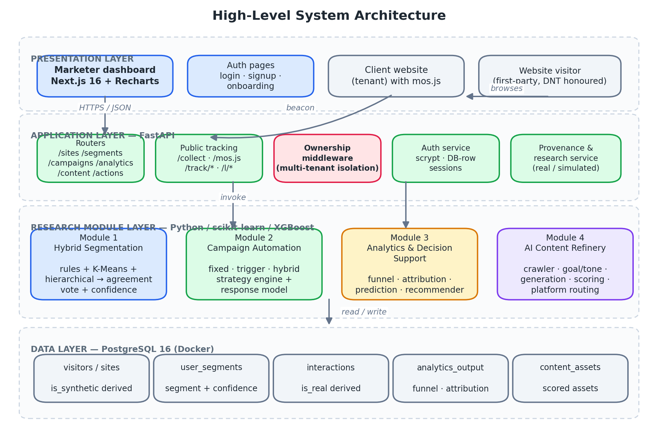
Figure 2 — High-level layered architecture of the orchestration platform.
Presentation layer. A Next.js dashboard with six pages (Overview, Audience, Campaigns, Analytics, Content, Research) plus authentication and website-onboarding flows. Separately, the client's own website carries the mos.js snippet; its visitors are the audience, and they never interact with the dashboard.
Application layer. A FastAPI service exposing site-scoped routers for segments, campaigns, analytics, content and actions; public tracking endpoints that require no authentication because a website's visitors are not signed in to anything; an ownership middleware enforcing tenant isolation in a single place; an authentication service; and a provenance service that reports, at request time, which data is real and which is simulated.
Research module layer. The four modules as importable Python packages. Because the API is itself Python, the module that produced a reported research number is the same object the API loads at run time; there is no re-implementation gap between the experiment and the product.
Data layer. A single PostgreSQL database whose principal tables carry the names specified in the interim report's architecture figures: user_segments, interactions, analytics_output and content_assets.

5.3 High-Level Architectures of Individual Modules

5.3.1 Module 1 — Audience Targeting and Personalization
Figure 3 shows the segmentation engine. The three methods are peers rather than a pipeline: each produces a complete labelling of the audience, and the agreement vote arbitrates. The confidence score is a first-class output, because a downstream module needs to know not only which segment a user is in but how much to trust it.
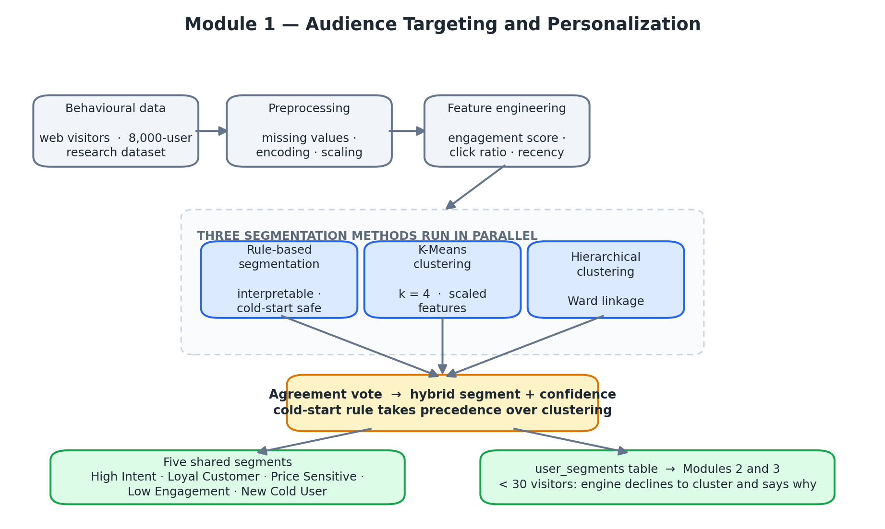
Figure 3 — Architecture of the hybrid segmentation engine (Module 1).
Two design points are load-bearing. The cold-start rule takes precedence over the clustering vote, so a genuinely new visitor cannot be absorbed into an established cluster. And the minimum audience threshold causes the engine to decline clustering outright below 30 visitors, returning interpretable rule-based labels with an explicit explanation rather than an unstable partition presented as a result.

5.3.2 Module 2 — Marketing Automation and Campaign Management
Figure 4 shows the campaign engine. The policy engine is the single point at which the three strategies differ; every other component — profile builder, response model, templates, event simulation, evaluation — is shared. This is what makes the comparison in Section 7.3 a controlled one.
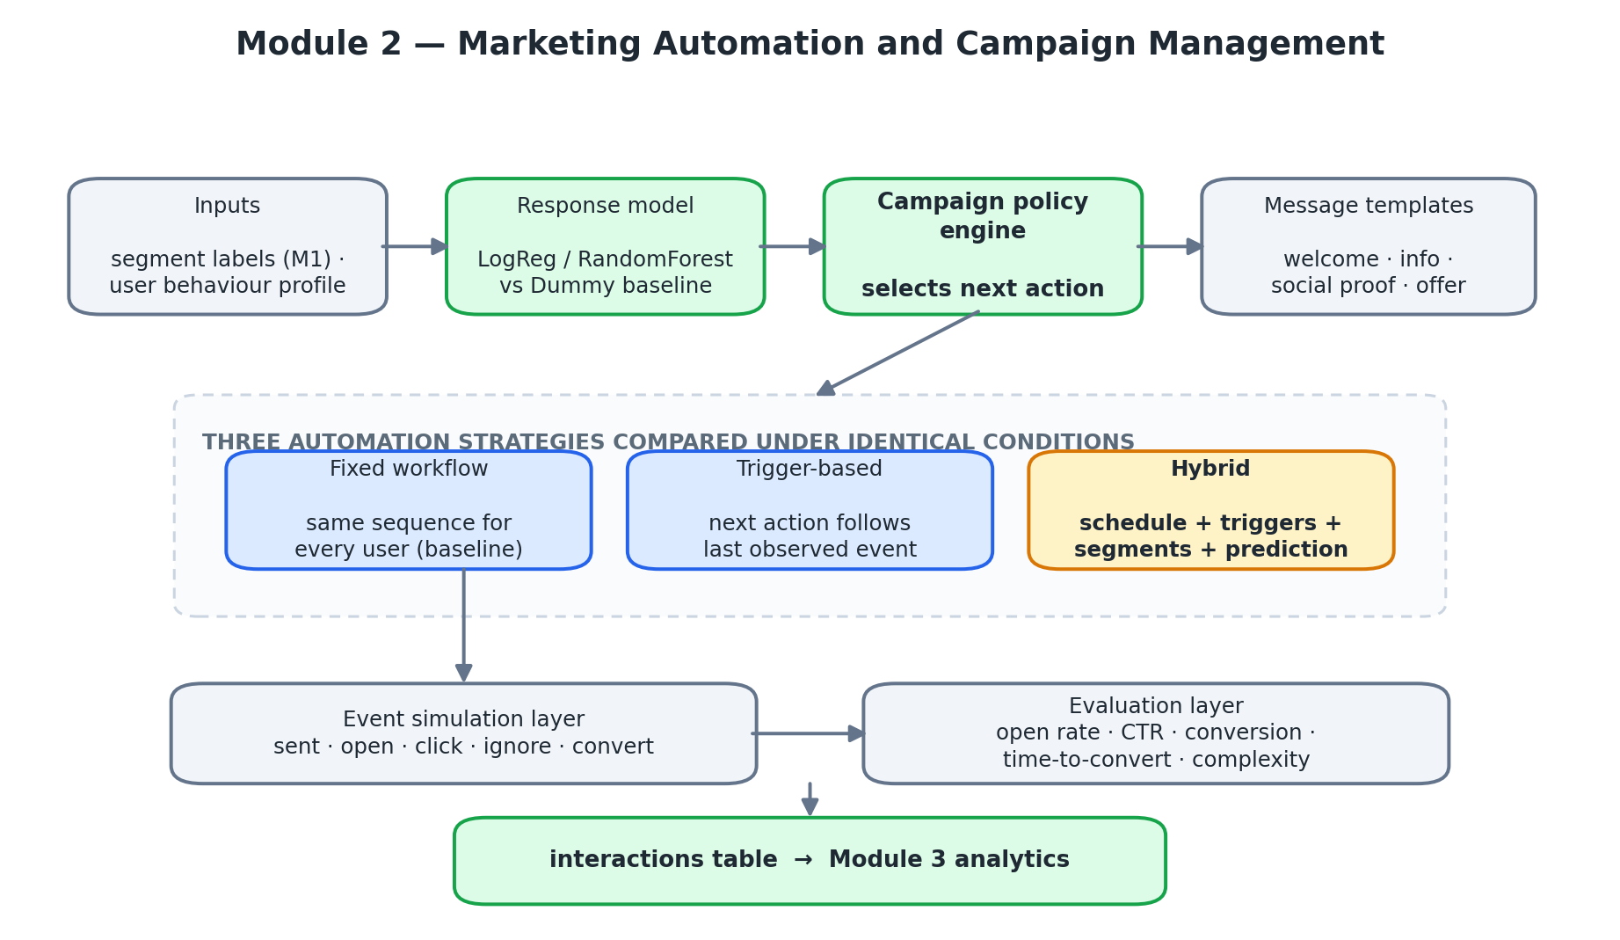
Figure 4 — Architecture of the campaign automation engine (Module 2).

5.3.3 Module 3 — Marketing Analytics and Decision Support
Figure 5 shows the analytics module. Four analytical tracks — feature construction, funnel analysis, drop-off analysis and attribution — feed two predictive models and a shared explainability and validation stage, which in turn feed the recommendation generator.
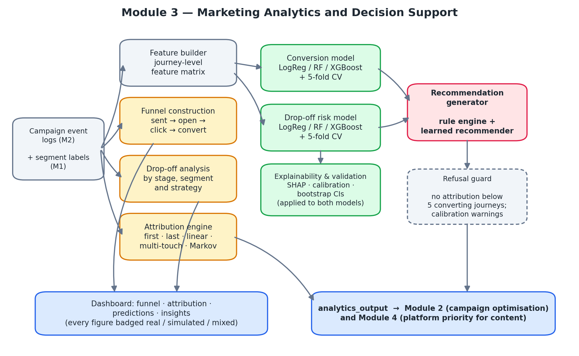
Figure 5 — Architecture of the analytics and decision support module (Module 3).
The refusal guard is drawn as a distinct component because it is one. It sits between the recommendation generator and the published output and can suppress a result entirely: below five converting journeys attribution returns no numbers and states why, and a prediction distribution that has collapsed to a constant raises a calibration warning rather than being presented as a confident forecast.

5.3.4 Module 4 — AI Content Refinery and Multi-Platform Distribution
Figure 6 shows the content refinery. The feedback arrow from Module 3 is the integration point that the literature review found missing: platform generation order is set by measured attribution credit, not by assumption.
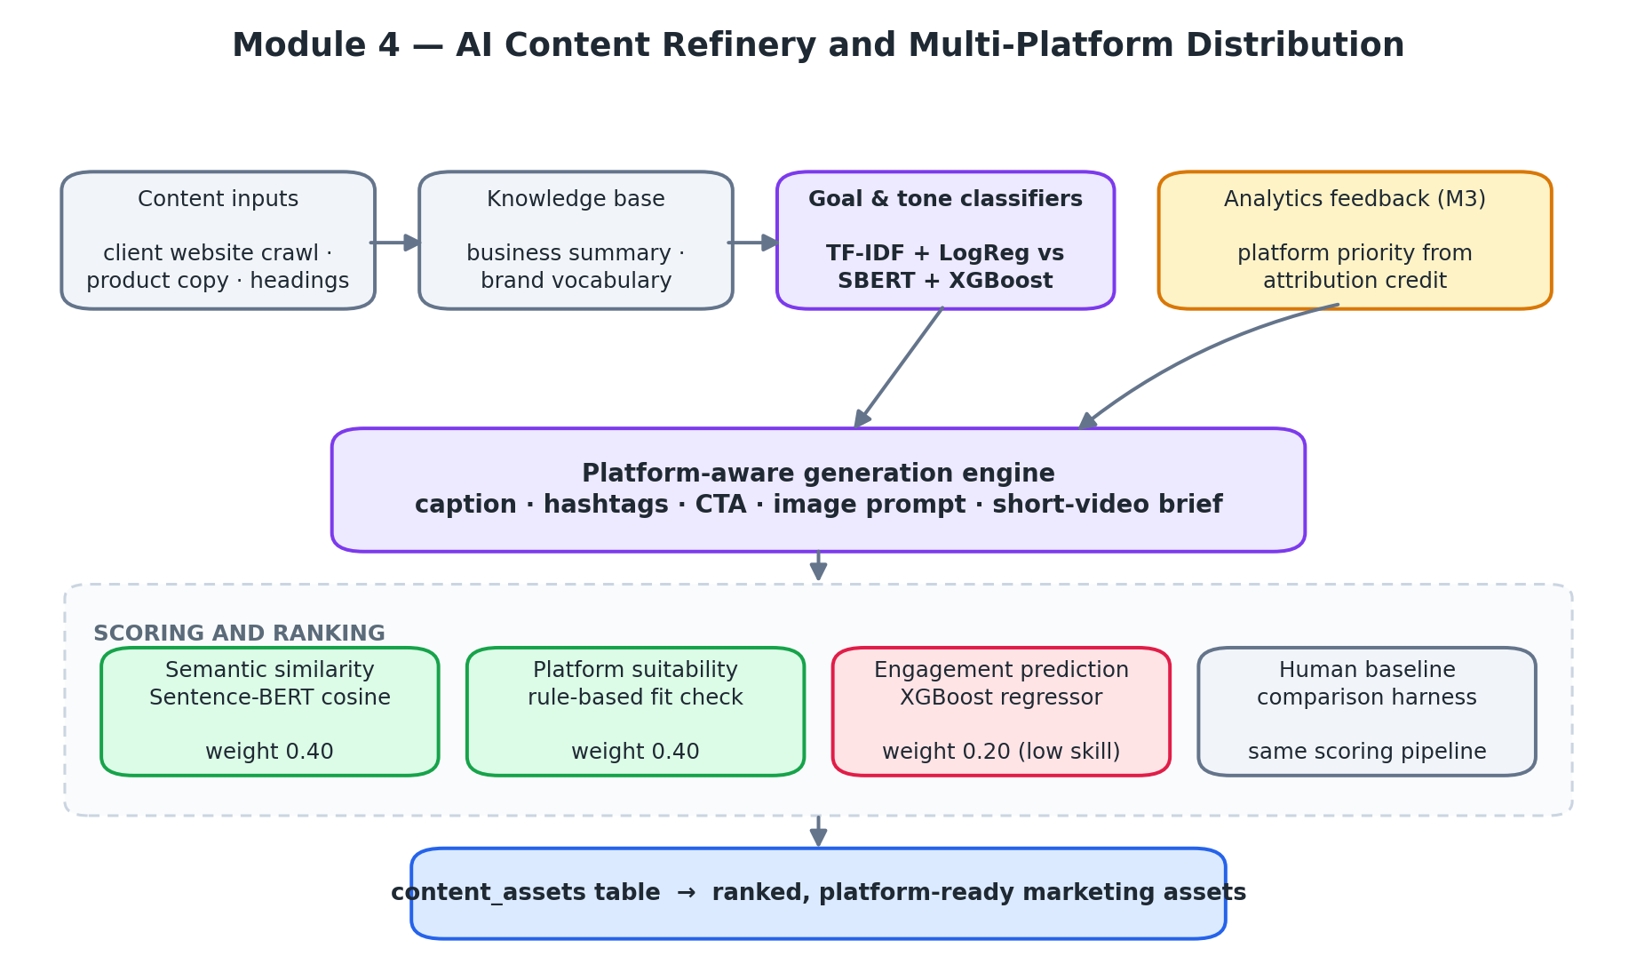
Figure 6 — Architecture of the AI content refinery (Module 4).

5.4 Database Design
Figure 7 shows the schema. The design follows the interim report's table naming so that the delivered system can be read directly against the architecture figures approved at that stage.
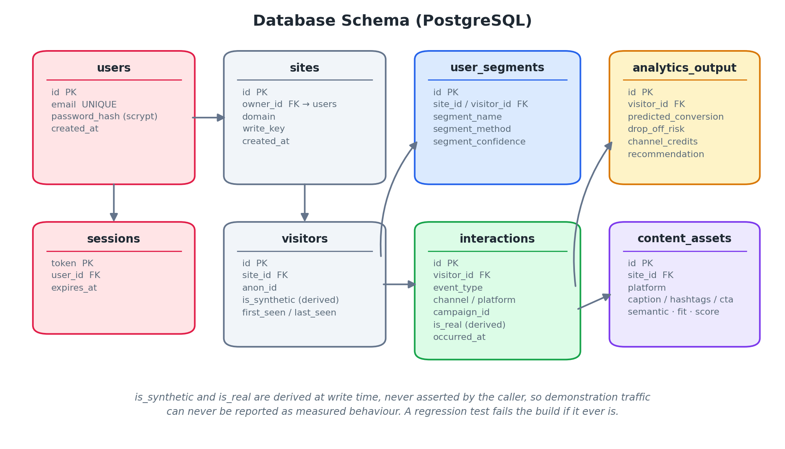
Figure 7 — Shared database schema. Provenance flags are derived at write time.
Table 9 — Principal database tables and their owning module.
Table | Written by | Read by | Key content
users, sessions | Auth service | All routes | Accounts, scrypt password hashes, database-row sessions
sites | Onboarding | All site-scoped routes | Registered client website, owner, write key
visitors | Tracking endpoint | Modules 1, 3 | Anonymous visitor identity, is_synthetic (derived)
user_segments | Module 1 | Modules 2, 3 | Segment name, method, confidence
interactions | Module 2, tracking | Module 3 | Event type, channel, platform, is_real (derived)
analytics_output | Module 3 | Modules 2, 4, dashboard | Conversion probability, drop-off risk, credits, recommendation
content_assets | Module 4 | Module 2, dashboard | Caption, hashtags, CTA, component and composite scores

5.5 Design for Research Integrity
The largest risk to a project of this kind is not that a model performs poorly but that a reader — or the team itself — mistakes a simulated result for a measured one. Three mechanisms were designed into the system rather than documented as conventions.
Provenance is derived, not asserted. The columns `visitors.is_synthetic` and `interactions.is_real` are computed when a row is written, from the path the data actually travelled; a caller cannot declare its own data real. Demonstration traffic passes through the same public endpoints as genuine visitor traffic, so the flag is decided by the same code in both cases. An automated test fails the build if a synthetic visitor ever produces a row marked real.
The provenance report is generated, not written. The dashboard's Research page reads dataset row counts from disk and from the database as the page loads, and reports which dataset trained which model, whether that data is real, and for each model both the headline number and its correct interpretation. Because it is generated it cannot drift away from the system it describes.
The system declines to report what it cannot support. The refusal thresholds described in Section 5.3.3 are enforced in code, and every dashboard figure carries a real / simulated / mixed badge derived from the provenance of the rows behind it.

5.6 Multi-Tenant Design
The platform is designed so that any organisation can create an account, register its website, install the snippet and receive its own segmentation, campaigns, analytics and content. This required the security design to be part of the architecture rather than an afterthought.
- One isolation point. All site-scoped routes pass through a single ownership middleware. A request for a site owned by another account returns 404 rather than 403, so the response does not even confirm that the site exists. A regression test registers two companies and asserts the isolation.
- Sessions are database rows. Signing out deletes the row, so the token dies immediately rather than remaining valid until expiry. Passwords are hashed with salted scrypt.
- The browser never holds the token. The dashboard receives an HttpOnly cookie set on its own origin, so client-side script cannot read it.
- Public routes stay public. The tracking endpoints require no authentication, because a website's visitors are not signed in to the platform and must not be asked to be.

5.7 Summary
The design is a four-layer architecture in which the research modules are ordinary Python packages behind an API, joined by a single relational store whose provenance columns are derived rather than declared. The next chapter describes how this design was implemented, including the defects discovered in the process.

CHAPTER 6 — IMPLEMENTATION

6.1 Introduction
This chapter describes the implementation of the framework: the data it was built on (Section 6.2), each module in turn (Section 6.3), the integrated platform (Section 6.4), the reproducibility and testing arrangements (Section 6.5), and the defects found in the project's own research code together with their corrections (Section 6.6).

6.2 Data Collection

6.2.1 Datasets
Four categories of data were used. Their provenance matters for the interpretation of every result in Chapter 7, so they are stated explicitly.
Table 10 — Datasets used, with size and role.
Dataset | Size | Real / simulated | Used by
Digital Marketing Campaign dataset | 8,000 users × 20 columns | Real (public) | Module 1 segmentation; Module 2 response model
UCI Bank Marketing (bank-additional-full) | 41,188 records | Real (public) | Module 3 simulator calibration and external model validation
Social media engagement corpus | 12,000 posts | Real (public) | Module 4 engagement regressor
Campaign goal / tone corpus | 527 labelled rows (453 goal, 173 tone) | Real, semi-automatically labelled | Module 4 text classifiers
Calibrated journey simulator | 2,000 users, 10,000 campaign sends | Simulated (calibrated on UCI) | Module 3 funnel, attribution and prediction experiments
Live tracked traffic | Variable | Real, first-party | Live operation of all four modules

6.2.2 Live audience collection
The audience for live operation is collected by mos.js, a small dependency-free script that a client installs on its website. It records page views, scroll depth, clicks, form submissions and purchases as first-party data, honours the Do Not Track header, and posts to the public `/collect` endpoint. Tracked links embedded in campaign content — `/track/click/{token}` for email and `/l/{token}` for social posts — allow a conversion to be matched back to the click that earned it even when the company sends the message through its own tools.
One measurement limitation follows from this design and is reported wherever it is relevant: open tracking depends on a pixel that most mail clients now block or pre-fetch, so sent → click is treated as the reliable signal and sent → open is not relied upon.

6.2.3 The journey simulator
A simulator was required because a launch-stage product has, by definition, no journey history, and because ground-truth attribution scoring is impossible with observational data. The simulator generates users with segment-conditional response propensities, assigns each a channel exposure sequence drawn from known per-channel influence weights, and emits sent, open, click and convert events.
Its stage transition probabilities are calibrated against the UCI Bank Marketing dataset (41,188 records) rather than chosen by hand, giving p(open | sent) = 0.899, p(click | open) = 0.557 and p(convert | click) = 0.198 for an overall conversion rate of 11.3 %. Automated tests verify schema correctness, event ordering, segment validity and attribution integrity of the generated data.

6.3 Implementation of Individual Modules

6.3.1 Module 1 — Audience Targeting and Personalization
The engine is implemented in `modules/m1_segmentation/segment.py` as a feature-set-agnostic function with two callers: `research_segmenter()` for the 8,000-user dataset and `web_segmenter()` for live tracked visitors. Preprocessing uses `StandardScaler`; clustering uses `KMeans` (k = 4, `n_init` = 10, fixed random state) and `AgglomerativeClustering` with Ward linkage.
Cluster naming is derived at run time by ranking cluster centroids on engagement and purchase dimensions, so that names remain correct on a new audience. The agreement vote is implemented with the cold-start rule evaluated first, before the clustering comparison, which is the ordering the defect described in Section 6.6 required. The confidence score is produced by a classifier trained on the vote outcome with the vote's own encoded label excluded from the feature set.

6.3.2 Module 2 — Marketing Automation and Campaign Management
Module 2 is implemented under `modules/m2_automation/src/` with the three strategies in a `strategies/` package behind a common interface, so that the simulator and evaluator are identical across strategies. `ml_model.py` fits the response models; `simulator.py` generates events; `evaluation.py` computes the comparison metrics.
A stratified dummy classifier is fitted alongside the real models and reported in the same table. This is deliberate: the dataset's base rate is 0.876, so a model can reach 87.6 % accuracy by predicting the majority class for every user. Publishing the dummy result in the same table makes that floor visible and prevents accuracy from being read as evidence of skill.
Operational complexity is computed as the number of distinct decision rules and branch points a strategy requires. It is a simple measure, but it makes explicit a trade-off the literature usually leaves implicit: the hybrid strategy requires roughly three times the rule surface of the fixed workflow.

6.3.3 Module 3 — Marketing Analytics and Decision Support
Module 3 is implemented under `modules/m3_analytics/src/` as nine co-operating components, run end to end by `pipeline.py`.
Table 11 — Components of the Module 3 analytics pipeline.
Component | Responsibility
simulator.py | Generate calibrated journeys with known channel influence
funnel.py | Funnel construction and drop-off analysis overall, by segment and by strategy
attribution.py | First-, last-, linear, multi-touch and Markov attribution
features.py | Journey-level feature matrix shared by both predictive models
prediction.py | Conversion and drop-off models with five-fold cross-validation
calibration.py | Probability calibration and degenerate-prediction warnings
bootstrap.py | Bootstrap confidence intervals and significance tests
shap_analysis.py | SHAP feature attribution for both models
recommender.py / learned_recommender.py | Rule-based and supervised recommendation generation

Two implementation decisions are worth recording. First, the feature matrix deliberately excludes any variable that is defined in terms of the target; the elevated AUC values obtained on simulated data (Section 7.4.4) are nonetheless treated as optimistic, because in a simulator the events used as features and the events that define the label are generated by the same process. Second, the external validation against UCI Bank Marketing was added specifically so that this optimism could be quantified rather than argued about.

6.3.4 Module 4 — AI Content Refinery and Multi-Platform Distribution
The crawler (`crawler.py`) fetches and cleans the client's site; `knowledge_base.py` builds the business summary; `goal_tone.py` trains and selects the goal and tone classifiers; `generator.py` produces platform-specific assets; `evaluation.py` computes semantic similarity and platform suitability; `engagement.py` provides the engagement regressor; and `human_baseline.py` scores human-written copy through the same pipeline.
Both classifiers are trained twice — once on TF-IDF features with logistic regression and once on Sentence-BERT embeddings with XGBoost — and the better model per target is selected on held-out performance. On this corpus the simpler representation won for both targets, which is reported in Section 7.5.1.
The engagement regressor is trained with an explicit leakage guard: `likes`, `comments`, `shares`, `impressions` and `engagement_rate` are excluded from the feature set by name, because the target is derived from them. The consequence of adding that guard is reported honestly in Section 7.5.2.

6.4 Integrated Platform Implementation
The FastAPI application (`api/`) exposes eleven routers over the four modules, with the module logic wrapped in a `services/` layer so that HTTP concerns never leak into research code. The database schema lives in `api/schema.sql`; the tracking snippet is served from `api/static/mos.js`.
Tenant isolation is implemented as a single middleware in `api/main.py` covering every site-scoped route, rather than as a check repeated in each handler — a deliberate choice, since an isolation check that must be remembered in twenty places will eventually be forgotten in one. Sites created by scripts and tests have no owner and remain open, so the command-line reproduction path needs no login.
The dashboard (`web/`) is a Next.js application with six authenticated pages plus login, signup and site onboarding. Authentication cookies are set through Next route handlers on the dashboard's own origin, and `middleware.ts` redirects unauthenticated requests. A site switcher in the application shell reads the current site from a cookie and redirects to onboarding when an account has no sites yet.
The entire system is reproducible from a clean checkout: `make setup` provisions dependencies, `make db` starts PostgreSQL in Docker, `make api` and `make web` start the services, `make site` serves a realistic demonstration client website with the snippet installed, and `make demo` populates a complete end-to-end demonstration in approximately sixty seconds.

6.5 Testing and Reproducibility
The automated suite comprises 208 test functions — 171 in the platform suite and 37 in Module 3's own suite — covering data contracts, API behaviour, tracking, segmentation, campaign actions, content generation, authentication and tenant isolation, in addition to a TypeScript build of the dashboard. API tests skip rather than fail when PostgreSQL is not running, so the suite remains usable on a machine without Docker.
Each defect described in the next section has a dedicated regression test, so that a corrected error cannot silently return. Two tests are structural rather than functional: one fails the build if a synthetic visitor produces a row marked real, and one walks every API response to assert that numeric fields are serialised as numbers — a guard added after PostgreSQL `NUMERIC` values twice reached the dashboard as JSON strings and silently broke chart rendering.

6.6 Defects Identified and Corrected in the Research Code
Converting the interim-stage notebooks into a running system exposed six defects in the project's own research code. Each had produced results that looked good and were not valid. They are reported here in full because the corrected figures are the ones used throughout Chapter 7, and because the pattern they form — every one of them inflated a result — is itself a finding.
Table 12 — Defects found in the research code, their effect and the correction applied.
# | Defect | Effect on reported results | Correction
D1 | Module 1's confidence classifier was trained with its own target (the encoded vote outcome) present as an input feature. | 6,248 of 8,000 users received confidence of exactly 1.00. | Target removed from the feature set; honest held-out accuracy is 0.92.
D2 | In the agreement vote, the clustering comparison was evaluated before the cold-start rule. | The New Cold User segment fell from 43 users to 0 on live data — the project's first novel contribution was being erased from its own output. | Cold-start rule evaluated first, with precedence over the clustering vote.
D3 | Cluster names were hardcoded to cluster indices. | Names were correct for one dataset and one random seed and arbitrary for any other audience. | Names derived from cluster centroids at run time.
D4 | Module 4's engagement regressor retained likes, comments, shares and impressions as features while predicting a ratio derived from them. | R² of 0.99 was entirely leakage; the honest value is −0.30. | Leakage guard by feature name; the model's weight in content scoring reduced from 0.45 to 0.20.
D5 | The goal/tone corpus required a row to clear the confidence threshold for both targets, although the two classifiers train independently. | The usable corpus was reduced from 527 rows to 114. | Per-target filtering: 453 rows for goal, 173 for tone.
D6 | The `shorts` platform declared a video visual type but defined no visual options. | The selector silently returned a static image brief instead of a video brief. | Visual options defined; selector asserts the declared type is satisfiable.

Two environment faults were also diagnosed and fixed. The first was a macOS OpenMP conflict: XGBoost and PyTorch each bundle their own `libomp`, and fitting or predicting with XGBoost while PyTorch was loaded terminated the process with exit code 139 and no traceback, killing training runs, the test suite and API workers. Only constraining OpenMP to a single thread resolved it; a guard module is imported first in every entry point. The second was a character-encoding fault in the crawler: the HTTP library defaults to ISO-8859-1 for `text/html` when the response header omits a charset, which corrupted every non-ASCII character in a client's marketing copy before it reached the content generator.
The defects share a signature: each one made a result better than it truly was, and none produced an error message. This is the reason the integrity mechanisms of Section 5.5 were designed into the system rather than left as good intentions.

6.7 Summary
All four modules are implemented, integrated behind a single API over a shared PostgreSQL database, exercised by 208 automated tests and reproducible from a clean checkout with a small number of commands. Six defects in the research code were identified and corrected, and the corrected figures are the ones evaluated in Chapter 7.

CHAPTER 7 — EVALUATION

7.1 Metrics Used
This section defines each metric used in the evaluation and states why it is appropriate for the quantity being measured. Several of the datasets in this project are strongly imbalanced, so the choice of metric is not a formality: on the campaign response dataset a model that predicts the majority class for every user achieves 87.6 % accuracy while being of no practical use whatsoever.

7.1.1 Accuracy
The proportion of correct predictions, (TP + TN) / (TP + TN + FP + FN). Reported throughout for comparability with the literature, but never used as the headline metric where the class distribution is skewed, for the reason given above.

7.1.2 Precision
TP / (TP + FP): of the cases predicted positive, the proportion that truly are. In this project precision governs cost — a high-intent user who is not high intent receives a premium offer that is wasted, and an over-eager drop-off classifier triggers unnecessary reactivation campaigns.

7.1.3 Recall
TP / (TP + FN): of the truly positive cases, the proportion identified. Recall governs opportunity: a converting user the model fails to identify is revenue not earned. Precision and recall trade against one another, which is why both are reported for every classifier in this chapter.

7.1.4 F1-Score
The harmonic mean of precision and recall, 2PR / (P + R). Two variants are reported. Weighted F1 averages per-class F1 weighted by support and is therefore dominated by the majority class. Macro F1 averages per-class F1 without weighting and therefore exposes failure on rare classes. Where the two diverge sharply — as they do for the campaign-goal classifier in Section 7.5.1 — macro F1 is the number to read.

7.1.5 ROC-AUC and PR-AUC
ROC-AUC is the probability that a randomly chosen positive case is ranked above a randomly chosen negative one; 0.5 is chance. It is threshold-independent, which suits this project because the predictive models are used for ranking audiences rather than for hard classification. PR-AUC summarises the precision–recall curve and is more informative than ROC-AUC under heavy imbalance; its baseline is the positive base rate, not 0.5, and it is interpreted against that floor throughout.

7.1.6 MAE, R² and Spearman correlation
For the regression and attribution tasks, mean absolute error (MAE) measures average deviation in the units of the quantity itself — for attribution, credit share. R² measures the proportion of variance explained; a negative R² means the model performs worse than predicting the mean, which is a meaningful and reportable outcome. Spearman rank correlation is reported alongside R² for the engagement model because that model is used to rank content rather than to predict an absolute value.

7.1.7 Silhouette coefficient
For clustering, the silhouette coefficient [58] compares each point's mean intra-cluster distance with its mean distance to the nearest other cluster, on a scale from −1 to 1. It measures geometric separation only, and this project reports it alongside a downstream marketing measure precisely because the two can disagree.

7.1.8 Bootstrap confidence intervals and significance
Differences between automation strategies are small in absolute terms, so point estimates alone would not support a conclusion. Non-parametric bootstrap resampling [57] with 95 % percentile confidence intervals and associated p-values is used wherever a strategy or attribution comparison is claimed.
Table 13 — Evaluation metrics by module and task.
Module | Task | Primary metric | Supporting metrics
M1 | Segmentation | Downstream conversion separation | Silhouette, method agreement, segment stability
M1 | Confidence model | Held-out accuracy | Feature-leakage audit
M2 | Strategy comparison | Conversions per 1,000 messages | Open rate, CTR, days-to-convert, complexity
M2 | Response model | ROC-AUC and PR-AUC | Accuracy against dummy floor, feature importance
M3 | Funnel | Stage drop-off rate | Overall conversion rate by segment and strategy
M3 | Attribution | MAE against ground truth | Bootstrap CI, credit distribution
M3 | Prediction | ROC-AUC (external validation) | CV AUC, precision, recall, F1, SHAP, calibration
M3 | Recommendation | Accuracy vs rule baseline | Per-class precision, recall, F1, agreement
M4 | Goal / tone classification | Macro F1 | Accuracy, weighted F1, cross-validated F1
M4 | Engagement regression | R² and Spearman | MAE against mean baseline
M4 | Content quality | Composite score | Semantic similarity, platform fit, human baseline

7.2 Module 1 — Audience Targeting and Personalization

7.2.1 Segment distribution and downstream conversion
The hybrid engine was run over the 8,000-user Digital Marketing Campaign dataset. Conversion is used only to evaluate the resulting segments — it is never supplied as a clustering feature — so the separation reported below is not circular.
Table 14 — Hybrid segmentation output on the 8,000-user dataset, with downstream conversion.
Segment | Users | Share | Conversion rate
High Intent | 813 | 10.2 % | 91.8 %
Loyal Customer | 2,247 | 28.1 % | 91.0 %
Price Sensitive | 1,393 | 17.4 % | 87.9 %
Low Engagement | 3,384 | 42.3 % | 86.0 %
New Cold User | 163 | 2.0 % | 53.4 %
Total / spread | 8,000 | 100 % | 38.4 pp separation

The engine separates the highest- from the lowest-converting segment by 38.4 percentage points. The commercially important result is the New Cold User segment: 163 users whose conversion rate of 53.4 % is roughly 33 points below every other segment. These are exactly the users a launch-stage marketing system must treat differently, and they are the users that pure clustering cannot isolate.

7.2.2 Geometric quality versus marketing usefulness
The same clustering achieves a silhouette coefficient of 0.087. This is a low value: the clusters overlap heavily and are not geometrically clean. Additionally, 41 % of users receive three different labels from the three methods, which is why the confidence score is exported alongside the label rather than discarded.
The two results are reported together because they disagree, and the disagreement is the finding. Judged as a clustering problem the segmentation is mediocre; judged as a marketing instrument — does it group users who behave differently in the way that matters commercially? — it separates conversion by 38.4 points. A study that reported only the silhouette would have discarded a useful segmentation; a study that reported only the conversion separation would have overstated its geometric quality.

7.2.3 Comparison against the constituent methods
At the interim stage the rule-based and K-Means segmenters were evaluated separately on the same dataset under an earlier five-segment taxonomy. The rule-based method separated its highest- and lowest-converting segments by 25.5 percentage points (92.7 % against 67.2 %), whereas K-Means produced more evenly sized but far less differentiated clusters, separated by only 7.7 points (90.9 % against 83.2 %). Critically, K-Means failed to isolate cold-start users at all, because a user with almost no interaction history has no distinguishing distance signature and is absorbed into the nearest centroid.
This comparison motivated the hybrid design and the cold-start precedence rule. It also predicted defect D2 in Section 6.6: when the agreement vote was implemented with the clustering comparison evaluated first, the cold-start segment collapsed from 43 users to zero on live data — clustering overruling the only method capable of recognising a new user.

7.2.4 Confidence model
The classifier that produces the confidence score originally reported near-perfect confidence for 6,248 of 8,000 users. Auditing revealed that the encoded vote outcome — the target itself — was present among its input features (defect D1). With the leaked feature removed, held-out accuracy is 0.92. This is the value used by the system and reported here.

7.3 Module 2 — Marketing Automation and Campaign Management

7.3.1 Strategy comparison
The three strategies were executed over the same 8,000-user cohort with the same templates and the same response model.
Table 15 — Automation strategy comparison over an identical 8,000-user cohort (Module 2 simulator).
Metric | Fixed | Trigger | Hybrid
Messages sent | 32,000 | 10,596 | 24,348
Open rate | 24.25 % | 24.75 % | 23.11 %
Click-through rate | 4.68 % | 4.78 % | 4.21 %
Conversion rate (per user) | 2.70 % | 1.35 % | 2.34 %
Conversions per 1,000 messages | 6.75 | 10.19 | 7.68
Average days to convert | 1.36 | 0.53 | 1.21
Operational complexity (rules) | 7 | 15 | 19

The result is more interesting than a simple ranking. The fixed workflow achieves the highest per-user conversion rate — but only by sending three times as many messages as the trigger strategy. Measured by efficiency, the ordering reverses completely: the trigger strategy converts 10.19 users per 1,000 messages against the fixed workflow's 6.75, a 51 % improvement, and it converts them in 0.53 days rather than 1.36.
This exposes a trade-off that reporting conversion rate alone would conceal. A fixed workflow buys conversions with volume, at a cost in send expense, list fatigue and deliverability that the conversion rate does not show. The hybrid strategy sits between the two on every metric — and carries the highest operational complexity at 19 rules against the fixed workflow's 7. For a small organisation, that near-tripling of the rule surface is a real maintenance cost that the marketing literature rarely quantifies.

7.3.2 Campaign response model
The response model was fitted with a stratified dummy classifier reported alongside it, because the dataset's base rate is 0.876.
Table 16 — Campaign response model performance against a dummy baseline (base rate 0.876).
Model | Accuracy | ROC-AUC | PR-AUC | Precision | Recall | F1
Dummy (majority) | 0.8762 | 0.5000 | 0.8762 | 0.8762 | 1.0000 | 0.9340
Logistic regression | 0.8931 | 0.7873 | 0.9460 | 0.8953 | 0.9943 | 0.9422
Random forest | 0.8950 | 0.8055 | 0.9491 | 0.8955 | 0.9964 | 0.9433

Accuracy is almost uninformative here: the random forest's 0.8950 exceeds the dummy's 0.8762 by less than two points. The meaningful signal is in the ranking metrics. ROC-AUC rises from 0.5000 (chance) to 0.8055, and PR-AUC rises from the base rate floor of 0.8762 to 0.9491. The model discriminates; it simply cannot demonstrate that through accuracy on a dataset this imbalanced.
The gap between random forest and logistic regression on ROC-AUC is only 0.018, which suggests the signal in these features is largely linear with limited interaction structure. The most important features are engagement score (0.117), click-through rate (0.078), conversion rate (0.077), advertising spend (0.076) and pages per visit (0.073) — behavioural rather than demographic, consistent with the segmentation design in Module 1.

7.4 Module 3 — Marketing Analytics and Decision Support

7.4.1 Funnel construction and drop-off
The funnel was constructed over 2,000 simulated users and 10,000 campaign sends, with stage transition probabilities calibrated against the UCI Bank Marketing dataset [51] (41,188 real records), giving p(open | sent) = 0.899, p(click | open) = 0.557 and p(convert | click) = 0.198.
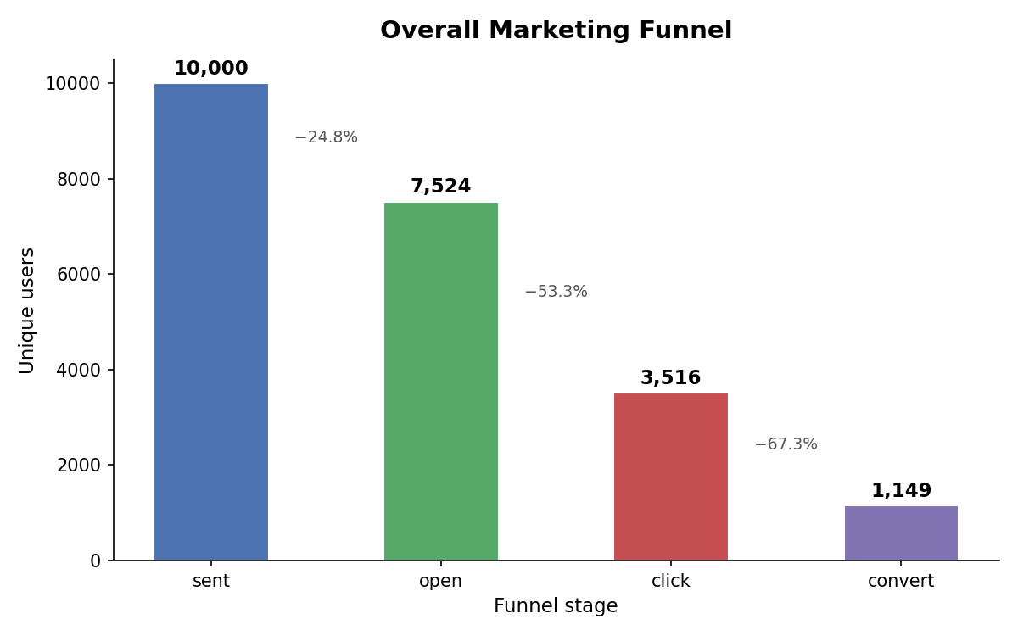
Figure 8 — Overall marketing funnel: sent → opened → clicked → converted.
The observed funnel is 10,000 sent → 7,524 opened (−24.8 %) → 3,516 clicked (−53.3 %) → 1,149 converted (−67.3 %), an overall conversion rate of 11.49 % against the 11.27 % implied by the calibration targets — confirming that the simulator reproduces the real-data transition structure it was fitted to. The largest single loss is at click → convert, which is where the drop-off model and the recommendation layer are directed.
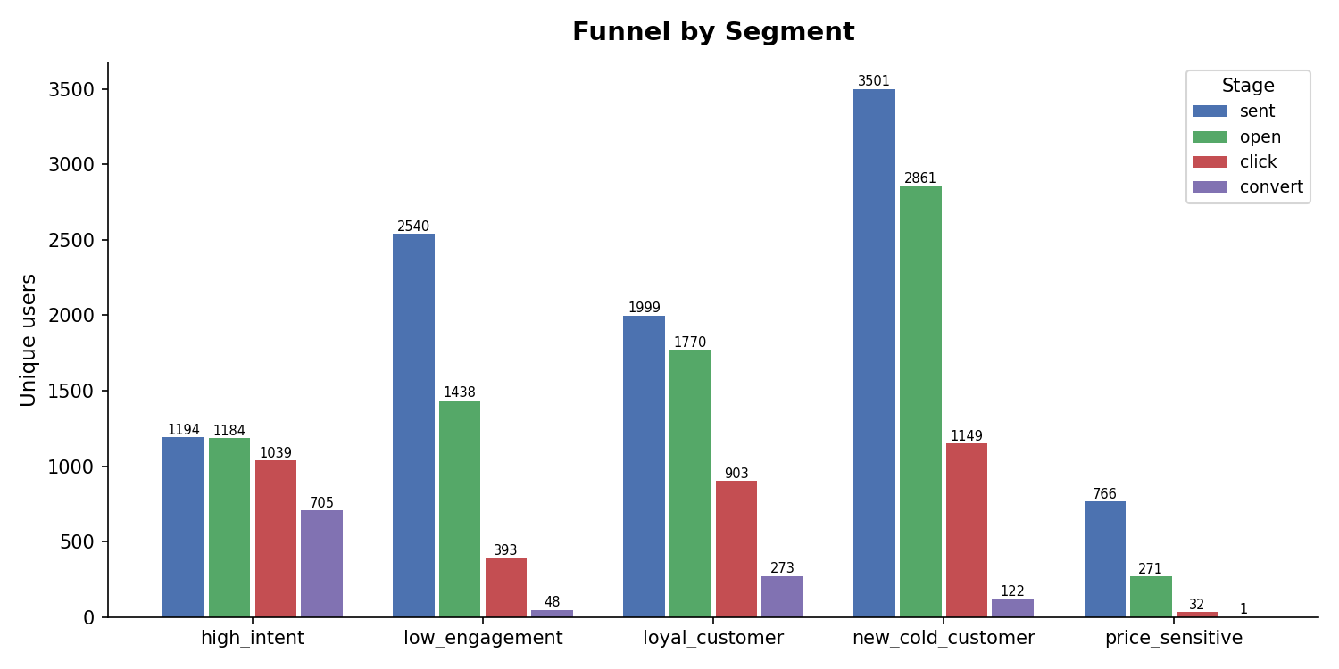
Figure 9 — Funnel performance disaggregated by audience segment.
Disaggregating by segment localises the loss. Drop-off between click and conversion is highest for the Price Sensitive segment at 96.9 % — these users engage readily and convert rarely, which is a pricing or offer problem rather than a targeting problem. High Intent is the strongest segment at 59.0 % end-to-end conversion. This is the kind of prescriptive statement the analytics module exists to produce: it names the stage, the audience and the likely cause.

7.4.2 Automation strategy comparison with significance testing
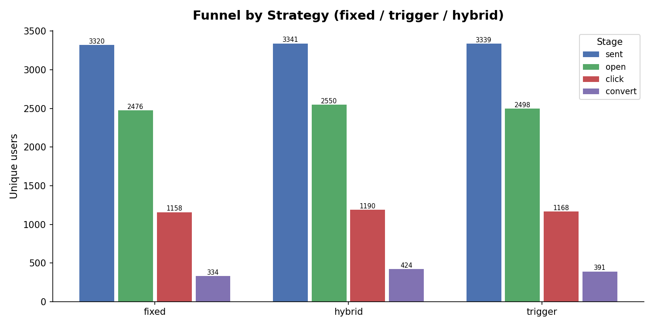
Figure 10 — Funnel progression by automation strategy.
Table 17 — Funnel and drop-off by automation strategy (Module 3 calibrated simulator).
Strategy | Sent | Opened | Clicked | Converted | Drop click→convert | Overall conversion
Fixed | 3,320 | 2,476 | 1,158 | 334 | 71.16 % | 10.06 %
Trigger | 3,339 | 2,498 | 1,168 | 391 | 66.52 % | 11.71 %
Hybrid | 3,341 | 2,550 | 1,190 | 424 | 64.37 % | 12.69 %

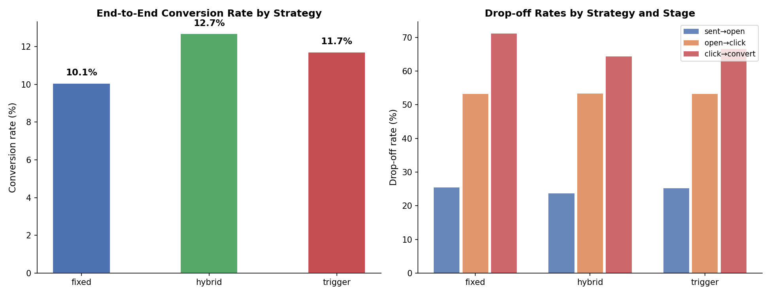
Figure 11 — Strategy comparison across funnel stages and conversion.
Under the calibrated simulator the hybrid strategy converts best, and the improvement survives significance testing.
Table 18 — Bootstrap 95 % confidence intervals for conversion rate and strategy lift.
Quantity | Point estimate | 95 % CI | p-value
Conversion rate — fixed | 0.1006 | [0.0909, 0.1108] | —
Conversion rate — trigger | 0.1171 | [0.1057, 0.1278] | —
Conversion rate — hybrid | 0.1269 | [0.1159, 0.1390] | —
Lift: trigger vs fixed | +16.4 % | [+2.3 %, +33.5 %] | 0.012
Lift: hybrid vs fixed | +26.2 % | [+10.1 %, +44.6 %] | < 0.001

Both lifts are statistically significant at the 5 % level and the hybrid lift is significant at the 0.1 % level. The confidence intervals are wide — the trigger interval reaches down to +2.3 % — which is honest information about the strength of the conclusion, and a reason to prefer the hybrid result.
The two simulators disagree, and the disagreement is informative. Module 2's simulator (Table 15) ranks the fixed workflow highest on per-user conversion; Module 3's calibrated simulator (Table 17) ranks it lowest. The reconciliation is message volume: Module 2's trigger strategy sends only a third as many messages, which depresses per-user conversion while raising conversion per message. Module 3's simulator holds send volume approximately constant across strategies, which isolates policy quality from send volume. The consistent finding across both is that behaviour-aware strategies are more efficient per message; the per-user conversion ranking depends on how many messages a strategy is permitted to send.

7.4.3 Attribution modelling against ground truth
Because the simulator generates journeys from known per-channel influence weights, the true credit distribution is available and each attribution model can be scored against it — a comparison that observational marketing data cannot support.
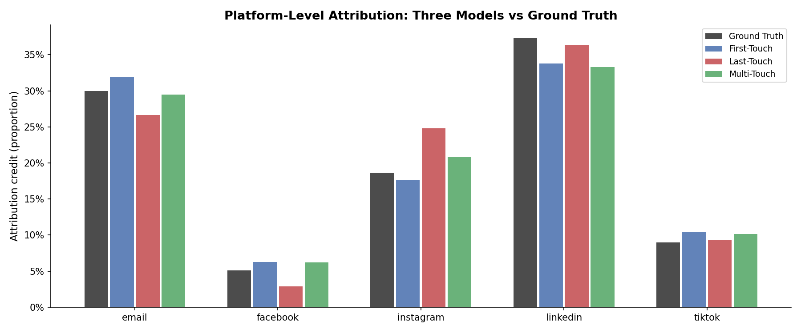
Figure 12 — Platform-level attribution credit: three models compared against known ground truth.
The ground-truth credit distribution generated by the simulator is LinkedIn 37.2 %, email 29.8 %, Instagram 18.5 %, TikTok 8.9 % and Facebook 5.1 %. Figure 12 shows the three models deviating from it in systematically different directions rather than randomly.
- First-touch over-credits email (31.9 % against 29.8 %) and under-credits LinkedIn (33.8 % against 37.2 %) — it rewards the channel that opens the journey.
- Last-touch over-credits Instagram by 6.3 percentage points (24.8 % against 18.5 %) while under-crediting email (26.6 %) and almost halving Facebook (2.9 % against 5.1 %) — it rewards whichever channel happens to be last.
- Multi-touch tracks ground truth most closely across the distribution, recovering email at 29.3 % against a true 29.8 % and LinkedIn at 33.3 % against 37.2 %.
The two single-touch models therefore disagree about the same journeys in opposite directions: first-touch says email creates the audience, last-touch says Instagram closes it, and each is blind to the other's evidence. An organisation relying on last-touch alone would over-invest in Instagram and cut the email spend that first-touch and ground truth both show to be responsible for roughly 30 % of conversion credit.
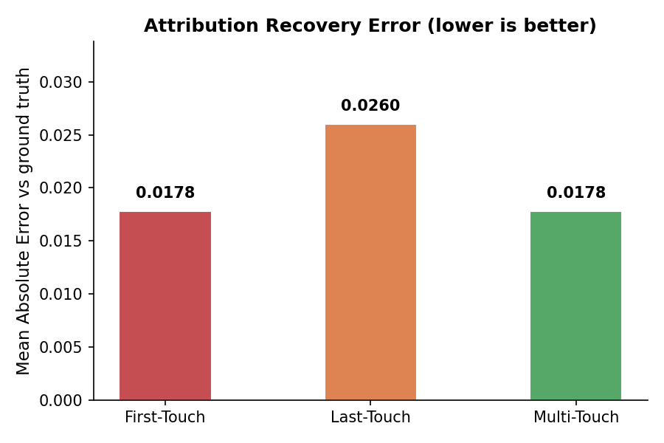
Figure 13 — Mean absolute error of each attribution model against known ground-truth credit.
Table 19 — Attribution accuracy against ground truth, with bootstrap confidence intervals (lower MAE is better).
Attribution model | MAE | 95 % CI
Multi-touch (weighted) | 0.0178 | [0.0102, 0.0250]
First-touch | 0.0178 | [0.0124, 0.0316]
Last-touch | 0.0260 | [0.0183, 0.0358]
Markov (removal effect) | 0.0525 | [0.0467, 0.0575]

Three findings follow. Last-touch is measurably the worse of the two single-touch models, with 46 % higher error than multi-touch — and it is the model most widely used in practice because it is the easiest to compute. Multi-touch attribution is the most reliable, matching first-touch on point estimate but with a tighter confidence interval. Markov attribution is the worst performer here, at nearly three times the error of multi-touch — not because the method is inferior in principle, but because removal-effect estimation requires far more converting journeys than a cold-start scenario provides. That is a direct, quantified demonstration of the cold-start constraint this project set out to study.
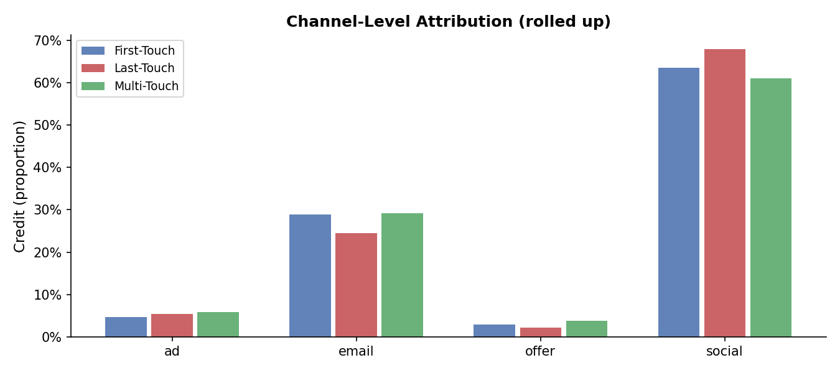
Figure 14 — Channel-level attribution credit (rolled up) under the three models.
Rolled up to the channel level (Figure 14) the three models agree far more closely — social carries 61–68 % of credit and email 24–29 % under all three. The disagreement is therefore concentrated within the social channel, at exactly the level of granularity at which a marketer must choose which platform to produce content for, which is why Module 4 consumes the platform-level rather than the channel-level distribution.
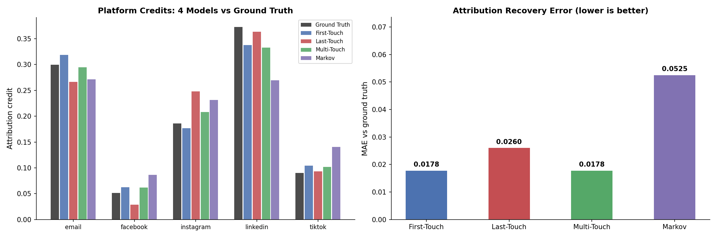
Figure 15 — Attribution study: platform credit for four models against ground truth (left) and recovery error (right).
Figure 15 adds the Markov model to the comparison. It over-credits Instagram (23.1 %) and TikTok (13.9 % against a true 8.9 %) while under-crediting LinkedIn by more than ten points (26.9 % against 37.2 %) — the largest deviations of any model, and the reason for its error of 0.0525.
The system-level insight generated from this analysis reads: email leads first-touch (31.9 %) but loses credit in last-touch, while Instagram gains the most last-touch credit (24.8 %) — use email for acquisition and Instagram for closing. This is passed to Module 4 as the platform generation priority.

7.4.4 Conversion and drop-off prediction
Three algorithms were fitted for each of the two targets, with five-fold cross-validation.
Table 20 — Conversion and drop-off model performance on simulated data (five-fold CV).
Target | Model | Accuracy | Precision | Recall | F1 | AUC | CV AUC (mean ± sd)
Conversion | Logistic regression | 0.9035 | 0.5491 | 0.9000 | 0.6820 | 0.9678 | 0.9624 ± 0.0066
Conversion | Random forest | 0.9510 | 0.9125 | 0.6348 | 0.7487 | 0.9712 | 0.9687 ± 0.0049
Conversion | XGBoost | 0.9010 | 0.5402 | 0.9348 | 0.6847 | 0.9756 | 0.9722 ± 0.0038
Drop-off | Logistic regression | 0.8865 | 0.9433 | 0.8745 | 0.9076 | 0.9299 | 0.9318 ± 0.0059
Drop-off | Random forest | 0.9510 | 0.9475 | 0.9773 | 0.9622 | 0.9867 | 0.9840 ± 0.0027
Drop-off | XGBoost | 0.9475 | 0.9563 | 0.9616 | 0.9589 | 0.9902 | 0.9879 ± 0.0006

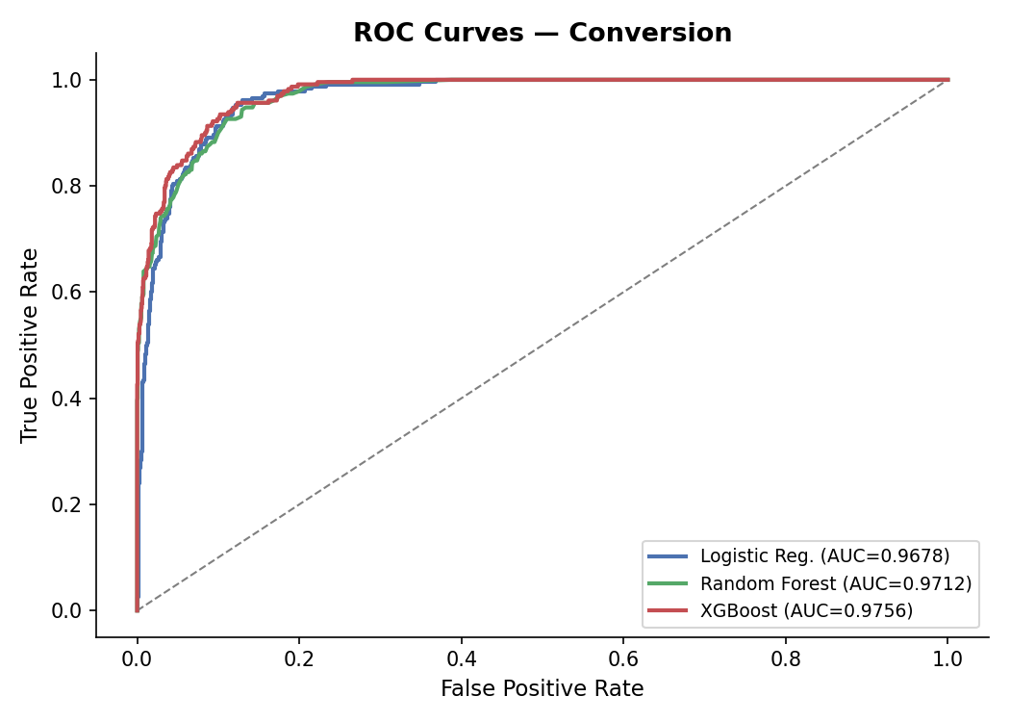
Figure 16 — ROC curves for the conversion prediction models.
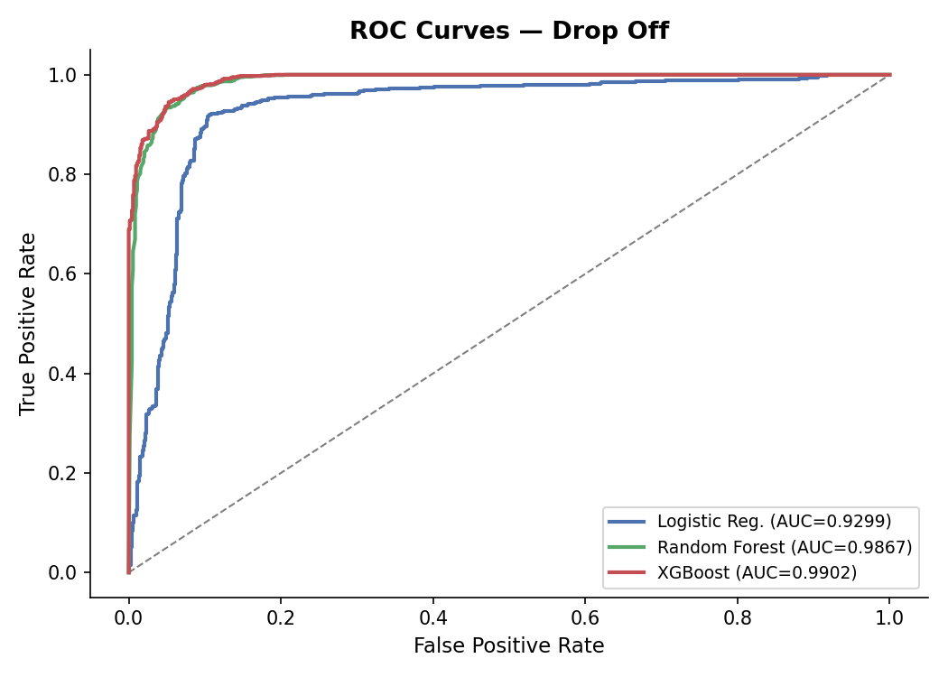
Figure 17 — ROC curves for the drop-off risk models.
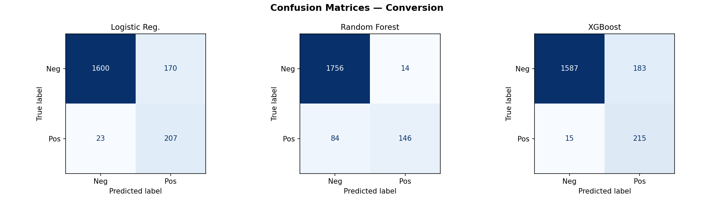
Figure 18 — Confusion matrix, conversion model.
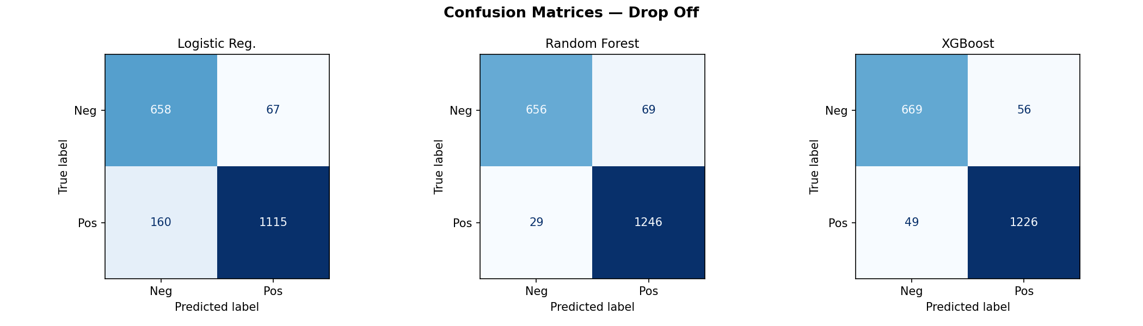
Figure 19 — Confusion matrix, drop-off model.
The precision–recall trade-off is visible and operationally meaningful. For conversion, the random forest achieves precision of 0.9125 at recall 0.6348, while XGBoost achieves recall 0.9348 at precision 0.5402. Which is preferable depends on the cost asymmetry: for an expensive premium offer, precision matters more; for a cheap reminder email, recall matters more. The system therefore exposes the probability and lets the recommendation layer choose the threshold, rather than fixing one.

7.4.5 External validation: quantifying simulator optimism
AUC values near 0.99 on simulated data should not be believed. In a simulator, the events used as features and the events that define the label are produced by the same generative process, so some degree of leakage is structural. Rather than argue about the magnitude of this effect, the models were re-fitted and re-evaluated on the real UCI Bank Marketing dataset [51].
Table 21 — Model AUC on simulated data versus the real UCI Bank Marketing dataset.
Model | Simulated AUC | Real-data AUC | Optimism
Logistic regression | 1.0000 | 0.9438 | 0.0562
Random forest | 0.9794 | 0.9492 | 0.0302
XGBoost | 0.9934 | 0.9535 | 0.0399

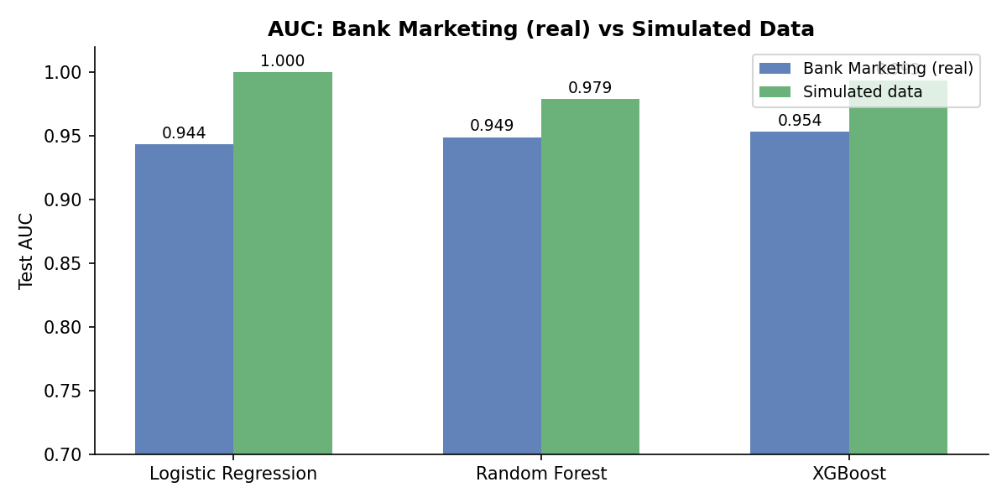
Figure 20 — Model AUC on simulated data compared with the real UCI Bank Marketing dataset.
Simulator optimism is between 3.0 and 5.6 AUC points, and logistic regression — which reached a perfect 1.0 on simulated data — is the most inflated. The honest headline figure for this module is therefore AUC 0.9535, obtained by XGBoost on real behavioural data, and that is the figure reported in the abstract and conclusion. The simulated values remain in the report, clearly labelled, because the difference between them is itself a methodological result: a study reporting only the simulated AUC would have overstated its models by up to five points.

7.4.6 Model explainability
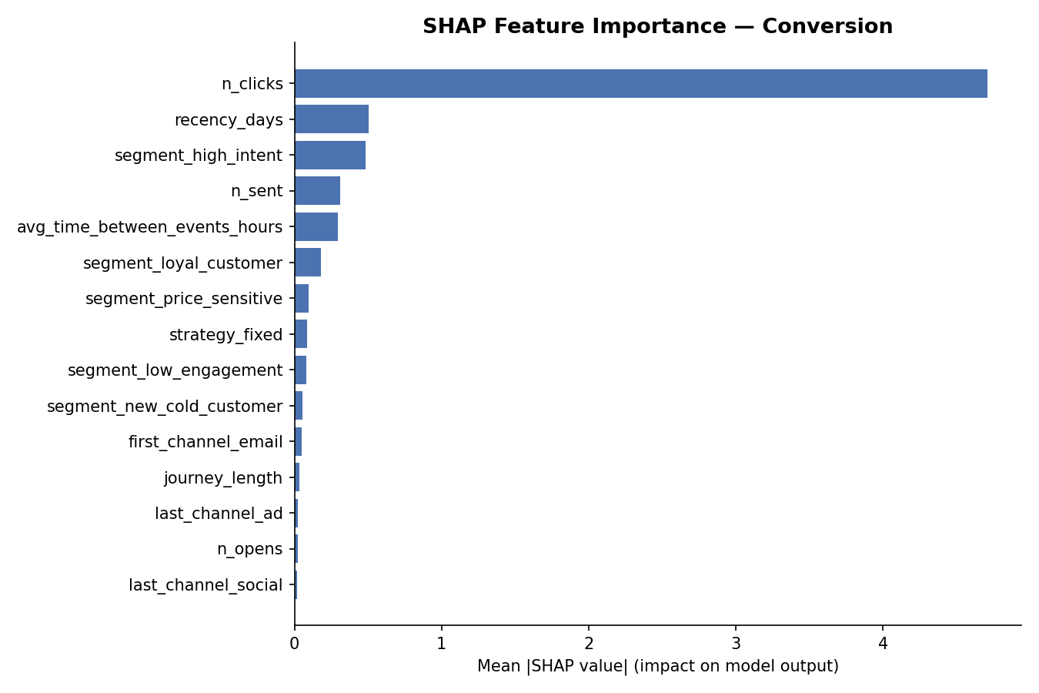
Figure 21 — SHAP feature importance for the conversion model.
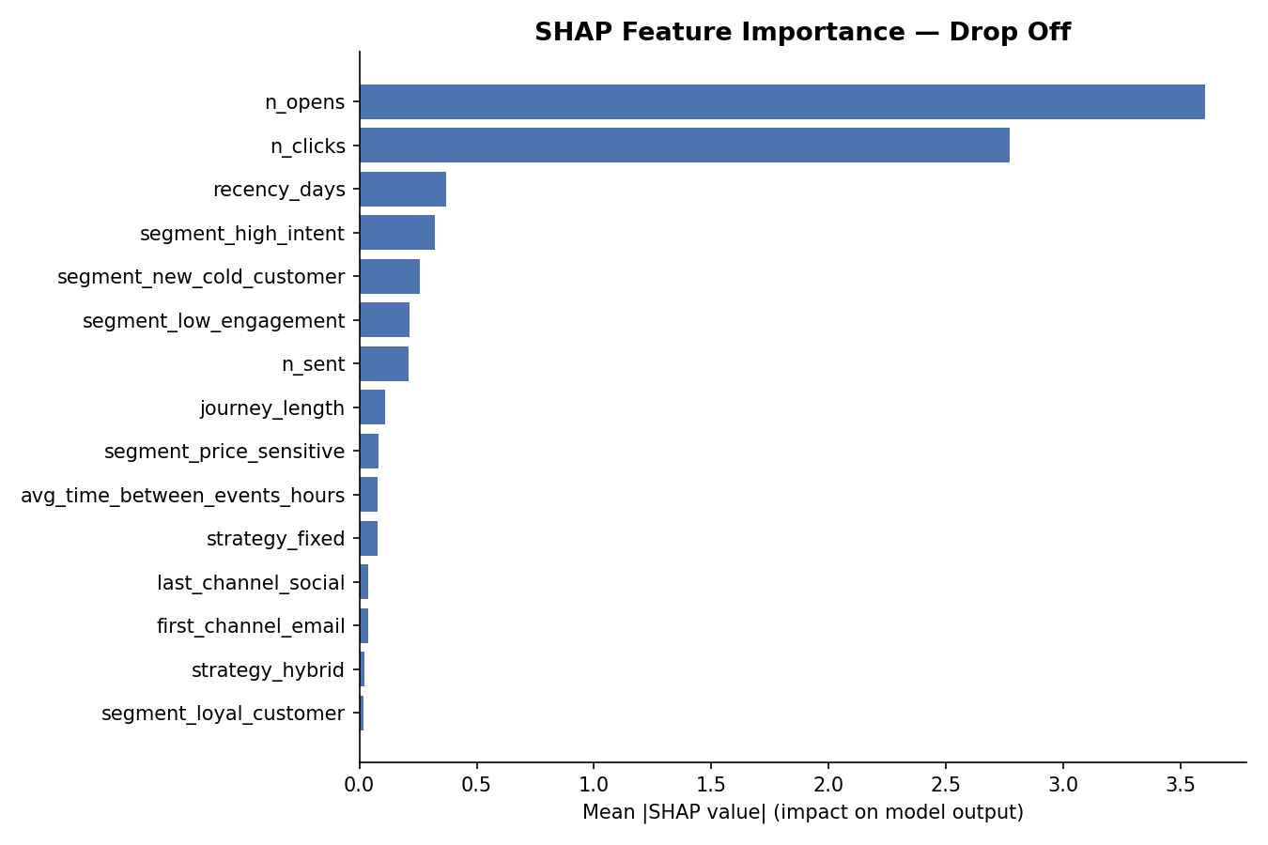
Figure 22 — SHAP feature importance for the drop-off risk model.
Table 22 — Top SHAP features (mean absolute SHAP value) for both predictive models.
Rank | Conversion model | Value | Drop-off model | Value
1 | Number of clicks | 4.708 | Number of opens | 3.601
2 | Recency (days) | 0.504 | Number of clicks | 2.769
3 | Segment: High Intent | 0.486 | Recency (days) | 0.370
4 | Number sent | 0.314 | Segment: High Intent | 0.324
5 | Avg. time between events | 0.295 | Segment: New Cold User | 0.259
6 | Segment: Loyal Customer | 0.180 | Segment: Low Engagement | 0.214

Two observations. First, click behaviour dominates conversion prediction by an order of magnitude over every other feature — consistent with the measurement decision in Section 6.2.2 to treat sent → click as the reliable signal and to distrust open tracking. Second, the segment labels produced by Module 1 appear among the top features of both models, with High Intent third in the conversion model and New Cold User fifth in the drop-off model. This is direct quantitative evidence that Module 1's output carries predictive value into Module 3, which is the integration effect the literature review found to be asserted but rarely measured.

7.4.7 Recommendation generation
A supervised recommender was trained to reproduce and improve on the rule-based recommendation engine, and evaluated on a held-out set of 2,000 journeys.
Table 23 — Learned recommender against the rule-based baseline (n = 2,000 held-out journeys).
Recommender | Test accuracy | Agreement with rules
Rule-based baseline | 0.8280 | —
Learned recommender | 0.9440 | 0.8215

Table 24 — Per-class performance of the learned recommender.
Recommended action | Precision | Recall | F1 | Support
Send general reminder | 0.9562 | 0.9796 | 0.9678 | 1,716
Send reactivation campaign | 1.0000 | 1.0000 | 1.0000 | 54
Send premium offer | 0.8212 | 0.7500 | 0.7840 | 196
Send personalised offer | 0.6667 | 0.1765 | 0.2791 | 34

The learned recommender improves on the rule baseline by 11.6 percentage points while agreeing with it on 82.2 % of cases — it has learned the rules and corrected them, rather than replacing them with something unrelated. Reactivation campaigns are identified perfectly, because dormancy is a clean signal.
The honest weakness is the personalised-offer class: recall of 0.1765 on 34 support means the model finds fewer than one in five of the users who should receive a personalised offer. With 34 examples in the test set this class is simply too rare to learn — an instance of the cold-start problem appearing inside the recommendation layer itself. In deployment the rule engine therefore retains authority over this class, and the report does not claim a capability the evidence does not support.

7.5 Module 4 — AI Content Refinery and Multi-Platform Distribution

7.5.1 Campaign goal and tone classification
Two feature representations were compared for each target on the same corpus and the same held-out split.
Table 25 — Goal and tone classification: TF-IDF with logistic regression against Sentence-BERT with XGBoost.
Target | Representation | Accuracy | Weighted F1 | Macro F1 | Test rows
Campaign goal | TF-IDF + logistic regression | 0.8022 | 0.8001 | 0.5391 | 91
Campaign goal | Sentence-BERT + XGBoost | 0.7692 | 0.7291 | 0.3793 | 91
Tone | TF-IDF + logistic regression | 0.8857 | 0.8672 | 0.7227 | 35
Tone | Sentence-BERT + XGBoost | 0.8000 | 0.7560 | 0.5136 | 35

The simpler representation won for both targets. TF-IDF with logistic regression outperformed Sentence-BERT with XGBoost on every metric, and the margin is widest on macro F1 (0.539 against 0.379 for goal; 0.723 against 0.514 for tone). With a corpus of 453 and 173 labelled rows respectively, the high-dimensional embedding model has too little data to exploit its capacity — a result consistent with the cold-start theme of the project, and a useful counterweight to the assumption that a transformer embedding is always the stronger choice.
The gap between weighted and macro F1 is the number to read. For campaign goal, weighted F1 of 0.800 sits beside macro F1 of 0.539, because the awareness class accounts for more than half the corpus (54 of 91 test rows) and is classified well (F1 0.904), while engagement has two test examples and is never predicted correctly (F1 0.000) and retention has four (F1 0.400). Accuracy flatters a model that handles rare classes badly, and this report states that plainly.
Cross-validated performance, which is more trustworthy on a corpus this small than any single split, is weighted F1 0.763 ± 0.091 for goal and 0.903 ± 0.073 for tone.

7.5.2 Engagement prediction — a negative result
The engagement regressor was trained on 12,000 social-media posts with 13 text and platform features, and with an explicit leakage guard excluding likes, comments, shares, impressions and engagement rate — the components from which the target is derived.
Table 26 — Engagement regression against a mean baseline (12,000 posts, leakage-guarded).
Model | MAE | R² | Spearman ρ | Beats baseline?
Baseline (predict mean) | 0.3278 | ≈ 0.000 | 0.000 | —
Random forest | 0.3931 | −0.1676 | 0.0120 | No
XGBoost | 0.3568 | −0.3011 | 0.0199 | No

Neither model beats predicting the mean. Both R² values are negative and both Spearman correlations are within noise of zero, meaning the ranking the model produces over candidate content is close to arbitrary. Before the leakage guard was applied the same model reported R² ≈ 0.99 (defect D4, Section 6.6); the entire apparent performance was the model reading its own target.
Investigation established that this is a property of the dataset rather than of the modelling: no text feature in the corpus correlates significantly with engagement — every feature returns p > 0.16. Engagement on social platforms is driven by factors absent from the post text, principally platform ranking algorithms, posting time, follower composition and trending topics.
Three responses were taken rather than removing the model. The component's weight in content scoring was reduced from an originally intended 0.45 to 0.20, with the freed weight moved to semantic similarity and platform suitability (0.40 each), both of which are deterministic and verifiable. The model's own metrics file records the verdict “no demonstrated skill on this dataset”. And the dashboard displays that verdict next to the score, so a marketer is not shown a number that implies more than it means.

7.5.3 Content quality and platform suitability
Generated assets are ranked by a composite of semantic similarity to the source business summary (weight 0.40), rule-based platform suitability (0.40) and predicted engagement (0.20). Semantic similarity is measured by Sentence-BERT cosine similarity [53] and guards against the generator introducing claims the business does not make — the principal safety risk in AI-generated marketing copy. Platform suitability is a deterministic, auditable check of length, hashtag count, emoji use and required structure per platform.
A human-baseline harness scores manually written marketing copy through the identical pipeline, so that any comparison between AI-generated and human content is made on one scale. The platform generation order is supplied by Module 3's attribution output, which is the closing link of the loop: the platform that measurably earned conversion credit is the platform for which content is generated first.

7.6 Overall System Evaluation

7.6.1 Integration
System-level evaluation asks a different question from module evaluation: not whether each part works, but whether joining them produces anything. Four pieces of evidence are offered.
Table 27 — Evidence that the loop closes.
Integration link | Evidence | Where reported
Module 1 → Module 3 | Segment labels appear among the top SHAP features of both predictive models (High Intent 3rd for conversion; New Cold User 5th for drop-off). | §7.4.6
Module 1 → Module 2 | Segment-conditional response propensity is an input to the hybrid policy, which achieves the highest measured conversion (+26.2 %, p < 0.001). | §7.4.2
Module 2 → Module 3 | Strategy is a feature of the predictive models and a dimension of the funnel; drop-off differs measurably by strategy (64.4 % vs 71.2 % at click→convert). | §7.4.1–7.4.2
Module 3 → Module 4 | Attribution credit sets platform generation order; the generated insight (“email for acquisition, Instagram for closing”) is consumed directly. | §7.4.3
Module 4 → Module 2 | The highest-scoring content asset becomes the opening message of the next campaign plan. | §4.6

The strongest of these is the first, because it is quantitative and was not designed to be flattering: SHAP was computed to explain the models, and the segment features earned their places in the ranking on their own. Integration in this framework is therefore not only architectural but measurable.

7.6.2 Results against the objectives
Table 28 — Achievement of the nine objectives stated in Section 1.4.2.
# | Objective | Status | Principal evidence
1 | Hybrid segmentation engine, evaluated against its constituents | Achieved | 38.4 pp conversion separation; silhouette 0.087 reported alongside (§7.2)
2 | Three automation strategies compared under identical conditions | Achieved | Tables 15 and 17; efficiency reversal identified (§7.3.1)
3 | Funnel and drop-off analysis by stage, segment and strategy | Achieved | Figures 8–11; Price Sensitive 96.9 % click→convert drop-off (§7.4.1)
4 | Five attribution models compared against ground truth | Achieved | MAE 0.0178 multi-touch vs 0.0260 last-touch vs 0.0525 Markov (§7.4.3)
5 | Calibrated predictive models validated on real data | Achieved | AUC 0.9535 on UCI Bank Marketing; optimism quantified at 3.0–5.6 pts (§7.4.5)
6 | Ranked recommendations; learned vs rule baseline | Achieved with a stated limit | 94.4 % vs 82.8 %; personalised-offer recall 0.177 reported (§7.4.7)
7 | AI content refinery with scored assets | Achieved with a negative result | TF-IDF beats SBERT on both targets; engagement model has no skill (§7.5)
8 | Integrated multi-tenant platform with live audience | Achieved | FastAPI + PostgreSQL + Next.js; 208 tests; isolation test (§6.4–6.5)
9 | Mechanisms preventing simulated results being reported as measured | Achieved | Derived provenance flags, generated research page, refusal thresholds (§5.5)

7.6.3 Discussion
Three themes run through the results.
Integration produces measurable, if modest, gains. The hybrid strategy — the only one that uses input from all of scheduling, behaviour, segmentation and prediction — converts 26.2 % better than a fixed workflow with a p-value below 0.001, and segment labels earn top-five SHAP positions in both predictive models. The gains are real but not dramatic, and this report resists inflating them: the confidence intervals are wide, and the hybrid strategy costs nearly three times the operational complexity of the fixed workflow. Whether that trade is worth making is an organisational decision that the evidence informs rather than settles.
The cold-start constraint is visible everywhere once it is measured. It appears as K-Means failing to isolate new users; as Markov attribution performing worst of five models because it lacks converting journeys; as the personalised-offer class being unlearnable at 34 examples; and as Sentence-BERT losing to TF-IDF on a 453-row corpus. These are four independent manifestations of one underlying condition, and together they constitute the project's clearest empirical finding: under cold-start conditions, the simpler and more constrained method usually wins.
Honest evaluation changes conclusions. Every one of the six defects in Section 6.6 inflated a result, and none produced an error. Had they gone undetected, this report would have claimed a segmentation confidence of 1.00, an engagement model with R² 0.99, and a cold-start contribution whose segment had silently become empty. The system-level lesson is that a research platform should be built so that self-deception is difficult — derived rather than asserted provenance, external validation against real data, and explicit refusal when evidence is insufficient.

7.7 Threats to Validity and Limitations
Table 29 — Threats to validity and how they are handled or bounded.
Threat | Impact | Mitigation / current status
The live funnel is driven by simulated visitors; the machinery is real, the audience is not. | External validity of live-operation claims. | Every figure is badged real / simulated / mixed; provenance is derived at write time and cannot be asserted.
Module 3's predictive models were fitted on simulated journeys. | Absolute probabilities and thresholds do not transfer to a live audience; ranking does. | External validation on UCI Bank Marketing; optimism quantified at 3.0–5.6 AUC points; 0.9535 reported as the headline.
Open-rate tracking is unreliable because mail clients block or pre-fetch the pixel. | sent → open is systematically under-reported. | sent → click is used as the reliable signal; SHAP confirms clicks dominate conversion prediction.
The engagement corpus contains no usable text signal (all features p > 0.16). | Predicted engagement cannot rank content reliably. | Reported as a negative result; weight reduced 0.45 → 0.20; verdict shown in the interface.
Small labelled corpora (453 goal, 173 tone rows); the humorous tone class has one example. | Rare-class performance is poor and unstable. | Macro F1 and cross-validated F1 with standard deviations reported; the humorous class is not claimed.
Both automation comparisons rely on simulators, which disagree on per-user conversion ranking. | Strategy ranking is conditional on send-volume policy. | Both results reported side by side with the reconciliation stated explicitly (§7.4.2).
Three real platform datasets could not be used. | Reduced breadth of real-world content evidence. | They are comment-level scrapes that pair no post text with post engagement; this is stated rather than concealed.

7.8 Summary
All four modules were evaluated against competing methods and naive baselines. Hybrid segmentation separates conversion by 38.4 points while retaining a cold-start segment that clustering destroys; the hybrid automation strategy improves conversion by 26.2 % (p < 0.001) at nearly three times the operational complexity; multi-touch attribution matches ground truth 46 % more closely than last-touch; the predictive models reach AUC 0.9535 on real data after simulator optimism is removed; the learned recommender improves on its rule baseline by 11.6 points; and in the content module the simpler text representation wins while the engagement regressor is reported as having no demonstrable skill. The integration itself is evidenced quantitatively through SHAP.

CHAPTER 8 — CONCLUSION

8.1 Conclusion
This project set out to determine whether the four principal functions of digital marketing — audience targeting, campaign automation, analytics and content production — can be operated as a single measurable feedback loop, and whether such a loop remains useful for a newly launched product that has almost no data. Both questions are answered affirmatively, with qualifications that the evaluation makes explicit.
A complete, running, multi-tenant platform was delivered: four research modules behind a FastAPI service over PostgreSQL, a Next.js dashboard, and a first-party tracking snippet through which any organisation can register its website and obtain its own segmentation, campaigns, analytics and content. The system is reproducible from a clean checkout and is covered by 208 automated tests.
The nine objectives of Section 1.4.2 were met (Table 28). Substantively, the project establishes four things. The hybrid segmentation engine separates conversion by 38.4 percentage points while retaining a cold-start segment that pure clustering eliminates entirely. The controlled comparison of automation strategies shows a statistically significant 26.2 % conversion improvement for the hybrid policy, while also revealing an efficiency reversal that a conversion-rate-only analysis would have concealed. Ground-truth attribution scoring — made possible by a simulator with known channel influence — shows last-touch attribution to be 46 % less accurate than multi-touch, and Markov attribution to fail outright under cold-start data volumes. And the integration itself is measurable: Module 1's segment labels appear among the top five SHAP features of both of Module 3's predictive models.
The project's methodological contribution is of comparable weight. Six defects were found in the team's own research code, every one of which had inflated a result without producing an error. Their correction changed the headline figures materially — a segmentation confidence of 1.00 became 0.92, an engagement R² of 0.99 became −0.30, and a cold-start segment that had silently emptied to zero was restored. This experience shaped the design: provenance flags derived at write time rather than asserted, a research page generated from disk rather than written by hand, refusal thresholds that suppress output the data cannot support, and external validation on real data for every model fitted on simulated data.
The clearest empirical theme is that under cold-start conditions the simpler, more constrained method usually wins. Rule-based logic outperforms clustering at identifying new users; TF-IDF outperforms Sentence-BERT on small labelled corpora; multi-touch attribution outperforms Markov when converting journeys are scarce. This is not an argument against sophisticated methods but a statement about when they pay: capacity requires data to exploit it, and at launch that data does not exist.
The limitations are stated plainly in Section 7.7 and are not minor. The live funnel is still driven by simulated visitors; the predictive models' thresholds do not transfer to a live audience even though their ranking does; open-rate tracking is unreliable by construction; and the engagement regressor has no demonstrable skill on the available corpus. These are reported as findings rather than concealed as gaps, because a framework whose purpose is to help marketers trust their measurements cannot be evaluated by a standard lower than the one it advocates.

8.2 Future Work
- Live-audience validation. The most valuable next step is a field deployment with a real launch-stage product, replacing simulated visitors with tracked ones and re-fitting the predictive models on measured journeys so that thresholds, and not only rankings, transfer.
- Adaptive strategy selection. The three automation strategies are currently compared offline. A contextual-bandit or reinforcement-learning layer could select the policy per segment online, using the conversion signal already collected, with the operational-complexity measure as an explicit cost term.
- A content corpus with genuine engagement signal. The negative engagement result is a data problem, not a modelling one. Collecting post-level text paired with post-level engagement from the platform's own campaigns — which the tracking layer already supports — would allow the model to be retrained and its weight restored if it earns it.
- Growing the labelled goal and tone corpora. Both classifiers are limited by corpus size rather than by method; active learning over the assets the platform already generates would expand the rare classes that currently fail.
- Richer attribution under sparsity. Shapley-value and Bayesian attribution should be evaluated against the same ground truth to establish whether any data-driven method is usable at cold-start journey volumes, given that Markov attribution is not.
- Multimodal content generation. The framework generates image prompts and video briefs but not the assets themselves; integrating generation and extending the platform-suitability scorer to visual assets is a natural extension.
- Privacy and regulatory hardening. The tracking layer is first-party and honours Do Not Track, but consent management, data retention policy and GDPR-style subject-access support would be required for commercial deployment.
The framework as delivered is a research instrument that happens to be a working product. Its value lies less in any single model than in demonstrating that the four marketing functions can be operated as one loop, that the effect of doing so can be measured rather than asserted, and that a system can be built to make its own results harder to overstate.

CHAPTER 9 — REFERENCES
[1] D. A. Aaker and C. Moorman, Strategic Market Management, 11th ed. Hoboken, NJ, USA: Wiley, 2017.
[2] C. C. Aggarwal, Data Mining: The Textbook. Cham, Switzerland: Springer, 2015.
[3] M. Alves Gomes and T. Meisen, “A review on customer segmentation methods for personalized customer targeting in e-commerce use cases,” Information Systems and e-Business Management, vol. 21, no. 3, pp. 527–570, 2023.
[4] A. Banks and E. Porcello, Learning React: Modern Patterns for Developing React Apps, 2nd ed. Sebastopol, CA, USA: O’Reilly Media, 2020.
[5] J. Bobadilla, F. Ortega, A. Hernando, and A. Gutiérrez, “Recommender systems survey,” Knowledge-Based Systems, vol. 46, pp. 109–132, 2013.
[6] T. B. Brown et al., “Language models are few-shot learners,” Advances in Neural Information Processing Systems, vol. 33, pp. 1877–1901, 2020.
[7] S. Chacon and B. Straub, Pro Git, 2nd ed. Berkeley, CA, USA: Apress, 2014.
[8] D. Chaffey and F. Ellis-Chadwick, Digital Marketing: Strategy, Implementation and Practice, 8th ed. Harlow, UK: Pearson, 2022.
[9] D. Chaffey, T. Hemphill, and D. Edmundson-Bird, Digital Business and E-Commerce Management, 8th ed. Harlow, UK: Pearson, 2024.
[10] D. Court, D. Elzinga, S. Mulder, and O. J. Vetvik, “The consumer decision journey,” McKinsey Quarterly, vol. 3, pp. 96–107, 2009.
[11] B. Dalessandro, C. Perlich, O. Stitelman, and F. Provost, “Causally motivated attribution for online advertising,” in Proc. 6th Int. Workshop on Data Mining for Online Advertising and Internet Economy (ADKDD), 2012, pp. 1–9.
[12] T. H. Davenport, A. Guha, D. Grewal, and T. Bressgott, “How artificial intelligence will change the future of marketing,” Journal of the Academy of Marketing Science, vol. 48, no. 1, pp. 24–42, 2020.
[13] Y. K. Dwivedi et al., “Artificial Intelligence (AI): Multidisciplinary perspectives on emerging challenges, opportunities, and agenda for research, practice and policy,” International Journal of Information Management, vol. 57, Art. no. 101994, 2021.
[14] A. Géron, Hands-On Machine Learning with Scikit-Learn, Keras, and TensorFlow, 3rd ed. Sebastopol, CA, USA: O’Reilly Media, 2022.
[15] I. Goodfellow, Y. Bengio, and A. Courville, Deep Learning. Cambridge, MA, USA: MIT Press, 2016.
[16] J. Han, J. Pei, and H. Tong, Data Mining: Concepts and Techniques, 4th ed. Cambridge, MA, USA: Morgan Kaufmann, 2022.
[17] T. Hastie, R. Tibshirani, and J. Friedman, The Elements of Statistical Learning: Data Mining, Inference, and Prediction, 2nd ed. New York, NY, USA: Springer, 2009.
[18] M. Haverbeke, Eloquent JavaScript: A Modern Introduction to Programming, 4th ed. San Francisco, CA, USA: No Starch Press, 2024.
[19] D. Herron, Node.js Web Development, 5th ed. Birmingham, UK: Packt Publishing, 2020.
[20] D. Hows, P. Membrey, and E. Plugge, MongoDB Basics. Berkeley, CA, USA: Apress, 2014.
[21] M.-H. Huang and R. T. Rust, “Artificial intelligence in service,” Journal of Service Research, vol. 21, no. 2, pp. 155–172, 2018.
[22] J. Järvinen and H. Karjaluoto, “The use of Web analytics for digital marketing performance measurement,” Industrial Marketing Management, vol. 50, pp. 117–127, 2015.
[23] B. Johnson, Visual Studio Code: End-to-End Editing and Debugging Tools for Web Developers. Hoboken, NJ, USA: Wiley, 2019.
[24] P. Kotler, H. Kartajaya, and I. Setiawan, Marketing 5.0: Technology for Humanity. Hoboken, NJ, USA: Wiley, 2021.
[25] P. Kotler, K. L. Keller, and A. Chernev, Marketing Management, 16th ed. Harlow, UK: Pearson, 2021.
[26] V. Kumar, A. Dixit, R. G. Javalgi, and M. Dass, “Digital transformation of marketing: A synthesis and research agenda,” Journal of Business Research, vol. 122, pp. 779–792, 2021.
[27] V. Kumar and W. Reinartz, Customer Relationship Management: Concept, Strategy, and Tools, 3rd ed. Berlin, Germany: Springer, 2018.
[28] J. Li, D. Li, C. Xiong, and S. C. H. Hoi, “BLIP: Bootstrapping language-image pre-training for unified vision-language understanding and generation,” in Proc. Int. Conf. Machine Learning (ICML), 2022, pp. 12888–12900.
[29] S. M. Lundberg and S.-I. Lee, “A unified approach to interpreting model predictions,” Advances in Neural Information Processing Systems, vol. 30, pp. 4765–4774, 2017.
[30] G. Magolan, P. Housley, A. de Peretti, J. Bell, and D. Guijarro, Nest.js: A Progressive Node.js Framework. Birmingham, UK: Packt Publishing, 2019.
[31] B. Marr and M. Ward, Artificial Intelligence in Practice: How 50 Successful Companies Used AI and Machine Learning to Solve Problems. Hoboken, NJ, USA: Wiley, 2019.
[32] W. McKinney, Python for Data Analysis, 3rd ed. Sebastopol, CA, USA: O’Reilly Media, 2022.
[33] C. Molnar, Interpretable Machine Learning, 2nd ed., 2022.
[34] S. Murray, Interactive Data Visualization for the Web: An Introduction to Designing with D3, 2nd ed. Sebastopol, CA, USA: O’Reilly Media, 2017.
[35] R. O. Obe and L. S. Hsu, PostgreSQL: Up and Running, 3rd ed. Sebastopol, CA, USA: O’Reilly Media, 2017.
[36] F. Pedregosa et al., “Scikit-learn: Machine learning in Python,” Journal of Machine Learning Research, vol. 12, pp. 2825–2830, 2011.
[37] F. Provost and T. Fawcett, Data Science for Business. Sebastopol, CA, USA: O’Reilly Media, 2013.
[38] A. Radford et al., “Learning transferable visual models from natural language supervision,” in Proc. Int. Conf. Machine Learning (ICML), 2021, pp. 8748–8763.
[39] P. Resnick and H. R. Varian, “Recommender systems,” Communications of the ACM, vol. 40, no. 3, pp. 56–58, 1997.
[40] F. Ricci, L. Rokach, and B. Shapira, Eds., Recommender Systems Handbook, 3rd ed. New York, NY, USA: Springer, 2022.
[41] M. Riva, Real-World Next.js: Build Scalable, High-Performance, and Modern Web Applications Using Next.js. Birmingham, UK: Packt Publishing, 2022.
[42] A. I. Schein, A. Popescul, L. H. Ungar, and D. M. Pennock, “Methods and metrics for cold-start recommendations,” in Proc. 25th Annu. Int. ACM SIGIR Conf. Research and Development in Information Retrieval, 2002, pp. 253–260.
[43] X. Shao and L. Li, “Data-driven multi-touch attribution models,” in Proc. 17th ACM SIGKDD Int. Conf. Knowledge Discovery and Data Mining, 2011, pp. 258–264.
[44] R. S. Sutton and A. G. Barto, Reinforcement Learning: An Introduction, 2nd ed. Cambridge, MA, USA: MIT Press, 2018.
[45] L. Tunstall, L. von Werra, and T. Wolf, Natural Language Processing with Transformers. Sebastopol, CA, USA: O’Reilly Media, 2022.
[46] J. VanderPlas, Python Data Science Handbook, 2nd ed. Sebastopol, CA, USA: O’Reilly Media, 2022.
[47] A. Vaswani et al., “Attention is all you need,” Advances in Neural Information Processing Systems, vol. 30, pp. 5998–6008, 2017.
[48] S. Verma, R. Sharma, S. Deb, and D. Maitra, “Artificial intelligence in marketing: Systematic review and future research direction,” International Journal of Information Management Data Insights, vol. 1, no. 1, Art. no. 100002, 2021.
[49] M. Wedel and P. K. Kannan, “Marketing analytics for data-rich environments,” Journal of Marketing, vol. 80, no. 6, pp. 97–121, 2016.
[50] T. Zhang, V. Kishore, F. Wu, K. Q. Weinberger, and Y. Artzi, “BERTScore: Evaluating text generation with BERT,” in Proc. Int. Conf. Learning Representations (ICLR), 2020.
[51] S. Moro, P. Cortez, and P. Rita, “A data-driven approach to predict the success of bank telemarketing,” Decision Support Systems, vol. 62, pp. 22–31, 2014.
[52] T. Chen and C. Guestrin, “XGBoost: A scalable tree boosting system,” in Proc. 22nd ACM SIGKDD Int. Conf. Knowledge Discovery and Data Mining, 2016, pp. 785–794.
[53] N. Reimers and I. Gurevych, “Sentence-BERT: Sentence embeddings using Siamese BERT-networks,” in Proc. Conf. Empirical Methods in Natural Language Processing (EMNLP-IJCNLP), 2019, pp. 3982–3992.
[54] S. Ramírez, “FastAPI documentation,” 2024. [Online]. Available: https://fastapi.tiangolo.com
[55] Vercel Inc., “Next.js documentation,” 2025. [Online]. Available: https://nextjs.org/docs
[56] The PostgreSQL Global Development Group, “PostgreSQL 16 documentation,” 2024. [Online]. Available: https://www.postgresql.org/docs/16/
[57] B. Efron and R. J. Tibshirani, An Introduction to the Bootstrap. New York, NY, USA: Chapman & Hall, 1993.
[58] P. J. Rousseeuw, “Silhouettes: A graphical aid to the interpretation and validation of cluster analysis,” Journal of Computational and Applied Mathematics, vol. 20, pp. 53–65, 1987.

APPENDIX A — INDIVIDUAL CONTRIBUTION
The project was divided into four research modules, one per team member, with integration, evaluation and reporting shared. Each member owned the design, implementation, evaluation and documentation of their module, and contributed to the integrated platform.

A.1 215001G — Aadhil M. H. M.

Module 4 — AI Content Refinery and Multi-Platform Distribution
I was responsible for the design, implementation and evaluation of the AI content refinery. I built the website crawler that extracts a client's own page copy, headings and product descriptions, and the knowledge-base component that condenses them into a business summary and brand vocabulary used as the grounding for every generated asset. During this work I diagnosed and fixed a character-encoding fault in which the HTTP library defaulted to ISO-8859-1 for `text/html` responses whose headers omitted a charset, corrupting every non-ASCII character in a client's marketing copy before it reached the generator.
I assembled and labelled the campaign-goal and tone corpus and implemented both classifiers as a controlled comparison — TF-IDF with logistic regression against Sentence-BERT embeddings with XGBoost — with per-target model selection on held-out performance. I found and corrected the corpus filtering defect (D5) in which a row was required to clear the confidence threshold for both targets although the classifiers train independently, which had reduced the usable corpus from 527 rows to 114. I reported macro F1 alongside accuracy because the awareness class dominates the corpus and accuracy alone flattered the model.
I implemented the platform-aware generation engine producing captions, hashtags, calls to action, image prompts and short-video briefs per platform, and fixed the defect (D6) in which the `shorts` platform declared a video visual type but had no visual options defined, so the selector silently returned a static image brief.
I built the three-component scoring framework — semantic similarity, rule-based platform suitability and predicted engagement — and the human-baseline harness that scores manually written copy through the identical pipeline. The most consequential piece of this work was negative: I discovered that the engagement regressor had been trained with likes, comments, shares and impressions among its features while predicting a ratio derived from them (D4). Adding an explicit leakage guard moved R² from 0.99 to −0.30. I then established that no text feature in the corpus correlates with engagement at all (every p > 0.16), reduced the component's weight in content scoring from 0.45 to 0.20, and made the model's own verdict visible in the interface rather than removing the result.
I also diagnosed the macOS OpenMP conflict between XGBoost and PyTorch that terminated training runs and API workers with no traceback, and implemented the guard module now imported first in every entry point. I wrote the Module 4 sections of this report and contributed to the evaluation and demonstration.

A.2 215015D — Arqam Z. H.

Module 3 — Marketing Analytics and Decision Support
I was responsible for the analytics and decision-support module, which is the component through which the framework's feedback loop closes. I designed and implemented the nine-component pipeline described in Table 11 and the calibrated journey simulator on which the controlled experiments depend, calibrating its stage transition probabilities against the 41,188-record UCI Bank Marketing dataset rather than choosing them by hand, and writing the PyTest suite that verifies schema correctness, event ordering, segment validity and attribution integrity of the generated data.
I implemented funnel construction and drop-off analysis disaggregated by stage, segment, channel and automation strategy, which produced the finding that the Price Sensitive segment loses 96.9 % of its users between click and conversion — a pricing problem rather than a targeting problem, and the kind of prescriptive statement the module exists to produce.
I implemented five attribution models and, more importantly, the evaluation method for them. Because my simulator generates each journey from known per-channel influence weights, the true credit distribution is available, so each model could be scored by mean absolute error against ground truth — a comparison observational marketing data cannot support. This produced the result that last-touch attribution, the model most widely used in practice, carries 46 % higher error than multi-touch, and that Markov attribution fails outright at cold-start journey volumes with nearly three times the error.
I built the journey-level feature matrix and the conversion and drop-off models, comparing logistic regression, random forest and XGBoost with five-fold cross-validation, probability calibration, bootstrap confidence intervals and SHAP explanations. Recognising that AUC values near 0.99 on simulated data should not be believed, I added external validation on the real UCI Bank Marketing dataset, which quantified simulator optimism at 3.0 to 5.6 AUC points and established 0.9535 as the honest headline figure for the module. The SHAP analysis also produced the project's clearest evidence of integration: Module 1's segment labels appear among the top five features of both models.
I implemented the rule-based recommendation engine and the supervised recommender trained to improve on it, measuring an 11.6-point accuracy gain at 82.2 % agreement, and reported honestly that the personalised-offer class reaches only 0.177 recall on 34 examples and must remain under rule-engine authority. I designed the refusal guard that suppresses attribution below five converting journeys and raises calibration warnings on degenerate predictions, and the bootstrap significance testing used for every strategy claim in Chapter 7.
Beyond my module I contributed to the integration architecture — the shared schema, the analytics API routes and the dashboard's analytics page — and to the research-integrity mechanisms, in particular the principle that provenance flags must be derived at write time rather than asserted by the caller. I compiled and wrote this final report.

A.3 215110N — Sarah M. M. F.

Module 1 — Audience Targeting and Personalization
I was responsible for the hybrid segmentation engine, the first module in the pipeline and the source of the segment taxonomy used by every other module. I prepared and preprocessed the 8,000-user Digital Marketing Campaign dataset — missing-value handling, categorical encoding, feature scaling and the derived behavioural features (engagement score, click ratio, recency) — and established the five-segment taxonomy shared across the system.
I implemented all three segmentation methods as peers over a common feature matrix: a rule-based segmenter encoding marketing heuristics, K-Means clustering and Ward-linkage agglomerative clustering. I then designed the agreement vote that combines them and produces a confidence score, and evaluated the hybrid engine against each constituent method.
The evaluation produced two results I consider central to the project. First, the engine separates the highest- from the lowest-converting segment by 38.4 percentage points while retaining a New Cold User segment that K-Means cannot isolate at all — because a user with almost no interaction history has no distinguishing distance signature. Second, the same clustering achieves a silhouette coefficient of only 0.087, and 41 % of users receive three different labels from the three methods. I reported both, because the disagreement between geometric quality and marketing usefulness is itself the finding, and because it is the reason the confidence score is exported alongside the label rather than discarded.
I found and corrected two defects in my own module. The first (D1) was that the confidence classifier had been trained with its own target present among its input features, which had produced confidence of exactly 1.00 for 6,248 of 8,000 users; with the leaked feature removed, honest held-out accuracy is 0.92. The second (D2) was the more serious: the agreement vote evaluated the clustering comparison before the cold-start rule, so clustering overruled the only method capable of recognising a new user, and the New Cold User segment fell from 43 users to zero on live data — erasing the module's novel contribution from its own output. I reordered the vote so the cold-start rule takes precedence, and added a regression test. I also replaced the hardcoded cluster-index naming (D3) with names derived from cluster centroids at run time, so the engine remains correct on a new audience and a new random seed.
I implemented the minimum-audience rule under which the engine declines to cluster below 30 visitors and states why, and the second feature domain (`web_segmenter`) that segments live tracked visitors on page views, scroll depth and session features rather than on email history, which a first-time visitor does not have. I wrote the Module 1 sections of this report.

A.4 215129F — Zanar M. H. M. R. A.

Module 2 — Marketing Automation and Campaign Management
I was responsible for the campaign automation and management module, which consumes segments from Module 1 and produces the interaction log that Module 3 analyses. I designed the module as a controlled experiment rather than a single implementation: the campaign policy engine is the only component that differs between the three strategies, while the profile builder, response model, message templates, event simulator and evaluator are shared, so that any measured difference is attributable to the policy alone.
I implemented all three strategies — fixed workflow, trigger-based and hybrid — behind a common interface, together with the message template library and the event simulation layer that converts campaign actions into sent, opened, clicked, ignored and converted events with segment-conditional response propensities. During early integration I built the mock segmentation file with the agreed schema so that my module could be developed in parallel with Module 1 and later swapped to the real output without changing the automation logic.
I implemented the campaign response model and made the deliberate decision to fit and report a stratified dummy classifier alongside it. The dataset's base rate is 0.876, so a model can reach 87.6 % accuracy by predicting the majority class for every user; publishing the dummy result in the same table makes that floor visible and prevents accuracy from being read as evidence of skill. The meaningful result is that ROC-AUC rises from 0.5000 at chance to 0.8055, and PR-AUC from the base rate floor of 0.8762 to 0.9491.
I designed the operational complexity measure that counts the distinct decision rules and branch points each strategy requires, because effectiveness alone is not a sufficient basis for an engineering choice. This produced what I consider my module's most useful finding: the fixed workflow achieves the highest per-user conversion rate but only by sending three times as many messages as the trigger strategy, and measured by conversions per thousand messages the ordering reverses entirely — 10.19 for trigger against 6.75 for fixed, a 51 % improvement, at less than half the time to conversion. The hybrid strategy sits between them on every outcome metric while requiring nearly three times the rule surface of the fixed workflow, which is a real maintenance cost for a small organisation.
I contributed the campaign execution and action-plan routes to the integrated API, the tracked-link mechanism that allows a conversion to be matched back to the click that earned it even when the company sends the message through its own tools, and the campaigns page of the dashboard. I wrote the Module 2 sections of this report.

APPENDIX B — ADDITIONAL IMPLEMENTATION DETAILS

B.1 Reproducing the System
The system is reproducible from a clean checkout. The following commands provision dependencies, start the database and services, serve a demonstration client website with the tracking snippet installed, and populate a complete end-to-end demonstration.
make setup # dependencies, browser, environment file
make db # PostgreSQL 16 in Docker
make api # FastAPI backend (terminal 2)
make web # Next.js dashboard (terminal 3)
make site # demo client website (terminal 4)
make demo # populate a full demonstration (~60 s)
make test # Python suites + dashboard build

Table 30 — Service endpoints in the running system.
Service | Address | Purpose
Dashboard | http://localhost:3000 | Marketer interface (6 pages + auth)
Demo client website | http://localhost:4000 | Realistic tenant site with mos.js installed
API | http://localhost:8000 | FastAPI service
API documentation | http://localhost:8000/docs | Interactive OpenAPI documentation
PostgreSQL | localhost:5434 | Database (non-default port to avoid collisions)

B.2 Repository Structure
web/ Next.js dashboard (6 pages + auth + onboarding)
api/ FastAPI backend
routers/ HTTP routes: sites, segments, campaigns,
analytics, content, actions, tracking, auth
services/ module wrappers + provenance + email sender
static/mos.js first-party tracking snippet
schema.sql database schema
modules/
m1_segmentation/ segment.py — hybrid segmentation engine
m2_automation/ strategy engine, simulator, evaluation
m3_analytics/ funnel, attribution, prediction, recommender
demo-site/ demonstration client website
scripts/ setup, demo data, training, threshold tuning
tests/ platform test suite (171 test functions)
report/assets/ architecture figures used in this report

B.3 Test Suite Composition
Table 31 — Automated test suite composition.
Suite | Test functions | Coverage focus
tests/ (platform) | 171 | API foundation, tracking, segmentation, campaigns, analytics, content, actions, auth, tenant isolation, learning loop, pipeline
modules/m3_analytics/tests/ | 37 | Simulator schema and event ordering, funnel integrity, attribution correctness, model pipeline
Total | 208 | Plus a TypeScript build of the dashboard

Every defect listed in Table 12 has a dedicated regression test. Two structural tests guard the research-integrity properties: one fails the build if a synthetic visitor produces a row marked real, and one walks every API response asserting that numeric fields serialise as numbers rather than as strings.

B.4 Research Output Artefacts
The evaluation figures and tables in Chapter 7 are generated artefacts, not screenshots, and can be regenerated by re-running the module pipelines. They are written to:
modules/m3_analytics/outputs/figures/ funnel, attribution,
ROC, SHAP, validation
modules/m3_analytics/outputs/reports/ model_metrics.csv,
attribution_mae.csv,
bootstrap_ci.csv,
funnel_summary.csv,
validation_comparison.csv,
insights.md
modules/m2_automation/outputs/ strategy_comparison.csv,
ml_model_report.txt
models/ goal_tone_training_metrics.json,
engagement_metrics.json
data/integrated/model_health.json cross-module honesty audit

B.5 System-Generated Insight Output
The following is the verbatim system-level insight summary produced by Module 3 from the evaluation run reported in Chapter 7. It is generated, not written.
Drop-off between click and convert is highest for segment
'price_sensitive' (96.9%).

Email leads first-touch (31.9%) but loses credit in last-touch,
while Instagram gains the most last-touch credit (24.8%) —
use Email for acquisition, Instagram for closing.

Trigger strategy yields 16.4% higher conversion rate than fixed
(11.7% vs 10.1%).

'high_intent' is the highest-converting segment (59.0%
end-to-end conversion rate).

B.6 Cross-Module Model Health Audit
The system maintains a generated audit of every model's honest status, which the dashboard's Research page renders directly. Its findings are summarised below.
Table 32 — Generated model health audit.
Model | Level | Finding and required interpretation
M2 campaign response model | OK | Accuracy sits near the base rate due to class imbalance; interpret with ROC-AUC and PR-AUC, not accuracy.
M4 campaign-goal classifier | Caution | Small labelled set with almost no support for rare classes; report cross-validated weighted F1 0.763 ± 0.091, not a single split.
M4 tone classifier | Caution | A perfect single-split score on ~24 rows is an overfitting signal; report CV weighted F1 0.903 ± 0.073.
M4 engagement regressor | Caution | No demonstrated skill on this dataset; treat as a relative ranker at most, and validate on real platform exports.
M3 conversion / drop-off models | Caution | Simulated AUC near 1.0 is inflated; the honest figure is the real-data validation AUC of 0.9535.

