Side-by-Side Visual Comparison Report
Input Image vs Generated Output Images
Input image | 1000_500.bmp
Input dimensions | 1000 x 500
Generated outputs compared | 18
Expected reference included | expected_hsv_roundtrip_no_flat_1000_500.bmp

Requested Testbench / Package Generic Settings
USE_FLAT_SEGMENT_PACKAGE : boolean := false;
FLAT_SEGMENT_SAT_THRESHOLD_LOW : integer := 60;
FLAT_SEGMENT_VALUE_DARK_LIMIT : integer := 40;
FLAT_SEGMENT_VALUE_WHITE_LIMIT : integer := 240;
FLAT_SEGMENT_MAJORITY_MIN_COUNT : integer := 5;
FLAT_SEGMENT_MAJORITY_PASSES : integer := 3;
RGB_HSV_HUE_OFFSET : integer := 0;
RGB_HSV_SATURATION_GAIN_PERCENT : integer := 100;
RGB_HSV_SATURATION_OFFSET : integer := 0;
RGB_HSV_VALUE_GAIN_PERCENT : integer := 100;
RGB_HSV_VALUE_OFFSET : integer := 0;
RGB_HSV_ENABLE_FLAT_COLOR : boolean := true;
RGB_HSV_HUE_STEP : integer := 64;
RGB_HSV_SATURATION_STEP : integer := 64;
RGB_HSV_VALUE_STEP : integer := 8;
RGB_HSV_FLAT_CENTER_BINS : boolean := true;

Summary Table: Generated Output Compared Against Input Image
Metrics are calculated over all RGB pixels. Lower MAE/RMSE indicates closer pixel-level similarity to the input image. PSNR is higher when the generated output is closer to the input image.
# | Generated Output BMP | Size | MAE | RMSE | PSNR | Exact % | Tol ±8 % | Mean RGB Output
1 | FlatSeg_Slt_30_Vdark_40_Vwhite_240_Maj_5_Pass_0.bmp | 1000 x 500 | 3.26 | 4.18 | 35.72 dB | 0.62% | 99.96% | (126.2, 129.3, 128.7)
2 | FlatSeg_Slt_60_Vdark_40_Vwhite_240_Maj_5_Pass_0 - Copy.bmp | 1000 x 500 | 3.26 | 4.18 | 35.72 dB | 0.62% | 99.96% | (126.2, 129.3, 128.7)
3 | FlatSeg_Slt_60_Vdark_40_Vwhite_240_Maj_5_Pass_0.bmp | 1000 x 500 | 3.26 | 4.18 | 35.72 dB | 0.62% | 99.96% | (126.2, 129.3, 128.7)
4 | FlatSeg_Slt_60_Vdark_40_Vwhite_240_Maj_5_Pass_3.bmp | 1000 x 500 | 3.26 | 4.18 | 35.72 dB | 0.62% | 99.96% | (126.2, 129.3, 128.7)
5 | Ho_0_Sgp_100_So_0_Vgp_100_Vo_0_Enf_t_Hs_8_Ss_8_Vs_16_Fcb_t.bmp | 1000 x 500 | 4.84 | 6.50 | 31.87 dB | 0.20% | 67.05% | (125.0, 127.5, 127.4)
6 | Ho_0_Sgp_100_So_0_Vgp_100_Vo_0_Enf_t_Hs_16_Ss_8_Vs_16_Fcb_t.bmp | 1000 x 500 | 6.51 | 9.89 | 28.23 dB | 0.09% | 47.00% | (125.0, 127.5, 127.2)
7 | Ho_0_Sgp_100_So_0_Vgp_100_Vo_0_Enf_t_Hs_16_Ss_8_Vs_64_Fcb_t.bmp | 1000 x 500 | 15.60 | 19.70 | 22.24 dB | 0.01% | 9.31% | (121.2, 123.6, 123.3)
8 | Ho_0_Sgp_100_So_0_Vgp_100_Vo_0_Enf_t_Hs_32_Ss_40_Vs_16_Fcb_t.bmp | 1000 x 500 | 11.43 | 18.30 | 22.88 dB | 0.05% | 21.04% | (124.8, 127.3, 127.1)
9 | Ho_0_Sgp_100_So_0_Vgp_100_Vo_0_Enf_t_Hs_36_Ss_8_Vs_16_Fcb_t.bmp | 1000 x 500 | 11.09 | 19.89 | 22.16 dB | 0.04% | 28.68% | (121.8, 130.5, 128.1)
10 | Ho_0_Sgp_100_So_0_Vgp_100_Vo_0_Enf_t_Hs_36_Ss_36_Vs_16_Fcb_t.bmp | 1000 x 500 | 12.20 | 20.49 | 21.90 dB | 0.05% | 21.59% | (121.9, 130.5, 128.2)
11 | Ho_0_Sgp_100_So_0_Vgp_100_Vo_0_Enf_t_Hs_36_Ss_36_Vs_64_Fcb_t.bmp | 1000 x 500 | 19.92 | 26.42 | 19.69 dB | 0.01% | 3.56% | (118.1, 126.5, 124.0)
12 | Ho_0_Sgp_100_So_0_Vgp_100_Vo_0_Enf_t_Hs_36_Ss_40_Vs_16_Fcb_t.bmp | 1000 x 500 | 12.47 | 20.65 | 21.83 dB | 0.05% | 19.73% | (121.7, 130.4, 127.9)
13 | Ho_0_Sgp_100_So_0_Vgp_100_Vo_0_Enf_t_Hs_40_Ss_40_Vs_16_Fcb_t.bmp | 1000 x 500 | 13.60 | 22.51 | 21.08 dB | 0.04% | 17.31% | (124.7, 127.3, 127.3)
14 | Ho_0_Sgp_100_So_0_Vgp_100_Vo_0_Enf_t_Hs_64_Ss_8_Vs_16_Fcb_t.bmp | 1000 x 500 | 17.50 | 32.69 | 17.84 dB | 0.02% | 18.46% | (124.9, 127.4, 126.2)
15 | Ho_0_Sgp_100_So_0_Vgp_100_Vo_0_Enf_t_Hs_64_Ss_8_Vs_64_Fcb_t.bmp | 1000 x 500 | 24.92 | 36.41 | 16.91 dB | 0.00% | 2.72% | (121.1, 123.4, 122.1)
16 | Ho_0_Sgp_100_So_0_Vgp_100_Vo_0_Enf_t_Hs_64_Ss_64_Vs_8_Fcb_t.bmp | 1000 x 500 | 20.00 | 33.65 | 17.59 dB | 0.03% | 10.24% | (128.2, 130.5, 129.3)
17 | Ho_0_Sgp_100_So_0_Vgp_100_Vo_0_Enf_t_Hs_64_Ss_64_Vs_64_Fcb_t.bmp | 1000 x 500 | 27.49 | 37.44 | 16.66 dB | 0.00% | 1.82% | (123.7, 125.9, 124.7)
18 | Ho_0_Sgp_125_So_0_Vgp_100_Vo_0_Enf_t_Hs_64_Ss_40_Vs_16_Fcb_t.bmp | 1000 x 500 | 22.73 | 37.30 | 16.70 dB | 0.02% | 9.91% | (117.0, 119.7, 118.2)

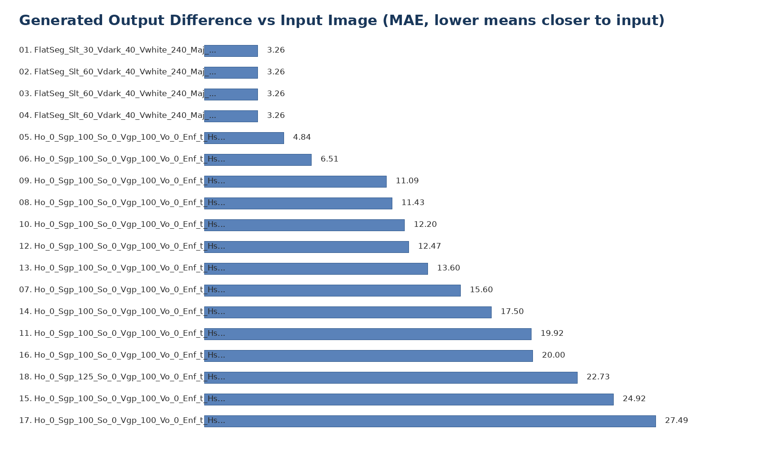

Generated Output 01: FlatSeg_Slt_30_Vdark_40_Vwhite_240_Maj_5_Pass_0.bmp
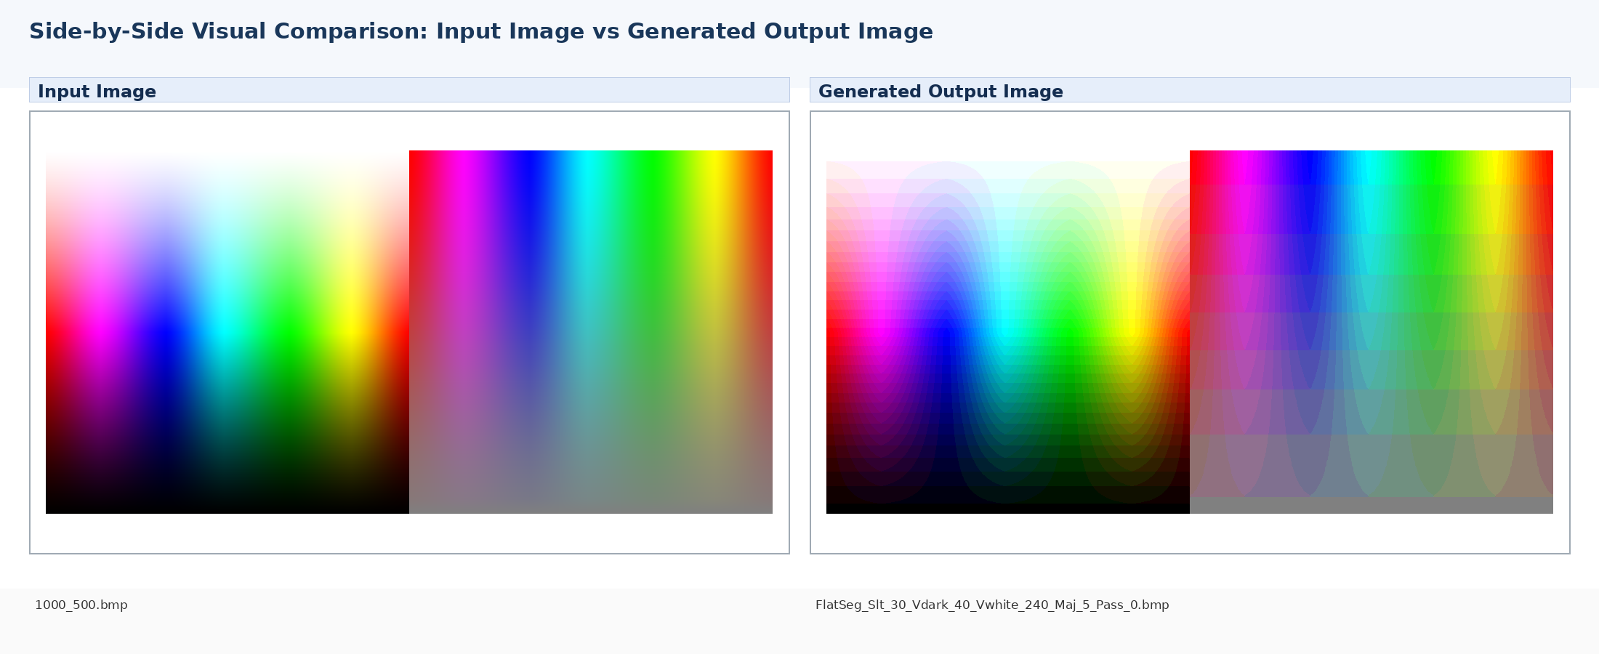
MAE vs Input | RMSE vs Input | PSNR | Exact Match | Tol ±2 | Tol ±8 | Max Error | Channel MAE R/G/B
3.262 | 4.176 | 35.72 dB | 0.623% | 10.687% | 99.964% | 10 | 3.28/3.25/3.26

Image | Mean R | Mean G | Mean B
Input Image | 125.86 | 128.88 | 128.29
Generated Output | 126.24 | 129.27 | 128.68

Generated Output 02: FlatSeg_Slt_60_Vdark_40_Vwhite_240_Maj_5_Pass_0 - Copy.bmp
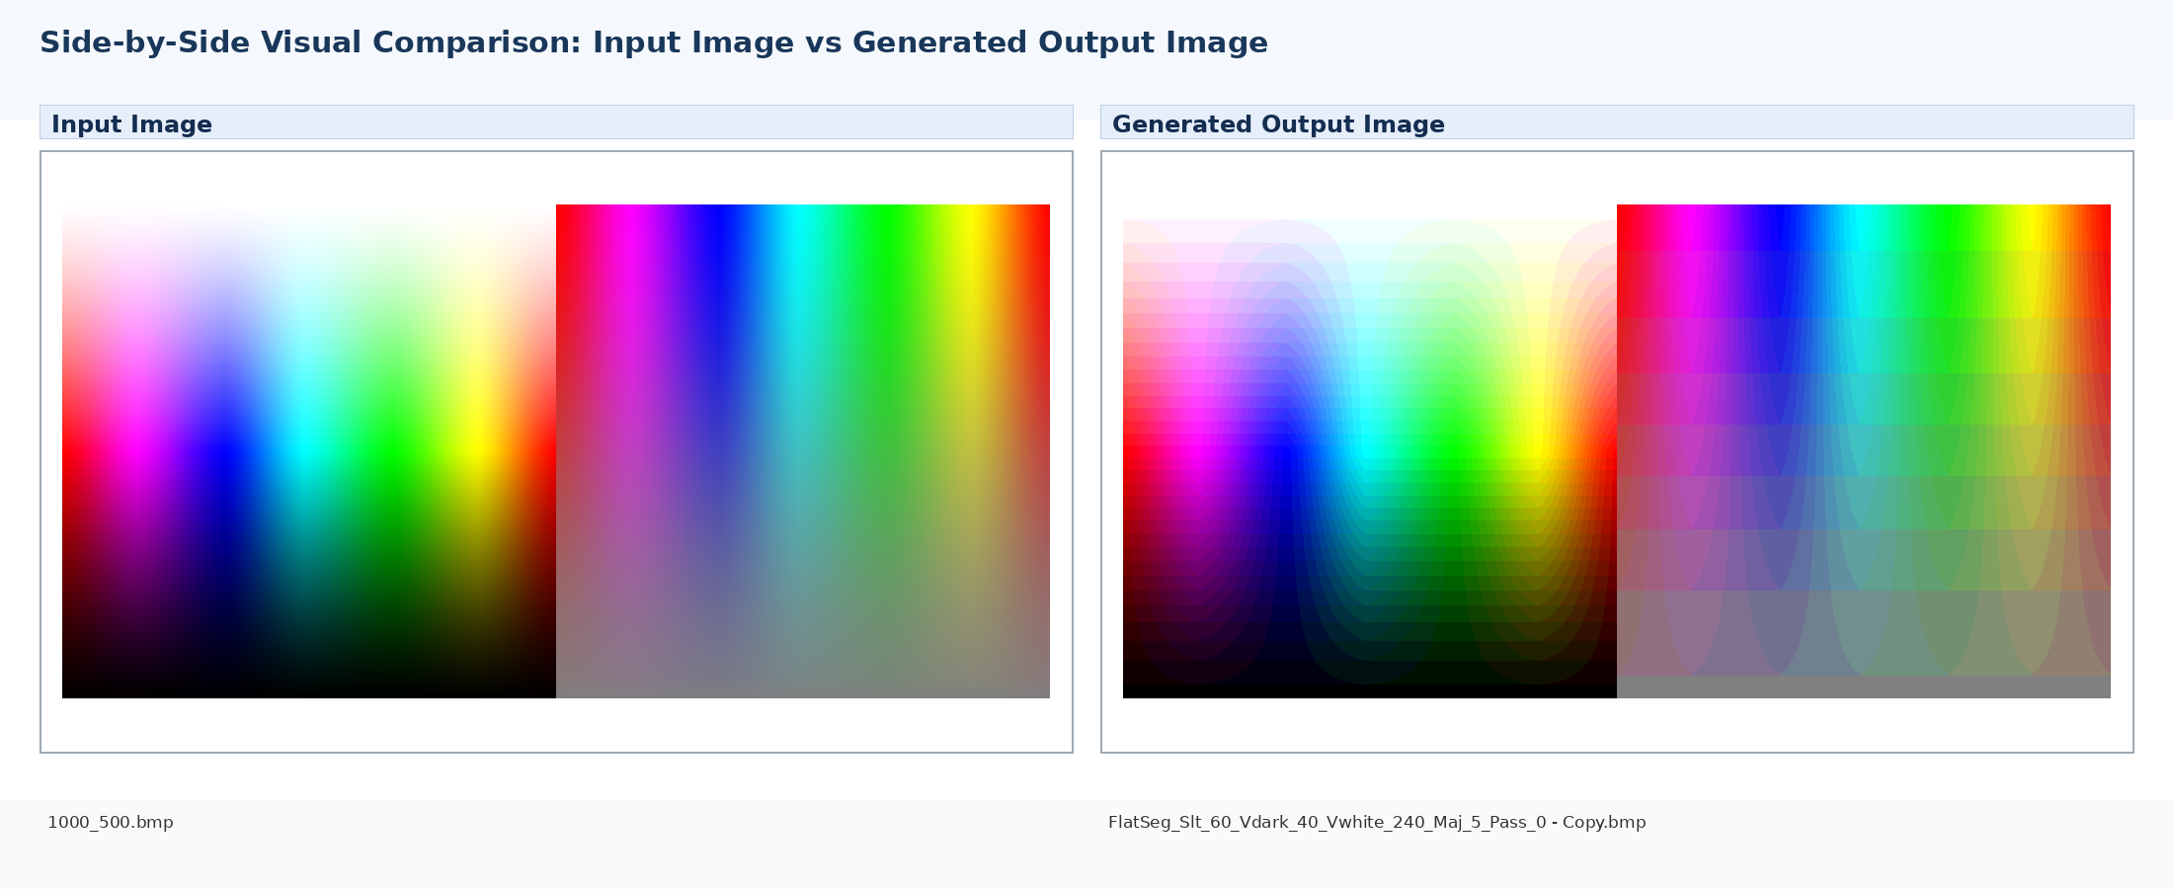
MAE vs Input | RMSE vs Input | PSNR | Exact Match | Tol ±2 | Tol ±8 | Max Error | Channel MAE R/G/B
3.262 | 4.176 | 35.72 dB | 0.623% | 10.687% | 99.964% | 10 | 3.28/3.25/3.26

Image | Mean R | Mean G | Mean B
Input Image | 125.86 | 128.88 | 128.29
Generated Output | 126.24 | 129.27 | 128.68

Generated Output 03: FlatSeg_Slt_60_Vdark_40_Vwhite_240_Maj_5_Pass_0.bmp
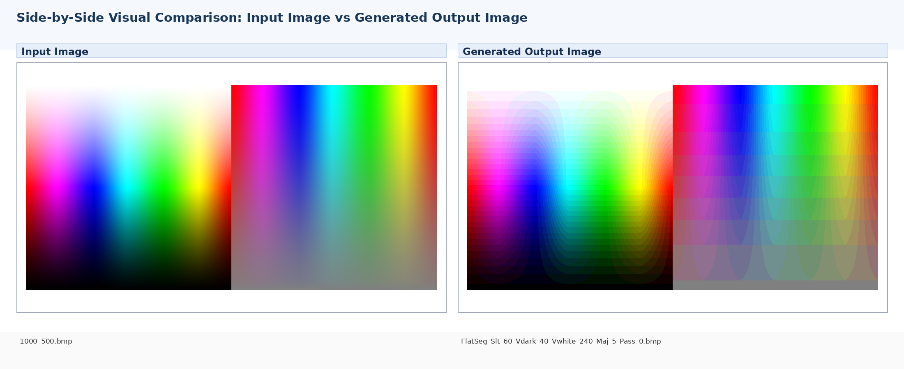
MAE vs Input | RMSE vs Input | PSNR | Exact Match | Tol ±2 | Tol ±8 | Max Error | Channel MAE R/G/B
3.262 | 4.176 | 35.72 dB | 0.623% | 10.687% | 99.964% | 10 | 3.28/3.25/3.26

Image | Mean R | Mean G | Mean B
Input Image | 125.86 | 128.88 | 128.29
Generated Output | 126.24 | 129.27 | 128.68

Generated Output 04: FlatSeg_Slt_60_Vdark_40_Vwhite_240_Maj_5_Pass_3.bmp
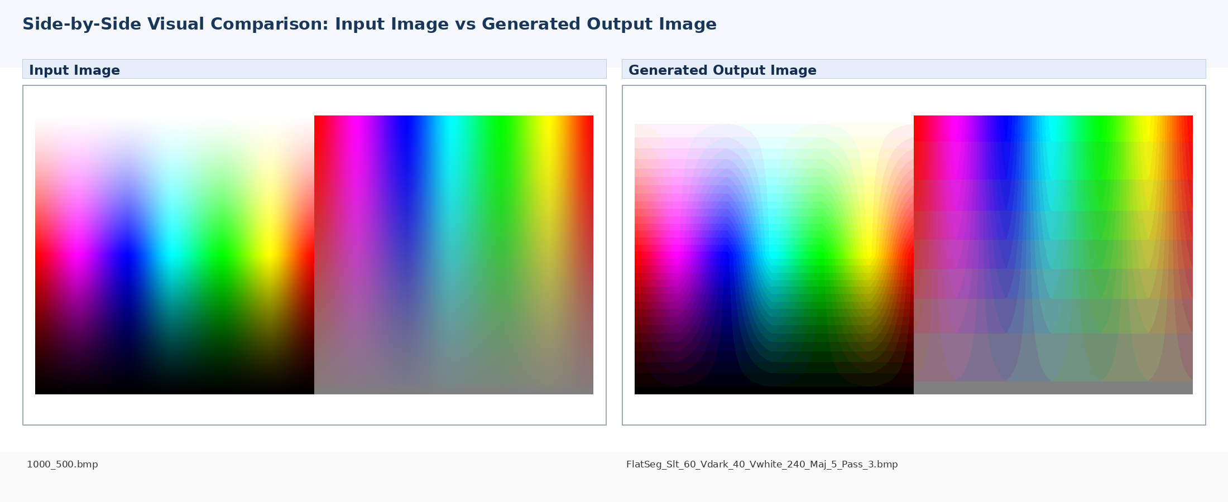
MAE vs Input | RMSE vs Input | PSNR | Exact Match | Tol ±2 | Tol ±8 | Max Error | Channel MAE R/G/B
3.262 | 4.176 | 35.72 dB | 0.623% | 10.687% | 99.963% | 10 | 3.28/3.25/3.26

Image | Mean R | Mean G | Mean B
Input Image | 125.86 | 128.88 | 128.29
Generated Output | 126.24 | 129.27 | 128.68

Generated Output 05: Ho_0_Sgp_100_So_0_Vgp_100_Vo_0_Enf_t_Hs_8_Ss_8_Vs_16_Fcb_t.bmp
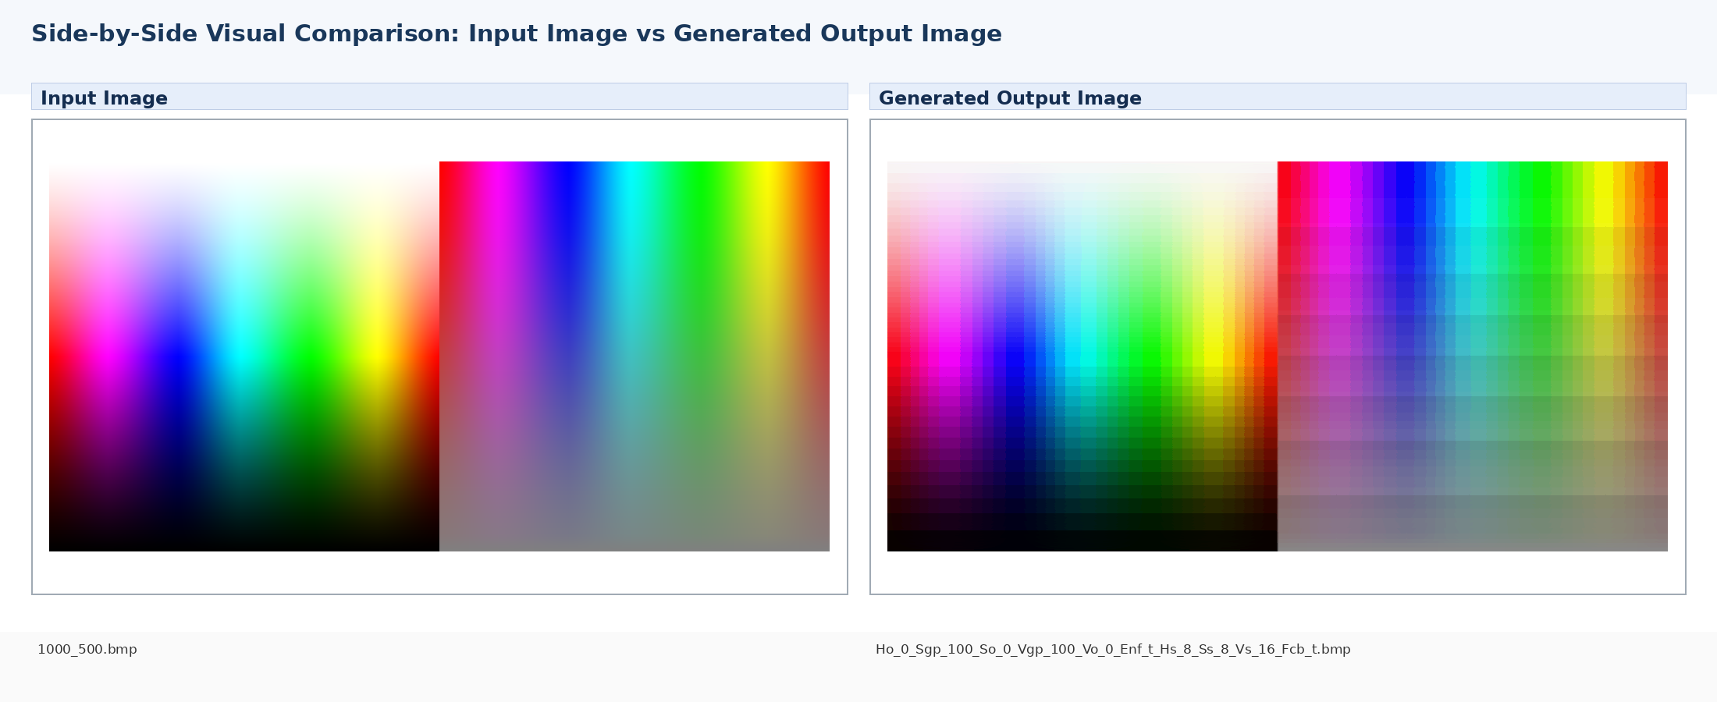
MAE vs Input | RMSE vs Input | PSNR | Exact Match | Tol ±2 | Tol ±8 | Max Error | Channel MAE R/G/B
4.836 | 6.502 | 31.87 dB | 0.195% | 7.428% | 67.048% | 96 | 4.87/4.87/4.77

Image | Mean R | Mean G | Mean B
Input Image | 125.86 | 128.88 | 128.29
Generated Output | 124.99 | 127.51 | 127.37

Generated Output 06: Ho_0_Sgp_100_So_0_Vgp_100_Vo_0_Enf_t_Hs_16_Ss_8_Vs_16_Fcb_t.bmp
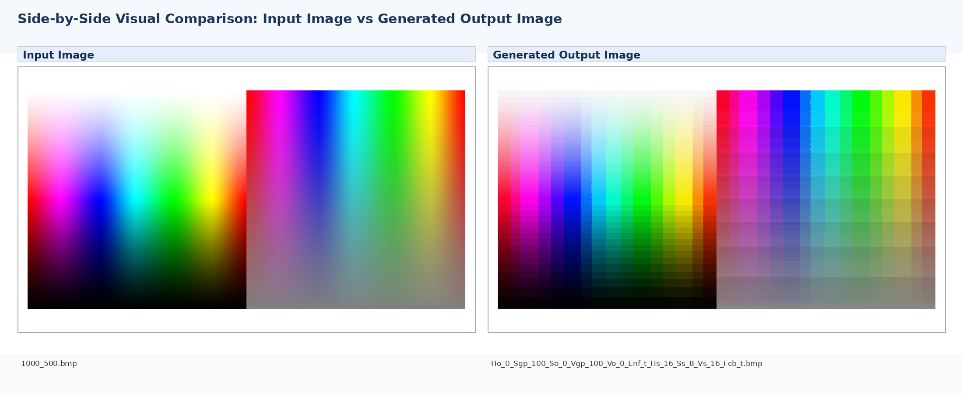
MAE vs Input | RMSE vs Input | PSNR | Exact Match | Tol ±2 | Tol ±8 | Max Error | Channel MAE R/G/B
6.513 | 9.891 | 28.23 dB | 0.090% | 4.844% | 46.997% | 112 | 6.16/6.73/6.65

Image | Mean R | Mean G | Mean B
Input Image | 125.86 | 128.88 | 128.29
Generated Output | 125.02 | 127.46 | 127.22

Generated Output 07: Ho_0_Sgp_100_So_0_Vgp_100_Vo_0_Enf_t_Hs_16_Ss_8_Vs_64_Fcb_t.bmp
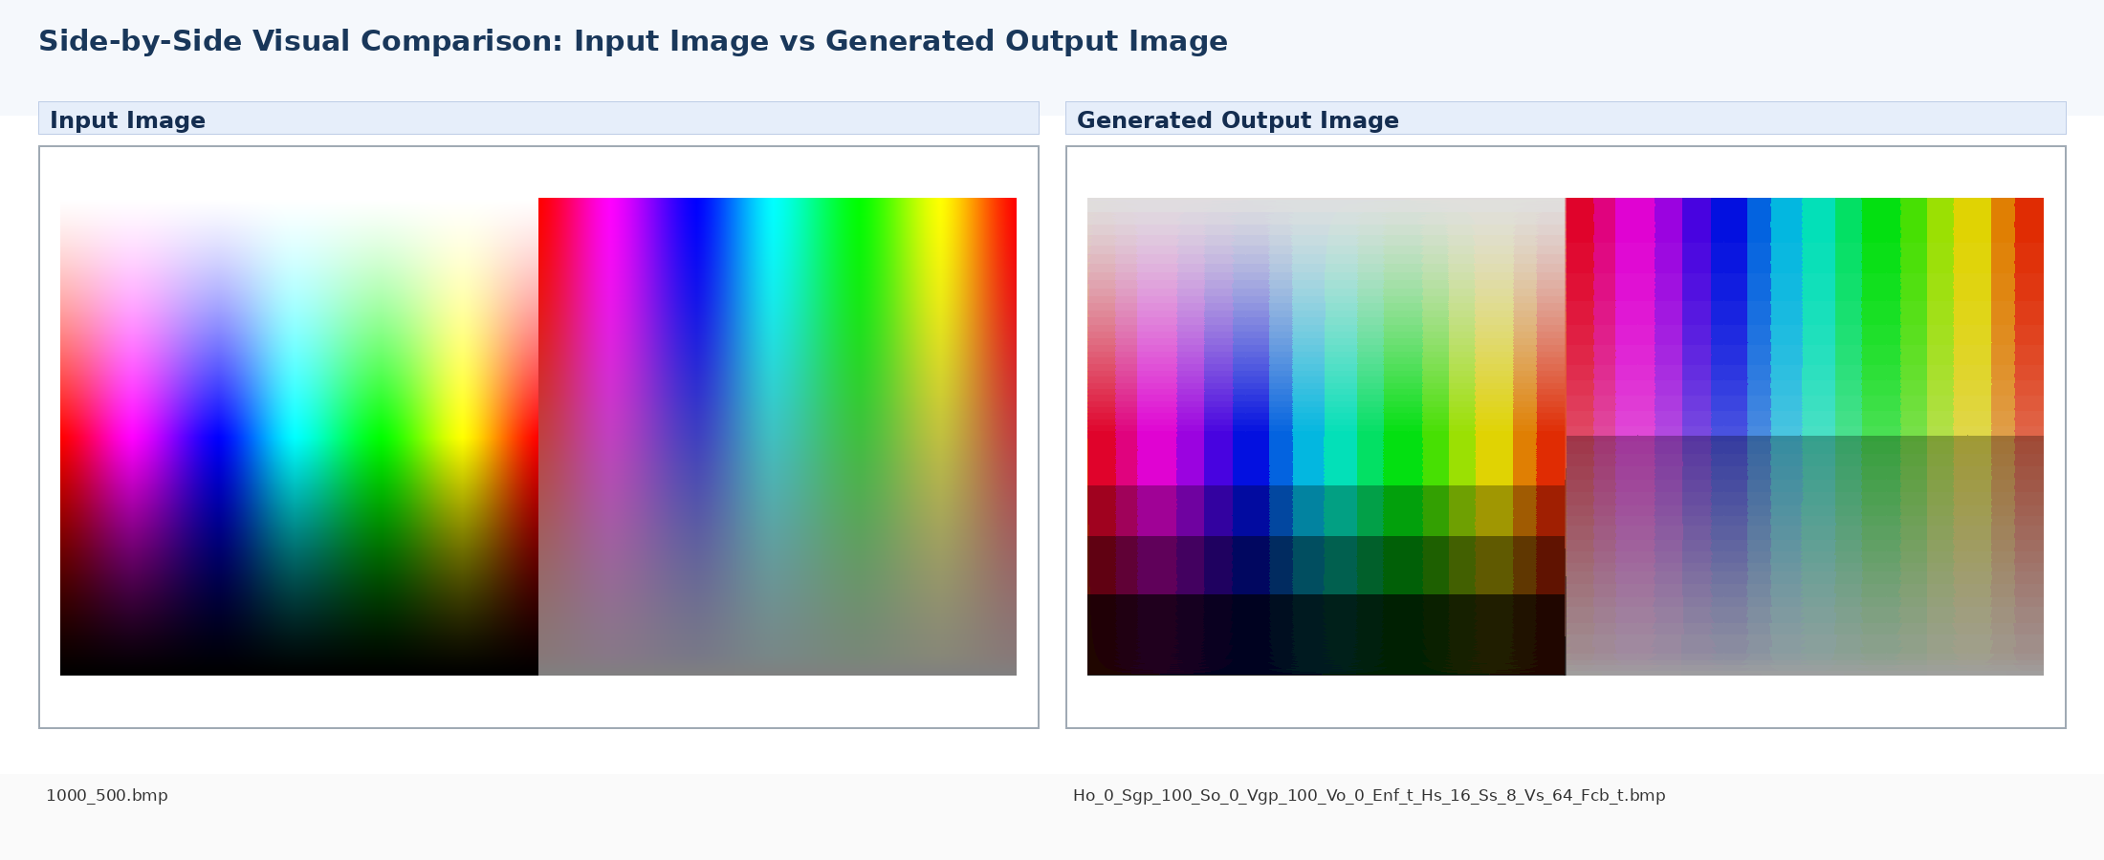
MAE vs Input | RMSE vs Input | PSNR | Exact Match | Tol ±2 | Tol ±8 | Max Error | Channel MAE R/G/B
15.603 | 19.695 | 22.24 dB | 0.013% | 0.821% | 9.315% | 108 | 15.12/15.93/15.76

Image | Mean R | Mean G | Mean B
Input Image | 125.86 | 128.88 | 128.29
Generated Output | 121.21 | 123.59 | 123.32

Generated Output 08: Ho_0_Sgp_100_So_0_Vgp_100_Vo_0_Enf_t_Hs_32_Ss_40_Vs_16_Fcb_t.bmp
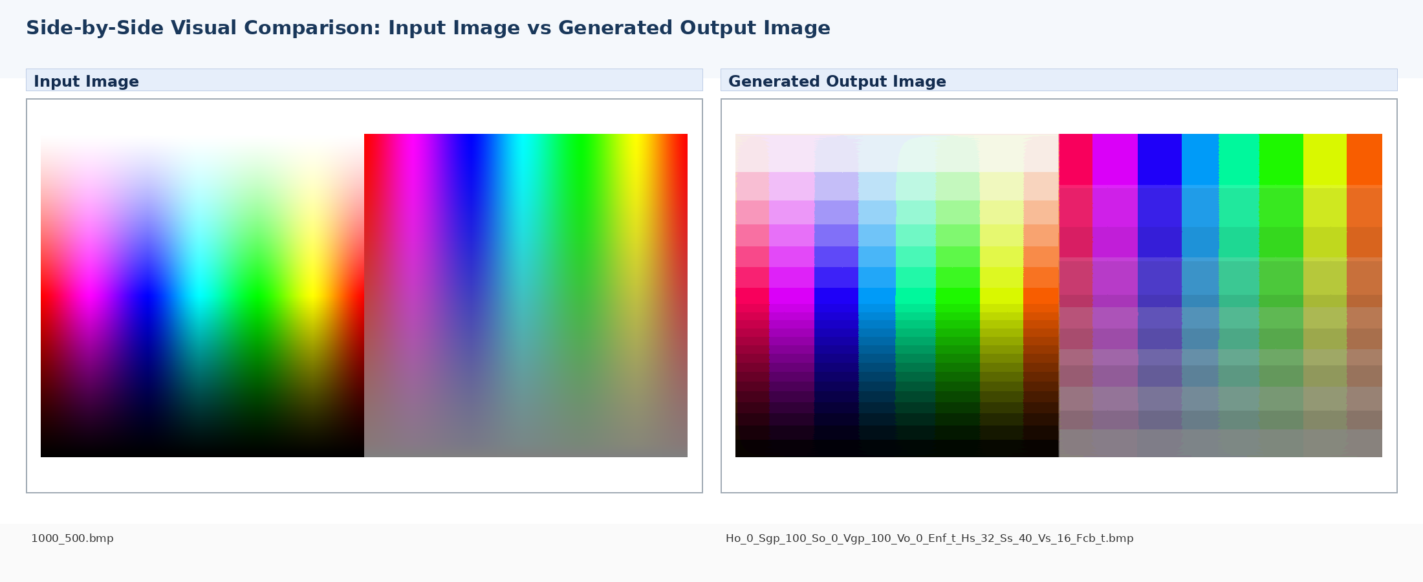
MAE vs Input | RMSE vs Input | PSNR | Exact Match | Tol ±2 | Tol ±8 | Max Error | Channel MAE R/G/B
11.434 | 18.301 | 22.88 dB | 0.053% | 1.242% | 21.041% | 138 | 12.22/11.14/10.94

Image | Mean R | Mean G | Mean B
Input Image | 125.86 | 128.88 | 128.29
Generated Output | 124.83 | 127.28 | 127.05

Generated Output 09: Ho_0_Sgp_100_So_0_Vgp_100_Vo_0_Enf_t_Hs_36_Ss_8_Vs_16_Fcb_t.bmp
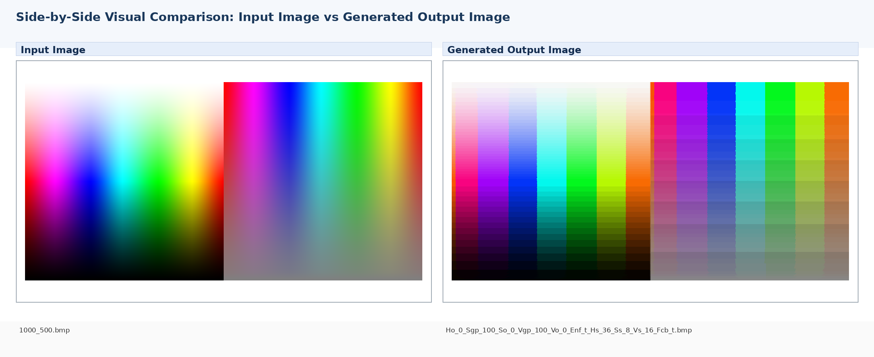
MAE vs Input | RMSE vs Input | PSNR | Exact Match | Tol ±2 | Tol ±8 | Max Error | Channel MAE R/G/B
11.095 | 19.895 | 22.16 dB | 0.040% | 2.476% | 28.680% | 150 | 11.78/11.21/10.29

Image | Mean R | Mean G | Mean B
Input Image | 125.86 | 128.88 | 128.29
Generated Output | 121.82 | 130.51 | 128.08

Generated Output 10: Ho_0_Sgp_100_So_0_Vgp_100_Vo_0_Enf_t_Hs_36_Ss_36_Vs_16_Fcb_t.bmp
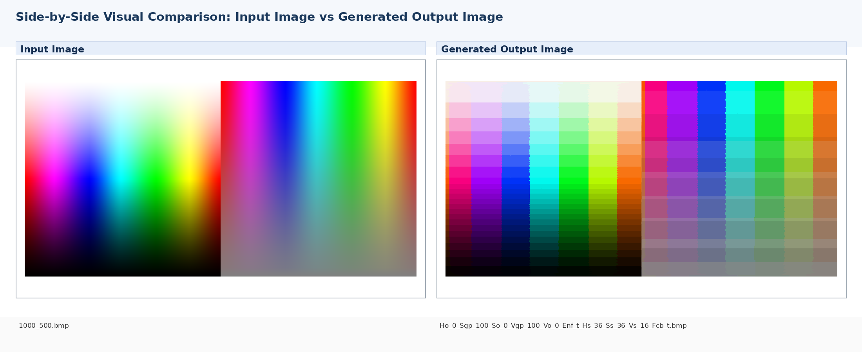
MAE vs Input | RMSE vs Input | PSNR | Exact Match | Tol ±2 | Tol ±8 | Max Error | Channel MAE R/G/B
12.198 | 20.489 | 21.90 dB | 0.049% | 1.217% | 21.591% | 156 | 13.00/12.22/11.37

Image | Mean R | Mean G | Mean B
Input Image | 125.86 | 128.88 | 128.29
Generated Output | 121.91 | 130.53 | 128.21

Generated Output 11: Ho_0_Sgp_100_So_0_Vgp_100_Vo_0_Enf_t_Hs_36_Ss_36_Vs_64_Fcb_t.bmp
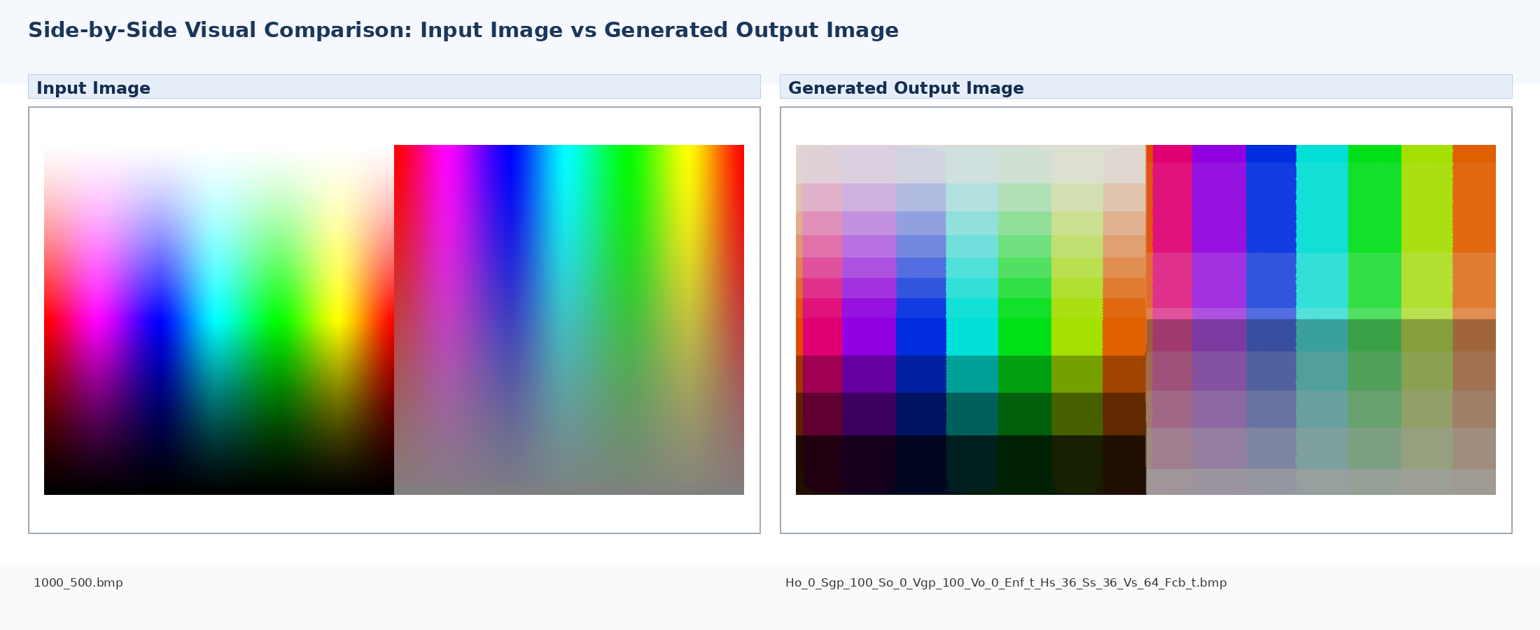
MAE vs Input | RMSE vs Input | PSNR | Exact Match | Tol ±2 | Tol ±8 | Max Error | Channel MAE R/G/B
19.924 | 26.422 | 19.69 dB | 0.005% | 0.163% | 3.563% | 140 | 20.38/20.11/19.28

Image | Mean R | Mean G | Mean B
Input Image | 125.86 | 128.88 | 128.29
Generated Output | 118.13 | 126.55 | 124.04

Generated Output 12: Ho_0_Sgp_100_So_0_Vgp_100_Vo_0_Enf_t_Hs_36_Ss_40_Vs_16_Fcb_t.bmp
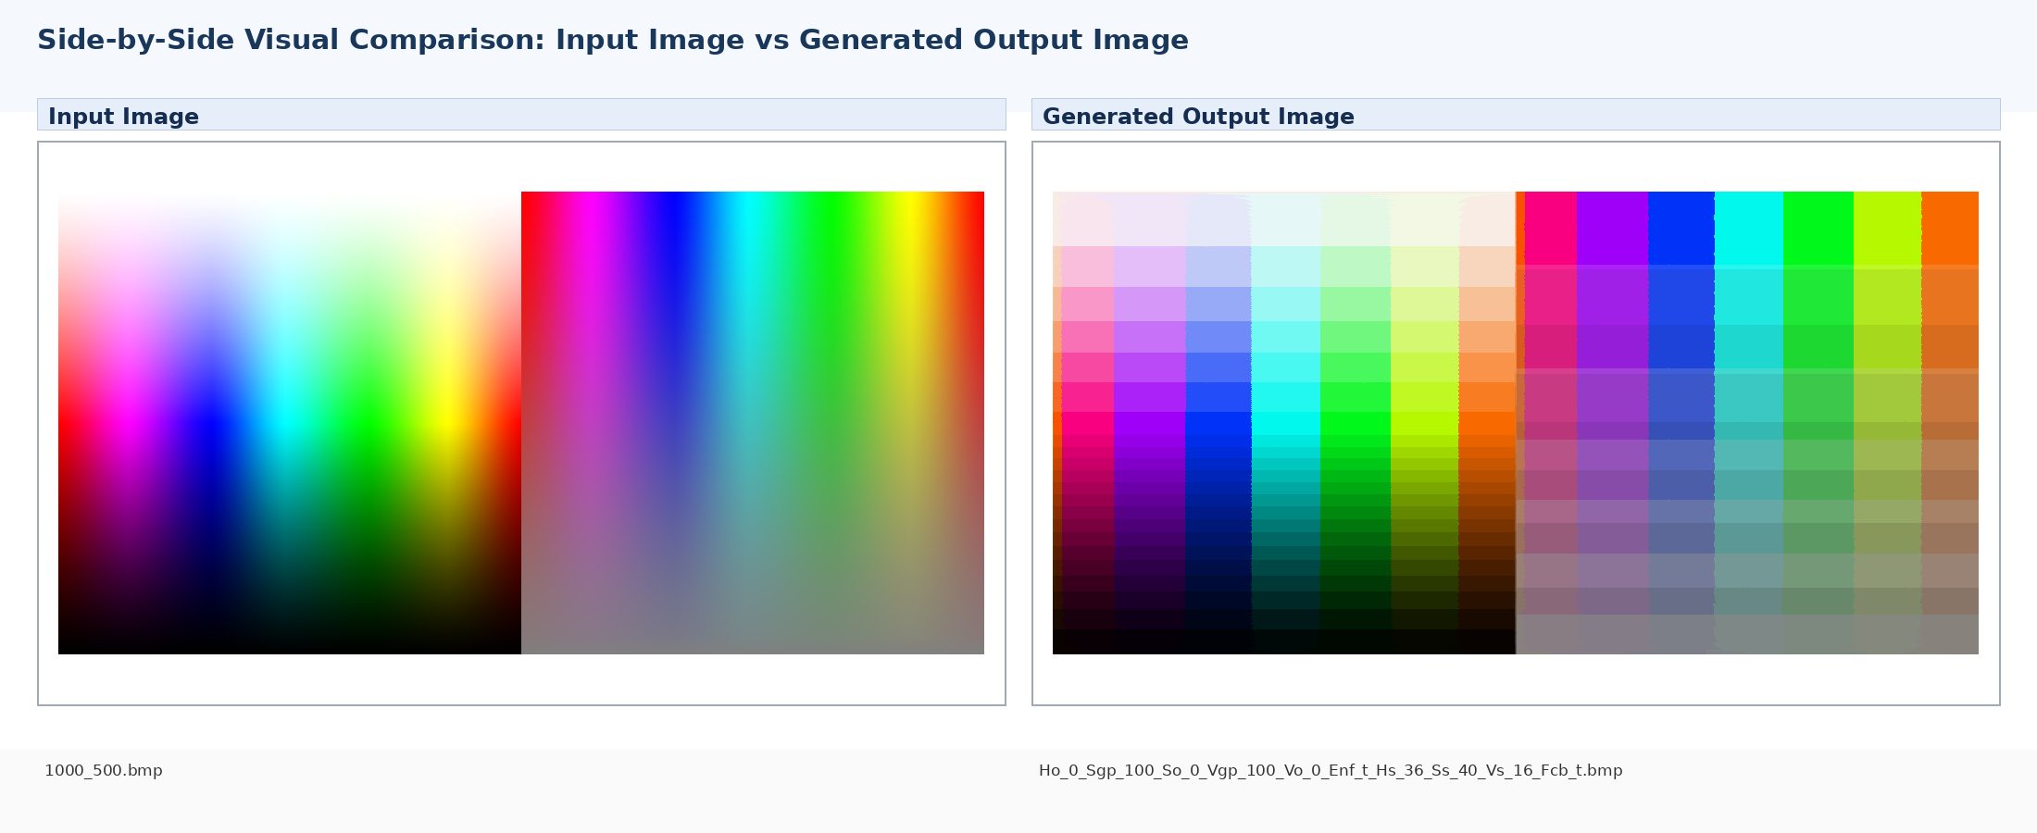
MAE vs Input | RMSE vs Input | PSNR | Exact Match | Tol ±2 | Tol ±8 | Max Error | Channel MAE R/G/B
12.473 | 20.648 | 21.83 dB | 0.049% | 1.132% | 19.735% | 145 | 13.34/12.44/11.63

Image | Mean R | Mean G | Mean B
Input Image | 125.86 | 128.88 | 128.29
Generated Output | 121.74 | 130.38 | 127.92

Generated Output 13: Ho_0_Sgp_100_So_0_Vgp_100_Vo_0_Enf_t_Hs_40_Ss_40_Vs_16_Fcb_t.bmp
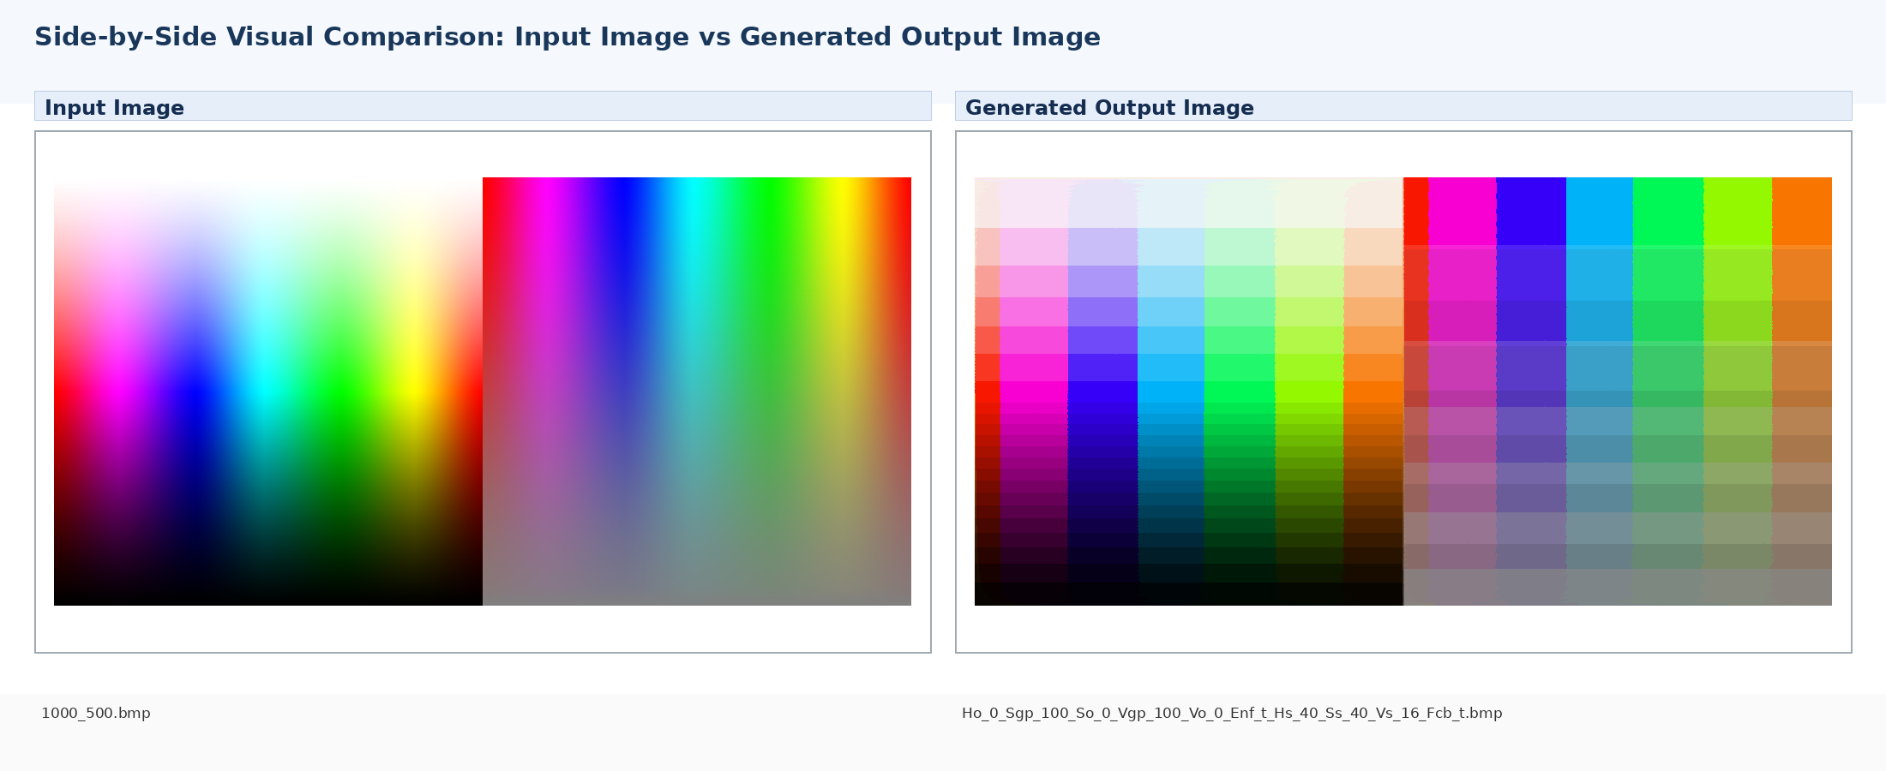
MAE vs Input | RMSE vs Input | PSNR | Exact Match | Tol ±2 | Tol ±8 | Max Error | Channel MAE R/G/B
13.603 | 22.508 | 21.08 dB | 0.037% | 0.933% | 17.314% | 154 | 13.77/13.64/13.40

Image | Mean R | Mean G | Mean B
Input Image | 125.86 | 128.88 | 128.29
Generated Output | 124.66 | 127.26 | 127.28

Generated Output 14: Ho_0_Sgp_100_So_0_Vgp_100_Vo_0_Enf_t_Hs_64_Ss_8_Vs_16_Fcb_t.bmp
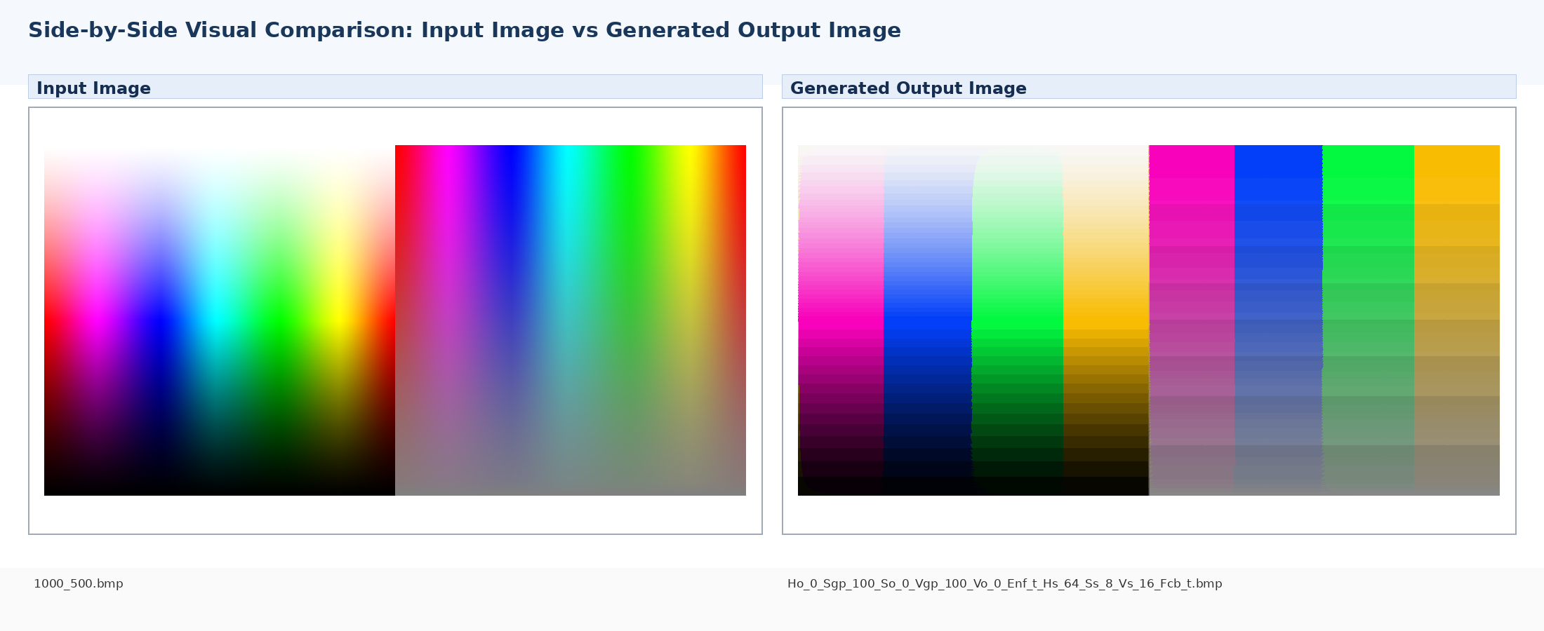
MAE vs Input | RMSE vs Input | PSNR | Exact Match | Tol ±2 | Tol ±8 | Max Error | Channel MAE R/G/B
17.495 | 32.686 | 17.84 dB | 0.021% | 1.397% | 18.461% | 206 | 11.70/20.54/20.24

Image | Mean R | Mean G | Mean B
Input Image | 125.86 | 128.88 | 128.29
Generated Output | 124.89 | 127.39 | 126.16

Generated Output 15: Ho_0_Sgp_100_So_0_Vgp_100_Vo_0_Enf_t_Hs_64_Ss_8_Vs_64_Fcb_t.bmp
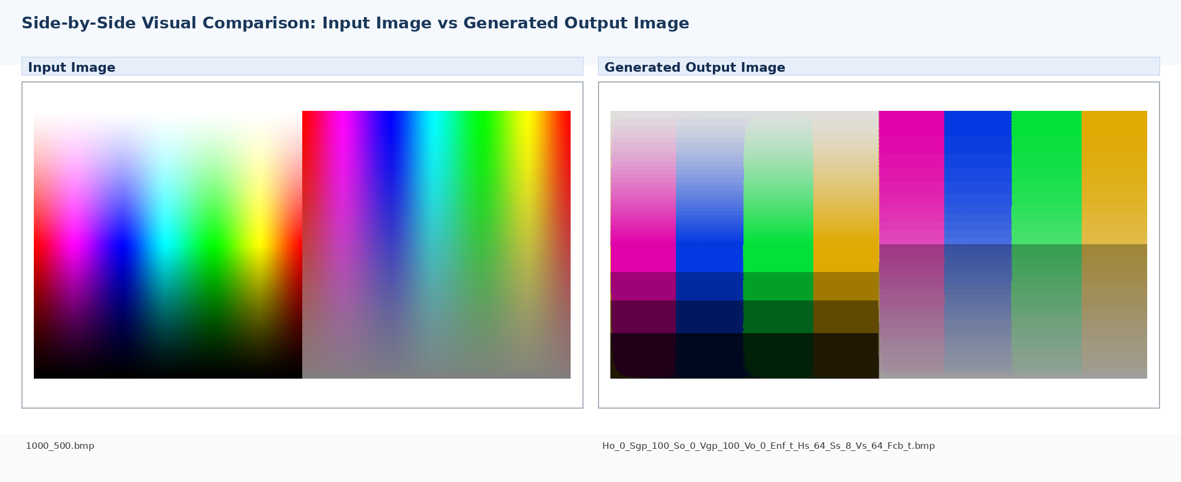
MAE vs Input | RMSE vs Input | PSNR | Exact Match | Tol ±2 | Tol ±8 | Max Error | Channel MAE R/G/B
24.923 | 36.408 | 16.91 dB | 0.004% | 0.179% | 2.716% | 198 | 19.53/27.79/27.45

Image | Mean R | Mean G | Mean B
Input Image | 125.86 | 128.88 | 128.29
Generated Output | 121.08 | 123.37 | 122.14

Generated Output 16: Ho_0_Sgp_100_So_0_Vgp_100_Vo_0_Enf_t_Hs_64_Ss_64_Vs_8_Fcb_t.bmp
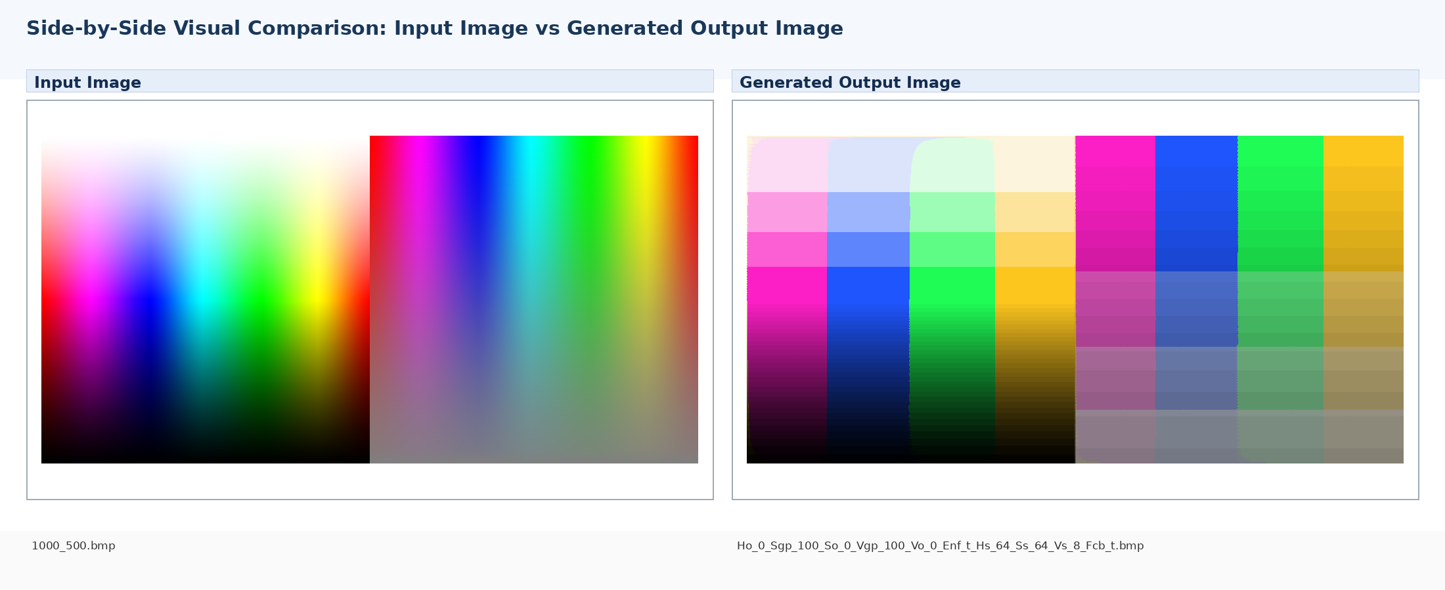
MAE vs Input | RMSE vs Input | PSNR | Exact Match | Tol ±2 | Tol ±8 | Max Error | Channel MAE R/G/B
20.000 | 33.649 | 17.59 dB | 0.025% | 1.125% | 10.243% | 212 | 14.47/22.89/22.65

Image | Mean R | Mean G | Mean B
Input Image | 125.86 | 128.88 | 128.29
Generated Output | 128.23 | 130.47 | 129.29

Generated Output 17: Ho_0_Sgp_100_So_0_Vgp_100_Vo_0_Enf_t_Hs_64_Ss_64_Vs_64_Fcb_t.bmp
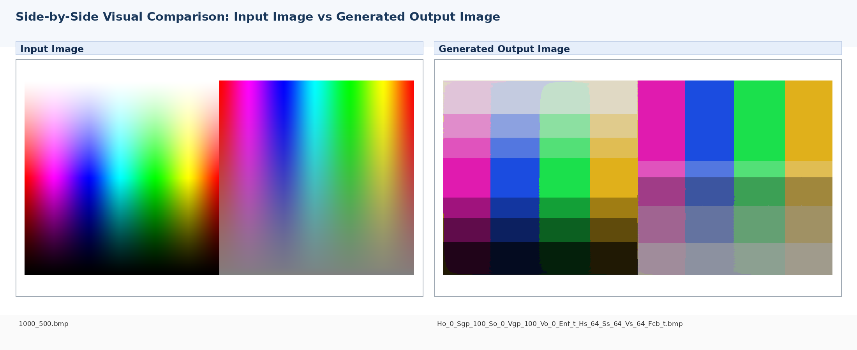
MAE vs Input | RMSE vs Input | PSNR | Exact Match | Tol ±2 | Tol ±8 | Max Error | Channel MAE R/G/B
27.494 | 37.437 | 16.66 dB | 0.000% | 0.006% | 1.824% | 189 | 22.22/30.29/29.98

Image | Mean R | Mean G | Mean B
Input Image | 125.86 | 128.88 | 128.29
Generated Output | 123.69 | 125.89 | 124.68

Generated Output 18: Ho_0_Sgp_125_So_0_Vgp_100_Vo_0_Enf_t_Hs_64_Ss_40_Vs_16_Fcb_t.bmp
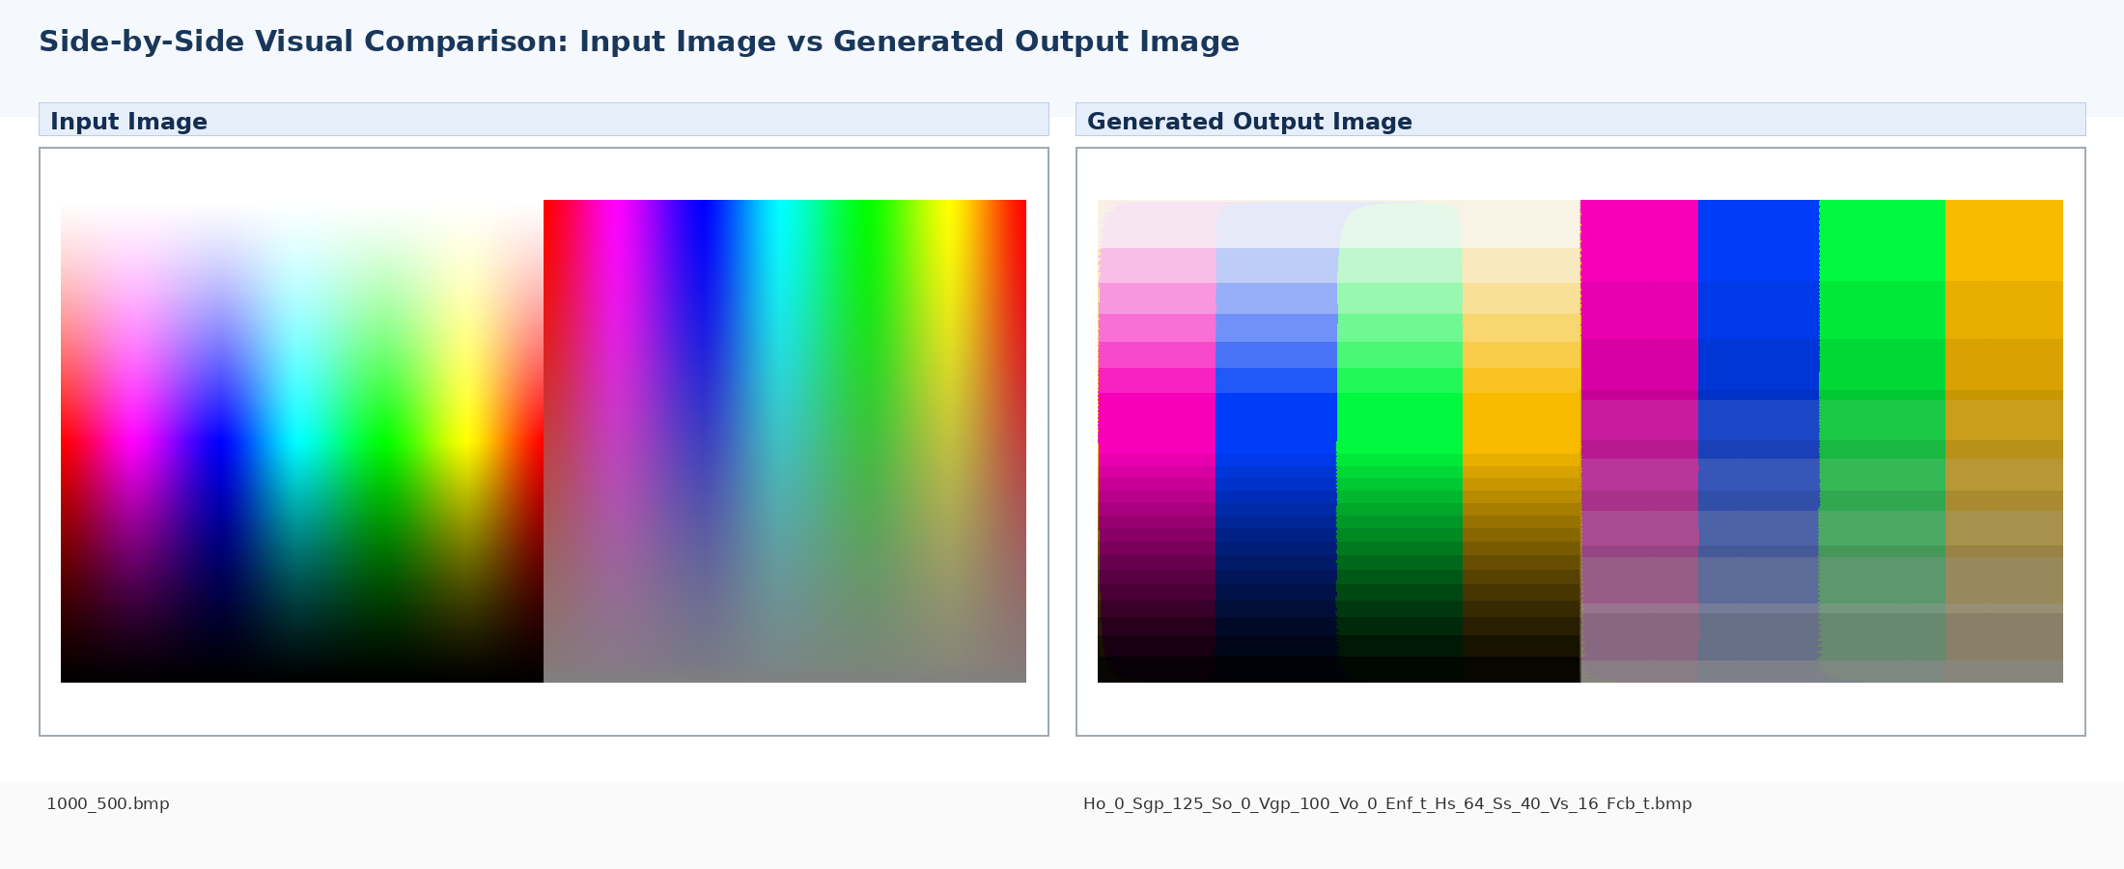
MAE vs Input | RMSE vs Input | PSNR | Exact Match | Tol ±2 | Tol ±8 | Max Error | Channel MAE R/G/B
22.729 | 37.302 | 16.70 dB | 0.024% | 0.687% | 9.911% | 195 | 19.21/24.56/24.42

Image | Mean R | Mean G | Mean B
Input Image | 125.86 | 128.88 | 128.29
Generated Output | 116.98 | 119.67 | 118.22

Optional Context: Generated Output Compared Against Expected Reference
This section is included because Expected_Reference.zip was available. It is additional numerical context; the requested visual pages above compare the input image against each generated output image.
# | Generated Output BMP | MAE vs Expected | RMSE vs Expected | PSNR vs Expected | Exact % | Tol ±8 %
1 | FlatSeg_Slt_30_Vdark_40_Vwhite_240_Maj_5_Pass_0.bmp | 3.26 | 4.18 | 35.72 dB | 0.62% | 99.96%
2 | FlatSeg_Slt_60_Vdark_40_Vwhite_240_Maj_5_Pass_0 - Copy.bmp | 3.26 | 4.18 | 35.72 dB | 0.62% | 99.96%
3 | FlatSeg_Slt_60_Vdark_40_Vwhite_240_Maj_5_Pass_0.bmp | 3.26 | 4.18 | 35.72 dB | 0.62% | 99.96%
4 | FlatSeg_Slt_60_Vdark_40_Vwhite_240_Maj_5_Pass_3.bmp | 3.26 | 4.18 | 35.72 dB | 0.62% | 99.96%
5 | Ho_0_Sgp_100_So_0_Vgp_100_Vo_0_Enf_t_Hs_8_Ss_8_Vs_16_Fcb_t.bmp | 4.84 | 6.50 | 31.87 dB | 0.20% | 67.05%
6 | Ho_0_Sgp_100_So_0_Vgp_100_Vo_0_Enf_t_Hs_16_Ss_8_Vs_16_Fcb_t.bmp | 6.51 | 9.89 | 28.23 dB | 0.09% | 47.00%
7 | Ho_0_Sgp_100_So_0_Vgp_100_Vo_0_Enf_t_Hs_16_Ss_8_Vs_64_Fcb_t.bmp | 15.60 | 19.70 | 22.24 dB | 0.01% | 9.31%
8 | Ho_0_Sgp_100_So_0_Vgp_100_Vo_0_Enf_t_Hs_32_Ss_40_Vs_16_Fcb_t.bmp | 11.43 | 18.30 | 22.88 dB | 0.05% | 21.04%
9 | Ho_0_Sgp_100_So_0_Vgp_100_Vo_0_Enf_t_Hs_36_Ss_8_Vs_16_Fcb_t.bmp | 11.09 | 19.89 | 22.16 dB | 0.04% | 28.68%
10 | Ho_0_Sgp_100_So_0_Vgp_100_Vo_0_Enf_t_Hs_36_Ss_36_Vs_16_Fcb_t.bmp | 12.20 | 20.49 | 21.90 dB | 0.05% | 21.59%
11 | Ho_0_Sgp_100_So_0_Vgp_100_Vo_0_Enf_t_Hs_36_Ss_36_Vs_64_Fcb_t.bmp | 19.92 | 26.42 | 19.69 dB | 0.01% | 3.56%
12 | Ho_0_Sgp_100_So_0_Vgp_100_Vo_0_Enf_t_Hs_36_Ss_40_Vs_16_Fcb_t.bmp | 12.47 | 20.65 | 21.83 dB | 0.05% | 19.73%
13 | Ho_0_Sgp_100_So_0_Vgp_100_Vo_0_Enf_t_Hs_40_Ss_40_Vs_16_Fcb_t.bmp | 13.60 | 22.51 | 21.08 dB | 0.04% | 17.31%
14 | Ho_0_Sgp_100_So_0_Vgp_100_Vo_0_Enf_t_Hs_64_Ss_8_Vs_16_Fcb_t.bmp | 17.50 | 32.69 | 17.84 dB | 0.02% | 18.46%
15 | Ho_0_Sgp_100_So_0_Vgp_100_Vo_0_Enf_t_Hs_64_Ss_8_Vs_64_Fcb_t.bmp | 24.92 | 36.41 | 16.91 dB | 0.00% | 2.72%
16 | Ho_0_Sgp_100_So_0_Vgp_100_Vo_0_Enf_t_Hs_64_Ss_64_Vs_8_Fcb_t.bmp | 20.00 | 33.65 | 17.59 dB | 0.03% | 10.24%
17 | Ho_0_Sgp_100_So_0_Vgp_100_Vo_0_Enf_t_Hs_64_Ss_64_Vs_64_Fcb_t.bmp | 27.49 | 37.44 | 16.66 dB | 0.00% | 1.82%
18 | Ho_0_Sgp_125_So_0_Vgp_100_Vo_0_Enf_t_Hs_64_Ss_40_Vs_16_Fcb_t.bmp | 22.73 | 37.30 | 16.70 dB | 0.02% | 9.91%

