Simulation Image Comparison Report
Actual Input Image, Expected Reference Output, and Generated Output Validation
Item | Value
Input image | 1000_500.bmp
Expected reference | expected_hsv_roundtrip_no_flat_1000_500.bmp
Selected generated output | FlatSeg_Slt_60_Vdark_40_Vwhite_240_Maj_5_Pass_0.bmp
Generated BMP files evaluated | 18
Input vs expected MAE | 0.000000
Selected generated vs expected MAE | 3.262476
Selected generated vs input MAE | 3.262476
Key result: The uploaded expected reference image is pixel-identical to the uploaded input image. Therefore, the target behavior for this validation set is input-color preservation, not object-color remapping. The selected flat-segment generated image differs from the expected reference with MAE = 3.262476 on a 0–255 RGB channel scale.

1. Artifact Inventory
Artifact | Resolved file path inside extracted ZIP
Input image | /mnt/data/sim_report_work/Input_Image/1000_500.bmp
Expected reference image | /mnt/data/sim_report_work/Expected_Reference/expected_hsv_roundtrip_no_flat_1000_500.bmp
Selected generated output | /mnt/data/sim_report_work/Generated_Outputs/FlatSeg_Slt_60_Vdark_40_Vwhite_240_Maj_5_Pass_0.bmp

2. Image Format and Pixel Statistics
Image | Size | Pixels | Mode | Unique RGB | Mean RGB | Std RGB | Min RGB | Max RGB
Input | 1000 x 500 | 500,000 | RGB | 243,986 | (125.81, 128.83, 128.24) | (85.88, 86.42, 86.25) | (0, 0, 0) | (255, 255, 255)
Expected Reference | 1000 x 500 | 500,000 | RGB | 243,986 | (125.81, 128.83, 128.24) | (85.88, 86.42, 86.25) | (0, 0, 0) | (255, 255, 255)
Selected Generated | 1000 x 500 | 500,000 | RGB | 1,917 | (126.18, 129.21, 128.61) | (86.11, 86.64, 86.48) | (0, 0, 0) | (255, 255, 255)
Interpretation: The expected reference has the same image dimensions and the same RGB values as the actual input image. The selected generated output has only 3,375 unique colors, indicating a posterized/flat-color transformation rather than a full input-preserving round trip.

3. Comparison Metric Definitions
Metric | Meaning
MAE | Mean Absolute Error across all RGB channels and all pixels. Lower is better. 0 means exact match.
RMSE | Root Mean Square Error across all RGB channels and pixels. Lower is better.
PSNR | Peak Signal-to-Noise Ratio in dB. Higher is better. 99 dB is used here for exact zero-error comparison.
Exact % | Percentage of pixels where all three RGB channels match exactly.
Tolerance % | Percentage of pixels whose maximum per-channel absolute error is within the tolerance threshold.
MaxAbsError | Largest absolute RGB channel difference found anywhere in the image.

4. Visual Comparison: Input, Expected Reference, and Generated Output
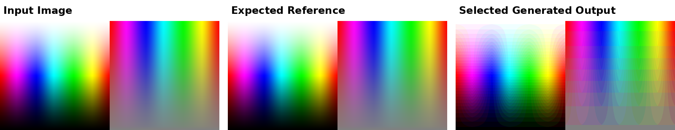
Figure 1. Side-by-side visual comparison. The input and expected reference are visually identical; the generated output is visibly quantized/segmented.

5. Primary Numeric Comparison Values
Comparison | MAE | RMSE | PSNR dB | Exact | Tol <=1 | Tol <=2 | Tol <=5 | Tol <=16 | Max Err
Input vs Expected Reference | 0.000000 | 0.000000 | 99.000 | 100.000% | 100.000% | 100.000% | 100.000% | 100.000% | 0
Selected Generated vs Expected Reference | 3.262476 | 4.175547 | 35.717 | 0.623% | 4.317% | 10.687% | 47.341% | 100.000% | 10
Selected Generated vs Input Image | 3.262476 | 4.175547 | 35.717 | 0.623% | 4.317% | 10.687% | 47.341% | 100.000% | 10
Result statement: The generated output is close numerically to the input/expected reference at low average error, but it is not an exact match. Because the generated output performs flat-color quantization, many individual RGB values are rounded to nearby 16-count levels, producing nonzero pixel differences even when the visual change is modest.

6. Error Maps
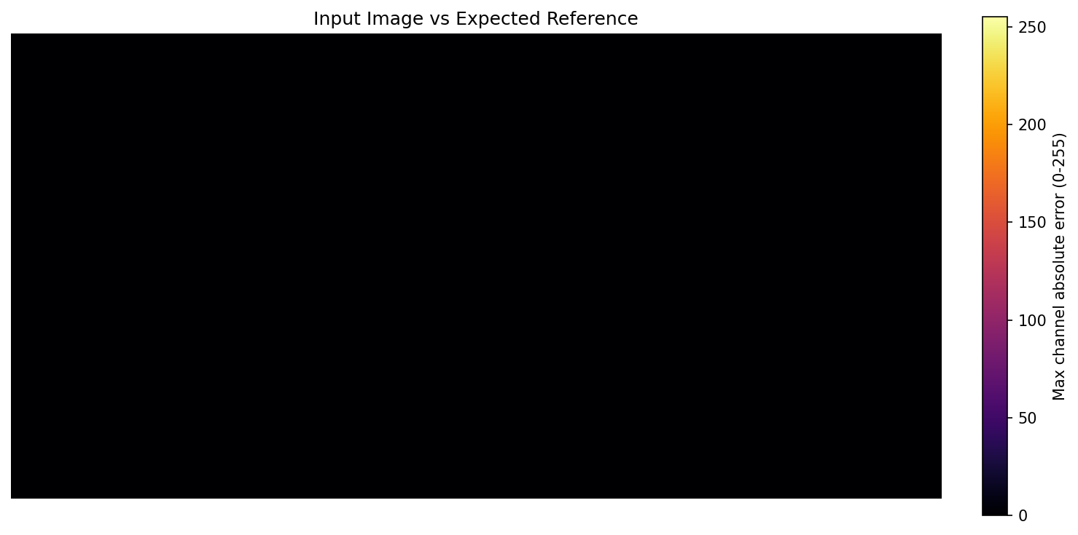
Figure 2. Input vs expected reference error map. Zero difference confirms the expected reference equals the input image.
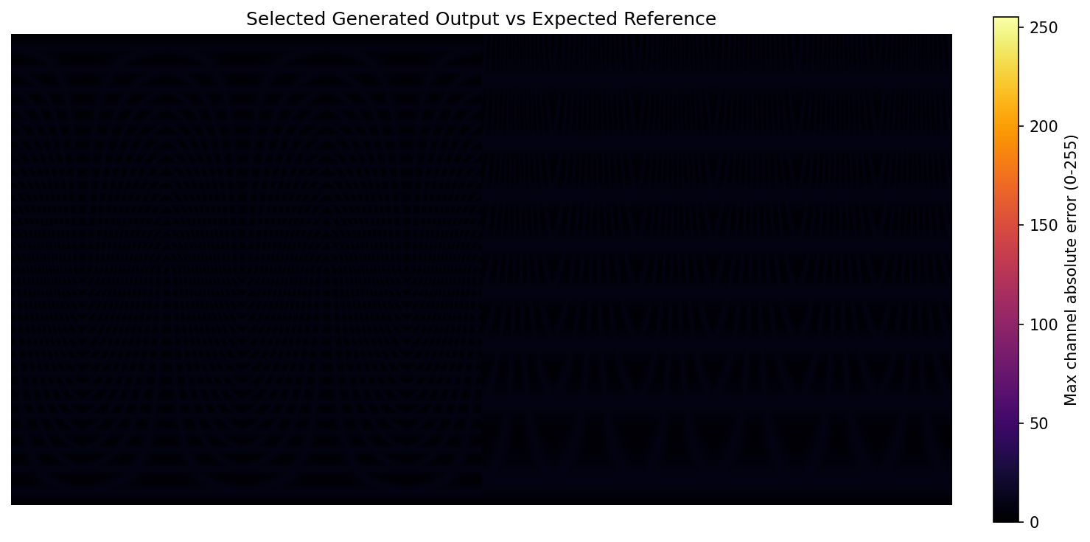
Figure 3. Selected generated output vs expected reference error map. Bright regions show larger max-channel absolute error caused by quantization/segmentation.

7. Generated Output Difference Against Input Image
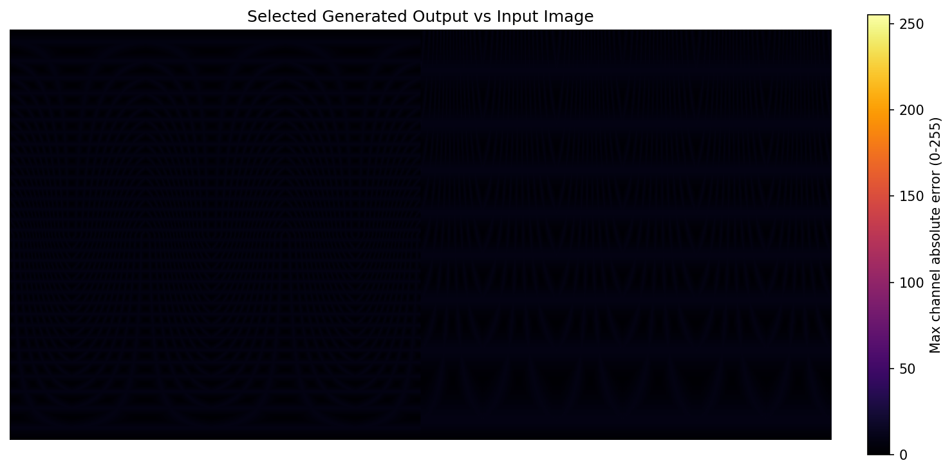
Figure 4. Selected generated output vs input image error map. This is equivalent to generated output vs expected reference because the expected reference matches the input.

8. Generated Output Ranking Against Expected Reference
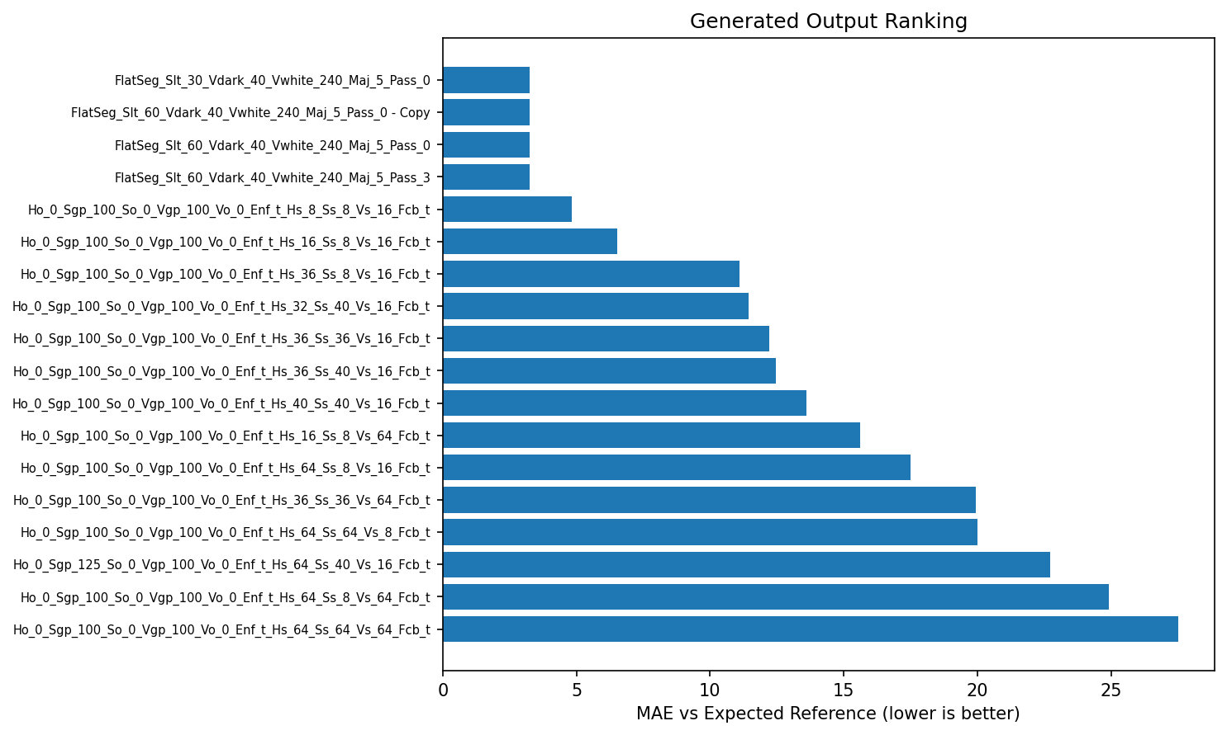
Figure 5. Generated outputs ranked by MAE against the expected reference. Lower MAE indicates closer RGB match.

8.1 Generated Output Ranking Table — Top 9
Rank | Generated BMP | Unique RGB | MAE vs Exp | RMSE vs Exp | PSNR | Exact % | Tol16 % | Max Err | MAE vs Input
1 | FlatSeg_Slt_30_Vdark_40_Vwhite_240_Maj_5_Pass_0.bmp | 1,917 | 3.2625 | 4.1755 | 35.72 | 0.62% | 100.00% | 10 | 3.2625
2 | FlatSeg_Slt_60_Vdark_40_Vwhite_240_Maj_5_Pass_0 - Copy.bmp | 1,917 | 3.2625 | 4.1755 | 35.72 | 0.62% | 100.00% | 10 | 3.2625
3 | FlatSeg_Slt_60_Vdark_40_Vwhite_240_Maj_5_Pass_0.bmp | 1,917 | 3.2625 | 4.1755 | 35.72 | 0.62% | 100.00% | 10 | 3.2625
4 | FlatSeg_Slt_60_Vdark_40_Vwhite_240_Maj_5_Pass_3.bmp | 1,917 | 3.2625 | 4.1756 | 35.72 | 0.62% | 100.00% | 10 | 3.2625
5 | Ho_0_Sgp_100_So_0_Vgp_100_Vo_0_Enf_t_Hs_8_Ss_8_Vs_16_Fcb_t.bmp | 2,663 | 4.8361 | 6.5023 | 31.87 | 0.20% | 92.99% | 96 | 4.8361
6 | Ho_0_Sgp_100_So_0_Vgp_100_Vo_0_Enf_t_Hs_16_Ss_8_Vs_16_Fcb_t.bmp | 1,390 | 6.5131 | 9.8914 | 28.23 | 0.09% | 74.25% | 112 | 6.5131
7 | Ho_0_Sgp_100_So_0_Vgp_100_Vo_0_Enf_t_Hs_36_Ss_8_Vs_16_Fcb_t.bmp | 743 | 11.0947 | 19.8949 | 22.16 | 0.04% | 48.91% | 150 | 11.0947
8 | Ho_0_Sgp_100_So_0_Vgp_100_Vo_0_Enf_t_Hs_32_Ss_40_Vs_16_Fcb_t.bmp | 312 | 11.4337 | 18.3014 | 22.88 | 0.05% | 47.87% | 138 | 11.4337
9 | Ho_0_Sgp_100_So_0_Vgp_100_Vo_0_Enf_t_Hs_36_Ss_36_Vs_16_Fcb_t.bmp | 327 | 12.1982 | 20.4893 | 21.90 | 0.05% | 45.04% | 156 | 12.1982

8.2 Generated Output Ranking Table — Remaining Outputs
Rank | Generated BMP | Unique RGB | MAE vs Exp | RMSE vs Exp | PSNR | Exact % | Tol16 % | Max Err | MAE vs Input
10 | Ho_0_Sgp_100_So_0_Vgp_100_Vo_0_Enf_t_Hs_36_Ss_40_Vs_16_Fcb_t.bmp | 311 | 12.4729 | 20.6482 | 21.83 | 0.05% | 44.40% | 145 | 12.4729
11 | Ho_0_Sgp_100_So_0_Vgp_100_Vo_0_Enf_t_Hs_40_Ss_40_Vs_16_Fcb_t.bmp | 278 | 13.6032 | 22.5084 | 21.08 | 0.04% | 39.95% | 154 | 13.6032
12 | Ho_0_Sgp_100_So_0_Vgp_100_Vo_0_Enf_t_Hs_16_Ss_8_Vs_64_Fcb_t.bmp | 971 | 15.6031 | 19.6952 | 22.24 | 0.01% | 26.59% | 108 | 15.6031
13 | Ho_0_Sgp_100_So_0_Vgp_100_Vo_0_Enf_t_Hs_64_Ss_8_Vs_16_Fcb_t.bmp | 424 | 17.4953 | 32.6859 | 17.84 | 0.02% | 34.60% | 206 | 17.4953
14 | Ho_0_Sgp_100_So_0_Vgp_100_Vo_0_Enf_t_Hs_36_Ss_36_Vs_64_Fcb_t.bmp | 147 | 19.9237 | 26.4221 | 19.69 | 0.01% | 15.62% | 140 | 19.9237
15 | Ho_0_Sgp_100_So_0_Vgp_100_Vo_0_Enf_t_Hs_64_Ss_64_Vs_8_Fcb_t.bmp | 233 | 20.0001 | 33.6489 | 17.59 | 0.03% | 25.84% | 212 | 20.0001
16 | Ho_0_Sgp_125_So_0_Vgp_100_Vo_0_Enf_t_Hs_64_Ss_40_Vs_16_Fcb_t.bmp | 166 | 22.7287 | 37.3016 | 16.70 | 0.02% | 23.33% | 195 | 22.7287
17 | Ho_0_Sgp_100_So_0_Vgp_100_Vo_0_Enf_t_Hs_64_Ss_8_Vs_64_Fcb_t.bmp | 289 | 24.9229 | 36.4077 | 16.91 | 0.00% | 10.52% | 198 | 24.9229
18 | Ho_0_Sgp_100_So_0_Vgp_100_Vo_0_Enf_t_Hs_64_Ss_64_Vs_64_Fcb_t.bmp | 50 | 27.4936 | 37.4372 | 16.66 | 0.00% | 8.91% | 189 | 27.4936
Note: Several FlatSeg files are numerically tied because the selected input/expected reference is a synthetic color field where the saturation and majority-cleanup parameters do not materially change the quantized output.

9. Generated Output Image Grid
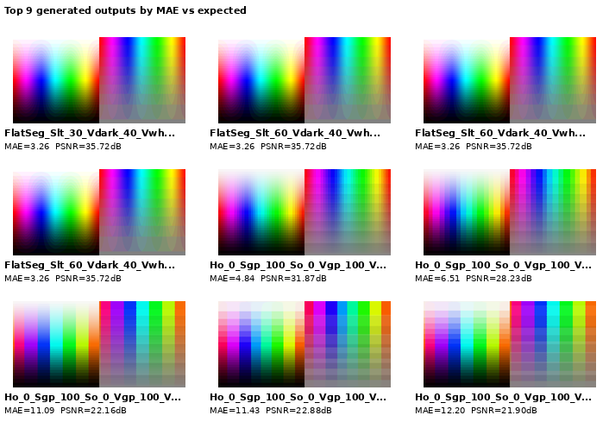
Figure 6. Top 9 generated output thumbnails ordered by MAE against expected reference. Each label shows MAE and PSNR.

9. Generated Output Image Grid — Continued
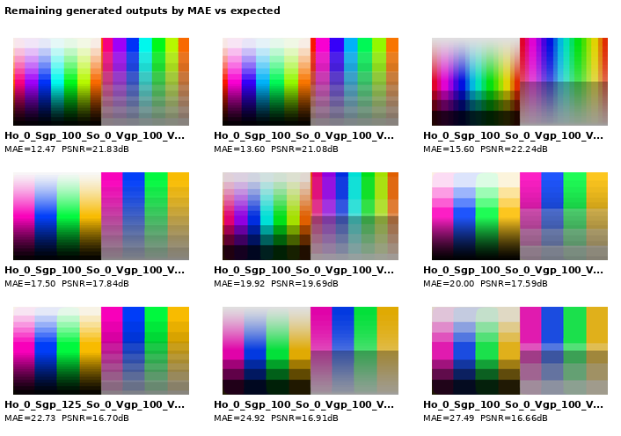
Figure 7. Remaining generated output thumbnails ordered by MAE against expected reference. Each label shows MAE and PSNR.

10. Representative Pixel RGB Value Comparison
Pixel (x,y) | Input RGB | Expected RGB | Generated RGB | |Generated-Expected| RGB | Max Err
(50, 50) | (255, 223, 246) | (255, 223, 246) | (255, 224, 240) | (0, 1, 6) | 6
(250, 50) | (223, 255, 254) | (223, 255, 254) | (224, 255, 255) | (1, 0, 1) | 1
(500, 50) | (247, 8, 8) | (247, 8, 8) | (240, 16, 16) | (7, 8, 8) | 8
(750, 50) | (8, 247, 239) | (8, 247, 239) | (16, 240, 240) | (8, 7, 1) | 8
(950, 50) | (247, 165, 8) | (247, 165, 8) | (240, 160, 16) | (7, 5, 8) | 8
(100, 250) | (196, 0, 255) | (196, 0, 255) | (192, 0, 255) | (4, 0, 0) | 4
(300, 250) | (0, 255, 92) | (0, 255, 92) | (0, 255, 96) | (0, 0, 4) | 4
(500, 250) | (191, 64, 64) | (191, 64, 64) | (192, 64, 64) | (1, 0, 0) | 1
(700, 250) | (64, 117, 191) | (64, 117, 191) | (64, 112, 192) | (0, 5, 1) | 5
(900, 250) | (167, 191, 64) | (167, 191, 64) | (160, 192, 64) | (7, 1, 0) | 7
(250, 450) | (0, 32, 31) | (0, 32, 31) | (0, 32, 32) | (0, 0, 1) | 1
(500, 450) | (140, 115, 115) | (140, 115, 115) | (144, 112, 112) | (4, 3, 3) | 4
(750, 450) | (115, 140, 139) | (115, 140, 139) | (112, 144, 144) | (3, 4, 5) | 5
Observation: The expected values match the input values at every sampled pixel. The generated output values are rounded/quantized, so the difference is usually small but nonzero.

11. Dominant RGB Colors

Input Image
Rank | RGB | Pixel Count | Percent
1 | (255, 255, 255) | 1,000 | 0.200%
2 | (0, 0, 0) | 500 | 0.100%
3 | (0, 1, 0) | 280 | 0.056%
4 | (0, 0, 1) | 272 | 0.054%
5 | (254, 255, 255) | 267 | 0.053%
6 | (255, 255, 254) | 260 | 0.052%
7 | (255, 254, 255) | 259 | 0.052%
8 | (1, 0, 0) | 248 | 0.050%

Expected Reference
Rank | RGB | Pixel Count | Percent
1 | (255, 255, 255) | 1,000 | 0.200%
2 | (0, 0, 0) | 500 | 0.100%
3 | (0, 1, 0) | 280 | 0.056%
4 | (0, 0, 1) | 272 | 0.054%
5 | (254, 255, 255) | 267 | 0.053%
6 | (255, 255, 254) | 260 | 0.052%
7 | (255, 254, 255) | 259 | 0.052%
8 | (1, 0, 0) | 248 | 0.050%

Selected Generated Output
Rank | RGB | Pixel Count | Percent
1 | (128, 128, 128) | 11,499 | 2.300%
2 | (255, 255, 255) | 7,499 | 1.500%
3 | (0, 0, 0) | 6,999 | 1.400%
4 | (128, 112, 144) | 3,934 | 0.787%
5 | (112, 144, 128) | 3,931 | 0.786%
6 | (128, 144, 112) | 3,717 | 0.743%
7 | (112, 144, 112) | 3,700 | 0.740%
8 | (112, 112, 144) | 3,601 | 0.720%

12. Conclusion and Engineering Interpretation
Expected Reference Status: The expected reference image is identical to the actual input image. The numerical comparison gives MAE = 0.000000, RMSE = 0.000000, and exact pixel match = 100%.
Generated Output Status: The selected generated output, FlatSeg_Slt_60_Vdark_40_Vwhite_240_Maj_5_Pass_0.bmp, does not exactly match the expected reference. Its MAE against expected is 3.262476, RMSE is 4.175547, and exact pixel match is 0.623%.
Root Cause: The generated output is a flat-color/posterized version of the input. That behavior intentionally reduces the number of unique RGB values and therefore cannot be a bit-exact match to an expected reference that preserves the original input colors.
Design Recommendation: If the target is exact expected-reference matching, use an input-preserving path or make the flat quantization step bypassable. If the target is a segmented/flat-color visual effect, update the expected reference to the intended segmented palette and validate against that image instead.

Appendix A. Selected File Hashes
Generated BMP | SHA-256 prefix
FlatSeg_Slt_30_Vdark_40_Vwhite_240_Maj_5_Pass_0.bmp | e6ec173a083e
FlatSeg_Slt_60_Vdark_40_Vwhite_240_Maj_5_Pass_0 - Copy.bmp | e6ec173a083e
FlatSeg_Slt_60_Vdark_40_Vwhite_240_Maj_5_Pass_0.bmp | e6ec173a083e
FlatSeg_Slt_60_Vdark_40_Vwhite_240_Maj_5_Pass_3.bmp | 43bda992c425
Ho_0_Sgp_100_So_0_Vgp_100_Vo_0_Enf_t_Hs_8_Ss_8_Vs_16_Fcb_t.bmp | 2fe7c7f8a2d4
Ho_0_Sgp_100_So_0_Vgp_100_Vo_0_Enf_t_Hs_16_Ss_8_Vs_16_Fcb_t.bmp | 889101c97eef
Ho_0_Sgp_100_So_0_Vgp_100_Vo_0_Enf_t_Hs_36_Ss_8_Vs_16_Fcb_t.bmp | 4a2c5ce3eb7b
Ho_0_Sgp_100_So_0_Vgp_100_Vo_0_Enf_t_Hs_32_Ss_40_Vs_16_Fcb_t.bmp | d3dc9cde6fb2
Ho_0_Sgp_100_So_0_Vgp_100_Vo_0_Enf_t_Hs_36_Ss_36_Vs_16_Fcb_t.bmp | 09963857fa9b
Ho_0_Sgp_100_So_0_Vgp_100_Vo_0_Enf_t_Hs_36_Ss_40_Vs_16_Fcb_t.bmp | 6b7866f58ad3
Ho_0_Sgp_100_So_0_Vgp_100_Vo_0_Enf_t_Hs_40_Ss_40_Vs_16_Fcb_t.bmp | a4b7ec7fe25d
Ho_0_Sgp_100_So_0_Vgp_100_Vo_0_Enf_t_Hs_16_Ss_8_Vs_64_Fcb_t.bmp | 1b8c9d470f5f
Ho_0_Sgp_100_So_0_Vgp_100_Vo_0_Enf_t_Hs_64_Ss_8_Vs_16_Fcb_t.bmp | 4deaa0a1d178
Ho_0_Sgp_100_So_0_Vgp_100_Vo_0_Enf_t_Hs_36_Ss_36_Vs_64_Fcb_t.bmp | fc66aba38172
Ho_0_Sgp_100_So_0_Vgp_100_Vo_0_Enf_t_Hs_64_Ss_64_Vs_8_Fcb_t.bmp | f6c188eddb44
Ho_0_Sgp_125_So_0_Vgp_100_Vo_0_Enf_t_Hs_64_Ss_40_Vs_16_Fcb_t.bmp | 4a022b8a0a74
Ho_0_Sgp_100_So_0_Vgp_100_Vo_0_Enf_t_Hs_64_Ss_8_Vs_64_Fcb_t.bmp | aa5e5aab5147
Ho_0_Sgp_100_So_0_Vgp_100_Vo_0_Enf_t_Hs_64_Ss_64_Vs_64_Fcb_t.bmp | 9c2cda1a74d2

