Video Frame Processing

Contents

1 Introduction 5

2 Architecture 6

3 Features 7

4 Clocks 8

5 Frame Time 9

6 Frame Rates at Common Resolutions 10

7 VFP 11

8 HSL Filter 12

9 HSV Filter 13

9.1 Generics 13

9.2 Ports 13

10 Sharp Filter 14

11 Blur Filter 15

12 Emboss Filter 15

13 Sobel Filter 15

14 YCbCr Color Space 15

15 Color Correction Matrix 15

16 Camera Raw Data 17

16.1 Ports 18

Port 18

Bits 18

Description 18

I/O 18

Clock 18

17 Operation 19

18 Image Read Interface 20

19 Three Taps data 21

20 Four Taps data 21

21 Pixel Coordinates 21

22 Camera Raw Data 23

Figure 1 6

Figure 2 11

Figure 3 : Hue Top 12

Figure 4: Hue Bottom 12

Figure 5: Hue Degree 12

Figure 6 17

Figure 7 17

Figure 8 20

Figure 9 21

Figure 10 21

Figure 11 21

Figure 12 22

Figure 13 23

# Introduction

The purpose of this design to take raw Bayer format data and convert into video 16-bit YCbCr [4:2:2] (YUV) color space. This design reads camera input data, then transform into rgb color space of 24-bit data bus with 8 bits each for the red pixel, green pixel, and blue pixel. Each rgb pixel either filtered or converted into color space. Sharp, blur, emboss and sobel filtered are used in this design. RGB into Ycbcr and color correction space are implemented in design.

Image frame resolution is set to 1920x1080 at 23 frames per second and maximum full resolution of 2592x1944 is also supported but limited to 15 frames per second.

# Architecture

The Video processing frame core provides a modular expandable interface for video frame processing.

General architecture consists of camera interface module “camera_raw_to_rgb” which convert bayer format data into rgb format” rgb_set”. Video stream module which filters rgb data into various filters and axis external module which stream the filtered data to axi4-stream.



Figure 1

# Features

Input format: Raw Bayer format

Output format: 16-bit YCbCr [4:2:2] (YUV) color space

24-bit User AXI Stream input.

**Filters:**

1. HSL
2. HSV
3. Sharp
4. Blur
5. Emboss
6. Sobel
7. YCbCr
8. Color Correction

# Clocks

There are two clocks used in this design, pixel clock is nominally the pixel clock rate, with a

set pll programed design frequency of 96MHz or below, and system clock which is a 150 Mhz.

# Frame Time

# Frame Rates at Common Resolutions

# VFP

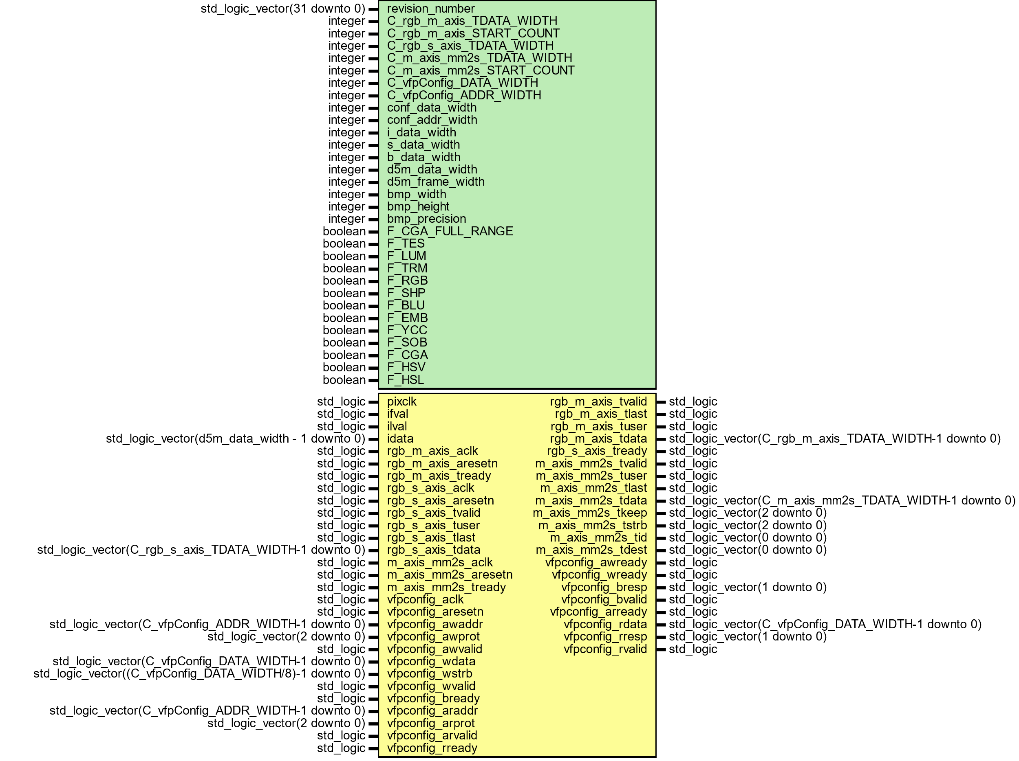

Figure 2

# HSL Filter



Figure

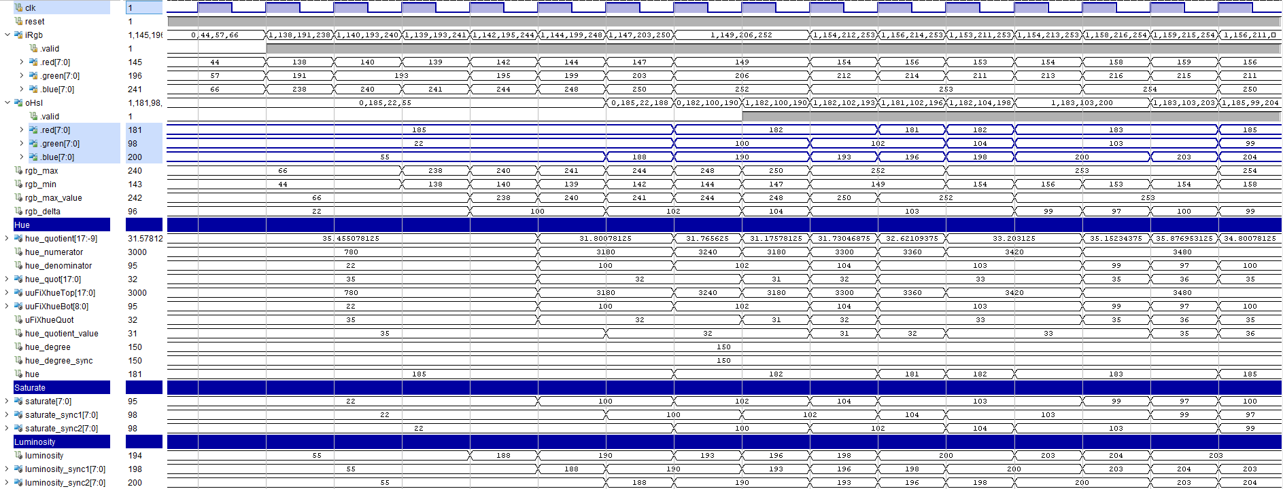

Figure HSL Filter Wave Diagram



Figure 5 : Hue Top



Figure 6: Hue Bottom



Figure 7: Hue Degree

# HSV Filter



Figure 8

## Generics

| **Generic name** | **Type** | **Value** | **Description** |
| --- | --- | --- | --- |
| i_data_width | natural | 8 |  |

## Ports

| **Port name** | **Direction** | **Type** | **Description** |
| --- | --- | --- | --- |
| clk | in | std_logic |  |
| reset | in | std_logic |  |
| iRgb | in | channel |  |
| oHsv | out | channel |  |

# Sharp Filter

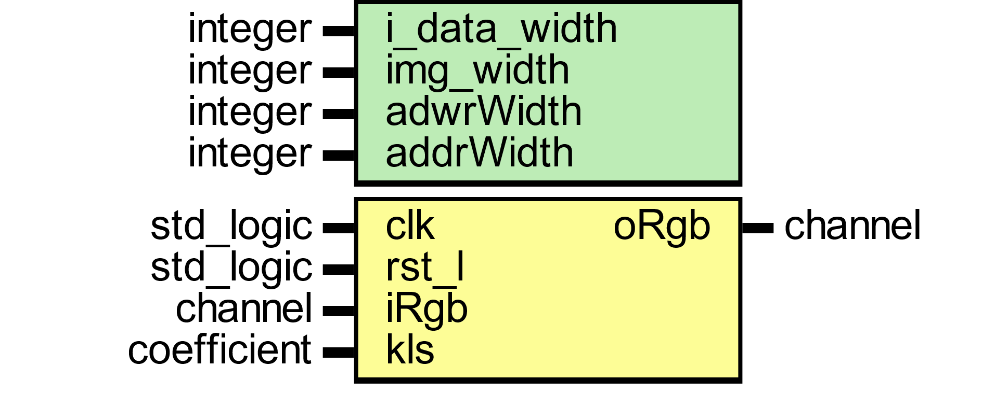

Figure 9

# Blur Filter

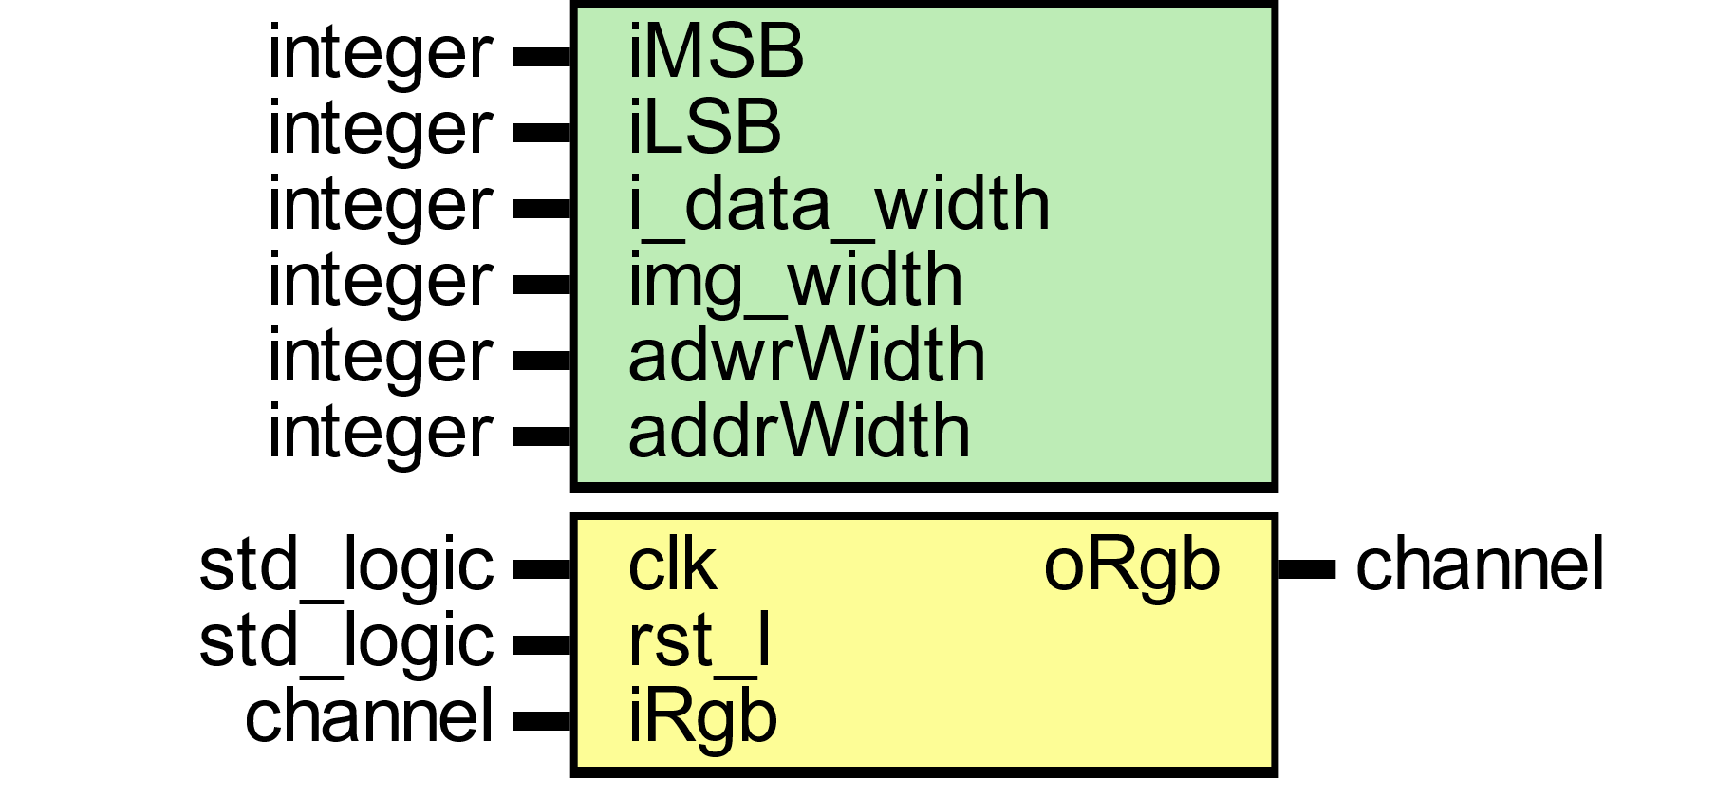

Figure 10

# Emboss Filter

# Sobel Filter

# YCbCr Color Space

# Color Correction Matrix

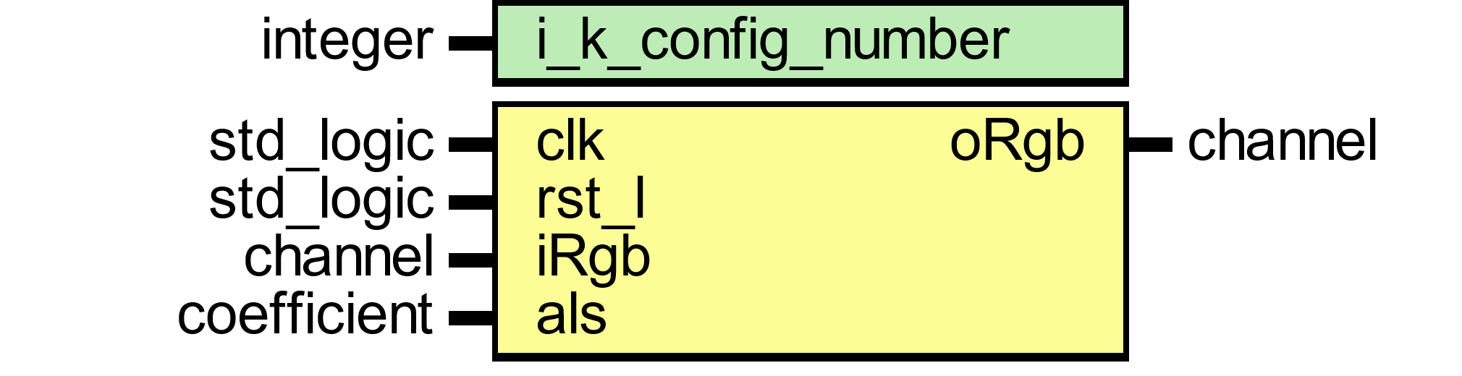

Figure 11

# Camera Raw Data

This module read raw bayer filter mosaic format 12-bit data from d5m camera. External Pixel clock is from camera used to sample 1 pixel which equal to 1 pll generated master external clock. Host camera data is than stored into buffer line by line which is ready to be fetch at system clock rate. Input line and frame valid signals are used to start reading stored buffer data. Valid read is enabled when both frame and line valid signal are asserted high. Buffer size set to be the size of frame width. The read controller side reads whole frame width from the buffer. Values written to buffer run at pixel clock rate whereas buffer read side run at faster rate than pixel clock.

Buffersize is auto size supported which is controlled by input line valid from host camera and maximum is set to default value of 3071.

Input data from camera is color filtered which is arranged in a bayer patten. Input data is read with line-by-line transfer rate of pixel clock which later synchronize into system clock.

Default: MAX_LINE_IMAGE_WIDTH=3071

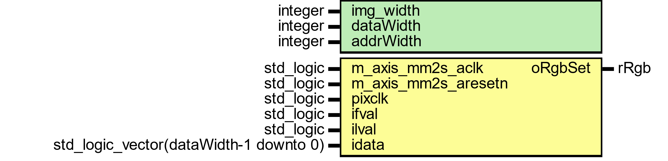

Figure 12

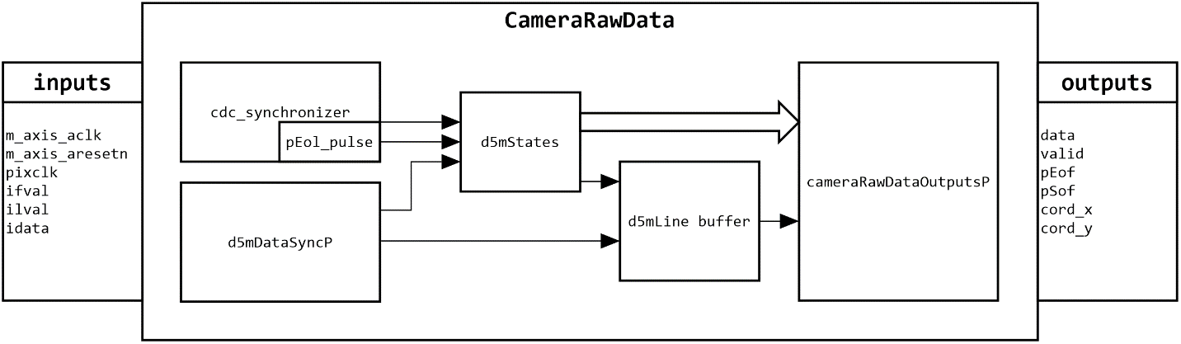

Figure 13

Figure 14

Host camera interface uses 12 bits parallel input data with line and frame valid control signals.

## Ports

Table 1.2 lists MPEG2 decoder input/output ports.

|  |  |  |  |  |
| --- | --- | --- | --- | --- |
| Port | Bits | Description | I/O | Clock |
|  |  |  |  |  |
|  |  |  |  |  |
|  |  |  |  |  |
|  |  |  |  |  |
|  |  |  |  |  |
|  |  |  |  |  |
|  |  |  |  |  |

Table 1

# Operation

# Image Read Interface

Figure 15

# Three Taps data



Figure 16

# Four Taps data



Figure 17

# Pixel Coordinates



Figure 18





Figure 19



Figure 20

# Camera Raw Data

# Histogram

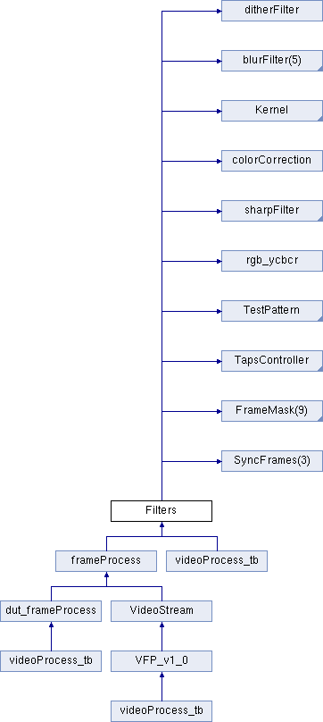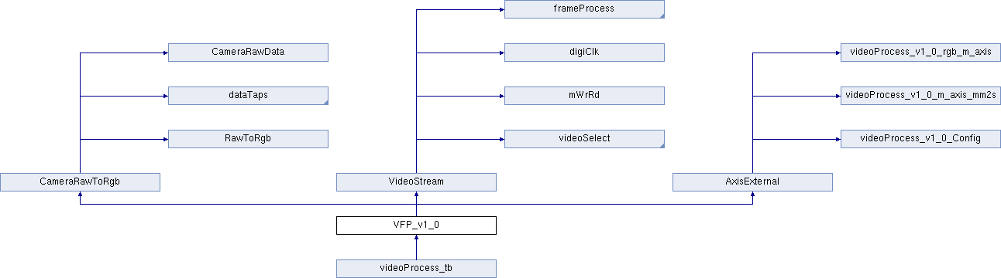

# Testbench

