|  |  |  |
| --- | --- | --- |
| **HUE** | **CB[DEPTH]** | **CR** |

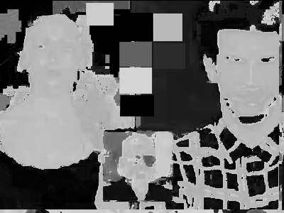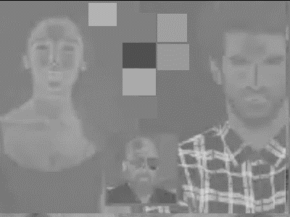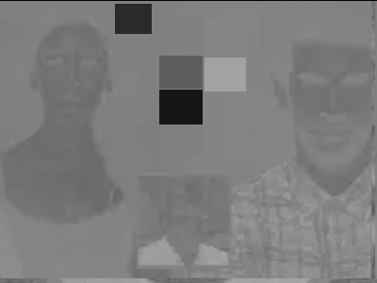

|  |  |  |
| --- | --- | --- |
| **SAT[DEPTH]** | **Y** | **L** |

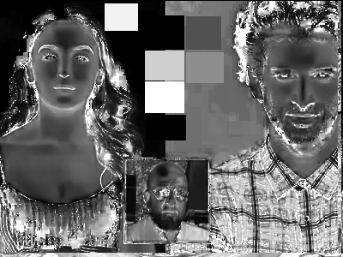  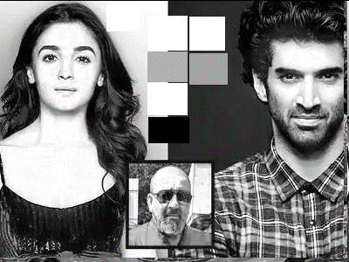

|  |  |  |
| --- | --- | --- |
| **ySatCr** | **SatCbCr** |  |

