Step 1: Launch URL "*https://us2a.app.anaplan.com/a/modeling/customers/8a81b00e68d4b3970168eeb2138441ec/workspaces/8a868cda871ab34b01874e505bef2bc5/models/D0B081660F514A288A63BFD6C0DC37AAhttps://us2a.app.anaplan.com/a/modeling/customers/8a81b00e68d4b3970168eeb2138441ec/workspaces/8a868cda871ab34b01874e505bef2bc5/models/D0B081660F514A288A63BFD6C0DC37AA*": **PASS**

Step 2: Click "LoginSSO": **PASS**

Step 3: Set value "*ssamal@lululemon.com*" to "emailAddress": **PASS**

Step 4: Click "loginButton": **PASS**

Step 5: Set value "*ssamal@lululemon.com*" to "enterEmailAddress": **PASS**

Step 6: Click "nextLogin": **PASS**

Step 7: Set value "*April@202three*" to "ssoPwd": **PASS**

Step 8: Pause for "5" seconds: **PASS**

Step 9: Press "*TAB*" key over "ssoPwd": **PASS**

Step 10: Click "nextPwd": **PASS**

Step 11: Click "staySignedIN": **PASS**

Step 12: Click "dropDown": **PASS**

Step 13: Click "selectModel": **PASS**

Step 14: Switch to iframe "*{"appShellConfig":{"SHELL_CONTEXT_ROOT":"/","APP_OUTER_CONTEXT_ROOT":"/home"}}*": **PASS**

Step 15: Click "selModelName": **PASS**

Step 16: Switch to default iframe"": **PASS**

Step 17: Switch to iframe "*{"appShellConfig":{"SHELL_CONTEXT_ROOT":"/","APP_OUTER_CONTEXT_ROOT":"/a/modeling"}}*": **PASS**

Step 18: Click "selModules": **PASS**

Step 19: Pause for "5" seconds: **PASS**

Step 20: Switch to iframe "*0*": **PASS**

Step 21: Click "metaParam": **PASS**

Step 22: Click "updParam": **PASS**

Step 23: Switch to default iframe"": **PASS**

Step 24: Pause for "5" seconds: **PASS**

Step 25: User define test "*processMetaData*":

Step 25.1: User define test "*start run for ORT Combination Limit with :360000*":

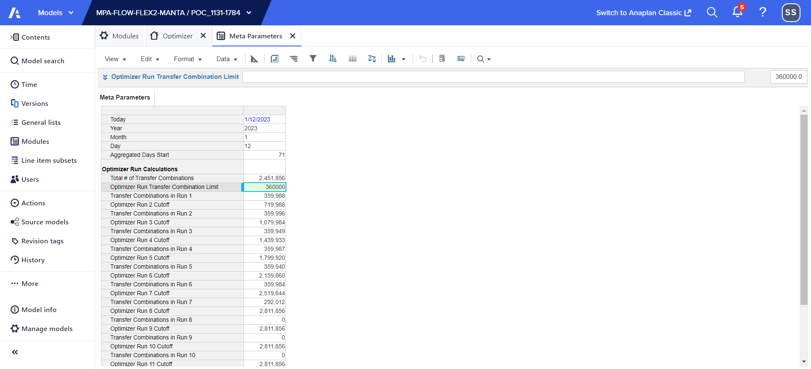

Step 25.2: User define test "*starting meta process for [Initiate Hyperdrive 1] with ORT Combination limit: 360000*":

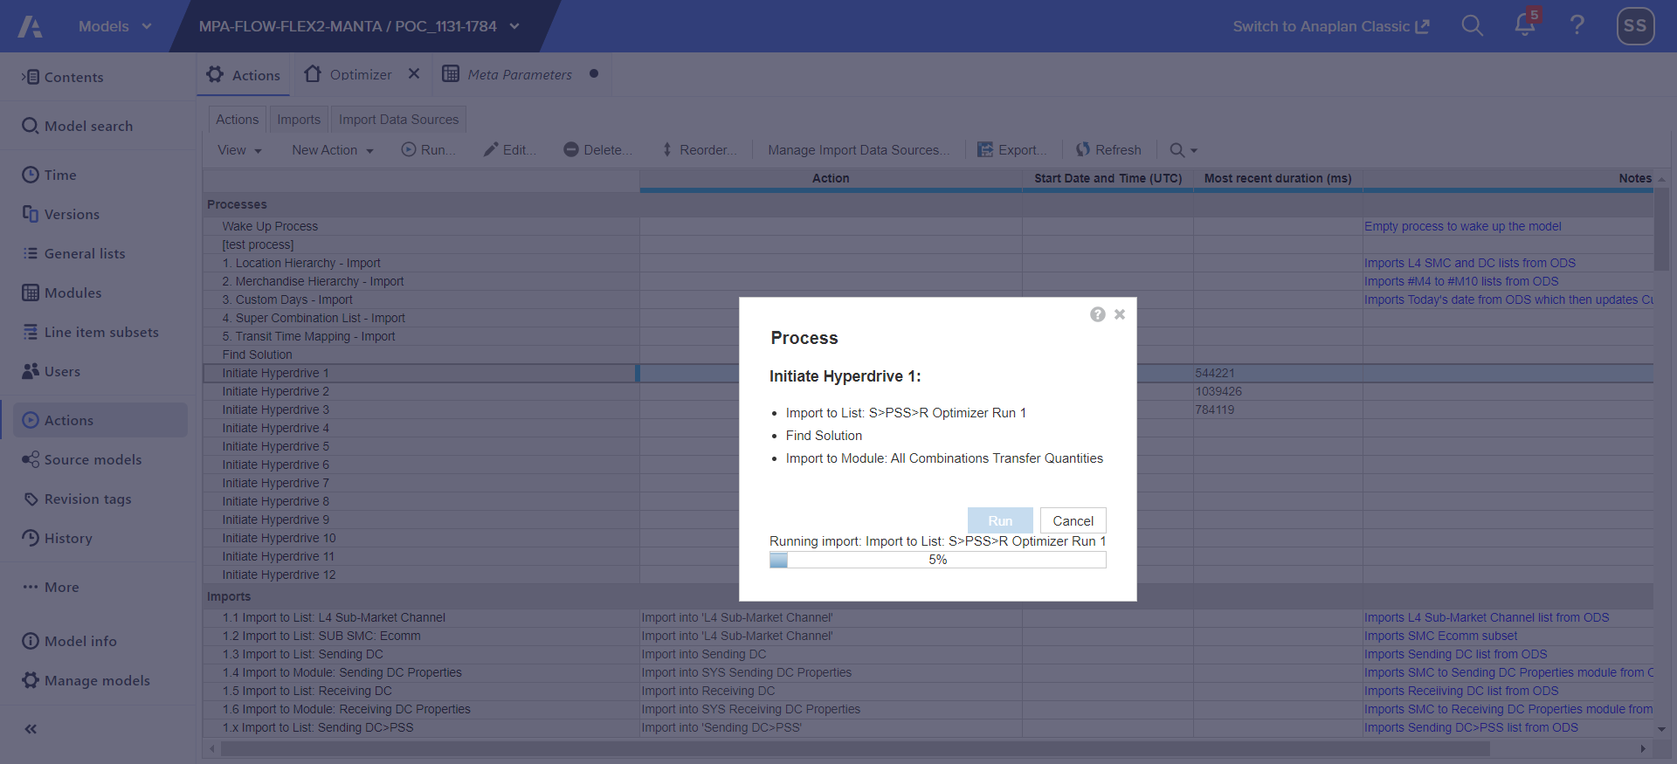

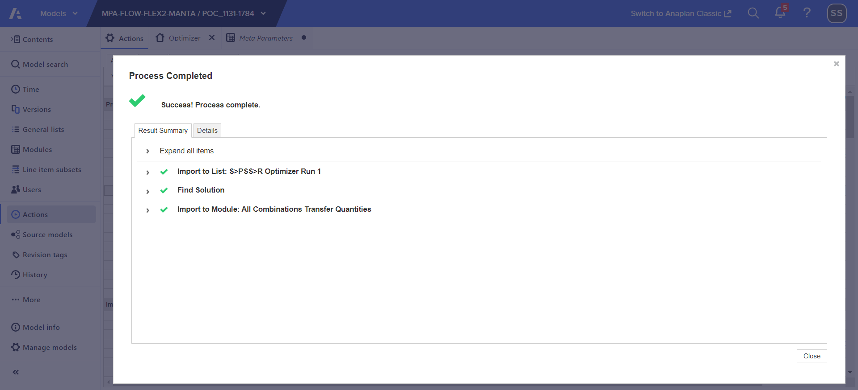

Step 25.3: User define test "*Success! Process complete.*":

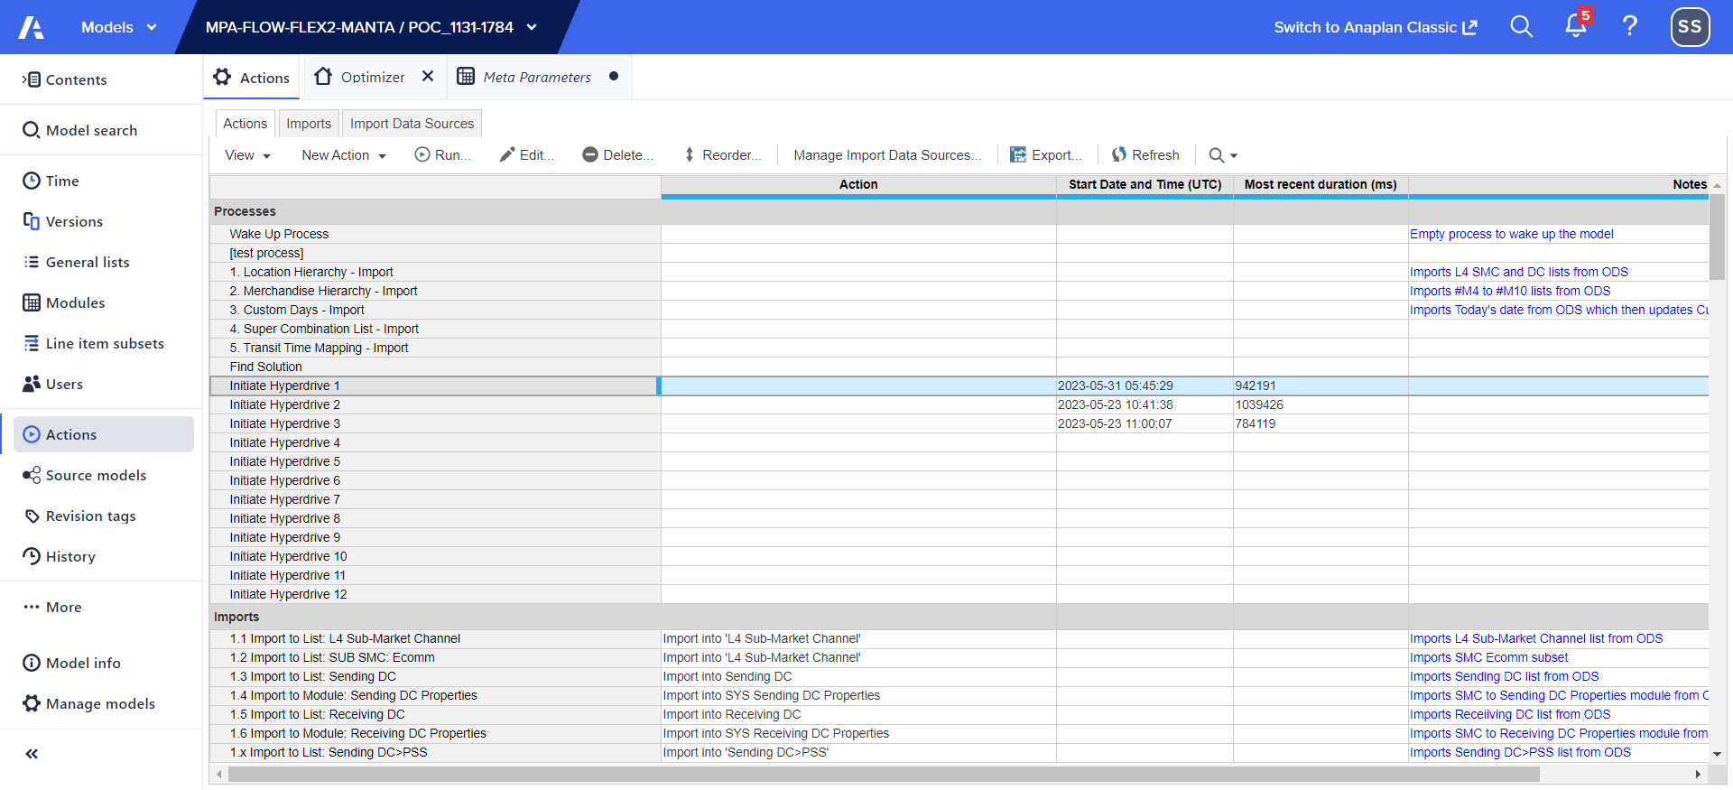

Step 25.4: User define test "*most recent duration (mins:secs): 15:42*":

Step 25.5: User define test "*starting meta process for [Initiate Hyperdrive 2] with ORT Combination limit: 360000*":

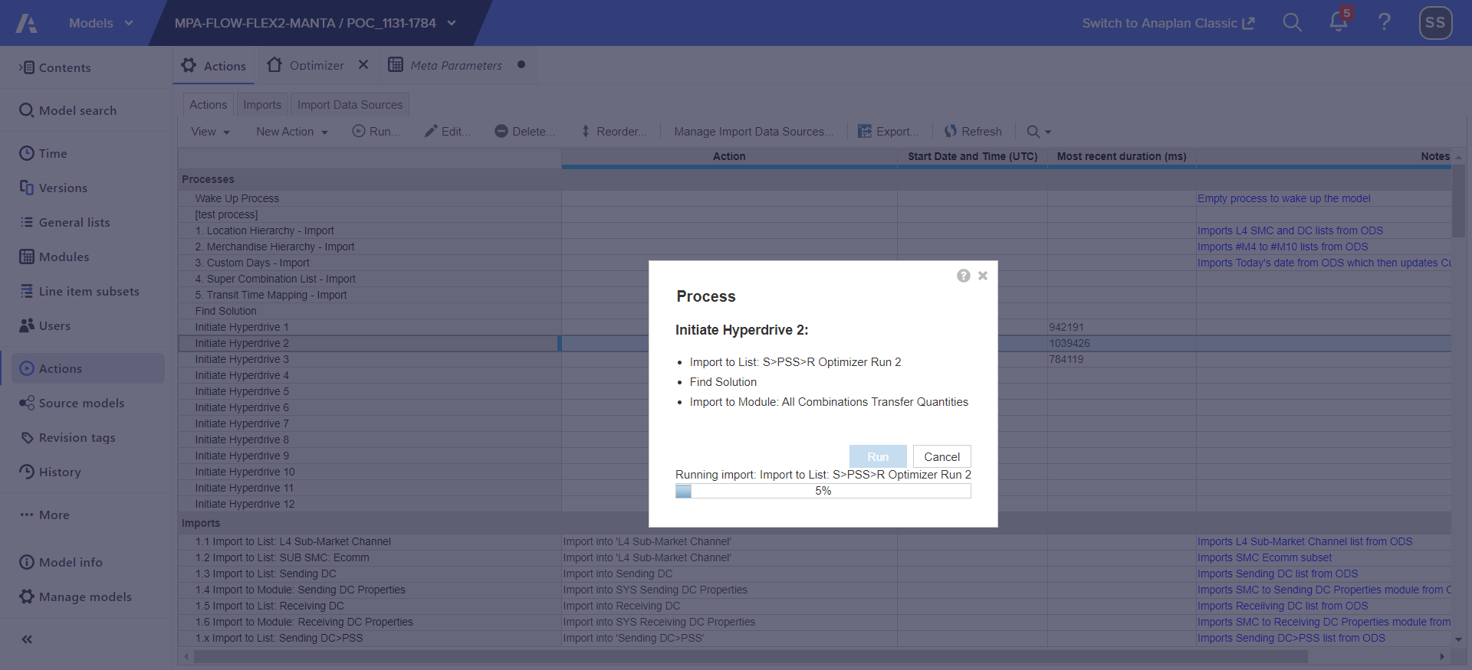

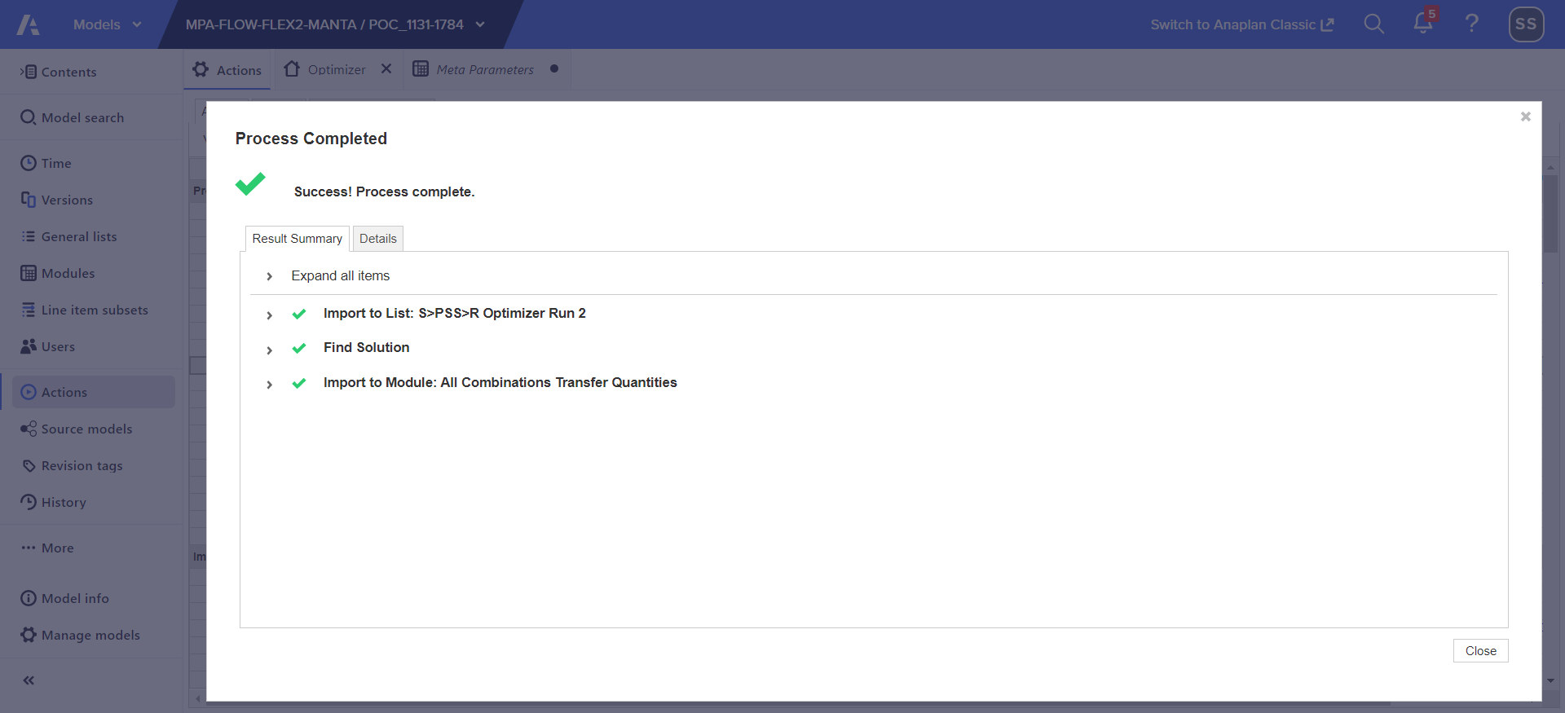

Step 25.6: User define test "*Success! Process complete.*":

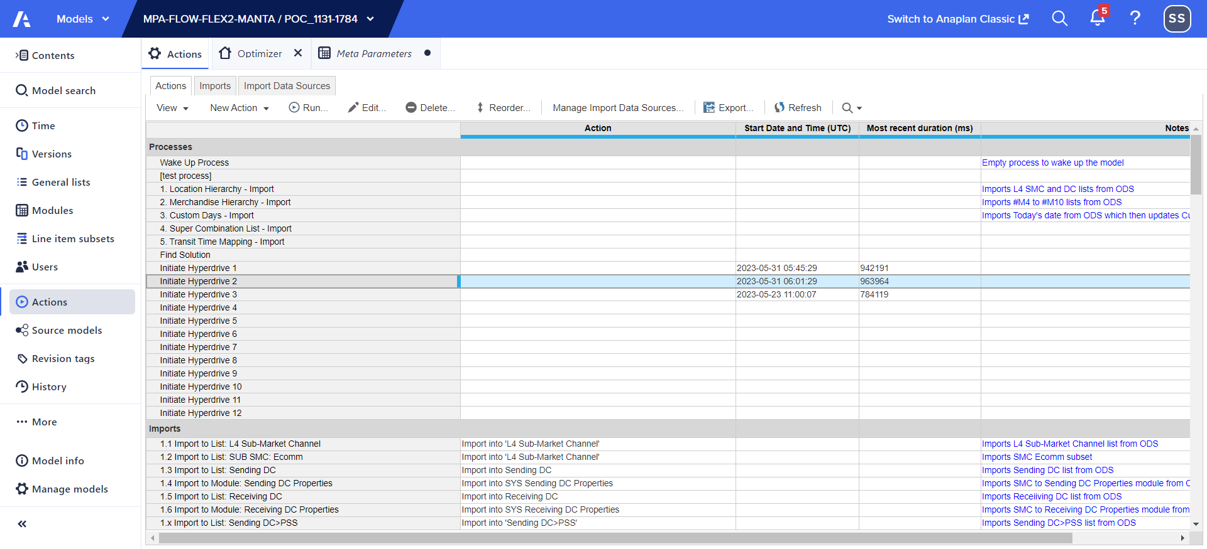

Step 25.7: User define test "*most recent duration (mins:secs): 16:3*":

Step 25.8: User define test "*starting meta process for [Initiate Hyperdrive 3] with ORT Combination limit: 360000*":

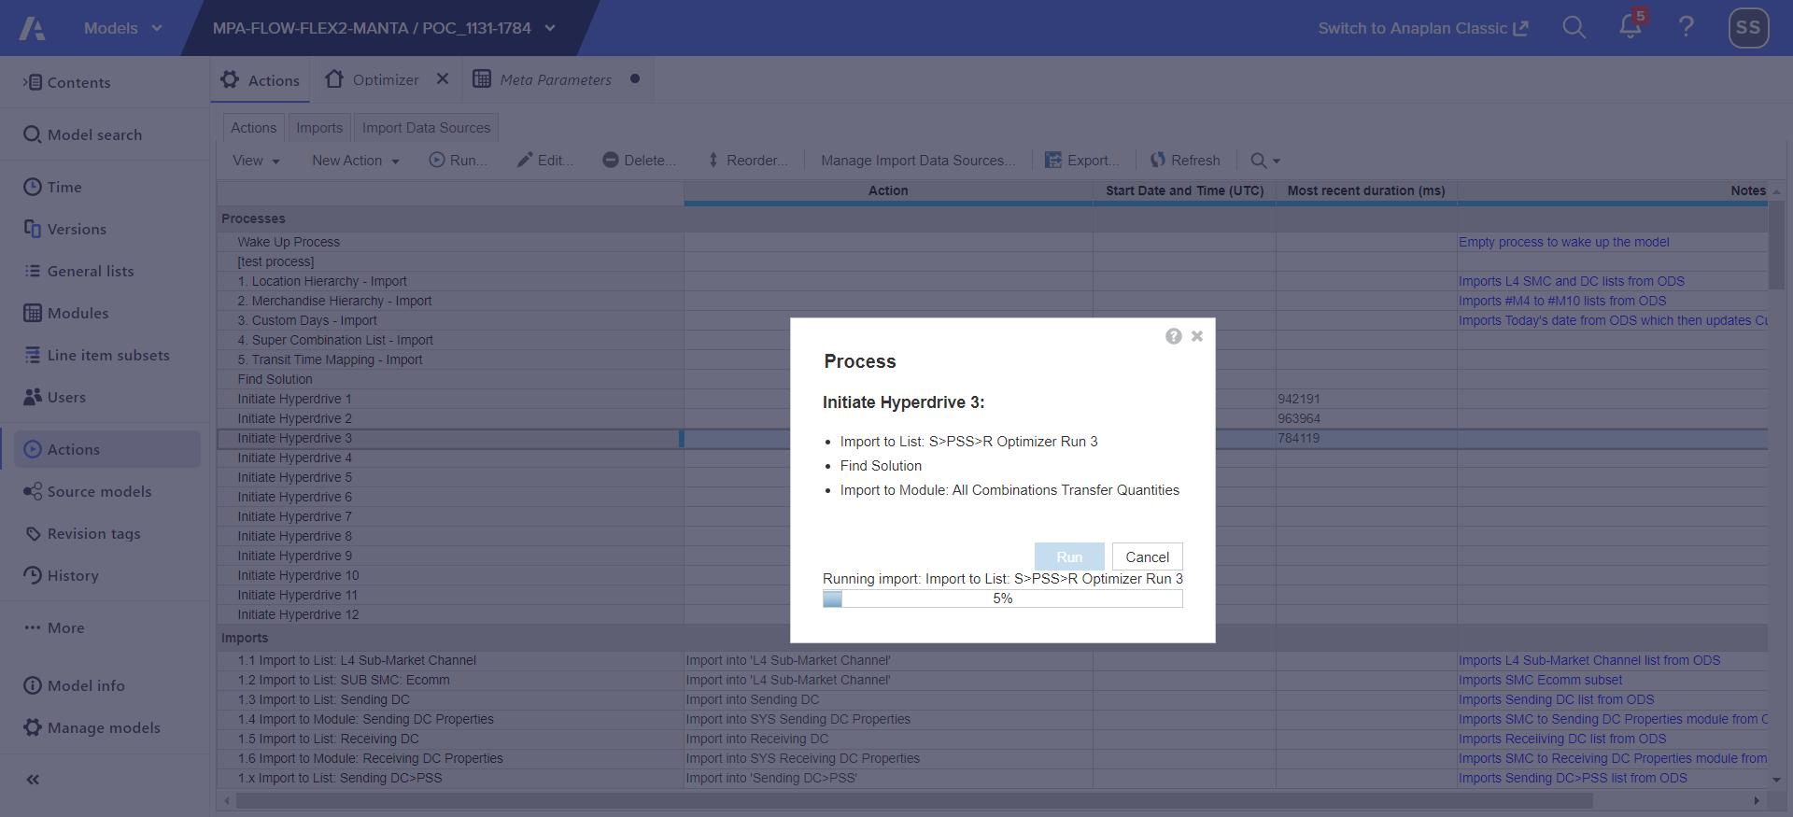

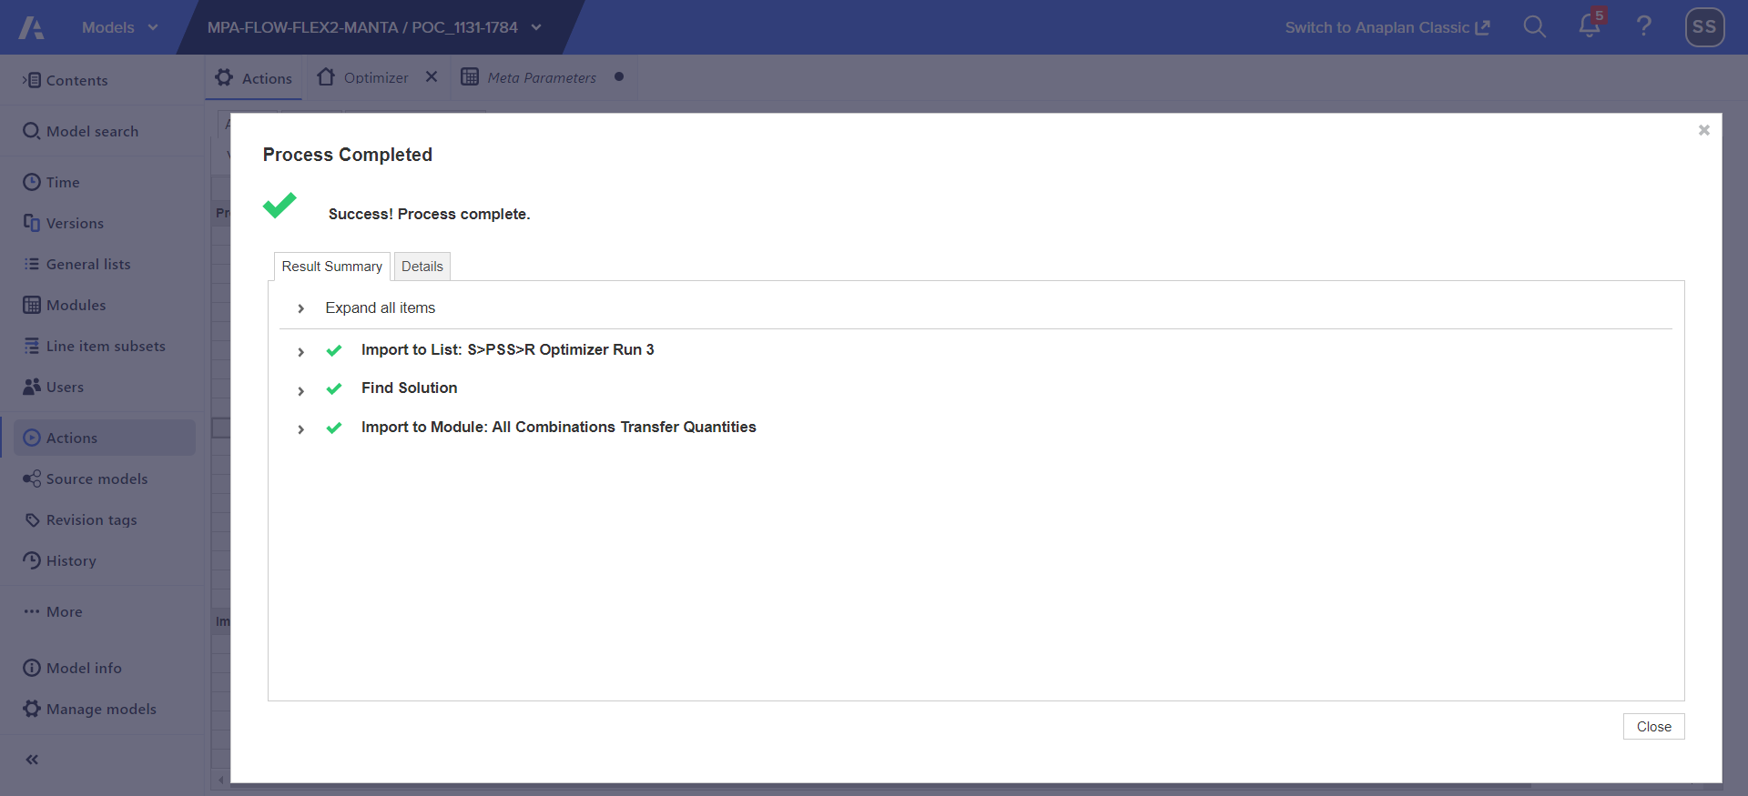

Step 25.9: User define test "*Success! Process complete.*":

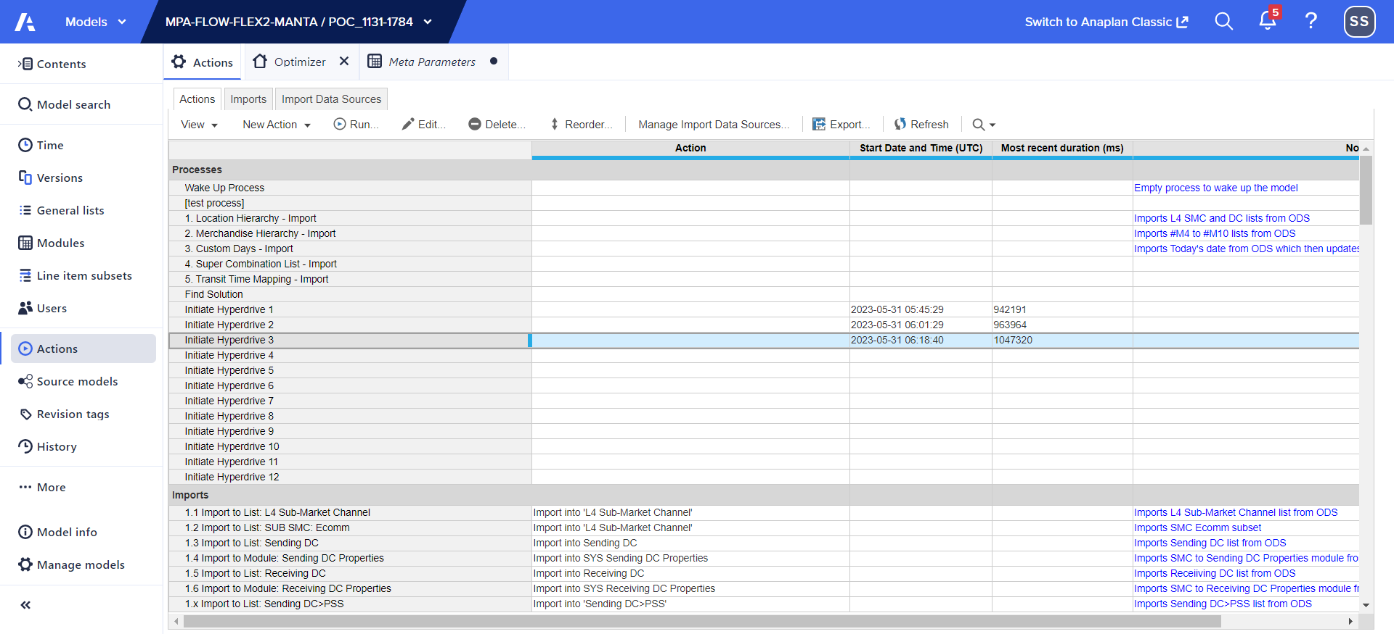

Step 25.10: User define test "*most recent duration (mins:secs): 17:27*":

Step 25.11: User define test "*start run for ORT Combination Limit with :361000*":

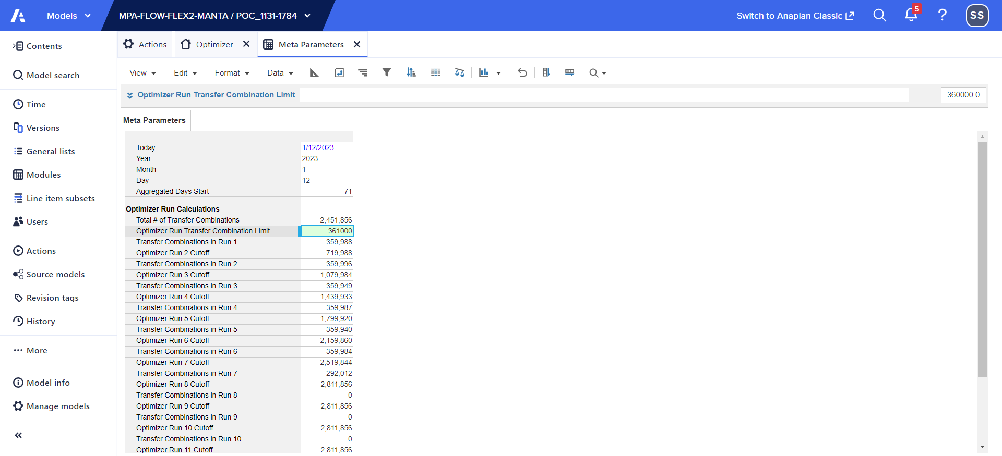

Step 25.12: User define test "*starting meta process for [Initiate Hyperdrive 1] with ORT Combination limit: 361000*":

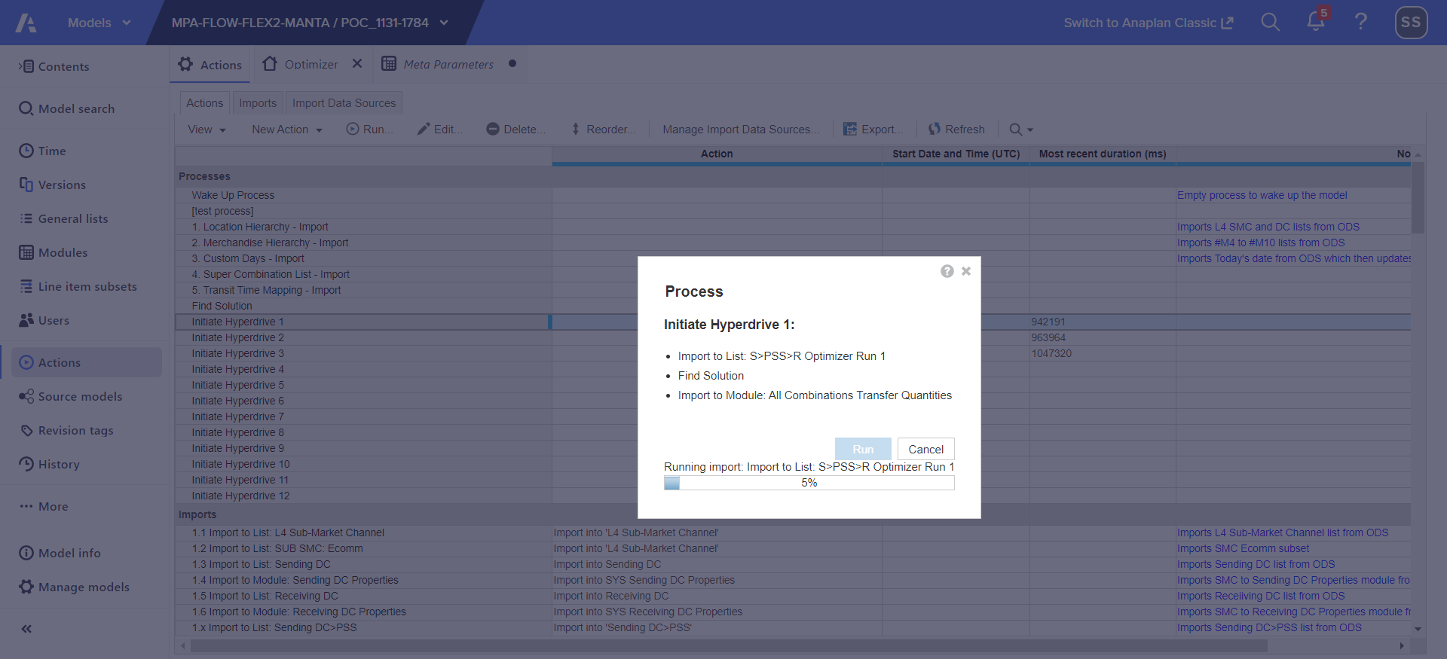

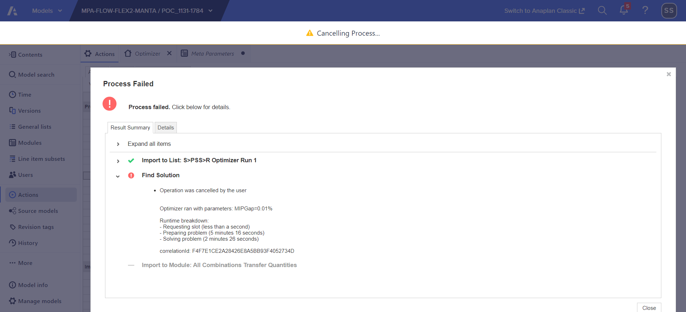

Step 25.13: User define test "*Process failed.*": **FAIL**

