Step 1: Launch URL "https://www.google.com": **PASS**

Step 2: Assert that "GoogleSearch" is visible: **PASS**

Step 3: Take screen-shot:

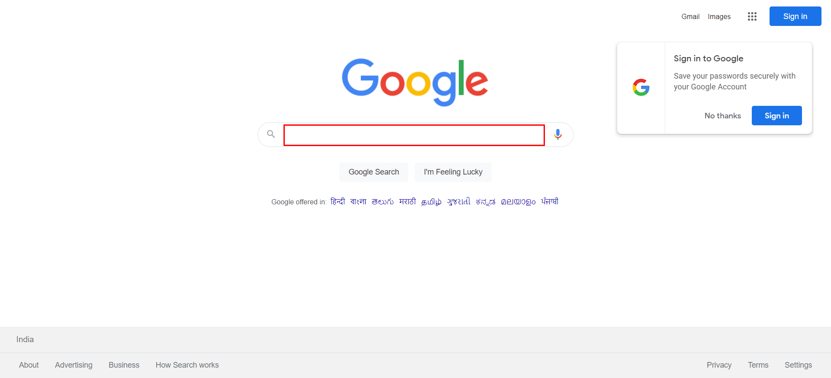

Step 4: Get value [हिन्दी] from "Hindi_Language": **PASS**

Step 5: Set value "हिन्दी" to "GoogleSearch": **PASS**

Step 6: Take screen-shot:

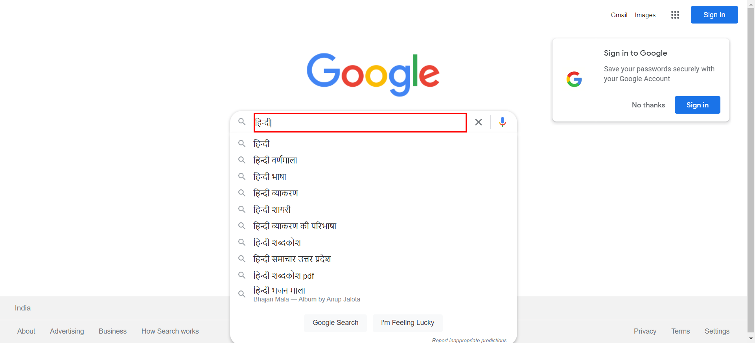

Step 7: Press "ENTER" key: **PASS**

Step 8: Take screen-shot:

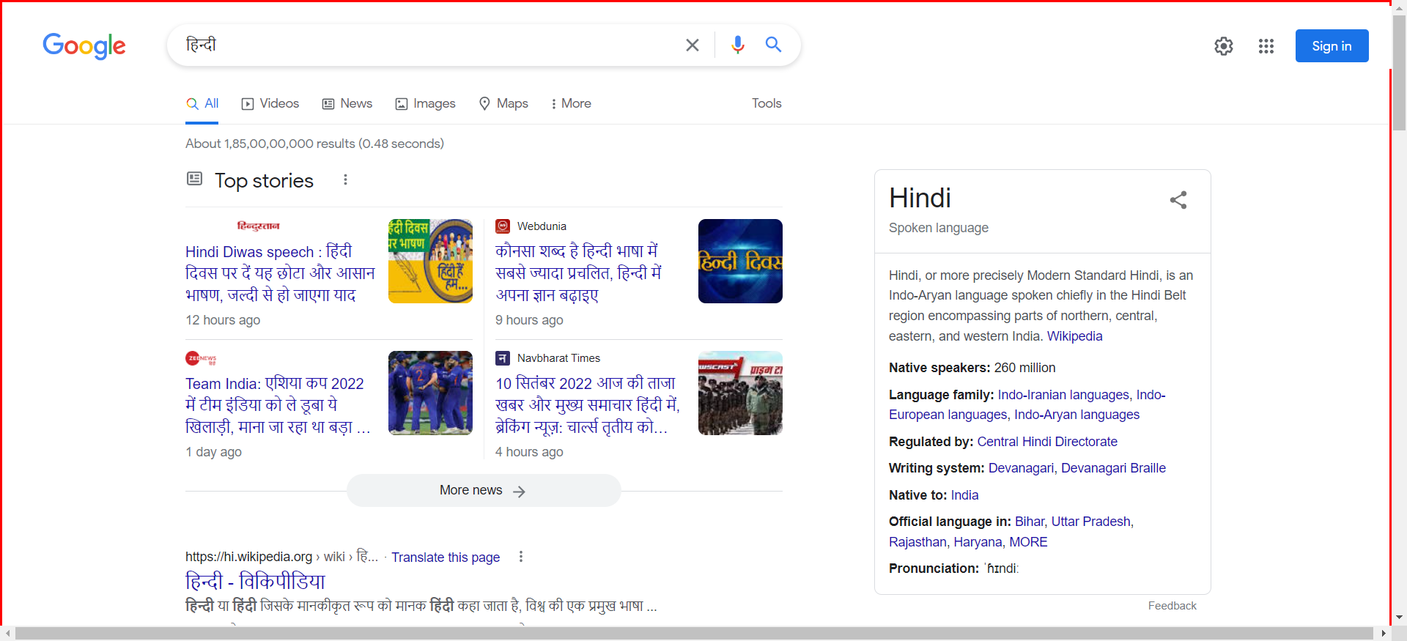

Step 9: Clear "GoogleSearch_1": **PASS**

Step 10: Set value "royal enfield" to "GoogleSearch_1": **PASS**

Step 11: Press "ENTER" key: **PASS**

Step 12: Assert that "RoyalEnfieldLogo" is visible: **PASS**

Step 13: Take screen-shot:

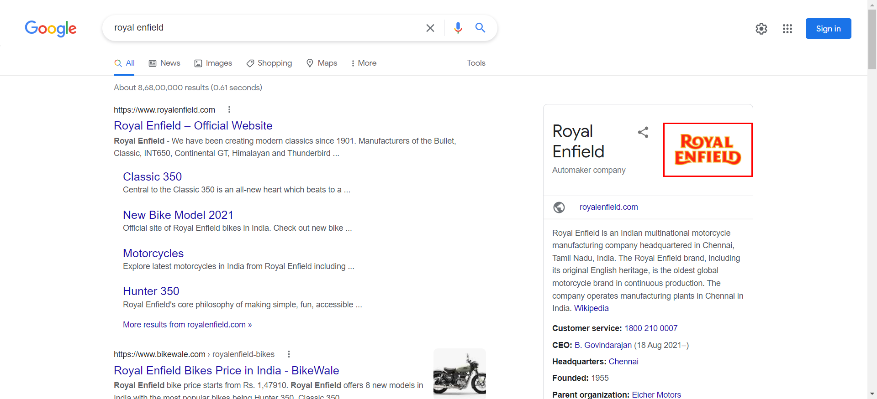

Step 14: Open "https://www.google.com/" new window: **PASS**

Step 15: Set value "selenium testing" to "GoogleSearch_1": **PASS**

Step 16: Press "ENTER" key: **PASS**

Step 17: Take screen-shot:

