- What is the purpose of an array?
- To organize data into key-value pairs.
- To store data only of the same type.
- To store data in an organize fashion
- To organize data at lettered positions.
- How can you find how many elements are within an array?
- length(myArray)
- myArray.findLength
- myArray.length
- What will happen after running the following code?
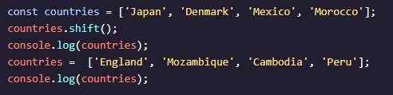
- Two arrays will be logged to the console:
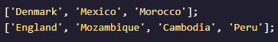
- Two arrays will be logged to the console:
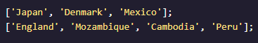
- One array will be logged to the console followed by an error message
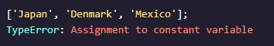
- One array will be logged to the console followed by an error message
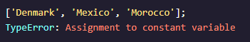
- What is the correct syntax for an array?
- Which of the methods below does NOT change the array it is called on?
- .push()
- .shift()
- .slice()
- .pop()
- What will be printed to the console?
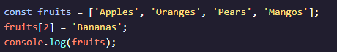
- 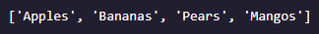
- 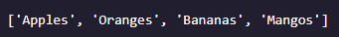
- How could you access the second item, `Lion`, in the following code block?
- animalArray[1]
- animalArray[2]
- animalArray[`Lion`]
- What is the value of topPriority?
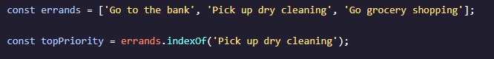
- 1
- 2
- -1
- Undefined
- What will be logged to the console when we run the code below?
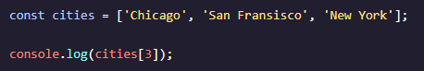
- Chicago
- undefined
- New York
- What will be logged to the console when we run code below?
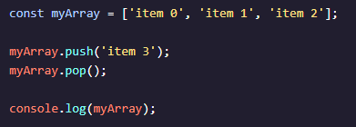
- [`item 0`, `item 1`, `item 2`, `item 3`]
- [`item 0`, `item 1`, `item 2`]
- [`item 1`, `item 2`, `item 3`]

