- How will you retrieve an element with the id "first"?
- document.getElementById("first")
- document.querySelector("#first")
- Both A and B
- Select the parent of an element ele using one of the following choices.
- ele.parentElement
- ele.parentContainer
- ele.parentNode
- ele.getParent()
- Select the first element with the selector statement .main .title .t1.
- document.querySelector(".main .title .t1")
- document.querySelectorAll(".main .title .t1")
- document.getElementsByClassname("main")
- What will document.getElementById("t1").childNodes[0] return?
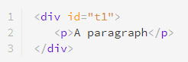
- A text node
- An element node
- A comment node
- None of the above
- The methods getElementsByClassName() and getElementsByTagName() both return a list of the matched elements, even if the match is for a single element.
True or false?
- True
- False
- What does div.className += " intro" do to the <div> element shown below, assuming it has been selected in the variable div?

- Adds a new class "intro" to it
- Replaces the previous class with the class "intro"
- Add an element node ele in the position show below. You shall assume that #div1 is saved in the variable div1 and #div2 in div2.
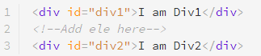
- div1.appendChild(ele)
- div2.appendChild(ele)
- div2.parentNode.insertBefore(div2, ele)
- div2.parentNode.insertBefore(ele, div2)
- In which of the following ways can the value of the id attribute of an element ele be retrieved? You may assume that ele has only one attribute on it and that is id.
- ele.id
- ele.attributes.id
- ele.attributes[0]
- All of the above
- How to remove the class nav from the following element? Choose all the possible choices in relation to this example.
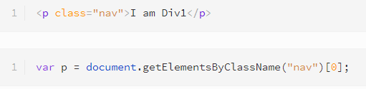
- p.classList.remove("nav")
- p.className = ""
- Both A and B
- Change the content inside an element foo to the text "Changed".
- foo.innerHTML = "Changed"
- foo.innerContent = "Changed"
- foo.innerText = "Changed"
- Both A and C
- How can you remove the highlighted element in the code below, given that it is not a child of <body>? You may assume it has already been fetched in the variable ele.
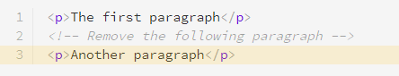
- ele.parentNode.removeChild(ele)
- ele.removeChild()
- document.body.removeChild(ele)
- Which specific object does JavaScript provide to fetch data- attributes of an element?
- Datalist
- Dataset
- dataAttributes
- None of the above
- In what ways can we add the text "Hello" to an empty element node ele?
- ele.innerText = "Hello"
- ele.innerHTML = "Hello
- ele.appendChild(document.createTextNode("Hello"))
- All of the above

- Spot the error in the code below.
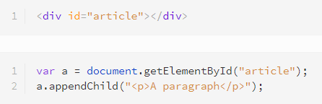
- The argument to appendChild() is not a node
- appendChild() isn't a defined method on a
- appendChild() can only be called on the body element

