- how to add new data to localstorage
- 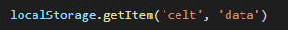
- 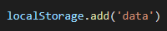
- How to console the value of sessionstorage
- 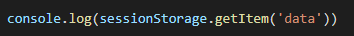
- 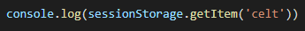
- 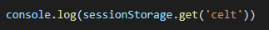
- How to add this array into localstorage
- 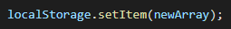
- How do you get cookies in JavaScript?
- window.cookies
- location.cookies
- document.cookie
- document.cookies

