- Why will the code below throw an error?
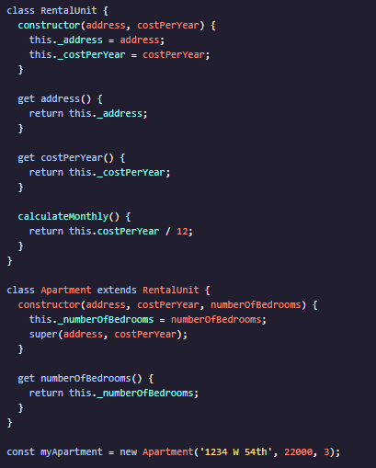
- 
- 
- Which of the following keywords is required to create a new class?
- new
- class
- const
- let
- What is the purpose of inheritance?
- To create new function that have the same data and methods as other functions.
- To create functions that pass through the same parameters through a chain of functions.
- To share data and methods between objects.
- Which of the following is a method of the RentalUnit class?
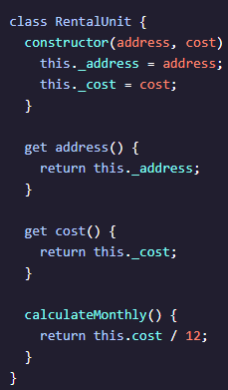
- RentalUnit
- _cost
- .calculateMonthly()
- _address
- When you create a subclass using the extends keyword, what will the class inherit from its parent?
- The subclass inherits only the parent class getters and setters.
- The subclass inherits all parent properties.
- The subclass does not directly inherit anything. You must use the super keyword to set properties and inherit getter, setters and methods.
- The subclass inherits all of the parent`s getters, setters, and methods, you need to use the super keyword to set the parent properties.

- Which of the following will create an instance of the RentalUnit class, and save it to variable called myRental?
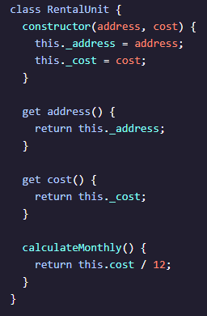
- 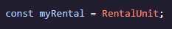
- 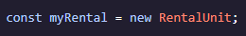

- Which of the following is the subclass in the example below?
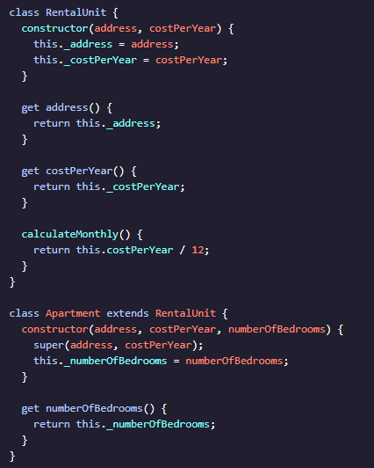
- bedrooms
- Apartment
- RentalUnit
- Address
- What is the purpose of the super keyword?
- The super keyword is used to make the methods in a parent class available to the subclass.
- The super keyword automatically create getters and setters for all properties.
- The super keyword is called in a parent class to access the properties in all subclasses.
- The super keyword is used in subclasses to call a parent constructor().
- What is the purpose of the constructor() methods?
- Each property has a constructor() method. It is called whenever you try to set or get the property.
- The constructor() method is only used in subclasses. The arguments are sent to the parent class where the properties are set.
- The constructor() is called when you create a new instance of a class. It sets the property values for each instance.
- Sunclasses inherit the constructor() from the parent class to set property values for the child class.
- How would you call the .randomBorough() method in the example below?
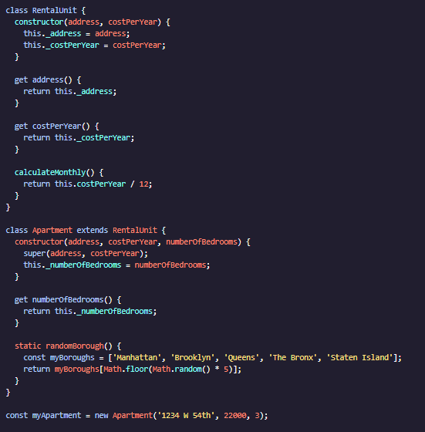
- myApartment.randomBorough()
- RentalUnit.randomBorough()
- Apartment.randomBorough()
- .randomBorough()

