- What is the general purpose of a conditional statement?
- Conditional statements answer binary (yes or no) questions.
- Conditional statements make all computers capable of thought.
- Conditional statements evaluate code as either true or false
- What will the following code log the console?
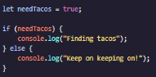
- Finding tacos
- Keep on keeping on!
- What will the code block log to the console?
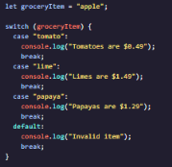
- Papayas are $1.29
- Tomatoes are $0.49
- Invalid item
- Limes are $1.49
- What will the code block log to the console?
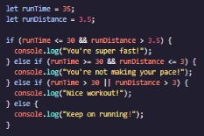
- You’re super fast!
- You’re not making your pace!
- Keep on running!
- Nice workout!
- Which of the following variables contains a truthy value?
- Translate this to JavaScript:
Log “Bear!” to console if isFurry is true and weight is over 100 pounds.
- 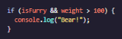
- 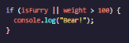
- 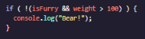
- To make this statement valid, what operator belongs in the __ space below?
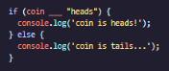
- =
- Either = or ==
- :=
- ===
- If isHungry equals true, which of the following expressions evaluates to true?

- What will the code block log to the console?
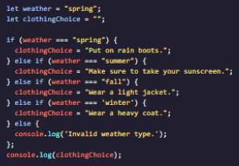
- Wear a heavy coat.
- Wear a light jacket.
- Make sure to take your sunscreen.
- Put on rain boots.
- How would you properly refactor this code block using ternary operator?
