- What will printed to the console?
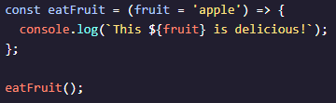
- This apple is delicious!
- This fruit is delicious!
- This is delicious!
- This undefined is delicious!
- What’s the purpose of a parameter?
- To specify actual values passed to a function.
- To call a function.
- To allow a function to accept data.
- What will this code print to the console?
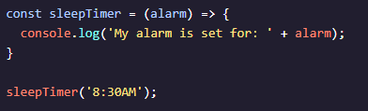
- My alarm is set for: alarm
- My alarm is set for: undefined
- My alarm is set for: 8:30AM
- My alarm is set for: sleepTimer
- This code prints: I ran 3 miles at an average of undefined per mile. Why does the text include undefined ?
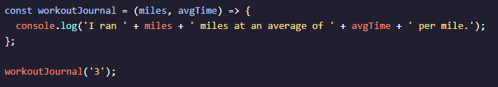
- workoutJournal does not print the value of both arguments.
- workoutJournal is not defined.
- The miles parameter is not declared.
- The call to workoutJournal is missing a second argument.

- What is the wrong with the code snippet provided?
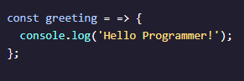
- The function expression cannot be declared with a const keyword.
- The greeting function is missing set of () between the = and =>.
- The curly braces {} should be parentheses ().
- The ordering of = and => should be switched.
- Which of the following is a parameter in the block of code below?
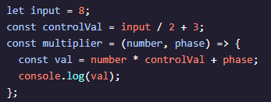
- controlVal
- val
- input
- number
- Which of the following most accurately describes the volumeOfCube() function?
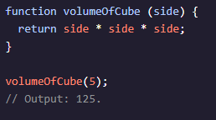
- It is a function declaration.
- It is an arrow function.
- It is an anonymous function.
- It is a function expression.
- Which of the following best describes what a function in JavaScript is used for?
- A function stores data.
- A function is a reusable piece of code that can accept input and performs a specific task.
- A function allows for the use of mathematical operators.
- A function creates new variables.
- Which correctly represents the most condensed form of the function? Recall that this syntax is also known as `concise body.`
- Which of the following is the correct way to call the function below?
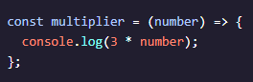
- multiplier(5)
- multiplier{5}
- multiplier 5
- multiplier[5]

