- What do nested for loops do?
- Nested for loops run the same code twice.
- Nested for loops are bad because they run forever.
- Nested for loops allow us to run multiple for loops at once.
- Nested for loops allow us to double check our if … else statements.
- What will be the result of the code block?
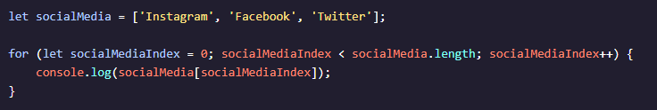
- 
- 
- 
- 
- What is incorrect about the code block?
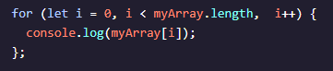
- i++ should be i = i + 1
- the condition of the loop should be separated by semicolons, not commas.
- let is not needed for the start condition.
- The for loop expressions are out of order.
- Which statement is true about while loops?
- while loops evaluate a condition for however long it`s true and the looping stops when the condition is false.
- while loops always loop over a code block a known amount of times.
- while loops will run at least once, then will run again if their condition is true.
- while loops only run while the condition is false.
- What is the general purpose of loops?
- Loops automatically iterate a block of code based on conditions.
- Loops iterate through arrays to find elements.
- All loops help the computer make decisions automatically.
- Loops read and recreate code automatically.
- Which statement is true about for loops?
- for loops can never result in an infinite loop.
- for loops are appropriate when looping a predetermined number of times.
- for loops always run an unknown number of times.
- for loops always count from 0 upwards.
- What problem is caused by this code block?
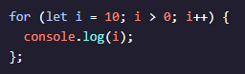
- The code will loop forever because i will always be greater than 0 and 10. This code will create infinite loop because it lacks a stop condition.
- i = 10 and i > 0 should be switched.
- You can`t run a loop withoutan array.
- The code won`t run because the stop condition is less than the start condition.
- You want to run a code block at least once, then loop as long as a condition remains true. Which kind of loop would you use?
- A do … while statement
- A for statement
- A while statement
- A nested for loop

- What would the output of this block of code be?

 