- Which of these lines of JS code properly store a string?
- var myName = Celt";
- var myName = Celt;
- var myName = Celt;
- var myName = "Celt;
- What operator do you use to combine strings together?
- ++
- &
- +
- &&
- Which of these lines of code display a string and have no errors?
- text(Heya, 10, 20);
- text("Heya", 10, 20);
- text("Heya, 10, 20");
- text("Heya, 10, 20);
- What function do you call to change the size of text in your program?
- textSize();
- fontSize();
- textHeight();
- textWidth();
- What is the outcome of this statement?
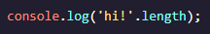
- hi! Is printed to the console.
- `hi!`.length will be printed to the console.
- 3 is printed to the console.
- 1 is printed to the console.
- What is the correct way to call a string’s built-in method?
- 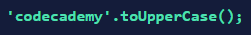
- 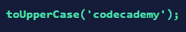
- 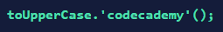
- 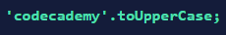

- What is the outcome of this statement?
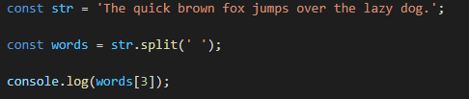
- brown
- the
- fox
- The quick brown
- What is the outcome of this statement?
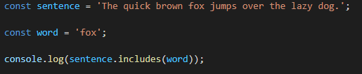
- fox
- 3
- true
- word

