Software Requirements Specification (SRS) for TicTacToe Project

*Baseline version 0.1*

*Issued on : October 30, 2014*

Issued by : Boardgames, Inc.

Issued for : Superior Company

# Change History

|  |  |  |  |
| --- | --- | --- | --- |
| **Version** | **Date** | **Author** | **Changes** |
| 0.1 | November 13, 2014 | M. Zaki Rasyadi / Aziis Yudha Adwitiya | First SRS |
| 1.0 | November 18, 2014 | M. Zaki Rasyadi / Aziis Yudha Adwitiya | Project revised |
| 2.0 | November 21, 2014 | M. Zaki Rasyadi / Aziis Yudha Adwitiya | Final project SRS |

# Document Approval

The following Software Requirements Specification has been accepted and approved by the following :

|  |  |  |  |
| --- | --- | --- | --- |
| **Name** | **Title** | **Date** | **Signature** |
| M. Zaki Rasyadi | Project Manager | 20 November 2014 |  |
| Mr. Mancung | Manager | 20 November 2014 |  |
|  |  |  |  |

Table of Contents

Change History 2

Document Approval 2

List of Figures 5

List of Tables 6

INRODUCTION 7

1.1 Purpose 7

1.2 Scope 7

1.3 Definitions, Acronyms, and Abbreviations 7

1.4 References 8

1.5 Overview 8

GENERAL DESCRIPTION 9

2.1 Product Perspective 9

2.2 Product Functions 9

2.3 User Characteristics 9

2.4 General Constraints 9

2.5 Assumptions and Dependencies 9

SPECIFIC REQUIREMENTS 10

3.1 External Interface Requirements 10

3.2 Functional Requirements 11

3.3 Use Cases 12

3.4 Classes/Objects 13

3.5 Non-Functional Requirements 13

3.6 Design Constraints 13

ANALYSIS MODELS 14

4.1 Sequence Diagrams 14

4.1.1 Sequence Diagram Play game 14

4.2 State-Transition Diagrams (STD) 15

CHANGE MANAGEMENT PROCESS 16

A. Appendices 17

A.1 Appendix 1 17

# List of Figures

Figure 1…………………………………………………………………………………………10

Figure 2…………………………………………………………………………………………11

Figure 3…………………………………………………………………………………………12

Figure 4…………………………………………………………………………………………13

Figure 5…………………………………………………………………………………………14

Figure 6…………………………………………………………………………………………15

# List of Tables

Table 1…………………………………………………………………………………….........7

Table 2…………………………………………………………………………………………16

Table 3…………………………………………………………………………………………17

Chapter 1

# INRODUCTION

## Purpose

The purpose of this document is to analyze the requirements of, design, implement, and maintain the software for Superior Company Client, which is designated specifically to help in monitoring TicTacToe project according to the requirements specified by the client.

## Scope

We have not yet finalized on a name yet, but we will refer to our game as Project TicTacToe throughout the development process. Project TicTacToe is a Board Strategy game, with rules based on the traditional game of tic tac toe, but implementing several new ideas. Such as, bigger board and how much dots to win the game.

## Definitions, Acronyms, and Abbreviations

|  |  |
| --- | --- |
| **Term** | **Definition** |
| Project TicTacToe | $The code name for our project.$ |
| Player | $$One who participates in a game or sport.$$ |
| TicTacToe board | A place that player can put dots |
| AI | The capability of a machine to imitate intelligent human behavior |
| Minimax | A strategy of game theory employed to minimize a player's maximum possible loss. |

*Table 1*

## References

* Dong Xiang, "Solve Tic Tac Toe with the MiniMax algorithm" @ http://www.codeproject.com/Articles/43622/Solve-Tic-Tac-Toe-with-the-MiniMax-algorithm.
* "Minimax Explained" @ http://ai-depot.com/articles/minimax-explained.

## Overview

This document includes five chapter and appendix. Chapter 1 discuss about project description, purpose, scope, definition, reference and overview. In chapter 2, about dicuss geberal decription. And in chapter 3, discuss about specific requirement, class and design constrain. Chapter 4 discuss analysis models and state transition diagram. And last chapter discuss about change management process.

Chapter 2

# GENERAL DESCRIPTION

## Product Perspective

University students need an entertainment tool to enjoy and play with AI. As described in section 1.2, of this document, TicTacToe intend to fill this need by providing a software allows entertainment with AI.

## Product Functions

TicTacToe system will provide the following functions:

Board Game.

Play with AI.

10x10.

Number of wins.

## User Characteristics

The user of TicTacToe need experience and be able to play tictactoe at least a basic level. Furthermore, users needs to be very familiar and the comprehended Tictactoe rules.

## General Constraints

AI and player can’t cheating in the game and will play fairly.

## Assumptions and Dependencies

TicTacToe is not platform dependence and can be installed in any operating system capable to run Java 5 environment,

Chapter 3

# SPECIFIC REQUIREMENTS

* Users shall be able to start a game with computer(AI).
* Player can choose to be the first or second in the order of playing.
* The active player shall select a square of the board by clicking it**.**
* Dots will be displayed in the board .

## External Interface Requirements

External interface requirements including the board, three button that has a different function such as button to start the game and to choose who will start first

.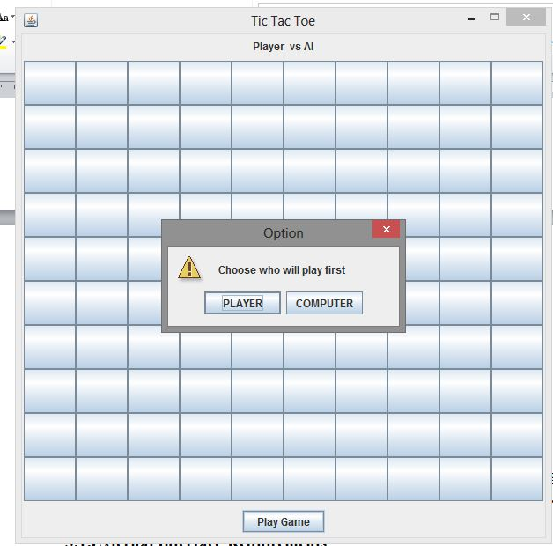

*Figure 1*

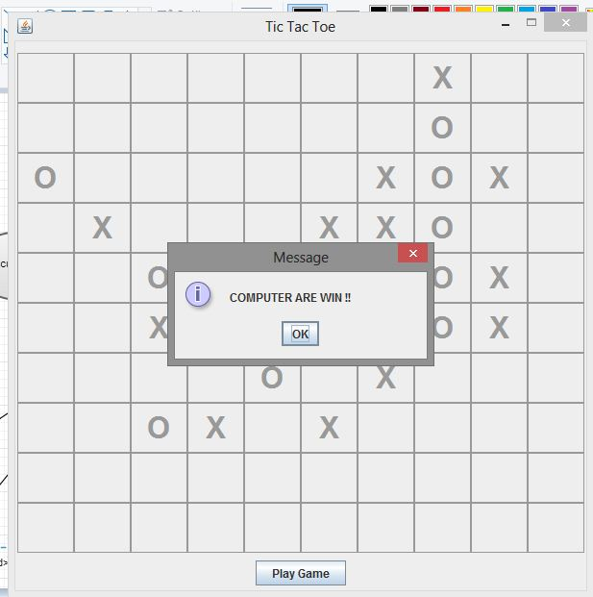

*Figure 2*

## Functional Requirements

Functional requirements including player can choose who will have the fisrt turn (player or AI), and play with hard artificial intelligence.

## Use Cases

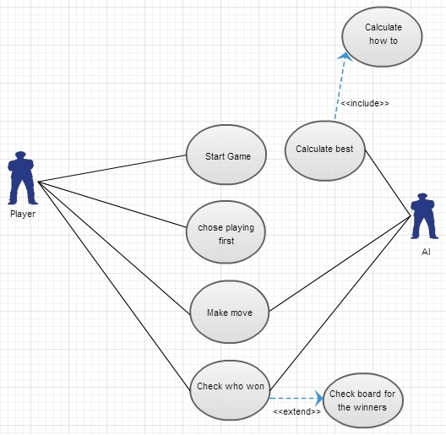

*Figure 3*

## Classes/Objects

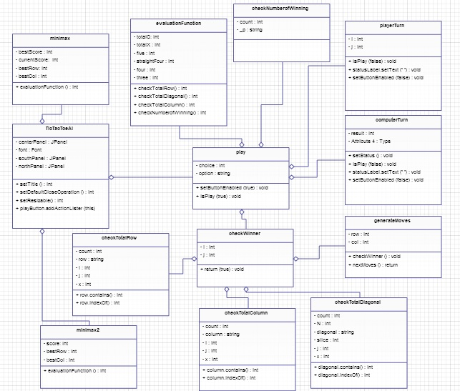

*Figure 4*

## Non-Functional Requirements

This project has a feature that showing minimax calculation and can be apeared from command prompt automatically.

## Design Constraints

This project has design constraints in programming language that written in Java and AI with Minimax method.

Chapter 4

# ANALYSIS MODELS

## Sequence Diagrams

* + 1. Sequence Diagram Play game

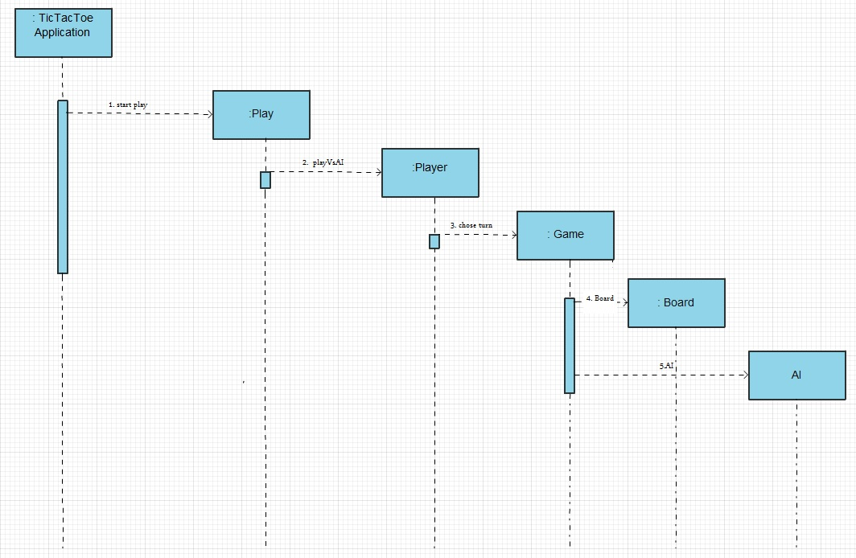

*Figure 5*

### State-Transition Diagrams (STD)

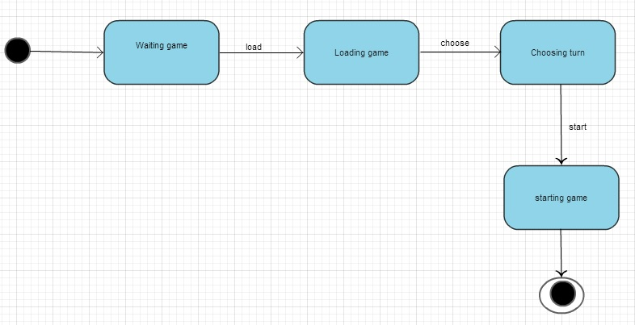

*Figure 6*

Chapter 5

# CHANGE MANAGEMENT PROCESS

Project TicTacToe

Req. No. 1

Change Specification Playes vs player

On Schedule Nil

On Effort 5

Status will be corporate in another devices

Impact Analysis -

*Table 2*

# Appendices

## Appendix 1

|  |
| --- |
| **Requirment Title Requirment type** |
| **OP001** Start Game Function |
| **OP002** Player vs AI Function |
| **OP003** Play Game Function |

*Table 3*