**“Programming using Python”**

|  |  |
| --- | --- |
| **College Name** | **Kirori Mal College** |
| **Paper Name** | **Programming with Python** |
| **Course Name** | **B.Sc. (Hons.) Math 3nd Semester** |
| **Student Name** | **Mohd Jabir Qureshi** |
| **College Roll number** | **2332185** |
| **Phone Number** | **8077129285** |

Table of Contents

**Question 13**

**Question 23**

**Question 34**

**Question 45**

**Question 55**

**Question 66**

**Question 76**

**Question 87**

**Question 99**

**Question 109**

**Question 119**

**Question 1210**

**Question 1311**

**Question 1411**

**Question 1512**

**Question 1613**

**Question 1714**

**Question 1815**

**Question 1916**

**Question 2017**

**Question 1🡪** Running instructions in Interactive interpreter and a Python Script

**Question 2🡪** Write a program to purposefully raise Indentation Error and Correct it

Part 1🡪With Indentation Error

Part 2🡪With fixing Indentation Error

**Question 3🡪 Write a program to compute distance between two points taking input from the user. (Pythagorean Theorem)**

**Question 4🡪 Write a program add.py that takes 2 numbers as command line arguments and prints its sum.**

Program in Visual studio Code (Name changes🡪 Question_3_sys_module

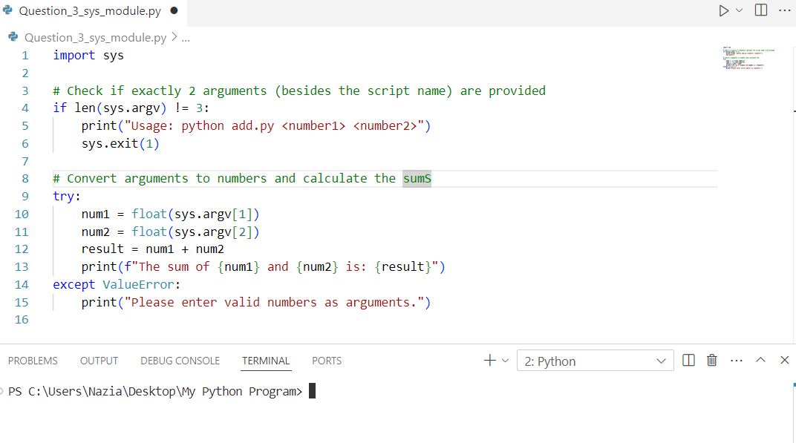

Solution🡪 Program executed in Linux

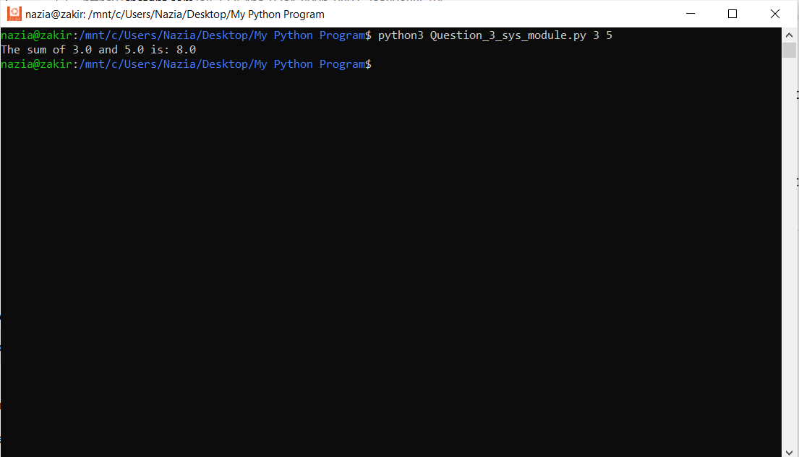

**Question 5🡪 Write a Program for checking whether the given number is an even number or not.**

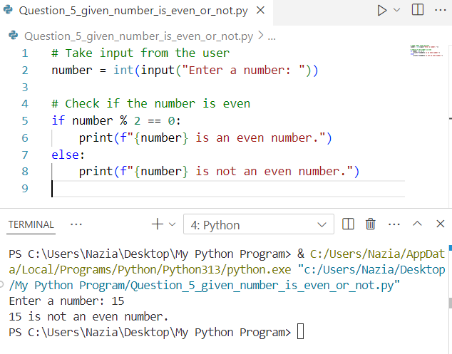

**Question 6🡪 Using a for loop, write a program that prints out the decimal equivalents of 1/2, 1/3.**

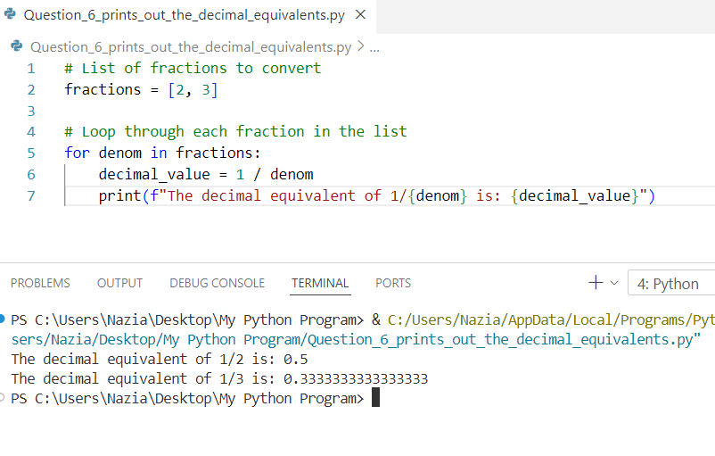

**Question 7🡪 1/4, 1/10 Write a program using a for loop that loops over a sequence. What is the sequence?**

**Question 8🡪 Write a program using a while loop that asks the user for a number, and prints a countdown from that number to zero?**

**Question 9🡪** Write a program using a while loop that asks the user for a number, and prints a countdown from that number to zero?

**Part🡪1**

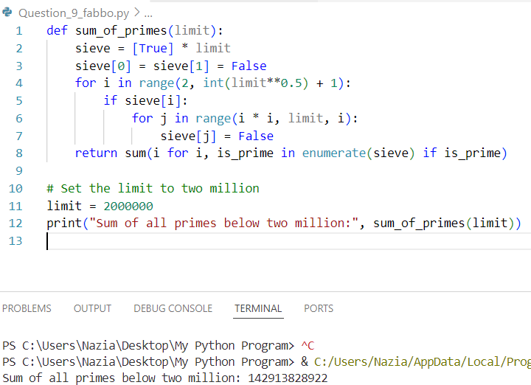

**Part🡪 2**

**Question 10🡪** By considering the terms in the Fibonacci sequence whose values do not exceed four million, find the sum of the even-valued terms?

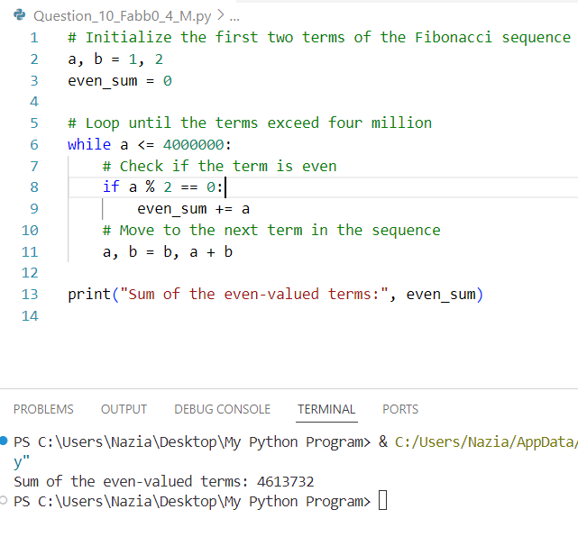

**Question 11🡪** Write a program to count the numbers of characters in the string and store them in a dictionary data structure?

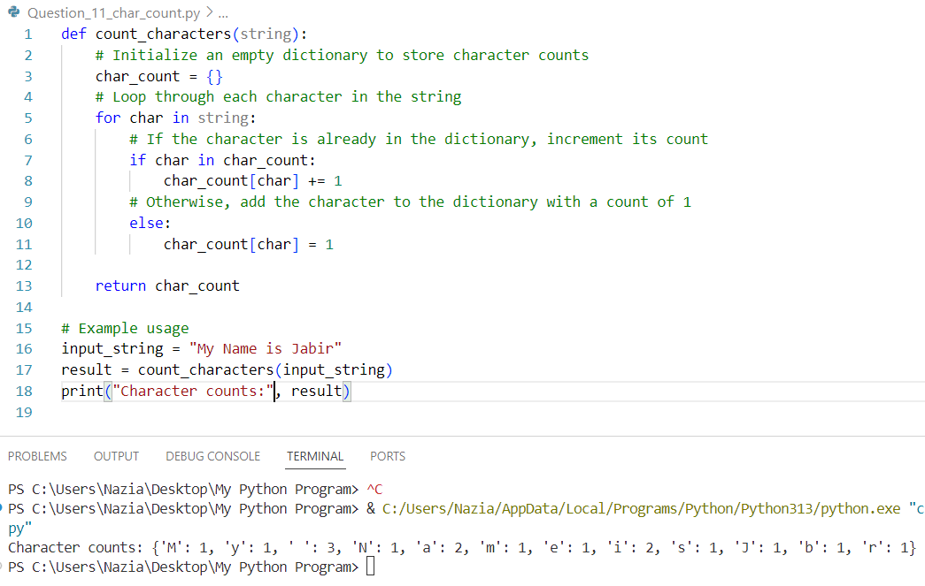

**Question 12🡪** Write a program to use split and join methods in the string and trace a birthday with a dictionary data structure?

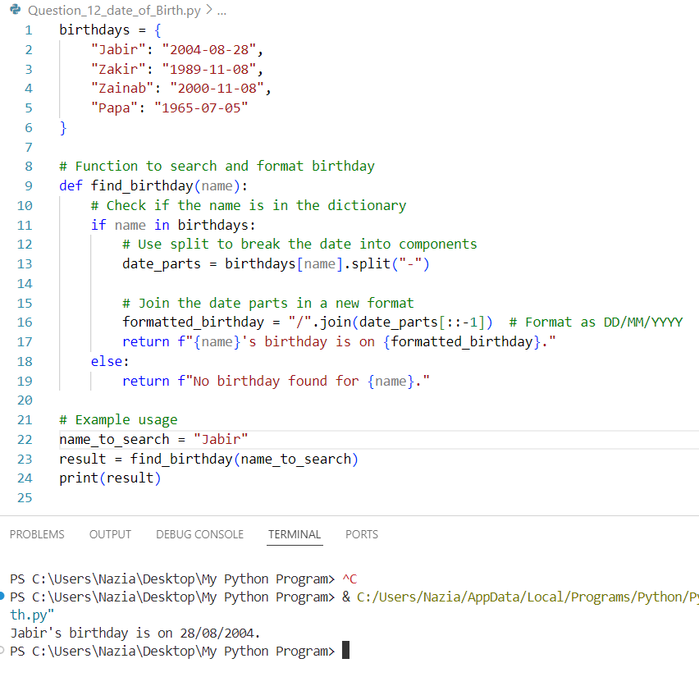

**Question 13🡪** Write a program combining lists that combines these lists into a dictionary?

**Question 14🡪** Write a program combining lists that combines these lists into a dictionary?

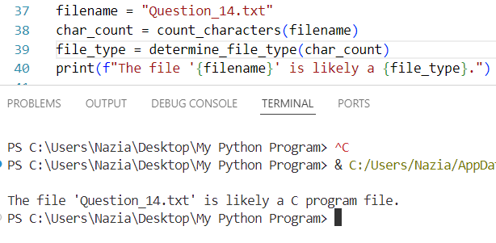

**Question 15🡪** Write a program to print each line of a file in reverse order.

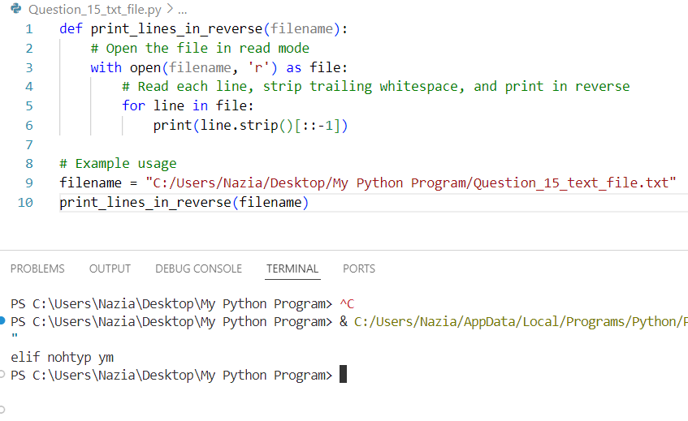

**Question 16🡪** Write a program to compute the number of characters, words and lines in a file?

**Question 17🡪** Write a function ball collide that takes two balls as parameters and computers if they are colliding. Your function should return a Boolean representing whether or not the balls are colliding. Hint: Represent a ball on a plane as a tuple of (x, y, r), r being the radius. If (distance between two balls centres) <= (sum of their radii) then (they are colliding)?

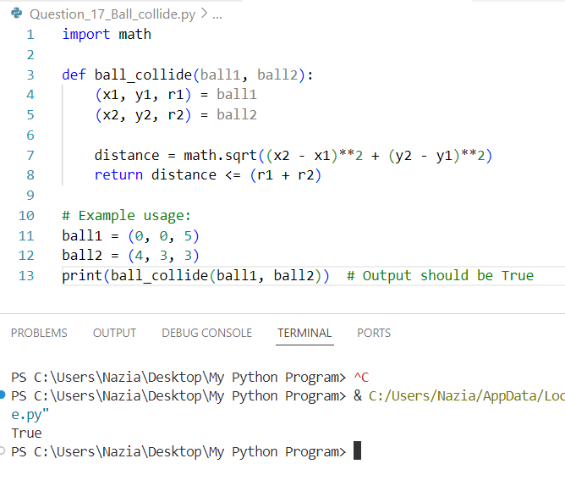

**Question 18🡪** Find mean, median, mode for the given set of numbers in a list

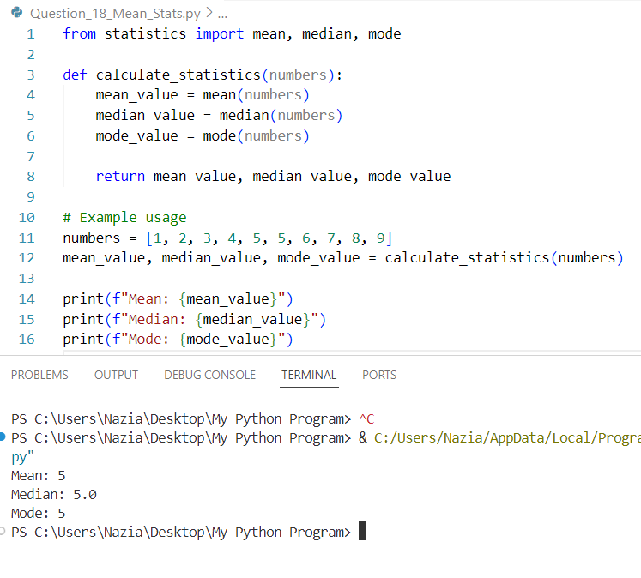

**Question 19🡪** Write a function nearly equal to test whether two strings are nearly equal. Two strings a and b are nearly equal when a can be generated by a single mutation on b.

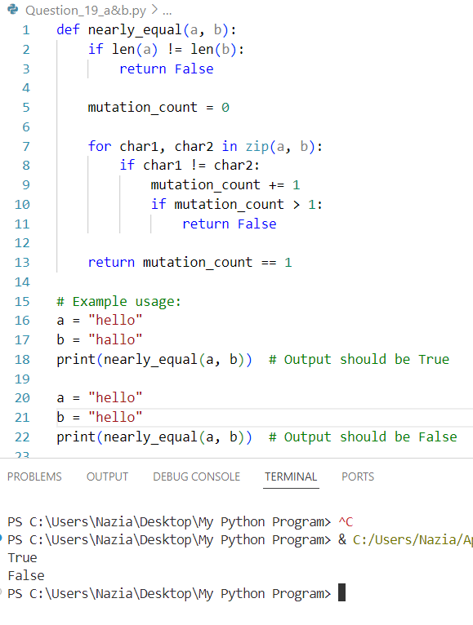

**Question 20🡪** Write a function dups to find all duplicates in the list.

