Title: Dragon's blood



# Author: Henry Milner Rideout

Report by Zakir Hasanli

# Chart of distribution of lengths of paragraphs

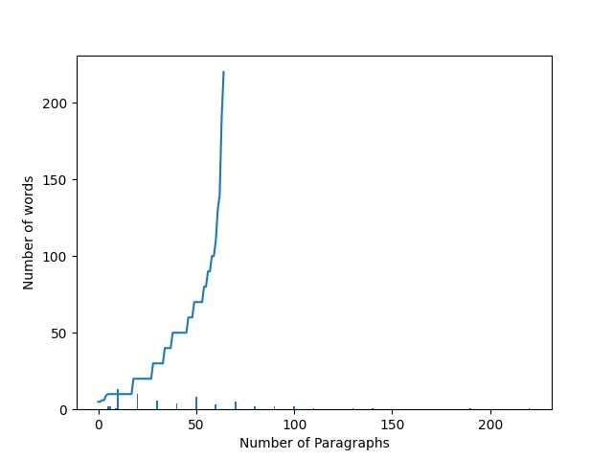

The Plot illustrates how many words were used in each paragraph of the first chapter from Dragon's blood book

Number of Paragraphs in the first chapter is 65

Number of words in the first chapter is equal to 2961

Biggest amount of words in one paragraph from first chapter: 220

Lowest amount of words in one paragraph from first chapter: 5

Average amount of words in paragraph from first chapter: 45.55384615384615

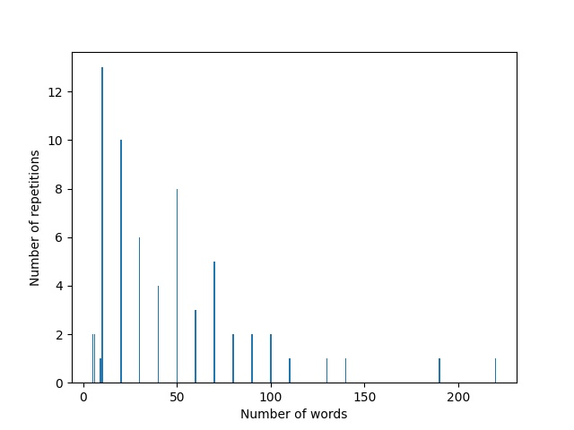

The book was taken from Project Gutenberg: https://www.gutenberg.org/ebooks/10321