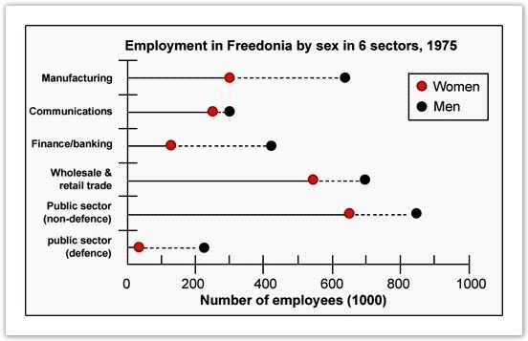
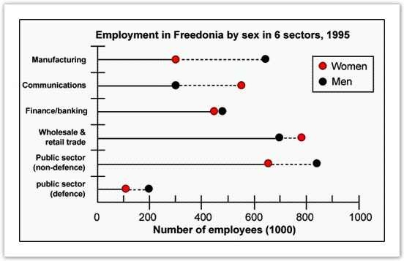
The graphs below show the numbers of male and female workers in 1975 and 1995 in several employment sectors of the republic of Freedonia.
Write a report for a university teacher describing the information shown.
You should write at least 150 words.
You should spend about 20 minutes on this task.

Sample Answer 1:
The given diagrams compare the male and female employment status in six different job sectors in two different years – 1975 & 1995. As is seen from the given illustration, men were well ahead of women in all the job sectors in Freedonia in 1975. However, the scenario changed in the 1995 and women did a remarkable progress in their professions.
According to the given diagrams, men in Freedonia were well ahead of female in manufacturing, finance/banking, wholesale & retail trade, defence and non-defence sectors. In manufacturing more than 600 male employees could be seen against only 300 female employees. Except in communication sector, the proportion of male employees was far greater than that of females. Among the given job sectors, the public /non-defence sector had the highest number of employees while the defence sector had the least number of employees.

After 20 years, women showed an outstanding advancement in the job sectors and they went well ahead of men in communication, wholesale & retail trade sectors. They become almost equal in number in finance and banking jobs while the gap between male and female employees’ numbers reduced in defence jobs. The only sector that was still male dominant was manufacturing and the job ratio in this sector remained almost same as it was 20 years earlier.

Sample Answer 2:
The given graphs provide data on the workforce in six different professions in the republic of Freedonia in 1975 and 1995. As is observed, the graphs illustrate the progress of empowering women in the work market over the twenty years, even the number of females exceeded the number of males in some work fields.
In 1975, the number of employed men was considerably higher compared to the number of women in all sectors, in particular,
manufacturing, finance and banking and public sector (defence). By 1995 there was a significant increase in the number of working females in communication, finance and marketing, and wholesale and retail trade, where the number of employed women in these sectors was around 250, 120 and 550 out of thousands respectively and it rose by approximately 300 out of thousand in each sector. Taking into consideration the number of women surpassed the number of men in communication and wholesale and retail sectors, it is evident that women empowerment in employment sectors in Freedonia had significantly progressed in the given period.

Summary of the graphs:
In Freedonia, women's involvement in major job sectors has increased remarkably in 20 years. Initially, in 1975, they were less in number than the male employees in all the 6 major job sectors. But within 20 years, they did significant progress and have crossed the number of male employees in some sectors.

Eating sweet foods produces acid in the mouth, which can cause tooth decay. (High acid levels are measured by low pH values)
Describe the information below and discuss the implications for dental health.
»You should spend about 20 minutes on this task.
»You should write at least 150 words.
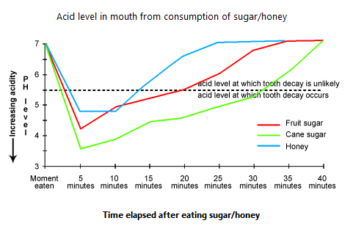

Sample Answer 2:
The provided line graph shows the acid level of our mouth which is created by the consumption of fruit sugar, cane sugar & honey and compares their effects on our tooth decay.

The given graph shows that the initial pH level of our mouth is 7 which begins to fall after consuming sweet foods. When we eat sweet item like cane sugar, the pH level drops to 3.5 in 5 minutes and remain in danger level (below pH level 5.5) for more than 30 minutes. Consuming fruit sugar drops the pH level nearly to 4 and remains in danger level for about 20 minutes. And finally, when we eat honey, the pH level falls below 5 and it remains under risk level for about 13 minutes.

In conclusion, all of the sweet items possess the possibility of causing tooth decay and as the low pH level means higher acidity and causes tooth decay, honey and fruit sugar are likely to cause less decay than the cane sugar does.

