The Task-1 should have
- Introduction
- Body
- Overview

Tips and Advice:
- Read the instruction carefully to understand what is required to fully complete the questions.
- Look for most significant trends.
- You have to identified 2 to 3 main and significant points on each diagram and describe these.
- Plan a theme for each paragraph.
- Paraphrase key words or use synonyms.
- Consider tenses that are relevant.
- Don’t describe every number on charts in graph.
- Don’t copied words from the exam question or title.
- Don’t use too many linking words or phrases just because you know that.
- Don’t describe every detail.
- Don’t rush answer ignoring instructions.

Paraphrase the keywords with different words:
The graph below gives information about cinema attendance in the UK between 1998 and the present, with projection to 2018. Summarise the information by selecting and reporting the main features, and make comparisons where relevant.

The diagram shows data on cinema-goers in the UK over 2 decades, from 1998, with forecast up to 2018.

It is evident that number of cinema-goer of all ages increased, with the biggest rise amongst the 35-49-year-olds. The 14-24-year-olds however, consistently had the highest proportion and the 50-year-olds always had the lowest quantity.

Degree of change:
Minimal moderate substantial
Slight considerable enormous
Gradual significant dramatic

Comparison between sentences:
In contrast বিপরীতে
By contrast বিপরীতে
In comparison তুলনা করলে
By comparison তুলনামূলক ভাবে
Likewise অনুরূপভাবে
Instead বদলে
However কিন্তু / যাহোক
Meanwhile এদিকে / অপরদিকে / ইতোমধ্যে

Sentence 1. ----------, Sentence 2

Sentence 1: The number of people driving to work rose to 7 million.
Sentence 2: There was a small drop of approximately .5 million in the number of bus user.

The number of people driving to work rose to 7 million. In contrast, there was a small drop of approximately 0.5 million in the number of bus users.

Comparison within sentences:
While যদিত্ত
Whereas পক্ষান্তরে, অপর পক্ষে
But কিন্তু, তবে
Compared to তুলনায়
in comparison with তুলনামূলক ভাবে

While + Clause 1, Clause 2
Clause 1, while Clause 2

While the number of people driving to work rose to 7 million, there was a small drop of approximately 0.5 million in the number of bus users.
The number of people driving to work rose to 7 million, while there was a small drop of approximately 0.5 million in the number of bus users.

Clause 1, but Clause 2

The number of people driving to work rose to 7 million, but there was a small drop of approximately 0.5 million in the number of bus users.

Clause 1 (Object 1), compared to Object 2
Clause 1 (Object 1) in comparison with Object 2

The number of people driving to work was 7 million, compared to approximately 0.5 million people traveling to work by bus.
The number of people driving to work was 7 million in comparison with approximately 0.5 million people traveling to work by bus.

Linking using WITH

S1 + V1, with S2 + V-ed / V-ing

The number of visits to two websites show fluctuations during 15 days.
The number of visits to website Pop Parade surpasses that of website Music choice in all most all periods.

The number of visits to two websites show fluctuations during 15 days, with the figure for Pop Parade surpassing that of Music choice in almost all periods.

Talking about similarities:
Canada = England
Both Canada and England have a queen.
Like Canada, England has many immigrants.
In England, they speak English. Similarly, in Canada many people speak English.
In England, they speak English. In comparison, in Canada many people speak English.
In England, they speak English. In the same way, in Canada many people speak English.
In England, they speak English. Likewise, in Canada many people speak English.
Canada is similar to England.
Canada is the same as England.

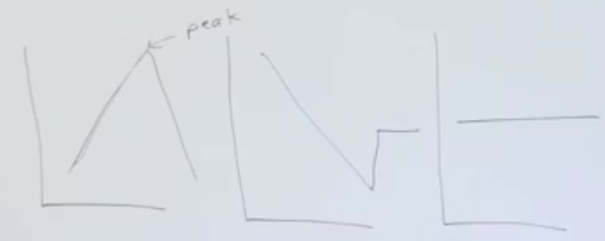
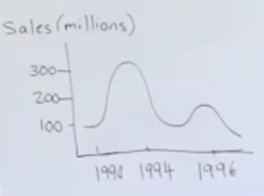

Presenting a graph introduction:

The
pie chart / bar graph / line graph / flow chart / table
in the figure
describes / shows / represents / depicts / indicates / demonstrate / illustrates / lists
Topic (the changes in sales)
between 1990 and 1996 / over a 6 year period / from 1990 to 1996

Example:
The line graph in the figure demonstrates the changes in sales over a 6 years period.

Describing Movement:
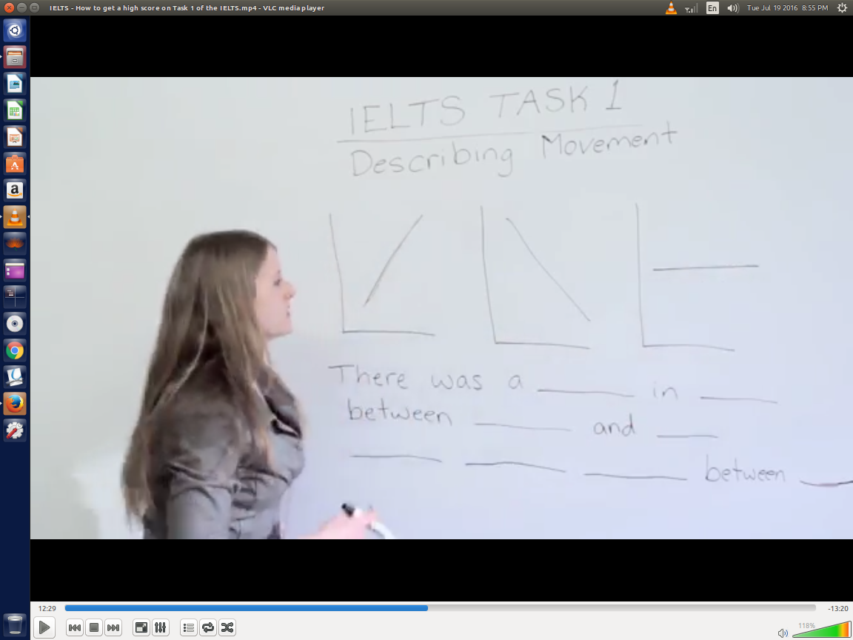

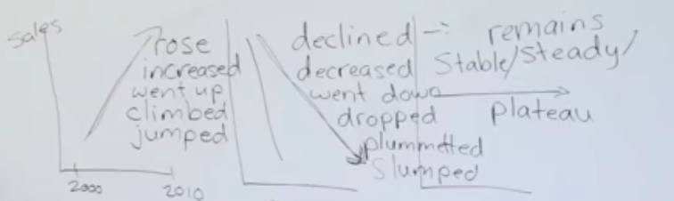

There was a significant / sudden / steady / rapid / dramatic rise / increase / climb / jump in sales between 2000 and 2010.

Sales rose / increased / went up / climbed / jumped significantly / suddenly / steadily / rapidly / dramatically between 2000 and 2010

There was a significant / sudden/ steady / rapid / dramatic decrease / drop / slump / decline / plummet in sales between 2000 and 2016.
Sales decreased / went down / declined / slumped / dropped / plummeted significantly / suddenly / steadily / rapidly / dramatically between 2000 and 2010

There was a plateau in sales between 2000 and 2016
Sales remained steady / stable between 2000 and 2016

Example:
There was a significant increase in sales between 2000 and 2010.

Describing Pi charts:
According to the chart….  We can see from the chart….  The chart shows that...  Rent makes up half of the living expense.  Half of the living expenses are rent.  Rent account for 50% of the total.  Fifty percent of the living expenses is rent. | Half  Two-thirds  three-thirds  A third  A quarter  A fifth  A sixth | Exactly, precisely 42%  Around, nearly, close to, roughly 42%  Slightly above, just over 40%  Slightly below, just under 45%  ----- is coffee.  Coffee makes up a ----- of the total at 10%  A small / large fraction  A small / large percentage  A small / large number  The lowest / highest percentage  A very small / large percentage  A very small / large proportion

Practice-1
The pie chart depicts the different costs involved in a book of price 250 $. Describe the information in not less than 150 words.

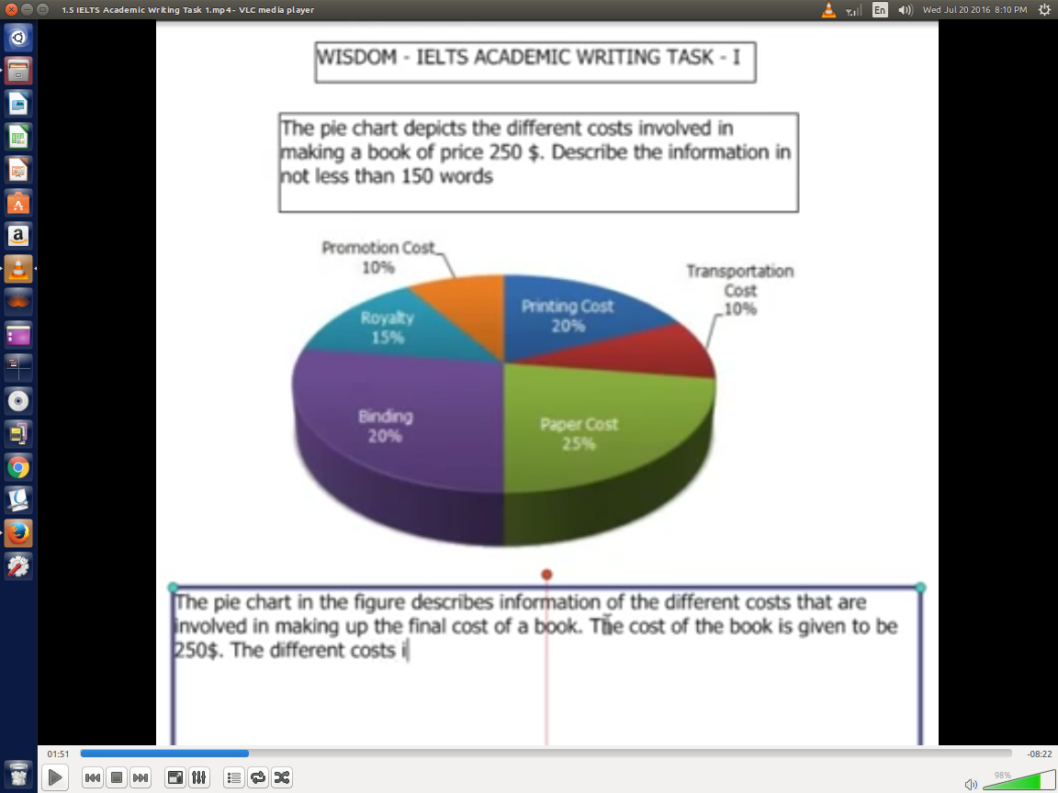

The pie chart in the figure describes information of the various costs that are involved in making up the final cost of a book. The cost of the book is given to be 250$. The different costs into which the final cost is segregated are - paper, printing, binding, transportation, promotion and royalty.

Paper contributes 25% of the total final cost. Its value comes out to be 62.5$. Binding and printing both cost 25$ separately and the respective contributions are 20% each. Royalty constitutes 15% of the total cost which is 37.5$. 10% of the total cost comes from transportation which is 25$. The remaining 10% of the final cost comes from promotion. This too account for 25$.

At the end, it can be concluded that paper, printing and binding are the main areas that influence the final cost of the book. This is because their share in the final cost is maximum and comes out to be a total of 65%. On the other hand royalty, transportation and promotion do not cost much separately but when combined they account for 35% of the total cost.
Accurate Data:

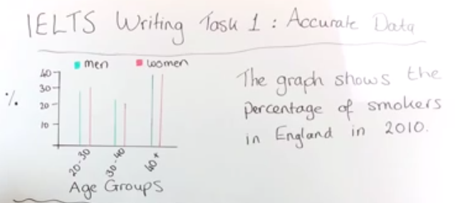

Under 30  Just under 30  Slightly under 30  Almost 30  Nearly 30  Close to 30  Below 30  Less than 30 | About 20  Around 20  Approximately 20  More or less 20 | Over 20  Just over 20  Well over 20  Above 20  Marginally above 20  More than 20  Considerably more than 20

Practice 2
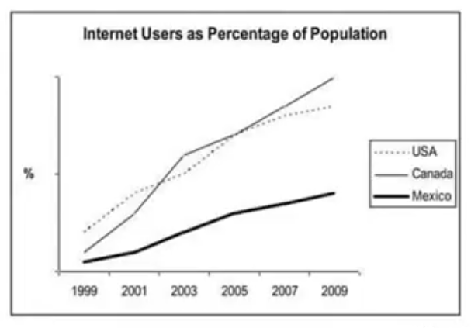
The line graph compares the percentage of people in three countries who used the Internet between 1999 and 2009.

It is clear that the portion of the population who used the Internet increased in each country over the period shown. Overall, a much larger percentage of Canadians and Americans had access to the Internet in comparison with Mexicans, and Canada experienced the fastest growth in Internet usage. In 1999, the portion of the people using the Internet in the USA was about 20%. The figures for Canada and Mexico were lower, at about 10% and 5% respectively. In 2005, Internet usage in both the USA and Canada rose to around 70% of the population, while the the figure for Mexico reached just over 25%.

By 2009, the percentage of the Internet users was highest in Canada, Almost 100% of Canadians used Internet, Compared to about 80% of Americans and only 40% of Mexicans.

Practice 3:
The following Bar Chart represents the number of people who visited a certain country from different parts of the world on the month of October in 2000 and 2001. Describe the chart in your own words in not less than 150 words.
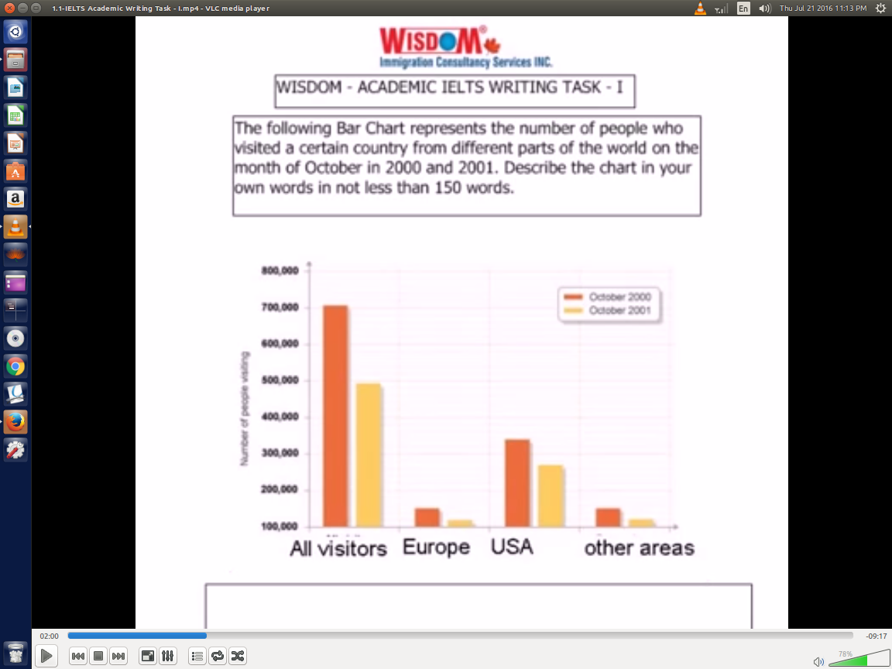

The Bar graph elucidates the number of visitors who visited a certain country in the month of October in 2000 and 2001. Information is segregated on the basis of countries - Europeans, Americans and others.

In October 2000, more than 300,000 visitors were Americans, less than 150,000 visitors were from Europe and the remaining 150,000 visitor were from other parts of the world. However, in October 2001, American visitors were less than 300,000 in number while European visitors were close to 120,000 in number. Even visitors from other areas were nearly 120,000 in number. It is evident that visitors from Europe and other parts except USA were almost equal in both October 2000 and 2001.

Observing the two dimension graph leads to the conclusion that more visitors visited the particular country in October 2000 than in October 2001. Also among all different areas, American visitors outnumbered visitors from other countries in 2000 and 2001.

