# Build an NFT marketplace

User can mint NFT, They are able to see NFTs as list with the bid price on the each event Auction page. User can donate their NFT to each EVENT. And another user can bid on this NFT. To, mint NFT and Event user have to connect his Aurora wallet.

# NEAR <> Aurora Integration

All the charity events and NFTs are creating on Aurora platform. And bidding in NEAR contract. So, when charity owner is creating the EVENT, then these are creating on Aurora. Using ERC-721 contract EVENTS and NFTs are creating on Aurora. And when user bid, then NEAR contract is using and bidding on NEAR platform.

# NEAR FOUNDATION - Airtable is the New Excel.

When user create EVENTs and NFTs and Bid then the data are saving into Airtable. And these are showing on the front-end. So, using it we can display lots of data without delay. Also we can search and sort by price. Also here we can delete the data.

# NEAR FOUNDATION - Bootcamp Capstone on Web3.

User can login with their wallet. And NEAR price has been used on this platform. So, when user bid then user has to use his wallet. After he connected then he can bid on the NFTs.

# Lottery

### Charity Event Owner

On the auction page only event owner can see a button to those NFTs, where no one has bidden. Which is “Add to Lottery”. After he clicked on that, a popup will show up.

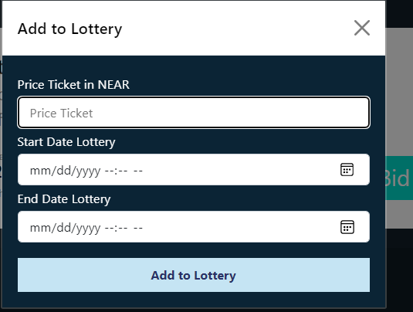

Here event owner has to fill these Price Ticket in NEAR, Start Date Lottery, End Date Lottery.

The event owner has to click on “Add to Lottery’. After it, on user view a button will show.

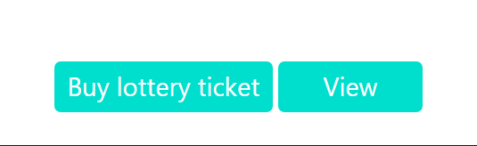

Now user can buy lottery ticket using his NEAR wallet.

### User

After event owner added the NFT to Lottery. Now user can see Buy lottery ticket. And at the top, user can see Go to Lottery. 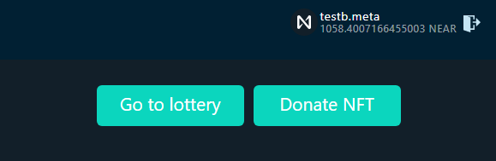 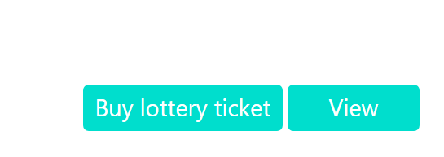

After user bought it “Go to lottery” button will show of that NFT.

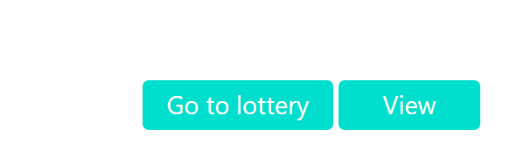

And when the date is finished. Then a button will show “Distribute”.

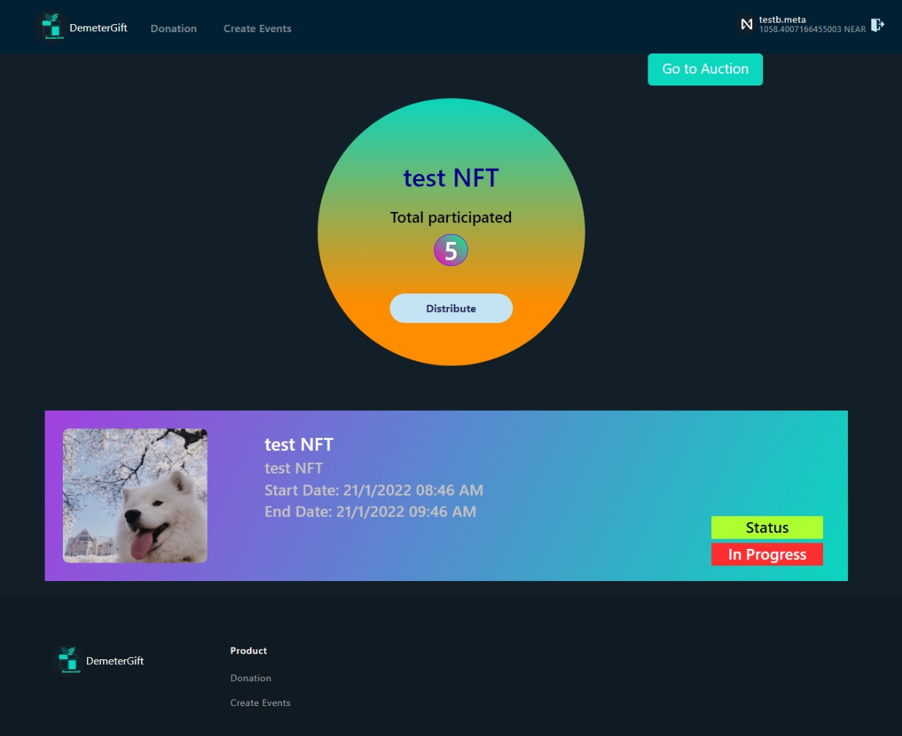

And anyone can click on it when the given time is finished. After click on it. It will show a popup for confirming on Metamsk for Gas fee.

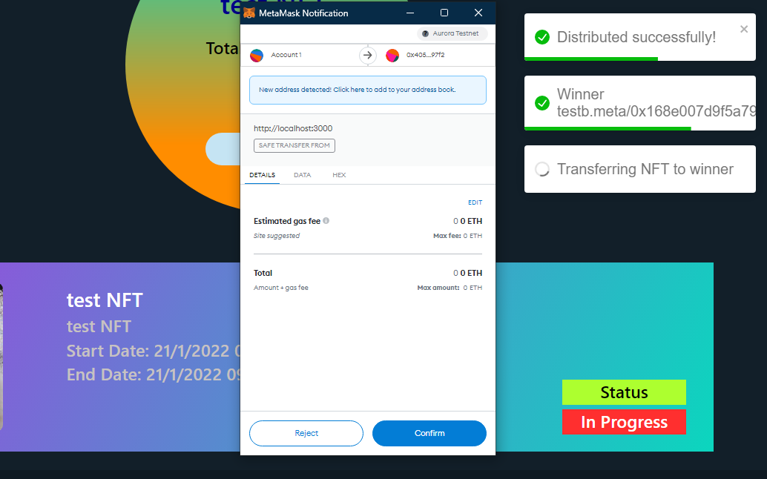

After confirm it will open a new tab of this transaction.

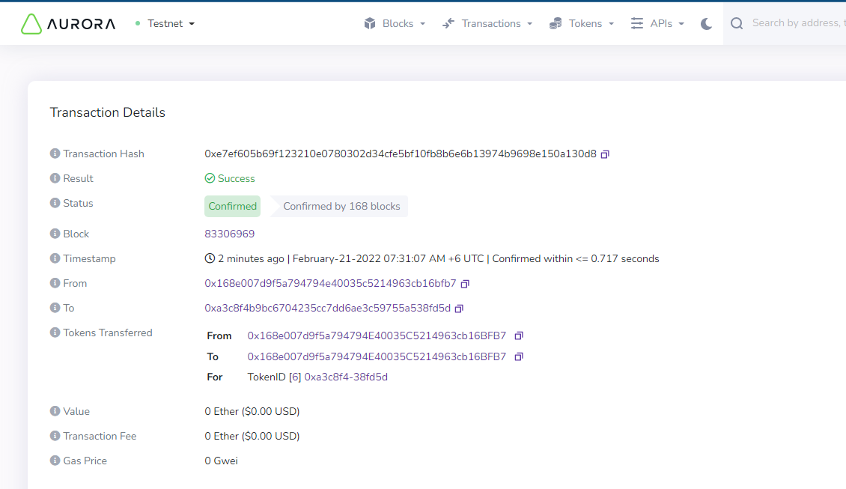

And that NFT is removed from Airtable database. So, it will not show in the event auction. But it will be in Aurora platform. Now, it will wait for next one.