Star Schema

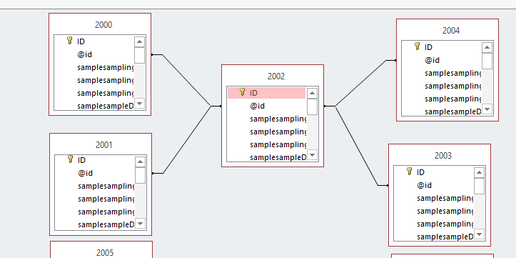

# ETL

First I connected Oracle Database into Sql Developer. Then I logged in with system and given password. After setup I started to extracting datas from MS access to Oracle. For extracting , I used a program (ESF Database Migration Tool). After installed this program. I ran the software. And then I opened the program. This is a trial version. And it has limit to 50000 rows to extract. This program asked me to provide the MS access database and Oracle server. After I gave them it automatically exported from MS access database and inserted into Oracle database with the given oracle connection. Now for check the database I connected the Oracle conection in Oracle sql developer program. And the results are perfect as expected. 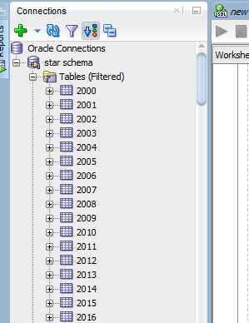

# Data Cleansing

For using the trial program in every tables this program added a extra column as TRIAL503.

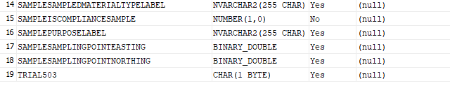

So, for deleted I executed the below query:

ALTER TABLE “2000” DROP COLUMN TRIAL503;

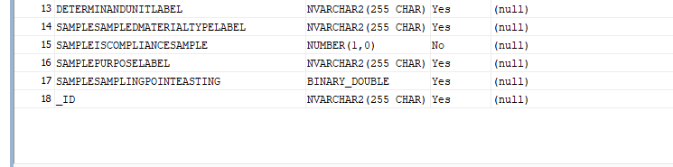

After executed this output shows.

So, I did this for also others tables. The output looks like this:

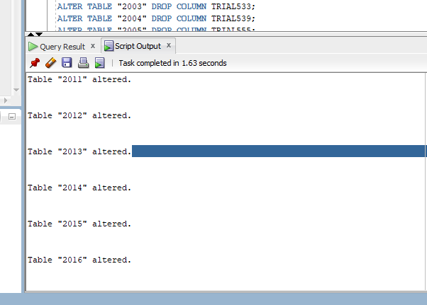

Building the Warehouse

For this I created a new table called FactTable. And then connected all the others Time Tables with this.

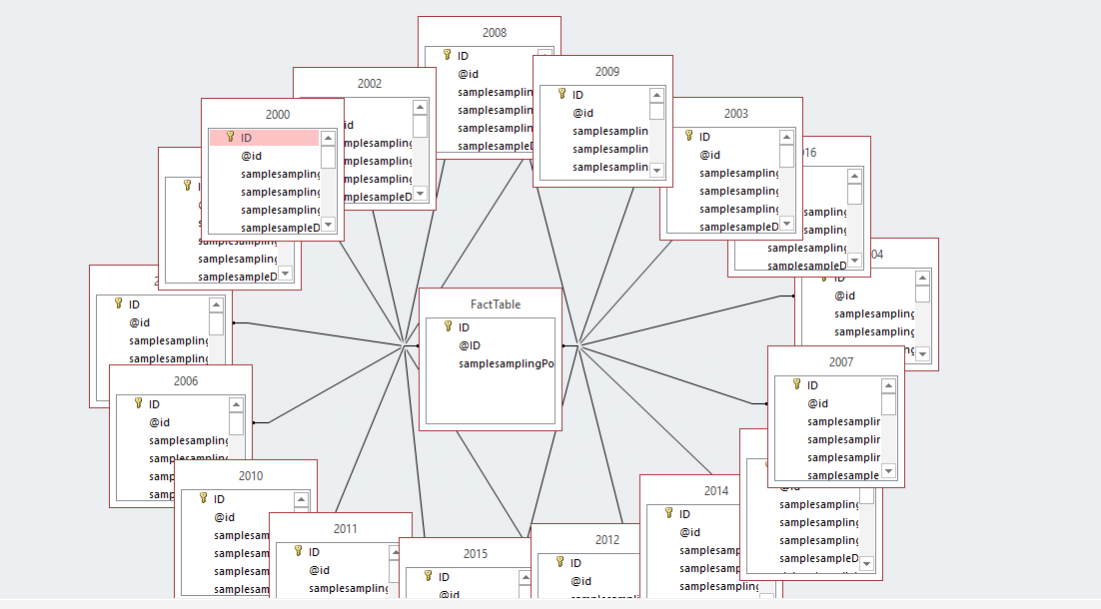

For viewing the SQL query is:

|  |
| --- |
| SELECT  FROM  (  (  (  (  (  (  (  (  (  (  (  (  (  (  (  (  FactTable  INNER JOIN 2000 ON FactTable.[@ID] = [2000].[@id]  )  INNER JOIN 2001 ON FactTable.[@ID] = [2001].[@id]  )  INNER JOIN 2002 ON FactTable.[@ID] = [2002].[@id]  )  INNER JOIN 2003 ON FactTable.[@ID] = [2003].[@id]  )  INNER JOIN 2004 ON FactTable.[@ID] = [2004].[@id]  )  INNER JOIN 2005 ON FactTable.[@ID] = [2005].[@id]  )  INNER JOIN 2006 ON FactTable.[@ID] = [2006].[@id]  )  INNER JOIN 2007 ON FactTable.[@ID] = [2007].[@id]  )  INNER JOIN 2008 ON FactTable.[@ID] = [2008].[@id]  )  INNER JOIN 2009 ON FactTable.[@ID] = [2009].[@id]  )  INNER JOIN 2010 ON FactTable.[@ID] = [2010].[@id]  )  INNER JOIN 2011 ON FactTable.[@ID] = [2011].[@id]  )  INNER JOIN 2012 ON FactTable.[@ID] = [2012].[@id]  )  INNER JOIN 2013 ON FactTable.[@ID] = [2013].[@id]  )  INNER JOIN 2014 ON FactTable.[@ID] = [2014].[@id]  )  INNER JOIN 2015 ON FactTable.[@ID] = [2015].[@id]  )  INNER JOIN 2016 ON FactTable.[@ID] = [2016].[@id]; |

Here using this sql query it is selecting all the Time Tables id with the new Fact Table.

# Develop Machine Learning solution in Python

For connecting with star schema I coded to connect with oracle server. For oracle I used cx_Oracle package. I used IPython to create this script. So for ‘2000’ table I coded like this:

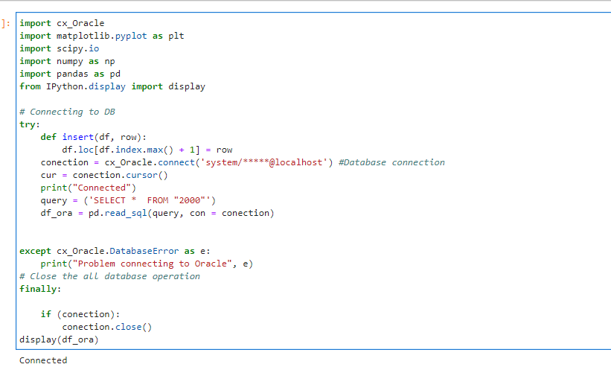

And the output for this table looks like this:

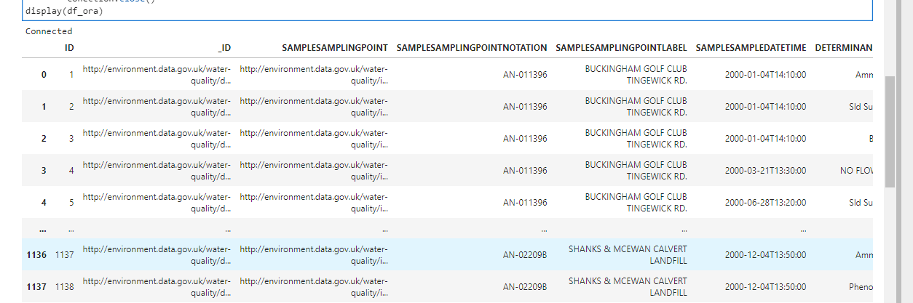

And for others tables I changed the table name. For 2001 table I coded like blew:

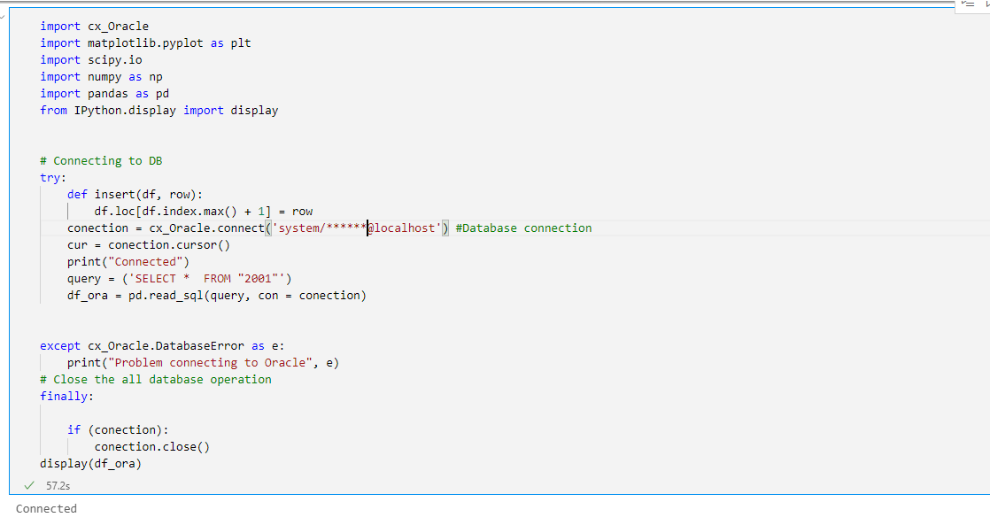

And the output:

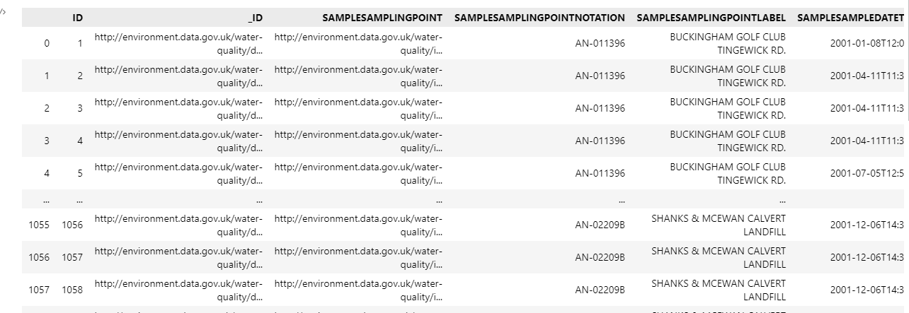

# Evaluate and compare the collected results from AI model in Pythons

After testing all the tables. I coded for selecting results:

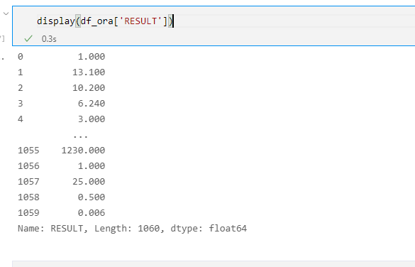

### And for the bar plot of table 2000 looks like this:

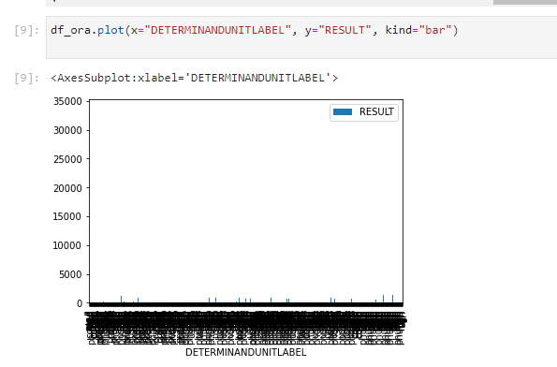

### For SAMPLESAMPLINGPOINTNOTATION output:

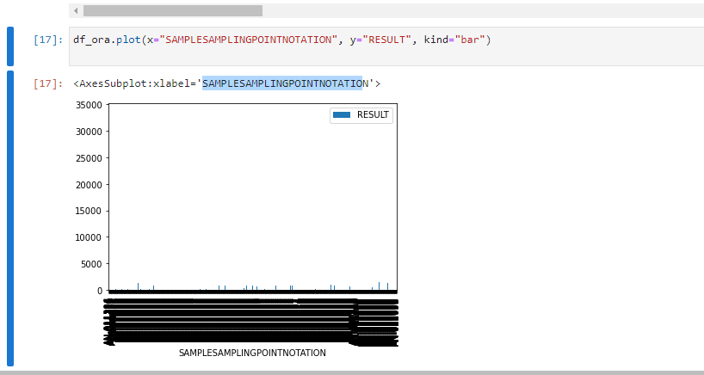

### And for the bar plot of table 2001 looks like this:

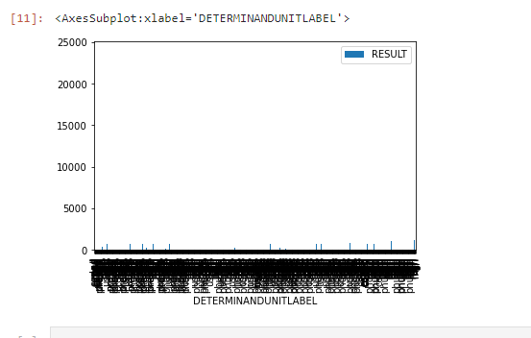

I continued with others and saw the same issue labels.

Pros:

1. Easy to detect all the values.
2. Easy to analyze all water sensors.

Con:

1. Too many labels.
2. Hard to read.